**LAB-01**

**Q1. Provide details about the following commands?**

1. apt-get: Command-line package management tool for Debian-based Linux distributions.

2. yum: Command-line package management tool for Red Hat-based Linux distributions.

3. wget: Command-line utility for downloading files from the web.

4. gzip tar: Combined use of `tar` to create and manipulate archives and `gzip` to compress them.

5. rar Command-line utility for creating, extracting, and managing RAR archive files.

**Q2. Find and Execute following commands in Linux Shell?**

**1 & 2**

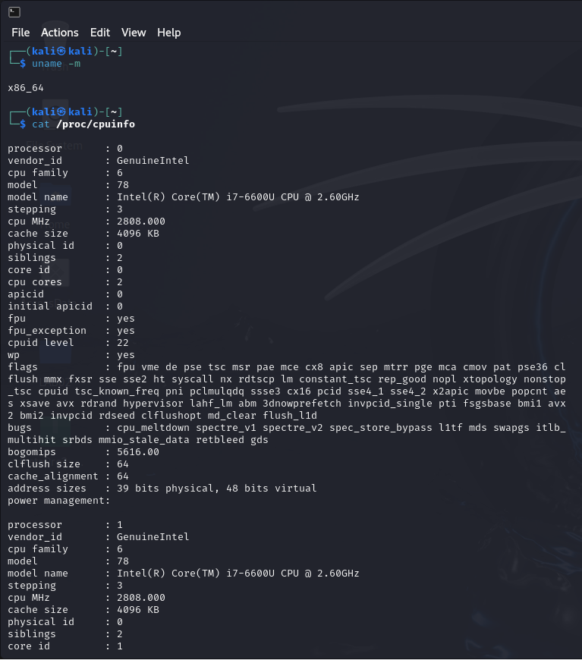

**3, 4, 5 & 6**

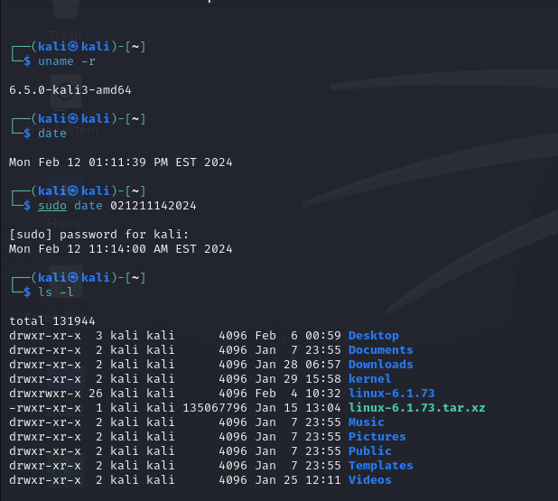

**7, 8, 9**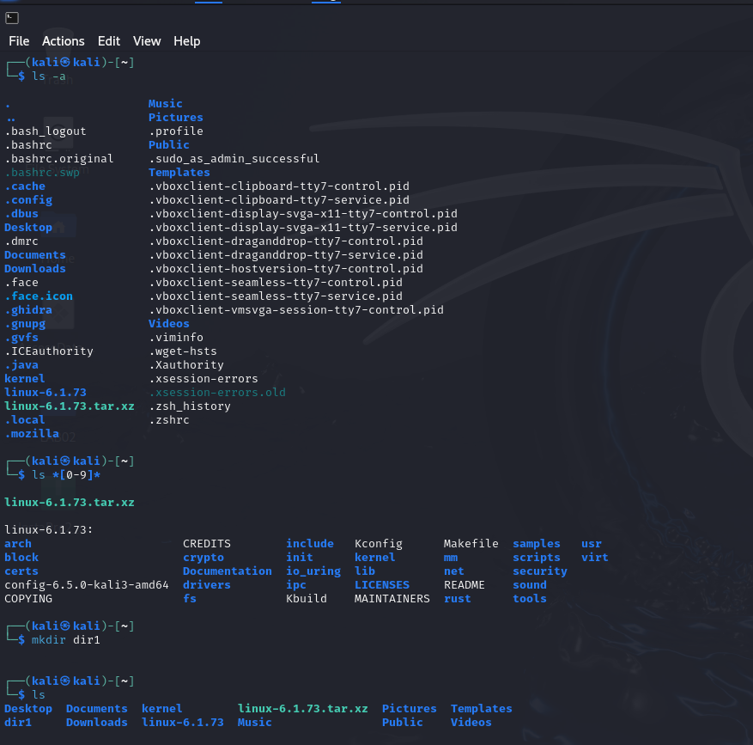

**10, 11,12,14,15**

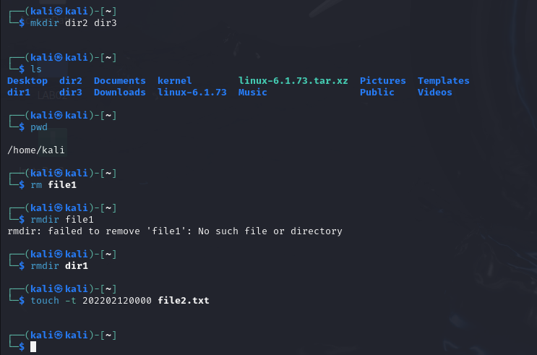

**13**

