

Operating System

LAB - 10

* Faculty name: Sir Usama
* Student ID: k224779
* Student name: Muhammad Bilal

**TASK # 1**

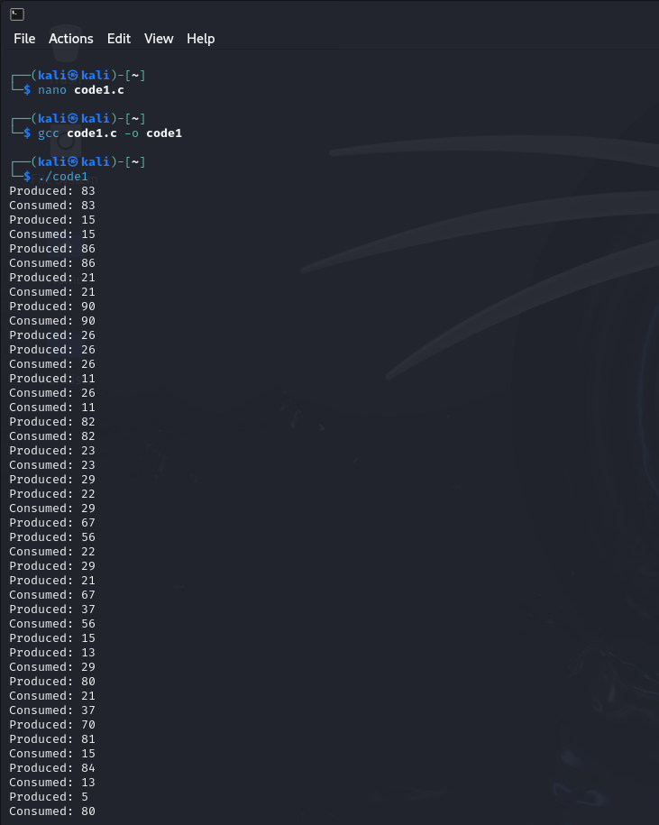

**B)**

Empty semaphore controls the number of empty slots in the buffer.

Full semaphore controls the number of filled slots in the buffer.

**C)**

The Sleep() function calls in the producer and consumer functions are used to simulate some processing time. After producing or consuming an item, the threads sleep for a random duration (up to 3 seconds) before continuing.

**TASK # 2**

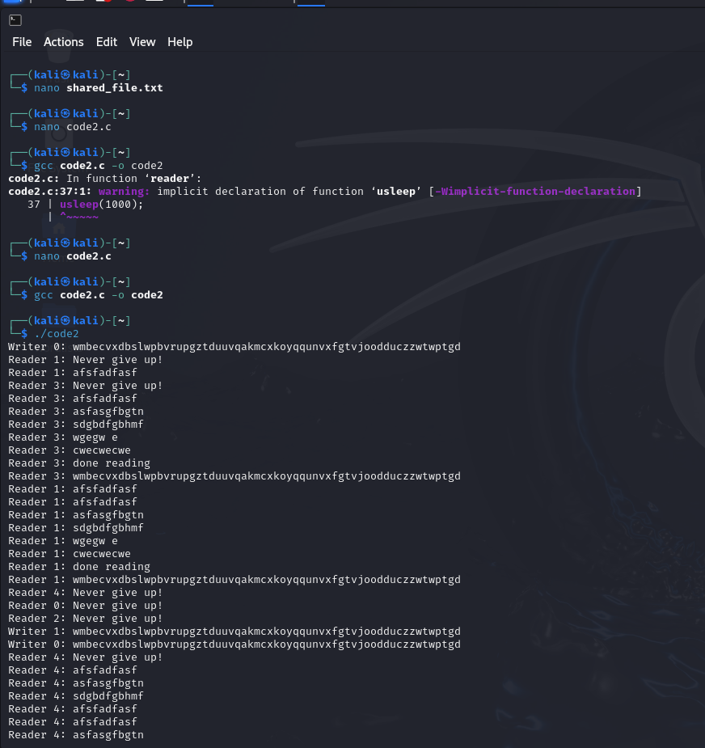

Dry Run:

**Reader Function:**

• Reader 1 acquires mutex semaphore.

• readers_count is incremented to 1.

• It acquires rw_mutex since it's the first reader.

• Releases mutex.

• Reads the file content.

• Acquires mutex again.

• readers_count is decremented to 0.

• Releases rw_mutex.

• Releases mutex.

• Sleeps for 1 millisecond.

**Writer Function:**

• Writer 1 acquires rw_mutex.

• Generates a random string.

• Appends the string to the file.

• Prints the string to the standard output.

• Flushes the file.

• Releases rw_mutex.

• Sleeps for 1 millisecond