**Post-lab task**

**PROBLEM # 1**

**Practical:**

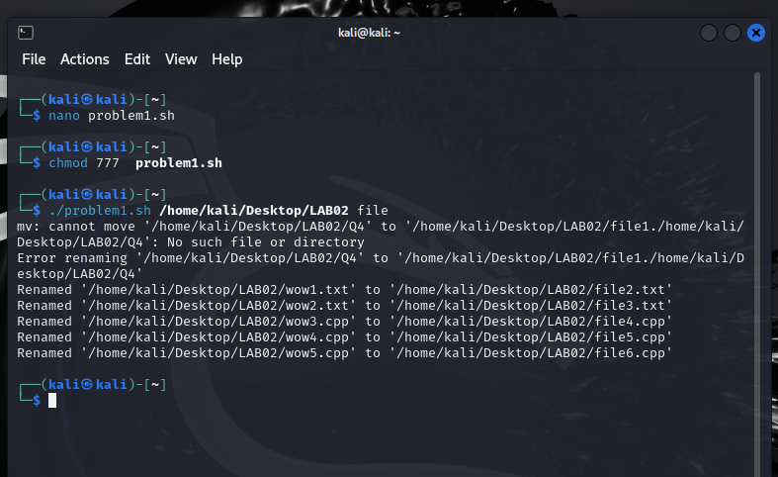

**Code:**

#!/bin/bash

if [ "$#" -ne 2 ]; then

echo "Enter the folder path: $0 <directory_path>"

exit 1

fi

folder="$1"

name_pattern="$2"

if [ ! -d "$folder" ]; then

echo "Error: Couldn't find the folder '$folder'."

exit 1

fi

counter=1

for item in "$folder"/*; do

extension="${item##*.}"

new_name="${folder}/${name_pattern}${counter}.${extension}"

mv "$item" "$new_name"

if [ $? -eq 0 ]; then

echo "Renamed '$item' to '$new_name'"

else

echo "Failed to rename '$item' to '$new_name'"

fi

((counter++))

done

**PROBLEM # 2**

**Practical:**

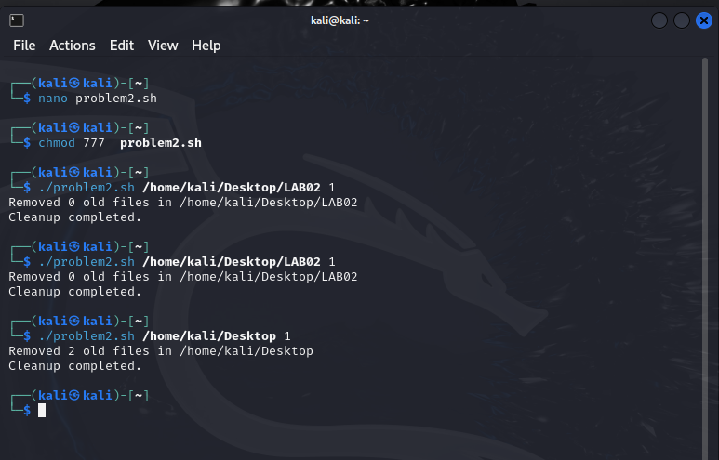

**code:**

#!/bin/bash

cleanup_empty_directories() {

find "$1" -type d -empty -delete

}

delete_old_files() {

local dir="$1"

local days="$2"

local count=0

while IFS= read -r -d '' file; do

rm -f "$file"

((count++))

done < <(find "$dir" -type f -mtime +"$days" -print0)

echo "Removed $count old files in $dir"

}

if [ "$#" -ne 2 ]; then

echo "Usage: $0 <directory_path> <days>"

exit 1

fi

directory="$1"

days="$2"

if [ ! -d "$directory" ]; then

echo "Error: Directory '$directory' not found."

exit 1

fi

delete_old_files "$directory" "$days"

cleanup_empty_directories "$directory"

echo "Cleanup completed."

**PROBLEM # 3**

**Practical:**

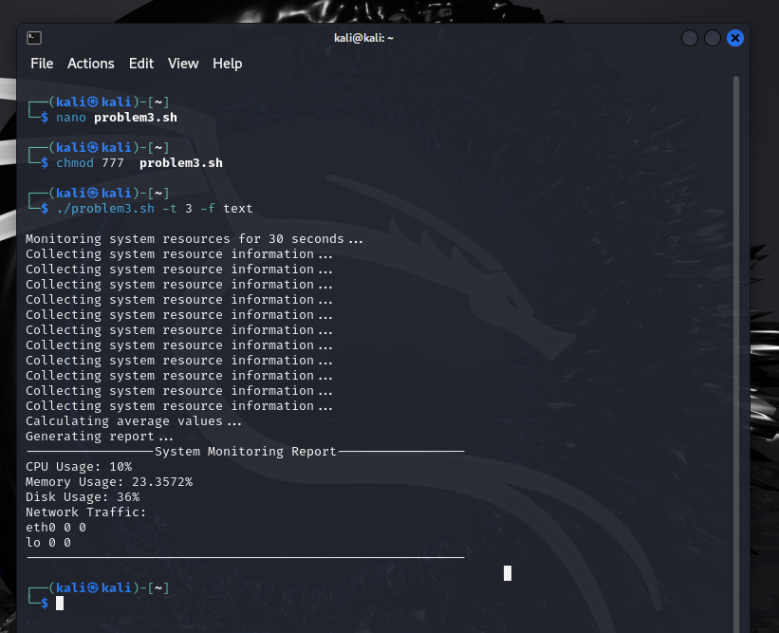

**Note:** I encountered too many error and didn’t knew many terms so, I have taken some from Google. Kindly consider this.

**Code:**

#!/bin/bash

DEFAULT_INTERVAL=3

DEFAULT_DURATION=30

DEFAULT_FORMAT="text"

display_usage() {

echo "Usage: $0 [-t <time_interval>] [-d <monitoring_duration>] [-f <output_format>]"

echo "Options:"

echo " -t <time_interval>: Specify the time interval for monitoring in seconds (default: $DEFAULT_INTERVAL)"

echo " -d <monitoring_duration>: Specify the duration for monitoring in seconds (default: $DEFAULT_DURATION)"

echo " -f <output_format>: Specify the output format (text or csv, default: $DEFAULT_FORMAT)"

exit 1

}

collect_info() {

echo "Collecting system resource information..."

cpu_usage=$(top -bn1 | grep "Cpu(s)" | sed "s/.*, *\([0-9.]*\)%* id.*/\1/" | awk '{print 100 - $1}')

memory_usage=$(free | grep Mem | awk '{print $3/$2 * 100.0}')

disk_usage=$(df -h | awk '$NF=="/"{printf "%s", $5}')

network_traffic=$(netstat -i | awk '{if(NR>2) print $1,$4,$8}')

}

calculate_average() {

echo "Calculating average values..."

avg_cpu_usage=$cpu_usage

avg_memory_usage=$memory_usage

avg_disk_usage=$disk_usage

avg_network_traffic=$network_traffic

}

generate_report() {

echo "Generating report..."

case $output_format in

text)

echo "-----------------System Monitoring Report-----------------"

echo "CPU Usage: $cpu_usage%"

echo "Memory Usage: $memory_usage%"

echo "Disk Usage: $disk_usage"

echo "Network Traffic:"

echo "$network_traffic"

echo "----------------------------------------------------------"

;;

csv)

echo "CPU Usage,Memory Usage,Disk Usage,Network Traffic"

echo "$cpu_usage%,$memory_usage%,$disk_usage,$network_traffic"

;;

*)

echo "Invalid output format: $output_format"

exit 1

;;

esac

}

while getopts ":t:d:f:" opt; do

case $opt in

t)

time_interval=$OPTARG

;;

d)

duration=$OPTARG

;;

f)

output_format=$OPTARG

;;

\?)

echo "Invalid option: -$OPTARG" >&2

display_usage

;;

:)

echo "Option -$OPTARG requires an argument." >&2

display_usage

;;

esac

done

time_interval=${time_interval:-$DEFAULT_INTERVAL}

duration=${duration:-$DEFAULT_DURATION}

output_format=${output_format:-$DEFAULT_FORMAT}

echo "Monitoring system resources for $duration seconds..."

while [ $duration -gt 0 ]; do

collect_info

sleep $time_interval

((duration -= time_interval))

done

collect_info

calculate_average

generate_report