

Operating

systems

LAB - 08

* Faculty name: Sir Usama
* Student ID: k224779
* Student name: Muhammad Bilal

**Q1:**

**(a)**

**Code:**

#include <stdio.h>

#include <stdlib.h>

#define ARRAY_SIZE 10000000

int main() {

float *A = (float *)malloc(ARRAY_SIZE * sizeof(float));

float *B = (float *)malloc(ARRAY_SIZE * sizeof(float));

float *C = (float *)malloc(ARRAY_SIZE * sizeof(float));

for (int i = 0; i < ARRAY_SIZE; i++) {

A[i] = i; // Example initialization, modify as needed

B[i] = i * 2; // Example initialization, modify as needed

}

for (int i = 0; i < ARRAY_SIZE; i++) {

C[i] = A[i] + B[i];

}

C

printf("First few elements of C: ");

for (int i = 0; i < 10; i++) {

printf("%.2f ", C[i]);

}

printf("\n");

free(A);

free(B);

free(C);

return 0;

}

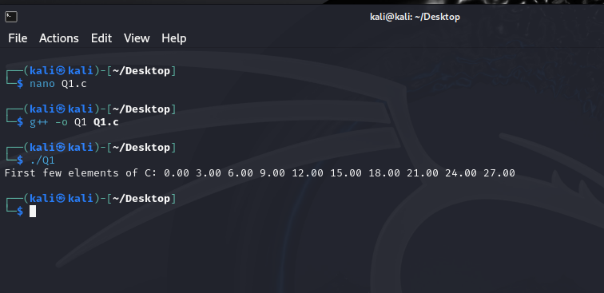

**(b)**

**Code:**

#include <stdio.h>

#include <stdlib.h>

#include <pthread.h>

#define ARRAY_SIZE 10000000

#define NUM_THREADS 10

float A[ARRAY_SIZE], B[ARRAY_SIZE], C[ARRAY_SIZE];

typedef struct {

int thread_id;

int start_index;

int end_index;

} ThreadData;

void *element_wise_addition(void *arg) {

ThreadData *data = (ThreadData *)arg;

int start = data->start_index;

int end = data->end_index;

for (int i = start; i < end; i++) {

C[i] = A[i] + B[i];

}

pthread_exit(NULL);

}

int main() {

pthread_t threads[NUM_THREADS];

ThreadData thread_data[NUM_THREADS];

for (int i = 0; i < ARRAY_SIZE; i++) {

A[i] = i; // Example initialization, modify as needed

B[i] = i * 2; // Example initialization, modify as needed

}

// Create threads

int chunk_size = ARRAY_SIZE / NUM_THREADS;

for (int i = 0; i < NUM_THREADS; i++) {

thread_data[i].thread_id = i;

thread_data[i].start_index = i * chunk_size;

thread_data[i].end_index = (i + 1) * chunk_size;

pthread_create(&threads[i], NULL, element_wise_addition, (void *)&thread_data[i]);

}

for (int i = 0; i < NUM_THREADS; i++) {

pthread_join(threads[i], NULL);

}

printf("First few elements of C: ");

for (int i = 0; i < 10; i++) {

printf("%.2f ", C[i]);

}

printf("\n");

return 0;

}

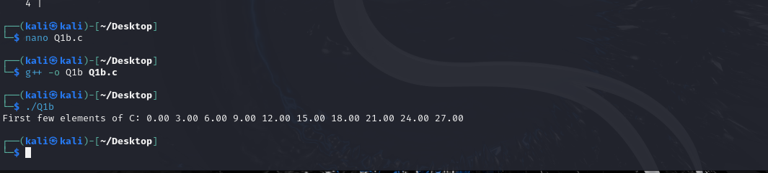

**Q2:**

**Code:**

#include <stdio.h>

#include <stdlib.h>

#include <pthread.h>

#include <cstdint>

#define MAX_NUMBERS 100

int numbers[MAX_NUMBERS];

int num_count;

typedef struct {

int *data;

int size;

} ThreadData;

void *find_average(void *arg) {

ThreadData *data = (ThreadData *)arg;

int *numbers = data->data;

int size = data->size;

int sum = 0;

for (int i = 0; i < size; i++) {

sum += numbers[i];

}

float average = (float)sum / size;

pthread_exit((void *)(intptr_t)average);

}

void *find_max(void *arg) {

ThreadData *data = (ThreadData *)arg;

int *numbers = data->data;

int size = data->size;

int max = numbers[0];

for (int i = 1; i < size; i++) {

if (numbers[i] > max) {

max = numbers[i];

}

}

pthread_exit((void *)(intptr_t)max);

}

void *find_min(void *arg) {

ThreadData *data = (ThreadData *)arg;

int *numbers = data->data;

int size = data->size;

int min = numbers[0];

for (int i = 1; i < size; i++) {

if (numbers[i] < min) {

min = numbers[i];

}

}

pthread_exit((void *)(intptr_t)min);

}

int main(int argc, char *argv[]) {

if (argc < 2) {

printf("Usage: %s <num1> <num2> ... <numN>\n", argv[0]);

return 1;

}

num_count = argc - 1;

for (int i = 0; i < num_count; i++) {

numbers[i] = atoi(argv[i + 1]);

}

pthread_t threads[3];

ThreadData thread_data[3];

void *thread_return;

thread_data[0].data = numbers;

thread_data[0].size = num_count;

pthread_create(&threads[0], NULL, find_average, (void *)&thread_data[0]);

thread_data[1].data = numbers;

thread_data[1].size = num_count;

pthread_create(&threads[1], NULL, find_max, (void *)&thread_data[1]);

thread_data[2].data = numbers;

thread_data[2].size = num_count;

pthread_create(&threads[2], NULL, find_min, (void *)&thread_data[2]);

for (int i = 0; i < 3; i++) {

pthread_join(threads[i], &thread_return);

if (i == 0)

printf("The average value is %.2f.\n", (float)(intptr_t)thread_return);

else if (i == 1)

printf("The maximum value is %d.\n", (int)(intptr_t)thread_return);

else

printf("The minimum value is %d.\n", (int)(intptr_t)thread_return);

}

return 0;

}

