

National University of Computer & Emerging Sciences (FAST-NU)

PromoLac

**Location Based E-Marketing App**

**Project Supervisor**

**Sir Farrukh Hassan**

**Project Team**

**Inam Gul 16k – 3607**

**Bilal Ashfaq 16k – 3636**

**Syed Ammar Mahmood 15k – 3629**

**Submitted in the partial fulfilment of the requirements for the degree of Bachelor of Science**

**Submitted on: May 30th, 2019**

Department of Computer Science

National University of Computer & Emerging Sciences (FAST-NU) Main Campus, Karachi

May 2020

National University of Computer & Emerging Sciences (FAST-NUCES)

|  |  |
| --- | --- |
| **Project Supervisor** | Sir Farrukh Hassan |
| **Project Manager** |  |
| **Project Team** |  |
| **Submission Date** |  |

**Supervisor**

**Farrukh Hassan**

**Head of Department**

**Dr. Muhammad Atif Tahir**

Department of Computer Science

National University of Computer & Emerging Sciences (FAST-NU) Main Campus, Karachi

Table of Contents

1. ACKNOWLEDGEMENT 4

2. Document Information 5

3. Definition of Terms, Acronyms, and Abbreviations 5

4. ABSTRACT 6

5. Chapter 1 -Introduction 3

5.1. Need for Product 3

5.2. Benefits to Users 3

5.3. Gap Analysis with existing solution 3

6. Chapter 2 - Requirements Analysis 3

6.1. Functional Requirements 3

6.1.1. Profile 3

6.1.2. Recent Meetings 3

6.1.3. Friends Nearby 3

6.1.4. Requests 3

6.1.5. CHAT OPTION 3

6.1.6. MAP 4

6.1.7. SCHEDULE MEETING 4

6.1.8. Friend List 5

6.1.9. Functional Hierarchy 5

6.1.10. Use Cases 5

6.2. Non-Functional Requirements 6

6.2.1. Performance Requirements 6

6.2.2. Safety Requirements 6

6.2.3. Security Requirements 6

6.2.4. User Documentation 6

## ACKNOWLEDGEMENT

*In the name of Almighty Allah, Most Gracious, Most Merciful.*

*All praises be to Allah, for with His grace and mercy that we were able to complete this Final Year Project successfully.*

*We would like to express our deepest appreciation to National University of Computer and Emerging Science (FAST). Thanks to Sir Farrukh Hassan, Associate Professor, and our Final Year Project coordinator for their hard work to ensure the success of this project.*

*Heartiest gratitude to our supervisor for this project. Sir Farrukh Hassan whose advice, encouragement, knowledge, and support gave me the strength to carry on with this study until its completion.*

*Last not least, our deepest gratitude and thankfulness are dedicated to our family for their prayers, support, and their encouragement to construct the project successfully. Not forgetting to all of our friends and all the people who have helped, support and contributed to complete this project. Without helps of particular that mentioned above, we faced difficulties while doing out FYP*

*Thank you to all that help us to finish this Project PromoLac. May Allah bless you.*

## Document Information

|  |  |
| --- | --- |
| **Category** | **Information** |
| Customer | Public |
| Project Title | PromoLac |
| Document Version | 1.1 |
| Author(s) | Inam Gul, Bilal Ashfaq, Ammar Mahmood |
| Approver(s) | Farrukh Hassan |
| Issue Date |  |

## Definition of Terms, Acronyms, and Abbreviations

|  |  |
| --- | --- |
| **Term** | **Description** |
| Firebase Realtime Database | Database for Android |
| Firebase Authentication | User Authentication for Android |
| Firebase Cloud Messaging | Push Notification for Android |
| Firebase Storage | Storing images data |
| Android | Mobile application of Android operating system |
| Activity | Refers to Android application screen |
| Service | Refers to Android background running task |
| SQL Server | Database for Web Application |
|  |  |
|  |  |
|  |  |
|  |  |
|  |  |
|  |  |

## ABSTRACT

In this age of globalization everyone needs to be aware of events occurring around them and tech minds are working on ways to provide quick and effective information to people with less hassle. If we talk about businesses nowadays, the success of their business and popularity of their products is highly dependent on promotional activities. So, every vendor nowadays is looking for efficient ways for promoting their products. As we are moving ahead in this age of technology new inventions are being made and technology is becoming easily accessible to everyone. So, taking advantage of this point, this FYP is motivated to bring modernity and efficiency in marketing techniques used nowadays. We are working on context-based marketing which will target specific people based on their location. If we have a look on marketing strategies nowadays, although they are much effective and provide required results but on the other hand these marketing strategies irritates customer at some point. Like if we take one strategy which is commonly used nowadays is that brands save the customers data and when they want to convey any notification to their customers they push message to all customers in their database irrespective of whether it is in the interest of that particular person or not, thus creating spam message. Another technique used is to through advertisements on different social websites which sometimes create irritation to user.

The major advantage of our product is reduced ratio of spam messages. We will be targeting specific people inside certain geo location thus reducing the factor of spamming. Secondly this app can be used by government bodies to notify public about any serious event like a pandemic alert of COVID 19, blood banks, etc. in order to update people about any emergency or any big events. We are trying to implement some efficient marketing strategies implemented by some vendors in different scenarios individually, in one project. Thus, a compact marketing package will be seen after completion of this project.

## Chapter 1 -Introduction

## Need for Product

The idea of the Promolac is to revolutionize the industry of marketing and promotion. Mostly companies use to purchase or spent huge amount of money and time through different marketing strategies to sell their products and to run their business. Now it’s crucial for

## Benefits to Users

## Gap Analysis

|  |  |  |
| --- | --- | --- |
| CATEGORY | PromoLac | OTHERS |
| **Description** | Location Based E marketing App | Server Based Promotion App |
| **Interface** | Web and Android based interface | Mostly App based |
| **Features** | Runtime conversion, Interactive interface, remote database | Static software, runtime conversion with less accuracy |
| **Constraint** | One end should have Leap motion connected | Other person should be in front of view so the conversion will work |
| **Constraint Solution** | NGO can support special person to have this device . OpenCV solution will be provided in future with accuracy | They added that improve accuracy with current program. |
| **Tools** | Python,MongoDB,JAVA,NodeJS | Don’t know, Mostly use Python |
| **Devices** | Leap Motion | Hand Glove uses in some system |

## Chapter 2 - Requirements Analysis

## Functional Requirements

### **User Requirements**

### **Profile**

User’s profile will be maintained properly with data gathered at the time of signup.

### **Deals Menu**

User have the lists of options to select the latest deals provided by different vendors.

### **Push Notification**

### **Fencing**

### **Messages**

### **Payment**

### **Target Marketing**

In this option user can view all those friends that are currently being present around him/her within specific range after they are tracked by GPS. This will be similar to face book’s online friends’ option.

### **Map Navigations**

A map will also be available in which that particular person can view his own location as well as his friends present in limited range

### SCHEDULE MEETING

An option will be given to user in which he schedules his/her meeting with other person in nearby future.

### Friend List

A friend list will be shown in which all those friends will be shown that are on board with user.

### Functional Hierarchy

[This section will give a big picture of overall system functionality. The main modules/features of system and their sub-functions will be described here in the form of a functional hierarchy so that, before getting into the use case, audience could grab the idea of overall system functions.]

### Use Cases

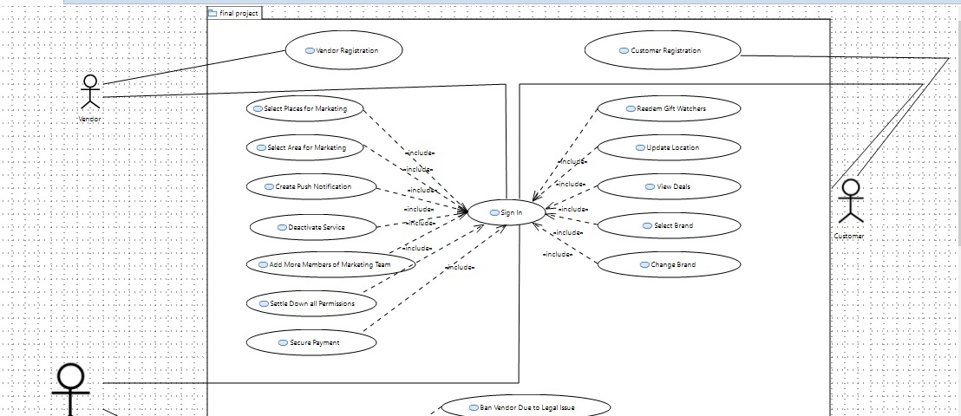

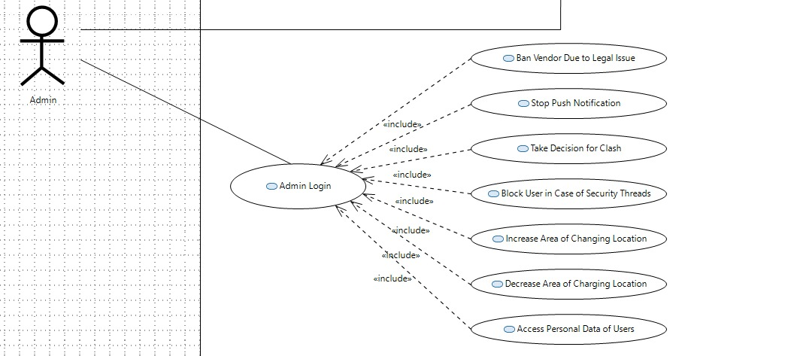

## Non-Functional Requirements

### Performance Requirements

The performance characteristics of the system that are required by the business should be outlined in this section. Performance characteristics include the speed, precision, concurrency, capacity, safety, and reliability of the software. These characteristics define the performance of the project.

### Safety Requirements

Specify the requirements that are concerned with possible loss, damage, or harm that could result from the use of the system. Define any safeguards or actions that must be taken, as well as potentially dangerous actions that must be prevented. Identify any safety certifications, policies, or regulations to which the system must conform.

### Security Requirements

Specify any requirements regarding security, integrity, or privacy issues that affect the use of the system and protection of the data used or created by the system. Define all user authentication or authorization requirements, if any. Identify any security or privacy policies or certifications the system must satisfy.

### User Documentation

[List the user documentation components that will be delivered along with the software, such as user manuals, online help, context-sensitive help and tutorials.]

* 1. **Features**
  2. **Admin**
* Have to sign up with authorize detail.
* Can create push notification for targeted audience
* Can add more members of their team as well as their dashboard.
* Can settle down all the permissions for their own members.
* Will have a dashboard for some useful information in terms of graphs and other actionable insights
* Can view their limit reaching the purchased amount like push messages will be allowed 10,000 in one month at some price, and 20,000 for more price etc.
* Can deactivate his service any time
* Can select the area and places for marketing.
* Secure Payment methods
* Having list of trusted users using their location-based services
* May be have some snapchat type vouchers too. That is, time limited, or even only available if the person was at the location at that time.
  1. Books Suppliers
* Take decisions but also have to register
* Have dashboard with all the relevant information about server requests hits, and push messages created by all the vendors
* Can ban any vendor in case of some legal issue
* Have access to stop the push notification created from any vendor.
* Have rights to take a decision for clash of same marketing place
* Can block any user in case of security threads
* Increase or decrease the area of changing location
* Can access the personal data of users of better experience and personalized suggestion
* Have a threshold marketing deal that every vendor should stay on their limit of offerings
  1. Users
* Have to make an account
* Can redeem gift vouchers
* Location update via backend service (have to give permission for asking details)
* Can view latest deals on nearby services. (Can have different features about how to view services. E.g. Can set app to receive notifications about some places, brands or products, whether when they are near, or just general alerts. Can create different tabs for notifications like email filters. Since there will be push notifications, we will also need to think about how to prevent a spamming situation. Also, will need to think about the persistence of messages, e.g. how long would they stay visible.)
* Trending offering
* Bonus points rank offerings by the provider
* Chatbot