|  |  |  |  |  |  |  |  |  |  |  |  |  |
| --- | --- | --- | --- | --- | --- | --- | --- | --- | --- | --- | --- | --- |
| **Software Requirement Specifications**  Promoloc  Version: V1.1   |  |  | | --- | --- | | Project Code |  | | Supervisor | Mr. Farrukh Hassan | | Co Supervisor | - | |  |  | | Project Team | 16k-3607 (Muhammad Inam Gul)  16k-3636 (Bilal Ashfaq )  16k3629 (Ammar Mahmood ) | | Submission Date |  | |

[Instructions]

* No section of template should be deleted. You can write ‘Not applicable’ if a section is not applicable to your project. But all sections must exist in the final document.
* All comments/examples mentioned in square brackets ([]) are in the template for explanation purposes and must be replaced / removed in final document.
* This’ Instruction’ section should also be removed in final document.
* MS-Word Reviewing feature must be used to get the document reviewed by supervisors or co-supervisors.

Document History

[Revision history will be maintained to keep a track of changes done by anyone in the document.]

|  |  |  |  |
| --- | --- | --- | --- |
| **Version** | **Name of Person** | **Date** | **Description of change** |
| V1.1 | Inam Gull, Bilal Ashfaq, Ammar Mahmood | 11/11/19 | Document created with some of the functional and nonfunctional requirements |
| V1.2 | Inam Gull, Bilal Ashfaq, Ammar Mahmood | 19/12/19 | Document Finalized  Use Cases Description |
|  |  |  |  |
|  |  |  |  |
|  |  |  |  |
|  |  |  |  |
|  |  |  |  |

Distribution List

|  |  |  |
| --- | --- | --- |
| **Name** | **Role** | |
| Mr. Farrukh Hassan | | Supervisor |
| - | | Co- Supervisor |
|  | |  |

Document Sign-Off

[Following table will contain sign-off details of document. Once the document is prepared and revised, this should be signed-off by the sign-off authority.

Any subsequent changes in the document after the first sign-off should again get a formal sign-off by the authorities.]

|  |  |  |
| --- | --- | --- |
| **Version** | **Sign-off Authority** | **Sign-off Date** |
| V1.1 | Mr. Farrukh Hassan | 13/11/19 |
|  |  |  |
|  |  |  |
|  |  |  |
|  |  |  |
|  |  |  |
|  |  |  |

**Table of Contents**

1. Introduction 7

1.1. Purpose of Document 7

1.2. Intended Audience 7  
1.3 Abbreviations ………………………………………………………………………………………...7

1.4. Document Convention 7

2. Overall System Description 8

2.1. Project Background 8

2.2. Project Scope 8

2.3. Not In Scope 8

2.4. Project Objectives 8

2.5. Stakeholders 8

2.6. Operating Environment 8

2.7. System Constraints 8

2.8. Assumptions & Dependencies 8

3. External Interface Requirements 9

3.1. Hardware Interfaces 9

3.2. Software Interfaces 9

3.3. Communications Interfaces 9

4. Functional Requirements 10

4.1. Functional Hierarchy 10

4.2. Use Cases 10

4.2.1. [Title of use case] 10

5. Non-functional Requirements 11

5.1. Performance Requirements 11

5.2. Safety Requirements 11

5.3. Security Requirements 11

5.4. User Documentation 11

6. References 12

7. Appendices 13

1. Introduction

* 1. Purpose of Document

The purpose of the document is to collect and analyze all assorted ideas that have come up to define the system, its requirements with respect to customers/client. Also, we shall predict and sort out how we hope this product will be used in order to gain a better understanding of the project, outline concepts that may be developed later, and document ideas that are being considered, but may be discarded as the product develops.

In short, the purpose of this SRS document is to provide a detailed overview of our software product, its parameters and goals. This document describes the project's target audience and its user interface, hardware and software requirements. It defines how our client, team and audience see the product and its functionality. Nonetheless, it helps any designer and developer to assist in software delivery lifecycle (SDLC) processes.

* 1. Intended Audience

The intended Audience for this project is Development Team working on Final Year Project, Project Supervisor and our Clients that are either Vendors or customers.

* 1. Abbreviations

Not Used yet

* 1. Document Convention

|  |  |
| --- | --- |
| Main Heading Font Size | 16 |
| Sub Headings Font Size | 14 |
| Text size | 11 |

1. Overall System Description
   1. Project Background

This project is intended to bring advancement in marketing strategies used nowadays. As far as location-based marketing is concerned there are four main pillars that lay down platform for this marketing strategy. These components are discussed below:

# Geo-Fencing

It is location-based advertisement technique in which user’s location is watched and only people in specific location target are notified. The targeted users use any applications or participate in any programs where they are prompted to enter their location or allow a web service to access their location.

Facebook and Google (Google AdWords) has provided this feature to their user, to create a geo fence and notify about anything to your targeted audience [1][2].

# Geo-Targeting:

The practice of delivering content/advertisements to people based on their geographic location is termed as geo-targeting. Google Ads (formerly known as AdWords) has a feature that allows search advertisers to specify a location, or a set of locations, as the only area(s) in which they want their ads to show. This technique facilitates those restaurants and markets that have branches in different areas and they want to notify only people of that particular area. This saves people from a lot of spamming and cost of advertiser is also reduced [1].

# Geo-Conquesting

This idea is somehow close to above to mentioned techniques. The core idea of this technique is to direct potential customers to your business when they are close to your competitors. This technique is used to increase brand awareness and attract customers towards your shop from your competitors. For example, if you are an independent coffee shop, you could introduce geo Conquesting to your marketing plans by targeting users who are at nearby big chains like Starbucks or Costa with ads about the great menu items you offer, cheaper coffee, fantastic loyalty scheme or the importance of supporting small, local, independent businesses [1][2].

# Beacons-Technology

This technique is used at lower level to market products individually. The core idea behind this technique is when customer passes by any product in shop the wireless transmitters notify him about any special packages offered by that shop on that product. This technique is considered to be latest development in proximity marketing [1][2].

* 1. Project Scope

This project in end will produce an android app and web application. Website will cover two aspects i.e. admin control and vendor control. Vendor will be provided functionalities for generation and management of notification. Admin panel will be for provision of services to vendors and regulating the whole process. Android app will be used for receiving notification and viewing deals.

* 1. Not In Scope

[This section will highlight/explicitly mention the functionalities (if any) that are not in the scope of current project.]

* 1. Project Objectives

If we have a look on marketing strategies nowadays, although they are much effective and provide required results but on the other hand these marketing strategies irritates customer at some point. Like if we take one strategy which is commonly used nowadays is that brands save the customers data and when they want to convey any notification to their customers they push message to all customers in their database irrespective of whether it is in the interest of that particular person or not, thus creating spam message. Another technique used is to through advertisements on different social websites which sometimes create irritation to user. The major advantage of our product is reduced ratio of spam messages. We will be targeting specific people inside certain geo location thus reducing the factor of spamming. Secondly this app can be used by government bodies, blood banks, etc. to update people about any emergency or any other scenario. We are trying to implement some efficient marketing strategies implemented by some vendors in different scenarios individually, in one project. Thus, a compact marketing package will be seen after completion of this project.

* 1. Stakeholders

People to be involved in this whole process will be

* Admin: admin panel of this project will be managed by us
* Notification generator: vendors can be any one that wants to through notifications. They can be any vendor, shop owner, event manager, government bodies,etc
* Users: people using android application and getting notifications will be users. They will be common man.
  1. Operating Environment

Operating environment for promolac is listed below:

* Operating system: windows
* Database: sql
* Architecture: client/server
  1. System Constraints

[Describe the constraints imposed on the system by the external environment. External environment may be caused by the stakeholders, business conditions, technical issues, academic requirements etc and may include the following:

* Software constraints
* Hardware constraints
* Cultural constraints (includes language etc.)
* Legal constraints
* Environmental constraints (e.g., the environment where the software will be installed, It could be a noisy environment, which may require that there is no sound event in the project).
* User constraints (e.g., the project is developed for children, so it may be required that the project has more graphic controls rather than textual controls).
* Off the shelf components that might be used in the project may have their constraints that are consequently transferred to the project.]
  1. Assumptions & Dependencies
* This system is designed keeping in mind assumption that user will have active internet connection in its mobile or any other device.

1. External Interface Requirements
   1. Hardware Interfaces

[Describe the characteristics of each interface between the software and hardware components of the system. This description might include the supported device types, the nature of the data and control interactions between the software and the hardware.]

* 1. Software Interfaces
* Admin side and vendor side will be generating data which will be stored in sql database
* Through middle ware info from sql database will be transferred to firebase.
* Firebase will generate notification
  1. Communications Interfaces
* Http protocol will be used for communication over internet

1. Functional Requirements
   1. Functional Hierarchy

[This section will give a big picture of overall system functionality. The main modules/features of system and their sub-functions will be described here in the form of a functional hierarchy so that, before getting into the use case, audience could grab the idea of overall system functions.]

* 1. Use Cases

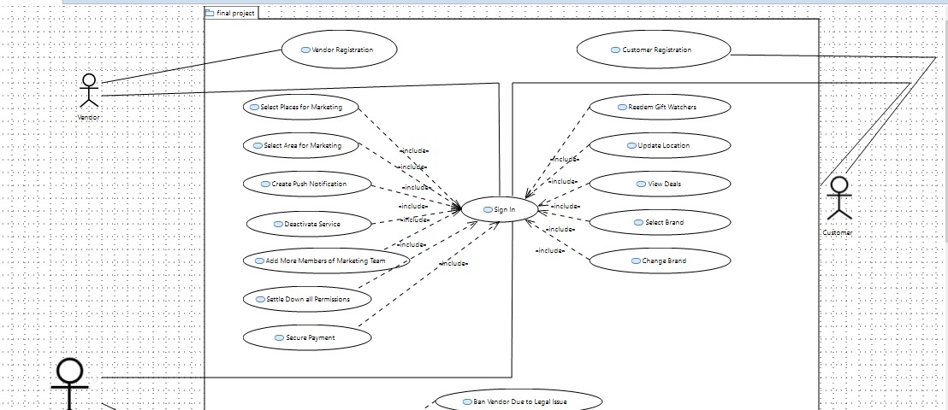

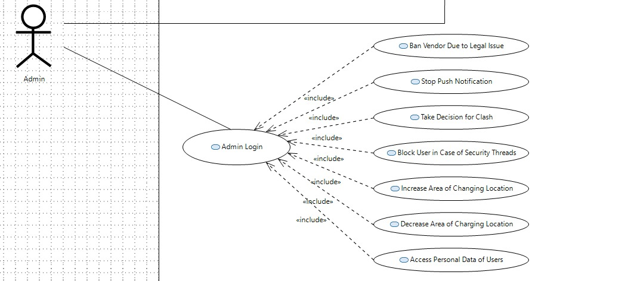

1. Non-functional Requirements
   1. Performance Requirements

[The performance characteristics of the system that are required by the business should be outlined in this section. Performance characteristics include the speed, precision, concurrency, capacity, safety, and reliability of the software. These characteristics define the performance of the project.]

* 1. Safety Requirements

[Specify the requirements that are concerned with possible loss, damage, or harm that could result from the use of the system. Define any safeguards or actions that must be taken, as well as potentially dangerous actions that must be prevented. Identify any safety certifications, policies, or regulations to which the system must conform.]

* 1. Security Requirements

[Specify any requirements regarding security, integrity, or privacy issues that affect the use of the system and protection of the data used or created by the system. Define all user authentication or authorization requirements, if any. Identify any security or privacy policies or certifications the system must satisfy.]

* 1. User Documentation

[List the user documentation components that will be delivered along with the software, such as user manuals, online help, context-sensitive help and tutorials.]

1. References

[1] A.B. Smith, C.D. Jones, and E.F. Roberts, “Article Title”, Journal, Publisher, Location, Date, pp. 1-10.

[2] Jones, C.D., A.B. Smith, and E.F. Roberts, Book Title, Publisher, Location, Date.

1. Appendices

-