Software Design Specifications

Promolac

Version: [xx.xx]

Project Code
Supervisor | Mr. Farrukh Hassan
Co Supervisor | -
Project Team | 16k-3607 (Muhammad Inam Gul)  16k-3636 (Bilal Ashfaq )  16k3629 (Ammar Mahmood )

[Instructions]
- No section of template should be deleted. You can write ‘Not applicable’ if a section is not applicable to your project. But all sections must exist in the final document.
- All comments/examples mentioned in square brackets ([]) are in the template for explanation purposes and must be replaced / removed in final document.
- This’ Instruction’ section should also be removed in final document.
- MS-Word Reviewing feature must be used to get the document reviewed by PMs or supervisors.

Document History
[Revision history will be maintained to keep a track of changes done by anyone in the document.]
Version | Name of Person | Date | Description of change
V1.1 | Inam Gull, Bilal Ashfaq, Ammar Mahmood | 11/11/19 | Document created with some of the functional and nonfunctional requirements
V1.2 | Inam Gull, Bilal Ashfaq, Ammar Mahmood | 19/12/19 | Document Finalized  Use Cases Description

Distribution List
[Following table will contain list of people whom the document will be distributed after every sign-off]

Name | Role
Mr. Farrukh Hassan | Supervisor
- | Co Supervisor

Document Sign-Off
[Following table will contain sign-off details of document. Once the document is prepared and revised, this should be signed-off by the sign-off authority.
Any subsequent changes in the document after the first sign-off should again get a formal sign-off by the authorities.]

Version | Sign-off Authority | Project Role | Signature | Sign-off Date
V1.1 | Mr. Farrukh Hassan | 13/11/19 | V1.1 | Mr. Farrukh Hassan

Document Information

Category | Information
Customer | FAST-NU
Project | Promolac
Document | Software Design Specification
Document Version | 1.0
Status | Draft
Author(s) | Bilal, Ammar, Inam
Approver(s) | Mr. Farrukh Hassan
Issue Date | 23/12/19
Document Location | Karachi
Distribution | Advisor  Project Coordinator’s Office (through Advisor)

Definition of Terms, Acronyms and Abbreviations
[This section should provide the definitions of all terms, acronyms, and abbreviations required to interpret the terms used in the document properly. ]

Term | Description
ASP | Active Server Pages
DD | Design Specification

Table of Contents
1 Introduction 8
1.1 Purpose of Document 8
1.2 Intended Audience 8
1.3 Document Convention 8
1.4 Project Overview 8
1.5 Scope 8
2 Design Considerations 9
2.1 Assumptions and Dependencies 9
2.2 Risks and Volatile Areas 9
3 System Architecture 10
3.1 System Level Architecture 10
3.2 Software Architecture 10
4 Design Strategy 11
5 Detailed System Design 12
5.1 Database Design 12
5.1.1 ER Diagram 12
5.1.2 Data Dictionary 12
5.1.2.1 Data 1 12
5.1.2.2 Data 2 12
5.1.2.3 Data n 12
5.2 Application Design 14
5.2.1 Sequence Diagram 14
5.2.1.1 <Sequence Diagram 1> 14
5.2.1.2 <Sequence Diagram 2> 14
5.2.1.3 <Sequence Diagram n> 14
5.2.2 State Diagram 14
5.2.2.1 <State Diagram 1> 14
5.2.2.2 <State Diagram 2> 14
5.2.2.3 <State Diagram n> 14
6 References 15
7 Appendices 16

Introduction

Purpose of Document

The purpose of the document is to collect and analyze all assorted ideas that have come up to define the system, its requirements with respect to customers/client. Also, we shall predict and sort out how we hope this product will be used in order to gain a better understanding of the project, outline concepts that may be developed later, and document ideas that are being considered, but may be discarded as the product develops.

In short, the purpose of this SRS document is to provide a detailed overview of our software product, its parameters and goals. This document describes the project's target audience and its user interface, hardware and software requirements. It defines how our client, team and audience see the product and its functionality. Nonetheless, it helps any designer and developer to assist in software delivery lifecycle (SDLC) processes.

Intended Audience

The intended Audience for this project is Development Team working on Final Year Project, Project Supervisor and our Clients that are either Vendors or customers.

Document Convention
Main Heading Font Size | 16
Sub Headings Font Size | 14
Text size | 11

Project Overview
[Provide a general description of the software system briefly stating its functionality and the basic design approach that you will undertake to develop the software.]

Scope
This project in end will produce an android app and web application. Website will cover two aspects i.e. admin control and vendor control. Vendor will be provided functionalities for generation and management of notification. Admin panel will be for provision of services to vendors and regulating the whole process. Android app will be used for receiving notification and viewing deals.

Design Considerations
[This section describes many of the issues which need to be addressed or resolved before attempting to devise a complete design solution. In other words, this section is used to formally set the groundwork for the system design.]

Assumptions and Dependencies
[Assumptions and dependencies for the system and project are already captured in the SRS document. This section should not repeat those issues. Instead it should bring up new issues that are only relevant to design.]

Risks and Volatile Areas
[Discuss the most likely sources of change and risks (new requirements, technology, etc.) that would impact the design of the system. If appropriate, describe how the system will be designed to allow timely response to changes or what the contingency path is for changes.]

System Architecture
[This section should provide a high-level overview of how the functionality and responsibilities of the system are partitioned and then assigned to subsystems or components. The main purpose is to gain a general understanding of how the system is decomposed, and how the individual parts work together to provide the desired functionality].

System Level Architecture
[The architecture should decompose the system at a top level in a way that provides a foundation for more detailed design work. The architecture discusses relationships and roles of system elements (subsystems, components, modules, etc.), but does not provide internal details. Areas for consideration are:
- System decomposition into elements
- The relationship between the elements
- Interfaces to external systems
- Major physical design issues such as where elements will execute
- Global design strategies such as error handling

NOTE: You may use appropriate UML diagrams (Package and Component diagrams) to document the overall system architecture.

Software Architecture
[The software architecture should include how User level Layer will interact with Database layer. Use diagram for showing the interaction between the layers.
- User Interface Layer
- Middle Tier
- Data Access Layer.
- Or other
You can give any other architecture also

Design Strategy
[Describe the design strategies or decisions that impact the overall organization of the system and its high-level structures. This information should provide the reader with insights into the key abstractions and mechanisms used in the system architecture.

For the strategy, discuss the reasoning employed (possibly referring to previously stated design goals and principles) and any trade-offs. Areas for consideration include:

- Future system extension or enhancement
- System reuse
- User interface paradigms
- Data management (storage, distribution, persistence)
- Concurrency and synchronization]

Detailed System Design
[A detailed design should include the following:

- Detailed class diagram along with a detailed description of all attributes, functions or methods specifying interactions between different classes/modules.
- Logical data model (E/R model)
- Detailed GUIs]

Database Design

ER Diagram
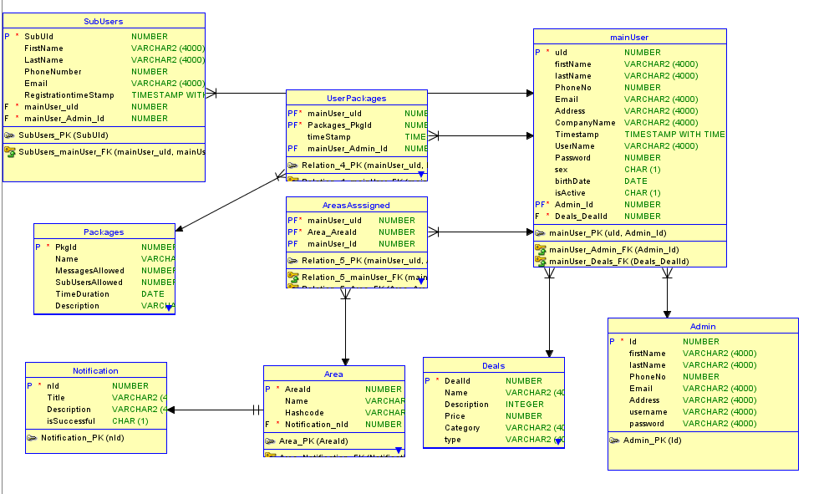

Data Dictionary
[The convention recommended for writing the data dictionary is as follows.]

Data 1
[Description (Refer to Template on next page). ]

Data 2
[Description (Refer to Template on next page). ]
.
.

Data n
[Description (Refer to Template on next page). ]

< Data 1>
Name |  | Give primary name of the data or control item, the data store or an external entity.
Alias |  | Write other names used for the first entry.
Where-used/how-used |  | List all processes that use the data or control item and how it is used (e.g., input to process, output from the process, as a store, as n external entity)
Content description |  | Notation for representing content.
Column Name | Description |  | Type | Length | Null able | Default Value | Key Type
[Column1 Name] | [Description of the column] |  | [Type of column] | [Length of column] | [Is Column Null able] | [Default Value] | [If Primary Key than write PK, if Foreign Key then FK, if not a key leave it blank]
[Column2 Name] | [Description of the column] |  | [Type of column] | [Length of column] | [Is Column Null able] | [Default Value] | [If Primary Key than write PK, if Foreign Key then FK, if not a key leave it blank]

[Make similar tables for all the data items.

The notation to develop content description is given below:

Data construct | Notation | Meaning
 | = | is composed of
Sequence | + | And
Selection | [|] | either-or
Repetition | {}n | n repetitions of
 | ( ) | optional data
 | * … * | delimits comments
]

Application Design
[A detailed application design should include the following:

- Detailed Sequence diagram with parameter list
- State Transition Diagram
- DFD level 1 diagram]

Sequence Diagram

<Sequence Diagram 1>
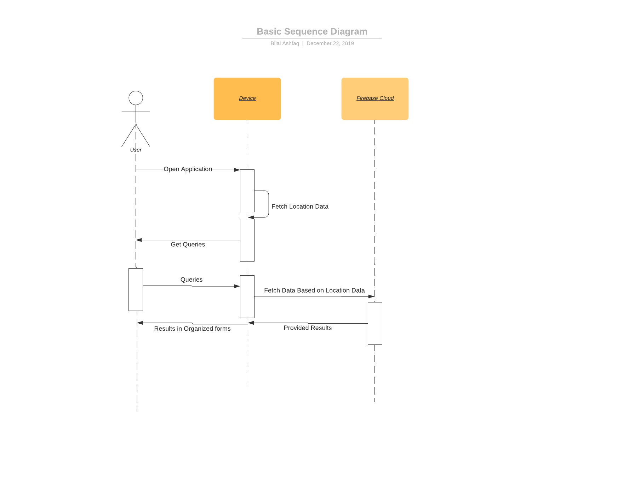

<Sequence Diagram 2>
. 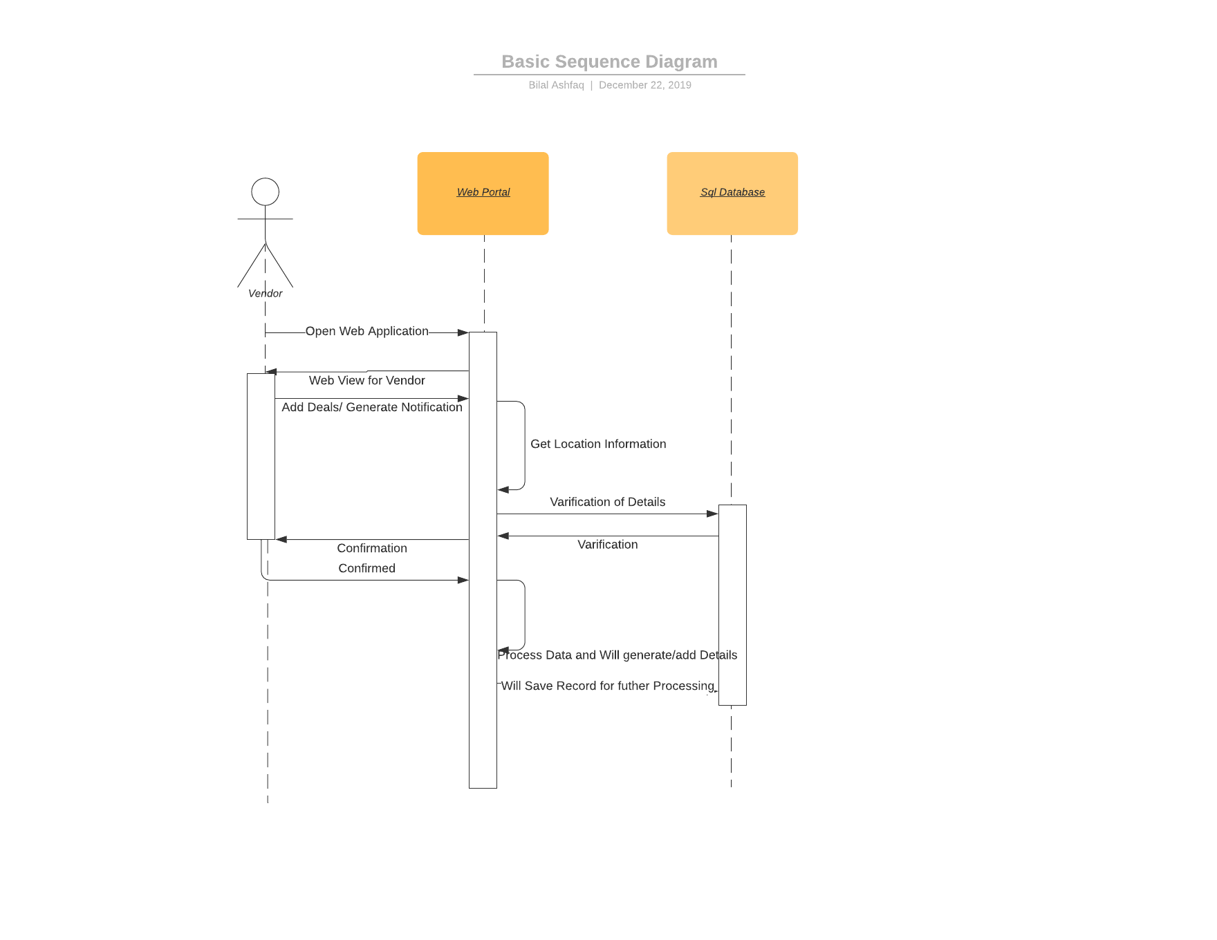

State Diagram

<State Diagram1>

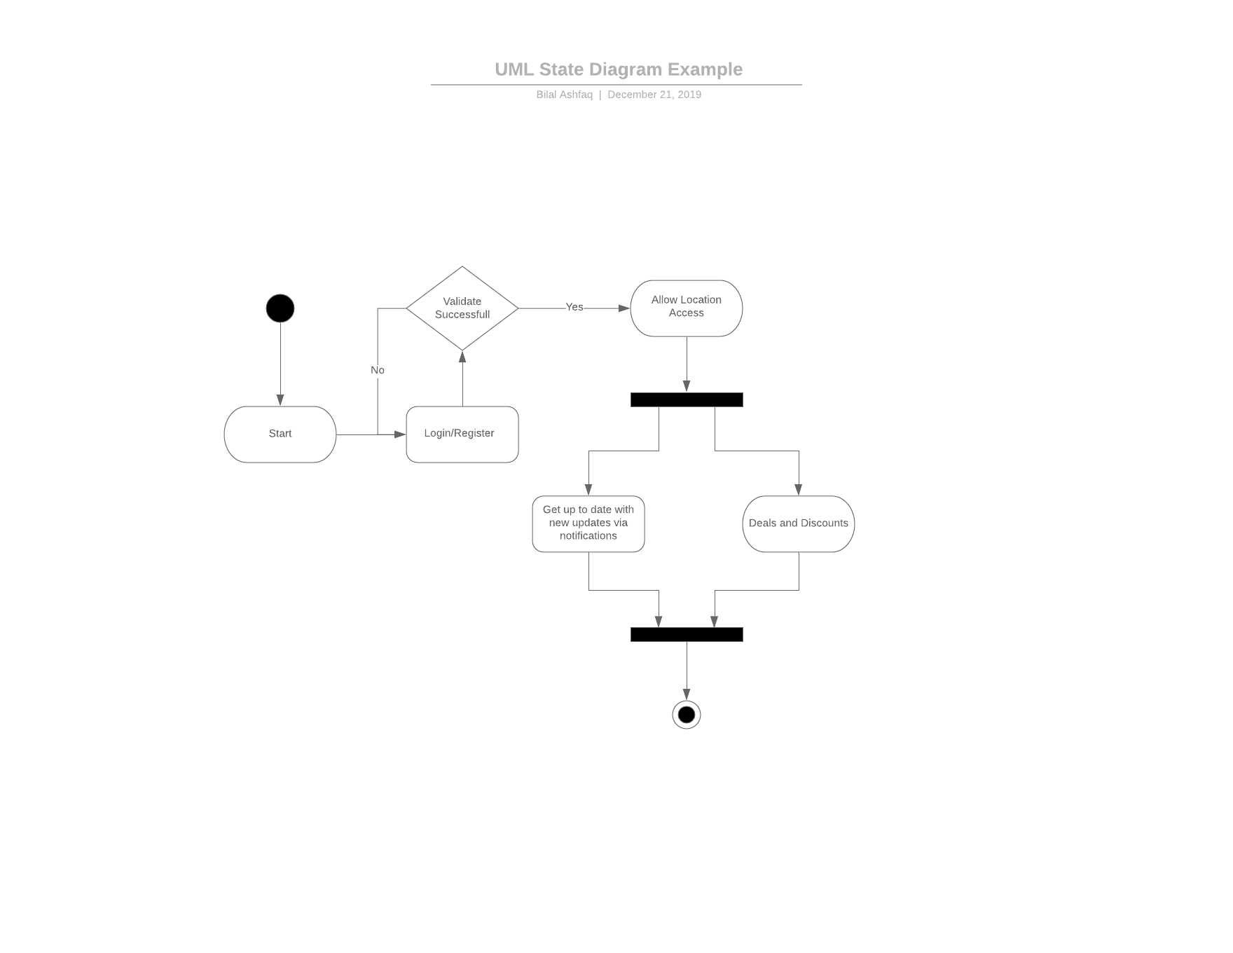

<State Diagram 2>

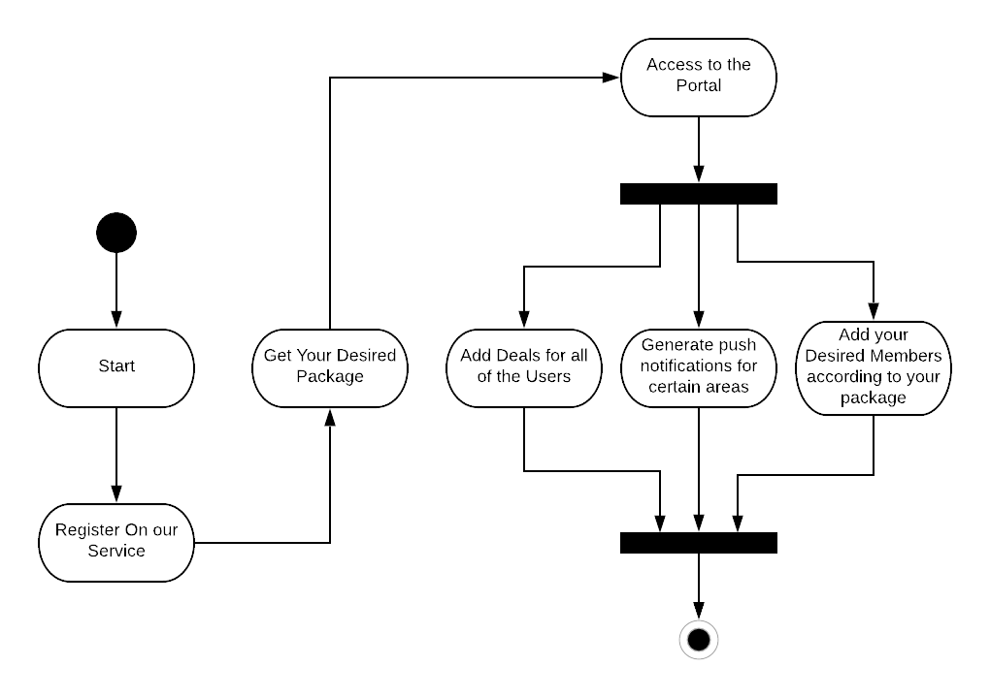.

References
[This section should provide a complete list of all documents referenced at specific point in time. Each document should be identified by title, report number (if applicable), date, and publishing organization. Specify the sources from which the references can be obtained (This section is like the bibliography in a published book)].

Appendices
[Include supporting detail that would be too distracting to include in the main body of the document.]

