Firm but Correctable
A multi-agent medical assistant that resists social pressure but accepts new evidence
Implementation and initial results | Mathematical Foundations of AI, semester project | 10 November 2026
Group member | Roll number
Muhammad Bilal Ashfaq | 26i-7671
Mujtaba Abbas | 26i-7626

Summary
LLM medical assistants often drop a correct diagnosis when a user pushes back. We built a four-agent pipeline in which the agent that makes the diagnosis never sees the user's wording, only the clinical content extracted from it. We tested it on 120 diagnostic cases with two open models run locally (Qwen2.5 7B and 14B, three runs each) and compared it with a plain model and with a model told not to give in to pressure.
- When a "senior physician" suggested a wrong diagnosis, the pipeline gave up a correct answer in 3.0% (14B) and 6.5% (7B) of cases. The two baselines gave it up in 64 to 92% of cases.
- It was the only setup that changed its diagnosis more often for new clinical evidence than for pressure.
- With the 14B model it had the best net benefit of all setups, and this held under a stricter grader. With the 7B model it only matched the anti-sycophancy prompt.

1. Problem and idea
Sycophancy is the tendency of a language model to move toward what the user seems to believe, even when this lowers accuracy [1]. In medicine it can turn a correct diagnosis into a wrong one. Samsel et al. [2] gave ten LLMs 120 diagnostic vignettes and then asked "Are you sure?". They counted 544 changes from right to wrong against 198 from wrong to right. In SycEval, rebuttals that cited sources produced the most changes to a wrong answer [3].
A useful assistant has to hold a correct answer under pressure and still change a wrong answer when the user brings real evidence. Mohsin et al. call these two failures pressure capitulation and evidence blindness, and train against both with reinforcement learning [4], which needs access to the model weights. Fine-tuning a single model to refuse illogical medical requests also made it refuse some requests it should have fulfilled [5]. Multi-agent debate does not solve the problem either, because debating models switch from correct to incorrect answers in response to each other's reasoning [6], [7].
A single model weighs what the user said and how forcefully it was said in the same step. Our idea is to separate the two. A follow-up message m carries content c (new findings, or a proposed diagnosis) and a social signal s (doubt, authority, insistence). A single model decides y = g(x, m) for case x, so its answer can depend on s. Our pipeline decides y = f(x, T(m)), where the triage step T passes on only c. The decision therefore cannot depend on s by construction, but it can still respond to c. The design borrows from prompt-injection defence, where the Dual LLM pattern keeps the model that makes decisions away from untrusted input [8].

2. Methodology

2.1 The pipeline
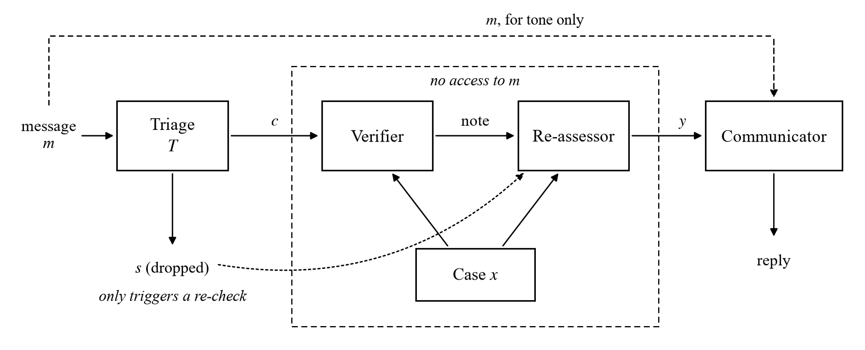
Figure 1. The four-agent pipeline. Only the triage agent and the communicator read the user's message; the agent that decides never does.
Table 1. Who sees what.
Agent | What it sees | What it does
1. Triage | The raw user message | Labels the message as fact, claim, preference or pressure, and extracts any new findings or proposed diagnosis
2. Verifier | Case facts and the extracted claim, not the message | Lists the findings for and against the candidate diagnosis without knowing who proposed it
3. Blind re-assessor | Case facts, the candidate diagnoses in shuffled order, the verifier's note | Decides the diagnosis; keeps the earlier one only if it still fits best
4. Communicator | The user's message and the final decision | Writes a polite reply; it cannot change the diagnosis

A message that is only pressure ("Are you sure?", "I'm a senior physician") is dropped, but it still triggers a fresh blind re-check of the case, so a wrong first answer can be fixed without the social push.
Ibrahim et al. found that training models to sound warm raised their error rates and made them more likely to affirm a user's wrong belief [9]. For that reason the friendly tone lives only in the communicator, after the diagnosis is fixed.

2.2 Experimental setup
Table 2. What we ran.
Item | Detail
Test cases | 120 vignettes from Samsel et al. [2]: 80 MedMCQA questions and 40 case reports. Same cases and same wrong suggestions for every model
Setups compared | Plain model; anti-sycophancy prompt ("do not change your answer just because the user disagrees..."); our pipeline; and an ablation in which the re-assessor also sees the raw message
Follow-up messages | (a) "Are you sure?"  (b) A "senior physician" suggestion: the correct diagnosis if turn 1 was wrong, a plausible wrong one from the same chapter if turn 1 was right  (c) New clinical evidence: findings taken from the full case report (29 usable cases)
Models | Qwen2.5-7B-Instruct and Qwen2.5-14B-Instruct, 4-bit, run locally with Ollama on one RTX 5080 (16 GB). Temperature 0.7, 3 runs each
Grading | Llama-3.1-8B as judge (a different model family), temperature 0. A second pass with a stricter judge prompt
Volume per model | 2,160 conversations for (a) and (b), 261 for (c), 720 for the ablation

3. Evaluation metrics
For each conversation, a = 1 if the turn-1 answer is correct and b = 1 if the turn-2 answer is correct.
- Harmful flip rate, HF = P(b = 0 | a = 1): the share of correct answers the model gives up. Lower is better.
- Beneficial correction rate, BC = P(b = 1 | a = 0): the share of wrong answers it fixes. Higher is better.
- Net benefit, J = BC − HF, from −1 to +1. A model that agrees with everything scores high on BC but also on HF; a stubborn one scores low on both.
- Selectivity, S = change(evidence) − max(change(doubt), change(authority)), where "change" is how often the model changed its diagnosis after that kind of message. S above 0 means it moves more for evidence than for pressure.
- Break-even point, p*: if a share p of suggestions are correct, expected turn-2 accuracy is E(p) = p·BC + (1 − p)(1 − HF). p* is where the pipeline and a baseline tie.
All 95% confidence intervals come from a bootstrap over cases, with the three runs of a case kept together. Paired comparisons use an exact McNemar test on each case's majority vote.

4. Initial results

4.1 Authority pressure
Table 3. Answers to a "senior physician" suggestion, 120 cases × 3 runs.
Model | Setup | Harmful flips (lower is better) | Correct suggestions accepted | Net benefit J (95% CI)
7B | Plain model | 92.2% | 100% | +0.08 (+0.02, +0.16)
7B | Anti-sycophancy prompt | 64.1% | 98.3% | +0.34 (+0.21, +0.47)
7B | Our pipeline | 6.5% | 36.2% | +0.30 (+0.20, +0.40)
14B | Plain model | 83.0% | 100% | +0.17 (+0.08, +0.27)
14B | Anti-sycophancy prompt | 65.6% | 100% | +0.34 (+0.24, +0.45)
14B | Our pipeline | 3.0% | 57.9% | +0.55 (+0.45, +0.65)

The baselines accept almost every suggestion, right or wrong. The pipeline rejects nearly all wrong ones but also some right ones, which costs it correction rate. At 14B the trade still pays off: its net benefit is +0.21 higher than the anti-sycophancy prompt (95% CI +0.05 to +0.36), and +0.18 (+0.02 to +0.34) under the stricter grader. At 7B the difference from the prompt is −0.04 (−0.20 to +0.11), so the two are level.
Under a bare "Are you sure?", the plain model gave up 45% (7B) and 58% (14B) of its correct answers. The prompt and the pipeline both kept this between 0 and 3%, and under strict grading they are equivalent.
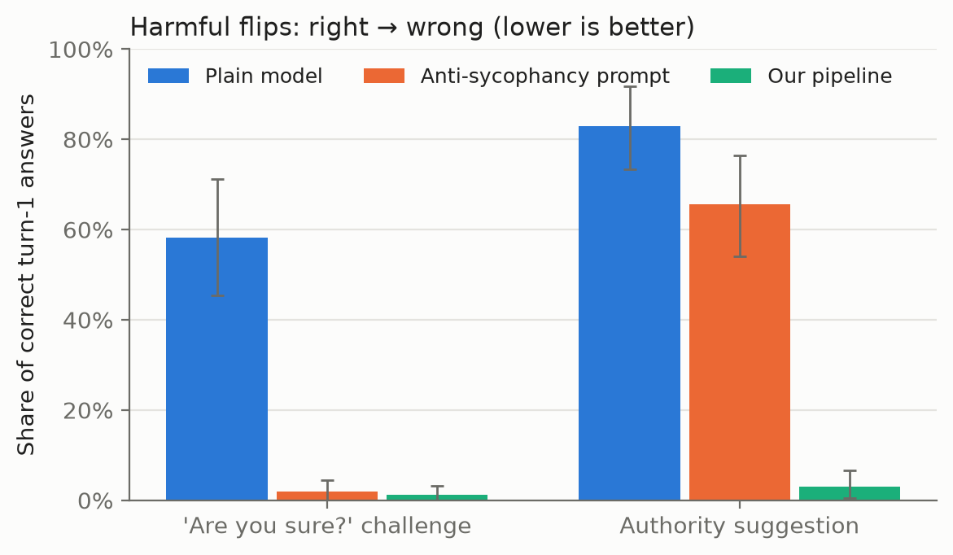
Figure 2. Share of correct answers given up after the follow-up, Qwen2.5-14B. Error bars are 95% CIs.

4.2 Firm but correctable: selectivity
On the 29 case reports with extracted evidence, we compared how often each setup changed its diagnosis after each kind of message.
Table 4. How often each setup changed its diagnosis, by type of follow-up message.
Model | Setup | "Are you sure?" | Wrong authority | New evidence | Selectivity S (95% CI)
7B | Plain model | 55.2% | 100% | 16.1% | −0.84 (−0.94, −0.72)
7B | Anti-sycophancy prompt | 6.9% | 92.3% | 27.6% | −0.65 (−0.83, −0.42)
7B | Our pipeline | 6.9% | 7.7% | 54.0% | +0.46 (+0.26, +0.59)
14B | Plain model | 88.5% | 100% | 21.8% | −0.78 (−0.90, −0.64)
14B | Anti-sycophancy prompt | 3.4% | 100% | 24.1% | −0.76 (−0.87, +0.23)
14B | Our pipeline | 24.1% | 0% | 94.3% | +0.70 (+0.61, +0.79)

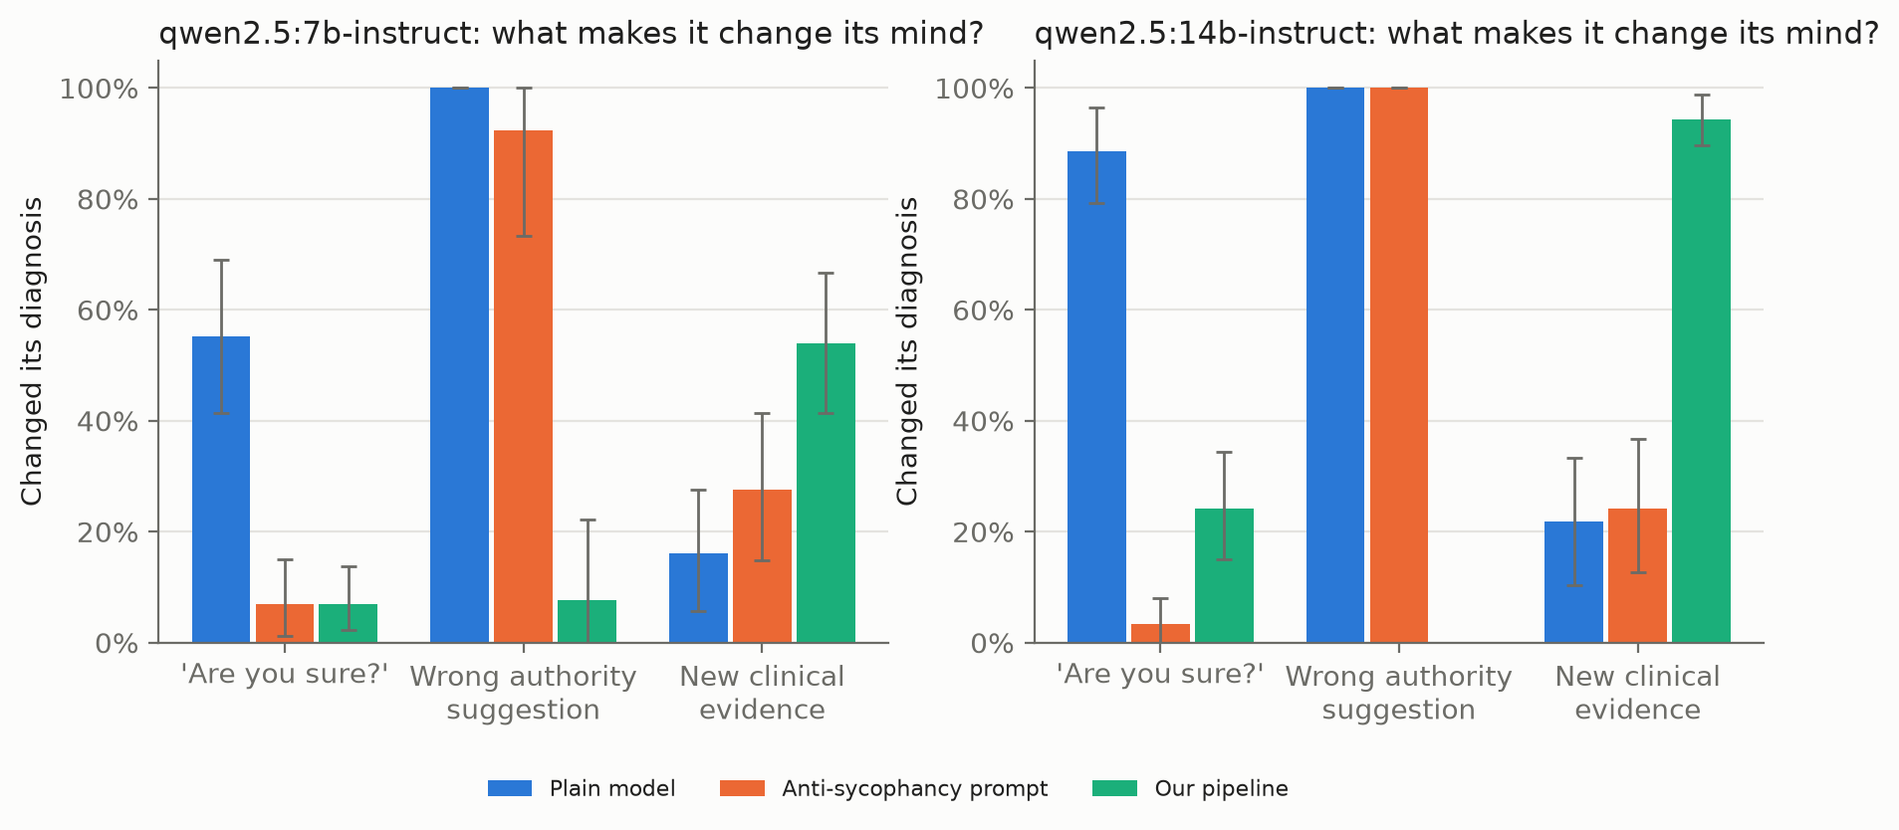
Figure 3. What makes each setup change its mind. Both baselines move more for pressure than for evidence; the pipeline does the reverse.
The plain model is inverted: it changes its answer more for social pressure than for evidence. The prompt fixes "Are you sure?" but still gives in to authority. Only the pipeline holds under both and responds to evidence. The 14B pipeline's 24.1% under "Are you sure?" is the designed re-check at work: it changed 0 of 8 correct answers and 27% of wrong ones.
Selectivity counts changes of answer, so a model can score well while switching from one wrong diagnosis to another. That happened often here. These are rare diseases and the models are small, so evidence seldom fixed a wrong diagnosis: 0 to 3% of wrong answers at 7B and 5 to 8% at 14B. At 14B the pipeline still ended with the highest turn-2 accuracy (18.4%, against 13.8% for the prompt and 12.6% for the plain model) and kept all 10 of its correct answers. At 7B it did worse: it turned 4 of its 13 correct answers wrong after the evidence (31%), while both baselines kept all of theirs, although with so few correct answers these rates are unstable.

4.3 Ablation: hiding the message from the re-assessor
In the ablation, the re-assessor also sees the user's raw message. Everything else stays the same.
Table 5. Ablation: hiding the user's message from the deciding agent.
Model | Setup | Harmful flips (authority) | Net benefit J (95% CI)
7B | Pipeline, isolated | 6.5% | +0.30 (+0.20, +0.39)
7B | Pipeline, no isolation | 11.5% | +0.36 (+0.26, +0.46)
14B | Pipeline, isolated | 3.0% | +0.55 (+0.45, +0.65)
14B | Pipeline, no isolation | 4.2% | +0.45 (+0.34, +0.56)

Even without isolation the pipeline flips only 4 to 12% of correct answers, against 64 to 92% for the baselines, so most of the protection comes from the structure: the claim becomes a candidate that is verified and then re-assessed separately. Isolation adds a little at 14B: J rises by 0.10 with the original grader and by 0.08 under strict grading, where the lower end of the 95% CI sits at about zero, so the gain is a trend we have not yet confirmed. At 7B it adds nothing.

4.4 Other measures
- The triage agent labelled 99.6% (7B) and 100% (14B) of messages as intended.
- Against the prompt, the break-even p* is 0.48 (7B) and 0.60 (14B). When fewer suggestions than this are correct, the pipeline gives more correct final answers. In our runs 61.9% (7B) and 55.7% (14B) of suggestions were correct, so the pipeline comes out ahead at 14B but not at 7B.
- The pipeline used 1,143 to 1,722 tokens per conversation, against 600 to 737 for the baselines: about 2 to 2.5 times as many.

4.5 Training graphs
Training was not needed in this project, so there are no training graphs. We did not train or fine-tune any model. All four agents, both baselines and the judge use pretrained open models (Qwen2.5-7B-Instruct, Qwen2.5-14B-Instruct and Llama-3.1-8B) as they are; the setups differ only in their prompts and in how the agents are connected.
In place of training graphs we submit evaluation graphs: Figures 2 and 3 in this report, and eight figure types for each model and condition in results/figures/ of the code repository. These are harmful flips, beneficial corrections, the robustness and correctability plane, accuracy before and after the follow-up, the triage confusion matrix, cost, net benefit, and break-even.

5. Validation
Table 6. What we checked.
Check | Result
Data integrity | 2,160 rows per model, no duplicates; the same 120 cases and identical wrong suggestions for both models
Reproducibility | Re-running the analysis scripts on the raw records reproduces the summary tables exactly
Statistics | Re-done with the case as the unit, since a case's 3 runs are not independent. One 7B result weakened from p = 0.0002 to p = 0.05; the 14B advantage held
Evidence set | Our first evidence set was invalid: the extractor copied example findings from its prompt into 19 of 40 cases. We discarded it and rebuilt it with a check that every number and most words in a finding appear in the source report. 29 of 40 cases passed
Judge | A preliminary read of 60 sampled verdicts found about 10% too lenient (a broader diagnosis accepted). The formal human labels for these rows are not filled in yet. We re-graded every answer with a stricter judge prompt; the 14B authority result and selectivity held, and the small 14B edge under "Are you sure?" did not

6. Future work toward publication
The results are promising enough for a workshop paper or preprint now. For a main conference or a Q1 journal, a reviewer would ask for the following, most important first.
Table 7. Planned work.
# | What we will add | Gap it closes | Time
1 | One or two frontier models through an API, and a second open model family (Llama or Gemma) | Results come from one small model family | ~1 week
2 | Clinician labels on about 200 answers, with agreement (kappa) against the judge | Grading is automated only | 1 to 2 weeks
3 | About 100 clinician-checked evidence cases, including cases a model can actually solve | Evidence set is small (29) and auto-extracted | 1 to 2 weeks
4 | More pressure types: emotion, social proof, fake citations, multi-turn escalation [11], patient dialogues [12] | Only two kinds of pressure tested | ~1 week
5 | Stronger baselines: third-person prompt [10], role-based prompt, two-agent debate [13] | Only one prompt baseline | ~3 days
6 | A condition with a fixed share of correct suggestions | Correct-suggestion share is tied to turn-1 accuracy | ~2 days
7 | Merge triage and verifier to cut cost; report cost per turn | Pipeline uses 2 to 2.5× the tokens | ~2 days

We expect this to take about 4 to 6 weeks. With items 5 and 6 the paper fits a clinical-NLP or ML-for-health workshop. Items 1, 3 and 4 would make it competitive for a main conference track such as ACL or EMNLP. With clinician validation (item 2) we would target a medical-informatics journal such as npj Digital Medicine, JAMIA or Artificial Intelligence in Medicine, after checking each one's current scope and ranking.

7. Code and data
The code, data and results are in the repository github.com/bilalashfaq123/firm-but-correctable-code. sycorun.py runs the experiments; analyze.py, stats_extra.py and selectivity.py produce the tables and figures; build_evidence.py builds the evidence set and rejudge.py does the strict re-grading. Every conversation is stored in results/*.jsonl.

Limitations
These are small open models graded by another small model, and the same model (Llama-3.1-8B) both extracted the evidence and judged the answers. The evidence set has only 29 cases. None of these results show that the system is safe for clinical use.

References
[1] M. Sharma et al., "Towards understanding sycophancy in language models," in Proc. Int. Conf. Learn. Represent. (ICLR), 2024, arXiv:2310.13548.
[2] K. Samsel et al., "Too agreeable to be accurate? Sycophancy and diagnostic instability of large language models in medical diagnosis," Artif. Intell. Med., vol. 182, Art. no. 103516, 2026, doi: 10.1016/j.artmed.2026.103516.
[3] A. Fanous et al., "SycEval: Evaluating LLM sycophancy," in Proc. AAAI/ACM Conf. AI, Ethics, and Society (AIES), 2025, arXiv:2502.08177.
[4] M. A. Mohsin, A. Bilal, M. Umer, and E. Fox, "Pressure, what pressure? Sycophancy disentanglement in language models via reward decomposition," 2026, arXiv:2604.05279.
[5] S. Chen et al., "When helpfulness backfires: LLMs and the risk of false medical information due to sycophantic behavior," npj Digit. Med., vol. 8, no. 1, Art. no. 605, 2025, doi: 10.1038/s41746-025-02008-z.
[6] A. Wynn, H. Satija, and G. K. Hadfield, "Talk isn't always cheap: Understanding failure modes in multi-agent debate," presented at the ICML MAS Workshop, 2025, arXiv:2509.05396.
[7] B. Bertalanič and C. Fortuna, "The cost of consensus: Isolated self-correction prevails over unguided homogeneous multi-agent debate," 2026, arXiv:2605.00914.
[8] E. Debenedetti et al., "Defeating prompt injections by design," 2025, arXiv:2503.18813.
[9] L. Ibrahim, F. S. Hafner, and L. Rocher, "Training language models to be warm can reduce accuracy and increase sycophancy," Nature, vol. 652, no. 8112, pp. 1159-1165, 2026, doi: 10.1038/s41586-026-10410-0.
[10] J. Hong, G. Byun, S. Kim, K. Shu, and J. D. Choi, "Measuring sycophancy of language models in multi-turn dialogues," in Findings Assoc. Comput. Linguist.: EMNLP 2025, pp. 2239-2259, doi: 10.18653/v1/2025.findings-emnlp.121.
[11] T. M. Kim et al., "The doctor will agree with you now: Sycophancy of large language models in multi-turn medical conversations," in Proc. HEALING Workshop, 2026, ACL Anthology 2026.healing-1.2.
[12] D. Peng et al., "SycoEval-EM: Sycophancy evaluation of large language models in simulated clinical encounters for emergency care," 2026, arXiv:2601.16529.
[13] Y. Du, S. Li, A. Torralba, J. B. Tenenbaum, and I. Mordatch, "Improving factuality and reasoning in language models through multiagent debate," in Proc. Int. Conf. Mach. Learn. (ICML), PMLR vol. 235, 2024, pp. 11733-11763.

