Movie DataBase

Everyday almost movies of dozens are released. In order not to get lost among these films and to reach the films in the genre we are looking for, we have to eliminate these films by using some restrictions. For that, having a movie database that we can filter all these movies will benefit us. Our task is to create this database in the most convenient and fast way to work and provide users with the data they want.

In this database we have 15 tables, 28 queries including crosstabs and parametric queries, 14 forms which contains macros, 13 reports which is constant and parametric and a macro.

TABLES

1. **MoviesMainTable**
   1. Moviename : Contains movie names inside. This is the Primary Key and related to other tables. (Check relations for more info)
   2. Runtime : (Number) The screen time of the movie.
   3. Budget : (Currency) Cost of the movie.
   4. Gross : (Currency) Total gross of movie.
   5. Year : (Number) Release date of the movie.
   6. IMDB : (Number) IMDB is an online movie database and people are commenting and score the movie. That score is the IMDB rating so that attribute contains that point for the movie.
   7. Taglines : (Text) Quotes from movie or lines used while advertising the movie.
   8. MovieID : (Autonumber) Unique ID for each movie.
2. **Companies**
   1. CompanyName : (Text) Contains producer company, studio or Corporation name. That field is the primary key of the table.
   2. CompanyID : (Autonumber) Unique ID for each producer company.
3. **CompanyMovie** : This table has two fields and they are “Foreign Key”.
   1. MovieName : (Text)
   2. CompanyName : (Text)
4. **Directors**
   1. DirectorName : (Text) Contains director name. That field is the primary key of the table.
   2. DirectorID : (Autonumber) Unique ID for each director.
5. **DirectorMovie :** This table has two fields and they are “Foreign Key”.
   1. MovieName : (Text)
   2. DirectorName : (Text)
6. **Genres**
   1. GenreName : (Text) Contains genre names. That field is the primary key of the table.
   2. GenreID : (Autonumber) Unique ID for each genre.
7. **GenreMovie :** This table has two fields and they are “Foreign Key”.
   1. MovieName : (Text)
   2. GenreName : (Text)
8. **Languages :** 
   1. LanguageName : (Text) Contains languages. That field is the primary key of the table.
   2. LanguageID : (Autonumber) Unique ID for each language.
9. **LanguageName :** This table has two fields and they are “Foreign Key”.
   1. MovieName : (Text)
   2. LanguageName : (Text)
10. **Stars :**
    1. StarName : (Text) Contains actors or actresses. That field is the primary key of the table.
    2. StarID : (Autonumber) Unique ID for each actor or actress.
11. **StarMovie :** This table has two fields and they are “Foreign Key”.
    1. MovieName : (Text)
    2. StarName : (Text)
12. **Writers :** 
    1. WriterName : (Text) Contains writer names. That field is the primary key of the table.
    2. WriterID : (Autonumber) Unique ID for each writer.
13. **WriterName :** This table has two fields and they are “Foreign Key”.
    1. MovieName : (Text)
    2. WriterName : (Text)
14. **Countries**
    1. CountryName : (Text) Contains countries that movies have filmed. That field is the primary key of the table.
    2. CountryID : (Autonumber) Unique ID for each country.
15. **CountryName :** This table has two fields and they are “Foreign Key”.
    1. MovieName : (Text)
    2. CountryName : (Text)

*When multiple values set as Primary Key at the same table they called a* ***“Foreign Key”.***

Relations

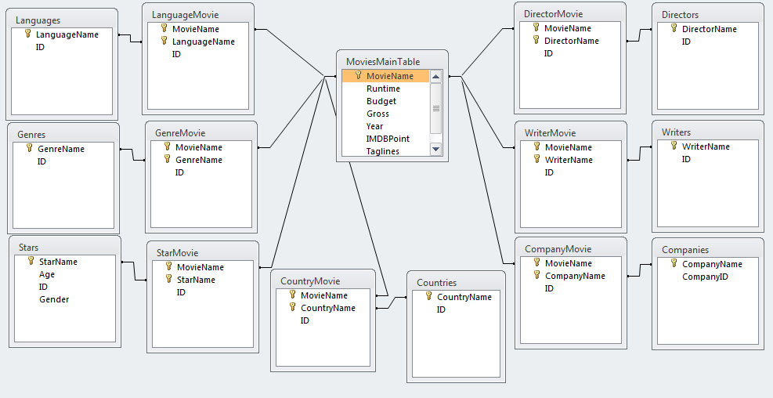

Queries

1. **Company :** That is a parametric query. When it started it asks for company name that you want to filter and shows a crosstab of movies which contains all companies related to movie. It uses CompanyMovie Table to show data and Company SubQuery to filter it.
2. **Country :** That is a parametric query. When it started it asks for country name that you want to filter and shows a crosstab of movies which contains all countries related to movie. It uses CountryMovie Table to show data and Country SubQuery to filter it.
3. **Director :** That is a parametric query. When it started it asks for director name that you want to filter and shows a crosstab of movies which contains all directors related to movie. It uses DirectorMovie Table to show data and Director SubQuery to filter it.
4. **Genre :** That is a parametric query. When it started it asks for genre name that you want to filter and shows a crosstab of movies which contains all genres related to movie. It uses GenreMovie Table to show data and Genre SubQuery to filter it.
5. **Language :** That is a parametric query. When it started it asks for genre name that you want to filter and shows a crosstab of movies which contains all languages related to movie. It uses LanguageMovie Table to show data and Language SubQuery to filter it.
6. **Star :** That is a parametric query. When it started it asks for star name that you want to filter and shows a crosstab of movies which contains all stars related to movie. It uses StarMovie Table to show data and Star SubQuery to filter it.
7. **Writer :** That is a parametric query. When it started it asks for writer name that you want to filter and shows a crosstab of movies which contains all writers related to movie. It uses WriterMovie Table to show data and Writer SubQuery to filter it.
8. **15 Non-Profit Movies :** That query shows top 15 movies that lost money the most. It uses MoviesMainTable to get Budget and Gross data and use a criteria to be sure cell is not empty and sort them.
9. **5 Longest Duration Movies :** That query also use MoviesMainTable and Runtime info in there. Sort Runtime and show movies.
10. **Company SubQuery :** That is a SubQuery. This a tool to use in “Company” Query. With that tool we are being able to use parameters in a crosstab. That query including a parameter and “Nz” function criteria to list all values if no value entered by user.
11. Countries of the 30 Most Grossed Movies
12. **Country SubQuery :** That is a SubQuery. This a tool to use in “Country” Query. With that tool we are being able to use parameters in a crosstab. That query including a parameter and “Nz” function criteria to list all values if no value entered by user.
13. **Director SubQuery :** That is a SubQuery. This a tool to use in “Director” Query. With that tool we are being able to use parameters in a crosstab. That query including a parameter and “Nz” function criteria to list all values if no value entered by user.
14. **Directors of Movies with higher that 8,5 :** Using DirectorMovie, Directors and MoviesMainTabe, that query shows directors and their movies which is made more than 8.5 IMDB Score. Uses only criteria is IMDBScore criteria. Doesnt show duplicated values thanks to relations that we created before.
15. **English Movies :** Show English movies using only LanguageMovie table with “English” criteria on LanguageName.
16. **Movies of 2016 :** Using only MoviesMainTable this query shows movies released in 2016.
17. **Genre SubQuery :** That is a SubQuery. This a tool to use in “Genre” Query. With that tool we are being able to use parameters in a crosstab. That query including a parameter and “Nz” function criteria to list all values if no value entered by user.
18. **Historical Movies Between 1950 and 1980 :** Shows movies with “History” genre and released between 1950 and 1980. We use MoviesMainTable to filter year and GenreMovie to filter genre and show them on query result screen.
19. **IMDB 7,0+ :** Shows movies with higher score than 7. Used MovieName and IMDBPoint of MoviesMainTable to show in result screen and filtering.
20. **Language SubQuery :** That is a SubQuery. This a tool to use in “Language” Query. With that tool we are being able to use parameters in a crosstab. That query including a parameter and “Nz” function criteria to list all values if no value entered by user.
21. **Movie Filter :** This is like a main query of our database. It asks user to enter almost all attributes connected to the movie. We use parameters in that query. When user run this query it starts asking for values for genres and star and etc. For example if user doesnt want to filter by writers of the movie, he just click enter and go to the other filter. To get that “NULL” valur we use “Nz” function in here too. With that function we get empty values like “writer doesn’t matter”. So our filter works perfectly. We use all tables end with “Movie” for criteria and MoviesMainTable to show movie names.
22. **Star SubQuery :** That is a SubQuery. This a tool to use in “Star” Query. With that tool we are being able to use parameters in a crosstab. That query including a parameter and “Nz” function criteria to list all values if no value entered by user.
23. **The Writers of The Most Budgeted Movies :** Uses WriterMovie table and MoviesMainTable. Sort budget of movies and show them descending. With “TOP 15” on “SELECT” function on SQL code it shows only 15 movies.
24. **Top Ten Most Profitable Movies :** With MoviesMainTable, it sort “Gross-Budget” values and shows only top ten with “TOP 10” on “SELECT” function on SQL code it shows only 10 movies.
25. **Top 20 Animated Movies :** Shows top 20 animated movies by IMDB Scores. Uses GenreMovie table for filtering and IMDBPoint field of MoviesMainTable for sorting and filtering. It show only top 10 values with “TOP 10” on “SELECT” function on SQL code it shows only 10 movies.
26. **Writer SubQuery :** That is a SubQuery. This a tool to use in “Writer” Query. With that tool we are being able to use parameters in a crosstab. That query including a parameter and “Nz” function criteria to list all values if no value entered by user.
27. **Year Constraint :** This is a parametric query. Ask user for year to show movies including that year and after. We use MoviesMainTable to show movie name and IMDB score and year.

FORMS

Forms used to add a new movie with all forms. With buttons forms are designed to minimize data entry by hand time. To achieve this we used buttons to move between tables. We start with MoviesMainTable with using buttons we end up in CompanyMovie and using Finish button we finish data entryin for a movie.

Buttons on these forms are same buttons with different text on them so here is a list of buttons to dont explain it in every form.

Button1 : This button has a macro inside and it simply works as “New Record” navigation button on navigation bar of the form.

Button2 : This button has a macro inside and it has two actions. First, “OpenForm”; it opens the form which is on its “Caption”.(The form it opens is actually “Caption”+”Movie”) The second action is “GoToRecord”; it goes to the “New Record” section to dont make user to click for it again.

Button3 : This button is used to go back to the last form. If a user forget to enter a data to form and goes to the next or remembers he entered something wrong he click that button and go back. That button has same actions with Button2 but it has no caption on it only an arrow that means turning back.

*Forms sorted by ranking*

1. MoviesMainTable : Form of its name. It contains all values from its table. To enter a new movie you simply click “New Movie” button. That button is Button1 in this form. And has another button named “Genre”. That button is used to travel between forms it is a copy of Button2.
2. GenreMovie : Form of its name. It contains all values from its table except ID because it is “AutoNumber” and doesn’t need to be entered. To enter a new genre for movie you simply click “New Genre” button. That button is Button1 in this form. And has another button named “Director”. That button is used to travel between forms. It is a copy of Button2. When you finish entering genres for movie click it to continue to other form.
3. DirectorMovie : Form of its name. It contains all values from its table except ID because it is “AutoNumber” and doesn’t need to be entered. To enter a new director for movie you simply click “New Director” button. That button is Button1 in this form. And has another button named “Writer”. That button is used to travel between forms. It is a copy of Button2. When you finish entering directors for movie click it to continue to other form. And the last button is Button3 which is used to go back to “GenreMovie” form.
4. WriterMovie: Form of its name. It contains all values from its table except ID because it is “AutoNumber” and doesn’t need to be entered. To enter a new writer for movie you simply click “New Writer” button. That button is Button1 in this form. And has another button named “Star”. That button is used to travel between forms. It is a copy of Button2. When you finish entering writers for movie click it to continue to other form. And the last button is Button3 which is used to go back to “DirectorMovie” form.
5. StarMovie : Form of its name. It contains all values from its table except ID because it is “AutoNumber” and doesn’t need to be entered. To enter a new star for movie you simply click “New Star” button. That button is Button1 in this form. And has another button named “Country”. That button is used to travel between forms. It is a copy of Button2. When you finish entering stars for movie click it to continue to other form. And the last button is Button3 which is used to go back to “WriterMovie” form.
6. CountryMovie : Form of its name. It contains all values from its table except ID because it is “AutoNumber” and doesn’t need to be entered. To enter a new country for movie you simply click “New Country” button. That button is Button1 in this form. And has another button named “Language”. That button is used to travel between forms. It is a copy of Button2. When you finish entering countries for movie click it to continue to other form. And the last button is Button3 which is used to go back to “StarMovie” form.
7. LanguageMovie : Form of its name. It contains all values from its table except ID because it is “AutoNumber” and doesn’t need to be entered. To enter a new language for movie you simply click “New Language” button. That button is Button1 in this form. And has another button named “Company”. That button is used to travel between forms. It is a copy of Button2. When you finish entering languages for movie click it to continue to other form. And the last button is Button3 which is used to go back to “CountryMovie” form.
8. CompanyMovie : Form of its name. It contains all values from its table except ID because it is “AutoNumber” and doesn’t need to be entered. To enter a new company for movie you simply click “New Company” button. That button is Button1 in this form. And has another button named “Finish”. That button is a different one it uses EndDataInputMacro. When you finish entering companies for movie click it to continue to other form. And the last button is Button3 which is used to go back to “LanguageMovie” form.

Other forms in the database are copy of these forms. They used to create a even simpler method of data entry. In the copy of MoviesMainTable which is called in database “MoviesMainTable1” form, it contains copies of all other forms as subforms.

They are not original ones because we don’t need navigation buttons which is called Button2 that we used in original forms. So they only have adding new value buttons when you done simply click new button of each subform and enter new value.

Reports

1. 15 Non-Profit Movies:
2. 5 Longest Movies Duration
3. Countries of The 30 Most Grossed Movies
4. Directors of Movies with IMDB score higher than 8,5
5. Genre
6. Historical Movies Between 1950 and 1980
7. IMDB 7,0+
8. Movie Filter 2
9. Movies of 2016
10. The Writers of The Most Budgeted Movies
11. Top 20 Animated Movie
12. Top Ten Most Profitable Movies
13. Year Constraint

We have a total of 13 reports. We created all of the reports from the query table. Each query has a report (except cross-queries and similar parametric queries). This is because queries look more elegant. The queries also include the time and date of the time it was created. That's why it provides us with a direct printable document.

For example, let's look at the report on historical movies between 1950 and 1980 :

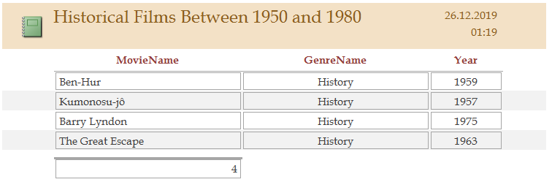

Macros

**EndDataInput**

There is only one macro visible in our database. Earlier in the article, we talked about macros that are embedded in form tables but not visible in tables. So now I'll only consider the EndDataImput macro.

Steps of the EndDataImput macro:

* Close the currently open DirectorMovie form.
* Close the currently open CountryMovie form.
* Close the currently open CompanyMovie form.
* Close the currently open Director Movie form.
* Close the currently open GenreMovie form.
* Close the currently open LanguageMovie form.
* Close the currently open MovieMainTable form.
* Close the currently open StarMovie form.
* Open MovieMainTable form
* Create new record

The purpose of this macro is to make a new recording after filling in the new movie and all the sub-tables of that movie.