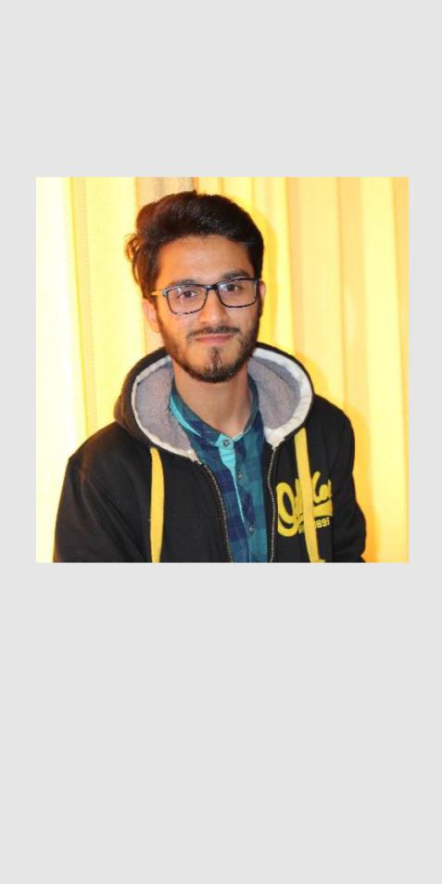

MUHAMMAD BILAL

Firdous market Lahore,
punjab pakistan 0344-6405416 mbilalbutt003@gmail.com

OBJECTIVE

Seeking a challenging career with a progressive organization that provides an opportunity to capitalize my Technical skills & abilities in the fields of Web development.

SKILLS

WORK


OOP


JAVASCRIPT

JQUERY

ANGULAR

C#

Bootstrap

CSS

PHP

MYSQL

PERSONAL


COMMUNICATION


ORGANIZATION


TEAM PLAYER
MUHAMMAD BILAL

Web Developer

Projects

Tweets Sentiment Analyzer

A web based application where user search a Hashtag and real time sentiment analysis performed on tweets which determine whether a tweet is positive, negative or neutral. Build using css3, bootstrap3, jquery, PYTHON,PANDAS PHP MySQL

Sports wear Ecommerce website

An E -commerce based website where user can buy sports wear build in Css3 jQuery, bootstrap3, php MySQL.

Airline Reservation System

A Desktop based application which has two user Admin and User.
Develop using C#,MSSQL and Entity Framework.

EDUCATION

(2014-2018)
BACHELOR IN COMPUTER SCIENCE
UNIVERSITY OF GUJRAT

Studied MATH, Web development and programming as core subject and acquired 2.6 CGA

(2009 - 2011)

INTERMEDIATE
Gov. COLLEGE OF TECHNOLOGY SIALKOT (PBTE)

Studied, Electrical and Electronics engineering as core and acquired 79% marks in intermediate.

EXPERIENCE

• Software Engineer at Emblem Technologies Lahore. (Nov 2018 – Jan 2019)

Certification

- Front-end Javascript Framework Angular from University Of Hong Kong

REFERENCE

- Available on demand

