**Feasibility Report**

**“Mobile App For Personal Finance:”**



**PROJECT GROUP MEMBERS:**

Muhammad Bilal (FA14-BSE-108)

Khizer Jadoon (FA14-BSE-110)

Sirat Ahmad (FA14-BSE-104)

**Supervised by:**

Dr.Waqas Jadoon

COMSATS INSTITUTE OF INFORMATION TECHNOLOGY

Abbottabad

**Table of Contents**

1. Title: “Mobile App for Personal Finance”………………………………………………………………….3

2. Functional Requirements:…………………………………….………………….…………………………………………………………………….3

2.1. SQLite …………………………………………………………..………………………………………………………………………………….3

2.2. TesseractOCR…………………………………………………………………………………………………………………………………………….3

2.3. Android Application…………………………………………………………………………………………………………………………………4

3. Feasibility Analysis:…………………………………………………………………………………………………………………………………………4

3.1. Technical Feasibility:………………………………………………………………………………………………………………………………..4

3.2. Financial Feasibility: ………………………………………………………………………………………………………………………………..4

3.3. Resource Feasibility:…………………………………………………………………………………………………………………………………5

3.5. Operational Feasibility: ……………………………………………………………………………………………………………………………5

4. Assumptions……………………………………………………………………………………………………………………………………………………5

**1. Title: “Mobile App for Personal Finance:”**

1. **Functional Requirements:**

* The user will enter his expenses by taking a picture of receipt
* The app will extract data from the image of receipt
* The user may also enter his expenses manually
* The app will maintain the record of the user’s expenses in a local database (SQLite)
* The user will enter the maximum limit for his expense in a specified period of time
* The app will issue an alert when the user’s expenses exceed the specified limit
* The app will allow the user to view the summary of his weekly and monthly expenses

1. **Feasibility Analysis:**

An overall study of the project has been carried out and the findings have been listed in this report. The feasibility of **“Mobile App For Personal Finance”** can be ascertained on the following assessments:

* Technical feasibility
* Financial feasibility
* Resources feasibility
* Operational feasibility (if applicable)
  1. **Technical Feasibility:**
* **Tesseract(OCR) :**

Free API for extracting information from images of receipt

* **Smart Phone:**

For display in android application

* **Android Studio (Latest Version):**

For android application

**3.2 Financial Feasibility:**

|  |  |  |
| --- | --- | --- |
| **Resource Name** | **Price** | **Source** |
| Laptop x3 | 120,000 | Bought |
| Mobile | 15,000-20,000 | Available |
| Android Studio | Open source | Android. Developer |
| Tesseract(OCR) | Open source | Github.com |
| SQLite Server | Available | [www.Microsoft.com](http://www.microsoft.com/) |
| Sponsors/funding source |  | Self |

**3.3 Resources Feasibility:**

* **SQLite**
* **Tesseract(OCR)**
* **Android Studio (Latest Version)**

These all resources are easily available.

**3.4** **Operational Feasibility:**

* This project is based on daily expenditure and facilitate people and should provide accurate results according to daily expenditures.
* This project will run on most android phones easily by only downloading it from the play store

**3.5 Schedule:**

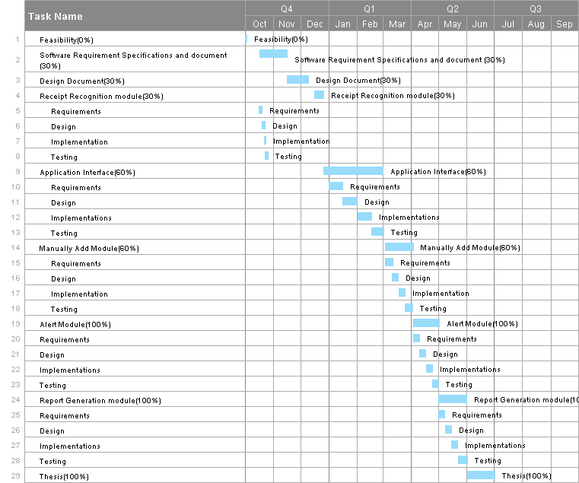.

1. **Assumption**

* The user’s phone will have a working camera
* The user should not reset the phone factory.