M. Bilal Naeem

Web Deveoper

I’m a passionate Web Developer wants to polish my skills and discover my inner potential by being a part of a challenging team, constantly pushing myself towards betterment.

Education

Personal Statement

**Web Development**

**3 Months Short Course - 2018**

I have been interested in the field of web development so I joined Career institute to groom my skills in the field of web development.

PHP MySQL

HTML

Ajax

WordPress

Laravel

JavaScript

CSS

JQuery

Bootstrap

React.js

Personal

Contact

Profile

Interest

Name

Date of birth

Nationality

Martial Status

Language

M. Bilal Naeem

24 June 1999

Pakistan

Single

English, Urdu Punjabi

Contact 1

Contact 2

Mail

Address

+92 313 7640646

+92 304 0292730

Bilalyar26@gmail.com

P-92 Street 3 Amin Park Sani Road Faisalabad

facebook.com/bilal.yar.5895

twitter.com/bilalyar26

Muhammad-Bilal-828625168

­

CYCLING

MUSIC

PHOTOGRAPHY

Professional Skills

Matriculation

2012-2014

Matriculation with computer science From Chenab High School Faisalabad securing 79.45% marks under BISE FSD.

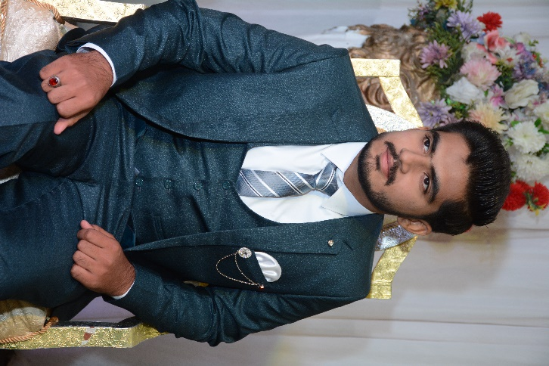

Education (Continued)

BS Software Engineering

2016-2020

Student of BS Software Engineering in Government College University Faisalabad(GCUF) with successful completion of six Semesters.

FSC (Pre-Engineering)

2014-2016

FSC (Pre-Engineering) From Summit College Faisalabad securing 73% marks under BISE FSD.

Achievements

Blog with admin panel Ecommerce Website

Teacher and Student Portal Order Management System

Key Achievement

I Want to explore my knowledge by joining your company and I want to support my family with my skills