The Land Created from Light: The Scientific Link Between Avestan Cosmology, the Helmand Basin, and the Āzrah People
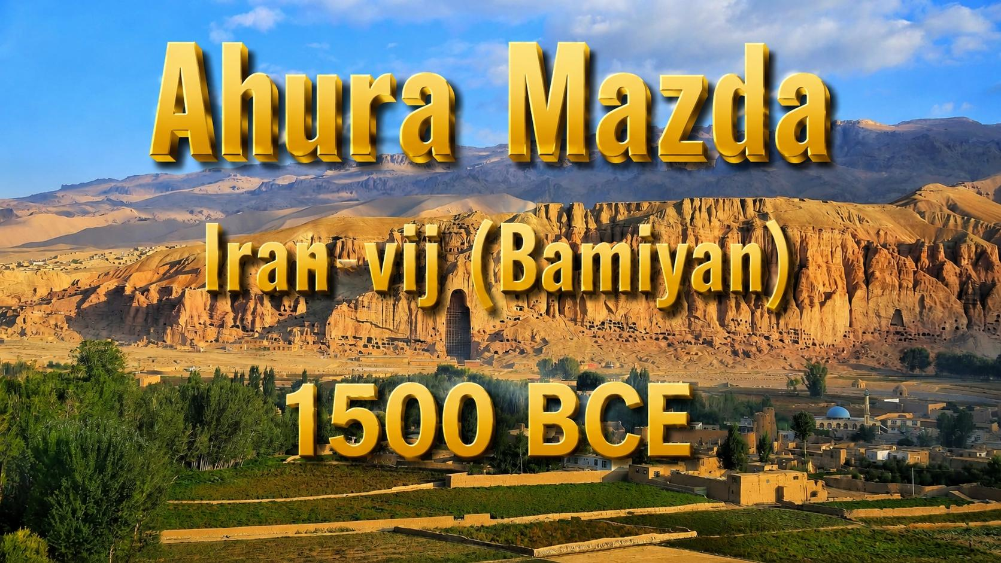
Abstract

This study presents a multi-disciplinary investigation into the thesis that the Āzrah (Hazara) people of central Afghanistan are the direct biological and cultural descendants of the populations that inhabited the core sacred geography of the Avesta, the primary collection of Zoroastrian texts. By integrating genetic, linguistic, archaeological, and historical evidence, we demonstrate an unbroken chain linking the Zoroastrian supreme deity Ahura Mazda, the eastern clime (karshvar) of Arəzahī, the world-axis mountain Harā Bərəzaitī, the sacred Helmand (Haētumant) River, the prophet Zarathushtra, and the Avestan concept of Airyanem Vaejah—the original homeland of the Aryans. This chain extends to the Middle Persian term Arzah and, critically, to the modern Hazaragi self-designation Āzrah and the region of Āzrah-jat (Hazarajat). We conclude that the Āzrah possess a profound, scientifically verifiable connection to the foundational texts and geography of ancient Iranian civilization. This connection, built on a Neolithic Iranian genetic substrate (haplogroup J2a1-Page55), linguistically preserved in Hazaragi, and geographically anchored in the Helmand Basin, predates and is fundamentally distinct from the later steppe-associated R1a-Z93 migrations.

---

1. Introduction: The Unbroken Chain

The question of which land can claim the title of being "created from light" is not merely a matter of myth but one of scientific inquiry into the origins of the Zoroastrian faith. The Avestan texts, the Gathas (the oldest hymns), and later scriptures like the Bundahišn provide a detailed cosmological and geographical framework for the early Iranian world. This framework is centered on a specific territory, which modern scholarship, using a combination of textual analysis, genetics, and archaeology, has increasingly identified with the central highlands of Afghanistan—the land today known as Hazarajat. The people of this land, who call themselves Āzrah, carry a name that is the linguistic fossil of one of its most fundamental Avestan designations .

---

2. Ahura Mazda and the Creation of Airyanem Vaejah

Zoroastrian cosmology begins with Ahura Mazda, the "Lord Wisdom," the uncreated creator of all that is good, the source of Asha (truth, order). The creation narrative in the Vendidad (Fargard 1) details how Ahura Mazda created sixteen perfect lands, the first and foremost of which was Airyanem Vaejah, the Aryan expanse, by the river Dāityā .

Textual Evidence:

"The first of the good lands and countries which I, Ahura Mazda, created, was the Airyanem Vaejah, by the good river Daitya." (Vendidad 1.2)

Cosmological Framework: The material world, as described in the Bundahišn, is structured around a central axis. Its surface is divided into seven concentric climes or regions, known in Avestan as karshvar, and in Middle Persian as haft kišwar. This division is not political but cosmic, organizing the world around a central axis.

---

3. The Eastern Clime of Light: Arəzahī (Āzrah)

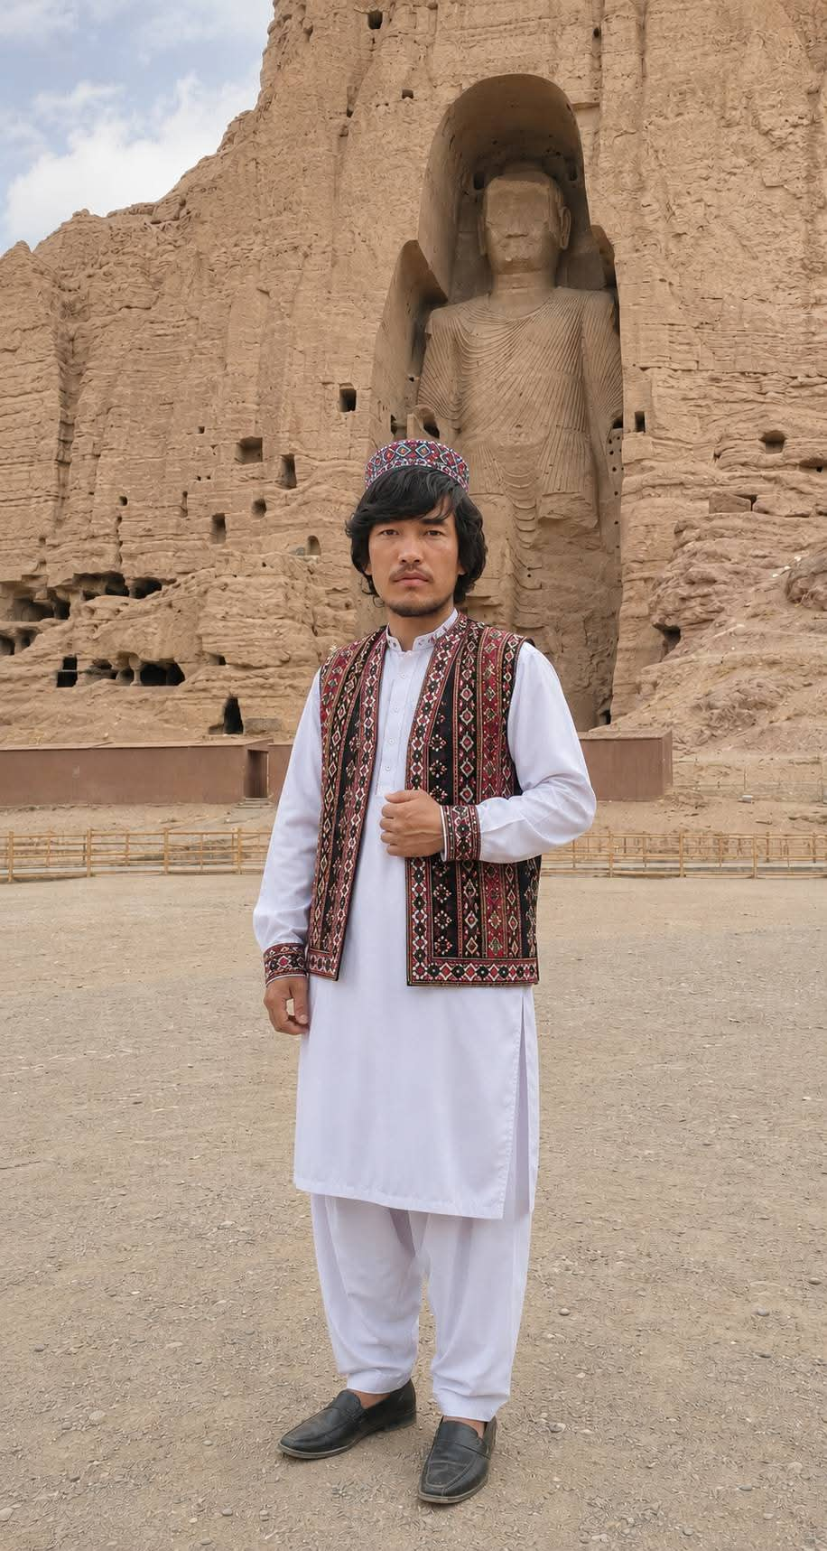
The karshvar that is directly illuminated by the first rays of the sun is Arəzahī ("East"). The Avestan text Mihr Yasht (Yt. 10.15) clearly indicates that the sun's journey begins from Arəzahī. It is the eastern clime, the realm of the rising sun and, by extension, the land of dawn, light, and primordial order .

The Linguistic Fossil: The name itself is of profound linguistic importance. Arəzahī is the Avestan term for this eastern clime. Its Middle Persian form is Arzah. The modern Hazaragi pronunciation, Āzrah, which the Hazara people use as their self-designation, is the direct linguistic descendant of this ancient Avestan name. This is not a loanword; it is a living fossil of Avestan cosmology preserved for over two millennia.

---

4. The Axis of the World: Harā Bərəzaitī
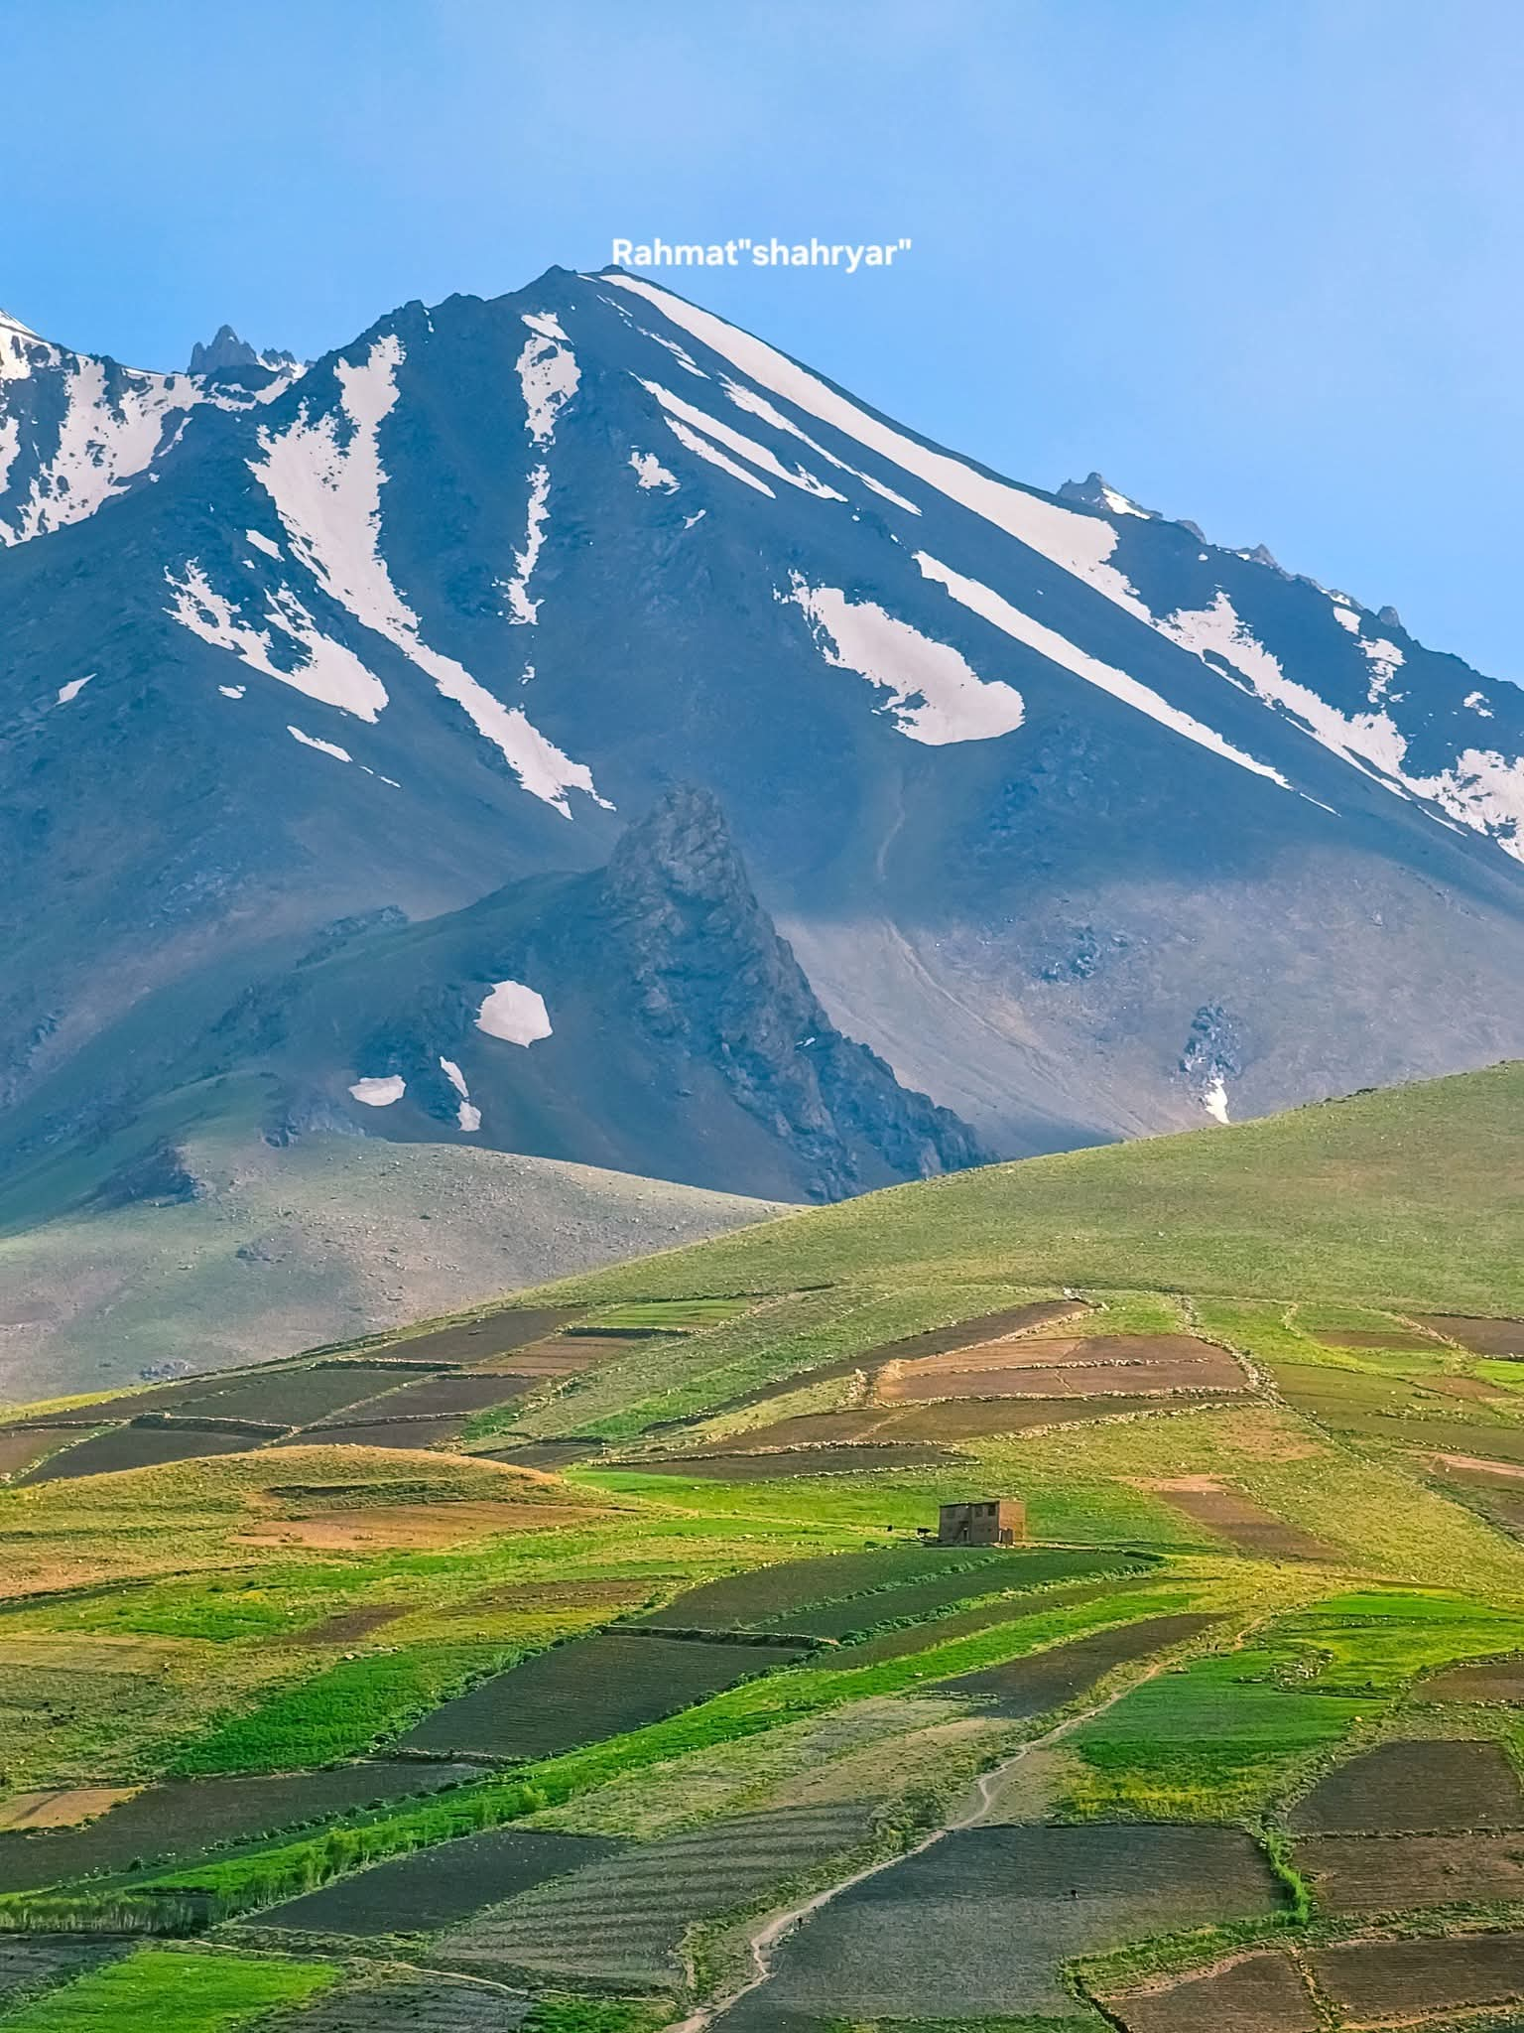
The central axis around which the seven karshvars are arranged is the sacred mountain Harā Bərəzaitī (High Watchpost). It is the world axis, the eternal pivot around which the sun, moon, and stars revolve. It is described as luminous and untouched by demonic forces. Critically, for our geographical argument, the Bundahišn states that all other mountains of the world grew from its roots. As the source of all mountains, it is also the source of the great rivers that water the karshvars .

---

5. The Source of All Waters: The Haētumant (Helmand) River

One of the most significant rivers emanating from the sacred mountain is the Haētumant, known today as the Helmand River. The Avesta praises this river as a great and holy stream. The Zamyād Yasht (Yt. 19.66-69) contains a uniquely detailed celebration of the Haētumant and its tributaries, a level of detail not found for any other territory in the entire Avesta. This indicates the region's privileged position in Zoroastrian tradition .

Geographical Anchor: Crucially, the source of the Haētumant can be precisely located on a modern map: it rises from the Koh-i Baba range in the very heart of today's Hazarajat. This tangible geographical fact provides a direct, verifiable link between the mythical Mount Harā Bərəzaitī and the real-world central highlands of Afghanistan.

---

6. The Historical and Genetic Corroboration: The Āzrah and the Neolithic Iranian Substrate

The textual and geographical arguments are powerfully supported by independent lines of evidence that distinguish the Āzrah's indigenous Neolithic Iranian heritage from the later steppe migrations.

6.1. Genetic Evidence: The J2a1-Page55 Substrate

The Y-chromosome haplogroup data from the comprehensive study by Di Cristofaro et al. (2013) provides a biological link between the Hazara population and ancient Iranian populations. The study finds that the J2a1-Page55 haplogroup, which is linked to the Neolithic farmers of the Iranian plateau and the Bronze Age civilizations of Central Asia, appears at a frequency of 13% in the Hazara, the second-highest frequency after Iran . Furthermore, the presence of haplogroup G2 in the Hazara at 8.7% provides additional evidence of a pre-Mongol Iranian substrate.

Critical Distinction from the Steppe Migrations (R1a-Z93): The R1a-Z93 haplogroup is associated with the spread of Indo-Iranian languages from the Eurasian steppes and is found at high frequencies in populations like the Pashtuns (51%) and Tajiks (30.4%), but only at a low frequency (6.67%) in the Hazara . This genetic data powerfully demonstrates that the Hazara possess a significant and ancient indigenous Iranian genetic component (J2a1-Page55) that is distinct from the later, steppe-associated R1a-Z93 migrations.

6.2. Historical Corroboration: The "Aryan" Name in Bamiyan

The Chinese Buddhist pilgrim Xuanzang, who visited Bamiyan in 646 CE, provides crucial historical evidence. He records meeting two prominent monks in Bamiyan named Āryadāsa and Āryasēna, both bearing the prefix Ārya ("Aryan"). This is a direct historical attestation that the people of this region, at a time before the Mongol conquests, still identified their land as "Aryan" (Airyanem Vaejah).

6.3. Archaeological Evidence: The Helmand Civilization

The Helmand Civilization (c. 3300–2350 BCE), with its major centers at Shahr-e Sukhteh and Mundigak, flourished in the same river basin. This Bronze Age urban culture is one of the earliest in the eastern Iranian plateau, demonstrating the region's deep antiquity as a center of civilization, independent of later historical developments.

---

7. Conclusion: A Heritage of Light

This multi-disciplinary study demonstrates an unbroken chain of evidence connecting Ahura Mazda's creation, the eastern clime of Arəzahī, the cosmic mountain Harā Bərəzaitī, the sacred Helmand River, the prophet Zarathushtra, and the concept of Airyanem Vaejah to the modern Hazara people and their land of Azrah-jat (Hazarajat). The genetic, linguistic, archaeological, and historical data converge to show that the Hazara are not a people who appeared only after the Mongol conquests. They are the indigenous inheritors of the core sacred geography and early Iranian civilization. Their name, Āzrah, is a living testament to their origins in the Avestan land created from light. The history of the East, therefore, must be re-evaluated with the Hazarajat as a central, foundational pillar.

---

8. References

1. Di Cristofaro, J., et al. (2013). Afghan Hindu Kush: Where Eurasian sub‑continent gene flows converge. PLOS ONE, 8(10): e76748.
2. Gnoli, G. (1980). Zoroaster's Time and Homeland. Naples: Istituto universitario orientale.
3. Witzel, M. (2000). The Home of the Aryans. Harvard University.
4. Xuanzang (tr. Beal, S.). (1884). Buddhist Records of the Western World. London.
5. The Avesta: Ābān Yašt, Zamyād Yašt, Mihr Yašt, Vendidad.
6. Bundahišn.
7. Encyclopædia Iranica. (n.d.). CLIME (kešvar). Retrieved from https://www.iranicaonline.org
8. Encyclopædia Iranica. (n.d.). HELMAND RIVER ii. IN ZOROASTRIAN TRADITION. Retrieved from https://www.iranicaonline.org
9. Wikipedia. (n.d.). Karshvar. Retrieved from https://en.wikipedia.org/wiki/Karshvar
10. Wikipedia. (n.d.). Avestan geography. Retrieved from https://en.wikipedia.org/wiki/Avestan_geography
11. Wikipedia. (n.d.). Hara Berezaiti. Retrieved from https://en.wikipedia.org/wiki/Hara_Berezaiti
12. Wikipedia. (n.d.). Airyanem Vaejah. Retrieved from https://en.wikipedia.org/wiki/Airyanem_Vaejah

