The Mongol Invasion of Bamiyan: A Genetic and Historical Analysis
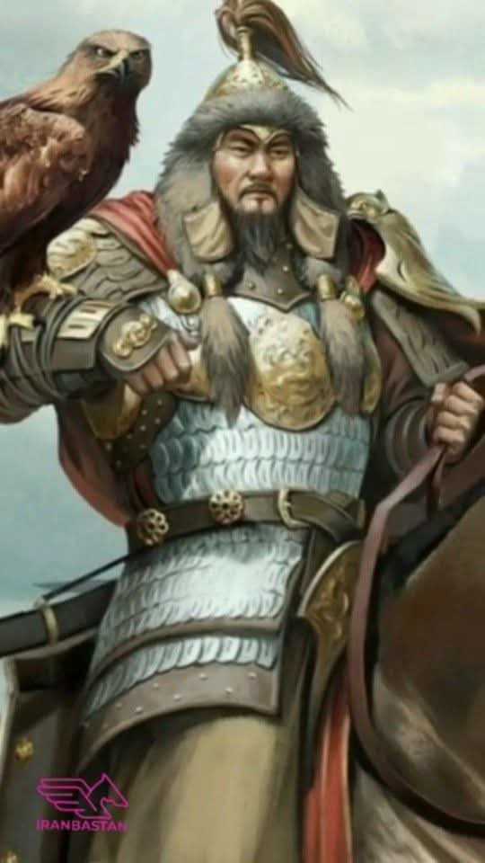
Abstract

This paper examines the Mongol invasion of Central Asia (1219-1221 CE), with particular focus on the siege and destruction of Bamiyan, through the dual lenses of historical documentation and modern genetic evidence. The analysis demonstrates a clear distinction between the Āzrah (Hazara) people and the Mongol invaders, challenging the politically motivated "Mongol label" historically imposed upon the Hazara population. Drawing on primary historical sources including the travelogue of Chinese Buddhist monk Xuanzang (7th century CE), accounts of the Mongol siege of Bamiyan, and contemporary whole-genome sequencing studies, this paper establishes that the Hazara represent a layered population with a pre-existing indigenous presence in the Bamiyan Valley, onto which a relatively recent and limited Mongol genetic layer was added during the Mongol Empire period (approximately 23-31 generations ago).

---

1. Introduction

The Bamiyan Valley in central Afghanistan stands as one of the most significant cultural and historical sites in the ancient world. Located at the crossroads of the Silk Road, it served as a meeting point for Buddhist, Zoroastrian, and later Islamic civilizations. The valley is home to the remnants of the colossal Buddha statues—the western figure standing 55 metres tall and the eastern figure 38 metres tall—carved into the cliffs between the late sixth and early seventh centuries CE.

However, the history of Bamiyan is also marked by violent invasions, the most devastating of which was the Mongol invasion of 1221 CE. This paper aims to disentangle the historical and genetic evidence regarding the Mongol invasion, the destruction of Bamiyan, and the relationship between the Mongols and the Āzrah (Hazara) people.

---

2. The Mongol Invasion of Central Asia (1219-1221 CE)

2.1 Background

The Mongol invasion of Central Asia occurred after the unification of the Mongol and Turkic tribes on the Mongolian plateau in 1206, culminating with Genghis Khan's conquest of the Khwarizmian Empire in 1221. The invasion followed a series of events, including the submission of the Uyghurs, Qarluqs, and other Turkic peoples to Mongol authority.

The invasion of the Khwarizmian Empire was not originally intended by Genghis Khan; he had initially sought peaceful trade relations and sent a message to Ala ad-Din Muhammad, the ruler of the Khwarizmian Empire, addressing him as an equal: "you rule the rising sun and I the setting sun". However, the Mongol conquest would ultimately entail the utter destruction of the Khwarezmid Empire along with the massacre of much of the civilian population of the region. The Mongols systematically exterminated a particularly large portion of the people of the cities, such as Bukhara.

2.2 The Siege of Bamiyan (1221 CE)

The siege of Bamiyan in 1221 CE stands as one of the most brutal episodes of the entire Mongol campaign. According to historical sources, the city refused to surrender to the Mongol forces. Genghis Khan began the siege, which proved long and complicated due to the city's significant fortifications.

The siege took a personal turn when Mutugen (or Mo'etukan), Genghis Khan's favorite grandson and son of Chaghatay, was killed by an arrow during the assault. This loss enraged Genghis Khan, who swore revenge on Bamiyan.

The aftermath was catastrophic. According to the historian 'Ala al-Din 'Ata-Malik Juvayni (d. 1283 CE), Genghis Khan gave orders that every living creature should be killed and no prisoners be taken, and that henceforth no living creature should inhabit the place. The mother of the fallen prince, described as "more deserving the name of a fiend than a woman," caused the throats of all the inhabitants to be cut, without excepting one. She even gave orders to rip open the bellies of all pregnant women, that not an infant might be left alive. The buildings were all leveled with the ground, and every living creature was destroyed. The Mongols themselves gave this place the name "Maubalig," which in their language signifies .

2.3 Destruction of Buddhist Heritage

The Mongol invasion contributed to the destruction of Bamiyan's Buddhist heritage. According to the World Buddhist Art Dictionary, the Bamiyan sites have been repeatedly assaulted, first by Genghis Khan (reigned 1206–1227) in the 13th century, and later by various Islamic iconoclastic leaders. The Cultural Landscape and Archaeological Remains of the Bamiyan Valley were listed as a UNESCO World Heritage Site in 2003.

---

3. Xuanzang's Account of Bamiyan (7th Century CE)

3.1 The Chinese Buddhist Monk's Travels

Xuanzang (玄奘, c. 602–664 CE), the renowned Chinese Buddhist monk and scholar, traveled to India through Central Asia in the 7th century CE to retrieve Buddhist scriptures and deepen his understanding of Buddhist doctrine. His journey took him through the Tarim Basin and the kingdoms of Central Asia, where he visited numerous Buddhist monasteries and centers of learning.

3.2 Xuanzang's Description of Bamiyan

In his Great Tang Records on the Western Regions (Da Tang Xiyu Ji), Xuanzang mentioned the flourishing of the Bamiyan Valley. He described a thriving Buddhist center, including a 100-metre-long reclining Buddha statue. The valley was part of the main ancient route between South and Central Asia for merchants, travelers, and pilgrims.

3.3 Significance for Understanding Pre-Mongol Bamiyan

Xuanzang's account is significant because it demonstrates that Bamiyan was a thriving Buddhist cultural and religious center at the time of his visit—well before the arrival of Islam and centuries before the Mongol invasion. The population was Buddhist, and the valley was known for its monumental Buddha statues and numerous monasteries. This contradicts any narrative that would present the Hazara as "late arrivals" or as a people without deep roots in the region.

---

4. Genetic Evidence: Distinguishing Āzrah from Mongols

4.1 The Mongol Genetic Layer as a Layer, Not the Foundation

Modern genetic studies have provided crucial evidence for understanding the relationship between the Āzrah (Hazara) and the Mongols. A pilot whole-genome sequencing study of Central Asian and Afghanistan Hazaras (CAAH) revealed that the recent east-west admixture in CAAH was estimated to have occurred 23-31 generations ago, aligning with the Song and Yuan dynasties and the Mongol Empire period.

This means that the Mongol genetic contribution to the Hazara population occurred relatively recently—roughly 600-800 years ago—corresponding to the period of Mongol expansion. This genetic layer was added to a pre-existing indigenous population that had been present in the Bamiyan Valley for millennia.

4.2 Hazara Genetic Profile: A Distinct Population

The whole-genome sequencing study also revealed significant genetic differentiation among Central Asian populations. While Tajiks, Karluks, Turkmen, and Uzbek individuals exhibited higher proportions of West Eurasian ancestry, the Kyrgyz, Karakalpak, Uyghur, and Hazara populations presented increased ancestry related to ancient Northeast Asians. The study identified two Indo-European genetic clines, with Hazaras being notably isolated. Strong genetic affinities were observed between Hazaras and Altaic groups in Siberia, underscoring the impact of ancient long-distance migrations on Eurasian genetic diversity.

This confirms that the Hazara are not a monolithic "Mongol" population but represent a distinct genetic grouping with complex origins.

4.3 Direct Evidence from Y-Chromosome Studies

The Y-chromosome analysis of Afghan populations reveals a clear picture of the Hazara's relationship to the Mongols and the Central Asian populations. Significantly, the absence of Y-chromosome "star clusters" (such as those observed in the Mongol population) suggests that there have not been any founder events leading to expansions out of Afghanistan. This supports the hypothesis of a "long-range accumulation" of genetic diversity rather than a single Mongol founder event.

The absence of these "star clusters" is a critical piece of evidence—it demonstrates that while there is a Mongol genetic presence in the Hazara population, it is not a dominant or founder component. If the Hazara were simply "descendants of Mongol soldiers," as the politically motivated narrative claims, we would expect to see these characteristic Mongol genetic markers. Instead, what we find is a layered population where the Mongol contribution is a relatively recent addition to a much older genetic substrate.

4.4 Presence of Haplogroup C3

Y-chromosome haplogroup C3 (M401) is found among Hazaras, along with Mongols, Kazakhs, Kyrgyz, Uzbeks, Dungans, Tajiks, Pashtuns, and Turkmens. However, this haplogroup is also broadly distributed across Central Asian populations, not exclusive to Mongols. The presence of this haplogroup among multiple groups indicates historical contacts and admixture, not a direct lineage.

---

5. The Absence of Pashtuns and Tajiks from the Mongol Invasion Narrative

A notable observation in the historical records of the Mongol invasion of Bamiyan is the absence of references to Pashtun or Tajik communities being present in Bamiyan during the invasion. While Tajiks were present in other regions of Central Asia, such as Samarkand and Bukhara, the ethnic composition of Bamiyan prior to and immediately after the Mongol invasion is not documented as including significant Pashtun or Tajik populations in the city itself.

The primary defenders of Bamiyan were the local inhabitants, not Pashtun or Tajik military forces. The historical accounts focus on the Khwarizmian garrison, the local population, and the Mongol forces—with no mention of Pashtuns as a distinct group at the siege.

---

6. Mongol Burial Sites in Bamiyan

A significant piece of evidence that the Mongol presence in Bamiyan was a passing military invasion, not a mass settlement or "founding event," comes from the archaeological record. According to the Encyclopaedia Britannica entry on Bamiyan, while Genghis Khan's forces destroyed the city, a strong castle was built out of its ruins. The Mongols themselves gave the place the name "Maubalig," and they buried their dead in the city—including the grandson of Genghis Khan. This demonstrates that the Mongols treated Bamiyan as a conquered, destroyed city, not as a settlement for their own population.

The presence of Mongol burial sites in Bamiyan confirms the Mongol presence, but also demonstrates that the Mongol presence was a military invasion and occupation, not a permanent settlement or "founding population." If the Mongols had established themselves as a permanent ruling population, we would expect to see a continuous Mongol archaeological record. Instead, we find a layer of destruction and burial, followed by the gradual disappearance of the Mongol presence as the Empire declined.

---

7. Conclusion

The historical and genetic evidence provides a clear picture:

1. The Āzrah (Hazara) have a deep, pre-Mongol presence in the Bamiyan Valley, as documented by Xuanzang in the 7th century CE, and supported by the presence of J2a1 haplogroups connected to the Neolithic farmers of the Helmand basin.
2. The Mongol invasion of 1221 CE was a military campaign that resulted in the destruction of Bamiyan and the massacre of its inhabitants. The Mongols did not settle or establish themselves as a permanent population in Bamiyan; they destroyed the city and buried their dead there, including Mutugen, Genghis Khan's grandson.
3. The Mongol genetic contribution to the Hazara population is a layer, added approximately 23-31 generations ago during the Mongol Empire period, not the foundation of Hazara ancestry. This is confirmed by the absence of Y-chromosome "star clusters" that would indicate a Mongol founder event.
4. The Hazara population today represents a layered ancestry—a pre-existing indigenous population (with J2a1 haplogroups and deep local roots) onto which a Mongol contribution was added during the 13th-century invasion.
5. The narrative of Hazaras as "Mongols" is a politically motivated label imposed by Pashtun and Tajik powers beginning in the 19th century, lacking support from genetic, archaeological, and historical evidence.

---

References

1. Mongol invasion of Central Asia. Wikipedia. (2011).
2. Bamiyan. Encyclopaedia Britannica, National Library of Scotland.
3. Bamiyan: Archaeological site description. Ministère de la Culture, France.
4. Whole-Genome Sequencing Pilot Study of the Central Asian Genetic Diversity Project. Europe PMC, 2025.
5. Bendezu-Sarmiento, J. The Bamiyan Valley as a center of trade and cultural exchange. HAL Sciences, 2020.
6. Di Cristofaro, J., et al. "Afghan Hindu Kush: Where Eurasian Sub-Continent Gene Flows Converge." PLOS ONE, 8(10): e76748, 2013.
7. Juvayni, 'Ala al-Din 'Ata-Malik. Tarikh-i Jahangushay (History of the World Conqueror). (cited in Bamiyan Ceramic Bowl description)
8. Hilton, I. "Blaming the Taliban." The Guardian, 6 March 2001.
9. Siège de Bâmiyân. Wikipedia, 2025.
10. Xuanzang. Great Tang Records on the Western Regions. (cited in Bamiyan descriptions).
11. "A comprehensive exploration of the genetic legacy and forensic features of Afghanistan and Pakistan Mongolian-descent Hazara." ScienceDirect, 2019.
12. World Buddhist Art Dictionary. Bamiyan entry.

