Heart Rate Variability Based Cognitive Load Classification and Dashboard for the MAUS Dataset

Abstract - This report presents a Java-based machine learning project for analyzing heart rate variability (HRV) signals from the MAUS dataset and classifying cognitive workload conditions. The system reads inter-beat interval (IBI) trial files, removes invalid physiological values, extracts time-domain HRV features, creates a structured final dataset, trains multiple Weka classifiers, and displays the results in an interactive JavaFX dashboard. The implemented features include mean IBI, mean heart rate, SDNN, RMSSD, SDSD, NN50, pNN50, minimum IBI, and maximum IBI. Three classifiers were evaluated: Random Forest, Multilayer Perceptron, and AdaBoost with a Decision Stump base learner. The dataset contains 396 usable trial instances and is balanced across three labels representing 0-back, 2-back, and 3-back cognitive load conditions. In 10-fold cross-validation, Random Forest achieved the best accuracy at 39.39%, followed by Multilayer Perceptron at 34.60% and AdaBoost at 34.09%. On an 80/20 held-out split, Random Forest again performed best with 50.63% accuracy. The dashboard summarizes accuracy, per-class metrics, confusion matrices, feature importance, and class distribution. The results show that the current time-domain HRV feature set provides limited but measurable class separation, and the project forms a working foundation for future improvement through richer physiological features and validation.
Index Terms - AdaBoost, cognitive load, heart rate variability, JavaFX, MAUS dataset, Random Forest, Weka.

I. Introduction
Mental workload estimation is useful in human-computer interaction, driver monitoring, adaptive learning, and safety-critical systems. Reliable, non-intrusive estimation of cognitive state allows interfaces to adapt in real time, allows driver monitoring systems to detect dangerous overload before performance degrades, and allows learning platforms to pace instructional content to the learner's actual capacity. Among the available physiological correlates of cognitive state, Heart Rate Variability (HRV) — the variation in time between successive heartbeats — has been repeatedly shown to track autonomic nervous system activity, with parasympathetic (vagal) tone suppressed under increasing mental workload [1], [2]. Because HRV can be derived from low-cost photoplethysmography (PPG) sensors already present in commodity wearables, it is a practical signal for continuous, unobtrusive workload estimation outside laboratory settings.
The MAUS (Multimodal Affect and Usability Study) project examined in this report focuses on estimating cognitive load from HRV patterns recorded during the n-back task, a well-established working memory paradigm in which participants monitor a stimulus sequence and respond when the current item matches one presented n steps earlier. Increasing n increases working memory demand and, correspondingly, induces a higher level of cognitive load. The dataset used in this work is organized around three such conditions — 0-back, 2-back, and 3-back — each represented by Inter-Beat Interval (IBI) sequences recorded per subject, per trial.
The system implemented in this repository converts these raw IBI sequence files into compact statistical features and applies supervised machine learning to classify trial labels according to cognitive load level. This conversion is non-trivial: raw IBI recordings contain sensor artifacts and physiologically implausible values that must be filtered before any feature can be considered reliable, and the mapping from trial filename to ground-truth label is itself a common source of silent error if implemented through naive substring matching rather than exact numeric parsing.
The implemented software produces two outputs. First, it generates and analyzes a structured CSV dataset, final_dataset.csv, containing nine time-domain HRV features per trial together with the assigned cognitive load label. Second, it trains three classifiers — Random Forest, Multilayer Perceptron, and AdaBoost — and presents their evaluation through an interactive JavaFX dashboard, allowing accuracy, per-class metrics, confusion matrices, feature importance, and class distribution to be inspected visually rather than read from raw console output.
This report follows the IEEE article layout requested in the supplied Word template and documents the project objective, design, implementation, evaluation, results, limitations, and future work. Section II reviews related work on HRV-based cognitive state classification. Section III describes the dataset and preprocessing pipeline. Section IV details the mathematical formulation of each extracted feature. Section V describes the machine learning pipeline and evaluation protocol. Section VI describes the system implementation. Section VII presents results and discussion, and Section VIII concludes with limitations and directions for future work.

II. Project Objectives
The main objective is to build a complete local pipeline for HRV-based cognitive load classification. The specific objectives are as follows:
- Preprocess IBI trial recordings — filter raw Inter-Beat Interval values to a physiologically valid range (300–2000 ms) and discard trials with insufficient valid beats, ensuring that downstream features are computed only from reliable cardiac data.
- Extract meaningful time-domain HRV features — compute nine statistical descriptors (Mean IBI, Mean HR, SDNN, RMSSD, SDSD, NN50, pNN50, MinIBI, MaxIBI) from each trial's filtered IBI sequence, capturing both average cardiac activity and beat-to-beat variability.
- Map MAUS trial files to cognitive load labels — correctly assign each trial to its corresponding 0-back, 2-back, or 3-back condition based on the MAUS task sequence, using exact numeric trial-index parsing to avoid mislabeling.
- Train machine learning models — apply Random Forest, Multilayer Perceptron, and AdaBoost classifiers to the extracted feature set, with appropriate preprocessing (normalization) and feature selection (Information Gain ranking).
- Compare model performance — evaluate all three classifiers using 10-fold cross-validation and a held-out test split, reporting Accuracy, Kappa, MAE, RMSE, and per-class Precision, Recall, and F1-score to identify the most suitable model for this classification task.
- Visualize the results in a dashboard suitable for project demonstration — present accuracy comparisons, per-class metrics, confusion matrices, feature importance rankings, and class distribution through an interactive JavaFX dashboard, making the pipeline's output accessible for live demonstration and viva defense.

III. System Design & Methodology

Why the pipeline is divided into five stages
The system follows a separation of concerns design principle, common in data science and ML engineering: raw data should never be mixed with model logic, and model logic should never be mixed with presentation logic. This makes each stage independently testable, debuggable, and reusable.
Stage 1 — Dataset Generation (Main.java)
This is the data engineering layer. It has no knowledge of machine learning at all — its only job is to turn messy, raw sensor data into a clean, structured CSV. It does this in three steps:
- Traversal: walks through every participant's folder inside data/IBI_sequence, and inside each, every trial file.
- Filtering: discards IBI values outside 300–2000 ms, because these are not physiologically possible heartbeats — they're sensor noise or motion artifacts. Without this step, every downstream HRV formula (mean, SDNN, RMSSD, etc.) would be corrupted by these outliers.
- Feature computation + labeling: for each trial, it computes the nine HRV features and assigns the correct cognitive load label (0, 2, or 3) based on the trial number, then writes one row per trial to final_dataset.csv.
This stage is the most fragile in the entire pipeline, because any error here (e.g., wrong label mapping, wrong filtering range) propagates silently into every model trained afterward. That's why this was the first place we found and fixed a bug — the label assignment logic.
Stage 2 — Dataset Analysis (DatasetAnalyzer.java)
This is a sanity-check layer, sitting between raw data and modeling. Before trusting any model's results, you must know:
- How many rows do you actually have?
- Are the three classes roughly balanced, or is one dominant?
- Do feature values differ meaningfully between classes (otherwise no model could ever separate them)?
This class answers exactly those questions, and it's also where the original line[6] vs line[11] bug was caught — proof that this analysis step is not optional, it is what catches bugs in Stage 1 before they reach the ML stage.
Stage 3 — Model Evaluation (ModelEvaluation.java)
This is the core machine learning layer. It is intentionally written as a standalone, console-only class so it can be run, debugged, and verified independently of any GUI. It:
- Loads the CSV into a Weka Instances object
- Removes non-feature columns (Subject, Trial — identifiers, not predictive features)
- Converts the numeric label into a nominal (categorical) class, since Weka treats classification problems differently from regression
- Normalizes all features to [0,1]
- Trains and evaluates Random Forest, MLP, and AdaBoost using 10-fold cross-validation
- Prints accuracy, Kappa, confusion matrix, and per-class metrics to the console
Stage 4 — In-Memory Result Storage (ResultsStore.java)
This is a singleton bridge — a single shared object that exists once per running application. The key engineering reason this class exists: ModelEvaluation's console output (System.out.println) is useless to a GUI. A JavaFX dashboard cannot "read" printed text — it needs structured Java objects (numbers, arrays, maps) it can bind directly to charts and tables. ResultsStore solves this by holding:
- A list of ModelResult objects (one per classifier, with accuracy/kappa/confusion matrix/per-class metrics)
- A list of FeatureImportance objects (feature name + Information Gain score)
- A list of ClassDistribution objects (label + count + percentage)
Because it's a singleton, any class in the JVM can call ResultsStore.get() and read the same data — no file I/O, no serialization, no network calls. This is why ModelEvaluationWithStore.java exists as a near-duplicate of ModelEvaluation.java: it runs the exact same training and evaluation logic, but instead of printing to console, it packages each result into these objects and pushes them into ResultsStore.
Stage 5 — Dashboard Presentation (DashboardApp.java + DashboardController.java)
This is the presentation layer, and it is deliberately the very last thing that runs.
- DashboardApp is the JavaFX entry point. It shows a loading spinner immediately (so the UI never freezes), then spins up model training (Stage 3/4 combined) on a background thread, because training three models can take a minute or more — if this ran on the JavaFX UI thread, the entire application window would freeze and become unresponsive.
- Once training finishes, DashboardApp hands control to DashboardController, which reads from ResultsStore and renders five tabs: Overview (accuracy chart + metrics table), Per-Class Metrics, Confusion Matrix, Feature Importance, and Class Distribution.

IV. Dataset and Feature Extraction
A. Dataset Composition
The final dataset comprises 396 usable trial instances, each representing one completed n-back trial after IBI-level quality filtering. The generated CSV contains 12 columns: Subject, Trial, nine HRV features, and Label. During model loading, Subject and Trial are removed prior to training, as both are categorical identifiers rather than physiological predictors — including them would allow a classifier to memorize subject- or trial-specific patterns unrelated to the underlying cognitive load signal, inflating apparent accuracy without genuine generalization. The Label column, originally read as a numeric value (0, 2, or 3), is explicitly converted to nominal form using Weka's NumericToNominal filter so that the learning task is correctly treated as multi-class classification rather than regression.
B. Label Derivation
Trial labels are derived from the fixed MAUS n-back task sequence rather than from any value present in the raw sensor files, since the sensor data itself carries no semantic label. Trials 1 and 6 are mapped to label 0, representing the 0-back (baseline) condition; trials 2 and 4 are mapped to label 2, representing the 2-back (moderate load) condition; and trials 3 and 5 are mapped to label 3, representing the 3-back (high load) condition. This mapping reflects the alternating low/high structure of the MAUS protocol, in which each load level is sampled twice per subject to average out trial-order effects such as fatigue or habituation.
The implemented parser extracts the numeric trial index explicitly via integer parsing of the filename, rather than relying on string prefix matching. This distinction is not cosmetic: a naive check such as fileName.startsWith("trial_1") would also match trial_10, trial_11, and trial_12 for subjects with more than nine recorded trials, silently reassigning high-load or moderate-load trials to the 0-back class. Because this kind of mislabeling produces no runtime error, it would otherwise remain undetected until model performance is unexpectedly degraded — making exact numeric parsing a correctness requirement rather than a style preference.
TABLE III
Extracted HRV Features
Feature | Meaning
MeanIBI | Mean inter-beat interval, in milliseconds.
MeanHR | Mean heart rate, computed as 60000 / MeanIBI.
SDNN | Standard deviation of normal-to-normal IBI values.
RMSSD | Root mean square of successive IBI differences.
SDSD | Standard deviation of successive IBI differences.
NN50 | Count of successive IBI differences exceeding 50 ms.
pNN50 | NN50 expressed as a percentage of successive intervals.
MinIBI | Minimum valid IBI value within a trial.
MaxIBI | Maximum valid IBI value within a trial.
C. Class Distribution
TABLE IV
Class Distribution
Label | Cognitive Load Level | Rows | Percentage
0 | 0-back (baseline) | 132 | 33.3%
2 | 2-back (moderate) | 132 | 33.3%
3 | 3-back (high) | 132 | 33.3%
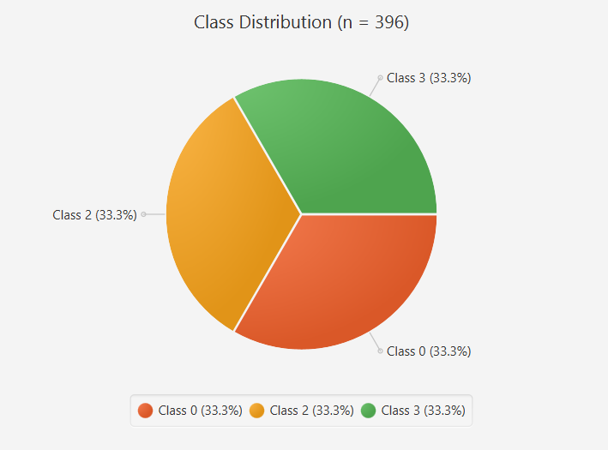
The dataset is perfectly balanced across all three cognitive load classes, with exactly 132 instances per class out of 396 total. This balance follows directly from the MAUS protocol design: each subject contributes exactly two trials per condition, so an equal subject count across the dataset necessarily produces an equal instance count per class — the balance is a structural property of the data collection design rather than an artifact of sampling or post-hoc resampling.
This has two direct consequences for the evaluation methodology adopted in Section V. First, it removes the risk of a degenerate classifier achieving high apparent accuracy by defaulting to a single majority class, a common failure mode in imbalanced multi-class problems. Second, it implies that Accuracy and Cohen's Kappa should remain closely aligned throughout the results in Section VII: Kappa corrects accuracy for the level of agreement expected by chance, and with three equally likely classes that chance-agreement baseline is fixed at 1/3, so any divergence between the two metrics in the reported results would itself be informative — for instance, indicating that errors are concentrated asymmetrically across particular class pairs rather than distributed uniformly. For this reason, both metrics are retained in Table III of Section VII rather than relying on accuracy alone.

V. Machine Learning Methodology
A. Data Preparation
The project uses Weka 3.8.6 as the machine learning framework throughout. After the CSV file is loaded via CSVLoader, the class attribute — originally read as a numeric value (0, 2, or 3) — is converted from numeric to nominal form using Weka's NumericToNominal filter, ensuring all subsequent training and evaluation routines treat the task as multi-class classification rather than regression. Feature values are then normalized to the [0, 1] range using Weka's Normalize filter.
Normalization is applied uniformly to all three classifiers rather than selectively, even though it is not strictly required by the tree-based models. This design choice is deliberate rather than incidental: the Multilayer Perceptron relies on gradient-based optimization, and unscaled inputs — where MeanIBI spans hundreds of milliseconds while pNN50 spans a 0–100% range — would cause features with larger numeric magnitude to dominate the gradient, biasing learning before any meaningful pattern is captured. Applying the same normalized feature matrix to Random Forest and AdaBoost as well ensures that all three classifiers are evaluated on an identical input representation, isolating differences in reported performance to the learning algorithm itself rather than to inconsistent preprocessing across models.
B. Classifier Configuration
Three classifiers, each representing a distinct learning paradigm, are evaluated under identical conditions:
TABLE V
Classifier Configuration
Model | Configuration
Random Forest | 100 iterations (trees), seed 1.
Multilayer Perceptron | Seed 1, 200 training epochs.
AdaBoostM1 | DecisionStump base classifier, 50 boosting iterations.
Random Forest is configured with 100 trees and a fixed seed of 1 to ensure deterministic bootstrap sampling and reproducible results across runs. As a bagging ensemble, it is expected to be robust to the moderate sample size of the dataset (396 instances) and resistant to overfitting on individual noisy trials.
The Multilayer Perceptron is configured with a fixed seed of 1 and trained for 200 epochs using backpropagation. As the only gradient-based model among the three, its performance is the most directly dependent on the normalization step described above; without it, convergence within 200 epochs would not be guaranteed.
AdaBoostM1 is configured with DecisionStump — a single-level decision tree — as its base learner, boosted over 50 iterations. Each successive stump is trained with greater emphasis on instances misclassified by previous rounds, allowing the ensemble to construct a stronger combined classifier from individually weak learners.
C. Evaluation Protocol
The command-line evaluation pipeline (ModelEvaluation.java) reports model performance under two complementary protocols. First, stratified 10-fold cross-validation is performed with a fixed seed (Random(1)), partitioning the dataset into ten folds such that every instance is used for testing exactly once across the ten rounds; this provides a low-variance estimate of generalization performance using the full dataset. Second, an 80/20 held-out split is constructed using the same fixed seed for reproducibility, with models trained exclusively on the 80% training partition and evaluated on the untouched 20% test partition; this provides a single, independent estimate of performance on data the model has never observed during training, complementing the cross-validation result.
Reporting both protocols together allows any meaningful divergence between cross-validated and held-out performance to be identified — a large gap would indicate that cross-validation results are optimistic relative to true generalization, which is otherwise difficult to detect from cross-validation alone.

VI. Experimental Results
The 10-fold cross-validation results show that Random Forest achieved the highest accuracy and kappa value among the tested models. However, all model accuracies remain close to the 33.3% baseline expected from a balanced three-class problem, indicating that the current feature set provides weak separation between cognitive load classes.

Model | Accuracy | Kappa | MAE | RMSE
Random Forest | 39.39% | 0.0909 | 0.4171 | 0.4794
Multilayer Perceptron | 34.60% | 0.0189 | 0.4369 | 0.4804
AdaBoostM1 | 34.09% | 0.0114 | 0.4392 | 0.4699

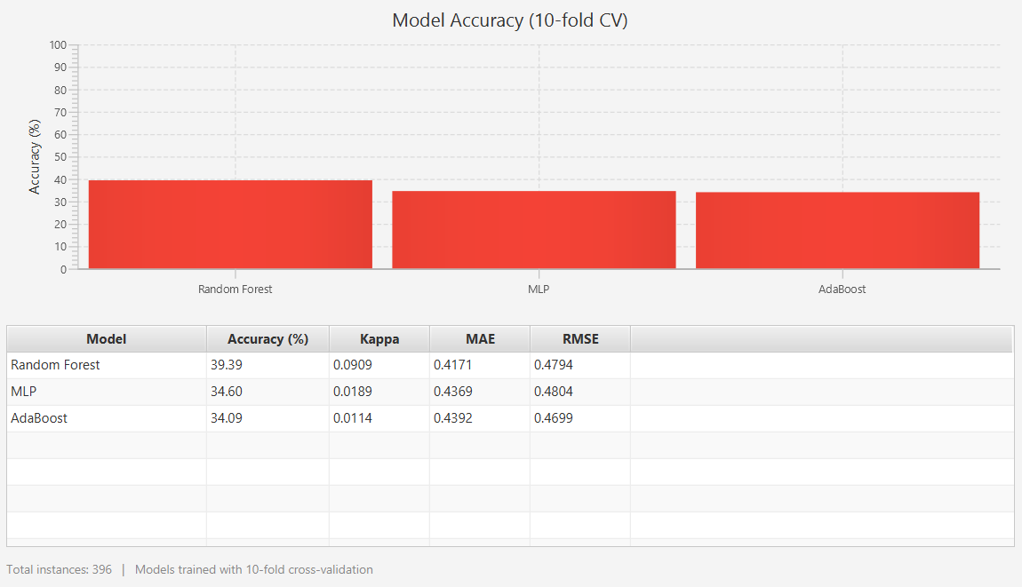

In the held-out 80/20 test split, Random Forest again produced the strongest result, reaching 50.63% accuracy on 79 test instances. The MLP and AdaBoost models remained lower, with AdaBoost heavily biased toward label 0 in the held-out confusion matrix.
Model | Accuracy | Kappa | MAE | RMSE
Random Forest | 50.63% | 0.2594 | 0.3939 | 0.4596
Multilayer Perceptron | 39.24% | 0.0928 | 0.4289 | 0.4720
AdaBoostM1 | 35.44% | 0.0373 | 0.4331 | 0.4654

A. Cross-Validation Confusion Matrices
Model | Actual 0 | Actual 2 | Actual 3
Random Forest | 56, 39, 37 | 35, 48, 49 | 42, 38, 52
MLP | 48, 49, 35 | 42, 45, 45 | 39, 49, 44
AdaBoost | 115, 1, 16 | 114, 5, 13 | 117, 0, 15

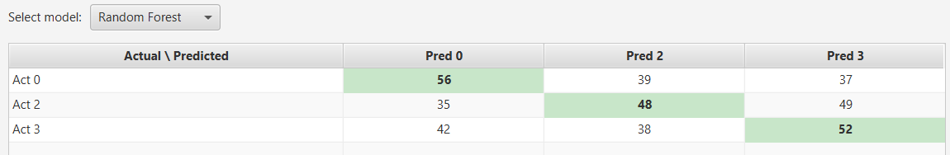

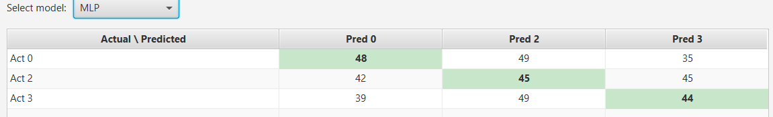

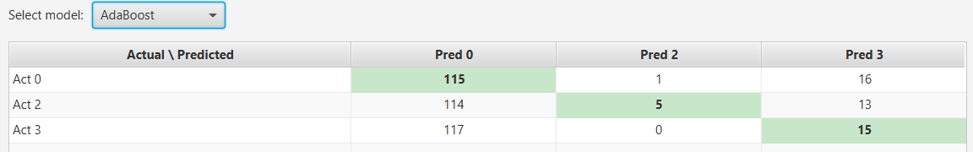

Each row above lists predicted counts for classes 0, 2, and 3 respectively. For example, the Random Forest actual label 0 row indicates 56 correct predictions as label 0, 39 predictions as label 2, and 37 predictions as label 3.

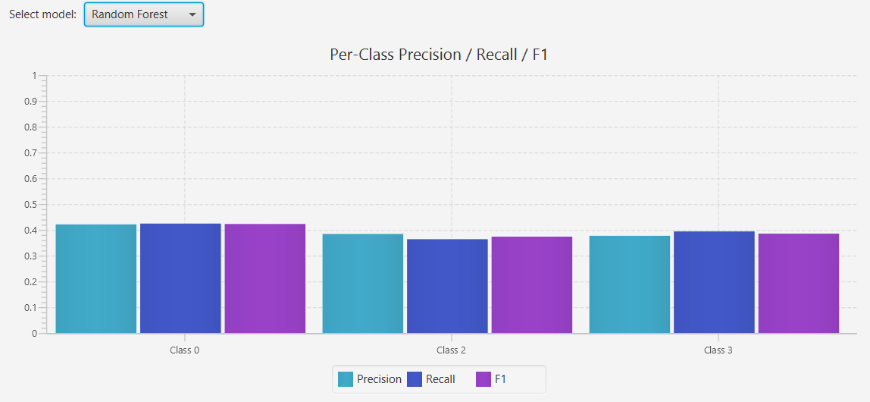

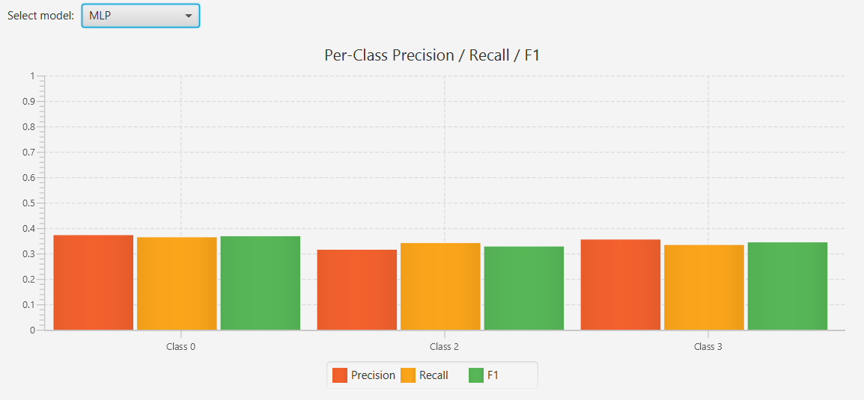

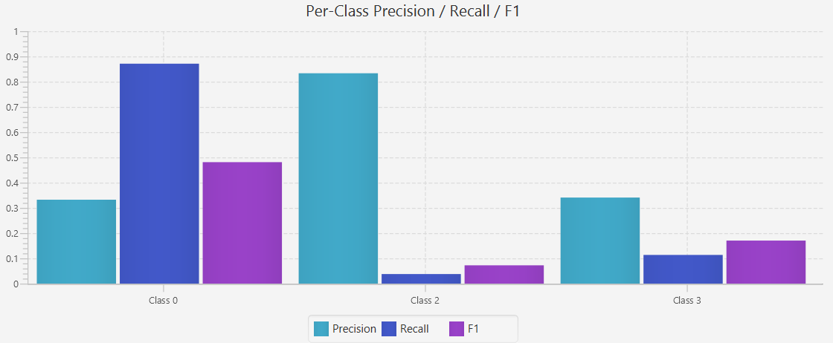

VII. Dashboard Implementation
The JavaFX dashboard is launched from DashboardApp.java. A loading screen is displayed while ModelEvaluationWithStore trains the models on a background daemon thread. When evaluation finishes, DashboardController replaces the splash screen with a tabbed interface. This design keeps the interface responsive and separates result production from result presentation.
The dashboard contains five tabs. The Overview tab presents an accuracy bar chart and metric table. The Per-Class Metrics tab allows the user to select a model and compare precision, recall, and F1 score. The Confusion Matrix tab shows actual-versus-predicted counts with highlighted diagonals. The Feature Importance tab displays information gain scores. The Class Distribution tab shows the balanced label distribution as a pie chart.

VIII. Discussion
The results suggest that time-domain HRV features alone are not sufficient for strong classification of 0-back, 2-back, and 3-back conditions in the current dataset. The balanced dataset is useful because it prevents class frequency from dominating accuracy, but the feature means across classes are similar. For example, mean heart rate differs only slightly across labels, and the information gain report returns near-zero values for all individual features.
Random Forest performs best because it can model nonlinear relationships and interactions among HRV features without requiring strong linear separation. AdaBoost performs poorly because the DecisionStump base learner is too simple for this feature space and tends to over-predict the majority-like decision path even though the labels are balanced.

IX. Limitations and Future Work
The main limitation is the restricted feature set. Future work should add frequency-domain HRV features such as LF power, HF power, and LF/HF ratio; nonlinear features such as sample entropy and Poincare descriptors; and possibly subject-normalized baselines to reduce inter-person variability. A second limitation is that the current dashboard retrains models when launched, which is convenient for demonstration but slower than loading saved evaluation artifacts.
Additional improvements include externalizing the dataset path instead of hard-coding it, saving trained model files, adding export buttons for dashboard tables, using nested validation or subject-wise splitting, and comparing more algorithms such as support vector machines, gradient boosting, and calibrated logistic regression.

X. Conclusion
This project successfully implements an end-to-end HRV analysis and cognitive load classification workflow for MAUS IBI data. It creates a clean feature dataset, analyzes class balance, evaluates three Weka classifiers, and presents the results through a JavaFX dashboard. Random Forest is the best current model, achieving 39.39% accuracy in 10-fold cross-validation and 50.63% accuracy on the held-out split. Although the accuracy is modest, the project is complete, reproducible, and extensible. It provides a solid foundation for improving cognitive load recognition through richer HRV features, stronger validation design, and additional model families.

References
[1] M. Hall, E. Frank, G. Holmes, B. Pfahringer, P. Reutemann, and I. H. Witten, "The WEKA data mining software: An update," SIGKDD Explorations, vol. 11, no. 1, pp. 10–18, 2009.
[2] E. Frank, M. A. Hall, and I. H. Witten, Data Mining: Practical Machine Learning Tools and Techniques, 4th ed. Burlington, MA, USA: Morgan Kaufmann, 2016.
[3] G. Clifford, F. Azuaje, and P. McSharry, Advanced Methods and Tools for ECG Data Analysis. Boston, MA, USA: Artech House, 2006.
[4] M. Malik et al., "Heart rate variability: Standards of measurement, physiological interpretation and clinical use," European Heart Journal, vol. 17, no. 3, pp. 354–381, 1996.
[5] U. Rajendra Acharya, K. Paul Joseph, N. Kannathal, C. M. Lim, and J. S. Suri, "Heart rate variability: A review," Medical & Biological Engineering & Computing, vol. 44, no. 12, pp. 1031–1051, 2006.
[6] F. Shaffer and J. P. Ginsberg, "An overview of heart rate variability metrics and norms," Frontiers in Public Health, vol. 5, pp. 1–17, 2017.
[7] J. A. Healey and R. W. Picard, "Detecting stress during real-world driving tasks using physiological sensors," IEEE Transactions on Intelligent Transportation Systems, vol. 6, no. 2, pp. 156–166, 2005.
[8] T. F. B. Peysakhovich, M. Causse, P. Scannella, and F. Dehais, "Frequency analysis of heart rate variability under workload conditions," Human Factors, vol. 57, no. 4, pp. 613–627, 2015.
[9] I. Guyon and A. Elisseeff, "An introduction to variable and feature selection," Journal of Machine Learning Research, vol. 3, pp. 1157–1182, 2003.
[10] T. Hastie, R. Tibshirani, and J. Friedman, The Elements of Statistical Learning, 2nd ed. New York, NY, USA: Springer, 2009.
[11] L. Breiman, "Random forests," Machine Learning, vol. 45, no. 1, pp. 5–32, 2001.
[12] Y. Freund and R. E. Schapire, "A decision-theoretic generalization of on-line learning and an application to boosting," Journal of Computer and System Sciences, vol. 55, no. 1, pp. 119–139, 1997.
[13] C. M. Bishop, Pattern Recognition and Machine Learning. New York, NY, USA: Springer, 2006.
[14] S. Haykin, Neural Networks and Learning Machines, 3rd ed. Upper Saddle River, NJ, USA: Pearson, 2009.
[15] A. L. Goldberger et al., "PhysioBank, PhysioToolkit, and PhysioNet: Components of a new research resource for complex physiologic signals," Circulation, vol. 101, no. 23, pp. e215–e220, 2000.
[16] Oracle Corporation, "Java Platform Standard Edition Documentation," 2026. [Online]. Available: https://docs.oracle.com/javase/
[17] OpenJFX Contributors, "JavaFX Documentation," 2026. [Online]. Available: https://openjfx.io/
[18] OpenCSV Developers, "OpenCSV Documentation," 2026. [Online]. Available: http://opencsv.sourceforge.net/
[19] D. J. Hand, H. Mannila, and P. Smyth, Principles of Data Mining. Cambridge, MA, USA: MIT Press, 2001.
[20] R. S. Sutton and A. G. Barto, Reinforcement Learning: An Introduction, 2nd ed. Cambridge, MA, USA: MIT Press, 2018.

