Big Data Management Project
Big Data Analytics Pipeline for Online Retail Transactions using HDFS, HBase, Hive, and Spark

Abstract
This report presents an end-to-end big data management and analytics pipeline for the Online Retail II dataset. The project addresses the need to ingest, store, manage, process and compare large-scale transactional data using Hadoop ecosystem tools. The dataset contains more than one million raw records and, after cleaning, 805,549 valid transaction records. The solution uses HDFS for distributed file storage, HBase as a NoSQL wide-column database, Hive for SQL-based distributed analytics and Spark for DataFrame-based analytics. Four business analytics tasks were implemented: top products by revenue, top countries by revenue, monthly revenue trend and top customers by spending. The Hive and Spark pipelines produced consistent outputs, and measured results were used to compare execution time, code complexity, scalability and ease of development. A bonus comparative experiment was also completed using 10,000, 50,000 and 100,000 row subsets. The final stack demonstrates a complete Hadoop-based architecture suitable for scalable data ingestion, NoSQL storage, distributed processing and analytical reporting.

1. Introduction and Problem Statement
Retail organizations generate large volumes of transaction data across invoices, products, customers and countries. Traditional single-machine analysis becomes difficult as data grows to hundreds of thousands or millions of records. The problem addressed in this project is how to implement a scalable Hadoop-based pipeline that can ingest retail data, store it in distributed and NoSQL systems, process it using multiple Hadoop ecosystem tools and compare the selected technologies.
The objectives are to clean a real-world dataset, upload raw and processed data to HDFS, use HBase as a NoSQL storage layer, implement two analytics pipelines using Hive and Spark, compare performance and development complexity, and produce professional evidence using screenshots, code snippets, architecture diagrams and tables. This aligns with big data management principles of distributed storage, parallel processing and technology selection [6].

2. Dataset Description
The dataset selected for this project is the Online Retail II dataset from the UCI Machine Learning Repository. It represents e-commerce transactions from a UK-based online retail company. The original Excel workbook was converted into CSV, profiled and cleaned using Python. The final data is structured and suitable for distributed processing because each row represents a transaction line with invoice, product, date, customer, country and revenue attributes [6].
Item | Description
Source | UCI Machine Learning Repository - Online Retail II
Domain | E-commerce transaction analytics
Raw records | 1,067,371 rows
Clean records | 805,549 valid transaction records
Columns | InvoiceNo, StockCode, Description, Quantity, InvoiceDate, UnitPrice, CustomerID, Country, Revenue
Justification | Large, structured, real-world and suitable for HDFS, HBase, Hive and Spark

Note: the cleaned CSV contains 805,550 lines including the header row, representing 805,549 cleaned transaction records. Screenshots showing 805,550 lines are therefore consistent with the cleaned dataset.
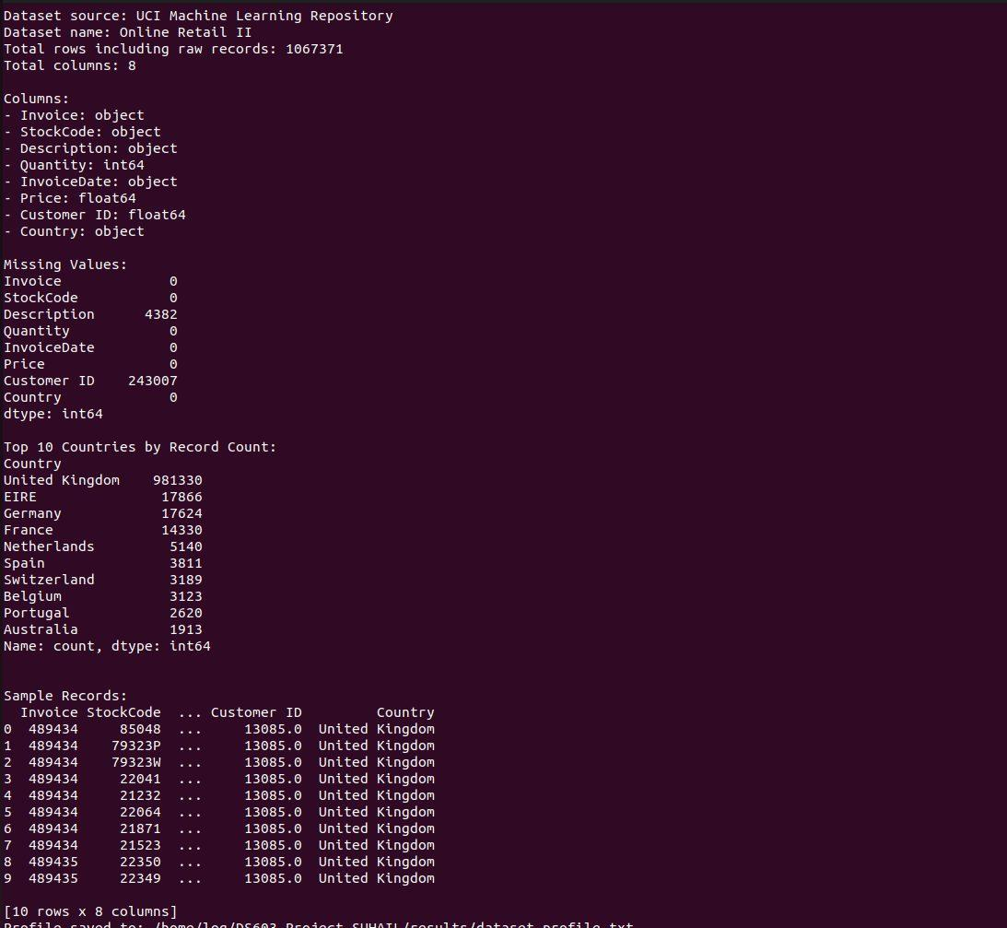 | 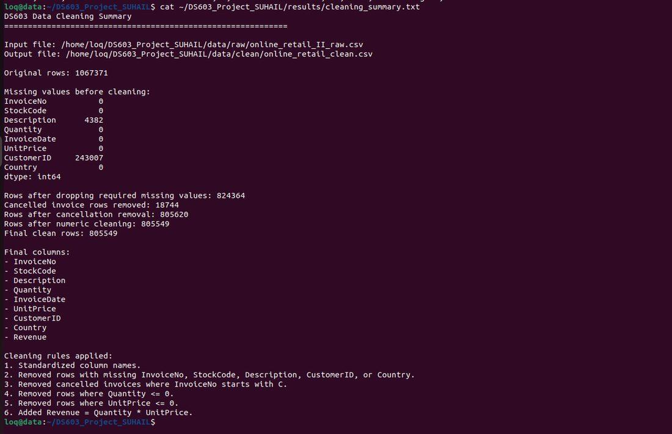
Dataset profile and structure. | Cleaning summary and final row count.

3. System Architecture and Data Flow
The architecture follows a layered design: Python prepares the data, HDFS stores raw and clean files, HBase provides NoSQL storage, and Hive and Spark process the cleaned HDFS dataset. The design demonstrates a complete flow from ingestion to storage, processing, output and comparison.
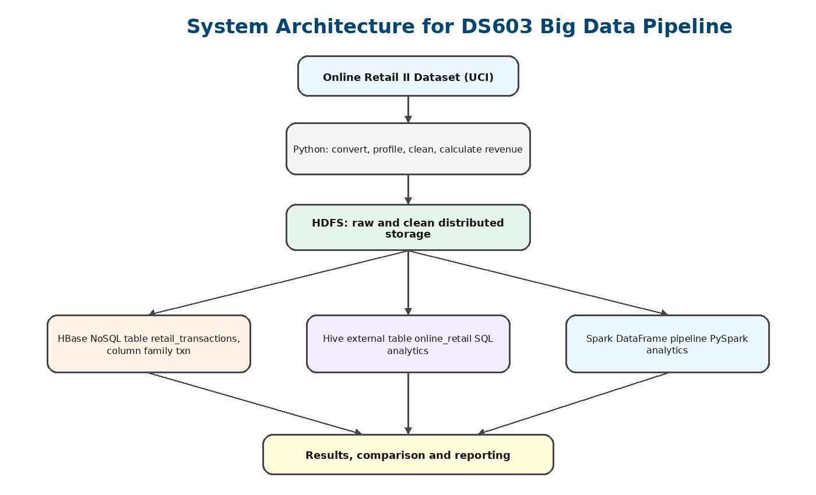
Figure 1. System architecture diagram for the Hadoop-based analytics pipeline.
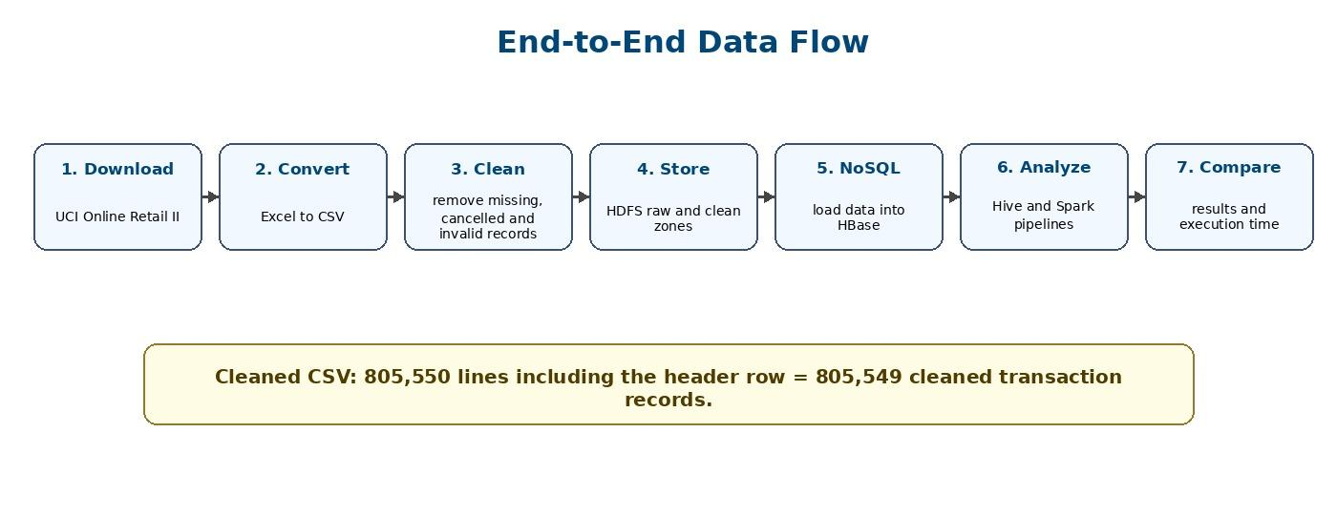
Figure 2. End-to-end data flow and cleaned-record note.

4. Data Ingestion and Storage Layer
The ingestion layer converted the Excel dataset into CSV, cleaned the dataset and uploaded both raw and clean datasets to HDFS. HDFS was selected because it is designed for distributed storage of large files and integrates directly with Hadoop tools such as Hive and Spark [1]. The raw dataset was stored under /ds603_project/raw/ and the cleaned dataset under /ds603_project/clean/.
Several screenshots show the warning: “WARN util.NativeCodeLoader: Unable to load native-hadoop library for your platform... using builtin-java classes where applicable”. This is common in single-node Ubuntu Hadoop setups and does not indicate failure. The file listings, sizes and row counts confirm successful ingestion.
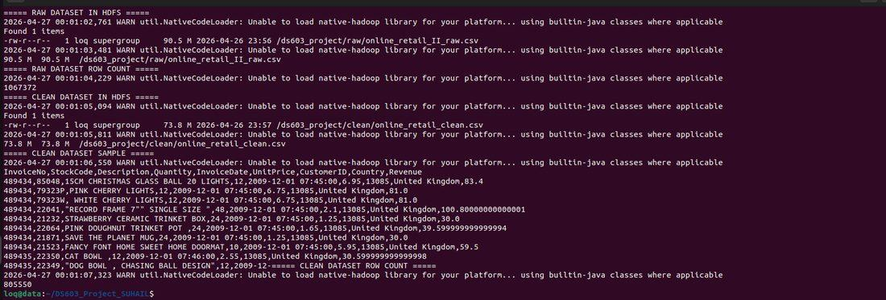 | 
Raw and clean datasets uploaded to HDFS. | HDFS health and capacity status.

5. NoSQL Storage Implementation: HBase
HBase was selected as the NoSQL database because it is a distributed wide-column store that runs on HDFS and supports scalable row-key access [1]. The table retail_transactions was created with one column family named txn. The row key uses InvoiceNo_StockCode_RowNumber to uniquely identify transaction records.
Design item | Value
Table | retail_transactions
Column family | txn
Row key | InvoiceNo_StockCode_RowNumber
Stored columns | invoice_no, stock_code, description, quantity, invoice_date, unit_price, customer_id, country, revenue
Imported records | 805,549 cleaned records

create 'retail_transactions', 'txn'
scan 'retail_transactions', {LIMIT => 5}
count 'retail_transactions', {INTERVAL => 100000}
get 'retail_transactions', '489434_21232_4'

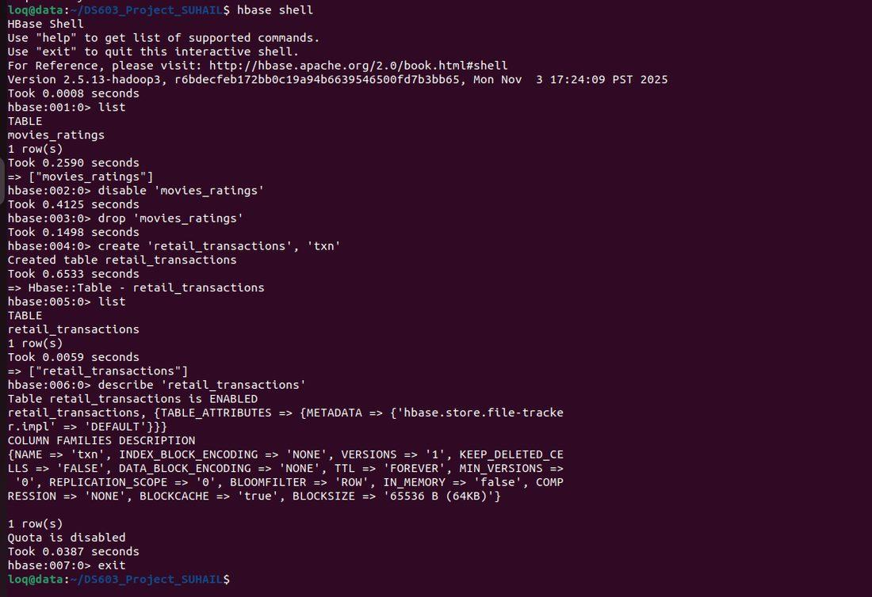 | 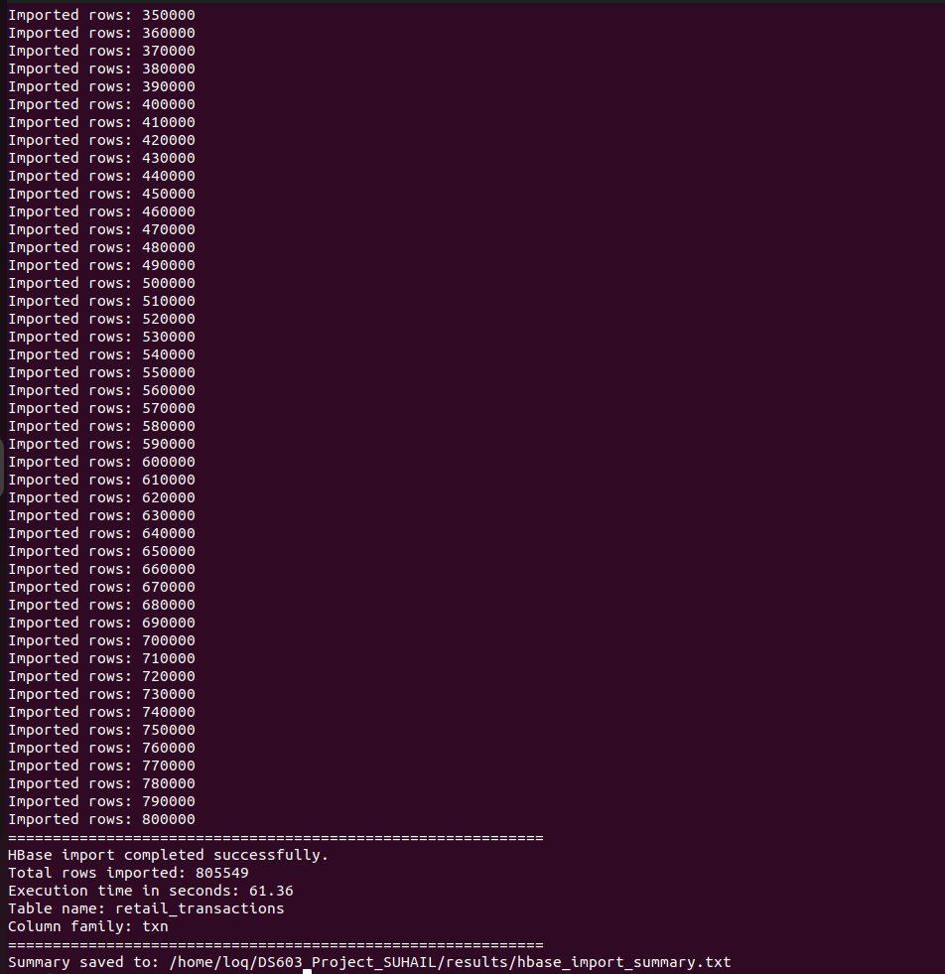
HBase table creation and schema verification. | HBase import completed with 805,549 rows.

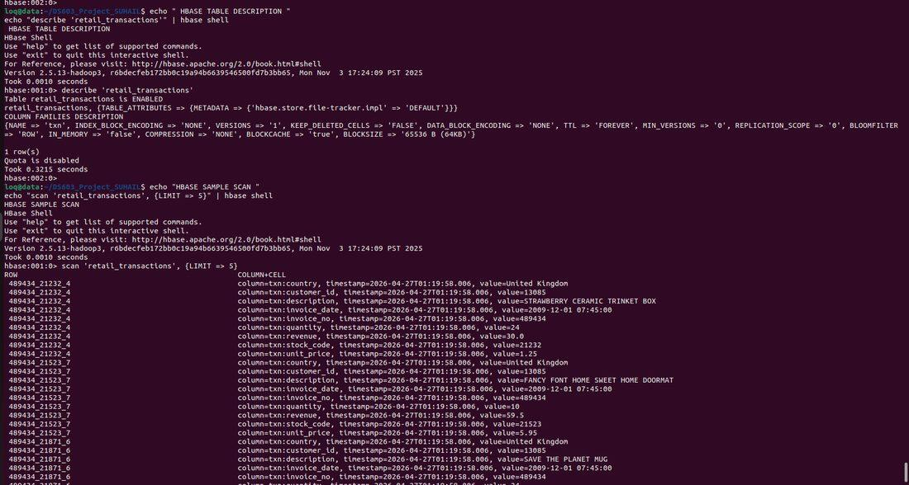 | 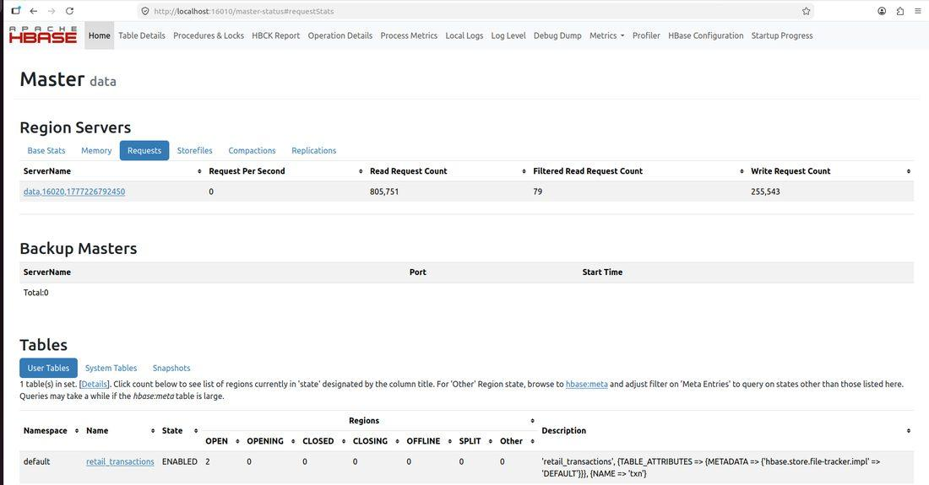
HBase scan/count verification. | HBase Master UI showing active table.

6. Distributed Processing Implementation
Two Hadoop ecosystem processing tools were implemented: Hive and Spark. Hive created an external SQL table over the cleaned HDFS dataset. Spark read the same dataset from HDFS into a DataFrame. Both pipelines generated analytics for top products, top countries, monthly revenue and top customers.

6.1 Hive Pipeline
Hive processed quoted CSV fields and SQL queries to group and aggregate records. The following query shows the country revenue task.
SELECT Country, ROUND(SUM(CAST(Revenue AS DOUBLE)), 2) AS total_revenue
FROM online_retail
WHERE Revenue IS NOT NULL AND CAST(Revenue AS DOUBLE) > 0
GROUP BY Country
ORDER BY total_revenue DESC
LIMIT 10;

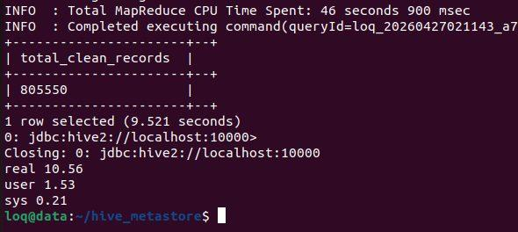 | 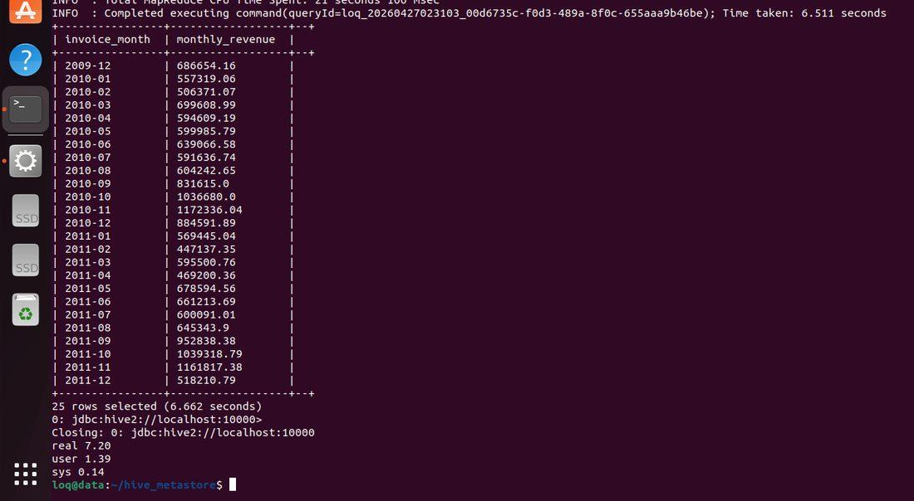
Hive database, table and schema verification. | Hive monthly revenue result with execution time.

6.2 Spark Pipeline
Spark 3.5.1 was used after resolving a Spark 2.4.8/Python compatibility issue. The PySpark script read the cleaned HDFS file, inferred the schema, filtered records, grouped by dimensions and saved outputs back to HDFS.
df = spark.read.option('header','true').option('inferSchema','true').csv(input_path)
country_revenue = df.filter(col('Revenue') > 0) .groupBy('Country') .agg(round(sum('Revenue'), 2).alias('total_revenue')) .orderBy(col('total_revenue').desc()).limit(10)

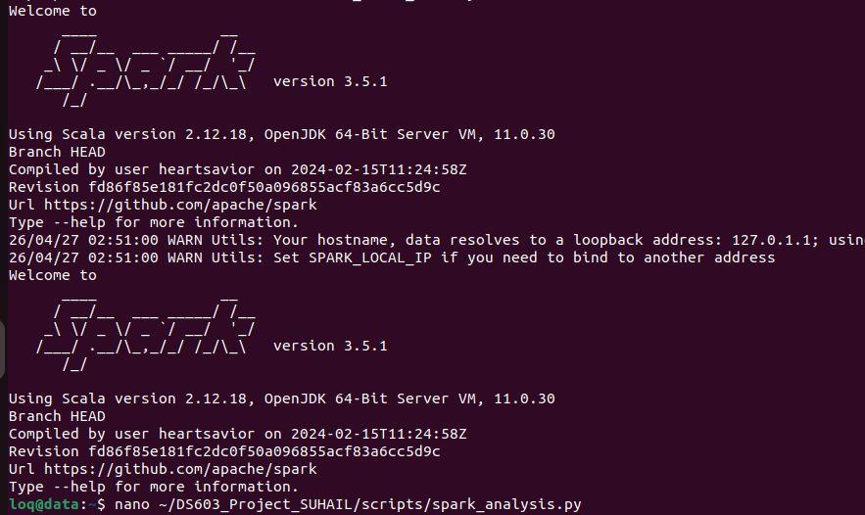 | 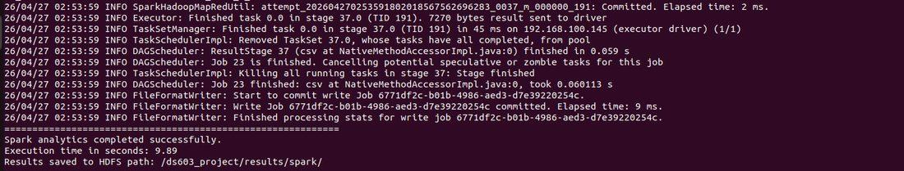
Spark 3.5.1 verification. | Spark full analytics pipeline completed in 9.89 seconds.

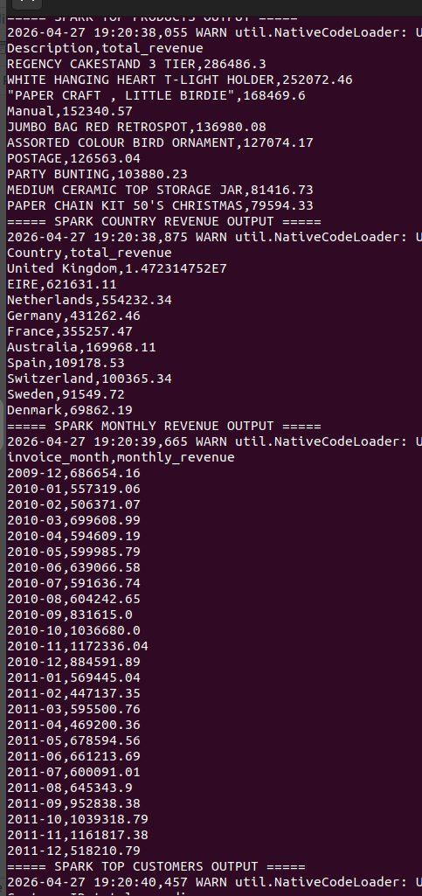
Figure 3. Spark result datasets saved in HDFS.

7. Technology Comparison
The selected technology stack is HDFS + HBase + Hive + Spark. HDFS provides distributed file storage, HBase provides NoSQL storage, Hive provides SQL-style batch analytics, and Spark provides flexible DataFrame-based analytics. The tables compare the selected technologies with alternatives required by the project.
Criteria | HBase | MongoDB | Relational DB
Storage model | Wide-column NoSQL | Document NoSQL | Relational tables
Hadoop integration | Excellent; HDFS-backed | Moderate | Limited
Scalability | Very high | High | Medium
Ease of implementation | Moderate | Moderate | High
Project suitability | Best fit | Good but less Hadoop-focused | Not suitable as NoSQL requirement

Criteria | Hive | Spark | MapReduce | Pig
Processing model | SQL batch queries | DataFrame/in-memory | Low-level batch jobs | Data-flow scripting
Ease of development | High | Moderate | Low | Moderate
Performance | Good for batch | Fast for pipelines | Slower | Medium
Code complexity | Low | Medium | High | Medium
Project suitability | Strong | Strongest | Useful but complex | Optional

8. Results and Discussion
Hive and Spark produced consistent analytical results. The top revenue country was the United Kingdom, the highest revenue customer was Customer ID 18102, and the top product was REGENCY CAKESTAND 3 TIER. The monthly trend covered December 2009 to December 2011 and showed strong seasonal revenue activity.
Result area | Main finding
Top product | REGENCY CAKESTAND 3 TIER
Top country | United Kingdom
Highest revenue customer | Customer ID 18102
Trend period | December 2009 to December 2011
Technical finding | Hive and Spark outputs matched

Analysis task | Hive execution time | Spark execution time
Top 10 products by revenue | 8.29 sec | Included in full Spark pipeline
Top 10 countries by revenue | 7.16 sec | Included in full Spark pipeline
Monthly revenue trend | 7.20 sec | Included in full Spark pipeline
Top 10 customers by spending | 35.11 sec | Included in full Spark pipeline
All four analytics together | Separate Hive queries | 9.89 sec

Note: Hive queries were measured separately, while Spark executed all four analytics in one PySpark pipeline. Hive was easier to write for simple reporting because it uses SQL. Spark required more code but is better for flexible, repeatable and larger analytical workflows.

9. Bonus Section: Advanced Comparative Experiment
The optional bonus experiment selected one task: Top 10 countries by total revenue. The same task was run using Hive and Spark on three subsets from the main cleaned dataset: 10,000, 50,000 and 100,000 rows. These are controlled subsets, not separate data sources.
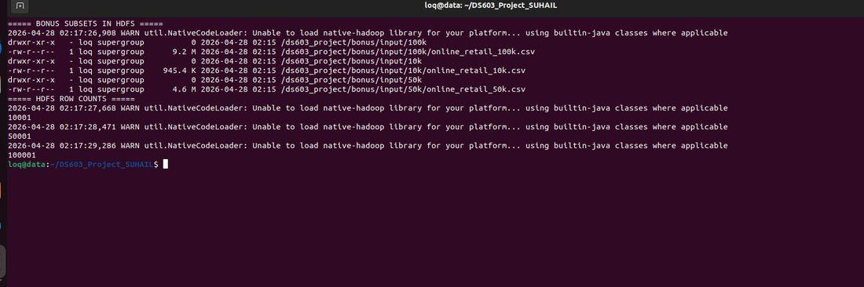 | 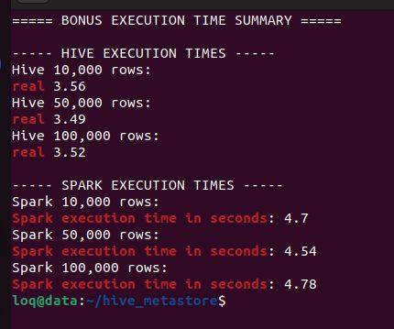
Bonus subsets uploaded to HDFS and verified. | Bonus execution-time summary for Hive and Spark.

Tool | Rows | Execution time | Notes
Hive | 10,000 | 3.56 sec | SQL query over Hive external table
Spark | 10,000 | 4.70 sec | PySpark DataFrame aggregation
Hive | 50,000 | 3.49 sec | SQL query over Hive external table
Spark | 50,000 | 4.54 sec | PySpark DataFrame aggregation
Hive | 100,000 | 3.52 sec | SQL query over Hive external table
Spark | 100,000 | 4.78 sec | PySpark DataFrame aggregation

Bonus discussion: In this bonus experiment, I selected analytics that was calculating the top 10 countries by total revenue. The same task was executed using two Hadoop ecosystem tools: Apache Hive and Apache Spark. Three dataset sizes were tested: 10,000 rows, 50,000 rows and 100,000 rows. Hive was easier to use because the analysis could be written using SQL. This makes Hive suitable for users who are familiar with relational query languages and batch reporting. In this local experiment, Hive also produced faster execution times than Spark for all three tested dataset sizes. Spark required a longer PySpark script, but it provided a more flexible and scalable processing approach. Spark used DataFrame operations such as filtering, grouping, aggregation, sorting and limiting the result set. Although Spark was slightly slower in this small-scale local test, it remains more suitable for larger datasets, repeated transformations and iterative analytics because Spark is optimized for distributed in-memory processing. Both tools produced the same type of business result, confirming the correctness of the experiment. Based on the observed execution times, Hive was faster for this specific task and dataset sizes. However, Spark remains the stronger recommendation for scalable analytics, while Hive is recommended for simple SQL-based reporting.

10. Conclusion and Reflection
The project successfully implemented a complete big data pipeline using Hadoop ecosystem tools. Raw and cleaned data were stored in HDFS, cleaned records were imported into HBase, and two distributed analytics pipelines were implemented using Hive and Spark. The outputs, performance results and screenshots demonstrate that the solution meets the project requirements.
The main reflection is that big data system design requires both technical implementation and tool-selection reasoning. HBase is suitable for Hadoop-based NoSQL storage, Hive is efficient for SQL-style reporting, and Spark is stronger for flexible analytics. Challenges included Hadoop warnings, HDFS safe mode, HiveServer2 connection handling and Spark version compatibility. These were resolved and documented, resulting in a professional and reproducible project implementation.

References

[1] Apache Software Foundation, Apache HBase Reference Guide, 2025. [Online]. Available: https://hbase.apache.org/book.html
[2] Apache Software Foundation, Apache Hive Language Manual, 2025. [Online]. Available: https://hive.apache.org/
[3] Apache Software Foundation, Apache Spark Documentation, 2025. [Online]. Available: https://spark.apache.org/docs/latest/
[4] D. Dua and C. Graff, UCI Machine Learning Repository: Online Retail II Data Set. Irvine, CA: University of California, School of Information and Computer Science, 2019.
[5] M. Zaharia et al., Apache Spark: A unified engine for big data processing, Communications of the ACM, vol. 59, no. 11, pp. 56-65, 2016.
[6] J. Dean and S. Ghemawat, MapReduce: Simplified data processing on large clusters, Communications of the ACM, vol. 51, no. 1, pp. 107-113, 2008.

