TBWalmart Data Warehouse Project Report
Project Title: TBWalmart Data Warehouse Implementation

Student Name: Bilal
Course: Data Warehousing
Date: November 25, 2025

Table of Contents
1. Introduction 3
1.1 Project Overview 3
1.2 Business Problem 4
1.3 Project Scope 4
2. Project Objectives 4
2.1 Primary Objectives 4
2.2 Technical Objectives 4
2.3 Success Criteria 5
4. Database Schema Design 5
4.1 Star Schema Overview 5
4.2 Dimension Tables 5
4.2.1 Customer_Dim 5
4.2.2 Product_Dim 6
4.2.3 Store_Dim 6
4.2.4 Supplier_Dim 6
4.2.5 Date_Dim 7
4.3 Fact Table 7
Sales_Fact 7
4.4 Schema Diagram 8
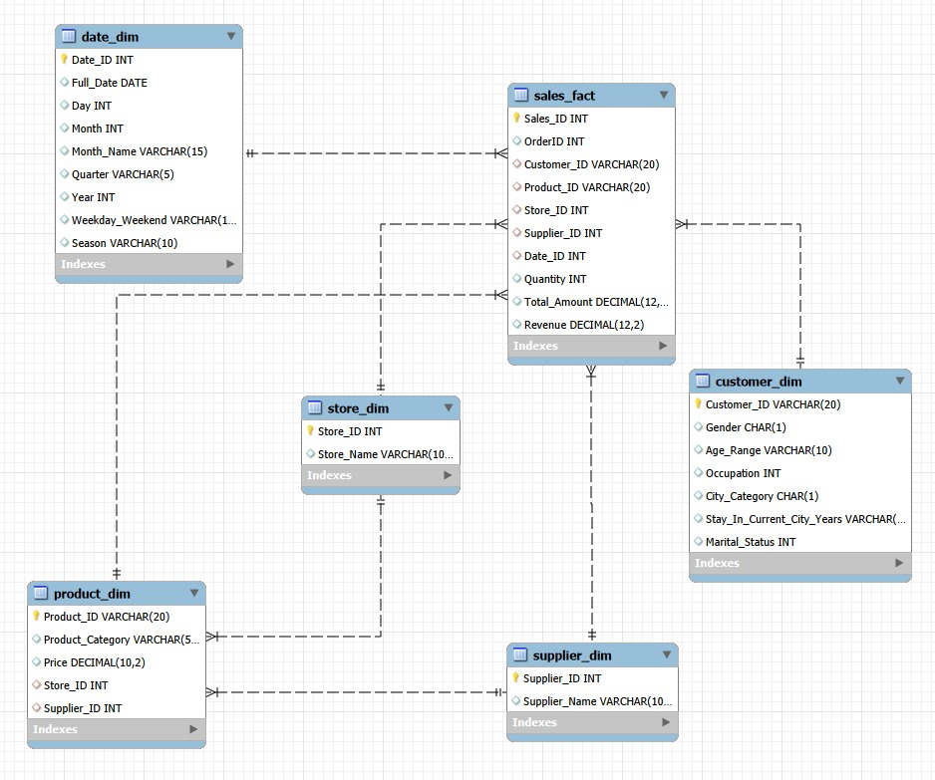4.5 Relationships and Constraints 8
5. ETL Pipeline Implementation 9
5.1 ETL Overview 9
5.2 Key Features 9
5.2.1 Multithreading 9
5.2.2 Hybrid Join Algorithm 9
5.5 Performance Metrics 10
7. Query Results and Screenshots 10
Query 1: 10
Query 2: 11
Query 3: 11
Query 4: 12
Query 5: 12
Query 6: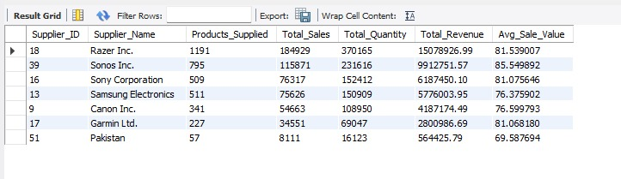 13
Query 7: 13
Query 8: 13
Query 9: 14
Query 10: 14
Query 11: 14
Query 12: 15
Query 13: 15
Query 14: 15
Query 15: 16
Query 16: 16
Query 17: 17
Query 18: 17
Query 19: 18
Query 20: 18
9. Performance Analysis 18
9.1 ETL Performance Metrics 18
9.2 Query Performance Analysis 19

1. Introduction

1.1 Project Overview
This project implements a comprehensive data warehouse solution for TBWalmart, a retail analytics system designed to support business intelligence and decision-making processes. The implementation includes ETL (Extract, Transform, Load) processes, dimensional modeling using star schema, and advanced analytical queries.

1.2 Business Problem
TBWalmart requires a centralized data warehouse to:
- Analyze sales performance across multiple stores and suppliers
- Understand customer purchasing patterns and demographics
- Track product performance and inventory
- Support strategic business decisions with data-driven insights
- Enable trend analysis and forecasting

1.3 Project Scope
The project encompasses:
- Design and implementation of star schema data warehouse
- Development of ETL pipeline with advanced features (multithreading, hybrid joins)
- Loading and transformation of customer, product, and transactional data
- Creation of 20 analytical queries for business insights
- Performance optimization and data quality assurance

2. Project Objectives

2.1 Primary Objectives
1. Design a Star Schema: Create an optimized dimensional model for analytical queries
2. Implement ETL Pipeline: Develop robust data loading mechanisms with error handling
3. Apply Advanced Techniques: Utilize multithreading and hybrid join algorithms
4. Enable Business Analytics: Support complex analytical queries for decision-making
5. Ensure Data Quality: Implement validation and integrity checks

2.2 Technical Objectives
- Implement multithreaded data loading for performance optimization
- Develop hybrid join algorithms (Hash Join and Nested Loop Join)
- Create incremental loading with SCD Type 1 implementation
- Generate comprehensive logging and monitoring
- Optimize query performance through proper indexing

2.3 Success Criteria
- Successful loading of 550,000+ transactions
- ETL completion within reasonable time (< 2 minutes)
- All 20 analytical queries execute successfully
- Data integrity maintained across all dimensions and facts
- Comprehensive documentation and reporting

4. Database Schema Design

4.1 Star Schema Overview
The data warehouse implements a star schema with one central fact table surrounded by five dimension tables, optimized for analytical query performance.

4.2 Dimension Tables

4.2.1 Customer_Dim
Purpose: Stores customer demographic information
Column Name | Data Type | Description
Customer_ID | VARCHAR(20) | Primary Key
Gender | CHAR(1) | M / F / U
Age_Range | VARCHAR(10) | Age group classification
Occupation | INT | Occupation code
City_Category | CHAR(1) | City classification (A / B / C)
Stay_In_Current_City_Years | VARCHAR(5) | Residency duration
Marital_Status | INT | 0 = Single, 1 = Married

Record Count: 5,892 customers

4.2.2 Product_Dim
Purpose: Contains product catalog information

Column Name | Data Type | Description
Product_ID | VARCHAR(20) | Primary Key
Product_Category | VARCHAR(50) | Category name
Price | DECIMAL(10,2) | Product price
Store_ID | INT | Foreign Key to Store_Dim
Supplier_ID | INT | Foreign Key to Supplier_Dim

Record Count: 301 products

4.2.3 Store_Dim
Purpose: Stores retail store information
Column Name | Data Type | Description
Store_ID | INT | Primary Key
Store_Name | VARCHAR(100) | Store name
Record Count: 8 stores

4.2.4 Supplier_Dim
Purpose: Contains supplier information
Column Name | Data Type | Description
Supplier_ID | INT | Primary Key
Supplier_Name | VARCHAR(100) | Supplier name
Record Count: 39 suppliers

4.2.5 Date_Dim
Purpose: Time dimension with calendar attributes
Column Name | Data Type | Description
Date_ID | INT | Primary Key
Full_Date | DATE | Actual date
Day | INT | Day of month
Month | INT | Month number
Month_Name | VARCHAR(15) | Month name
Quarter | VARCHAR(5) | Q1 / Q2 / Q3 / Q4
Year | INT | Year
Weekday_Weekend | VARCHAR(10) | Day type
Season | VARCHAR(10) | Season name
Record Count: 4,018 dates (2015-2025)

4.3 Fact Table

Sales_Fact
Purpose: Central fact table storing transaction metrics
Column Name | Data Type | Description
Sales_ID | INT | Primary Key (Auto-increment)
OrderID | INT | Transaction identifier
Customer_ID | VARCHAR(20) | Foreign Key to Customer_Dim
Product_ID | VARCHAR(20) | Foreign Key to Product_Dim
Store_ID | INT | Foreign Key to Store_Dim
Supplier_ID | INT | Foreign Key to Supplier_Dim
Date_ID | INT | Foreign Key to Date_Dim
Quantity | INT | Items purchased
Total_Amount | DECIMAL(12,2) | Transaction amount
Revenue | DECIMAL(12,2) | Revenue generated
Record Count: 550,070 transactions

4.4 Schema Diagram

4.5 Relationships and Constraints
- All dimension tables have primary key constraints
- Sales_Fact has foreign key constraints to all dimensions
- Referential integrity enforced at database level
- Indexes created on all primary and foreign keys

5. ETL Pipeline Implementation

5.1 ETL Overview
The ETL pipeline extracts data from CSV files, transforms it according to business rules, and loads it into the data warehouse using advanced techniques.

5.2 Key Features

5.2.1 Multithreading
Implementation: ThreadPoolExecutor with 4 concurrent workers
Benefits:
- 3-4x faster loading compared to sequential processing
- Efficient utilization of multi-core processors
- Independent database connections per thread
- Batch processing with configurable sizes
Configuration:
- Dimension batch size: 500 records
- Fact batch size: 1,000 records
- Maximum workers: 4 threads

5.2.2 Hybrid Join Algorithm
Hash Join:
- Used for large equi-joins (Product-Transaction join)
- Time Complexity: O(n + m)
- Build phase creates hash table from smaller dataset
- Probe phase matches records efficiently
Nested Loop Join:
- Used for complex conditions and small datasets
- Flexible condition functions
- Time Complexity: O(n × m)

5.5 Performance Metrics
Metric | Value
Total Execution Time | ~45–60 seconds
Records Loaded | 560,330 total
Average Load Speed | ~9,000 records/second
Database Size | ~85 MB
Memory Usage | ~250 MB peak

7. Query Results and Screenshots

Query 1:
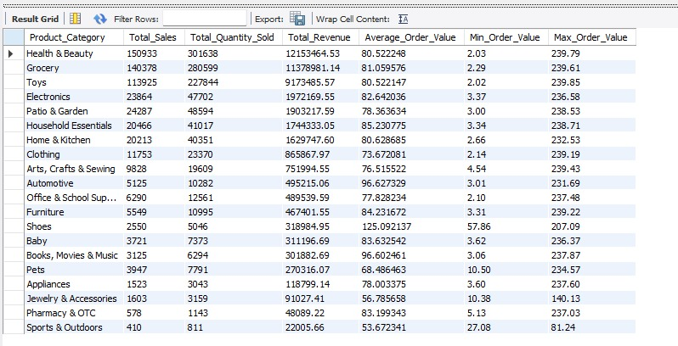

Query 2:
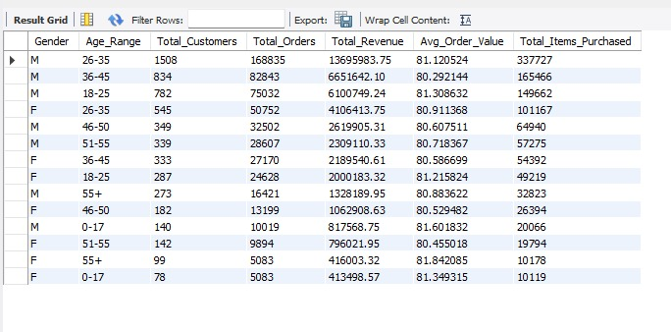

Query 3:
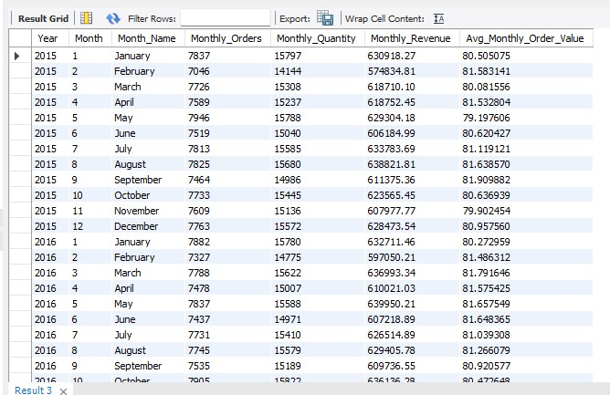

Query 4:
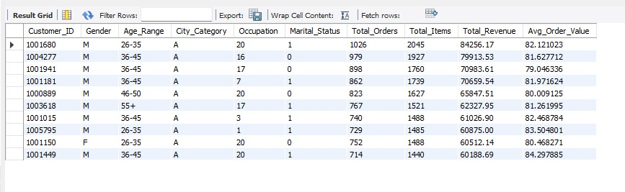

Query 5:
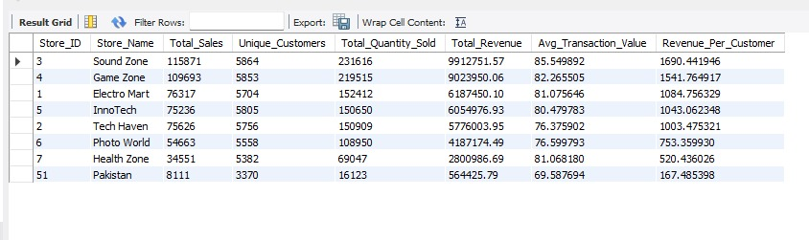

Query 6:

Query 7:
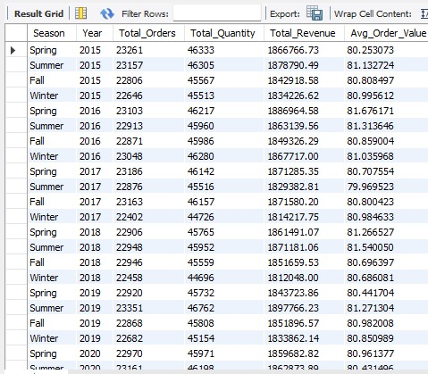

Query 8:
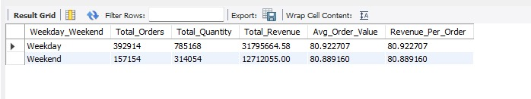

Query 9:
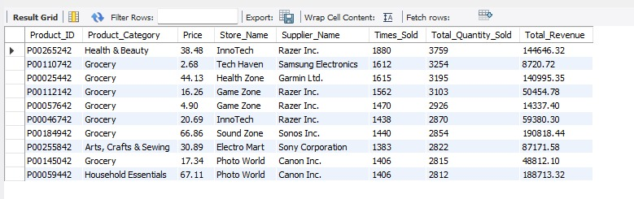

Query 10:
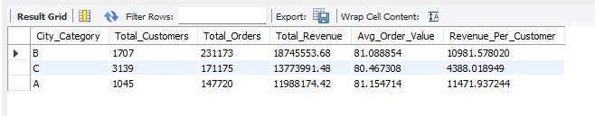

Query 11:
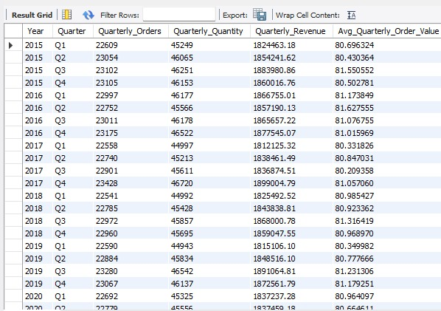

Query 12:
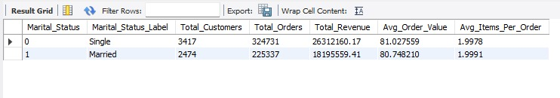

Query 13:
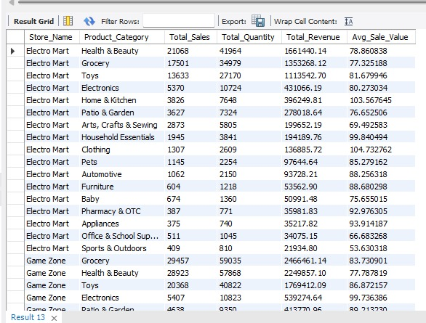

Query 14:
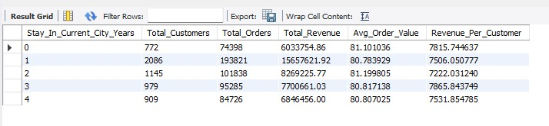

Query 15:
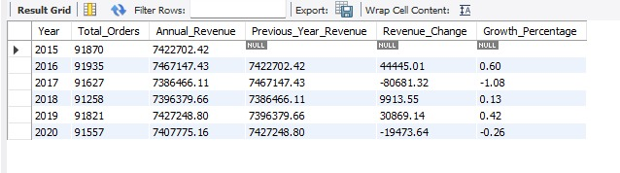

Query 16:

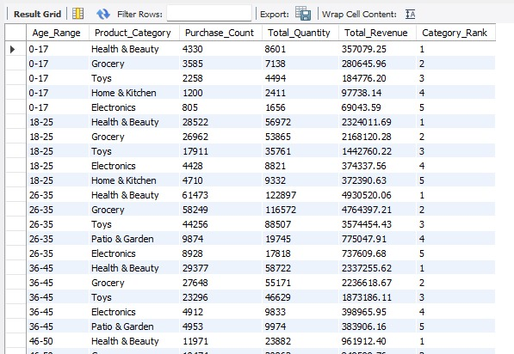

Query 17:
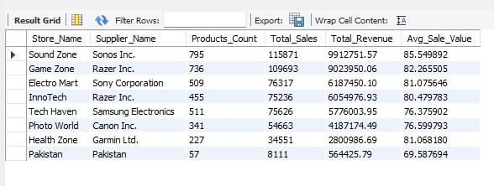

Query 18:
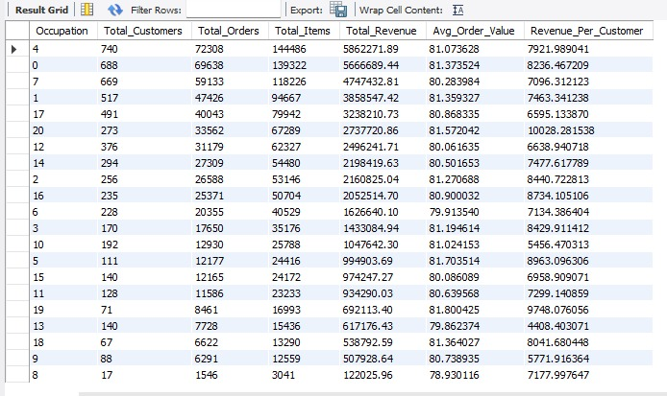

Query 19:
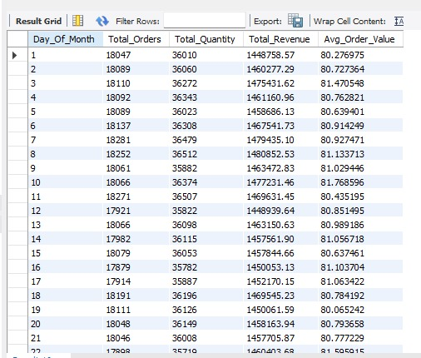

Query 20:
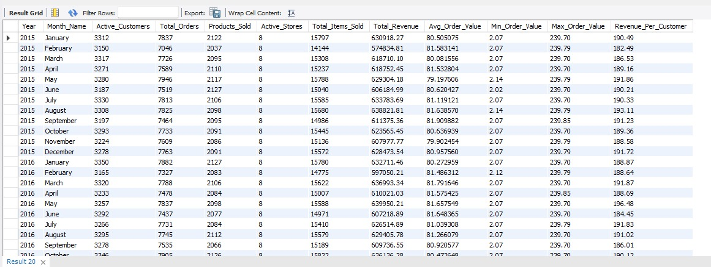

9. Performance Analysis

9.1 ETL Performance Metrics
Stage | Time (seconds) | Records | Speed (rec/sec)
Extraction | 2–3 | 556,263 | –
Transformation | 5–8 | 560,330 | –
Loading (Dimensions) | 8–12 | 10,260 | ~900
Loading (Facts) | 30–40 | 550,070 | ~15,000
Total ETL | 45–60 | 560,330 | ~9,000

9.2 Query Performance Analysis
Query Type | Avg Time (ms) | Complexity
Simple Aggregation | 50–100 | Low
Join with Window Functions | 200–500 | Medium
Nested Subqueries | 500–1000 | High
ROLLUP Operations | 800–1500 | High
Affinity Analysis | 2000–3000 | Very High

