Functional Specification Documentation

DOCUMENT | CEO/MD FLOW
PREPARED BY | CWARE TECHNOLOGIES
CLIENT | MATRACON
PROJECT | ODOO ERP IMPLEMENTATION
VERSION | 1.0.4

TABLE OF CONTENTS

Introduction: 2
Current Users: 2
Dashboards Include: 2
Procurement Related Expected Odoo Views: 3
Payment Related Expected Odoo Views: 7
Bank Guarantee Dashboard Expected Odoo Views: 14
Post Dated Cheques Dashboard Expected Odoo Views: 15

Introduction:

Current Users:
Jahan Zaib

Dashboards Include:
- Total Vendor Payables - Informational
- Total Subcontractor Payables (IPC Wise Summary) - Informational
- Project-wise Liability Overview (Vendor + Subcontractor) - Informational
- Procurement Approvals - Actionable
- Payment Approvals - Actionable
- HO Direct Payments Flow - Actionable
- Site Wise Expenses (Petty Cash) - Informational
- Material Cost Consumption - Informational
- Active Projects Financial Health Overview - Informational
- Project Work Done & Remaining Status - Informational
- Bank Guarantee - Informational
- Post-Dated Cheques - Informational

Procurement Related Expected Odoo Views:

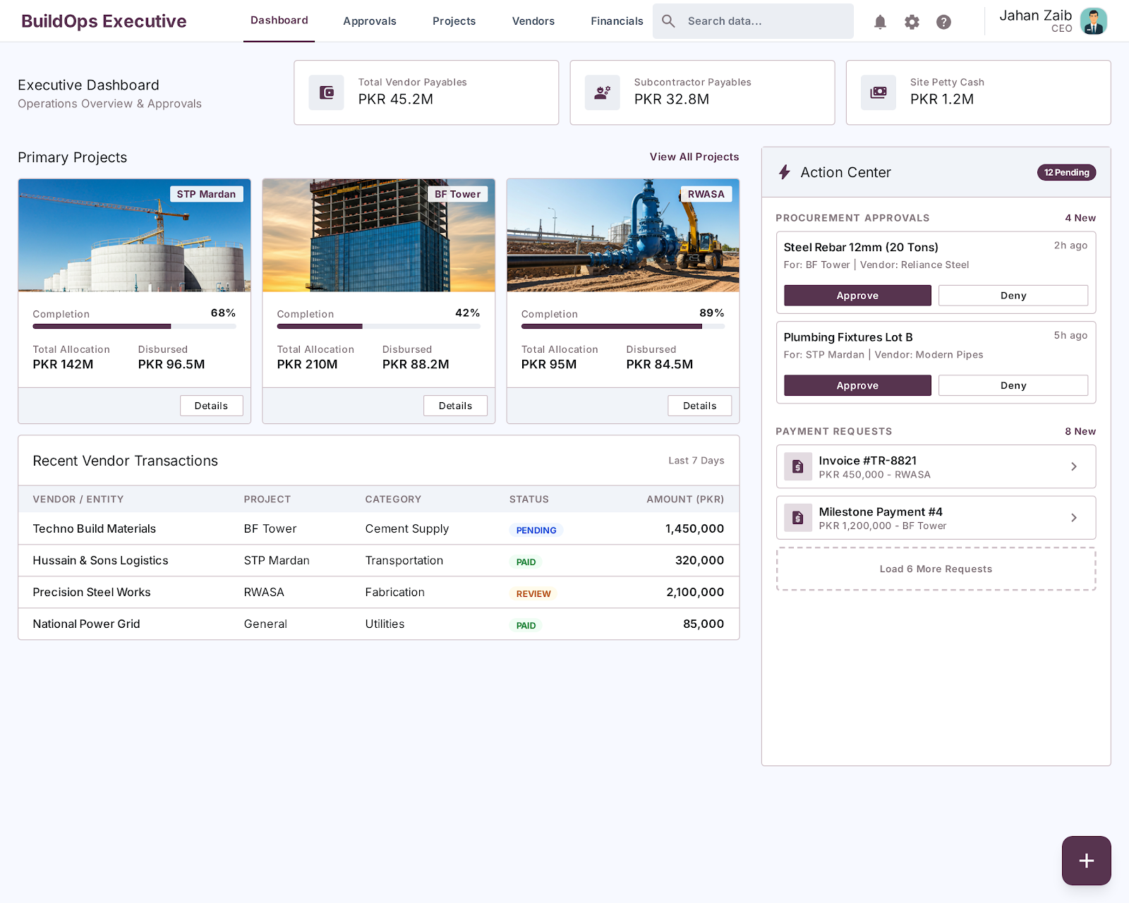
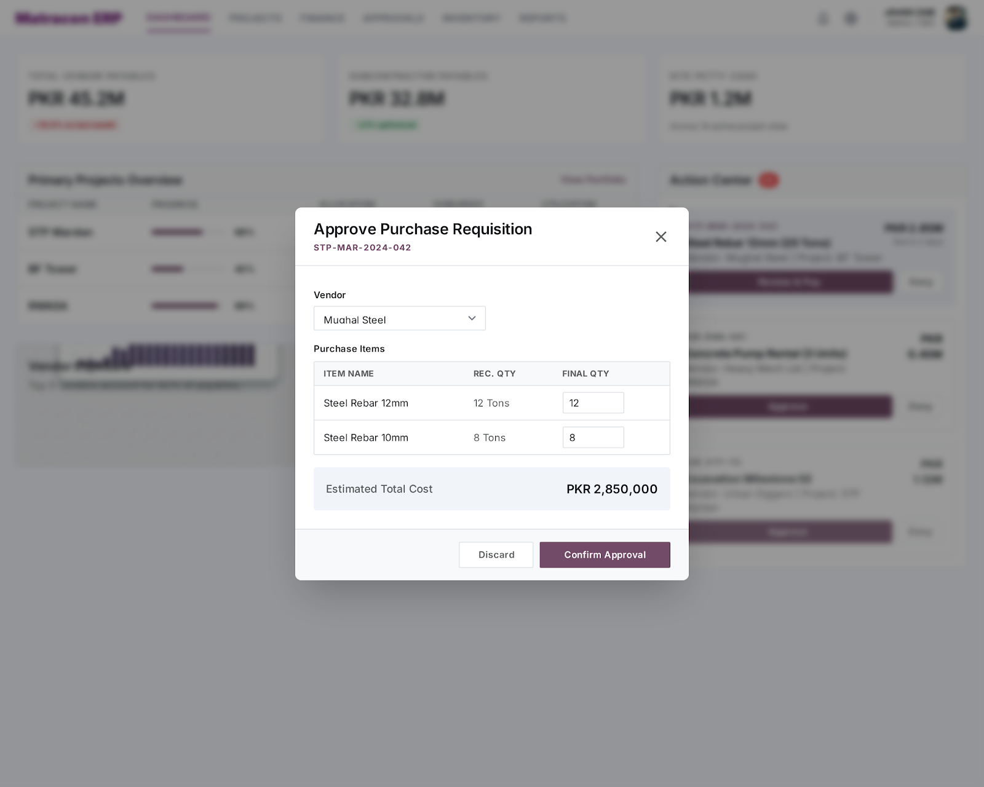
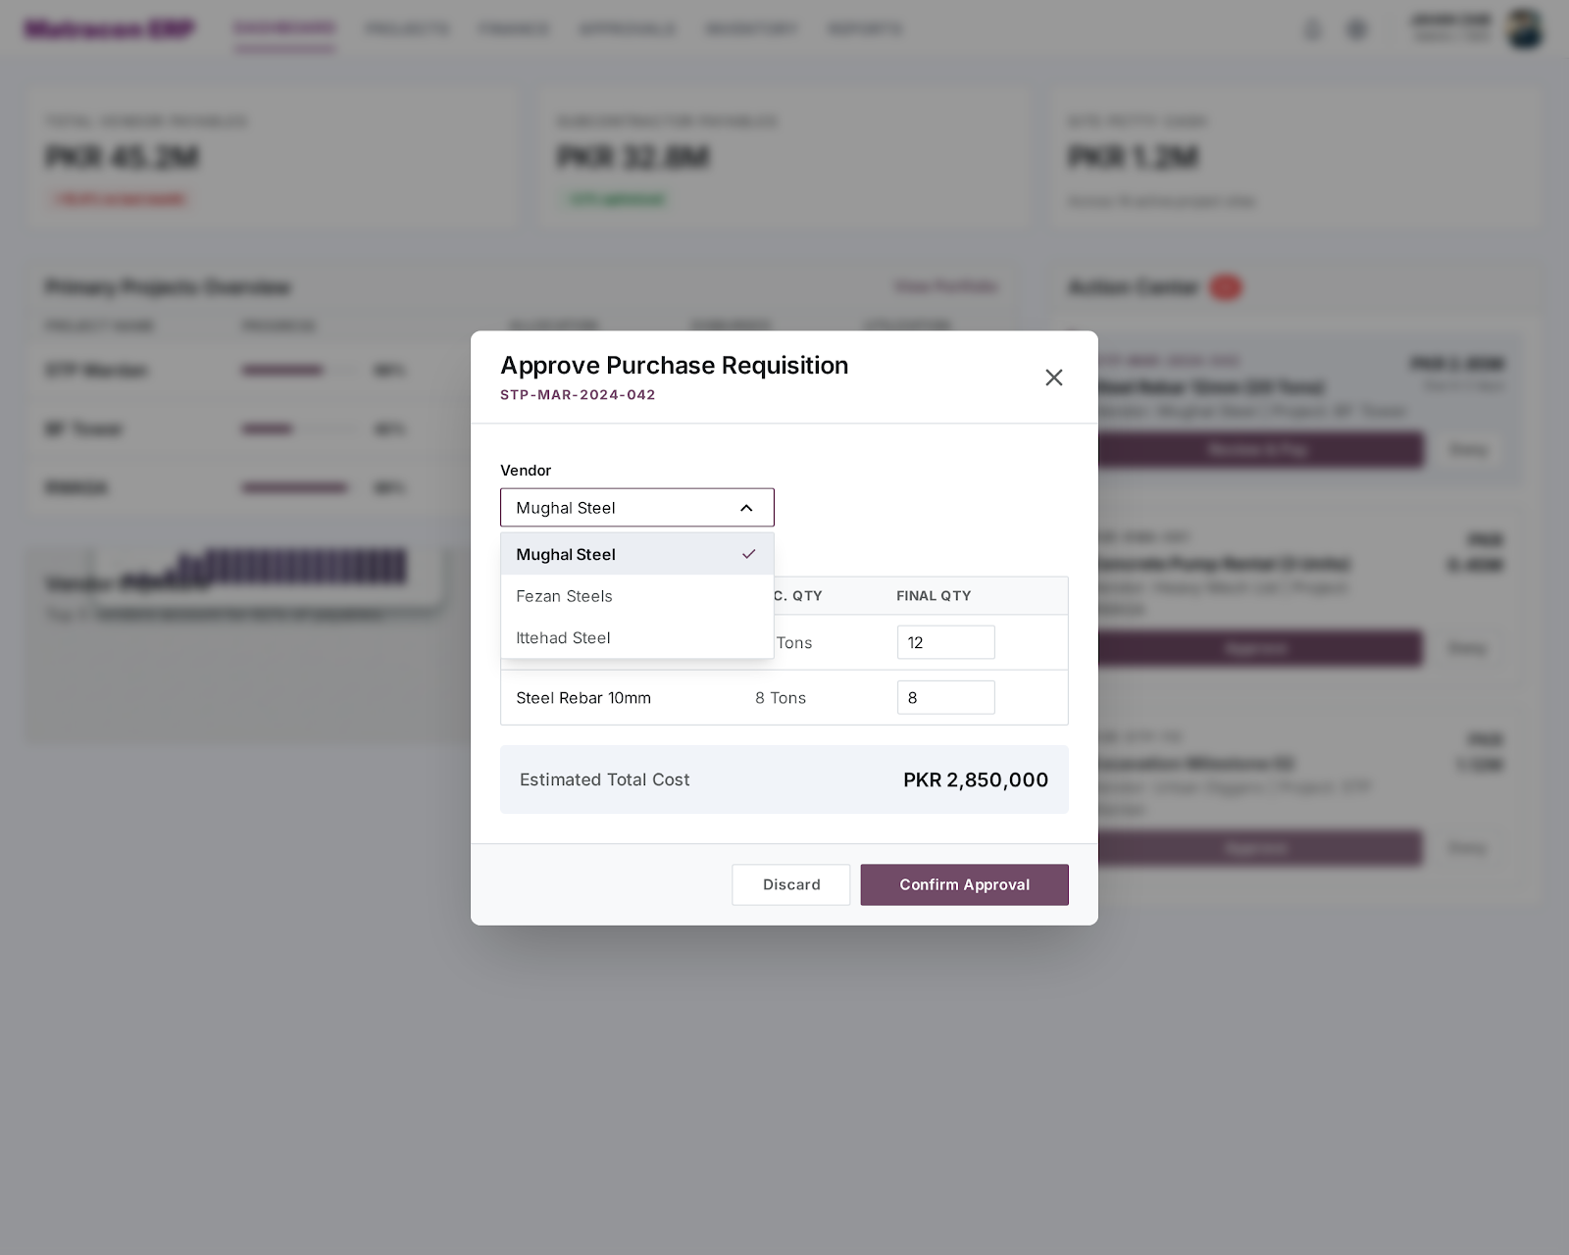
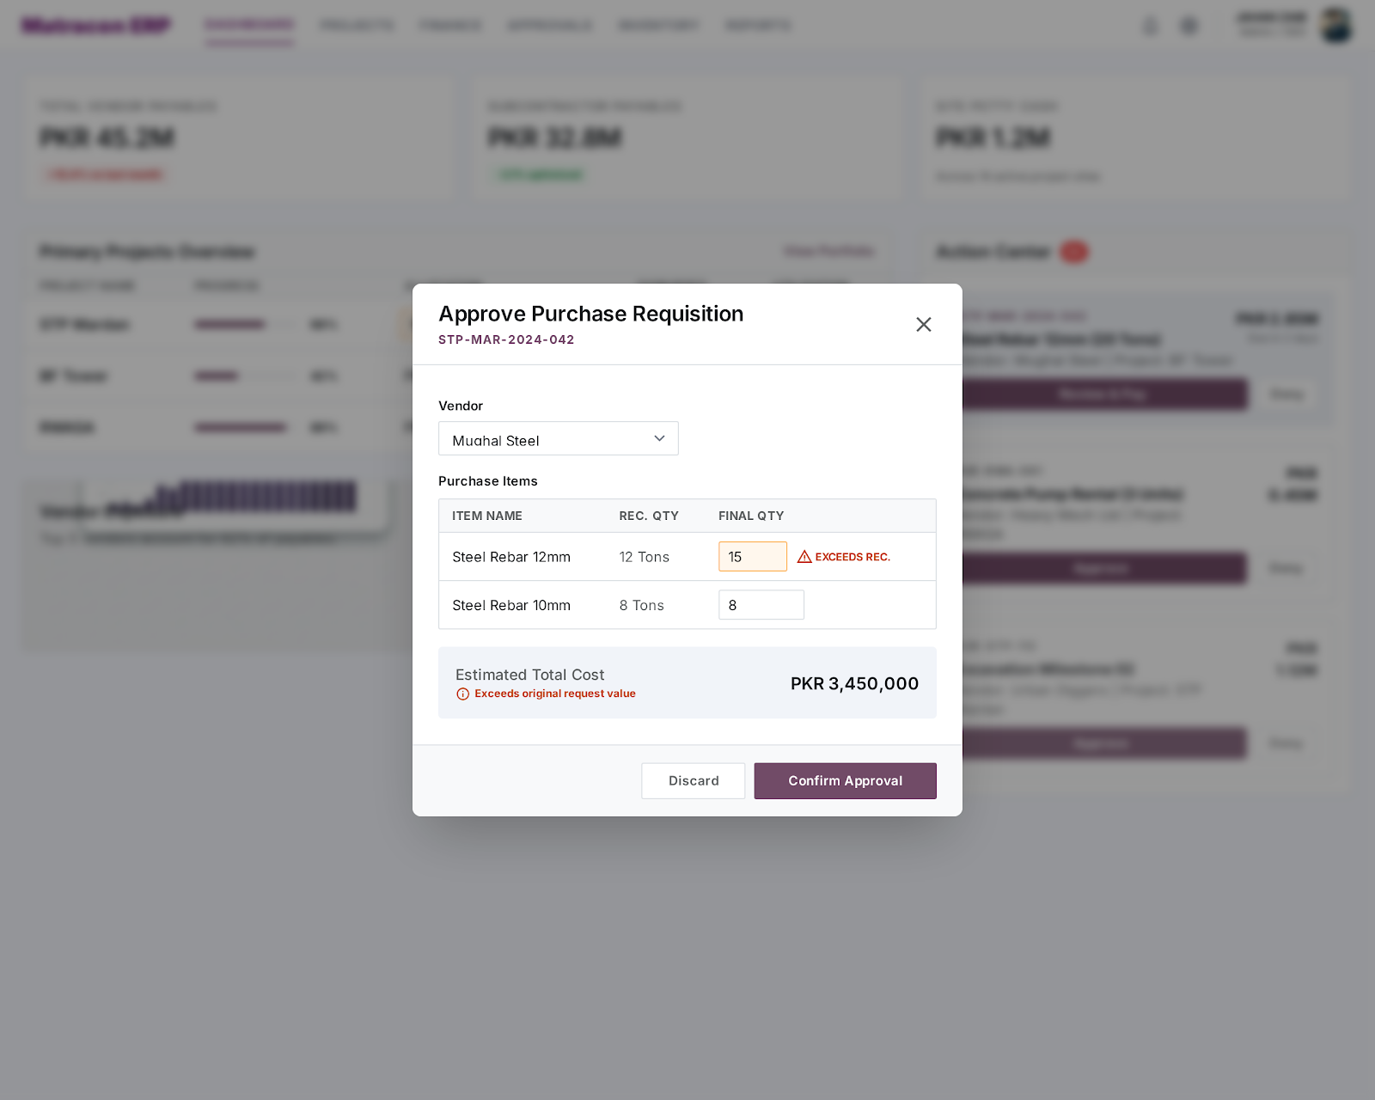

Payment Related Expected Odoo Views:
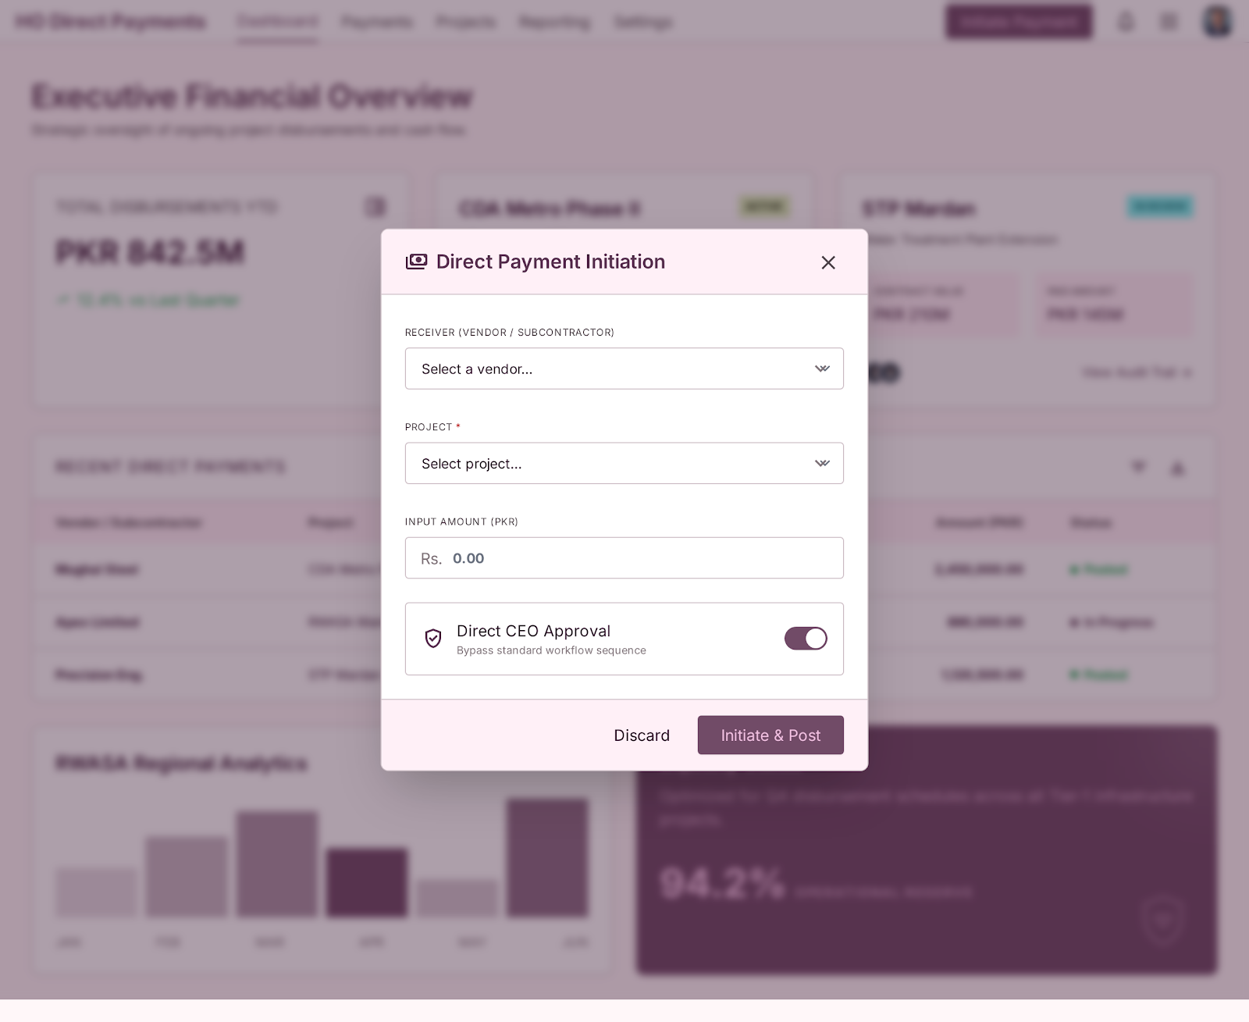
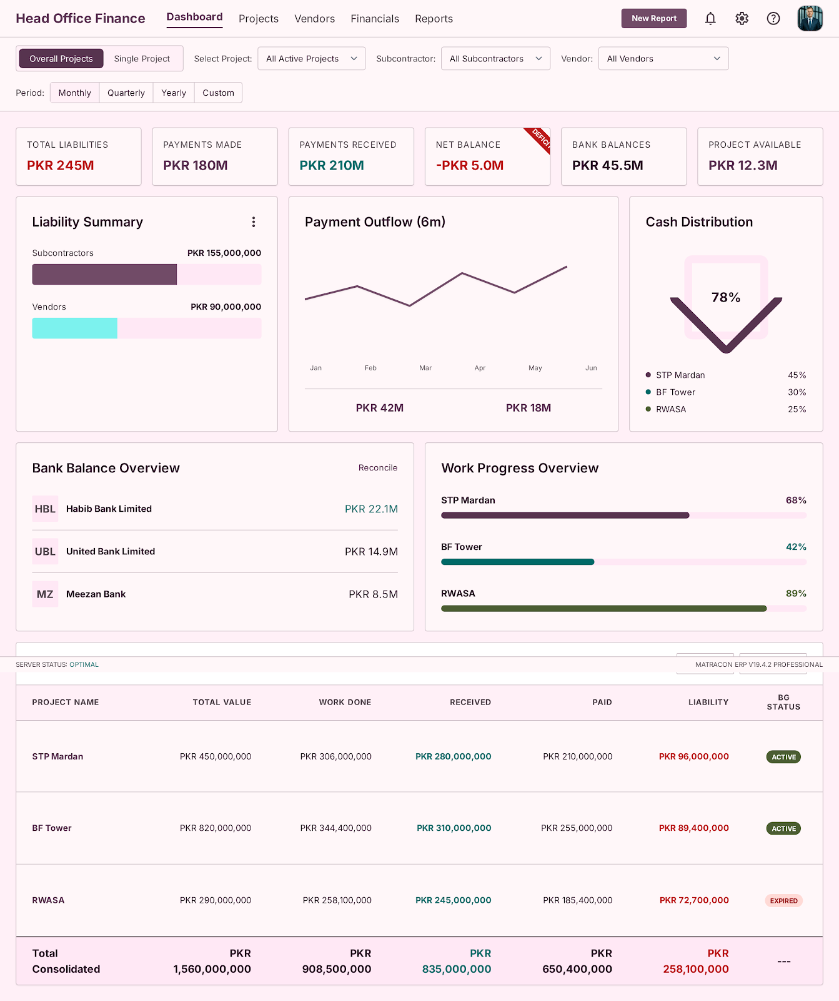
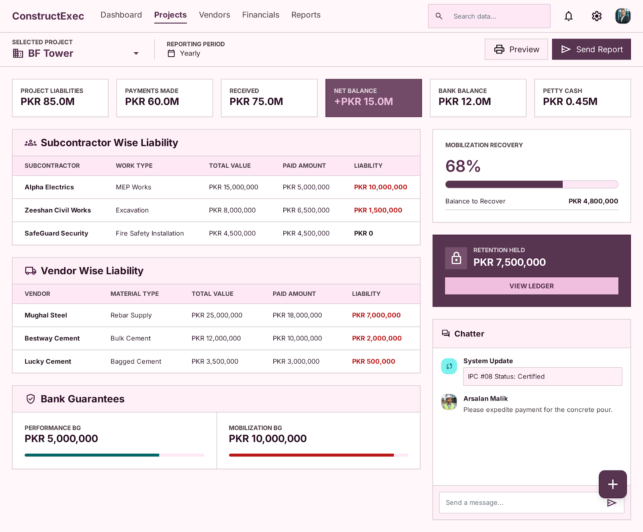
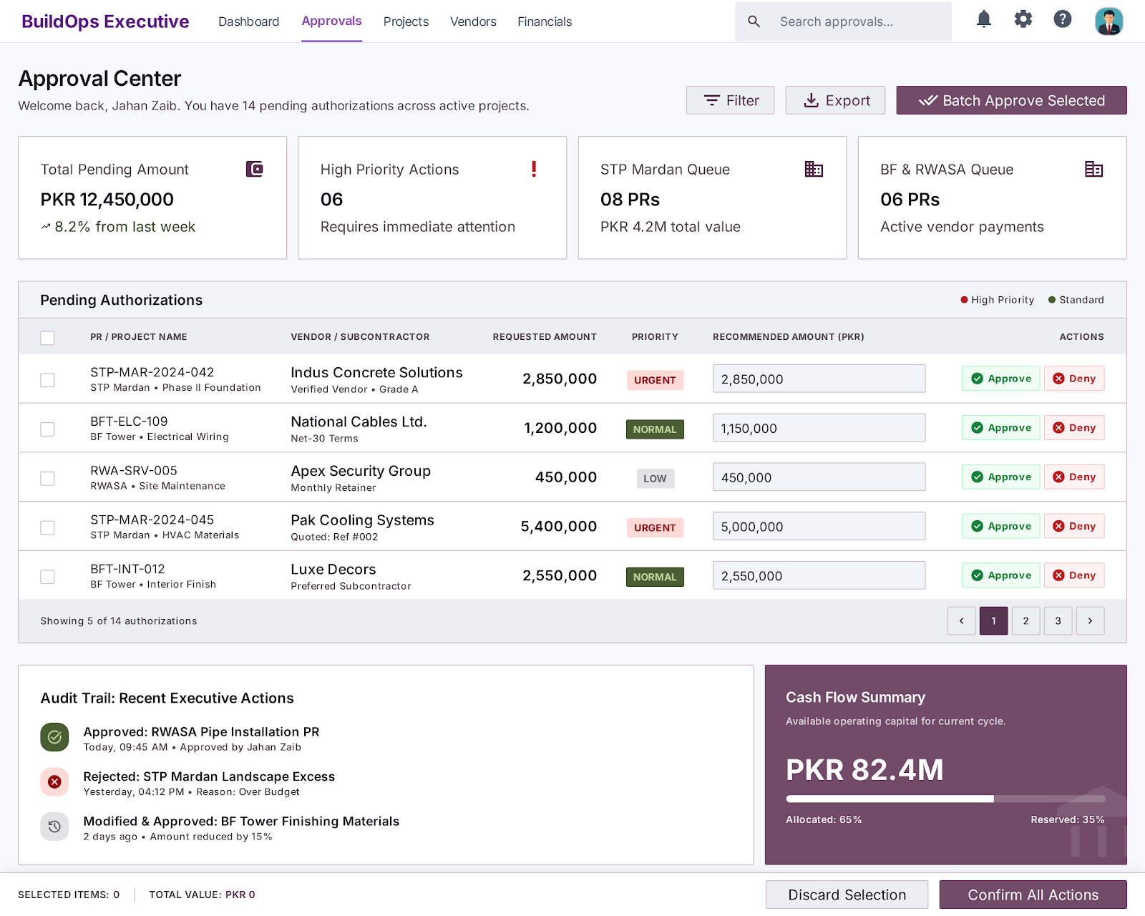
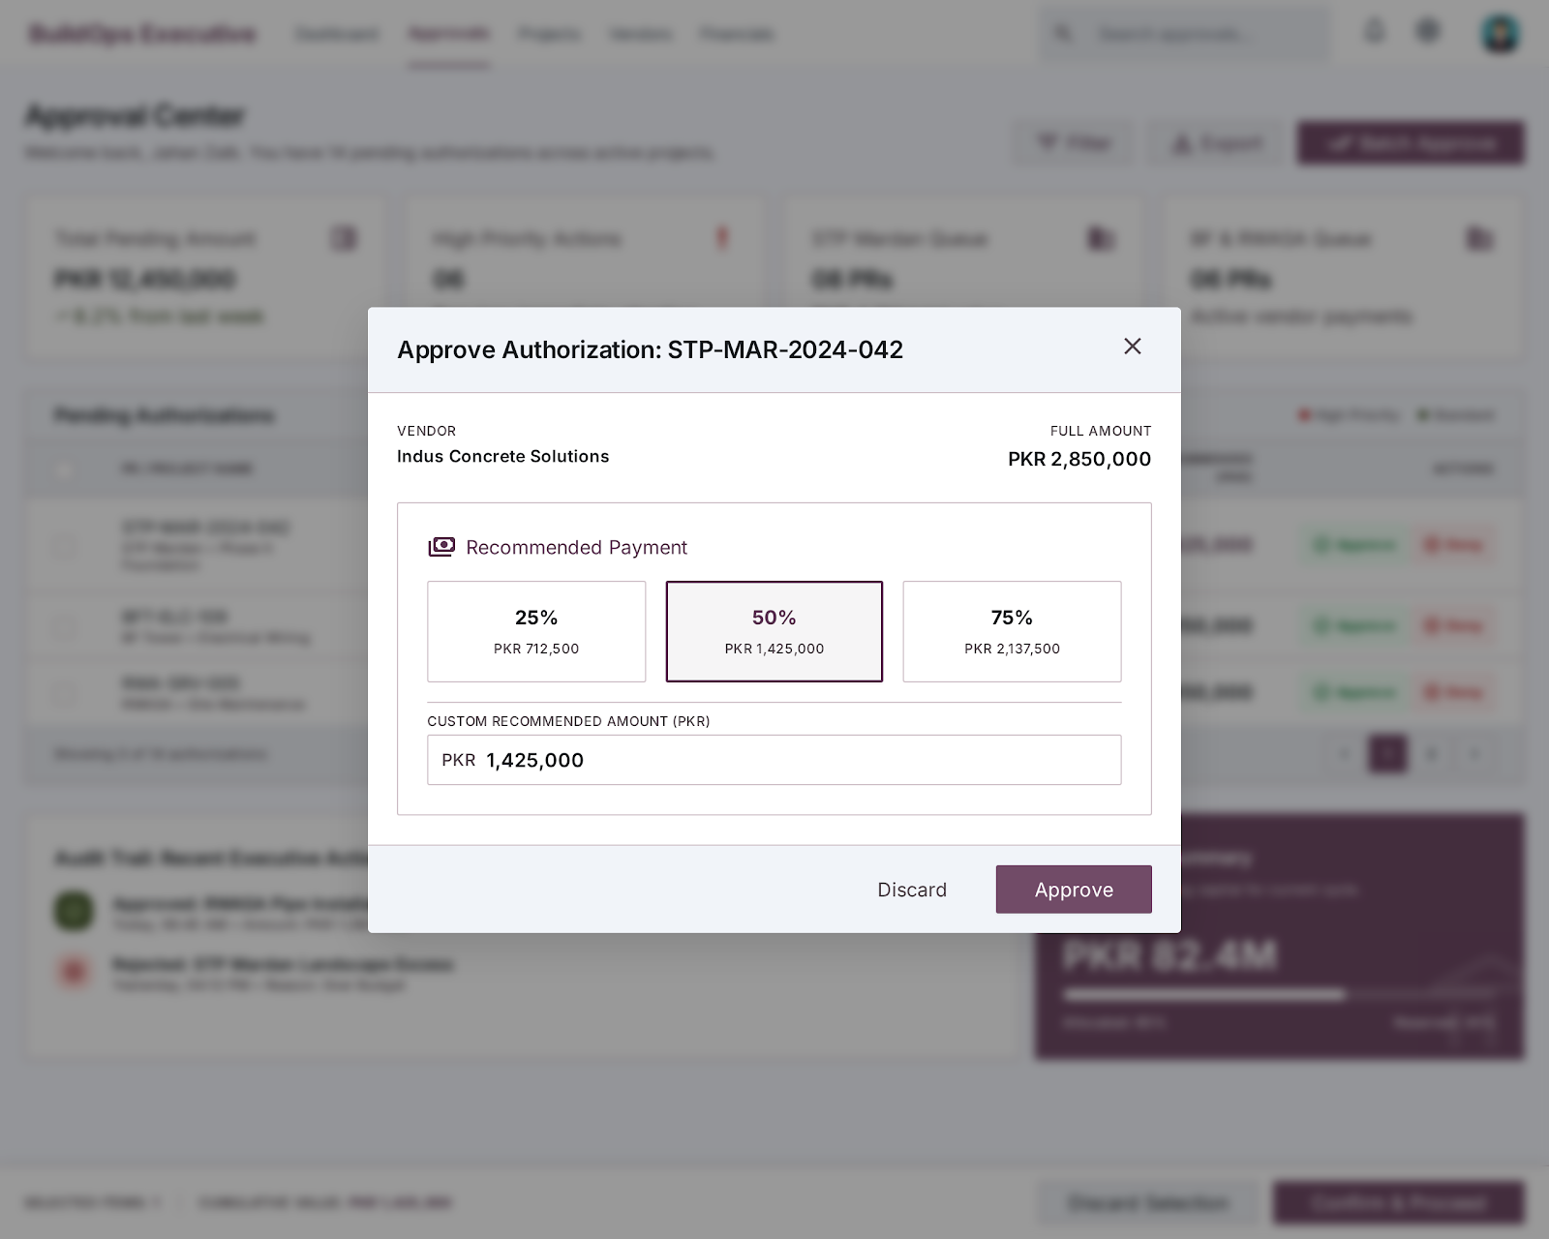
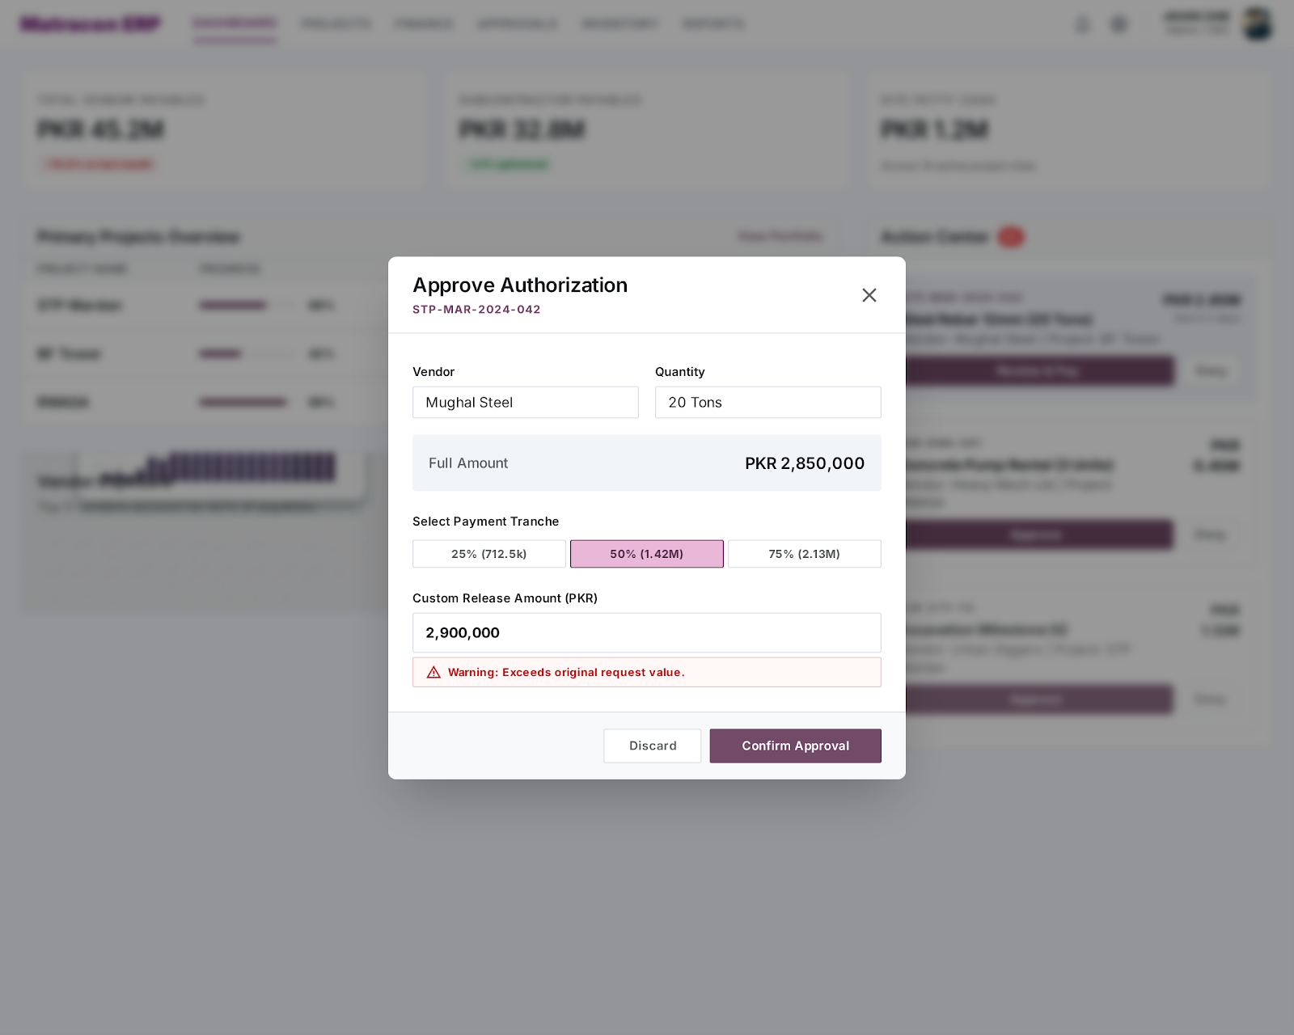
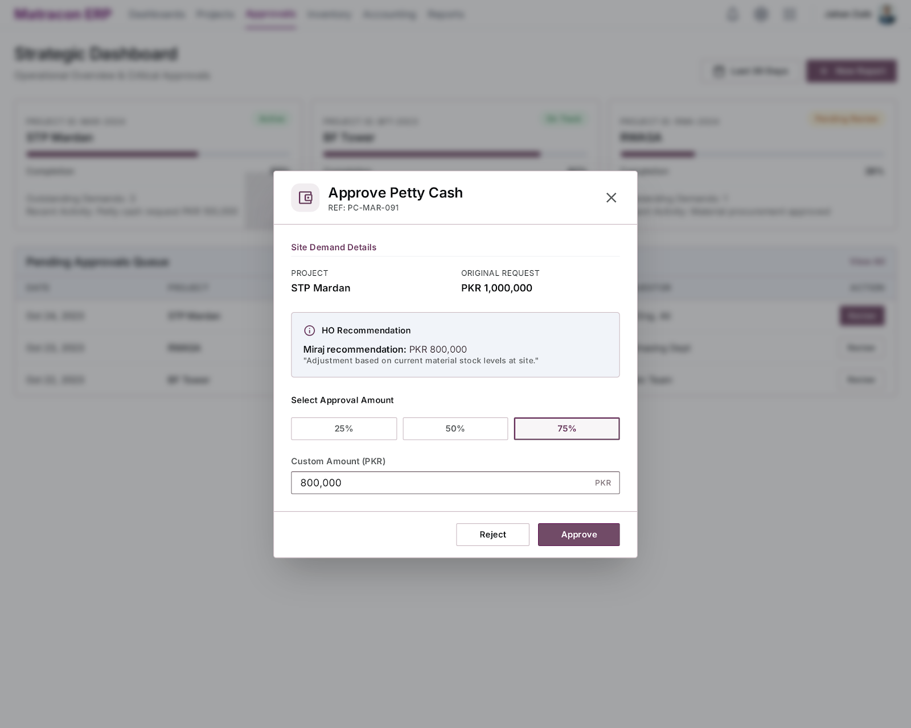

Bank Guarantee Dashboard Expected Odoo Views: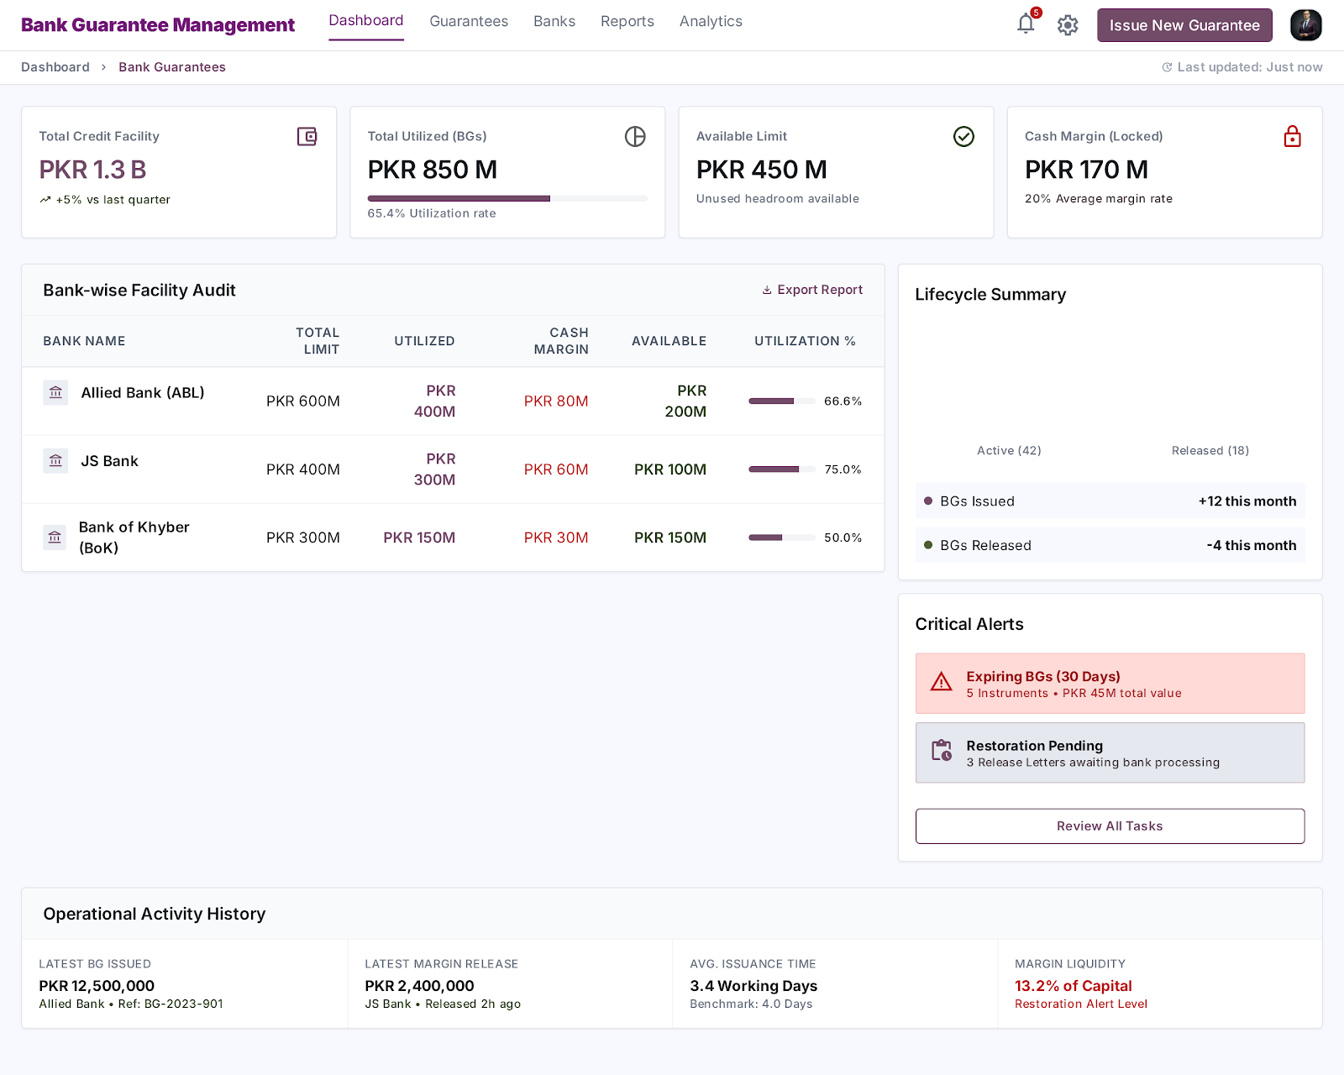

Post Dated Cheques Dashboard Expected Odoo Views:
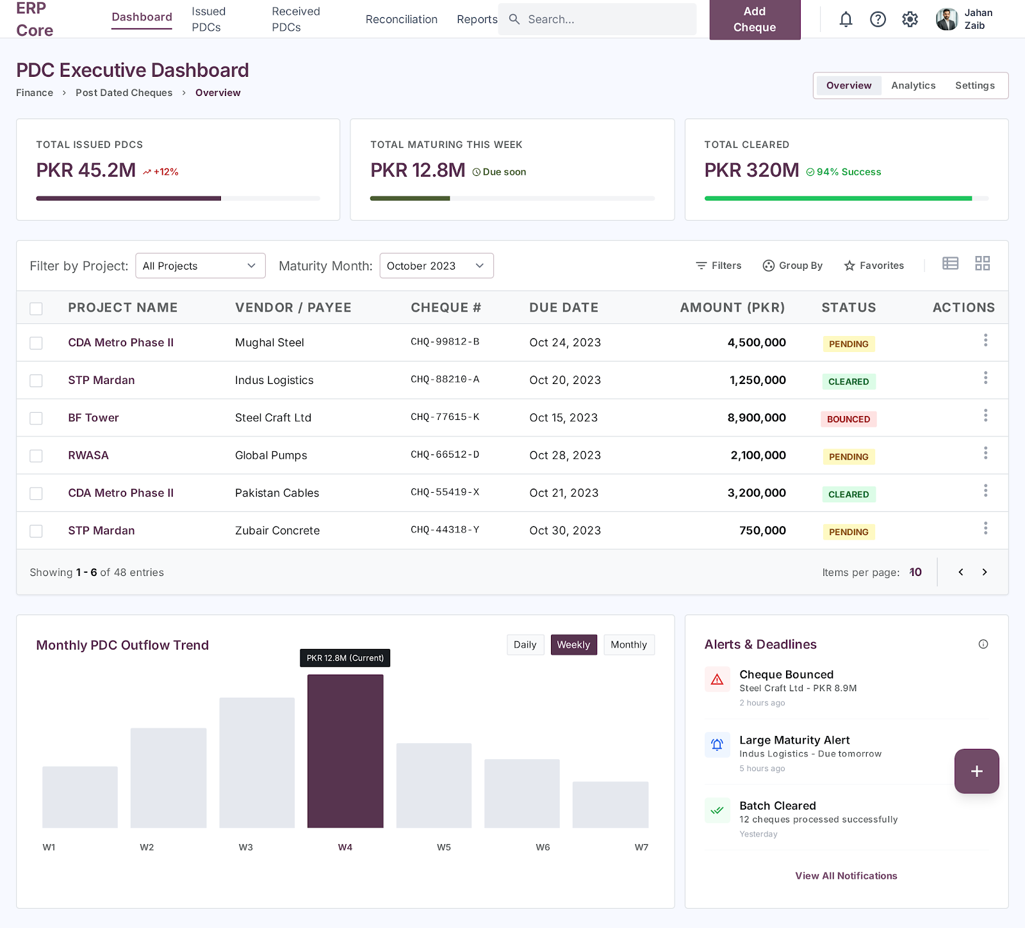

General Dashboard Expected Odoo Views:
