Functional Specification Documentation

DOCUMENT | FINANCE (HO) FLOW
PREPARED BY | CWARE TECHNOLOGIES
CLIENT | MATRACON
PROJECT | ODOO ERP IMPLEMENTATION
VERSION | 1.0.4

TABLE OF CONTENTS

Introduction: 2
Current Users: 2
Processes Include: 2
1. Payment To Vendors 3
2. Payment to Subcontractors 5
3. Petty Cash Release to sites 8
4. Petty Cash (HO) 9
5. Adjustments & Miscellaneous Entries (MD Sb) 11
6. Tax & WHT Management 13
7. Employees’ Salary Sheets & Slips 15
8. HO Direct Payments Flow 17
9. Cheque Printing 19
10. Cheque Number Management 21
11. Bank Guarantee Management 24
12. Tax Notices - Orders & Status 27
Management Dashboard: 31

Introduction:
This document outlines the end-to-end user flow for the Finance (Head Office) Flow within the MATRACON Odoo ERP implementation, developed by CWare Technologies. It serves as a functional reference for how the Head Office finance team will manage and execute all outgoing financial transactions through the system. The processes covered include the processing of vendor payments and subcontractor payments — both received as CEO/MD-approved and locked liability amounts — as well as the release of petty cash funds to active project sites. Each process has been documented with its step-by-step logic, system actions, approval requirements, and business rules to ensure accurate, compliant, and fully auditable financial operations in line with MATRACON's internal controls and applicable tax obligations.

Current Users:
- Miraj – Head of Finance Department
- Shahid - CFO
- Bilal - Tax Orders & Reporting
- Muzammil – Assistant

Processes Include:
- Payments to Vendors
- Payment to subcontractors
- Petty Cash Release to Sites
- Petty Cash (HO)
- Adjustments & Miscellaneous Entries (MD Sb)
- Tax & HT Management
- Employee’s Salary Sheets & Slips
- HO Direct Payments Flow
- Cheque Printing
- Cheque Number Management
- Bank Guarantees Management
- Tax Notices — Orders & Status

Payment To Vendors

Step Name | Description | Inputs | System Actions / Logic | Outputs | Approval? | Remarks / Business Rules
Receive Vendor Liability | Receive approved vendor liability from system | Locked Vendor Liability Sheet | Fetch recommended amount for payment | Vendor payment request | No | Amount already locked from CEO/MD recommendation
Payment Verification | Verify vendor payable details | Vendor Liability Sheet, Invoice Reference | Check payable amount and vendor details | Verified payment record | No | No amount changes allowed
WHT Deduction | Apply withholding tax deduction | Vendor Amount, Tax Rules | Auto-calculate WHT and deduction | WHT record | No | Mandatory tax compliance
Vendor Payment Processing | Process vendor payment | Verified Amount, Vendor Details | Release payment through bank/cheque | Payment confirmation | Finance Manager | Strictly based on locked amount
Tax Certificate Recording | Record WHT certificate details | WHT Data | Update vendor tax ledger | Tax certificate record | No | Required for compliance
Final Ledger Posting | Complete accounting entries | Payment + WHT Data | Update Bank/Cash + Vendor Ledger | Updated financial ledger | No | Final closure of payment cycle
Expected Odoo View:

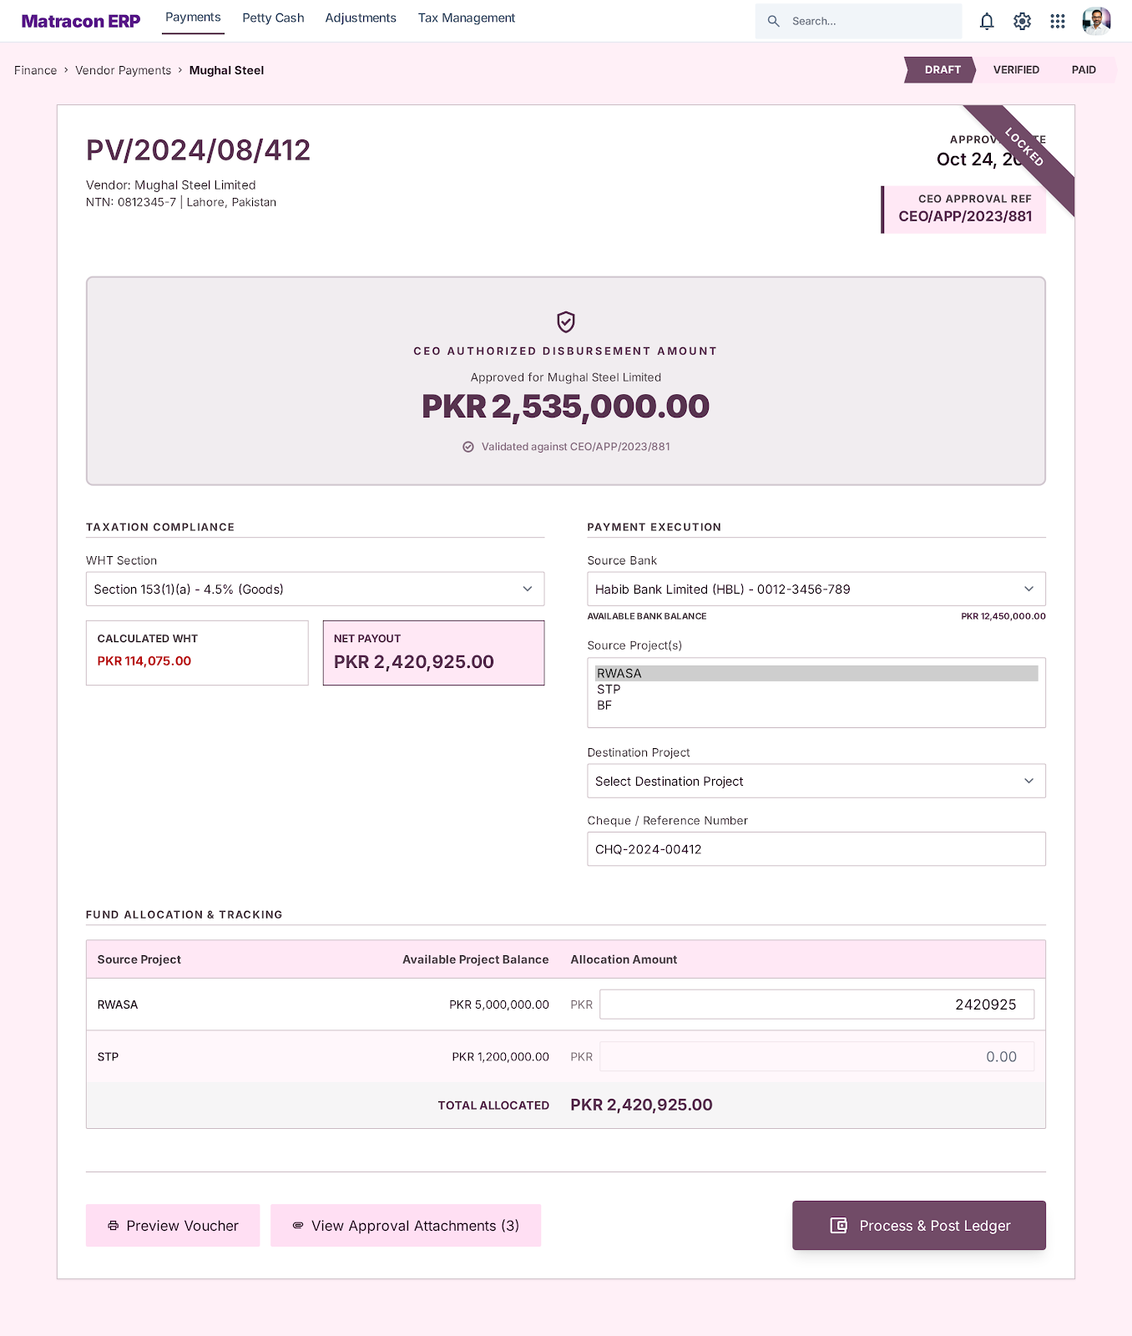

Payment to Subcontractors

Step Name | Description | Inputs | System Actions / Logic | Outputs | Approval? | Remarks / Business Rules
Receive Subcontractor Liability | Receive approved subcontractor liability from system | Locked Subcontractor Liability Sheet | Fetch recommended amount for payment | Subcontractor payment request | No | Amount already locked from CEO/MD recommendation
Payment Verification | Verify subcontractor payable details | Liability Sheet, IPC Reference | Check payable amount and subcontractor details | Verified payment record | No | Includes IPC, retention, previous payments
WHT Deduction | Apply withholding tax deduction | Payable Amount, Tax Rules | Auto-calculate WHT and deduction | WHT record | No | Mandatory tax compliance
Subcontractor Payment Processing | Process subcontractor payment | Verified Amount, Subcontractor Details | Release payment through bank/cheque | Payment confirmation | Finance Manager | Strictly based on locked amount
Tax Certificate Recording | Record WHT certificate details | WHT Data | Update subcontractor tax ledger | Tax certificate record | No | Required for compliance
Final Ledger Posting | Complete accounting entries | Payment + WHT Data | Update Bank/Cash + Subcontractor Ledger | Updated financial ledger | No | Final closure of payment cycle

Expected Odoo View:
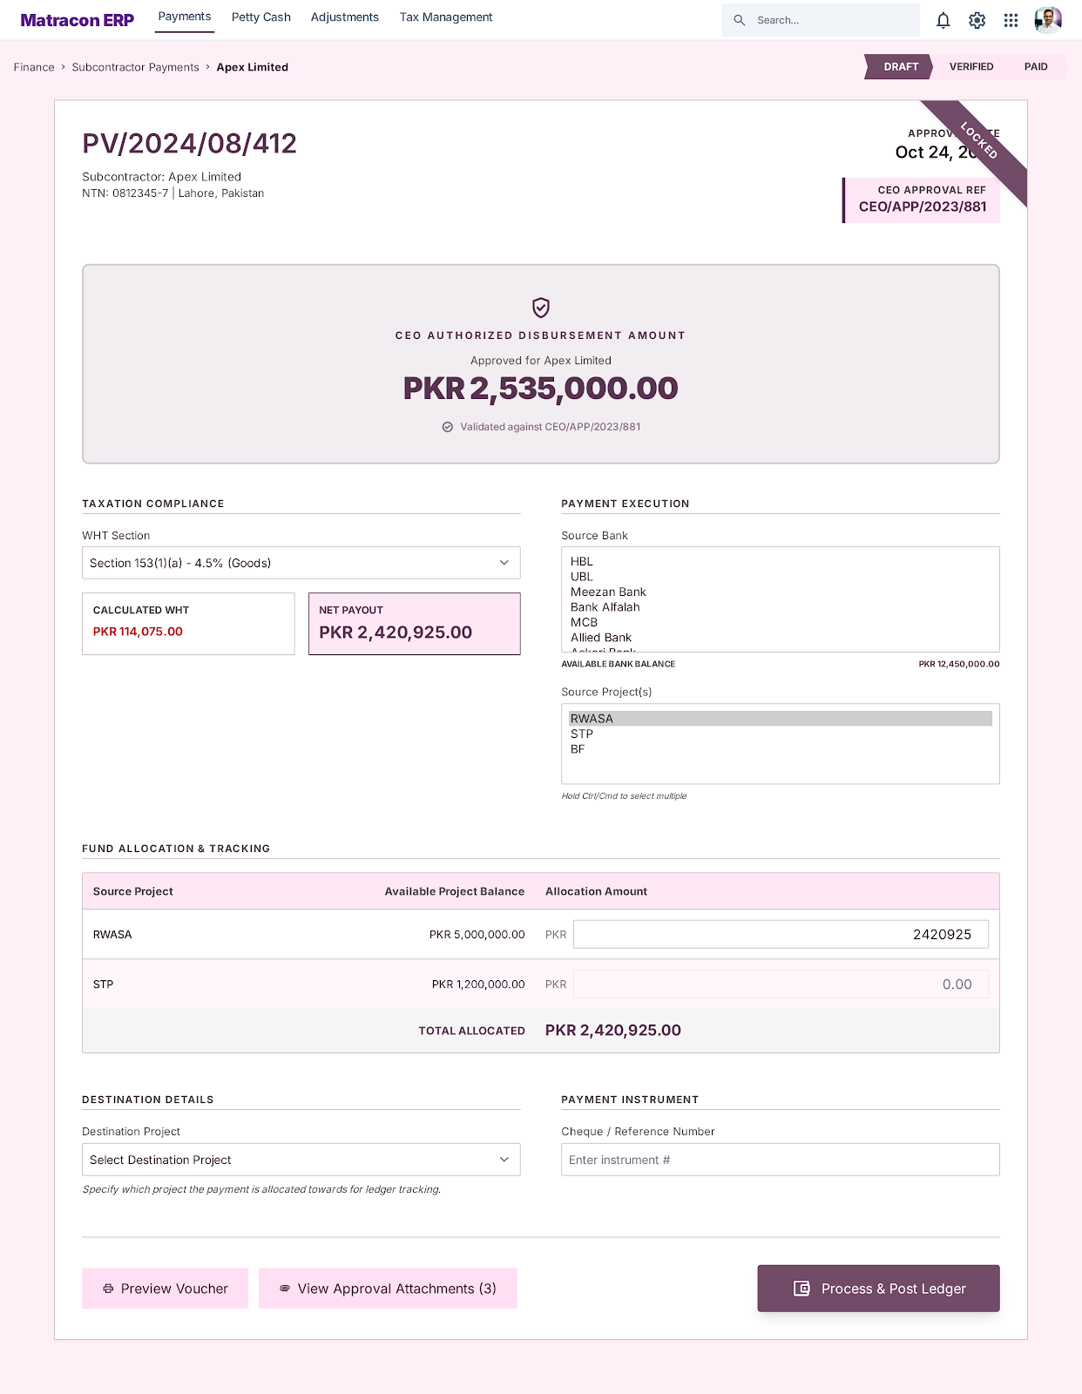
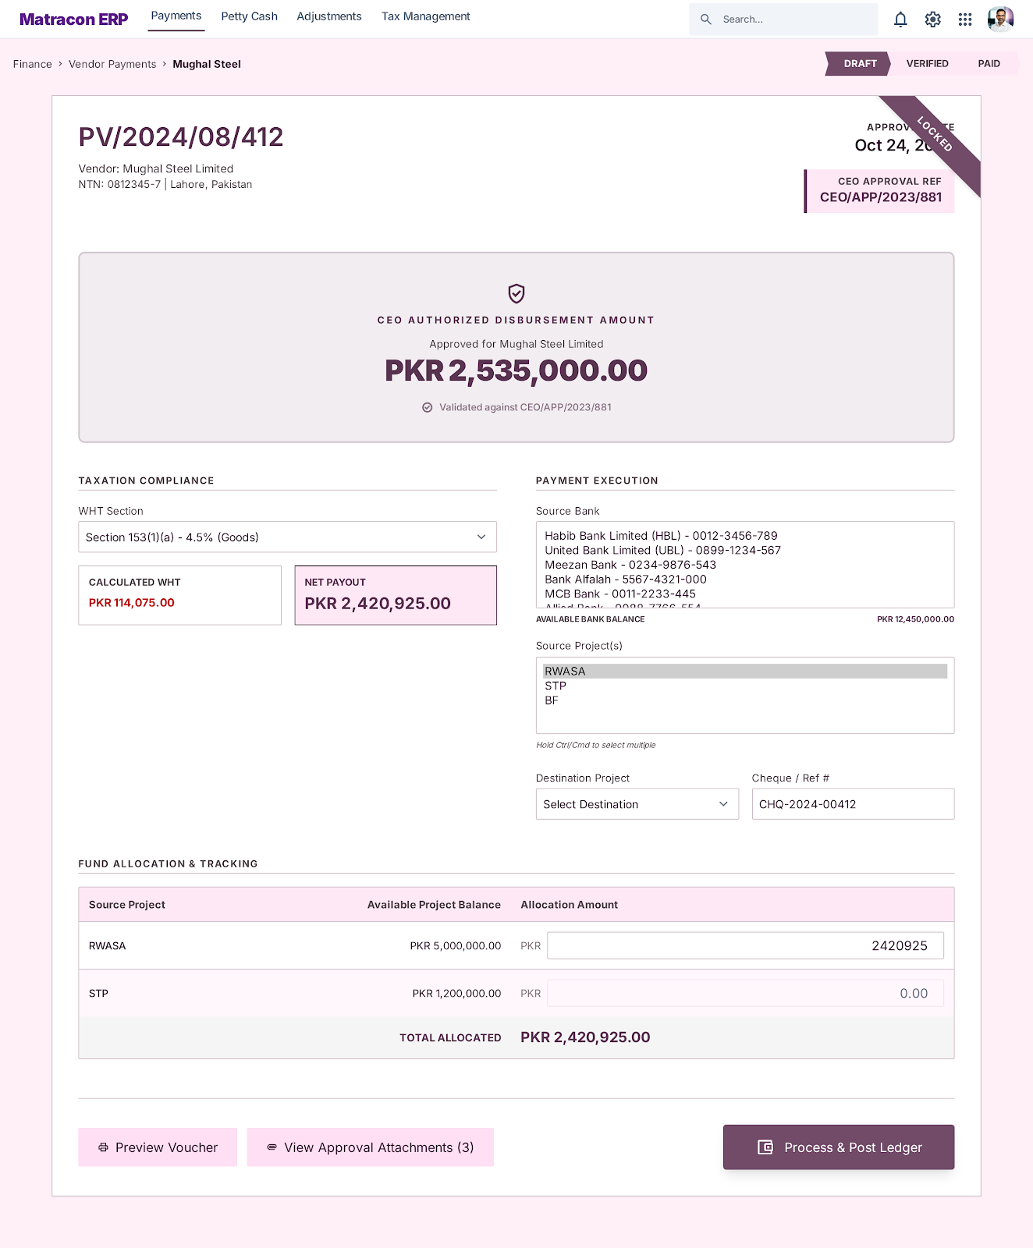

Petty Cash Release to sites

Step Name | Description | Inputs | System Actions / Logic | Outputs | Approval? | Remarks / Business Rules
Receive Petty Cash Request | Receive petty cash demand from site | Current Balance, Required Amount, Reason | Record petty cash request in system | Petty cash request | No | Request initiated by site accountant
Request Verification | Verify site cash requirement | Petty Cash Request, Previous Balance | Review requirement and available balance | Verified request | No | Based on site operational need
Petty Cash Release | Release approved petty cash amount | Verified Request | Process cheque/bank transfer to site | Petty cash released | Finance Manager | Usually released through cheque
Fund Transfer Recording | Record transfer details | Released Amount, Transfer Reference | Update petty cash transaction record | Transfer record | No | Required for audit trail
Balance Update | Update site petty cash opening balance | Released Amount | Reflect updated balance in system | Updated petty cash balance | No | Site updates after actual receipt
Expected Odoo View:
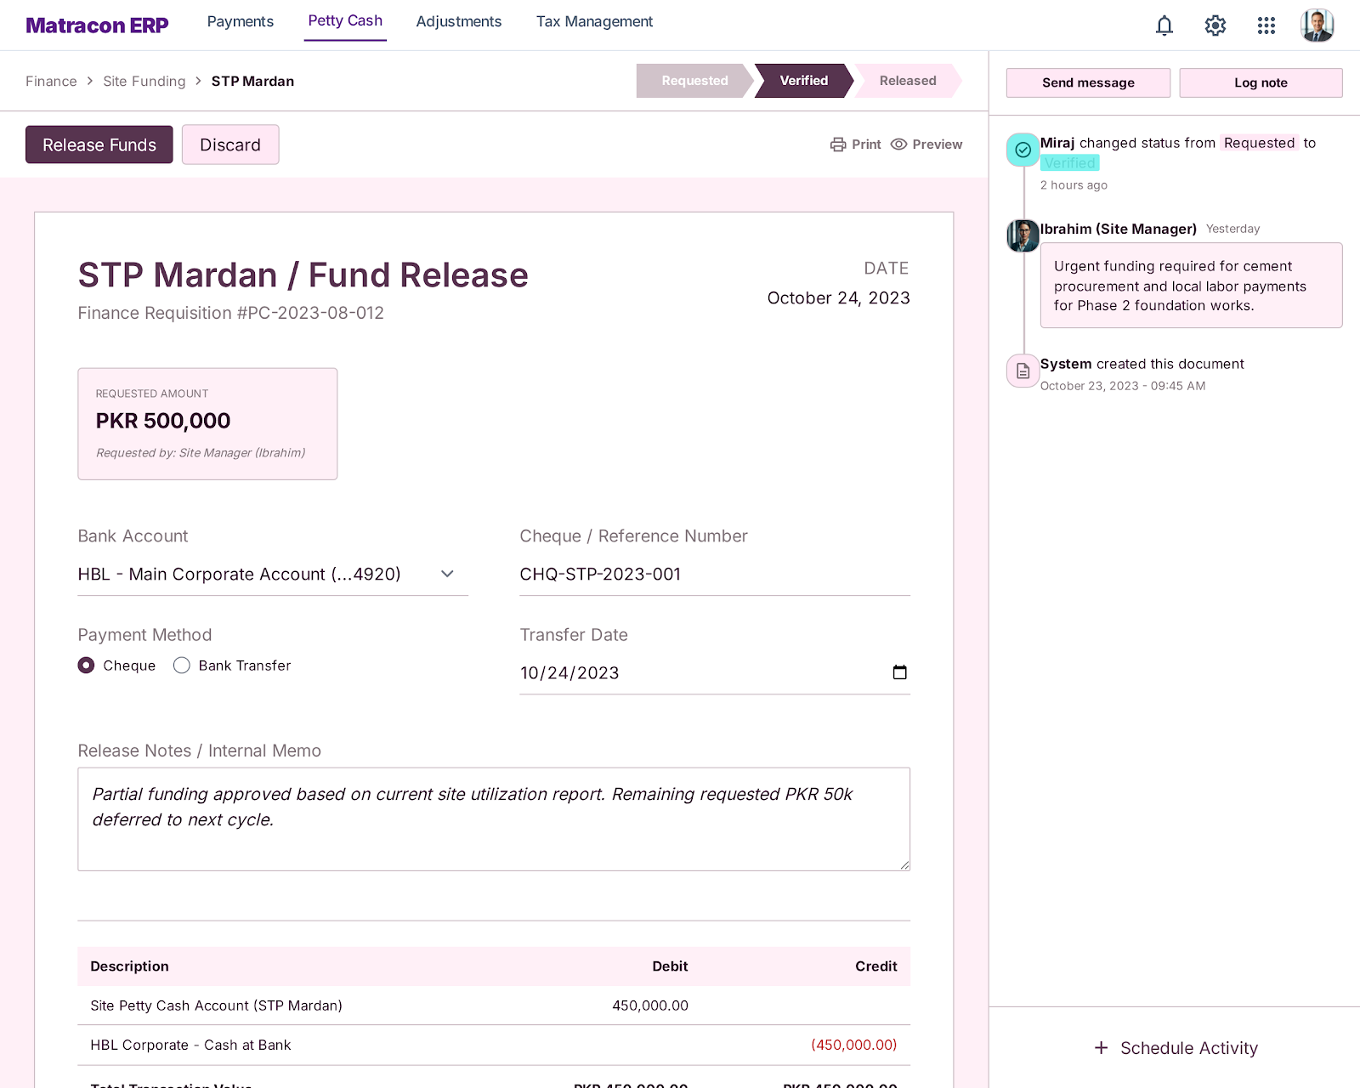

Petty Cash (HO)

Step Name | Description | Inputs | System Actions / Logic | Outputs | Approval? | Remarks / Business Rules
HO Petty Cash Setup | Maintain head office petty cash | Opening Balance | Create HO petty cash account | HO petty cash record | No | Separate from site petty cash
Expense Recording | Record daily petty expenses | Expense Details, Amount | Log expense entries in system | Expense record | No | Small day-to-day expenses
Adjustment Entry | Apply corrections if required | Adjustment Reason, Amount | Pass journal adjustment entry | Adjusted balance | Finance Manager | Used for misc corrections
Balance Tracking | Track running balance | All Transactions | Auto-calculate available balance | Current balance | No | Real-time visibility

Expected Odoo View:
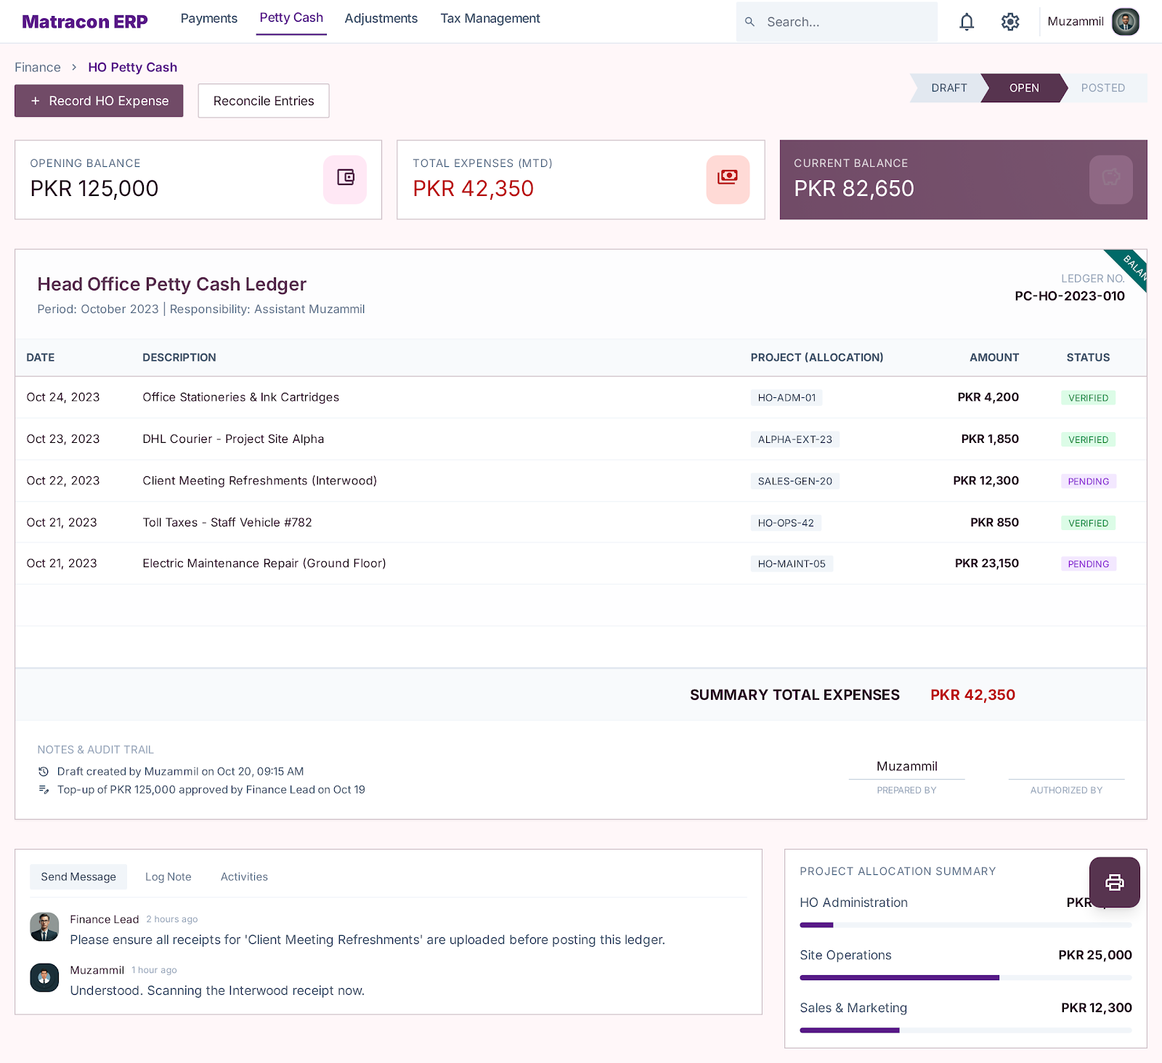

Adjustments & Miscellaneous Entries (MD Sb)

Step Name | Description | Inputs | System Actions / Logic | Outputs | Approval? | Remarks / Business Rules
Adjustment Entry Creation | Record misc or correction entry | Amount, Reason, Reference | Create journal entry | Adjustment record | No | Used for misc & corrections
Loan Entry (Given/Received) | Record loan transactions | Amount, Party, Type | Post journal entry | Loan record | Finance Manager | MD Sb account handling
Adjustment Verification | Review adjustment details | Adjustment Entry | Validate entry correctness | Verified adjustment | No | Ensure accuracy
Journal Posting | Post final entry | Verified Entry | Update ledgers | Updated ledger | No | Impacts financials
Audit Trail Logging | Maintain record of changes | Entry Details | Store change history | Audit log | No | Mandatory tracking

Expected Odoo View:
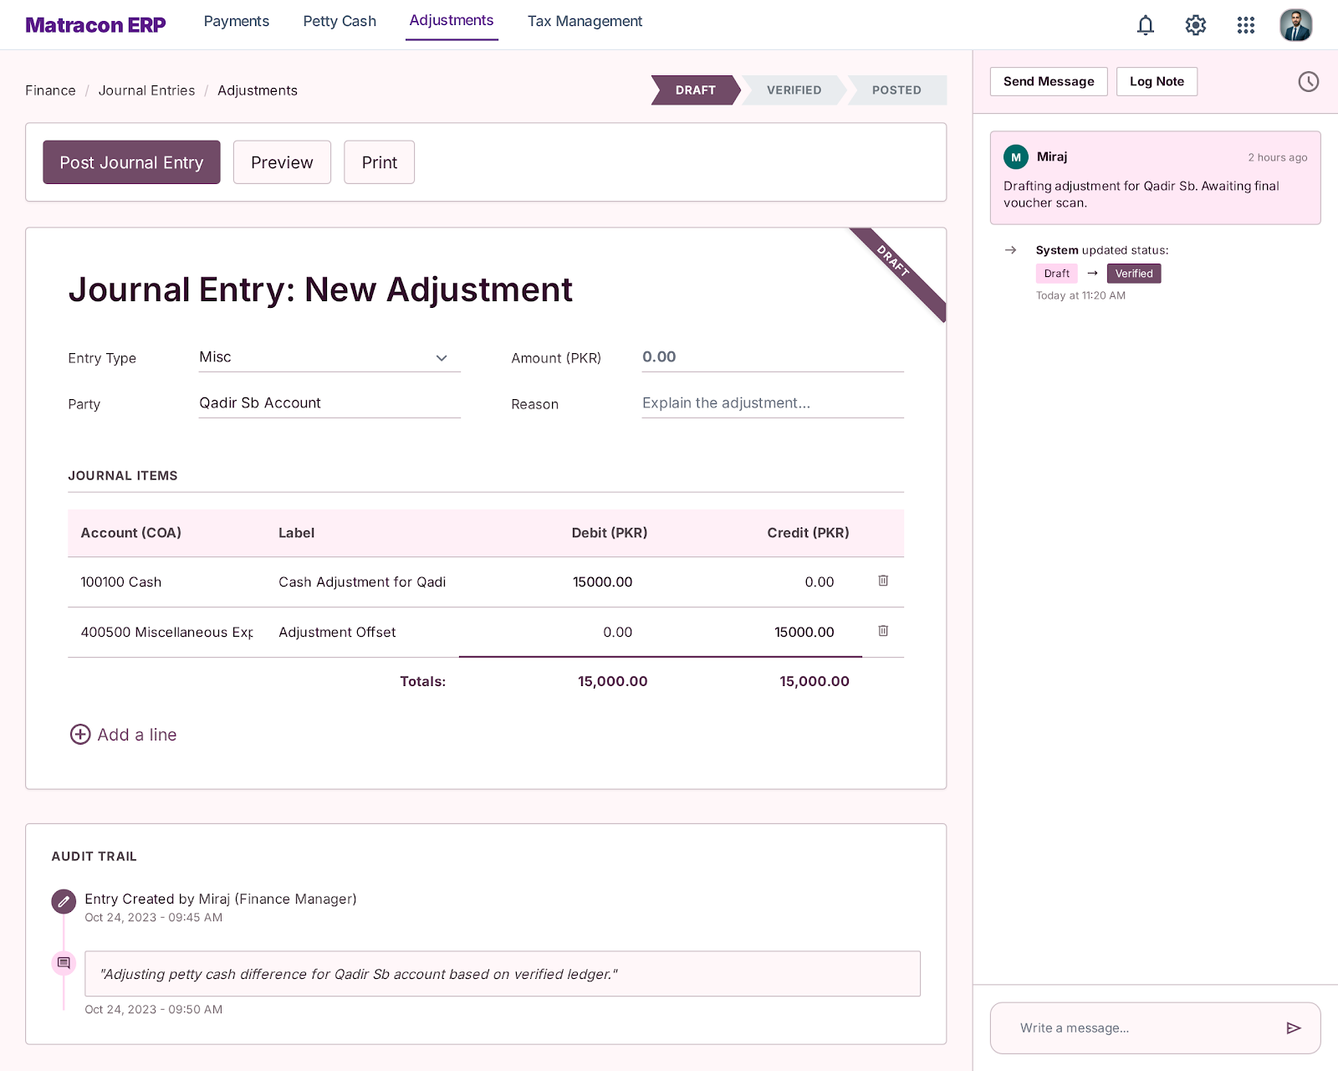

Tax & WHT Management

Step Name | Description | Inputs | System Actions / Logic | Outputs | Approval? | Remarks / Business Rules
Tax Rule Setup | Define tax rules and sections | Tax Rates, Sections | Configure WHT rules | Tax configuration | No | One-time setup
WHT Calculation | Calculate tax on payments | Payable Amount, Section | Auto-calculate WHT | WHT amount | No | Mandatory on all payments
Section Selection | Select applicable tax section | Vendor/Subcontractor Type | Apply correct section | Section applied | No | Dropdown selection required
Tax Deduction Recording | Record deducted tax | WHT Amount | Update tax ledger | WHT record | No | Linked to payment
Tax Certificate Generation | Generate tax certificate | WHT Data | Create certificate | Tax certificate | No | Compliance requirement
Tax Ledger Update | Update tax records | Payment + WHT | Post to tax accounts | Updated tax ledger | No | Final accounting impact

Expected Odoo View:
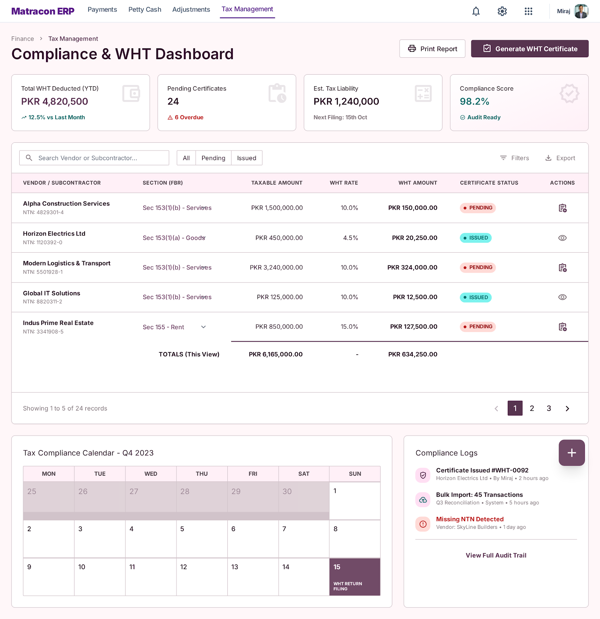

Employees’ Salary Sheets & Slips

Expected Odoo View:
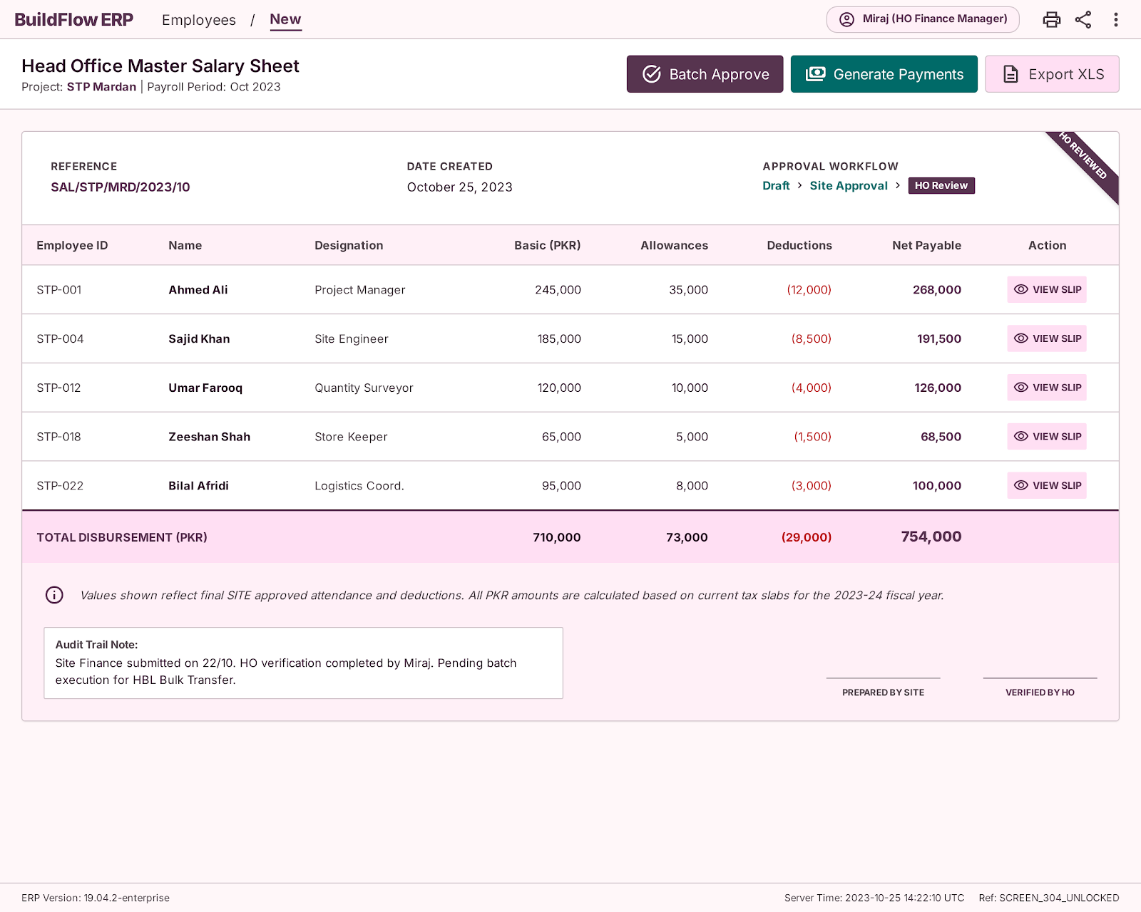
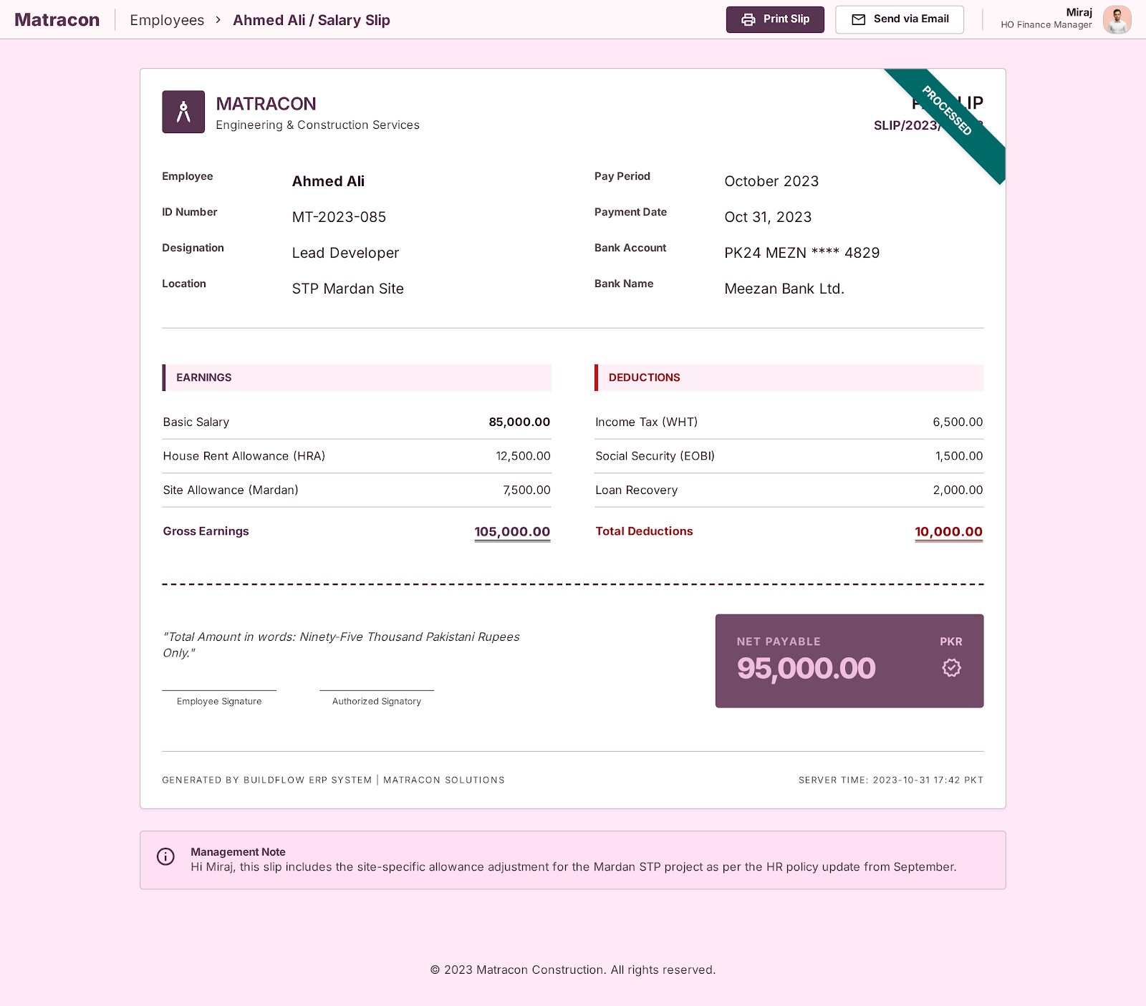

HO Direct Payments Flow

Step Name | Description | Inputs | System Actions / Logic | Outputs | Approval? | Remarks / Business Rules
Payment Initiation by CEO | CEO initiates direct payment | Receiver (Vendor/Subcontractor), Project, Amount | Create direct payment request | Direct payment request | CEO | Project selection mandatory
Payment Verification | Verify payment details | Receiver Details, Amount, Project | Miraj verifies payment information | Verified payment request | No | Only operational verification
WHT Deduction | Apply withholding tax if applicable | Amount, Tax Rules | Auto-calculate WHT | WHT record | No | Mandatory tax compliance
Payment Processing | Process payment through bank/cheque | Verified Payment | Execute payment transaction | Payment confirmation | Finance Manager | Auto-approved by CEO
Ledger Posting | Update accounting ledgers | Payment Data, WHT Data | Update Bank/Cash + Receiver Ledger | Updated financial ledger | No | Final accounting impact
Audit Trail Logging | Maintain payment history | Payment Details | Store transaction logs | Audit trail | No | Mandatory tracking

Expected Odoo View:
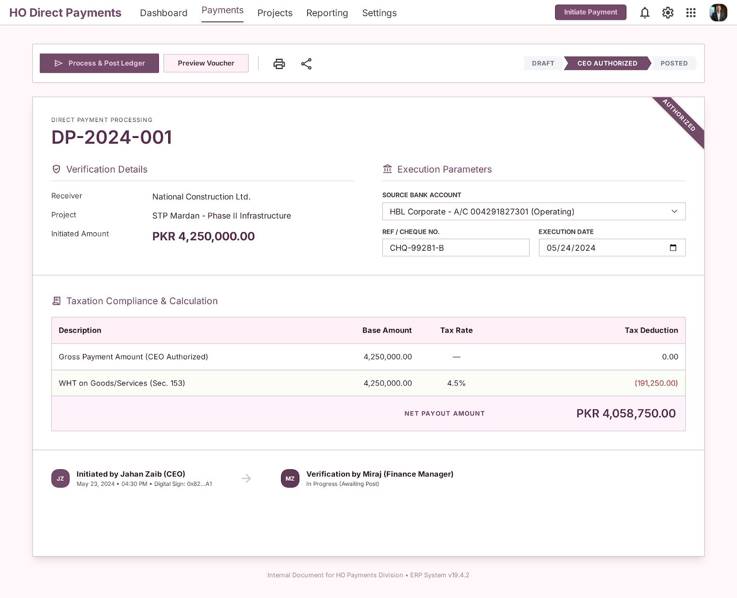

Cheque Printing

Step Name | Description | Inputs | System Actions / Logic | Outputs | Approval? | Remarks / Business Rules
Cheque Template Setup | Configure cheque layout | Bank Account, Cheque Format | Setup printable cheque template | Cheque template | No | Bank-wise cheque format
Cheque Number Assignment | Assign cheque number to payment | Payment Voucher, Cheque Number | Link cheque with payment | Assigned cheque | No | Mandatory before printing
Cheque Printing | Print cheque directly from system | Approved Payment | Generate printable cheque | Printed cheque | Finance Manager | System supports cheque printing
Cheque Posting | Record cheque issuance | Printed Cheque | Update payment and bank records | Posted cheque transaction | No | Linked with accounting entry

Expected Odoo View:

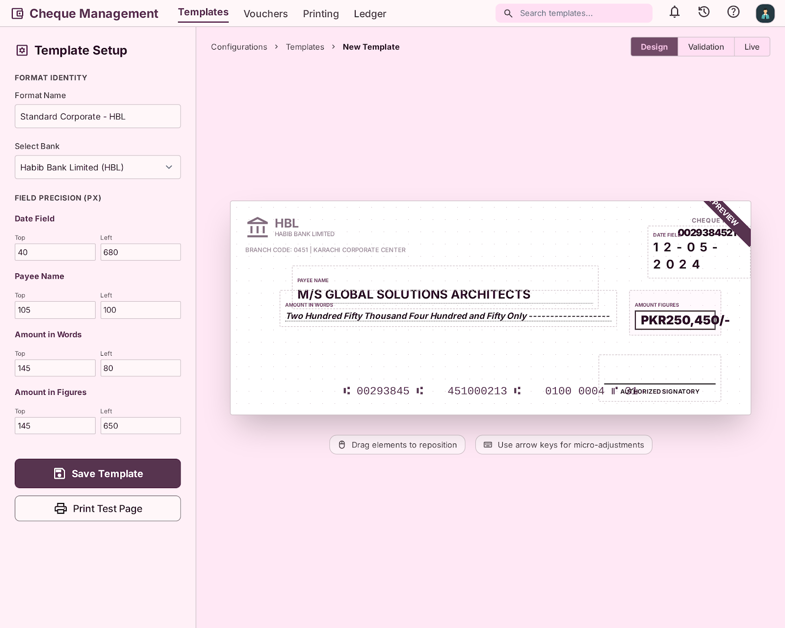

Cheque Number Management

Step Name | Description | Inputs | System Actions / Logic | Outputs | Approval? | Remarks / Business Rules
Cheque Book Setup | Create cheque series | Bank Account, Starting Number, Ending Number | Store cheque series in system | Cheque inventory | No | Custom app/module
Cheque Number Selection | Select unused cheque number during payment | Available Cheque Numbers | System shows only unused cheque numbers in dropdown | Selected cheque number | No | Duplicate use not allowed
Cheque Usage Locking | Lock used cheque number | Posted Payment | Mark cheque number as consumed | Locked cheque number | No | Used cheque cannot appear again
Cheque Tracking | Maintain cheque history | Cheque Details, Payment Ref | Store issuance history | Cheque audit log | No | Required for reconciliation and audit

Expected Odoo View:

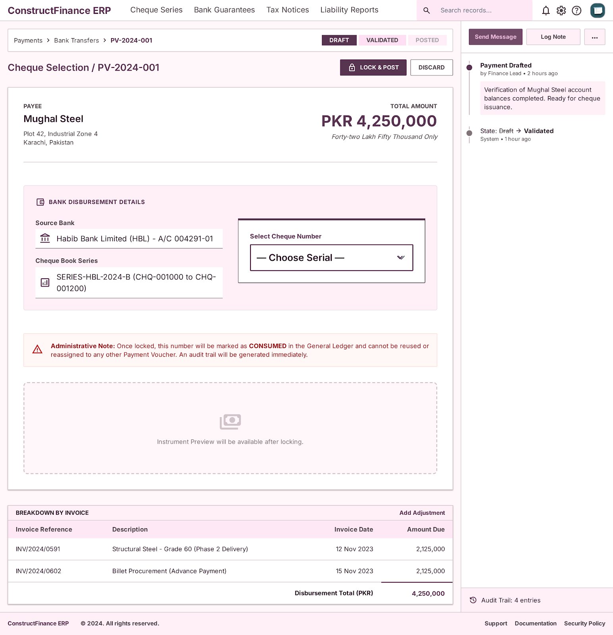
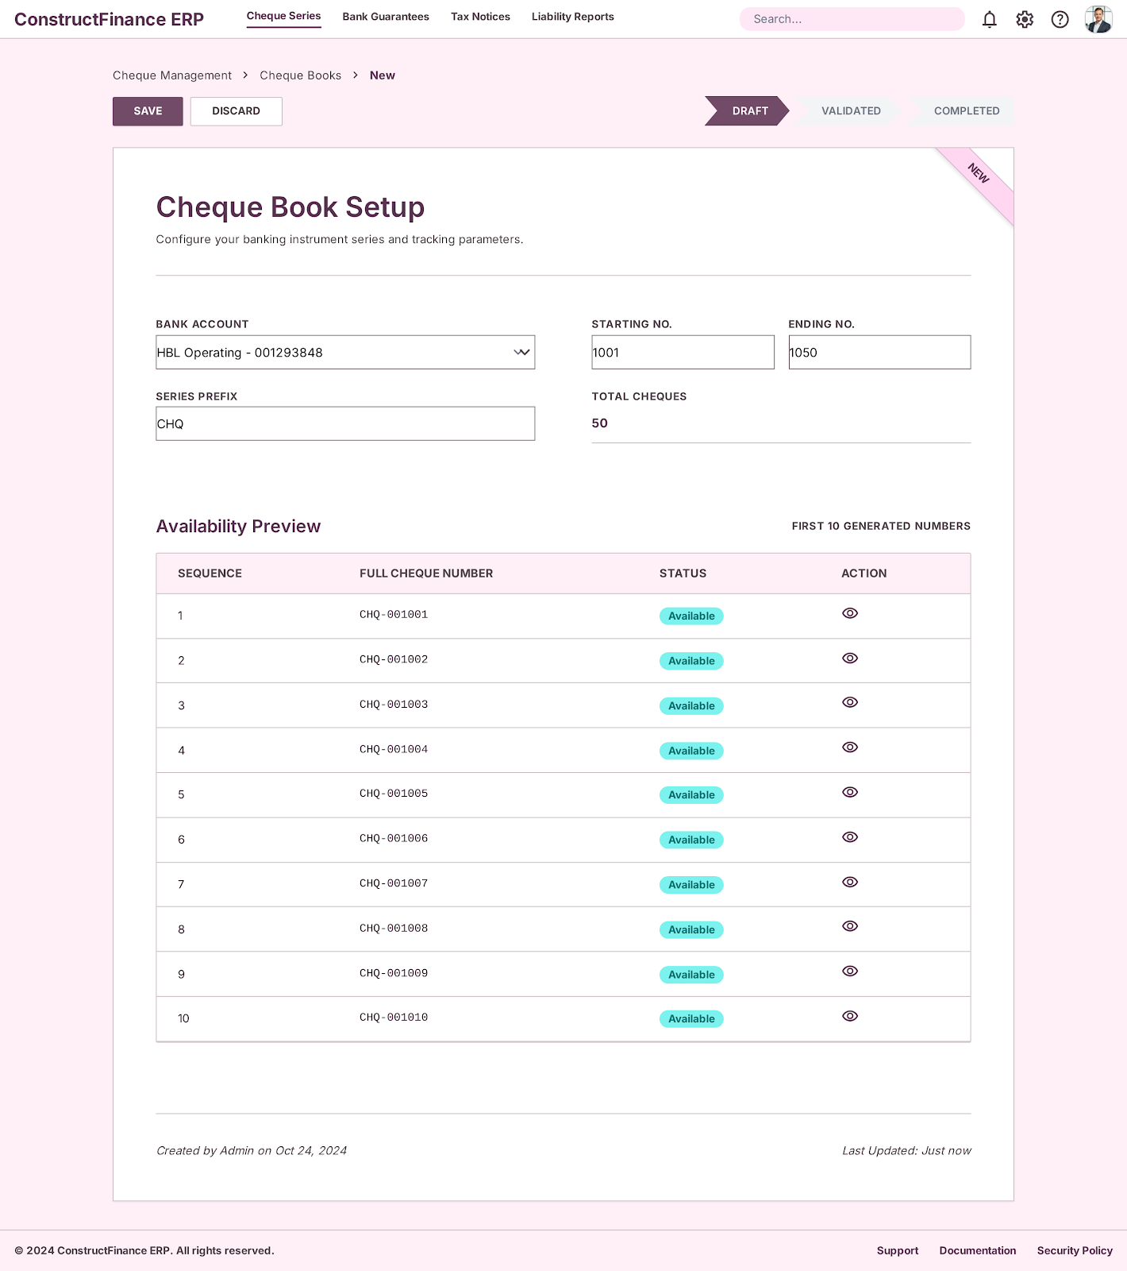

Bank Guarantee Management

Step Name | Description | Inputs | System Actions / Logic | Outputs | Approval? | Remarks / Business Rules
Bank Guarantee Entry | Create BG record | Sr No, Bank Name, BG Nature, Guarantee No | Create BG master record | BG record | No | Centralized BG management
BG Financial Details | Record financial information | Total Limit, BG Amount, Cash Margin, Pricing | Store BG financial data | Financial BG details | No | Required for tracking utilization
BG Project Linking | Link BG with project and JV | JV, Project, Beneficiary | Associate BG with operational project | Linked BG | No | Multiple projects supported
BG Validity Tracking | Monitor issue and expiry dates | Issue Date, Expiry Date | Track validity lifecycle | BG validity status | No | Expiry alerts required
BG Utilization Tracking | Monitor utilized and available limits | Utilized Amount, Available Limit | Auto-calculate available BG capacity | Updated BG balance | No | Real-time visibility
BG Status Management | Maintain BG operational status | Active/Expired/Released Status | Update BG state | BG status | No | Dashboard visibility required

Expected Odoo View:
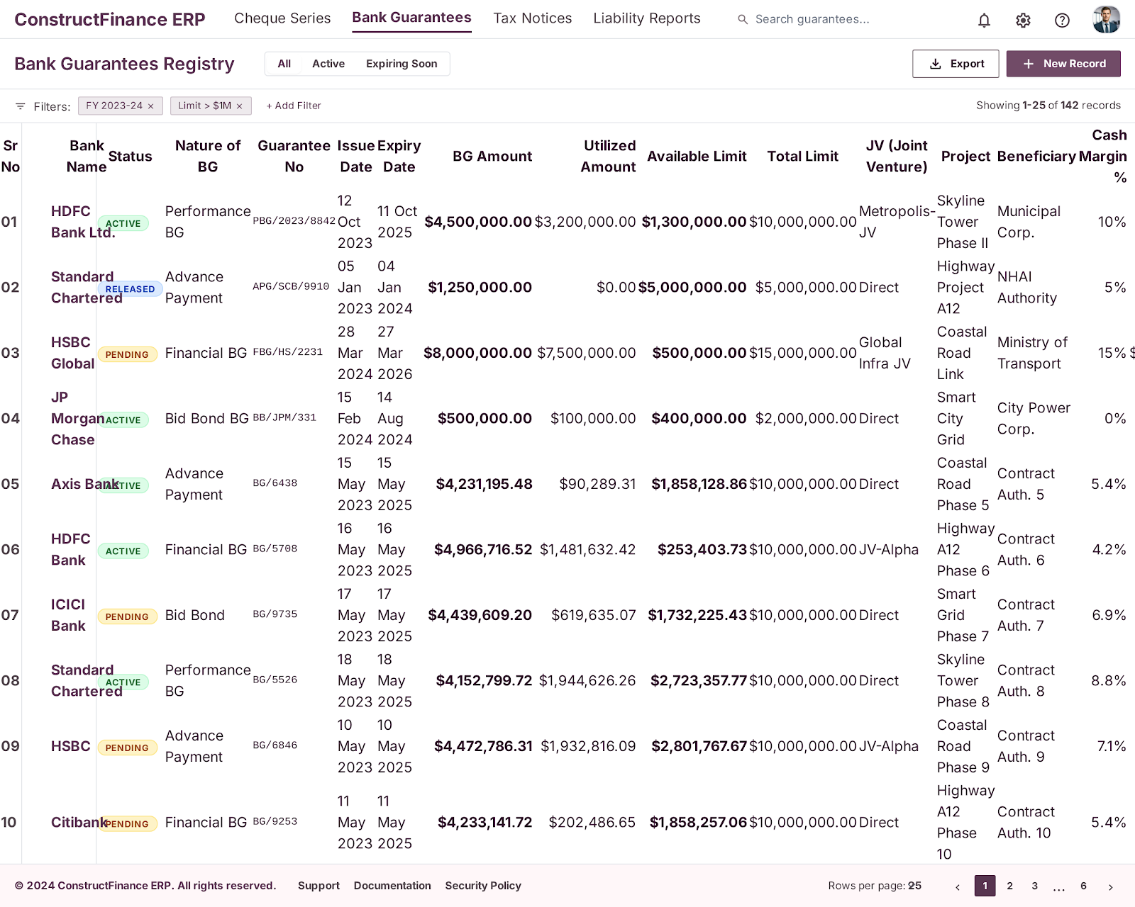
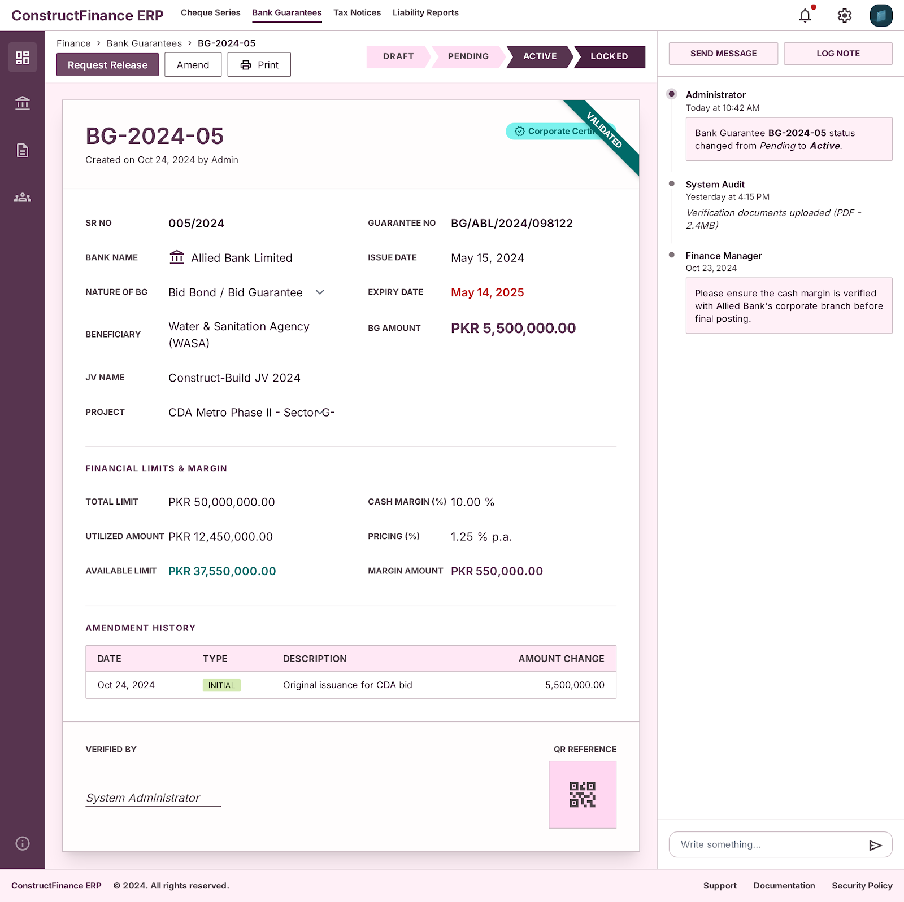

Tax Notices - Orders & Status

Step Name | Description | Inputs | System Actions / Logic | Outputs | Approval? | Remarks / Business Rules
Tax Notice Entry | Create tax notice record | Sr No, JV/Taxpayer Name, Ref No | Create tax notice master record | Tax notice entry | No | Centralized tax notice management
Notice Details Recording | Record notice information | Notice U/S, Description, Tax Year | Store complete notice details | Detailed tax notice | No | Legal/tax compliance tracking
Due Date Tracking | Monitor notice deadlines | Document Date, Due Date | Track compliance timelines | Due date alerts | No | Alert before expiry/due date
Liability Recording | Record tax liability | Tax Liability Amount | Store payable tax liability | Liability record | No | Linked with finance records
Payment Tracking | Record official/unofficial payments | Official Payment, Unofficial Payment, Consultant Fee | Update payment details | Updated payment status | No | Supports multiple payment types
Remaining Amount Calculation | Track outstanding liability | Total Payment, Liability Amount | Auto-calculate remaining amount | Remaining balance | No | Real-time liability tracking
Notice Status Management | Maintain notice status | Open/In Process/Closed | Update notice lifecycle | Updated notice status | No | Dashboard visibility required

Expected Odoo View:
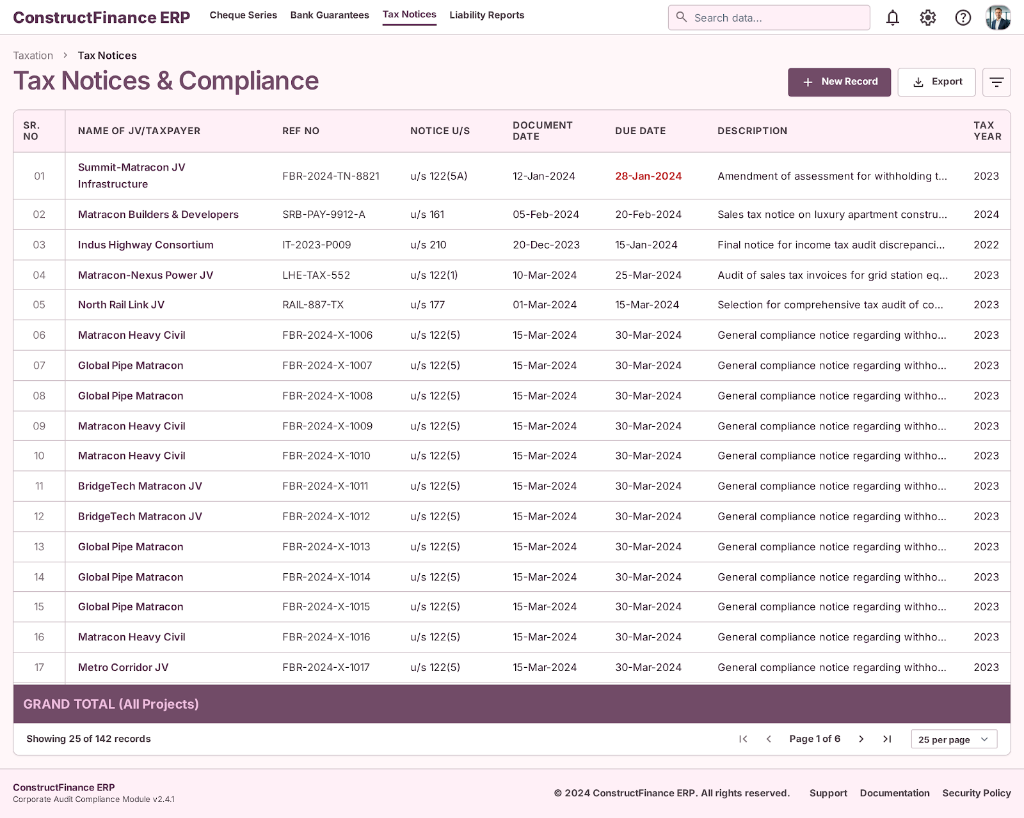
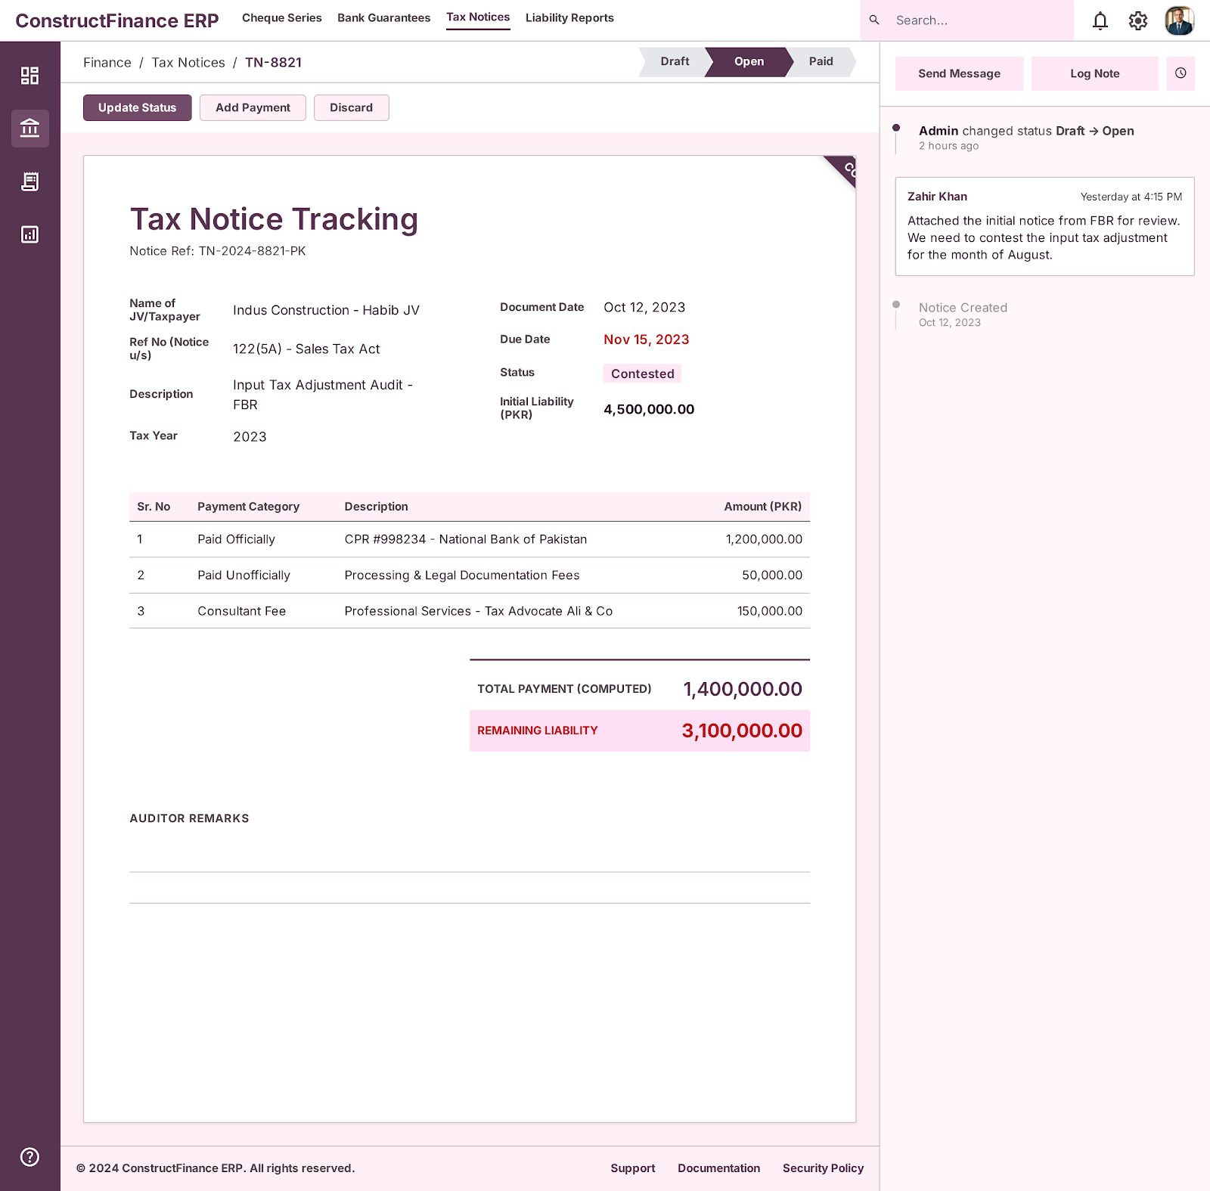

Management Dashboard:
