Functional Specification Documentation

DOCUMENT | PROCUREMENT (HO) FLOW
PREPARED BY | CWARE TECHNOLOGIES
CLIENT | MATRACON
PROJECT | ODOO ERP IMPLEMENTATION
VERSION | 1.0.4

TABLE OF CONTENTS

Introduction: 2
Current Users: 2
Processes Include: 2
1. Requisition Of Inventory coming from Site 2
2. Procurement Cycle with Comparative Statement 4
3. Confirm Order To finalized vendor 6
Management Dashboard: 10

Introduction:
This document outlines the end-to-end user flow for the Procurement (Head Office) Flow within the MATRACON Odoo ERP implementation, developed by CWare Technologies. It serves as a functional reference for how the Head Office procurement team — will manage and execute the procurement cycle through the system. The processes covered begin at the point where material demands are received from project sites, moving through vendor inquiry, comparative statement preparation, negotiation, and culminating in the confirmation and dispatch of a locked purchase order to the finalized vendor. Each process has been documented with its step-by-step logic, system actions, approval requirements, and business rules to ensure a transparent, competitive, and fully auditable procurement operation that supports all active MATRACON project sites.

Current Users:
- Nasir – Head of Procurement Department
- Abdullah – Assistant

Processes Include:
- Requisition Of Inventory coming from Site
- Procurement Cycle with Comparative Statement
- Confirm Order To finalized vendor

Requisition Of Inventory coming from Site

Step Name | Description | Inputs | System Actions / Logic | Outputs | Approval? | Remarks / Business Rules
Receive Site Demand | Receive material demand raised from site | Site Material Demand, Quantity, Project Details | Capture demand in procurement system | Demand record | No | Demand originates from site
Demand Review | Review site demand for feasibility | Demand Record, Stock Position, Market Availability | Validate quantity vs requirement and availability | Reviewed demand | No | Procurement only evaluates
Quantity Optimization | Adjust recommended quantity | Original Demand, Stock Levels, Budget Constraints | Calculate optimized quantity (e.g., 100 → 70) | Recommended quantity | No | Based on procurement judgment
Procurement Recommendation | Prepare internal recommendation | Reviewed Demand, Recommended Qty | Generate recommendation sheet | Recommendation document | No | Internal step only
Recommendation Record | Store recommendation history | Demand + Recommended Qty | Save recommendation in system | Recommendation log | No | Audit trail
Expected Odoo View:
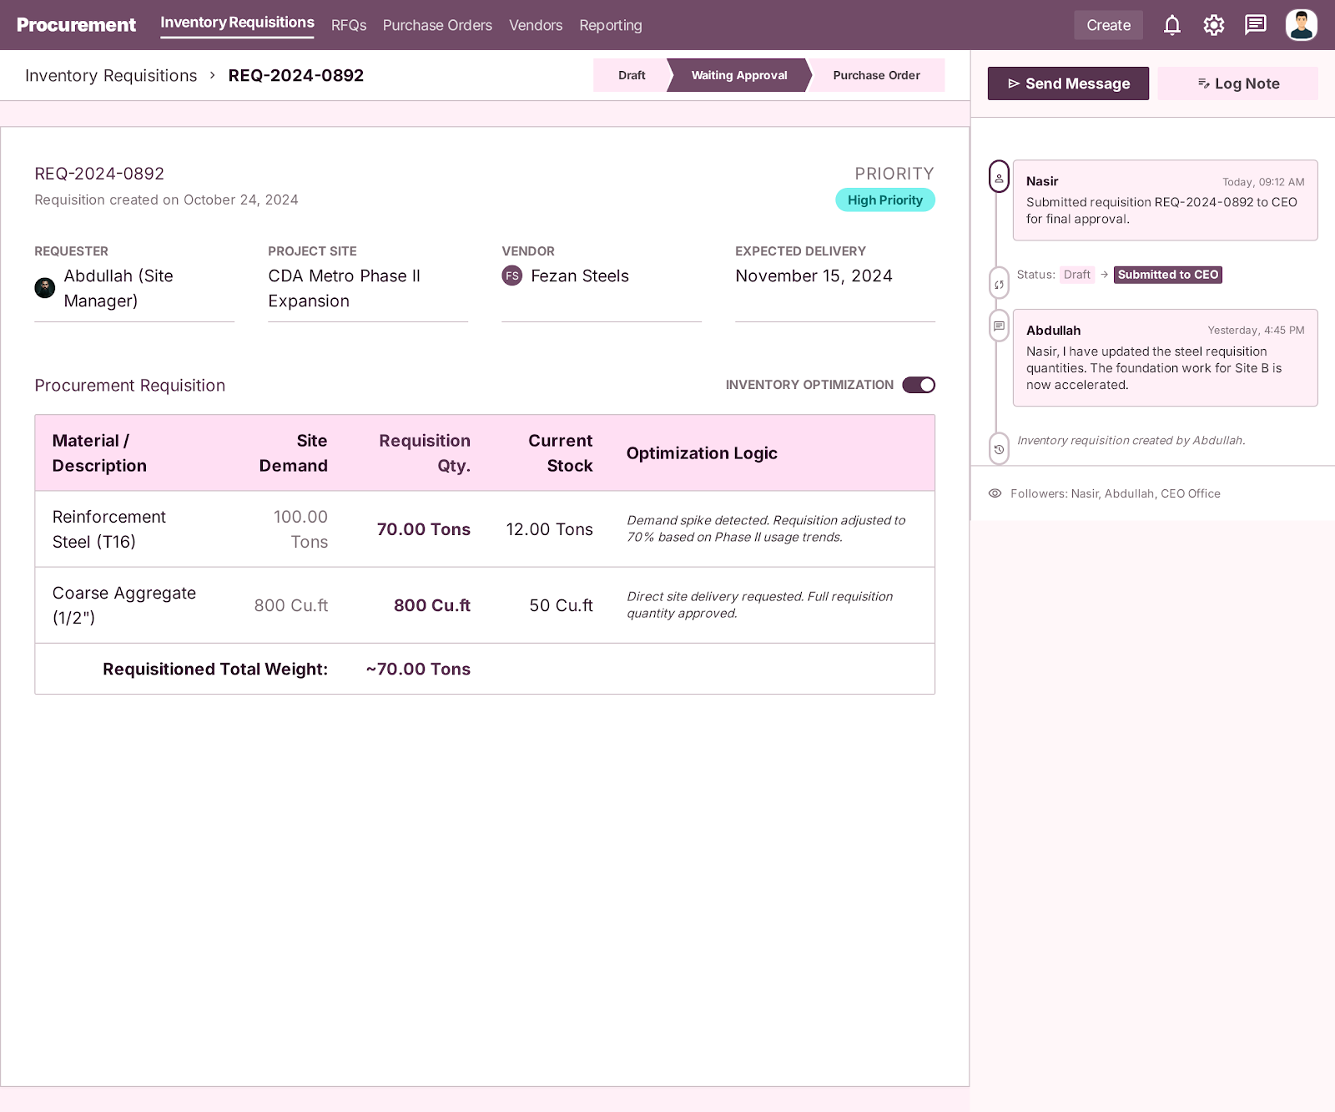

Procurement Cycle with Comparative Statement

Step Name | Description | Inputs | System Actions / Logic | Outputs | Approval? | Remarks / Business Rules
Vendor Inquiry | Contact multiple vendors | Material Demand, Specifications | Send RFQs to vendors | Vendor inquiry list | No | Multiple vendors mandatory
Quotation Collection | Collect vendor quotations | Vendor Quotes, Terms, Delivery Time | Store all quotations against linked RFQs | Quotation records | No | Price, delivery, payment terms
Quotation Comparison | View all vendor quotations together | Linked RFQs, Vendor Quotes | System displays quotations from multiple vendors in one comparative statement | Comparative quotation view | No | Required for side-by-side comparison
Comparative Statement Preparation | Prepare CS | All Vendor Quotations | Generate comparison sheet | CS document | No | Core decision document
Vendor Evaluation | Evaluate vendors | CS Data | Rank vendors | Evaluated vendor list | No | Based on price + terms
Vendor Finalization | Select best vendor | Evaluation Output | Mark final vendor | Final vendor selection | No | Only one vendor
Negotiation Record | Record negotiations | Emails, Revised Quotes | Attach all discussions | Negotiation record | No | Full audit trail
Attach Documents to PO | Attach CS + negotiations | CS, Documents | Link docs after subtotal in PO | Document bundle | No | Mandatory
Procurement Final Submission | Prepare final case | All Documents | Lock procurement package | Final procurement file | No | Ready for CEO/MD

Expected Odoo View:
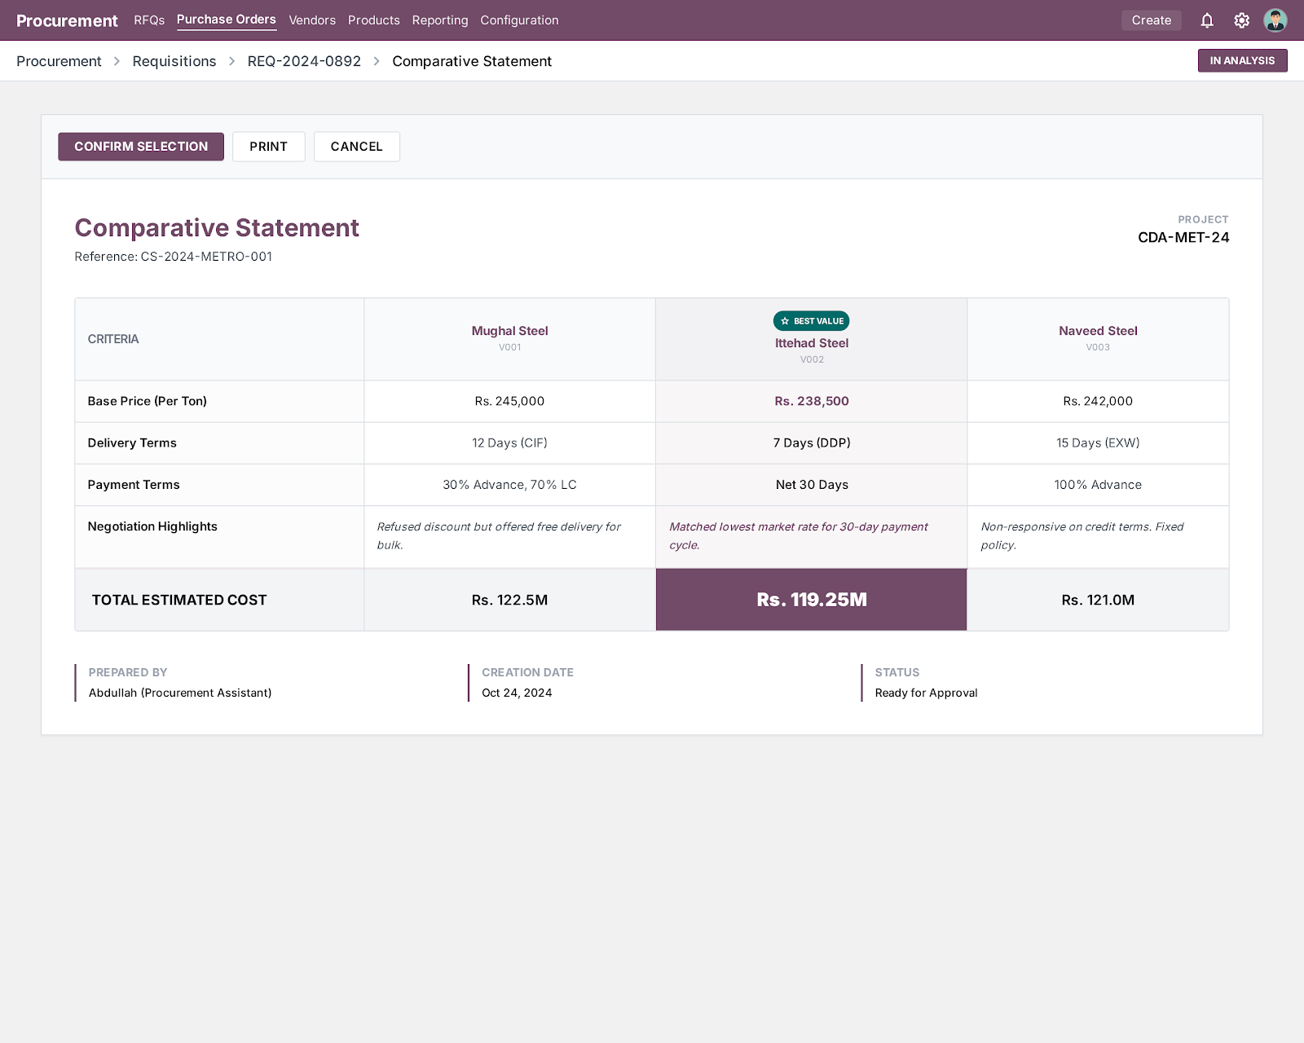

Confirm Order To finalized vendor

Step Name | Description | Inputs | System Actions / Logic | Outputs | Approval? | Remarks / Business Rules
Prepare Final PO | Prepare purchase order | Final Vendor, Quantities, Terms | Generate PO draft | PO draft | No | Includes all agreed terms
PO Compliance Fields | Add compliance details | Vendor NTN, Exemption Cert No, Validity | Capture compliance fields in PO | Updated PO | No | Mandatory fields on PO
Apply Product-Vendor Terms | Apply predefined terms and conditions | Product, Vendor | System fetches predefined Terms & Conditions based on product-vendor combination | Applied T&C | No | Only predefined approved terms allowed
Purchase Order Communication Control | Disable PO chat functionality | Purchase Order | Disable internal and vendor-facing chatter/email discussion on PO | Controlled PO communication | No | No PO chat allowed; communication must follow predefined T&C
Attach Final Documents | Attach CS + negotiations | All Documents | Attach approved CS and required documents after subtotal section | Complete PO | No | Required before approval
Submit to Nasir Sb | Submit finalized PO for procurement approval | Final PO, Supporting Documents | Route PO to Nasir Sb approval stage | Submitted PO | No | First approval stage before CEO
Nasir Sb Approval | Procurement head reviews PO | Submitted PO | Approve or reject PO based on procurement review | Procurement approved PO | Yes (Nasir Sb) | PO moves to CEO only after Nasir approval
Submit to CEO/MD | Submit procurement-approved PO for final approval | Procurement Approved PO | Route PO to CEO/MD approval stage | Submitted PO | No | Final decision stage
CEO/MD Approval | CEO/MD approves or rejects | Submitted PO | Approve and lock PO | Approved PO | Yes (CEO/MD) | Final authority
Auto Notification | Notify all stakeholders | Approved PO | Send notification to Site, Procurement, Vendor | Notification sent | No | System auto-notification
Dispatch Order | Send PO to vendor | Approved PO | Send PO electronically/manual | Sent PO | No | Official order
Order Locking | Lock PO after approval | Approved PO | Restrict all edits | Locked PO | No | No changes allowed
Expected Odoo View:

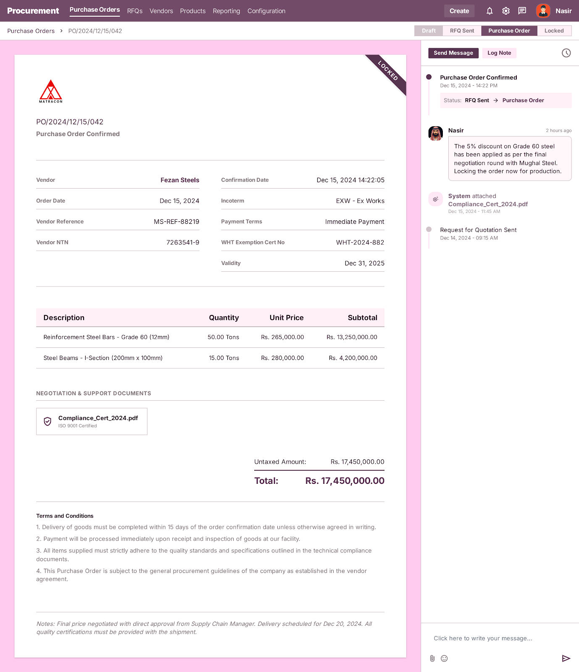

Management Dashboard:
