Functional Specification Documentation

DOCUMENT | SITE ACCOUNTANT FLOW
PREPARED BY | CWARE TECHNOLOGIES
CLIENT | MATRACON
PROJECT | ODOO ERP IMPLEMENTATION
VERSION | 1.0.4

TABLE OF CONTENTS

Introduction: 2
Current Users: 2
Processes Include: 2
1. Update Vendor Ledger & Liability Sheet 2
2. Update Subcontractors Ledger & Liability Sheet 4
3. Petty Cash Management 6
4. Attendance of all employees 9
5. Salary Slips (Advance + Adjustments) 11
6. Employee Creation 13
Management Dashboard: 15

Introduction:
This document outlines the end-to-end user flow for the Site Accountant role within the MATRACON Odoo ERP implementation, developed by CWare Technologies. It serves as a functional reference for how site accountants across active project sites will manage day-to-day financial and administrative operations through the system. The processes covered include updating vendor and subcontractor ledgers with payable entries and liability sheets for CEO/MD review, managing site-level petty cash from request through to daily expense recording, maintaining attendance records for all site employees, and generating monthly salary slips with advance deductions and approved adjustments. Each process has been documented with its step-by-step logic, system actions, approval requirements, and business rules to ensure accurate, controlled, and fully auditable site-level financial operations across all MATRACON project sites.

Current Users:
- Shah G (BF Tower)
- Waqas (RWASA)
- Ibrahim (STP Mardan)

Processes Include:
- Update Vendor Ledger & Liability Sheet
- Update Subcontractor Ledger & Liability Sheet
- Petty Cash Management
- Attendance of all employees
- Salary Slips (Advance + Adjustment)

Update Vendor Ledger & Liability Sheet

Step Name | Description | Inputs | System Actions / Logic | Outputs | Approval? | Remarks / Business Rules
Receive Vendor Invoice | Receive vendor claim after material receipt | GRN, Vendor Details | Create liability entry (no invoice number dependency) | Vendor liability record | No | Liability-based system only
Liability Creation | Create payable entry | Total Amount, Vendor Info | Store full liability amount only | Liability sheet entry | No | No invoice number required
Tax & Exemption Entry | Record tax details | Tax Type, Exemption Cert No, Validity | Attach tax + exemption data | Tax tagged liability | No | Mandatory fields
Vendor Ledger Update | Update ledger | Liability Amount | Post payable entry | Updated ledger | No | Financial record
Liability Sheet Update | Update HO visibility | Ledger Entry | Show total + remaining after recommendation | Liability sheet | No | Remaining must be visible
Auto Paid Flag | System trigger after update | Liability Entry | Mark payable as auto-ready for finance | Auto-paid status | System | No manual invoice payment
Expected Odoo View:
Removed the recommended field while updating;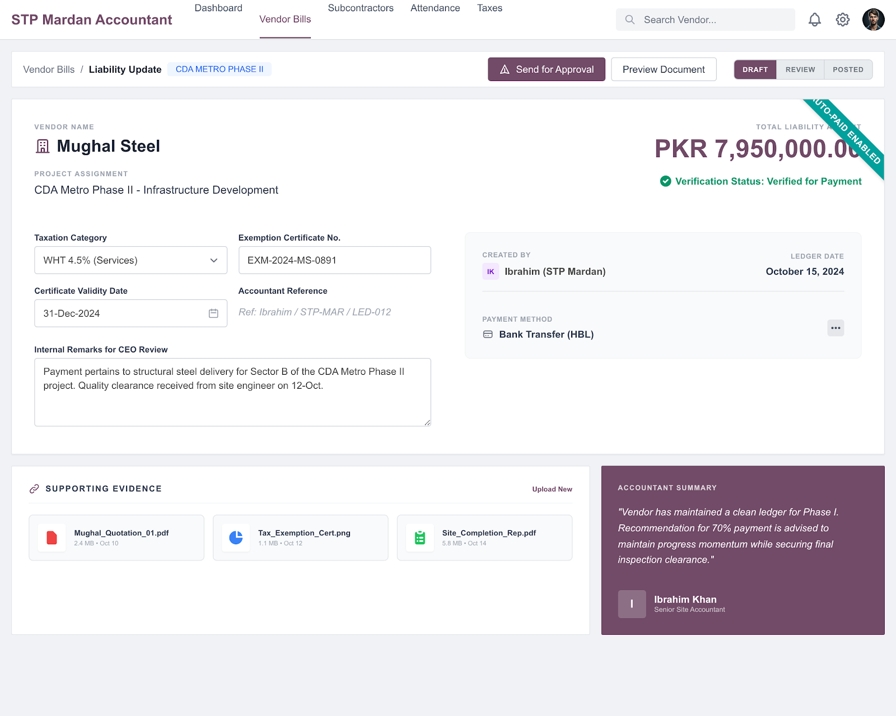

Update Subcontractors Ledger & Liability Sheet

Step Name | Description | Inputs | System Actions / Logic | Outputs | Approval? | Remarks / Business Rules
Receive IPC | Receive work certification | IPC Data | Create liability base | IPC record | No | No invoice concept
Liability Creation | Create payable entry | IPC Value | Store total liability only | Liability entry | No | Net liability only
Tax & Exemption Entry | Add tax details | Tax Type, Certificate No, Validity | Attach tax data | Tax tagged record | No | Mandatory
Backcharge Entry | Apply deductions | Material Issue, Contract | Deduct from payable | Backcharge record | No | Key control point
Withheld Amount Tracking | Track security hold | Previous IPC Data | Hold/release logic | Withheld record | No | Released in next IPC
Retention Calculation | Apply retention | IPC Value | Auto deduction | Retention record | No | Standard % logic
Advance Adjustment | Adjust advance recovery | Advance Record | Deduct advance | Adjusted liability | No | Mandatory deduction
Ledger Update | Update subcontractor ledger | Net Payable | Post final amount | Updated ledger | No | Final payable
Liability Sheet Update | Update HO view | Ledger Entry | Show remaining after recommendation | Liability sheet | No | Remaining visible
Auto Paid Flag | System trigger | Liability Entry | Mark payable auto-ready | Auto-paid status | System | No invoice dependency

Expected Odoo View:
Removed the recommended field while updating;
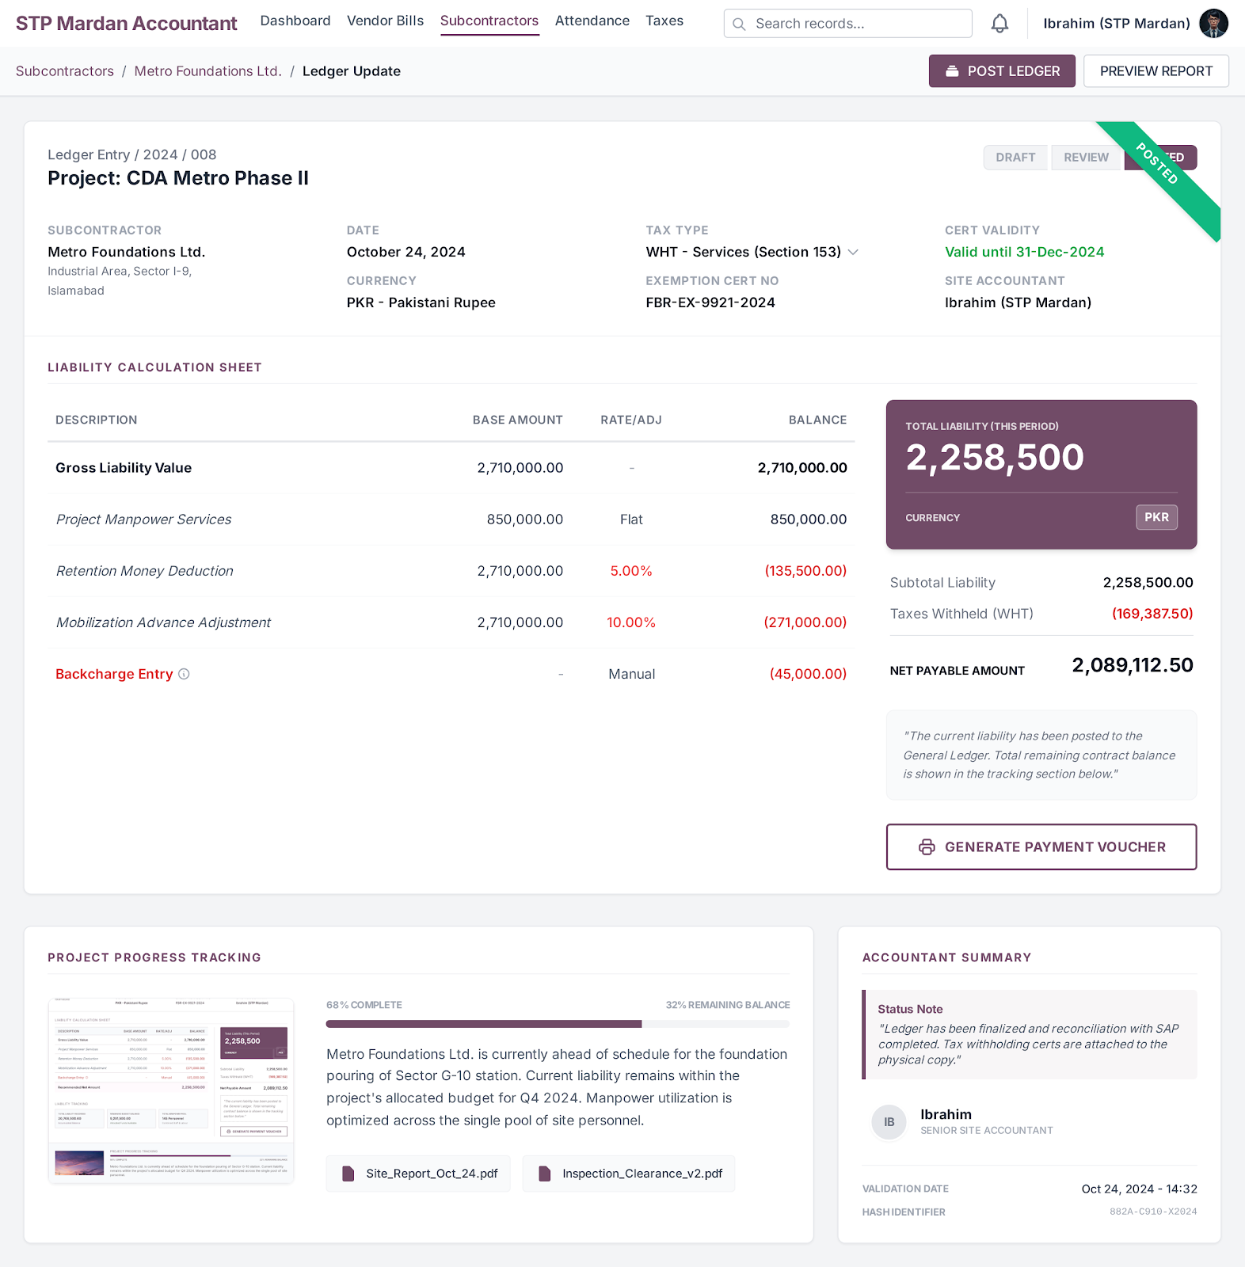

Petty Cash Management

Step Name | Description | Inputs | System Actions / Logic | Outputs | Approval? | Remarks / Business Rules
Petty Cash Request | Request funds | Requirement, Balance | Create request | Request record | No | Site initiated
Verification | Validate request | Cash Position | Check eligibility | Verified request | No | Control check
Release Cash | Release funds | Verified request | Process payment | Cash released | Finance Manager | Cheque/bank
Receipt Confirmation | Confirm receipt | Cheque/Bank Ref | Mark received | Updated balance | No | After receipt
Expense Entry | Record expenses | Daily expenses | Log transactions | Expense record | No | Real-time
Balance Update | Update balance | Expenses | Auto calculate | Closing balance | No | System controlled
Expected Odoo View:

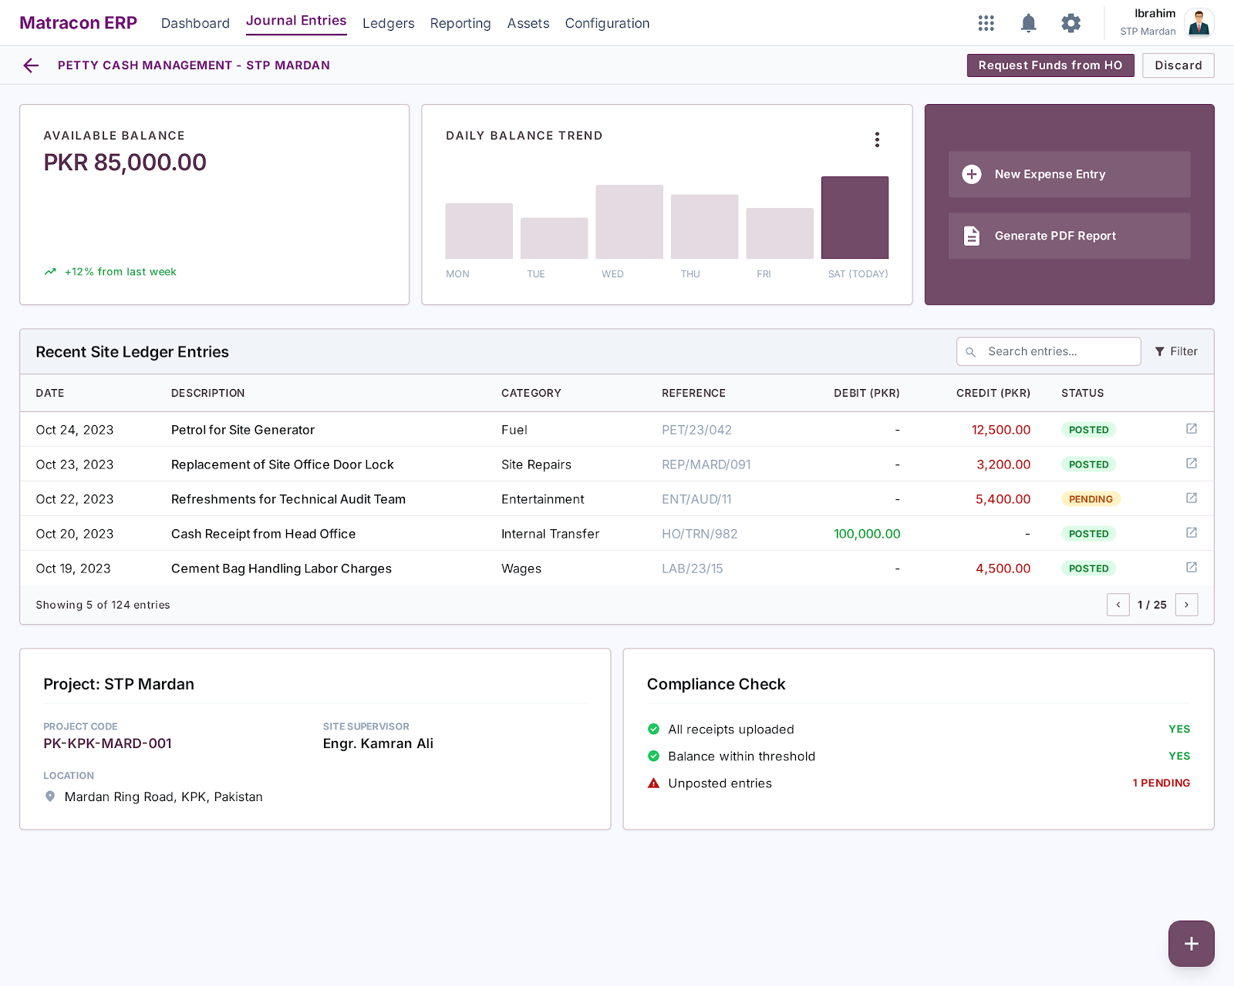
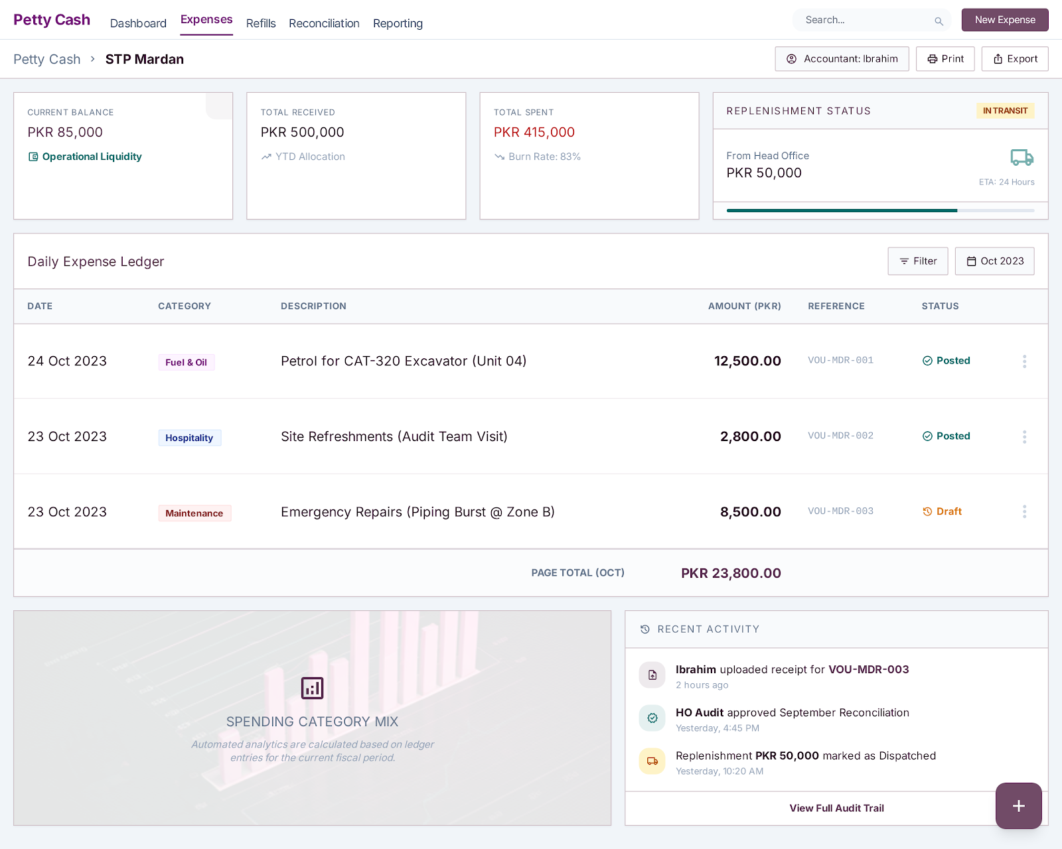

Attendance of all employees

Step Name | Description | Inputs | System Actions / Logic | Outputs | Approval? | Remarks / Business Rules
Employee Master | Maintain workforce | Employee List | Single combined labor/staff list | Employee master | No | No classification
Daily Attendance | Mark attendance | Daily Status | Record Present, Absent, Leave, and Public Holiday status | Attendance log | No | Site accountant only
Attendance Validation | Validate data | Attendance sheet | Ensure correctness | Verified data | No | Payroll ready
Monthly Summary | Generate report | Monthly data | Calculate totals | Summary sheet | No | Used for payroll
Average Employees | Calculate average manpower | Monthly headcount | Avg = total / months | Avg employee count | No | Monthly + period-based
Present Average | Calculate presence avg | Daily attendance | Compute attendance avg | Avg present report | No | Includes all days
Expected Odoo View:
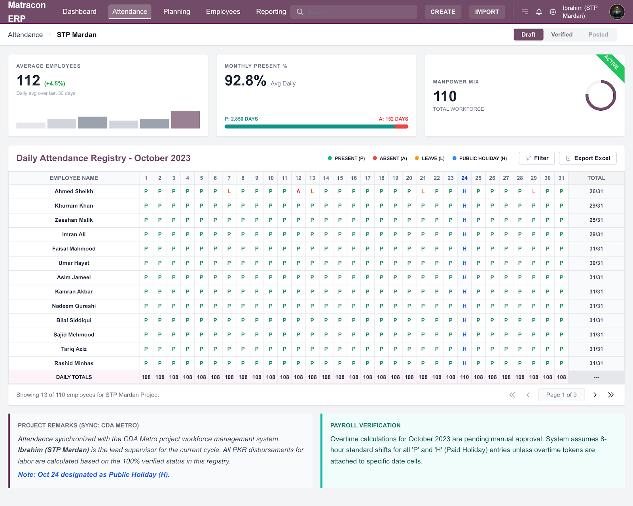

Salary Slips (Advance + Adjustments)

Step Name | Description | Inputs | System Actions / Logic | Outputs | Approval? | Remarks / Business Rules
Salary Calculation | Compute salary | Attendance data | Calculate gross salary | Salary sheet | No | Attendance-based
Advance Deduction | Deduct advances | Advance records | Auto deduction | Net salary | No | Only advances
Adjustments | Apply corrections | Adjustment data | Add/deduct values | Adjusted salary | No | Approved only
Salary Slip Generation | Generate slips | Final salary | Create slip | Salary slip | No | One per employee
Payroll Summary | Final payroll | Salary slips | Consolidate payroll | Payroll report | No | HO reporting
Expected Odoo View:

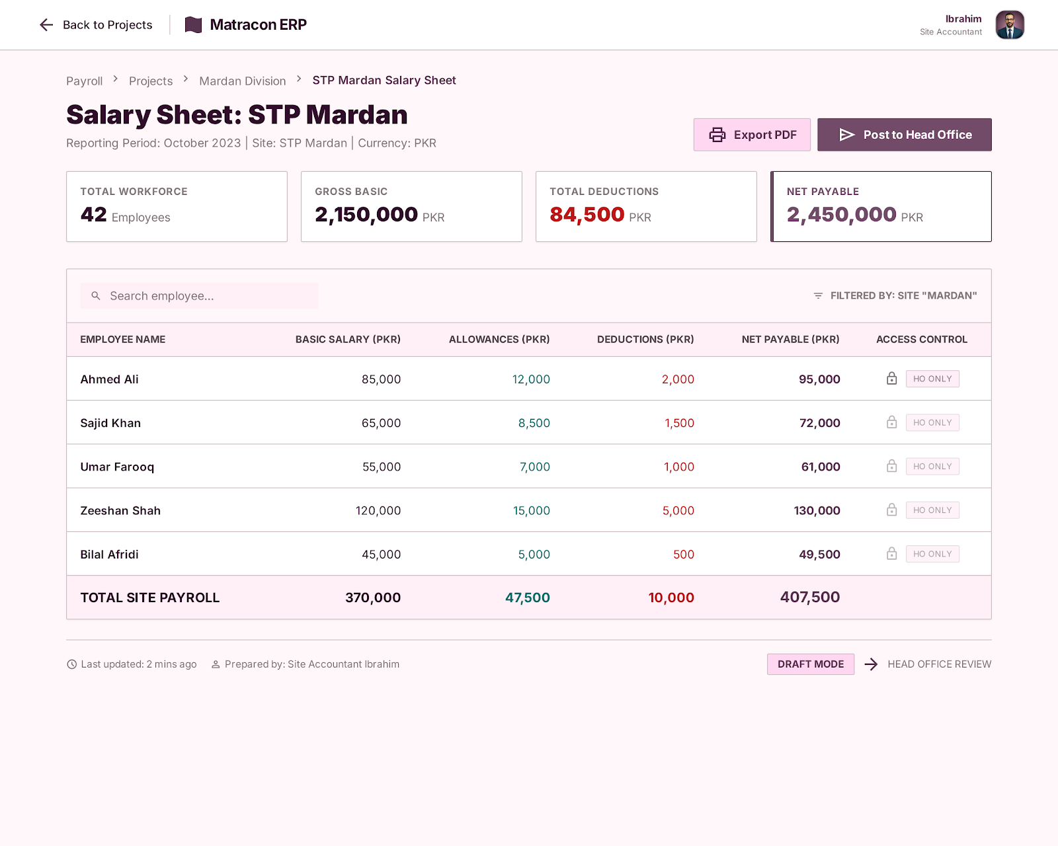

Employee Creation

Step Name | Description | Inputs | System Actions / Logic | Outputs | Approval? | Remarks / Business Rules
Employee Information Entry | Create employee profile | Employee Name, CNIC, Job Position, Department | Store employee master data in system | Employee record | No | Employee does not require Odoo user
Required Documents Upload | Attach mandatory employee documents | CNIC Copy, Supporting Documents | Upload documents against employee profile | Document record | No | Mandatory for employee onboarding
Employee Card Generation | Generate employee card from employee profile | Employee Record, CNIC, Photo | System generates printable employee card | Employee card | No | Employee card should be printable/exportable
Employee Record Confirmation | Confirm employee profile completion | Employee Details, Documents | Mark employee record as completed | Completed employee profile | No | Required before payroll/attendance use

Expected Odoo View:
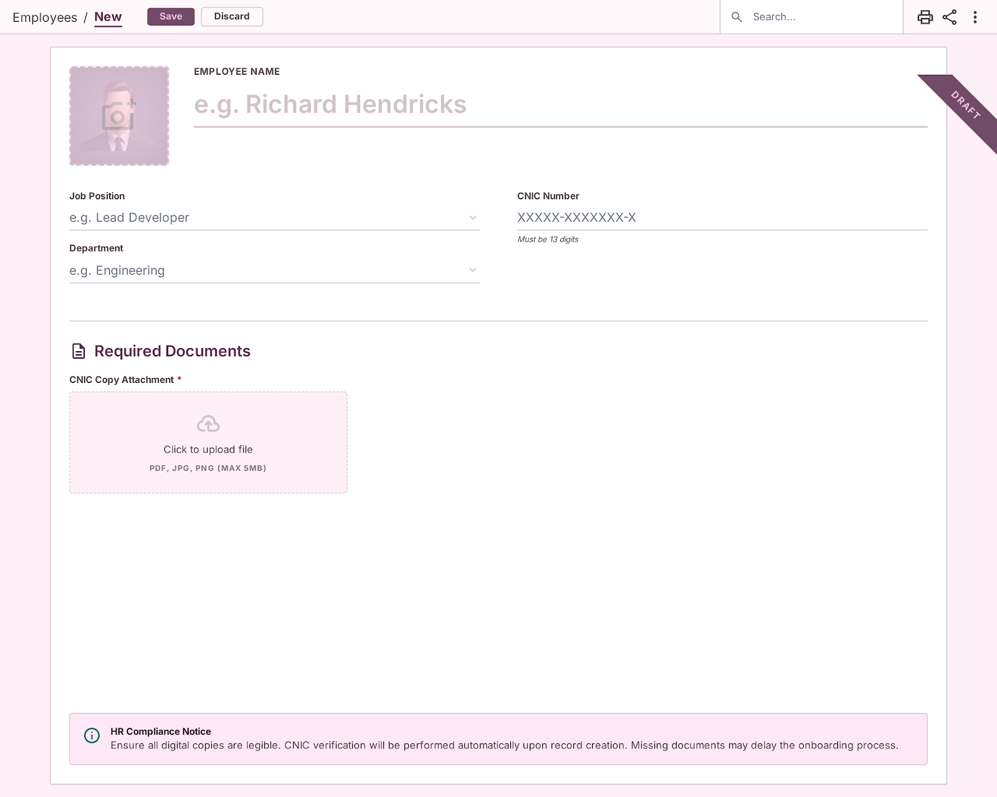

Management Dashboard:
