Functional Specification Documentation

DOCUMENT | SITE STORE FLOW
PREPARED BY | CWARE TECHNOLOGIES
CLIENT | MATRACON
PROJECT | ODOO ERP IMPLEMENTATION
VERSION | 1.0.4

TABLE OF CONTENTS

Introduction: 2
Current Users: 2
Processes Include: 2
1. Demand Raise 2
2. Validation of Material Received 5
3. Normal Issuance 7
4. 3rd Party (Sub-Contractor) Issuance 10
5. Normal Return 12
6. 3rd Party (Sub-Contractor) Return 14
7. Site To Site Transfer 16
Management Dashboard: 20

Introduction:
This document outlines the end-to-end user flow for the Site Store Manager role within the MATRACON Odoo ERP implementation, developed by CWare Technologies. It serves as a functional reference for how store managers across active project sites — will interact with the system on a day-to-day basis. The processes covered span the full material lifecycle at site level, from raising purchase requisitions and validating incoming deliveries, to issuing materials to site teams and subcontractors, managing returns, and coordinating inter-site transfers. Each process has been documented with its step-by-step logic, system actions, approval requirements, and business rules to ensure consistent, auditable, and controlled inventory operations across all project sites.

Current Users:
- Safdar (BF Tower)
- Shafiq (RWASA)
- Umer (STP Mardan)

Processes Include:
- Purchase Requisition / Demand Raise
- Validation of Material Received
- Normal Issuance
- 3rd Party (Sub-Contractor) Issuance
- Normal Return
- 3rd Party (Sub-Contractor) Return
- Site to Site Transfer

Demand Raise

Step Name | Description | Inputs | System Actions / Logic | Outputs | Approval? | Remarks / Business Rules
Open Purchase Application | Open procurement request screen for new demand | Material Requirement, Site Need | Access purchase requisition form in system | PR screen opened | No | Starting point for PR creation
Create New PR | Create new purchase requisition | Material Details, Quantity, Site, Required Date | Generate new PR record in system | PR created | No | Raised when stock falls below minimum level
Product Category Restriction | Restrict product selection to predefined categories | Product, Category Selection | System only allows products from approved categories and provides “Other” option for undefined products | Categorized PR item | No | “Other” category used for unidentified or miscellaneous items
Unknown Vendor Handling | Allow site store manager to proceed without finalized vendor | Material Requirement, Optional Vendor Details | System allows selection of predefined “Unknown Vendor” or blank vendor during PR creation | PR with Unknown Vendor | No | Procurement team will finalize actual vendor during comparative statement / RFQ stage
On-hand Quantity Visibility | Display current on-hand stock quantity during demand raising and issuance processes | Product, Warehouse/Site | System fetches and displays real-time available stock quantity | Live stock visibility | No | Helps avoid unnecessary procurement and duplicate demand raising
Confirm & Print Out | Confirm PR details and print hard copy | Created PR | Validate PR and generate printable document | Printed PR copy | No | Required for physical signatures
Sign From PM | Project Manager reviews and signs PR manually | Printed PR | PM verifies requirement and signs hard copy | PM signed PR | PM - Manual | PM approval remains outside system
Attach Signed PR | Upload signed PR into system | Signed PR Copy | Attach scanned signed document with PR record | Attached signed PR | No | Mandatory before final submission
Submit | Forward PR for approval workflow | Attached PR, Approved Request | Submit PR to CEO/MD approval workflow | Submitted PR | No | Moves request to HO approval cycle
Expected Odoo View:
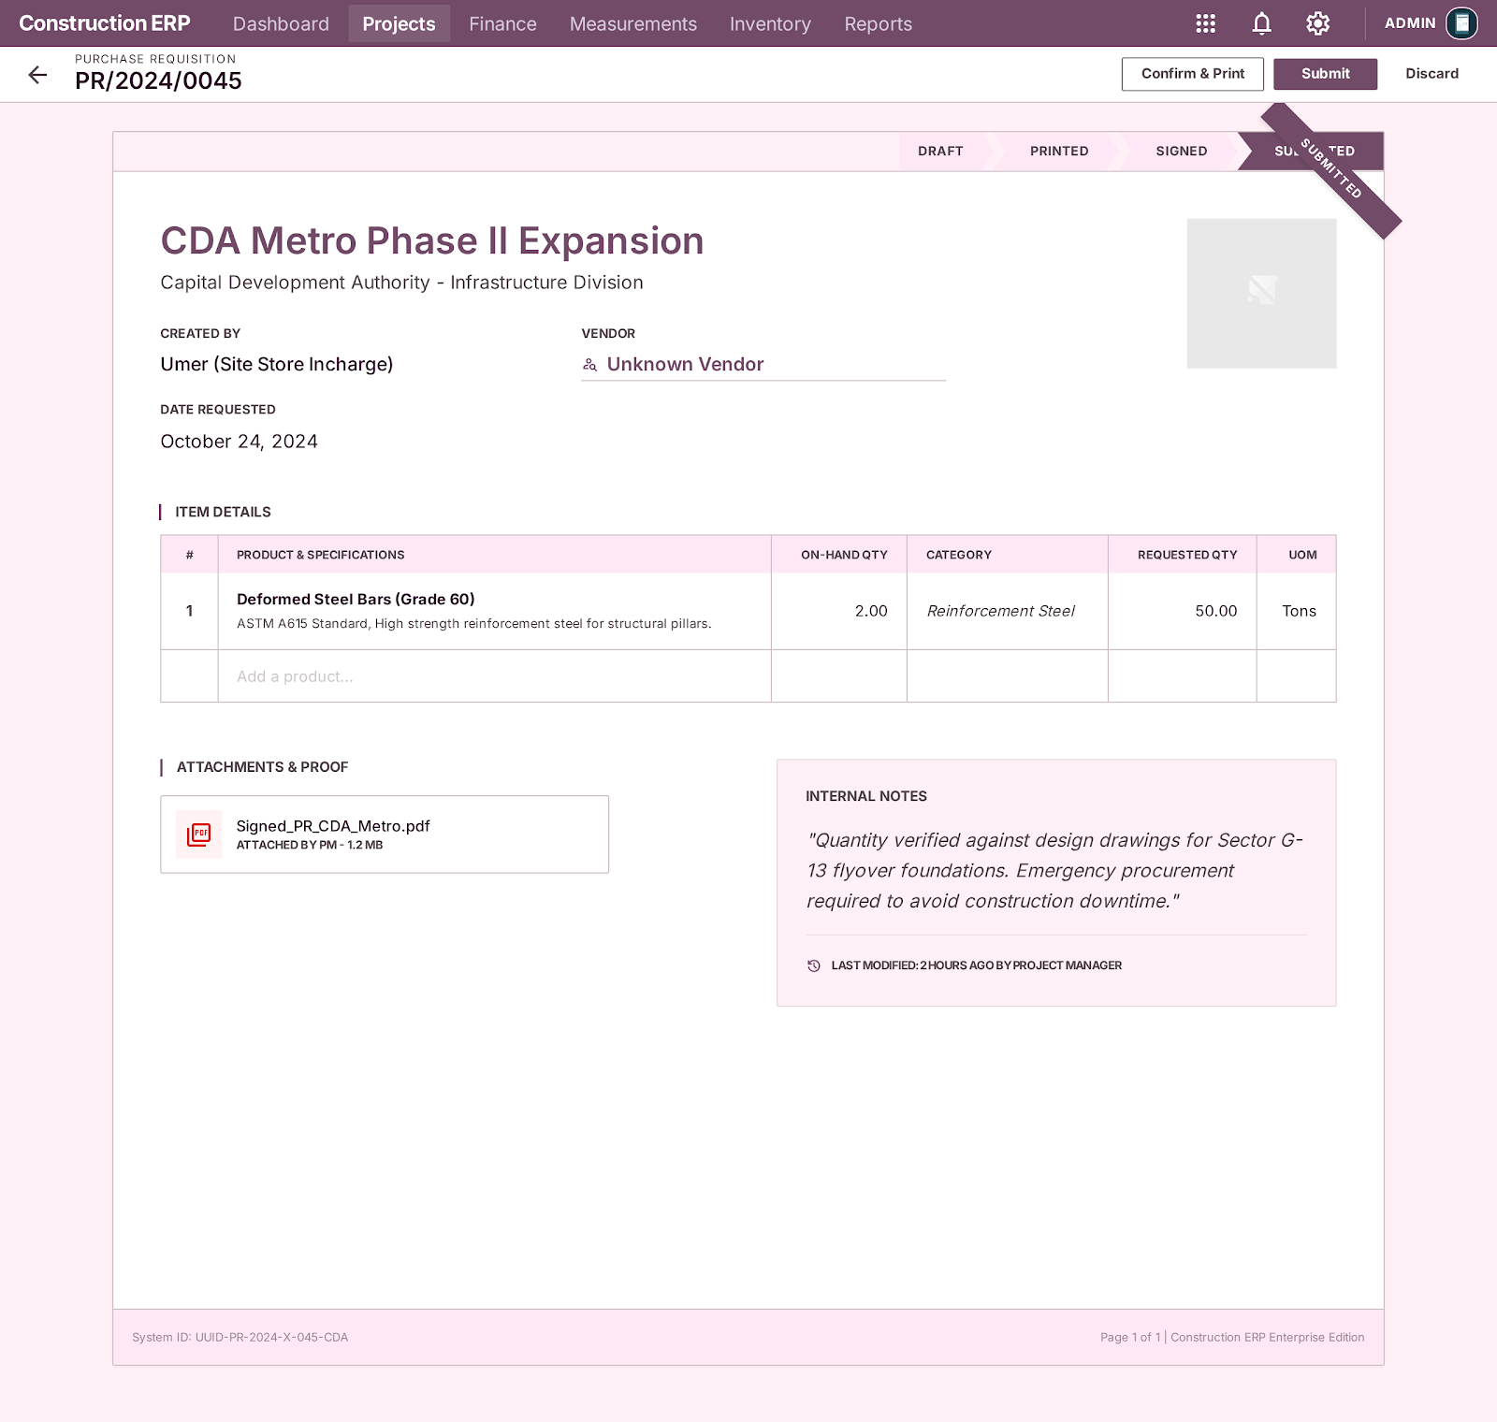

Validation of Material Received

Step Name | Description | Inputs | System Actions / Logic | Outputs | Approval? | Remarks / Business Rules
Material Arrival Verification | Material arrives at site against PO | PO Number, Vendor, Delivery Challan | Match incoming material with PO in system | Arrival record created | No | Only PO-linked material allowed
Quantity & Quality Check (QC) | Store Incharge verifies received material | Delivered Quantity, PO Quantity | Compare actual vs ordered quantity | QC Verified / Rejected status | Internal | QC signature mandatory
Partial Receipt Handling | Handle partial deliveries | Partial Quantity Received | Update received qty, generate backorder for remaining | Partial receipt + Backorder created | No | Backorder auto-linked to PO
Gate Pass Inward Creation | Record entry of material into site | QC Approved Material | Generate inward gatepass record | Gate Pass Inward | No | Managed by Store Incharge
Inventory Update | Add material into stock | Approved Received Quantity | Update stock quantity in system | Stock updated | No | Inventory updated in real-time
Vendor Liability Control | Control payable creation logic | Vendor Invoice (if received) | Liability created only when invoice arrives | Payable entry (if applicable) | No | No liability at receiving stage
Backorder Dashboard Update | Track pending material delivery | Unfulfilled PO Quantity | System flags remaining quantity as backorder | Backorder record visible | No | Visible in dashboard until fulfilled
Expected Odoo View:
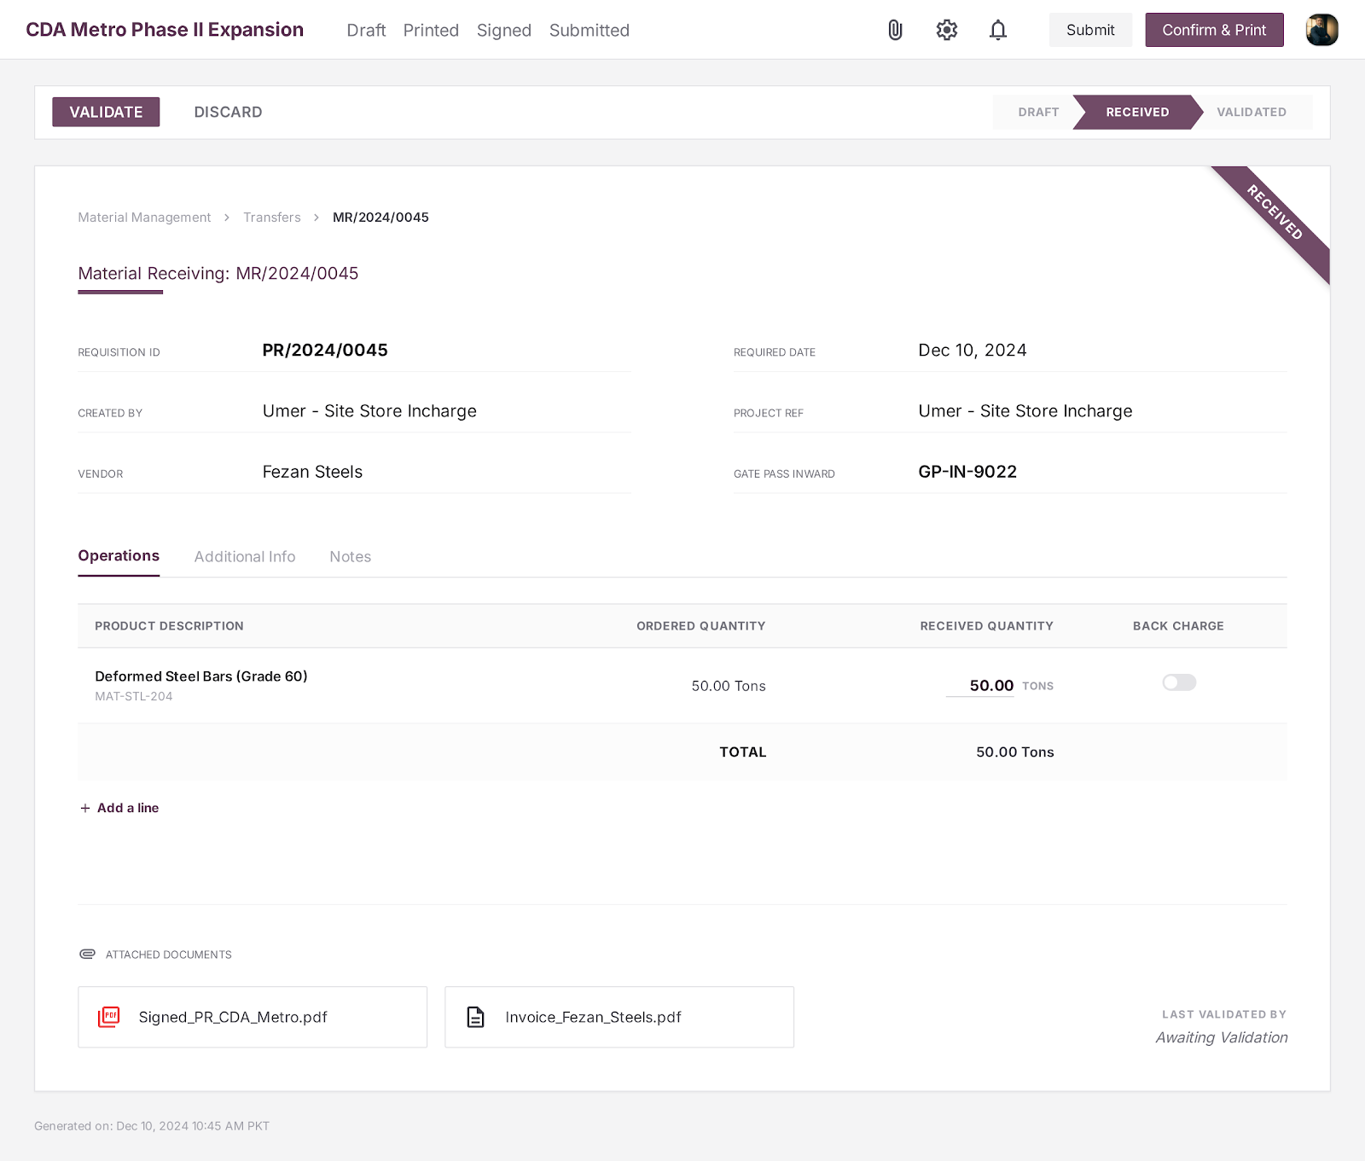

Normal Issuance

Step Name | Description | Inputs | System Actions / Logic | Outputs | Approval? | Remarks / Business Rules
Receive Material Demand | Receive material demand from site | Material Request, Quantity, Receiver Details | Record incoming demand in system | Material demand note | No | Site store receives request from site team
Stock Availability Check | Verify stock before issuance | Demand Request, Inventory Levels | Check available quantity in store | Stock availability status | No | Issuance depends on stock availability
Inventory Type Selection | Define whether issued item is Consumable or Asset | Product Type, Receiver Details | System automatically selects Consumable by default with option to change to Asset | Inventory type classification | No | Important for tracking returnable assets vs consumables
Asset Issuance Validation | Prevent duplicate asset issuance | Asset Item, Receiver Details | System displays warning if same asset is already issued to same person | Validation warning | No | Prevents duplicate asset allocation
Material Issuance | Issue material to site | Approved Demand, Stock Qty | Deduct stock and record issuance | Issued material record | Store Incharge | Physical handover required
Gate Pass Outward | Record movement of issued material | Issued Material Details | Generate outward gate pass | Gate Pass Outward | No | Mandatory for material leaving store
Inventory Update | Update stock after issuance | Issued Quantity | Reduce warehouse inventory | Updated stock record | No | Real-time inventory update required

Expected Odoo View:

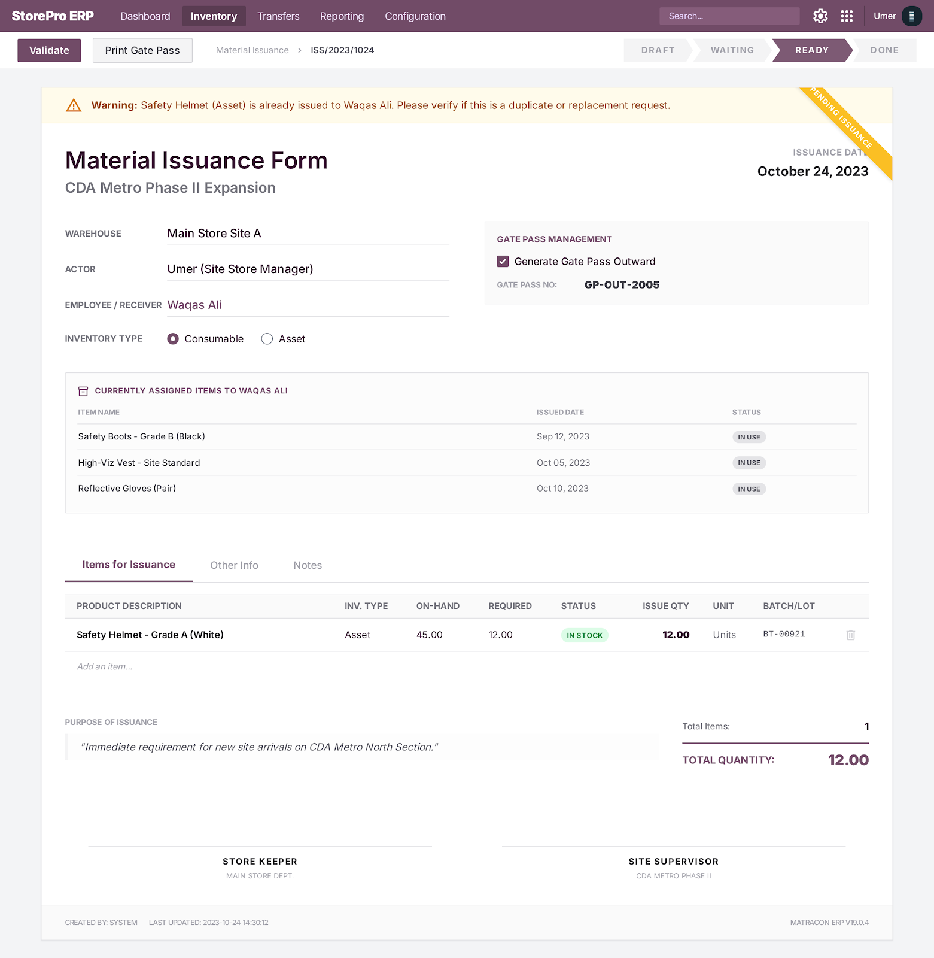
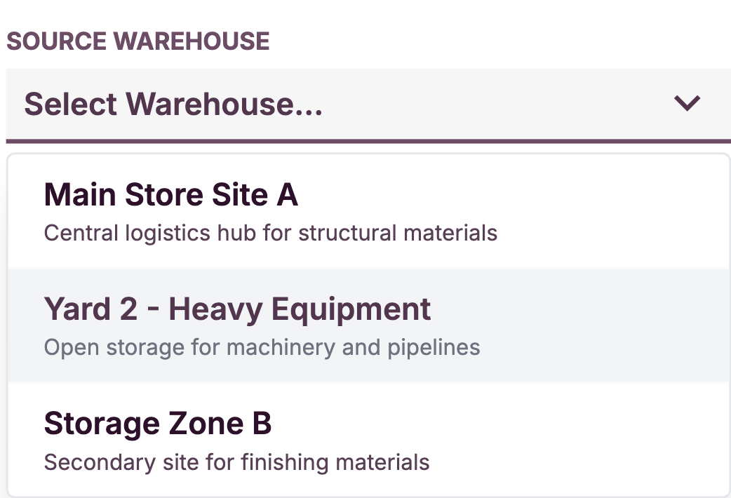

3rd Party (Sub-Contractor) Issuance
gExpected Odoo View:
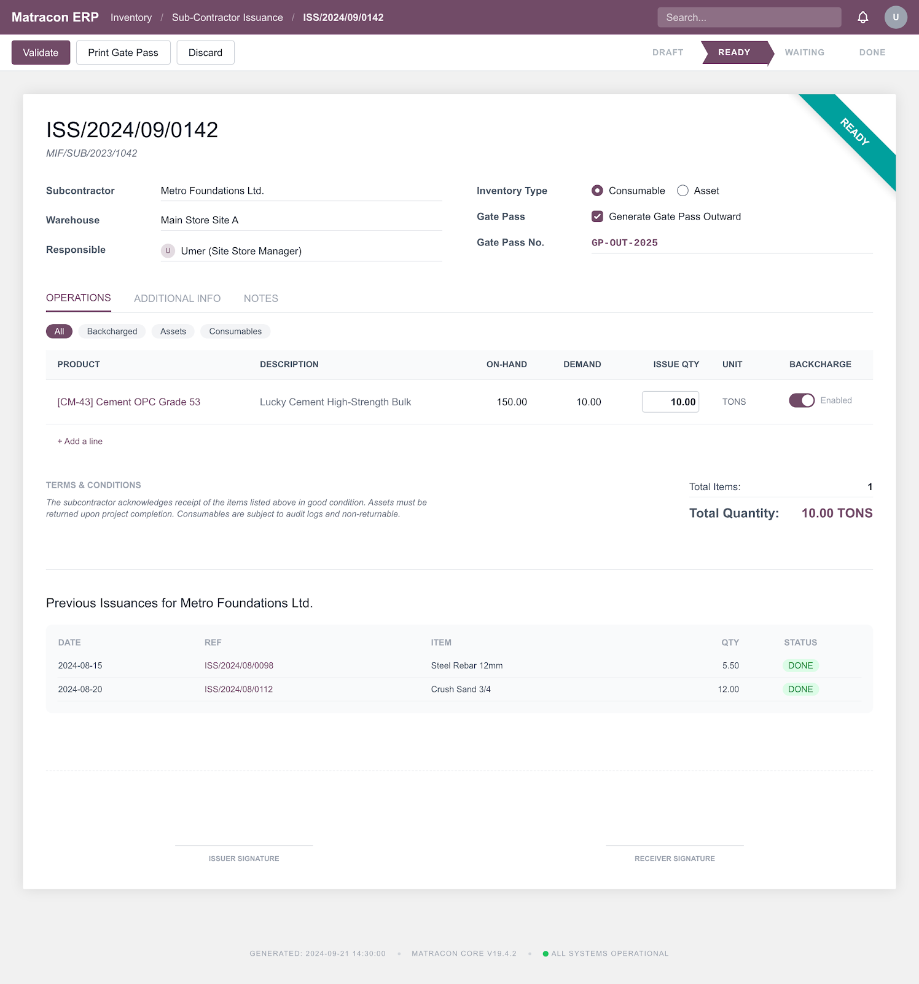


Normal Return

Step Name | Description | Inputs | System Actions / Logic | Outputs | Approval? | Remarks / Business Rules
Receive Return Material | Receive returned material from site team | Returned Material, Quantity, Receiver Details | Record return request in system | Return material note | No | Site store receives returned material
IS-Personal Verification | Verify whether returned item is personal asset or consumable | Product Type, Receiver Details | Check IS-Personal field in system | IS-Personal status | No | Return mainly applies for returnable assets
Material Inspection | Verify condition of returned material | Returned Material, Physical Check | Check condition as New / Used / Repairable / Scrap | Material condition status | No | Condition-based acceptance required
Partial Return Adjustment | Handle partial used material return | Returned Qty, Remaining Qty | Record adjusted quantity/dimensions | Partial return record | No | Example: 10m pipe → 9m returned
Return Acceptance | Accept approved returned material | Verified Return Material | Confirm material acceptance into store | Accepted return record | Store Incharge | Only acceptable material enters stock
Inventory Update | Update stock after return | Accepted Quantity | Add returned material back to inventory | Updated stock record | No | Real-time inventory update required
Scrap Handling | Process unusable returned material | Scrap Material, Condition Status | Mark as scrap if not usable | Scrap record | No | Scrap option must be available
Historical Tracking | Maintain return history | Return Record, Receiver Info | Store return transaction history | Return history record | No | Required for audit and traceability
Expected Odoo View:
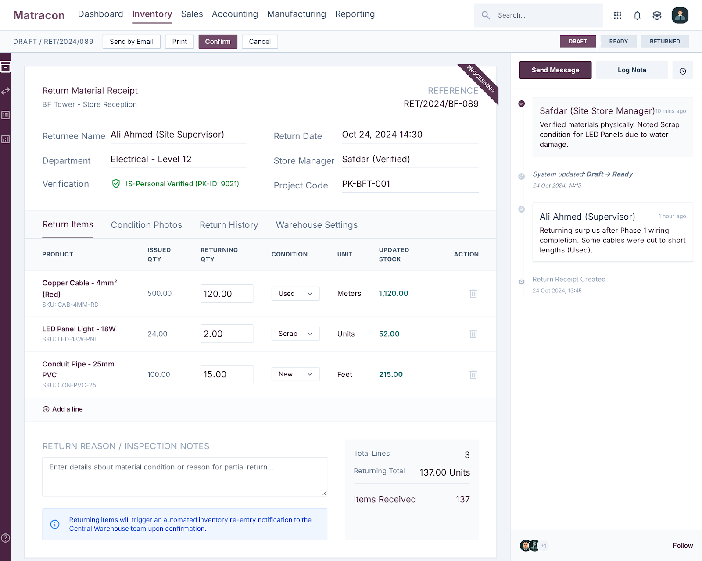

3rd Party (Sub-Contractor) Return

Step Name | Description | Inputs | System Actions / Logic | Outputs | Approval? | Remarks / Business Rules
Receive Return Material | Receive returned material from subcontractor | Returned Material, Quantity, Subcontractor Details | Record return request in system | Return material note | No | Site store receives returned material
Inventory Type Verification | Verify whether returned item is Consumable or Asset | Product Type, Subcontractor Details | Check inventory type in system | Inventory type status | No | Return mainly applies for returnable assets
Backcharge Verification | Verify backcharge applicability | Contract Terms, Material Record | Check backcharge option in system | Backcharge status | No | Based on subcontract terms
Backcharge to Subcontractor | Recover missing or faulty returned assets | Returned Asset, Subcontractor Details | System allows backcharge entry against subcontractor for missing/damaged assets | Backcharge record | No | Applicable for missing or faulty returned assets
Material Inspection | Verify condition of returned material | Returned Material, Physical Check | Check condition as New / Used / Repairable / Scrap | Material condition status | No | Condition-based acceptance required
Partial Return Adjustment | Handle partial used material return | Returned Qty, Remaining Qty | Record adjusted quantity/dimensions | Partial return record | No | Example: partial pipe return
Return Acceptance | Accept approved returned material | Verified Return Material | Confirm material acceptance into store | Accepted return record | Store Incharge | Only acceptable material enters stock
Inventory Update | Update stock after return | Accepted Quantity | Add returned material back to inventory | Updated stock record | No | Real-time inventory update required
Historical Tracking | Maintain return history | Return Record, Subcontractor Info | Store return transaction history | Return history record | No | Required for audit, liability, and reconciliation
Expected Odoo View:
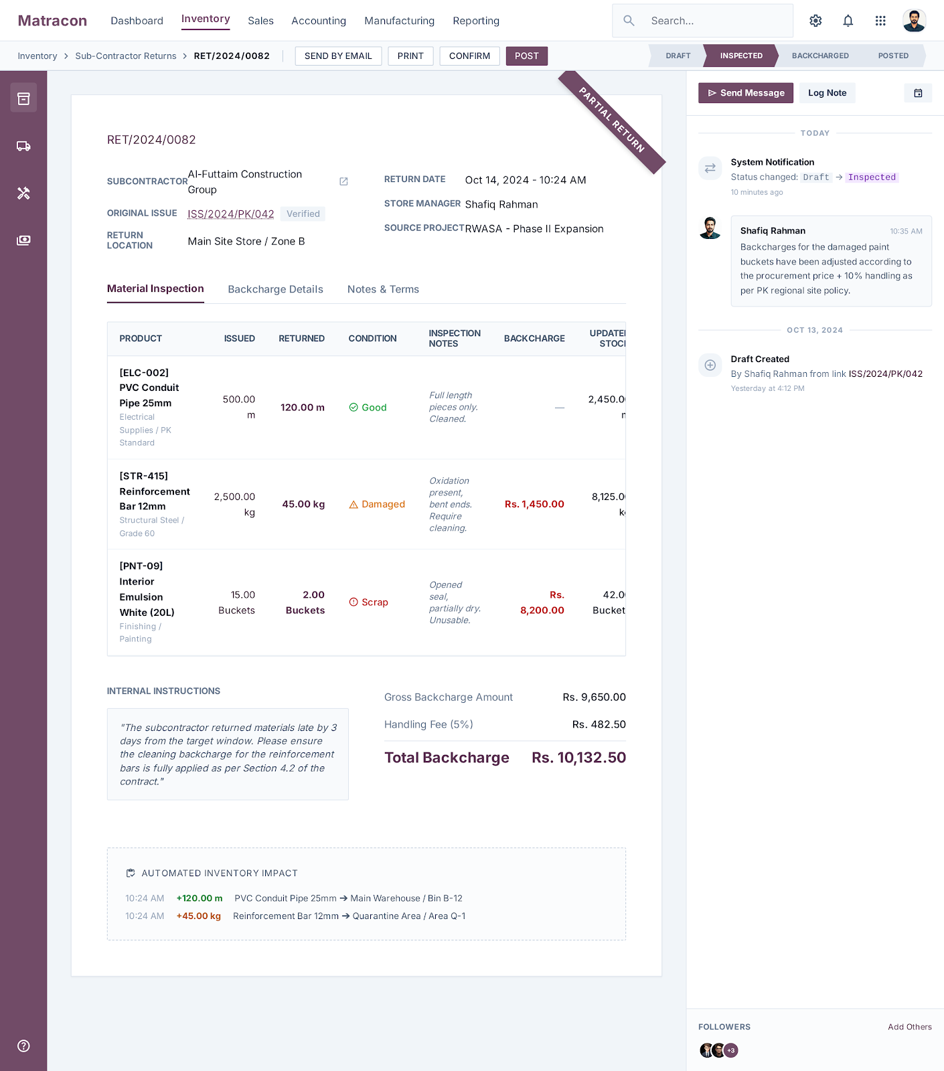

Site To Site Transfer

Step Name | Description | Inputs | System Actions / Logic | Outputs | Approval? | Remarks / Business Rules
Transfer Requirement Identification | Identify need for material transfer between sites | Material Requirement, Source Site, Destination Site | Record transfer need in system | Transfer request note | No | Used when one site needs material from another
MTN Creation | Create Material Transfer Note (MTN) | Material Details, Quantity, Source & Destination | Generate MTN in system | MTN record | No | Mandatory for inter-site transfer
HO Approval Request | Send MTN for head office approval | MTN Record | Forward request to CEO/MD/Procurement for approval | Approval request submitted | No | Approval required before transfer
CEO/MD/Procurement Approval | Approve internal material transfer | MTN Request | Approve or reject transfer request | Approved MTN | CEO/MD / Procurement | Mandatory control step
Gate Pass Outward | Create outward gate pass from source site | Approved MTN, Material Details | Generate gate pass for dispatch | Gate Pass Outward | No | Source and destination must be mentioned
Material Dispatch | Dispatch material from source site | Approved MTN, Gate Pass | Reduce stock from source site | Dispatch record | Store Incharge | Physical movement starts
Material Receipt at Destination | Receive material at destination site | Delivered Material, MTN | Confirm receipt and verification | Receipt confirmation | Store Incharge | Destination site must acknowledge
Inventory Update | Update stock at both sites | Dispatch + Receipt Data | Reduce source stock and increase destination stock | Updated stock record | No | Real-time inventory adjustment
Historical Tracking | Maintain full transfer history | MTN, Gate Pass, Receipt | Store transfer history for audit | MTN history record | No | Required for traceability

Expected Odoo View: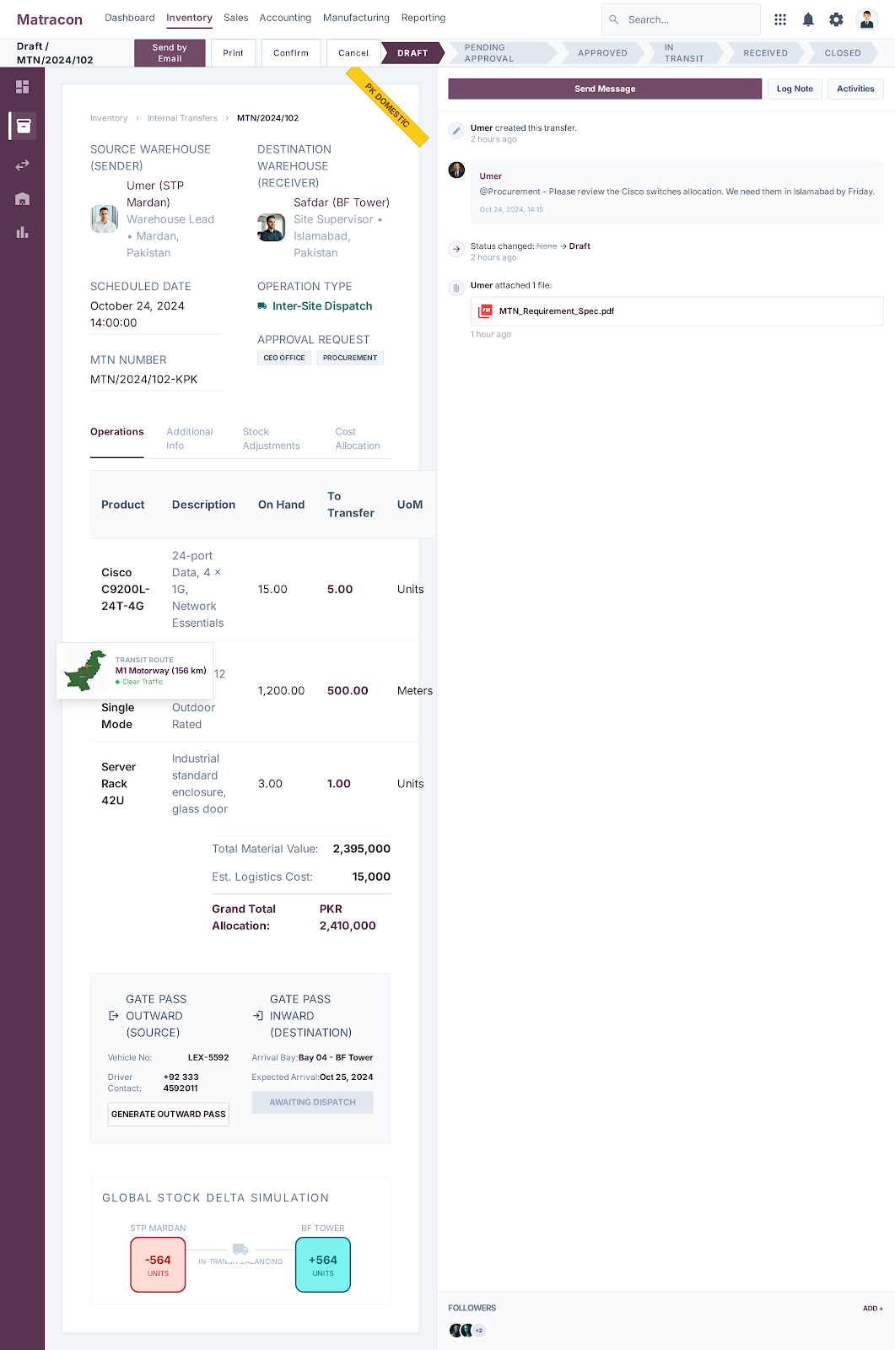

Management Dashboard:
