## **Bilal Hameed**

## **Data Scientist @ CareCloud**

## **ML/DL Algorithm’s Notes**

# **Deep Learning**

******************************************************************************

**Explain ANN and step involve to train a ANN**

Artificial Neural Networks (ANNs) are computational models inspired by the structure and function of the human brain. They consist of interconnected nodes, also called neurons or units, organized into layers. ANNs are a fundamental component of machine learning and are used for tasks such as classification, regression, pattern recognition, and more. Training an ANN involves adjusting its parameters so that it can learn from data and make accurate predictions. Here are the key steps involved in training an Artificial Neural Network:

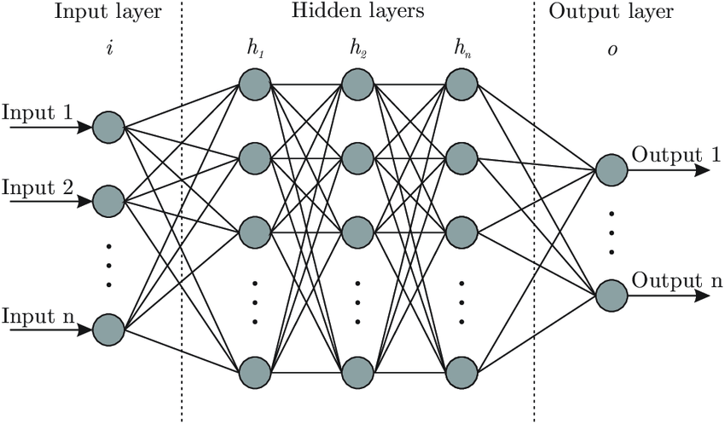

1. **Initialization:**
   * Initialize the weights and biases of the neurons in the network. This can be done randomly or using specific initialization techniques to set a starting point for learning.
2. **Forward Propagation:**
   * Pass the input data through the network to generate predictions (output) using the current weights and biases.
   * Each layer in the network performs a linear transformation (weighted sum of inputs) followed by an activation function.
3. **Calculate Loss:**
   * Compare the model's predictions with the actual target values to quantify the error. This is typically done using a loss or cost function, which measures the difference between predicted and actual values.
4. **Backpropagation:**
   * Backpropagation is a key algorithm for updating the weights and biases of the network to minimize the loss.
   * Compute the gradients of the loss with respect to the weights and biases using the chain rule of calculus. This involves calculating how much the loss would change with respect to each weight and bias.
   * Update the weights and biases in the opposite direction of the gradients to reduce the loss. This step is usually performed using an optimization algorithm like gradient descent.
5. **Optimization:**
   * Use an optimization algorithm (e.g., gradient descent, stochastic gradient descent) to adjust the model parameters iteratively.
   * The learning rate is a hyperparameter that determines the step size during optimization. It influences how much the weights are adjusted in each iteration.
6. **Repeat:**
   * Repeat steps 2-5 for multiple epochs or until the model's performance converges to a satisfactory level.
   * An epoch is one complete pass through the entire training dataset.
7. **Validation:**
   * Monitor the model's performance on a validation dataset that was not used during training. This helps assess the model's generalization to unseen data and avoid overfitting (fitting the training data too closely).
8. **Testing:**
   * Evaluate the final trained model on a separate test dataset to assess its performance on completely unseen data.
9. **Fine-Tuning (Optional):**
   * Based on the validation results, fine-tune hyperparameters (e.g., learning rate, number of layers, number of neurons) or adjust the model architecture to improve performance.
10. **Deployment:**
    * Once satisfied with the model's performance, deploy it for making predictions on new, unseen data.

It's important to note that the success of training an ANN depends on various factors, including the choice of architecture, hyperparameters, and the quality and quantity of the training data. Experimentation and tuning are often necessary to achieve optimal performance.

******************************************************************************

**Explain CNN?**

Convolutional Neural Networks (CNNs) are a class of deep learning models designed for tasks involving grid-like data, such as images. CNNs are particularly powerful in image recognition, object detection, and other computer vision tasks. Here are the key steps involved in training a Convolutional Neural Network:

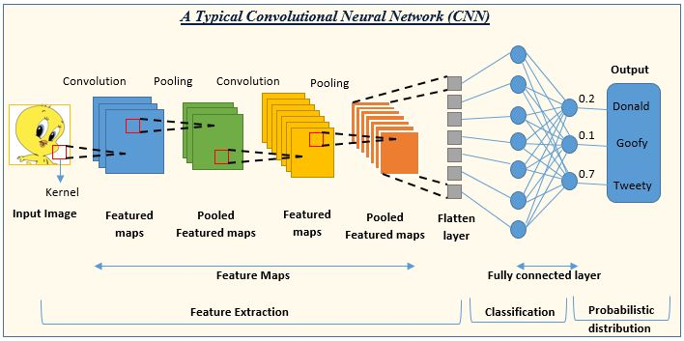

1. **Input Layer:**
   * The input layer of a CNN is typically an image or a grid-like data structure. Images are represented as a grid of pixels, and each pixel value serves as an input feature to the network.
2. **Convolutional Layers:**
   * Convolutional layers are the core building blocks of CNNs. They apply convolutional operations to the input data using filters (also called kernels).
   * Filters slide across the input to detect patterns, edges, textures, or more complex features.
   * Multiple filters are used in parallel to capture different features in the input.
3. **Activation Function:**
   * After convolution, an activation function (commonly ReLU - Rectified Linear Unit) is applied element-wise to introduce non-linearity to the model.
   * The activation function helps the network learn complex mappings and relationships in the data.
4. **Pooling Layers:**
   * Pooling layers follow convolutional layers and are used to reduce spatial **dimensions (width and height)** of the input volume.
   * Max pooling or average pooling is commonly used to retain the most important information while reducing computational complexity.
5. **Flattening:**
   * The output from the convolutional and pooling layers is flattened into a one-dimensional vector.
   * Flattening is necessary to connect the convolutional layers to fully connected layers.
6. **Fully Connected Layers:**
   * Fully connected layers are traditional neural network layers where each neuron is connected to every neuron in the previous and subsequent layers.
   * These layers combine high-level features learned by convolutional layers to make predictions.
   * The final fully connected layer typically has the number of neurons equal to the number of classes in a classification task.
7. **Output Layer:**
   * The output layer produces the final predictions based on the features learned by the network.
   * Common activation functions for the output layer include softmax for multi-class classification and sigmoid for binary classification.
8. **Loss Function:**
   * The loss function quantifies the difference between the predicted values and the true labels.
   * For classification tasks, cross-entropy loss is commonly used.
9. **Optimization:**
   * An optimization algorithm, such as stochastic gradient descent (SGD) or one of its variants, is employed to minimize the loss by adjusting the weights and biases of the network.
   * Learning rate and other hyperparameters are crucial for successful optimization.
10. **Training:**
    * The network is trained by iteratively feeding batches of training data, computing the loss, and updating the weights and biases using backpropagation.
    * Training is performed for multiple epochs until the model converges.
11. **Validation:**
    * The model's performance is evaluated on a validation dataset not used during training to monitor for overfitting and make adjustments if necessary.
12. **Testing:**
    * The final trained model is evaluated on a separate test dataset to assess its generalization to unseen data.

These steps outline the typical training process for a Convolutional Neural Network. Tuning hyperparameters, adjusting the architecture, and using data augmentation are common practices to improve performance.

******************************************************************************

**Diff b/w Max Pooling and Average Pooling?**

**1. Max Pooling**

Max pooling selects the maximum value from each patch of the feature map. It captures the most prominent features and reduces the dimensions, thereby retaining the most significant information.

**How it works:**

Choose a window size (e.g., 2x2).

Slide this window over the input feature map with a specific stride (e.g., stride of 2).

For each position, take the maximum value within the window.

The resulting output is a downsampled version of the input feature map.

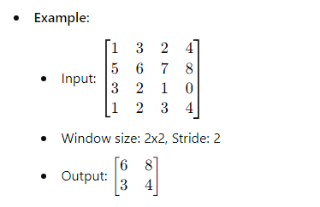

**2. Average Pooling**

Average pooling calculates the average value within each patch of the feature map. This approach is less aggressive than max pooling and provides a smoother output.

**How it works:**

Choose a window size (e.g., 2x2).

Slide this window over the input feature map with a specific stride.

For each position, calculate the average value within the window.

The resulting output is a downsampled version of the input feature map with averaged values.

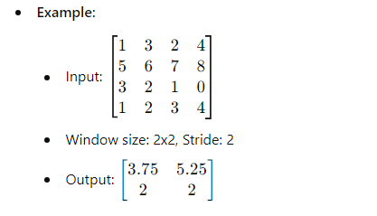

**\*\*\*\*\*\*\*\*\*\*\*\*\*\*\*\*\*\*\*\*\*\*\*\*\*\*\*\*\*\*\*\*\*\*\*\*\*\*\*\*\*\*\*\*\*\*\*\*\*\*\*\*\*\*\*\*\*\*\*\*\*\*\*\*\*\*\*\*\*\*\*\*\*\*\*\*\*\***

**What is Feed Forward Neural network? Explain it.**

A feedforward neural network is a fundamental type of artificial neural network in which information travels in one direction—forward—from the input layer through the hidden layers (if any) to the output layer. It is called "feedforward" because there are no cycles or loops in the network; the data moves in a forward direction without feedback loops.

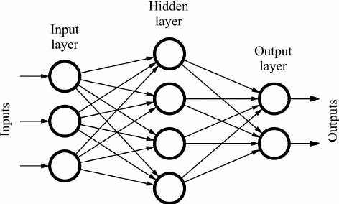

Here's a brief explanation of the key components of a feedforward neural network:

1. **Input Layer:** This layer receives the initial input data. Each node (or neuron) in this layer represents a feature of the input data.
2. **Hidden Layers:** These are intermediate layers between the input and output layers. Each neuron in a hidden layer takes input from the neurons in the previous layer, performs some computation, and passes the result to the next layer. The term "hidden" comes from the fact that the computations within these layers are not directly observable from the network's input or output.
3. **Output Layer:** This layer produces the final output of the network. The number of nodes in the output layer corresponds to the number of output values or classes the network is designed to predict.
4. **Weights and Biases:** Each connection between neurons has an associated weight, and each neuron has a bias. These parameters are learned during the training process, adjusting to optimize the network's performance.
5. **Activation Function:** Neurons in the hidden and output layers usually have an activation function that introduces non-linearity to the network. Common activation functions include the sigmoid, hyperbolic tangent (tanh), and rectified linear unit (ReLU).

The computation in a feedforward neural network involves passing the input through the network layer by layer, with each layer transforming the input using the learned weights and biases. The final output is then compared to the desired output (target) during training, and the network's parameters are adjusted using optimization algorithms like gradient descent to minimize the difference between the predicted and actual outputs.

Feedforward neural networks are the basis for many other neural network architectures, and they are widely used for various tasks such as image recognition, natural language processing, and regression analysis.

******************************************************************************

**What is mean by "there are no cycles or loops in the network"**

When we say "there are no cycles or loops in the network," we are referring to the structure of the neural network architecture. In a feedforward neural network, the flow of information moves in a strictly forward direction, from the input layer through the hidden layers to the output layer, without any feedback loops or connections that loop back on themselves. This characteristic distinguishes feedforward networks from recurrent neural networks (RNNs), where connections can create cycles, allowing information to be fed back into the network.

To illustrate this concept further:

1. **Feedforward Neural Network:**
   * Input Layer → Hidden Layers → Output Layer
   * Information flows only in one direction: forward.
   * No connection allows information to loop back to the same layer or a previous layer.
2. **Recurrent Neural Network (RNN):**
   * In an RNN, connections between neurons can create cycles or loops.
   * This allows the network to maintain a memory of previous inputs and consider sequential information.

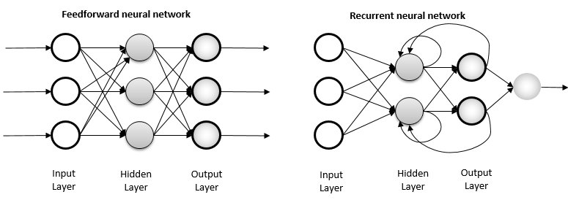

The absence of cycles or loops in feedforward neural networks simplifies their architecture and makes them suitable for certain tasks, especially when the input data is not sequential or does not have a temporal aspect. Feedforward networks are commonly used in tasks such as image classification, where each input (e.g., an image) is processed independently without the need to consider the order of inputs.

******************************************************************************

**What is RNN in Deep learning. Explain it**

Recurrent Neural Networks (RNNs) are a type of artificial neural network designed for sequential data processing. They are particularly well-suited for tasks where the input and output data are sequences, such as time series prediction, natural language processing, and speech recognition. RNNs have the ability to maintain a hidden state that captures information about previous inputs in the sequence, allowing them to exhibit temporal dynamics.

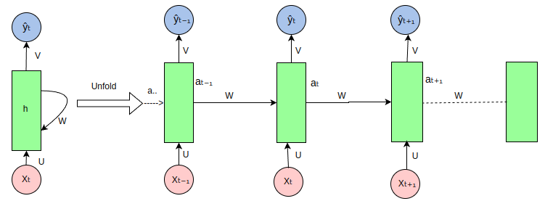

Here's a basic explanation of how RNNs work:

1. **Sequential Data Processing:**
   * RNNs process input data sequentially, one element at a time. Each element in the sequence is processed along with information from the previous elements.
2. **Hidden State:**
   * RNNs maintain a hidden state vector that acts as memory, capturing information from previous time steps. This hidden state is updated at each time step based on the current input and the previous hidden state.
3. **Parameter Sharing:**
   * One key feature of RNNs is parameter sharing across time steps. The same set of weights and biases is used at each time step, allowing the network to learn and generalize patterns in sequential data.
4. **Unrolling in Time:**
   * To conceptualize how an RNN processes a sequence, you can think of it as unrolling over time. At each time step, the RNN takes an input, updates its hidden state, and produces an output.
5. **Training:**
   * During training, the network learns the parameters (weights and biases) by adjusting them based on the error between the predicted output and the actual target at each time step. This is done through backpropagation through time (BPTT).
6. **Vanishing and Exploding Gradients:**
   * One challenge with vanilla RNNs is the vanishing or exploding gradient problem. As the network processes sequences over many time steps, gradients can become very small or very large, making it difficult to train the model effectively. Long Short-Term Memory (LSTM) and Gated Recurrent Unit (GRU) are popular variants of RNNs that address this issue.

In summary, RNNs are designed to handle sequential data by maintaining a hidden state that captures information from previous time steps. Despite their effectiveness, RNNs have limitations, and more advanced architectures like LSTMs and GRUs have been developed to overcome some of these challenges in capturing long-range dependencies in sequences.

******************************************************************************

**What is LSTM in Deep Learning/Machine Learning? Explain it?**

Long Short-Term Memory (LSTM) is a **type of recurrent neural network (RNN)** architecture designed to address the vanishing gradient problem, which often occurs in traditional RNNs. The vanishing gradient problem makes it difficult for RNNs to capture long-range dependencies in sequential data, as the gradients of the error with respect to the weights tend to become very small during backpropagation, leading to slow or stalled learning.

LSTMs were introduced by Hochreiter and Schmidhuber in 1997 to overcome this limitation. They have a more complex structure than standard RNNs and include a memory cell, which allows them to capture and store information over longer sequences. The key components of an LSTM network include:

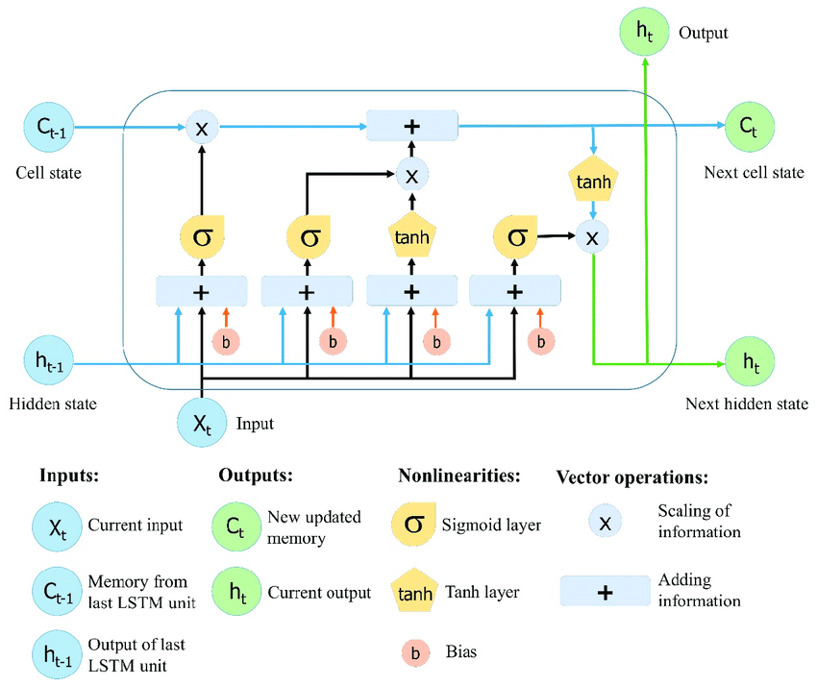

1. **Cell State (Ct):** The cell state is a long-term memory that runs through the entire sequence. It can be modified by information from the **current input**, and it can also be affected by the **previous cell state.**
2. **Hidden State (ht):** The hidden state is the short-term memory that captures information from the **current input** and the **previous hidden state**. It is used to make predictions or decisions at each time step.
3. **Input Gate (i), Forget Gate (f), Output Gate (o):** These gates control the flow of information into and out of the memory cell. The **input gate** determines how much of the new information should be stored in the cell state. The **forget gate** decides what information from the previous cell state should be discarded. The **output gate** determines how much of the cell state should be exposed to the next hidden state.

The architecture of an LSTM allows it to selectively remember or forget information at different time steps, making it well-suited for learning from sequential data with long-term dependencies. This makes LSTMs particularly effective for tasks such as natural language processing, speech recognition, and time series prediction.

In summary, LSTMs are a type of recurrent neural network designed to address the challenges of learning long-range dependencies in sequential data by using a more sophisticated memory cell and gating mechanisms.

******************************************************************************

**What is GRU Explain it?**

Gated Recurrent Unit (GRU) is another **type of recurrent neural network (RNN)** architecture, introduced by Cho et al. in 2014. Like LSTM, GRU is designed to address the vanishing gradient problem in traditional RNNs and is well-suited for modeling sequential data.

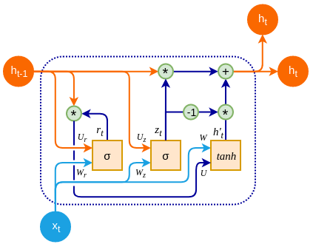

GRUs share some similarities with LSTMs but have a simpler structure with only two gates: an **update gate and a reset gate.** The key components of a GRU include:

1. **Update Gate (z):** This gate determines how much of the **previous memory** should be retained and how much of the **new memory** candidate should be added to the **updated memory**. It controls the flow of information from the previous hidden state to the current hidden state.
2. **Reset Gate (r):** This gate decides how much of the **previous hidden state** should be forgotten or reset. It controls the influence of the previous hidden state on the calculation of the new hidden state.
3. **Current Memory (h_t):** This is the current hidden state, which is updated based on the input, the previous hidden state, and the information from the update and reset gates.

One of the advantages of GRUs is their simplicity compared to LSTMs, which makes them computationally more efficient and easier to train. Despite their simpler architecture, GRUs have been found to perform competitively with LSTMs on various tasks. However, LSTMs might still have an edge in tasks that require modeling very long-term dependencies.

In summary, GRU is a type of recurrent neural network architecture that, like LSTM, addresses the vanishing gradient problem by introducing gating mechanisms. It uses an update gate and a reset gate to control the flow of information in the network, allowing it to capture dependencies in sequential data. GRUs are particularly useful when a balance between model complexity and computational efficiency is desired.

******************************************************************************

## **Generative Models**

1. **Explain Generative Adversarial Networks (GANs)?**

Generative Adversarial Networks (GANs) are a class of machine learning frameworks designed to generate new data that mimics a given dataset. Introduced by Ian Goodfellow and his colleagues in 2014, GANs consist of two neural networks, the Generator and the Discriminator, which are trained simultaneously through a process of adversarial competition.

### Components of GANs

1. **Generator (G)**:
   * The Generator's role is to produce data that resembles the real dataset. It takes random noise as input and transforms it into a plausible data instance (e.g., an image, a piece of text, etc.).
   * The Generator aims to create outputs that are indistinguishable from the real data to the Discriminator.
2. **Discriminator (D)**:
   * The Discriminator's job is to differentiate between real data (from the actual dataset) and fake data (produced by the Generator).
   * It outputs a probability that a given input is real (i.e., from the actual dataset) rather than generated by the Generator.

### Training Process

The training process of GANs involves two competing objectives:

* The Generator tries to improve its capability to produce realistic data to fool the Discriminator.
* The Discriminator tries to improve its ability to distinguish real data from fake data generated by the Generator.

This process can be likened to a game where:

* The Generator is like a counterfeiter trying to produce fake currency that looks like real money.
* The Discriminator is like the police trying to detect the counterfeit money.

### Challenges and Techniques

Training GANs can be challenging due to issues such as:

* **Mode collapse**: The Generator may produce limited varieties of outputs, missing the diversity of the real data.
* **Training instability**: The adversarial training process can be unstable, making it hard to converge.

Various techniques have been developed to address these issues, including:

* **Improved architectures**: Using different network architectures such as Deep Convolutional GANs (DCGANs).
* **Regularization techniques**: Applying regularization to stabilize training.
* **Alternative loss functions**: Using Wasserstein loss (WGAN) instead of the original minimax loss to improve training stability.

### Applications

GANs have numerous applications, including:

* **Image generation**: Creating realistic images, such as faces, landscapes, or artwork.
* **Data augmentation**: Generating additional training data to improve machine learning models.
* **Style transfer**: Applying the style of one image to the content of another.
* **Super-resolution**: Enhancing the resolution of images.

In summary, GANs are a powerful and versatile tool in the field of generative modeling, leveraging the adversarial training of two neural networks to produce highly realistic data that mimics a given dataset.

******************************************************************************

1. **Explain Autoencoders?**

Autoencoders are a type of artificial neural network used for unsupervised learning of efficient codings. They are primarily used for dimensionality reduction and feature learning. The goal of an autoencoder is to learn a representation (encoding) for a set of data, typically for the purpose of data compression.

Here is a breakdown of the key components and functionality of autoencoders:

### Structure of Autoencoders

Autoencoders consist of two main parts:

1. **Encoder**: The encoder transforms the input data into a reduced-dimensional representation, which is often referred to as “latent space” or “encoding”. The encoder function h=f(x)h = f(x)h=f(x) maps the input xxx to a hidden representation hhh.
2. **Decoder**: From that representation, a decoder rebuilds the initial input. For the network to gain meaningful patterns in data. The decoder function x′=g(h)x' = g(h)x′=g(h) maps the hidden representation hhh back to a reconstructed input x′x'x′.

### Basic Architecture

* **Input Layer**: Takes the input data.
* **Hidden Layers**: Multiple hidden layers can be used to learn complex features. The layer in the middle of the network (bottleneck) is the encoded representation (latent space).
* **Output Layer**: Attempts to reconstruct the input data from the encoded representation.

Autoencoders are powerful tools in modern machine learning, especially in fields requiring data compression, noise reduction, and feature extraction.

******************************************************************************

**Explain Seq2Seq (Sequence-to-Sequence)** **Modeling.**

Seq2Seq (Sequence-to-Sequence) modeling is a **type of neural network architecture** designed to transform one sequence into another sequence. This approach is commonly used for tasks where the input and output are both sequences, but they can have different lengths. The Seq2Seq model is particularly useful in applications such as machine translation, text summarization, speech recognition, and chatbot development.

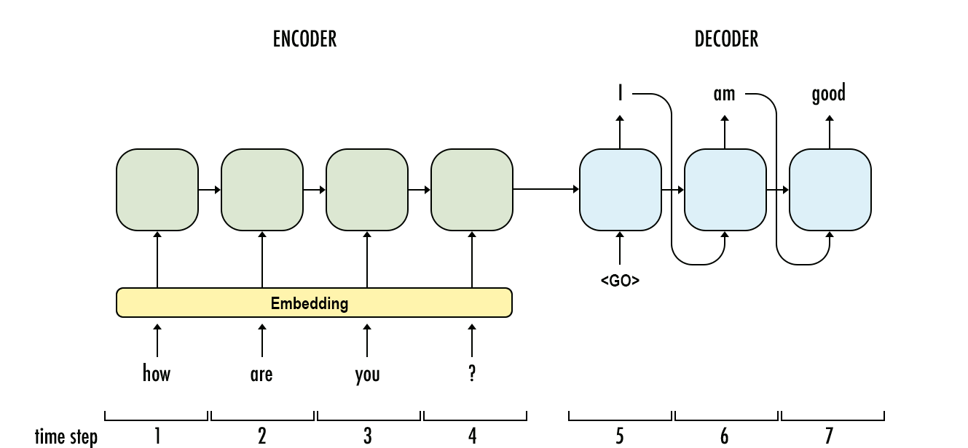

Here's a breakdown of how Seq2Seq modeling works and its components:

### Key Components

1. **Encoder**:
   * The encoder processes the input sequence and compresses the information into a fixed-size context vector (also known as the hidden state or thought vector).
   * It typically consists of layers of recurrent neural networks (RNNs), Long Short-Term Memory (LSTM) networks, or Gated Recurrent Units (GRUs).
2. **Decoder**:
   * The decoder takes the context vector generated by the encoder and generates the output sequence, one element at a time.
   * Like the encoder, the decoder is also usually built with RNNs, LSTMs, or GRUs.
   * The decoder can generate sequences of varying lengths, different from the length of the input sequence.
3. **Context Vector**:
   * This is the output of the encoder's final hidden state, which encapsulates the entire input sequence's information.
   * The context vector serves as the initial hidden state for the decoder.

******************************************************************************

**Explain Encoder in Sequence to Sequence Model?**

In a Sequence-to-Sequence (Seq2Seq) model, the encoder is a crucial component responsible for processing the input sequence and converting it into a **fixed-size context vector**, also known as the **encoder's hidden state**. This context vector contains the essential information from the input sequence that the decoder will use to generate the output sequence.

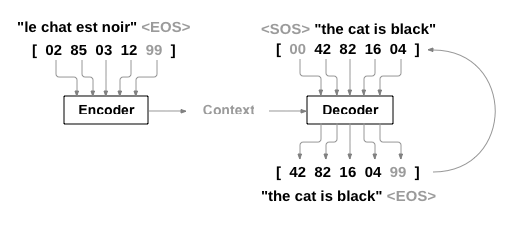

Here's a step-by-step explanation of how the encoder works in a Seq2Seq model:

1. **Input Sequence:** The input sequence, often represented as a sequence of tokens or words, is fed into the encoder.
2. **Word Embeddings:** Each token in the input sequence is typically transformed into a dense vector representation called word embeddings. These embeddings capture semantic relationships between words and help the model understand the meaning of the input.
3. **Recurrent Neural Network (RNN) or Long Short-Term Memory (LSTM):** The core of the encoder is typically a recurrent neural network (RNN) or a variant like Long Short-Term Memory (LSTM). These types of networks are capable of processing sequential data. The input sequence is fed into the RNN one token at a time, and the hidden state of the RNN is updated at each step. The hidden state serves as a memory that accumulates information from the entire input sequence.
4. **Final Hidden State (Context Vector):** Once the entire input sequence has been processed, the final hidden state of the RNN becomes the context vector. This context vector is a condensed representation of the input sequence and contains information about the input's semantic meaning.

Mathematically, if h represents the hidden state at each time step, the final hidden state is often denoted as h_t. This final hidden state h_t is the encoded representation of the input sequence.

The encoder's role is to capture the relevant information from the input sequence and create a fixed-size representation that the decoder can use to generate the output sequence. This enables the model to handle variable-length input sequences and generate corresponding variable-length output sequences, making Seq2Seq models suitable for tasks like machine translation, summarization, and more.

******************************************************************************

**Explain Decoder in Sequence to Sequence Model?**

In a Sequence-to-Sequence (Seq2Seq) model, the decoder is responsible for generating an output sequence based on the **context vector** produced by the **encoder**. The decoder takes the fixed-size context vector, which summarizes the input sequence, and produces a variable-length output sequence.

Here's a step-by-step explanation of how the decoder works in a Seq2Seq model:

1. **Context Vector:** The context vector generated by the encoder serves as the initial hidden state for the decoder. This context vector contains the essential information from the input sequence and serves as a starting point for generating the output sequence.
2. **Recurrent Neural Network (RNN) or Long Short-Term Memory (LSTM):** Similar to the encoder, the decoder often uses a recurrent neural network (RNN) or a variant like Long Short-Term Memory (LSTM). The decoder processes the output sequence step by step, updating its hidden state at each time step.
3. **Teacher Forcing (Optional):** During training, the decoder can be trained using a technique called teacher forcing. Instead of using its own generated output as input for the next time step, the decoder is provided with the true target output at each step during training. This helps stabilize training but may lead to exposure bias, where the model is not exposed to its own errors during training.
4. **Output Sequence:** The decoder generates the output sequence one token at a time. At each time step, the model predicts the next token in the sequence based on the current hidden state and the context vector. This process is repeated until an end token is generated, or a predefined maximum length is reached.

Mathematically, if h represents the hidden state of the decoder at each time step and y_t represents the predicted token at time step t, the generation process can be expressed as:

yt=Decoder(yt−1,ht)y_t = \text{Decoder}(y_{t-1}, h_t)yt​=Decoder(yt−1​,ht​)

The decoder's role is to utilize the information in the context vector to produce a meaningful output sequence. This makes Seq2Seq models suitable for tasks such as machine translation, where the input and output sequences can have different lengths and structures. The training process involves adjusting the model parameters to minimize the difference between the predicted and actual output sequences.

******************************************************************************

**Attention in Machine Learning**

Attention mechanisms in machine learning refer to a mechanism that **allows models to** **focus on specific parts of input data when making predictions**. It's particularly useful in tasks like natural language processing, image recognition, and sequence-to-sequence problems. Attention helps the model weigh the importance of different elements in the input, improving its ability to capture relevant information.

******************************************************************************

**What is transformer attention mechanism?**

The Transformer attention mechanism is a key component in the Transformer architecture, introduced in the "**Attention is All You Need**" paper by Vaswani et al. It revolutionized natural language processing tasks. The attention mechanism in a Transformer model consists of **self-attention layers**, where each element in the input sequence attends to all other elements



In self-attention, a **query, key, and value are linearly transformed** to produce attention scores. These attention scores determine the **weights** given to **different parts** of the **input sequence**. The **attention scores** are then used to create a **weighted sum** of the **values**, **producing the output for each position**. This process is performed in parallel for all positions, making Transformers highly efficient for sequence processing tasks.

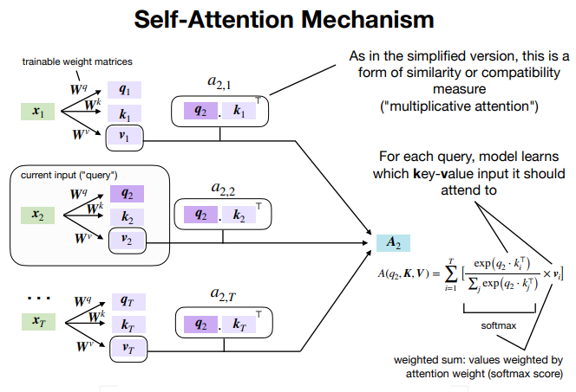

The self-attention mechanism allows the model to focus on relevant parts of the input sequence, capturing long-range dependencies and improving performance in tasks like machine translation and text generation.

******************************************************************************

**Transformer in NLP**

Certainly! The Transformer is a **deep learning model** architecture that was introduced in the paper "**Attention is All You Need**" by Vaswani et al. in 2017. It has become a foundational model for various natural language processing (NLP) tasks due to its ability to capture **long-range dependencies** and **parallelize training effectively**.

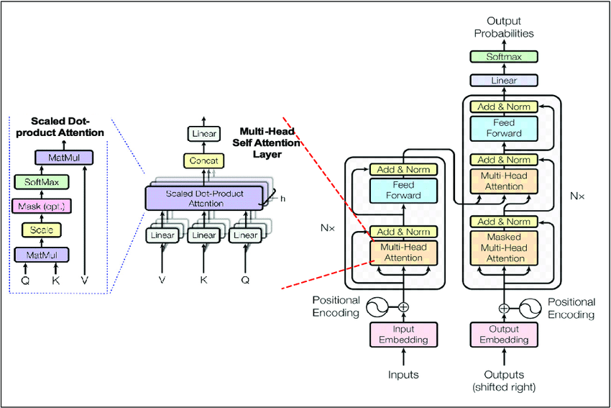

Here are the key components of the Transformer architecture:

1. **Self-Attention Mechanism:**
   * The core innovation of the Transformer is the self-attention mechanism, which allows the model to weigh different words in a sequence differently based on their importance.
   * Given a sequence of words, self-attention computes a set of attention scores for each word, indicating how much focus it should give to other words in the sequence.
   * This attention mechanism enables the model to consider the entire context of a word when making predictions.
2. **Encoder-Decoder Architecture:**
   * Transformers are often used in a sequence-to-sequence setup where an input sequence is transformed into an output sequence.
   * The model consists of an encoder and a decoder. The encoder processes the input sequence, and the decoder generates the output sequence.
   * Each encoder and decoder layer has its own self-attention mechanism.
3. **Multi-Head Attention:**
   * To capture different aspects of the input sequence, the self-attention mechanism is employed in multiple heads in parallel.
   * Each head learns different attention patterns, and their outputs are concatenated and linearly transformed.
4. **Positional Encoding:**
   * Since transformers don't have an inherent sense of order in the input sequence, positional encodings are added to the input embeddings to convey the position of each token in the sequence.
5. **Feedforward Neural Networks:**
   * After the attention mechanism, the output is passed through a feedforward neural network at each position in the sequence. FFNN’s introduce **non-linear** **transformations**, enabling the model to capture **complex patterns**; they help in **transforming data dimensions**; and they **enhance feature extraction**.
6. **Layer Normalization and Residual Connections:**
   * Layer normalization and residual connections are used to **stabilize and speed up training**.
7. **Transformer Training:**
   * The model is trained using a **variant** of the **attention mechanism** called **scaled dot-product attention**, and it is optimized using backpropagation and gradient descent.
8. **Masking:**
   * In training, the self-attention mechanism is often modified to prevent attending to future tokens, which is achieved through masking.
9. **BERT and GPT Models:**
   * **BERT (Bidirectional Encoder Representations from Transformers) and GPT (Generative Pre-trained Transformer)** are two popular **applications** of the **Transformer architecture in NLP.**
   * BERT is designed for tasks like **question answering and text classification**, while GPT is a **generative model** used for tasks like **language modeling and text generation.**

The Transformer architecture has shown remarkable performance in various NLP tasks and has become the foundation for many state-of-the-art models in the field. Its attention mechanism allows it to capture dependencies regardless of their distance in the input sequence, making it effective for tasks requiring a deep understanding of context.

******************************************************************************

**Difference Between causal and masked Language Model.**

Causal Language Model and Masked Language Model are two types of language models commonly used in natural language processing tasks, particularly in tasks like text generation and understanding. Here's the difference between them:

1. **Causal Language Model (Autoregressive Model)**:

CLM is an **autoregressive** **method** where the model is trained to predict the **next token** in a sequence given the previous tokens. CLM is used in models like **GPT-2 and GPT-3** and is well-suited for tasks such as **text generation and summarization**. However, CLM models have **unidirectional** context, meaning they **only consider** the **past** and **not the future context** when generating predictions.

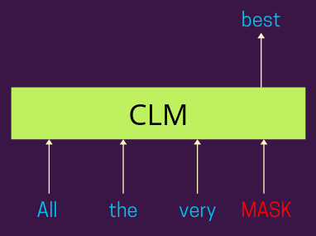

1. **Masked Language Model**:

MLM is a training method used in models like **BERT**, where **some tokens in the input** sequence are **masked**, and the model learns to predict the masked tokens based on the **surrounding context**. MLM has the advantage of **bidirectional** context, allowing the model to consider both **past and future** tokens when making predictions. This approach is especially useful for tasks like text classification, sentiment analysis, and named entity recognition.

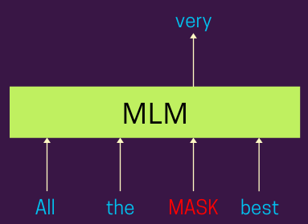

In summary, the key difference lies in how the models are trained and make predictions. Causal language models predict tokens sequentially based on the tokens that came before, while masked language models are trained to predict masked tokens based on the context provided by the surrounding tokens in the sequence.

******************************************************************************

**Next Sentence Prediction (NSP):**

NSP involves training the model to predict whether two sentences in a document are consecutive or not. NSP is designed to help the model understand the relationship between sentences, which is crucial for various downstream tasks such as question answering and document classification.

### **Example:**

Let's say we have the following sentences:

* Sentence A: "The cat sat on the mat."
* Sentence B: "It was a sunny day."
* Sentence C: “The mat was very comfortable”

For training, we provide the model with pairs like:

* (Sentence A, Sentence B) labeled as 'NotNext' (since these two sentences are not consecutive in a document).
* (Sentence A, Sentence C) labeled as 'IsNext' (assuming Sentence C follows Sentence A in the document).

The model processes these inputs and learns to predict the correct labels, improving its ability to understand sentence coherence and context.

******************************************************************************

**BERT in NLP**

BERT, which stands for **Bidirectional Encoder Representations from Transformers**, is a powerful natural language processing (NLP) model introduced by **Google in the paper "BERT: Pre-training of Deep Bidirectional Transformers for Language Understanding"** by Devlin et al. **BERT** has significantly impacted the field of NLP and has become the basis for various downstream applications due to its **ability to capture bidirectional context and contextualized word representations**. Here are the key aspects of BERT:

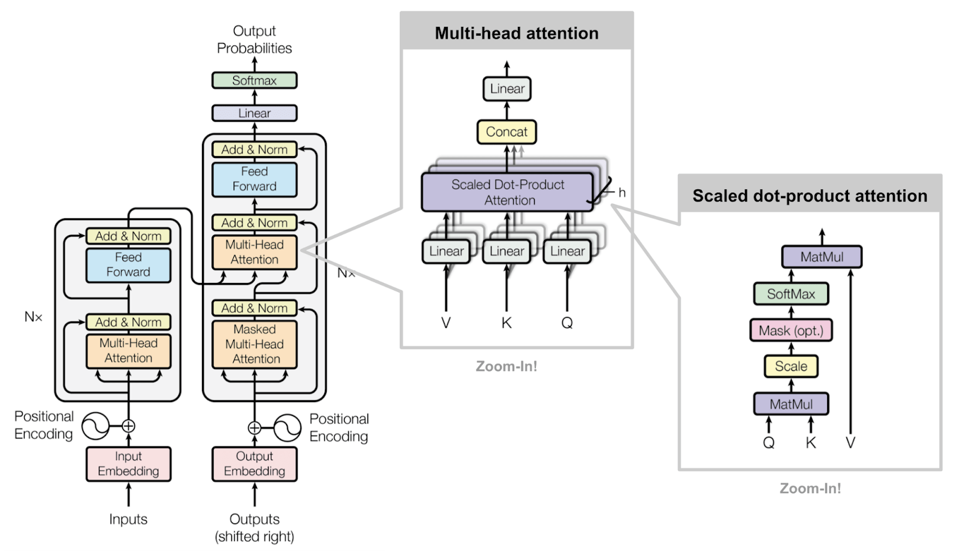

1. **Bidirectional Context:**
   * Unlike previous models that processed text in a left-to-right or right-to-left manner, **BERT is bidirectional**. It **considers** both the **left and right** context of each word in a sequence, allowing it to capture richer contextual information. Bidirectional meaning it reads the **entire sequence of words at once**. This allows it to understand the context of a word based on the words that come before and after it.
2. **Pre-training Objective:**
   * BERT is pre-trained on large corpora using **two unsupervised tasks: masked language modeling (MLM) and next sentence prediction (NSP).**
   * In MLM, a certain percentage of words in each input sequence are randomly masked, and the model is trained to predict the masked words based on the context.
   * NSP involves training the model to predict whether two sentences in a document are consecutive or not.
3. **Architecture:**
   * BERT uses the **Transformer architecture**, comprising multiple layers of **self-attention** and **feedforward neural networks.**
   * It consists of an **encoder** with a stack of transformer layers. The attention mechanism in BERT is bidirectional and attends to all positions in the input sequence.
4. **Contextualized Word Representations:**
   * BERT produces **contextualized word embeddings**, meaning that the representation of each word depends on its context within the sentence.
   * The model captures a deep understanding of word meaning based on its surrounding words, allowing it to handle word sense disambiguation and context-dependent semantics.
5. **Tokenization:**
   * BERT uses WordPiece tokenization, which involves breaking words into smaller subwords or pieces. This helps handle out-of-vocabulary words and improves the model's ability to generalize.
6. **Fine-Tuning for Downstream Tasks:**
   * After pre-training, BERT can be fine-tuned on specific downstream tasks such as text classification, named entity recognition, question answering, and more.
   * During fine-tuning, task-specific layers are added on top of the pre-trained BERT model.
7. **Applications:**
   * BERT has achieved state-of-the-art results on various NLP benchmarks and tasks, including the Stanford Question Answering Dataset (SQuAD), the General Language Understanding Evaluation (GLUE) benchmark, and more.
   * BERT's contextualized representations have been leveraged in various applications, making it a popular choice for researchers and practitioners.
8. **BERT Variants:**
   * Since the introduction of BERT, several variants and improvements have been proposed, such as RoBERTa, ALBERT, and DistilBERT, each with modifications to the architecture or training objectives to enhance performance.

BERT's success has led to its widespread adoption in the NLP community, and its principles have influenced the development of subsequent transformer-based models. It has demonstrated the importance of pre-training large models on diverse data for achieving superior performance on a wide range of NLP tasks.

******************************************************************************

<https://chatgpt.com/share/80398b79-3973-415a-b76f-741b90bcb2fb>

<https://chatgpt.com/share/73322b82-14f8-49da-bc47-8b3f9cdf6cd9>

******************************************************************************

**What is Naive Bayes' Classifier?**

Naive Bayes is a simple but powerful classification algorithm based on Bayes' theorem, which is a probability theory named after the mathematician Thomas Bayes. The "naive" part of Naive Bayes comes from the assumption that features used to describe an observation are conditionally independent, given the class label. In other words, it assumes that the presence of a particular feature in a class is unrelated to the presence of any other feature.

The Naive Bayes classifier is particularly popular for text classification tasks, such as spam filtering or sentiment analysis. It is computationally efficient and works well in practice, even when the independence assumption is not entirely accurate.

Here's a basic overview of how the Naive Bayes classifier works:

1. **Bayes' Theorem:** Bayes' theorem calculates the probability of a hypothesis (class) given the observed evidence (features). The formula is:

P(Class∣Features)=P(Features∣Class)×P(Class)P(Features)P(\text{Class} | \text{Features}) = \frac{P(\text{Features} | \text{Class}) \times P(\text{Class})}{P(\text{Features})}P(Class∣Features)=P(Features)P(Features∣Class)×P(Class)​

1. **Independence Assumption:** The "naive" assumption is that features are independent given the class label. Mathematically, it simplifies the calculation:

P(Features∣Class)=P(Feature1∣Class)×P(Feature2∣Class)×…×P(Featuren∣Class)P(\text{Features} | \text{Class}) = P(\text{Feature}_1 | \text{Class}) \times P(\text{Feature}_2 | \text{Class}) \times \ldots \times P(\text{Feature}_n | \text{Class})P(Features∣Class)=P(Feature1​∣Class)×P(Feature2​∣Class)×…×P(Featuren​∣Class)

1. **Maximum A Posteriori (MAP) Decision Rule:** Given an observation, the classifier assigns it to the class that maximizes the posterior probability:

ClassMAP=arg⁡max⁡ClassP(Class∣Features)\text{Class}_{\text{MAP}} = \arg \max_{\text{Class}} P(\text{Class} | \text{Features})ClassMAP​=argmaxClass​P(Class∣Features)

1. **Training:** During the training phase, the algorithm estimates the prior probabilities P(Class)P(\text{Class})P(Class) and the likelihoods P(Featurei∣Class)P(\text{Feature}_i | \text{Class})P(Featurei​∣Class) from the training data.
2. **Prediction:** During the prediction phase, the algorithm uses the trained probabilities to classify new instances.

Despite its simplicity and the naive assumption, Naive Bayes often performs surprisingly well in practice, especially in text and document classification tasks. It is easy to implement, computationally efficient, and requires a small amount of training data to make accurate predictions.

******************************************************************************

**Types of Naive Bayes Model**

There are several variants of the Naive Bayes classifier, each with its own assumptions about the distribution of the data. The choice of which type to use depends on the nature of the data and how well the assumptions align with reality. Here are three common types of Naive Bayes models:

1. **Gaussian Naive Bayes:**
   * Assumes that the continuous values associated with each class are distributed according to a Gaussian (normal) distribution.
   * Suitable for features that have a continuous distribution.
2. **Multinomial Naive Bayes:**
   * Appropriate when the features are discrete and represent counts or frequencies (e.g., word counts in a document).
   * Commonly used in text classification tasks, such as spam detection or document categorization.
3. **Bernoulli Naive Bayes:**
   * Designed for binary or Boolean features, where each feature is a binary variable (0 or 1).
   * Often used in text classification tasks, particularly when dealing with binary data, such as presence or absence of words in a document.

These models differ in their assumptions about the distribution of the data and the type of features they are designed to handle. The choice of the Naive Bayes model depends on the characteristics of the dataset you are working with. If the assumptions of a particular model align well with the nature of your data, it is likely to perform better.

In practice, the choice between these models often depends on the specific problem at hand and empirical evaluation of their performance on the given dataset. It's not uncommon to try different types of Naive Bayes models and choose the one that yields the best results for a particular task.

******************************************************************************

**K Nearest Neighbor Algorithm.**

The k-Nearest Neighbors (k-NN) algorithm is a simple and widely used classification and regression technique in machine learning. It falls under the category of instance-based learning, where the algorithm makes predictions based on the similarity of new data points to existing labeled data points.

Here's a brief overview of how the k-NN algorithm works:

1. **Data Representation:**
   * The algorithm requires a dataset with labeled instances. Each instance in the dataset has features (attributes) and a corresponding class label for classification problems or a numerical value for regression problems.
2. **Choosing the Value of k:**
   * The parameter "k" represents the number of nearest neighbors to consider when making predictions. The choice of k is crucial and depends on the specific problem and dataset. A smaller k value makes the model more sensitive to noise, while a larger k value may lead to oversmoothing.
3. **Calculating Distance:**
   * The algorithm calculates the distance between the new data point and all other data points in the training set. Common distance metrics include Euclidean distance, Manhattan distance, Minkowski distance, etc.
4. **Finding Neighbors:**
   * The k-NN algorithm identifies the k training instances that are closest (most similar) to the new data point based on the calculated distances.
5. **Majority Voting (Classification) or Weighted Averaging (Regression):**
   * For classification problems, the algorithm assigns the class label that is most common among the k neighbors. In the case of regression, it takes the average (weighted or unweighted) of the target values of the k neighbors.
6. **Prediction:**
   * The predicted class label or regression value is assigned to the new data point.
7. **Evaluation:**
   * The performance of the k-NN model is evaluated using metrics such as accuracy for classification problems or mean squared error for regression problems.

It's important to note that k-NN has some limitations, including sensitivity to irrelevant features, the need for a sufficient amount of training data, and high computational cost during prediction, especially in high-dimensional spaces. Additionally, scaling of features is often required to prevent certain features from dominating the distance calculations.

Despite its simplicity, k-NN can be quite effective for certain types of datasets, especially when there is a clear separation between classes or when the decision boundary is not highly complex.

******************************************************************************

**What is K-mean Clustering, Explain it?**

K-means clustering is a popular unsupervised machine learning algorithm used for partitioning a dataset into K distinct, non-overlapping subsets (clusters). The goal of the algorithm is to group similar data points together and assign them to clusters, with each cluster represented by its centroid. The number of clusters, K, is a user-specified parameter.

Here's a step-by-step explanation of the K-means clustering algorithm:

1. **Initialization:**
   * Choose K initial centroids randomly from the dataset. A centroid is a point that represents the center of a cluster.
2. **Assignment Step:**
   * Assign each data point to the nearest centroid. The distance metric commonly used is Euclidean distance, but other distance measures can also be employed.
3. **Update Step:**
   * Recalculate the centroids based on the mean of all the data points assigned to each cluster in the assignment step. The new centroid becomes the center of the cluster.
4. **Repeat:**
   * Repeat steps 2 and 3 until convergence is achieved. Convergence occurs when the centroids no longer change significantly or when a specified number of iterations is reached.
5. **Final Clustering:**
   * The algorithm produces K clusters, and each data point is assigned to the cluster with the nearest centroid.

The objective of K-means clustering is to minimize the within-cluster variance, which is the sum of squared distances between each data point and the centroid of its assigned cluster. Mathematically, the objective function to be minimized is:

J=∑i=1K∑j=1ni∣∣xj(i)−μi∣∣2J = \sum_{i=1}^{K} \sum_{j=1}^{n_i} || x_j^{(i)} - \mu_i ||^2J=∑i=1K​∑j=1ni​​∣∣xj(i)​−μi​∣∣2

where:

* KKK is the number of clusters.
* nin_ini​ is the number of data points in cluster iii.
* xj(i)x_j^{(i)}xj(i)​ is the jjj-th data point in cluster iii.
* μi\mu_iμi​ is the centroid of cluster iii.

K-means has some key characteristics and considerations:

* The algorithm is sensitive to the initial placement of centroids, and different initializations can lead to different final clusters. Techniques like K-means++ are often used to improve the initialization.
* It may converge to a local minimum, depending on the initial centroids.
* The algorithm can be computationally efficient for large datasets and a moderate number of clusters.
* The choice of the number of clusters KKK is a crucial decision and can be determined using techniques like the elbow method or silhouette analysis.

K-means clustering is widely used in various applications, including image segmentation, document clustering, customer segmentation, and anomaly detection.

******************************************************************************

**What is K mean ++?**

K-means++ is an enhancement to the traditional K-means clustering algorithm that improves the quality of the initial centroids' selection. In the standard K-means algorithm, the initial centroids are randomly chosen from the data points, which can lead to poor convergence and increase the likelihood of converging to a suboptimal solution. K-means++ addresses this issue by introducing a more intelligent initialization process for selecting the initial centroids.

The K-means++ initialization works as follows:

1. **First Centroid:**
   * Select one data point uniformly at random from the dataset as the first centroid.
2. **Subsequent Centroids:**
   * For each remaining centroid (K−1K-1K−1 centroids), choose the next centroid from the remaining data points with a probability proportional to the square of the distance from that point to the nearest existing centroid.

This initialization process ensures that the initial centroids are spread out across the dataset, making it less likely for the algorithm to converge to a suboptimal solution. By starting with well-spaced centroids, K-means++ tends to converge faster and results in a more accurate final clustering.

The use of K-means++ initialization helps mitigate the sensitivity of the K-means algorithm to the initial placement of centroids and improves its performance on various datasets. Many implementations of K-means, including those in popular machine learning libraries, use the K-means++ initialization by default.

In summary, K-means++ is a smart and probabilistic way to initialize the centroids in the K-means clustering algorithm, leading to more robust and reliable convergence to better solutions.

******************************************************************************

**What is Decision Tree?**

A Decision Tree is a popular machine learning algorithm used for both classification and regression tasks. It is a tree-like model where an internal node represents a decision or a test on an attribute, each branch represents an outcome of the test, and each leaf node represents the predicted outcome or class label. The topmost node in a decision tree is called the root node.

Here's how a Decision Tree works:

1. **Splitting:** The tree is built by recursively splitting the dataset based on the features that result in the best separation of classes or the most significant reduction in variance (for regression tasks). The process involves selecting the best attribute at each node to split the data into subsets.
2. **Decision Making:** At each internal node, a decision is made based on a specific feature or attribute. The decision is usually in the form of a binary choice (e.g., true/false, yes/no).
3. **Leaf Nodes:** The process continues until a stopping criterion is met, such as reaching a maximum depth or having a minimum number of samples in a leaf node. The terminal nodes, or leaf nodes, represent the final output or class prediction.
4. **Prediction:** When a new data point is fed into the decision tree, it traverses the tree based on the decision rules until it reaches a leaf node. The prediction at that leaf node is then assigned to the input data.

Decision Trees are advantageous for several reasons:

* **Interpretability:** Decision Trees are easy to understand and interpret, making them a popular choice for visualizing decision-making processes.
* **No need for feature scaling:** Decision Trees are not sensitive to the scale of features, and there's no need to normalize or standardize them.
* **Handling both numerical and categorical data:** Decision Trees can handle a mix of numerical and categorical features.

However, they can also be prone to overfitting, especially if the tree is deep and captures noise in the training data. Techniques like pruning or using ensemble methods (e.g., Random Forests) can help mitigate overfitting and enhance performance.

******************************************************************************

**XGBoost Regression explanation**

XGBoost (Extreme Gradient Boosting) is a popular machine learning algorithm used for both classification and regression tasks. Here's an overview and explanation of its key parameters for regression:

1. **Objective Function (objective):**
   * For regression tasks, set objective to 'reg:squarederror'. This minimizes the mean squared error.
2. **Learning Rate (learning_rate):**
   * Controls the contribution of each tree to the final prediction. Lower values make the model more robust but require more trees.
3. **Number of Trees (n_estimators):**
   * The number of boosting rounds or trees to build. Increasing this improves the model but may lead to overfitting.
4. **Maximum Depth of a Tree (max_depth):**
   * Controls the depth of each tree. Deeper trees can capture more complex relationships but may lead to overfitting.
5. **Minimum Child Weight (min_child_weight):**
   * Minimum sum of instance weight (hessian) needed in a child. It helps control over-fitting.
6. **Gamma (gamma):**
   * Minimum loss reduction required to make a further partition on a leaf node. It adds regularization.
7. **Subsample (subsample):**
   * Proportion of training data to randomly sample for growing trees. Lower values prevent overfitting but may lead to underfitting.
8. **Column Subsampling (colsample_bytree):**
   * Fraction of features to be randomly sampled for building each tree. It helps prevent overfitting.
9. **Lambda (reg_lambda):**
   * L2 regularization term on weights. It adds a penalty for large weights, controlling overfitting.
10. **Alpha (reg_alpha):**
    * L1 regularization term on weights. Similar to lambda, it adds a penalty but uses the absolute values of weights.
11. **Scale Pos Weight (scale_pos_weight):**
    * Controls the balance of positive and negative weights, especially useful for imbalanced datasets.

Remember to fine-tune these parameters based on your specific dataset characteristics to achieve the best model performance.

******************************************************************************

**When we use this model, in which type of scenarios?**

XGBoost regression is versatile and can be applied in various scenarios. Here are some common use cases:

1. **Financial Forecasting:**
   * Predicting stock prices, currency exchange rates, or other financial metrics.
2. **Sales Prediction:**
   * Forecasting sales figures for products or services based on historical data.
3. **Healthcare:**
   * Predicting patient outcomes, disease progression, or medical cost estimation.
4. **Energy Consumption Prediction:**
   * Forecasting energy consumption patterns to optimize resource allocation.
5. **Real Estate:**
   * Predicting property prices or rental rates based on location and property features.
6. **Demand Forecasting:**
   * Estimating demand for products or services to optimize inventory and supply chain management.
7. **Quality Control:**
   * Predicting product defects or quality issues in manufacturing processes.
8. **Time Series Analysis:**
   * Handling time-dependent data, such as weather forecasting or sensor data.
9. **Customer Churn Prediction:**
   * Identifying customers who are likely to churn from a service or product.
10. **Anomaly Detection:**
    * Detecting anomalies or outliers in data, which can be crucial for fraud detection.
11. **Marketing Campaign Optimization:**
    * Predicting the effectiveness of marketing campaigns and optimizing strategies.
12. **Insurance:**
    * Estimating insurance claim amounts or predicting the likelihood of insurance fraud.

XGBoost's ability to handle complex relationships in data and its robustness make it suitable for a wide range of regression tasks, especially when dealing with large datasets and high-dimensional feature spaces. It often outperforms other regression algorithms and is a popular choice in machine learning competitions.

******************************************************************************

**Which type of data this model is good for**

XGBoost is well-suited for a variety of data types and scenarios. It performs particularly well in the following situations:

1. **Structured Data:**
   * XGBoost is highly effective with structured data, where features have clear relationships and tabular structures, such as databases or spreadsheets.
2. **Numerical Data:**
   * It excels with datasets containing numerical features, making it suitable for tasks involving regression on numerical variables.
3. **Medium to Large Datasets:**
   * XGBoost is efficient for medium to large-sized datasets due to its ability to parallelize the training process and handle a large number of observations.
4. **High-Dimensional Data:**
   * It can handle high-dimensional feature spaces, making it suitable for datasets with a large number of features.
5. **Mixed Data Types:**
   * XGBoost can handle a mix of numerical and categorical features, provided categorical variables are properly encoded.
6. **Imbalanced Datasets:**
   * It has techniques to handle imbalanced datasets, making it useful for tasks where the classes are not evenly distributed.
7. **Regression Problems:**
   * XGBoost is designed for regression tasks, predicting continuous numerical values, and often outperforms other regression algorithms.
8. **Ensemble Learning:**
   * XGBoost is an ensemble learning method, combining the predictions of multiple weak learners, making it robust and less prone to overfitting.
9. **Predictive Modeling Competitions:**
   * XGBoost has been widely used and successful in various machine learning competitions, showcasing its effectiveness in diverse datasets.

While XGBoost is powerful and versatile, it's essential to preprocess the data appropriately, handle missing values, and tune the model parameters to achieve optimal performance for a specific task. Additionally, understanding the nature of the problem and the characteristics of the data is crucial for successful implementation.

******************************************************************************

**When we have nonlinear data which model is best suited?**

When dealing with non-linear data, models that can capture complex relationships are generally more effective. Here are some models that are well-suited for handling non-linear data:

1. **Random Forests:**
   * Random Forests are ensemble learning methods that build multiple decision trees and combine their predictions. They handle non-linearities well and are robust against overfitting.
2. **Gradient Boosted Trees (e.g., XGBoost, LightGBM):**
   * Similar to Random Forests, gradient boosted trees build multiple weak learners (trees) sequentially, learning from the errors of previous models. XGBoost, LightGBM, and similar algorithms are powerful for non-linear relationships.
3. **Neural Networks:**
   * Deep learning models, particularly neural networks, are highly flexible and can model intricate non-linear patterns. They require more data and computational resources but can be effective for complex tasks.
4. **Support Vector Machines (SVM) with Kernels:**
   * SVMs with non-linear kernels (e.g., radial basis function kernel) can map data into higher-dimensional spaces, making them capable of handling non-linear relationships.
5. **Kernelized Support Vector Regression (SVR):**
   * SVR with non-linear kernels is suitable for non-linear regression tasks, capturing complex patterns in the data.
6. **Gaussian Processes:**
   * Gaussian Processes are probabilistic models that can capture non-linear relationships and provide uncertainty estimates for predictions.
7. **Decision Trees:**
   * Single decision trees can also capture non-linear relationships. However, they are prone to overfitting, so techniques like Random Forests or pruning are often used to enhance their performance.
8. **K-Nearest Neighbors (KNN):**
   * KNN is a non-parametric method that can capture non-linear relationships by considering the local structure of the data.

The choice of the best model depends on factors such as the amount of data available, interpretability requirements, and computational resources. It's often beneficial to experiment with multiple models and assess their performance on the specific non-linear patterns present in your data. Additionally, proper feature engineering and preprocessing play a crucial role in enhancing the performance of these models on non-linear tasks.

******************************************************************************

******************************************************************************

******************************************************************************

******************************************************************************

******************************************************************************

******************************************************************************

******************************************************************************

******************************************************************************

******************************************************************************

******************************************************************************

******************************************************************************

******************************************************************************

******************************************************************************

******************************************************************************

******************************************************************************

******************************************************************************

******************************************************************************

******************************************************************************

******************************************************************************

******************************************************************************

******************************************************************************

******************************************************************************

******************************************************************************

******************************************************************************

******************************************************************************

******************************************************************************

******************************************************************************

******************************************************************************

******************************************************************************

******************************************************************************

******************************************************************************

******************************************************************************

******************************************************************************

******************************************************************************

******************************************************************************

******************************************************************************

******************************************************************************

******************************************************************************

******************************************************************************

******************************************************************************

******************************************************************************