## **Bilal Hameed**

## **Data Scientist @ CareCloud**

## **Machine Learning Interview Notes**

## **Machine learning Explanation to lay man?**

Explaining machine learning to a layperson can be done by using simple analogies and everyday examples. Here's a breakdown:

1. **Start with a Familiar Concept**: Begin by comparing machine learning to something the layperson already understands, like how we learn from examples in everyday life.
2. **Analogies**: Analogies can be powerful tools. For example, you can compare machine learning algorithms to recipes: just as a chef learns from a recipe to cook a dish, a machine learning algorithm learns from data to make predictions or decisions.
3. **Training Process**: Explain the training process using familiar terms. You can liken it to teaching a child how to distinguish between different animals by showing them pictures and telling them the names of each animal.
4. **Types of Machine Learning**: Differentiate between supervised, unsupervised, and reinforcement learning using relatable examples. For instance, supervised learning is like a teacher guiding a student with correct answers, unsupervised learning is like discovering patterns in a collection of items without labels, and reinforcement learning is akin to trial and error learning, like teaching a dog new tricks through rewards and punishments.
5. **Applications**: Highlight real-world applications of machine learning that the layperson might encounter daily, such as personalized recommendations on streaming platforms or predictive text on smartphones.
6. **Ethical Considerations**: Touch upon ethical considerations and potential biases in machine learning algorithms, using examples such as biased hiring practices or unfair loan approvals.
7. **Interactive Demonstrations**: Whenever possible, use interactive demonstrations or simple visualizations to illustrate concepts. Websites like TensorFlow Playground or Kaggle kernels can be helpful.
8. **Encourage Questions**: Finally, encourage questions and be patient in addressing them. It's important to gauge their understanding and clarify any confusion they may have.

By breaking down complex concepts into relatable terms and providing concrete examples, you can help a layperson grasp the fundamentals of machine learning more easily.

**------------------------------------------------------------------------------------------------------------------------------------------**

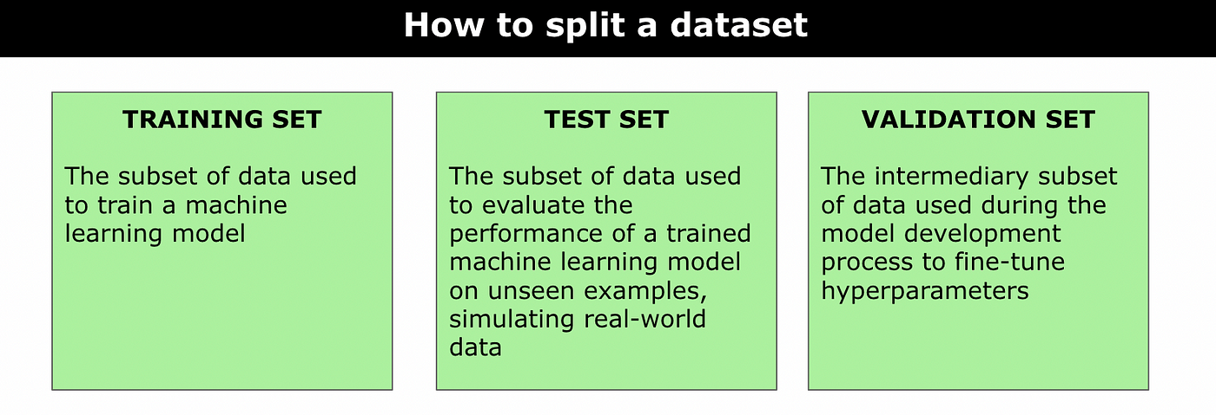

**------------------------------------------------------------------------------------------------------------------------------------------**

## **Evaluate the performance of a binary classifier in machine learning, you can use various metrics:**

## **Confusion Matrix**

A confusion matrix is sometimes used to illustrate classifier performance based on the bellow four values (TP, FP, TN, FN). These are plotted against each other to show a confusion matrix:

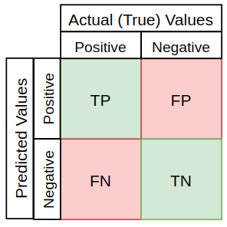

Using the cancer prediction example, a confusion matrix for 100 patients might look something like this:

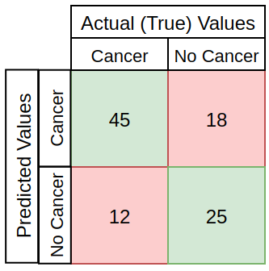

- True Positive (TP): Instances correctly predicted as positive.

- True Negative (TN): Instances correctly predicted as negative.

- False Positive (FP) (**Type I error**): Instances incorrectly predicted as positive.

- False Negative (FN) (**Type II error**): Instances incorrectly predicted as negative.

## **2. Accuracy**

The base metric used for model evaluation is often Accuracy, describing the number of correct predictions over all predictions:

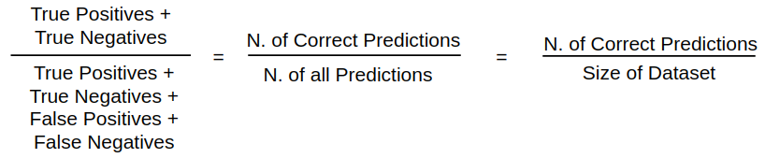

## **3. Precision**

Precision is a measure of how many of the positive predictions made are correct (true positives) out of all positive predictions. The formula for it is:

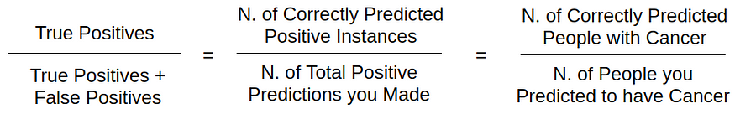

## **4. Recall / Sensitivity**

Recall is a measure of how many of the positive predictions made are correct (true positives), over all the positive cases in the data. [It is sometimes also referred to as Sensitivity](https://stats.stackexchange.com/questions/362332/is-there-any-difference-between-sensitivity-and-recall). The formula for it is:

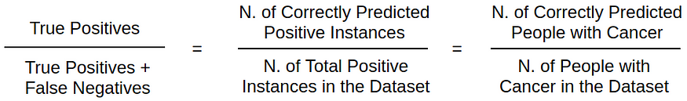

## **5. Specificity**

Specificity is a measure of how many negative predictions made are correct (true negatives) , over all the negative cases in the data. The formula for it is:

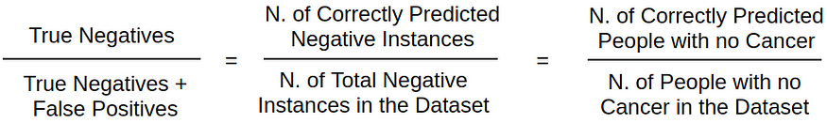

## **6. F1-Score**

F1-Score is a measure combining both precision and recall. It is generally described as the [harmonic mean](https://en.wikipedia.org/wiki/Harmonic_mean) of the two. **Harmonic mean** is just another way to calculate an “average” of values, generally **described as more suitable for ratios** (such as precision and recall) than the traditional arithmetic mean. The formula used for F1-score in this case is:

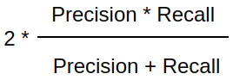

**------------------------------------------------------------------------------------------------------------------------------------------**

## **Diff b/w Arithmetic Mean and Harmonic Mean?**

**Arithmetic Mean**: This is just the average of two numbers. If we use the arithmetic mean for precision and recall, it could give us a misleadingly high score if one of them is very high, even if the other is very low.

**Harmonic Mean**: This is another way to calculate the average, but it's more sensitive to low values. It gives more balanced importance to both precision and recall.

**------------------------------------------------------------------------------------------------------------------------------------------**

## **Why is the harmonic mean calculated in the f1 score and not the mean?**

The harmonic mean of precision and recall is used to calculate the F1 score because it is more forgiving of imbalanced class proportions (This means that one class (e.g., positive or negative) is much more common than the other. For example, in a medical test, there might be many more healthy patients (negatives) than sick patients (positives).) than the arithmetic mean. It is especially useful when the number of positives and negatives are not balanced.

If the harmonic means were not used, the F1 score would be higher because it would be based on the arithmetic mean of precision and recall, which would give more weight to the high precision and less weight to the low recall. The use of the harmonic mean in the F1 score helps to balance the precision and recall and gives a more accurate overall assessment of the classifier’s performance.

**------------------------------------------------------------------------------------------------------------------------------------------**

## **How do you evaluate a model’s performance for a multi-class classification problem?**

One approach for evaluating a multi-class classification model is to calculate a **separate evaluation metric for each class**, and then calculate a macro or micro average. The **macro average** gives equal weight to all the classes, while the **micro average** gives more weight to the classes with more observations. **Additionally, some commonly used metrics for multi-class classification problems such as confusion matrix, precision, recall, F1 score, Accuracy and ROC-AUC can also be used.**

**------------------------------------------------------------------------------------------------------------------------------------------**

## **AUC-ROC: (Receiver operating characteristics)**

This metric measures the **ability of the model** to distinguish between positive and negative classes. It is commonly used for imbalanced classification problems.

**------------------------------------------------------------------------------------------------------------------------------------------**

## **What is the ROC curve?**

The Receiver Operating Characteristic (ROC) curve is a graphical representation used in machine learning and statistics to evaluate the performance of a binary classifier. It plots the True Positive Rate (TPR) against the False Positive Rate (FPR)

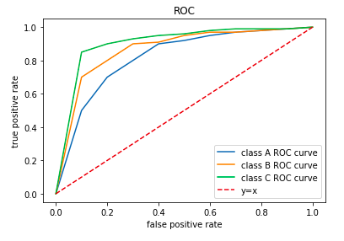

**------------------------------------------------------------------------------------------------------------------------------------------**

## **Precision-recall curve:**

The precision-recall curve shows the tradeoff between precision and recall for different threshold. A high area under the curve represents both high recall and high precision, where high precision relates to a low false positive rate, and high recall relates to a low false negative rate.

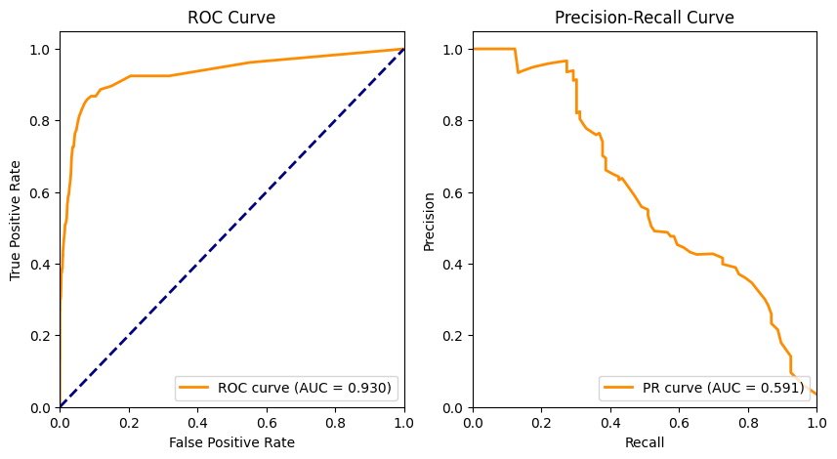

**------------------------------------------------------------------------------------------------------------------------------------------**

## **What is cost sensitive learning**

Cost-sensitive learning is a machine learning approach that takes into account the varying costs associated with different types of errors during model training. It assigns different penalties to misclassifying instances based on their importance in a particular context. This is especially useful when the consequences of false positives and false negatives are not equal. The goal is to optimize the model for the overall cost rather than just accuracy.

**------------------------------------------------------------------------------------------------------------------------------------------**

# **Class imbalance and solutions of class imbalance**

Class imbalance in machine learning refers to the situation where one class has **significantly fewer samples** than another, leading to a biased model. Solutions include:

## **Resampling Techniques:**

**Undersampling**: Reduce the size of the majority class.

**Oversampling:** Increase the size of the minority class (e.g., duplication or generation of synthetic samples).

## **Algorithmic Approaches:**

Use algorithms that handle imbalanced data well, like Random Forests, Gradient Boosting, or ensemble methods.

## **Cost-sensitive Learning:**

Assign different misclassification costs to different classes to make the model more sensitive to minority class errors.

## **Ensemble Methods:**

Combine predictions from multiple models to improve overall performance, as ensemble methods can be more robust to class imbalance.

## **Data Augmentation:**

Increase the size of the minority class by creating new, slightly modified samples.

## **Customized Evaluation Metrics:**

Use metrics like precision, recall, F1-score, or area under the Precision-Recall curve that focus on model performance regarding the minority class.

## **Transfer Learning:**

Leverage knowledge from a related task or pre-trained models to boost performance on the imbalanced dataset.

Choose the technique based on the specific characteristics of your dataset and the requirements of your problem.

**------------------------------------------------------------------------------------------------------------------------------------------**

## **Explain Bias, High Bias and Low bias?**

**Bias** refers to how far the predicted values are from the actual values.

**High bias:** If the average predicted value is far from the actual value, then the bias is high. When a model has high bias, it implies that the model is too simple and does not capture the complexity of the data, leading to under-fitting. Increasing the model complexity, such as adding layers or neurons to a neural network, can help reduce bias and improve performance.

**Low bias:** Low bias means the model is more flexible and better captures the true relationship.

**------------------------------------------------------------------------------------------------------------------------------------------**

# **Explain variance, low variance and high variance**

Variance in the context of statistics and machine learning refers to the spread or dispersion of a set of values. It quantifies how much the values in a dataset deviate from their mean or expected value.

## **Low Variance:**

If a dataset has low variance, the values are closely packed around the mean.

It suggests that the data points are consistent and don't vary much from the average.

A model trained on low-variance data may be overly simplistic and might not capture underlying patterns well.

## **High Variance (Overfitting):**

If a dataset has high variance, the values are more spread out from the mean.

It indicates greater variability among the data points.

A model trained on high-variance data may capture noise in the training set, leading to poor generalization on new, unseen data.

## **In the context of machine learning models:**

## **Low Variance Model:**

Predictions are relatively consistent and stable across different datasets.

There's a risk of underfitting, meaning the model may not capture the underlying patterns in the training data.

## **High Variance Model:**

Predictions can vary widely depending on the training data.

There's a risk of overfitting, where the model learns the training data too well, including its noise, but performs poorly on new data.

Achieving a balance between low and high variance is crucial for building models that generalize well to new, unseen data. This balance is often referred to as the **bias-variance tradeoff**.

**------------------------------------------------------------------------------------------------------------------------------------------**

## **What is k-fold cross-validation technique**

K-fold cross-validation is a technique used to assess the performance of a machine learning model by dividing the dataset into k subsets (or folds). The model is trained on k-1 folds and validated on the remaining one. This process is repeated k times, each time using a different fold for validation. The results are then averaged to provide a more reliable estimate of the model's performance. K-fold cross-validation helps in assessing how well a model generalizes to different subsets of the data and reduces the impact of variability in a single train-test split.

**------------------------------------------------------------------------------------------------------------------------------------------**

**Regularization in machine Learning**

Regularization is a technique used in machine learning to prevent overfitting and improve the generalization of a model. Overfitting occurs when a model performs well on the training data but fails to generalize to new, unseen data. Regularization introduces a penalty term to the model's objective function, discouraging overly complex models that might fit the training data too closely.

The basic idea behind regularization is to **add a term to the cost function that penalizes large weights or complex model structures**. This additional term encourages the learning algorithm to choose simpler models that are more likely to generalize well to new data.

There are different types of regularization commonly used in machine learning:

## **L1 Regularization (Lasso):**

In L1 regularization, a penalty term is added to the cost function proportional to the **absolute** **values** (**the non-negative value of without regard to its sign**) of the model parameters (weights).

It encourages sparsity in the model, meaning it tends to drive some weights to exactly zero. This leads to feature selection, as some features become irrelevant and are effectively ignored by the model.

## **L2 Regularization (Ridge):**

L2 regularization adds a penalty term to the cost function proportional to the **square** of the model parameters (weights).

It discourages large weights and tends to distribute the importance of features more evenly. L2 regularization is less likely to drive weights to exactly zero, but it still helps in preventing overfitting.

## **Elastic Net Regularization:**

Elastic Net is a combination of L1 and L2 regularization. It adds both the absolute values of the weights (L1) and the squares of the weights (L2) to the cost function.

Elastic Net allows for a balance between the sparsity-inducing property of L1 and the smoothing effect of L2.

Regularization is typically applied during the **training phase** of a machine learning model. The **strength of the regularization** (the amount of penalty applied) is controlled by a **hyperparameter**, often denoted as **"lambda" or "alpha."** The choice of the regularization strength depends on the specific problem and the characteristics of the data.

By using regularization techniques, machine learning practitioners can build models that are more robust, less prone to overfitting, and better at generalizing to new, unseen data.

**------------------------------------------------------------------------------------------------------------------------------------------**

# **How to reduce variance or over fitting?**

Reducing variance, or mitigating overfitting, involves strategies to make your model generalize better to new, unseen data. Here are some common techniques:

## **Cross-Validation:**

Use techniques like k-fold cross-validation to assess how well your model generalizes to different subsets of the data. This helps identify overfitting.

## **Regularization:**

Introduce regularization terms in your model's cost function (e.g., L1 or L2 regularization). This discourages overly complex models by penalizing large coefficients.

## **Pruning:**

For decision tree-based models, pruning involves removing branches that add little predictive power. This helps prevent the model from becoming too specific to the training data.

## **Feature Selection:**

Choose a subset of relevant features and discard unnecessary ones. This can simplify the model and reduce overfitting.

## **Data Augmentation:**

Increase the size of your training dataset by creating slightly modified copies of existing data. This helps the model generalize better to variations in the input.

## **Ensemble Methods:**

Use ensemble methods like Random Forests or Gradient Boosting. These combine predictions from multiple models, reducing the risk of overfitting present in individual models.

## **Early Stopping:**

Monitor the model's performance on a validation set during training. Stop training when the performance starts degrading, preventing the model from learning noise in the training data.

## **Cross-Validation and Hyperparameter Tuning:**

Use cross-validation to evaluate different hyperparameter settings. This helps in selecting the model configuration that generalizes well.

## **Dropout (Neural Networks):**

In neural networks, dropout involves randomly ignoring a proportion of neurons during training. This prevents the model from relying too much on specific neurons and helps prevent overfitting.

## **Simpler Model Architectures:**

Choose simpler model architectures that are less prone to overfitting. For example, reduce the number of layers or nodes in a neural network.

By applying a combination of these techniques, you can often strike a balance between fitting the training data well and generalizing to new, unseen data.

**------------------------------------------------------------------------------------------------------------------------------------------**

## **Null and Alternate Hypothesis with Example.**

Certainly! In statistics, hypotheses are used to make inferences about populations based on sample data. The two main types of hypotheses are the null hypothesis (H0) and the alternative hypothesis (H1 or Ha).

## **Null Hypothesis (H0):**

The null hypothesis is a statement of no effect or no difference. It represents the status quo or a default assumption that there is no real change or no effect. This hypothesis states that there is no difference between groups or no relationship between variables.

It is denoted by H0.

**Example:** Suppose you are testing a new drug, and you want to know if it has any effect on reducing blood pressure. The null hypothesis might be that the drug has no effect, and the average blood pressure before and after taking the drug is the same.

**H0:** The mean blood pressure before = the mean blood pressure after

## **Alternative Hypothesis (H1 or Ha):**

The alternative hypothesis contradicts the null hypothesis.

It represents a claim that there is a real effect, difference, or relationship in the population.

It is denoted by H1 or Ha.

**Example:** Continuing with the drug example, the alternative hypothesis might be that the new drug does have an effect on reducing blood pressure.

**Ha:** The mean blood pressure before is not equal to the mean blood pressure after (indicating a change in blood pressure)

When conducting a hypothesis test, you collect sample data and use statistical methods to determine whether there is enough evidence to reject the null hypothesis in favor of the alternative hypothesis.

Here are a few scenarios after collecting and analyzing data:

If there is enough evidence to reject the null hypothesis, you may accept the alternative hypothesis.

If there is not enough evidence to reject the null hypothesis, you fail to accept the alternative hypothesis. The null hypothesis is not proven; it's just not rejected based on the available data.

It's important to note that statistical hypothesis testing involves a level of uncertainty, and decisions are made based on probabilities. Researchers use significance levels (e.g., 0.05) to determine the threshold for rejecting the null hypothesis.

In summary, the null hypothesis represents the default assumption of no effect, while the alternative hypothesis suggests a specific effect or difference. Hypothesis testing helps researchers make informed decisions about population parameters based on sample data.

**------------------------------------------------------------------------------------------------------------------------------------------**

# **P value in data science and statistics:**

In statistics, the p-value is a measure that helps you assess the evidence against a null hypothesis. It indicates the probability of observing the data or more extreme results, assuming the null hypothesis is true. A lower p-value suggests stronger evidence against the null hypothesis, often leading to its rejection in favor of an alternative hypothesis. Typically, a significance level (e.g., 0.05) is chosen, and if the p-value is below this threshold, the results are considered statistically significant.

**------------------------------------------------------------------------------------------------------------------------------------------**

# **What is statistically significant.**

"Statistically significant" refers to the likelihood that an observed effect or relationship in data is not due to random chance but is a genuine and meaningful pattern. When conducting statistical hypothesis testing, researchers set a significance level (often denoted as alpha, typically 0.05), which represents the threshold for accepting or rejecting the null hypothesis.

If the p-value associated with a statistical test is less than or equal to the chosen significance level, the results are considered statistically significant. In practical terms, this means that the observed data is unlikely to have occurred by random chance alone, and researchers may reject the null hypothesis in favor of the alternative hypothesis.

It's important to note that statistical significance does not necessarily imply practical or clinical significance. A result can be statistically significant but still have a small effect size or limited real-world relevance. Researchers should consider both statistical and practical significance when interpreting their findings.

**------------------------------------------------------------------------------------------------------------------------------------------**

# **How to compute p value?**

To compute a p-value, follow these general steps:

## **Formulate Hypotheses:**

**Null Hypothesis (H0​):** Assumes no effect or no difference.

**Alternative Hypothesis (H1​ or Ha​):** Assumes an effect or a difference.

## **Select a Significance Level (α):**

Common choices are 0.05, 0.01, etc. This is the threshold below which you would reject the null hypothesis.

## **Choose a Statistical Test:**

The choice depends on your data and the type of comparison you're making (e.g., t-test, chi-square test, ANOVA).

## **Collect and Analyze Data:**

Use the chosen statistical test on your data.

## **Calculate the Test Statistic:**

This depends on the chosen test and the nature of your data.

## **Determine the p-value:**

The p-value is the probability of obtaining results as extreme as or more extreme than the observed results, assuming the null hypothesis is true.

## **Make a Decision:**

If the p-value is less than your chosen significance level (α), you reject the null hypothesis. Otherwise, you fail to reject it.

## **Interpret Results:**

If you reject the null hypothesis, it suggests evidence for the alternative hypothesis. If you fail to reject, it suggests insufficient evidence to support the alternative.

It's important to note that the process may vary depending on the specific statistical test being used and the characteristics of your data. Statistical software or calculators are often employed to perform the calculations associated with these steps.

**------------------------------------------------------------------------------------------------------------------------------------------**

# **What is Feature Selectin and How can we select features in machine Learning/Data Science**

Feature selection is a process in machine learning and data science where you choose a subset of relevant and significant features (variables or attributes) from a larger set of features in your dataset. The goal of feature selection is to improve the performance of a machine learning model by reducing dimensionality, removing irrelevant or redundant features, and enhancing the model's interpretability.

There are several methods for feature selection, broadly classified into three categories:

## **Filter Methods:**

**Statistical Methods:** These methods use statistical measures to rank and select features. Common statistical measures include correlation, mutual information, and chi-square.

**Variance Thresholding**: Features with low variance are often less informative. This method filters out features with low variance.

**Information Gain or Gini Index:** These are used for feature ranking in decision tree-based models.

## **Wrapper Methods:**

**Forward Selection:** Start with an empty set of features and add one feature at a time, choosing the one that improves model performance the most.

**Backward Elimination:** Start with all features and iteratively remove the least important ones, based on model performance.

**Recursive Feature Elimination (RFE):** A method that recursively removes the least important features until the desired number of features is reached.

## **Embedded Methods:**

**LASSO (Least Absolute Shrinkage and Selection Operator):** Adds a penalty term to the linear regression cost function, forcing some coefficients to be exactly zero, effectively performing feature selection.

**Tree-based Methods:** Decision tree-based models like Random Forest and Gradient Boosting naturally perform feature selection by considering feature importance during training.

Choosing the appropriate feature selection method depends on the characteristics of your dataset and the specific machine learning algorithm you are using. It's common to experiment with different methods and evaluate their impact on model performance using metrics like accuracy, precision, recall, or F1 score.

Here's a basic example using scikit-learn in Python to perform feature selection:

from sklearn.feature_selection import SelectKBest, f_classif

# Assuming X is your feature matrix and y is the target variable

X_new = SelectKBest(f_classif, k=5).fit_transform(X, y)

In this example, f_classif is a statistical test for the analysis of variance (ANOVA), and SelectKBest selects the top k features based on the chosen statistical test. Adjust the method and parameters based on your specific needs and the characteristics of your data.

**------------------------------------------------------------------------------------------------------------------------------------------**

## **Mention some techniques used for sampling.**

Sampling is the selection of individual members or a subset of the population to estimate the characters of the whole population. There are two types of Sampling, namely Probability and Non-Probability Sampling.

**------------------------------------------------------------------------------------------------------------------------------------------**

## **What is Multi-collinearity?**

A. [Multi-collinearity](https://www.analyticsvidhya.com/blog/2021/03/multicollinearity-in-data-science/) occurs when **two or more predictor/feature variables** in a multiple regression model are highly correlated. This can lead to unstable and inconsistent coefficients, and make it difficult to interpret the results of the model.

In other words, multi-collinearity occurs when there is a high degree of correlation between two or more predictor variables. This can make it difficult to determine the unique contribution of each predictor variable to the response variable, as the estimates of their coefficients may be influenced by the other correlated variables.

**------------------------------------------------------------------------------------------------------------------------------------------**

## **Can you explain the concept of correlation and covariance?**

A. **Correlation** is a statistical measure that describes the strength and direction of a linear relationship between two variables. A **positive correlation** indicates that the two variables increase or decrease together, while a **negative correlation** indicates that the two variables move in opposite directions.

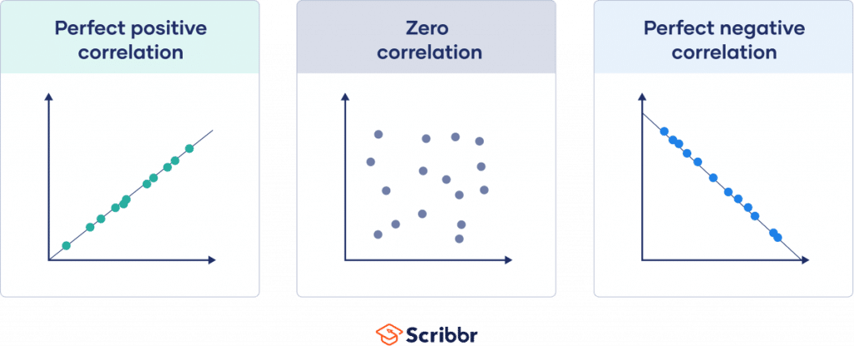

**Covariance** is a measure of the joint variability of two random variables. It is used to measure how two variables are related.

**------------------------------------------------------------------------------------------------------------------------------------------**

## **What is Correlation and How can we calculate it?**

Correlation is a statistical measure that quantifies the degree to which two variables change together. In other words, it assesses the strength and direction of a linear relationship between two variables. The most common measure of correlation is the **Pearson correlation coefficient**, denoted by **r**. The Pearson correlation coefficient ranges from **-1 to 1**, where:

**r=1** indicates a perfect positive linear relationship.

**r=−1** indicates a perfect negative linear relationship.

**r=0** indicates no linear relationship.

The formula for calculating the Pearson correlation coefficient (r) between two variables X and Y with n data points is as follows:

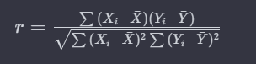

Where:

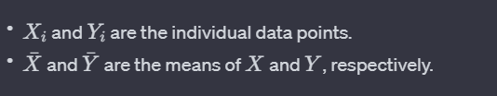

In Python, you can use libraries like NumPy or pandas to calculate the Pearson correlation coefficient. Here's a simple example using NumPy:

import numpy as np

# Sample data

X = np.array([1, 2, 3, 4, 5])

Y = np.array([2, 3, 4, 5, 6])

# Calculate Pearson correlation coefficient

correlation_coef = np.corrcoef(X, Y)[0, 1]

print(f"Pearson correlation coefficient: {correlation_coef}")

Alternatively, if you are working with a pandas DataFrame, you can use the corr() method:

import pandas as pd

# Create a DataFrame

df = pd.DataFrame({'X': [1, 2, 3, 4, 5], 'Y': [2, 3, 4, 5, 6]})

# Calculate Pearson correlation coefficient

correlation_coef = df['X'].corr(df['Y'])

print(f"Pearson correlation coefficient: {correlation_coef}")

These methods will give you the Pearson correlation coefficient between the two variables. Remember that correlation does not imply causation, and a correlation coefficient close to zero does not necessarily mean there is no relationship; it might indicate a nonlinear relationship or other factors influencing the data.

**------------------------------------------------------------------------------------------------------------------------------------------**

## **What is covariance in machine learning?**

Covariance in machine learning is a statistical measure that indicates the extent to which two variables change together. If the variables tend to increase or decrease simultaneously, the covariance is positive. If one variable tends to increase when the other decreases, the covariance is negative.

Covariance is used in machine learning for:

1. **Feature Selection**: Identifying features that are correlated with each other. Highly correlated features might provide redundant information and can be dropped to simplify the model without losing much information.
2. **Principal Component Analysis (PCA)**: A dimensionality reduction technique that uses the covariance matrix of the data to identify the principal components (directions of maximum variance) of the data.

Understanding covariance helps in understanding the relationship between features and can guide the preprocessing steps in building machine learning models.

**------------------------------------------------------------------------------------------------------------------------------------------**

# **What is dimensionality reduction?**

Dimensionality reduction is a technique used in machine learning and data analysis to reduce the number of features (or dimensions) in a dataset while preserving its essential information. High-dimensional datasets, where the number of features is large, can suffer from the curse of dimensionality, leading to increased computational complexity, overfitting, and difficulties in visualization and interpretation.

There are two main approaches to dimensionality reduction:

## **Feature Selection:**

In feature selection, you choose a subset of the original features and discard the rest. The goal is to retain the most relevant and informative features while eliminating irrelevant or redundant ones.

Feature selection methods include filter methods (e.g., based on statistical measures), wrapper methods (e.g., forward selection, backward elimination), and embedded methods (e.g., LASSO regularization).

## **Feature Extraction:**

Feature extraction involves transforming the original features into a new set of features, typically of lower dimensionality. These new features are combinations of the original features, and they aim to capture the most important information in the data.

**Principal Component Analysis (PCA)** is a common technique for feature extraction. It identifies the directions (principal components) in which the data varies the most and projects the data onto a lower-dimensional subspace.

## **Principal Component Analysis (PCA):**

PCA is a widely used technique for dimensionality reduction. It works by finding the principal components (PCs) of the data, which are linear combinations of the original features. The first principal component captures the most variance in the data, and each subsequent component captures the maximum remaining variance orthogonal to the previous components.

**------------------------------------------------------------------------------------------------------------------------------------------**

# **What is Cost Function In Machine Learning**

In machine learning, a **cost function, also known as a loss function or objective function**, is a crucial component used to measure the difference between the predicted values of a model and the actual values (ground truth) of the target variable. The goal of a machine learning algorithm is to minimize this cost function.

The choice of the cost function depends on the type of machine learning problem being addressed, such as regression or classification. Here are some common types of cost functions:

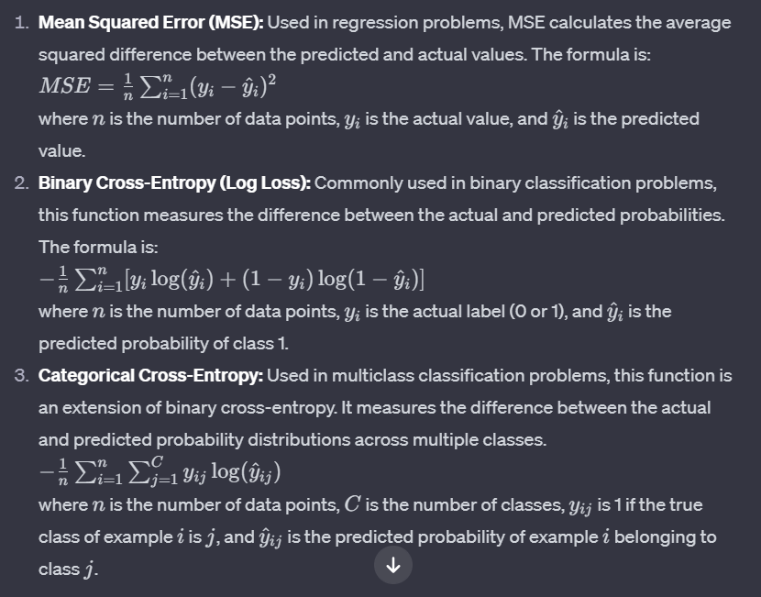

**2). Binary Cross-Entropy:**

In the context of multi-label classification, it can be applied independently to each output node. The overall loss is the sum or average of the losses across all output nodes.

Choosing an appropriate cost function is essential because it directly influences the training process and the performance of the machine learning model. The optimization algorithm adjusts the model parameters to minimize the cost function during the training process.

**------------------------------------------------------------------------------------------------------------------------------------------**

# **What is back propagation?**

Backpropagation, short for "backward propagation of errors," is a supervised learning algorithm used for training artificial neural networks. It is a key component of training neural networks and involves minimizing the error or loss by adjusting the model's weights.

Here's a high-level overview of the backpropagation algorithm:

## **Forward Pass:**

During the forward pass, input data is fed into the neural network, and calculations are performed layer by layer to generate predictions.

Each layer in the network applies a set of weights to the input data, passes the result through an activation function, and produces an output.

## **Compute Loss:**

The output of the neural network is compared to the actual target values, and a loss (error) is calculated. The loss is a measure of the difference between the predicted and actual values.

## **Backward Pass (Backpropagation):**

The key idea of backpropagation is to propagate the error backward through the network and adjust the weights to minimize the error.

Starting from the output layer and moving backward towards the input layer, the algorithm computes the gradient of the loss with respect to the weights of the network. This is done using the chain rule of calculus.

## **Weight Update:**

The calculated gradients are used to update the weights of the neural network in the direction that reduces the error. This is typically done using optimization algorithms such as gradient descent.

The learning rate parameter determines the size of the steps taken during the weight update.

## **Iteration:**

Steps 1-4 are repeated iteratively for multiple epochs or until the model converges to a satisfactory level of performance.

The backpropagation algorithm enables neural networks to learn from training data by adjusting their internal parameters (weights) to minimize the difference between predicted and actual outcomes. It leverages the gradient of the loss function with respect to the model parameters to guide the learning process.

It's worth noting that backpropagation is a computationally efficient way to train neural networks and has played a crucial role in the success of deep learning. Additionally, variations such as stochastic gradient descent and mini-batch gradient descent are often used to speed up the training process.

**------------------------------------------------------------------------------------------------------------------------------------------**

# **How to Evaluate the Accuracy of Regression Results?**

Evaluating the accuracy of regression results is crucial to assess how well the model is performing and to make informed decisions about its suitability for a given task. Here are some common methods for evaluating the accuracy of regression results:

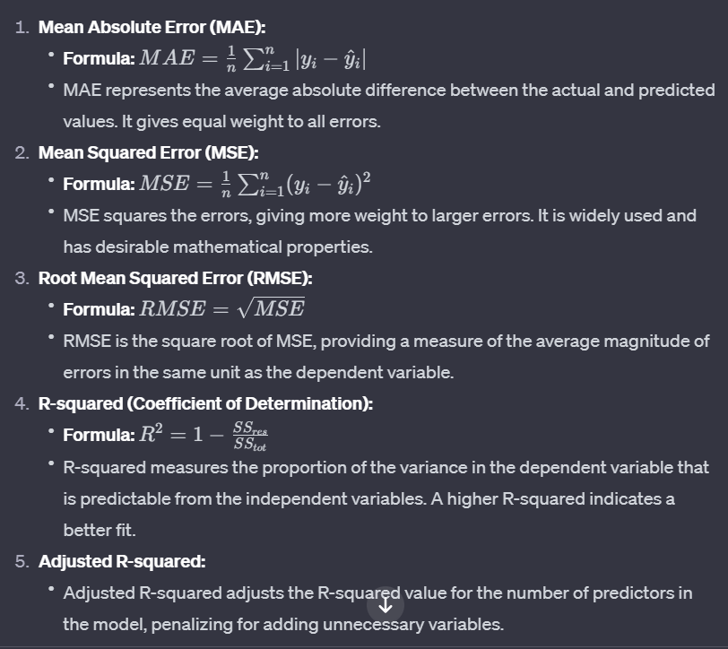

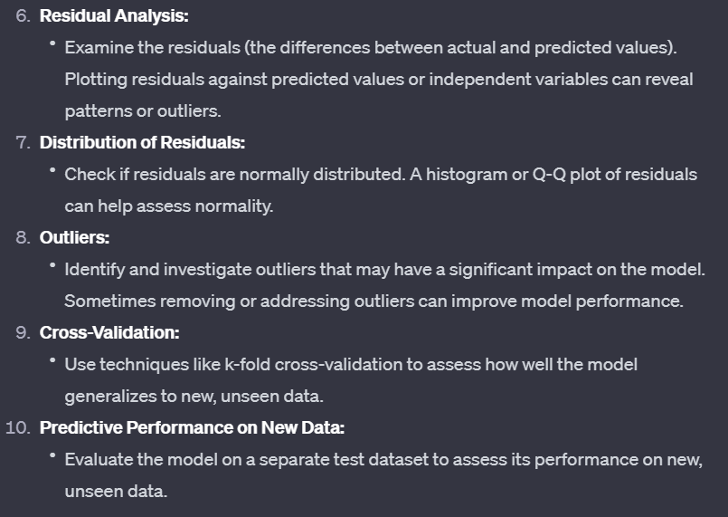

When evaluating regression results, it's essential to consider a combination of these metrics and analyses to get a comprehensive understanding of the model's accuracy and reliability. Keep in mind that the choice of evaluation metrics may depend on the specific characteristics of the data and the goals of the modeling task.

**------------------------------------------------------------------------------------------------------------------------------------------**

# **Activation Function & their use cases:**

Certainly! Let's go through each activation function and discuss their characteristics and common use cases:

1. **Sigmoid Function (Logistic Function):**

- **Range**: (0, 1)

- **Formula**: 

- **Use Case**: Historically used in the output layer for **binary classification** problems. It squashes the output between 0 and 1, providing probabilities. In **multi-label classification** scenario, each output node corresponds to a class, and the sigmoid activation allows each node to independently represent the probability of presence for its corresponding class.

2. **Hyperbolic Tangent Function (tanh):**

- **Range**: (-1, 1)

- **Formula**: 

- **Use Case**: Similar to the sigmoid function but with a range from -1 to 1. It's often used in hidden layers of neural networks, providing stronger gradients during training compared to the sigmoid function.

3. **Rectified Linear Unit (ReLU):**

- **Range:** [0, +∞)

- **Formula**: 

- **Use Case:** One of the most widely used activation functions. It introduces non-linearity and is computationally efficient. Suitable for most hidden layers in deep neural networks.

4. **Leaky ReLU:**

- **Range**: (-∞, +∞)

- **Formula**: 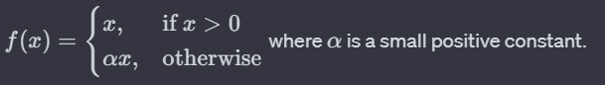

- **Use Case:** Addresses the "dying ReLU" problem where neurons might become inactive during training. Leaky ReLU allows a small, non-zero gradient when the input is negative, helping information flow during backpropagation.

5. **Parametric ReLU (PReLU):**

- **Use Case:** Similar to Leaky ReLU, but with the slope (α (alpha)) as a learnable parameter. It allows the network to adapt the slope during training.

6. **Exponential Linear Unit (ELU):**

- **Range**: (-∞, +∞)

- **Formula**: 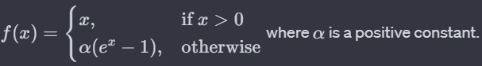

- **Use Case:** ELU can alleviate the vanishing gradient problem and may lead to faster convergence compared to ReLU. It is suitable for architectures where learning long-term dependencies is important.

7. **Softmax:**

- **Range**: (0, 1) and the sum of all output values is 1.

- **Formula**: 

- **Use Case**: Specifically used in the output layer for multi-class classification problems. It converts the raw output scores into probabilities, making it suitable for scenarios where the model needs to choose among multiple classes.

Choosing the appropriate activation function depends on the specific problem, architecture, and characteristics of the data. ReLU and its variants are often preferred in many scenarios due to their simplicity and effectiveness, but experimentation is crucial to find the best fit for a particular task.

**------------------------------------------------------------------------------------------------------------------------------------------**

# **Decision boundary in Machine Learning?**

In machine learning, a decision boundary is a dividing line or surface that separates different classes in a classification problem. It represents the regions in the input space where the algorithm assigns different labels or outcomes to the data points. The decision boundary is a crucial concept, especially in binary classification problems where the goal is to classify input data points into one of two classes.

The nature and complexity of the decision boundary depend on the algorithm used and the characteristics of the data. Here are a few examples to illustrate different types of decision boundaries:

## **Linear Decision Boundary:**

In linear classifiers like Support Vector Machines (SVM) or logistic regression, the decision boundary is a straight line in two-dimensional space or a hyperplane in higher-dimensional space.

**Example**: In a binary classification problem with two features (2D space), the decision boundary might be a straight line that separates the points of one class from the other.

## **Non-Linear Decision Boundary:**

In many real-world scenarios, the relationship between features and classes is not linear. In such cases, non-linear classifiers like decision trees, k-nearest neighbors, or kernelized SVMs may create decision boundaries that are curves or more complex surfaces.

**Example**: A decision boundary in a 2D space could be a circle, ellipse, or any non-linear shape.

## **Complex Decision Boundary:**

Deep learning models, especially neural networks with multiple hidden layers, can learn highly complex decision boundaries. These boundaries can adapt to intricate patterns and relationships in the data.

**Example**: In image classification, a deep neural network might learn a decision boundary that accurately separates images of cats from images of dogs, even when the differences are subtle and complex.

Understanding the decision boundary is essential for assessing the performance and generalization of a machine learning model. The goal is to find a decision boundary that accurately separates classes in the training data and generalizes well to unseen data. Visualizing the decision boundary is a helpful technique for gaining insights into how a model makes predictions and for diagnosing potential issues such as overfitting or underfitting.

**------------------------------------------------------------------------------------------------------------------------------------------**

## **Difference between Normalization and Standardization**

|  |  |
| --- | --- |
| Standardization | Normalization |
| The technique of converting data in such a way that it is normally distributed and has a standard deviation of 1 and a mean of 0. | The technique of converting all data values to lie between 1 and 0 is known as Normalization. This is also known as min-max scaling |

**------------------------------------------------------------------------------------------------------------------------------------------**

**Eigenvectors and Eigenvalues in machine Learning**

Eigenvectors and eigenvalues are concepts from linear algebra that are widely used in machine learning, especially in tasks such as dimensionality reduction, feature extraction, and solving systems of linear equations. They play a significant role in various algorithms, including principal component analysis (PCA) and the covariance matrix.

Eigenvalues and Eigenvectors:

## **Eigenvalues:**

Eigenvalues are the directions along which a particular linear transformation acts by flipping, compressing, or stretching.

Eigenvalue is a scalar that is used to transform the eigenvector. The basic equation is

**Ax = λx**

## **Eigenvectors:**

Eigenvectors are for understanding linear transformations. In data analysis, we usually calculate the eigenvectors for a correlation or covariance matrix.

Eigenvectors are the vectors (non-zero) that do not change the direction when any linear transformation is applied. It changes by only a scalar factor

Let us say A is an “n × n” matrix and λ is an eigenvalue of matrix A, then **x**, a non-zero vector, is called as eigenvector if it satisfies the given below expression;

A**x** = λ**x**

**x** is an eigenvector of A corresponding to eigenvalue, λ.

### **Can Eigenvalue be Zero?**

Yes, Eigenvalue can be zero. But we don’t consider the zero vector to be an Eigenvector.

### **How many Eigenvalues does a 2×2 matrix can have?**

A 2×2 matrix can have 2 Eigenvalues, as a 2×2 matrix has two Eigenvector directions.

## **Application in Machine Learning:**

**Principal Component Analysis (PCA):**

PCA is a dimensionality reduction technique that uses eigenvectors and eigenvalues to transform the data into a new coordinate system.

The eigenvectors of the covariance matrix of the data represent the principal components, and the corresponding eigenvalues indicate their importance.

**Covariance Matrix:**

Eigenvectors and eigenvalues are used in the context of the covariance matrix to capture the directions of maximum variance in the data.

**The eigenvectors of the covariance matrix represent the directions of maximum variance, and the corresponding eigenvalues indicate the amount of variance along those directions.**

**Solving Systems of Linear Equations:**

In some machine learning applications, systems of linear equations arise, and eigenvectors can be used to solve these systems.

**Graph Theory:**

In graph-based algorithms, eigenvectors of certain matrices (e.g., Laplacian matrix) are used for tasks like clustering and community detection.

Understanding eigenvectors and eigenvalues is crucial in various machine learning contexts because they provide a way to analyze and transform data in a mathematically meaningful manner. The eigenvalues indicate the importance or significance of certain directions or features, while eigenvectors represent the directions themselves.

**------------------------------------------------------------------------------------------------------------------------------------------**

# **Local minima, Local maxima, Global minima and global maxima:**

In the context of machine learning and deep learning, the terms local minima, local maxima, global minima, and global maxima are associated with optimization problems, particularly during the training of models. Let's break down each term:

## **Local Minimum:**

A local minimum is a point in the parameter space where the objective function (often a loss function in machine learning) has a lower value than its neighboring points.

It is important to note that a local minimum is not necessarily the absolute lowest point in the entire parameter space.

## **Local Maximum:**

A local maximum is a point in the parameter space where the objective function has a higher value than its neighboring points.

Similar to local minima, a local maximum is not necessarily the highest point in the entire parameter space.

## **Global Minimum:**

The global minimum is the absolute lowest point in the entire parameter space. It represents the lowest value of the objective function over all possible combinations of model parameters.

In the context of machine learning, finding the global minimum is the goal during the training process, as it indicates the best set of parameters for the model.

## **Global Maximum:**

The global maximum is the absolute highest point in the entire parameter space. It represents the highest value of the objective function over all possible combinations of model parameters.

In practice, finding the global maximum is not usually a goal in machine learning, as the objective is often to minimize a loss function rather than maximize it.

In the context of training machine learning models, the optimization process involves adjusting the model parameters to minimize a given loss function. The challenge is that the parameter space is vast, and there may be multiple local minima and maxima. Finding the global minimum is the ideal scenario, but it's not guaranteed, and the optimization algorithm might converge to a local minimum instead.

Various optimization algorithms, such as gradient descent, are used to navigate the parameter space and converge to a minimum. However, the choice of optimization algorithm, learning rate, and other hyperparameters can impact whether the algorithm converges to a local or global minimum. Additionally, the presence of multiple minima adds complexity to the optimization process. Techniques like random initialization and advanced optimization methods aim to mitigate issues related to local minima and help improve the chances of finding a good set of parameters for the model.

**------------------------------------------------------------------------------------------------------------------------------------------**

# **One Hot Encoding in ML DL:**

One Hot Encoding is a technique used in Machine Learning and Deep Learning to represent categorical variables as binary vectors. In this encoding, each category is represented by a binary vector with all zeros except for the index corresponding to the category, which is marked with a one. This helps machine learning models better understand and process categorical data, as it transforms qualitative information into a numerical format suitable for algorithms.

**------------------------------------------------------------------------------------------------------------------------------------------**

## **When to use one-hot encoding and label encoding?**

One-hot encoding and label encoding are two different techniques that can be used to encode categorical variables as numerical values. They are often used in machine learning models as a preprocessing step before fitting the model to the data.

**One-hot encoding** is typically used when you have categorical variables that do not have any ordinal relationship, i.e., the categories do not have a natural order or ranking ([male, female], [boy, girl, men, women]). One-hot encoding creates new binary columns for each category, with a value of 1 indicating the presence of the category and a value of 0 indicating the absence of the category. This can be useful when you want to preserve the uniqueness of each category and prevent the model from assuming any ordinal relationships between the categories.

On the other hand**, label encoding** is typically used when you have categorical variables that do have an ordinal relationship, i.e., the categories have a natural order or ranking ([A, B, C], [Bachelor, Master, PHD]). Label encoding assigns a unique integer value to each category, and the integer values are usually determined by the natural order of the categories. This can be useful when you want to preserve the ordinal relationships between the categories and allow the model to make use of this information.

In general, it is best to use one-hot encoding for nominal data (i.e., data that has no inherent order) and label encoding for ordinal data (i.e., data that has an inherent order). However, the choice between one-hot encoding and label encoding can also depend on the specific requirements of your model and the characteristics of your dataset.

**------------------------------------------------------------------------------------------------------------------------------------------**

## **What can be an appropriate encoding technique when you have hundreds of categorical values in a column?**

A. A few techniques can be used when we have hundreds of columns in a categorical variable.

**Frequency encoding:** This involves replacing each category with the frequency of that category in the dataset. This can work well if the categories have a natural ordinal relationship based on their frequency.

**Target encoding:** This involves replacing each category with the mean of the target variable for that category. This can be effective if the categories have a clear relationship with the target variable.

**------------------------------------------------------------------------------------------------------------------------------------------**

## **What is the difference between MinMaxScaler and StandardScaler?**

Both the MinMaxScaler and StandardScaler are tools used to transform the features of a dataset so that they can be better modeled by machine learning algorithms. However, they work in different ways.

**MinMaxScaler (Normalization)** scales the features of a dataset by transforming them to a specific range, usually between 0 and 1. It does this by subtracting the minimum value of each feature from all the values in that feature, and then dividing the result by the range (i.e., the difference between the minimum and maximum values). This transformation is given by the following equation:

x_scaled = (x - x_min) / (x_max - x_min)

**StandardScaler (Standardization):** standardizes the features of a dataset by transforming them to have zero mean and unit variance. It does this by subtracting the mean of each feature from all the values in that feature, and then dividing the result by the standard deviation. This transformation is given by the following equation:

x_scaled = (x - mean(x)) / std(x)

In general, StandardScaler is more suitable for datasets where the distribution of the features is approximately normal, or Gaussian. MinMaxScaler is more suitable for datasets where the distribution is skewed or where there are outliers. However, it is always a good idea to visualize the data and understand the distribution of the features before choosing a scaling method.

**------------------------------------------------------------------------------------------------------------------------------------------**

## **What are some common methods for hyperparameter tuning?**

A. There are several common methods for hyperparameter tuning:

**Grid Search:** This involves specifying a set of values for each hyperparameter, and the model is trained and evaluated using a combination of all possible hyperparameter values. This can be computationally expensive, as the number of combinations grows exponentially with the number of hyperparameters.

**Random Search**: This involves sampling random combinations of hyperparameters and training and evaluating the model for each combination. This is less computationally intensive than grid search, but may be less effective at finding the optimal set of hyperparameters.

**------------------------------------------------------------------------------------------------------------------------------------------**

# **What is binary relevance and how it can be applied to solve classification challenge**

Binary relevance is a technique used in multi-label classification where each instance can be associated with multiple labels, and the task is to predict the presence or absence of each label independently. In binary relevance, the multi-label problem is decomposed into multiple binary classification problems, one for each label.

**For example**, if you have a set of documents and each document can belong to multiple topics (labels), binary relevance would involve creating a separate binary classifier for each topic. Each classifier then predicts whether a document belongs to its corresponding topic or not.

This approach simplifies the multi-label classification problem into several binary classification problems, making it easier to apply traditional binary classifiers. It's a straightforward and intuitive way to extend binary classification algorithms to handle multi-label scenarios.

**To apply binary relevance:**

**Data Transformation:** Represent the problem as a binary matrix where each row corresponds to an instance, and each column corresponds to a label. The entries in the matrix indicate whether a label is present for a given instance.

**Binary Classifiers:** Train a binary classifier (e.g., logistic regression, decision tree) for each label independently. Each classifier focuses on predicting the presence or absence of a specific label.

**Prediction:** When making predictions, apply all the binary classifiers to an instance. The output of each classifier represents the predicted presence or absence of the corresponding label.

Binary relevance is a simple and effective method, but it doesn't consider label dependencies. If labels are correlated, other approaches like label powerset or classifier chains may be more suitable.

**------------------------------------------------------------------------------------------------------------------------------------------**

# **How would you define number of neuron, layers in DNN**

In a Deep Neural Network (DNN), the number of neurons refers to the **individual processing units in each layer**. A layer consists of neurons, and the number of neurons in a layer is a design choice based on the complexity of the task and the data.

Layers in a DNN are organized into an **input layer**, **one or more hidden layers**, and an **output layer**. The **number of layers** in a DNN is known as its **depth**. Deeper networks can capture more complex patterns but may require more data and computational resources.

So, the architecture of a DNN is defined by the number of neurons in each layer and the overall structure, which includes the number of hidden layers and the type of connections between neurons.

**------------------------------------------------------------------------------------------------------------------------------------------**

# **What is the Goal of Dropout in DNN**

The goal of dropout in a Deep Neural Network (DNN) is to prevent overfitting. Overfitting occurs when a model learns not only the underlying patterns in the training data but also captures noise or random fluctuations that are present in that specific dataset. This can lead to poor generalization to new, unseen data.

Dropout is a regularization technique where, during training, randomly selected neurons are ignored or "dropped out" with a certain probability. This means that their contribution to the forward pass and backward pass is temporarily removed. By doing this, dropout helps prevent the co-adaptation of neurons and encourages the network to learn more robust features.

Dropout acts as a form of ensemble learning within a single neural network, as different combinations of neurons are active during each training iteration. This randomness during training helps the network generalize better to new, unseen data, making it more robust and less prone to overfitting.

**------------------------------------------------------------------------------------------------------------------------------------------**

# **How do you check did we get over fitting?**

Overfitting in a machine learning model can be assessed through various methods. Here are some common approaches to check if your model is experiencing overfitting:

## **Training and Validation Loss Comparison:**

Plot the training and validation loss over time. If the training loss continues to decrease, but the validation loss plateaus or starts increasing, it's a sign of overfitting. The model is becoming too specific to the training data and may not generalize well.

## **Learning Curves:**

Analyze learning curves that show the model's performance on the training and validation sets during training. A large gap between the training and validation curves suggests overfitting.

## **Cross-Validation:**

Use cross-validation to assess the model's performance on multiple subsets of the data. If the model performs significantly better on the training data compared to validation or test data, it might be overfitting.

## **Evaluation Metrics:**

Look at evaluation metrics on both the training and validation sets. If there is a significant difference in performance, it may indicate overfitting.

## **Validation Set Performance:**

Monitor the performance on a separate validation set. If the model's accuracy is high on the training set but low on the validation set, overfitting may be occurring.

## **Regularization Techniques:**

Apply regularization techniques like dropout, L1 or L2 regularization, or early stopping to prevent overfitting.

## **Data Augmentation:**

If applicable, use data augmentation techniques to artificially increase the size of the training dataset, which can help the model generalize better.

Remember, it's crucial to strike a balance between model complexity and generalization. If a model is too complex relative to the amount of available training data, overfitting becomes a risk. Regular monitoring and thoughtful adjustments to the model architecture and training process can help mitigate overfitting issues.

**------------------------------------------------------------------------------------------------------------------------------------------**

## **How can we convert regression model to classification model?**

Converting a regression model to a classification model involves changing the nature of the prediction problem. Here are common approaches:

1. **Thresholding:**
   * In regression, the model predicts continuous values. To convert it to a classification task, you can introduce a threshold.
   * Set a threshold value, and predictions above the threshold are classified as one class, while those below are classified as another.
2. **Binning or Discretization:**
   * Transform the continuous output into discrete classes or bins.
   * Define intervals and assign each prediction to the corresponding bin, effectively turning it into a classification problem.
3. **Softmax Activation:**
   * If you're using neural networks, switch the activation function in the output layer.
   * Replace a linear activation (common in regression) with softmax for multi-class classification or sigmoid for binary classification.
4. **One-Hot Encoding:**
   * If your regression model is predicting a single continuous variable, you can discretize the variable into categories and then apply one-hot encoding.
   * Each category becomes a binary feature, and the problem turns into a multi-class or multi-label classification task.
5. **Problem Transformation:**
   * Reformulate the problem entirely, considering it as a classification problem with a suitable loss function (e.g., cross-entropy).
   * This may require rethinking the target variable and the training approach.

Choose the method based on the characteristics of your data and the nature of your regression problem. Be cautious about the implications of the conversion, as it might affect the interpretability and performance of the model.

**------------------------------------------------------------------------------------------------------------------------------------------**

## **Difference between validation set and test set:**

Both the validation set and test set are subsets of data used to assess the performance of a machine learning model, but they serve different purposes in the training and evaluation process:

1. **Validation Set:**
   * **Purpose:** The validation set is used during the training phase to tune hyperparameters and make decisions about the model's architecture.
   * **Role:** It helps prevent overfitting by providing an independent dataset that the model has not seen during training.
   * **Frequency of Use:** The validation set is used multiple times during the training process to adjust the model based on its performance.
   * **No Influence on Model Parameters:** The model does not learn from the validation set; it is solely used for evaluation and adjusting hyperparameters.
2. **Test Set:**
   * **Purpose:** The test set is reserved for the final evaluation of the model after training is complete and hyperparameters are set.
   * **Role:** It provides an unbiased assessment of the model's generalization to unseen data, simulating its performance on new, real-world examples.
   * **Frequency of Use:** The test set is used only once or a limited number of times after the model is trained and tuned.
   * **No Influence on Model Parameters:** Similar to the validation set, the test set does not influence the model's parameters; its purpose is to assess the model's performance.

In summary, the validation set is actively used during the training process to guide the model's development, while the test set is held out until the end to provide an unbiased evaluation of the model's overall performance on unseen data. Separating these sets helps ensure that the model's reported performance is a reliable indicator of its ability to generalize to new, unseen examples.

**------------------------------------------------------------------------------------------------------------------------------------------**

## **Which function we can use to solve multi label classification?**

In multi-label classification, where instances can belong to multiple classes simultaneously, you typically use activation functions and loss functions that support multiple classes for each instance. Here are common choices:

1. **Activation Function:**
   * **Sigmoid Activation:** Use sigmoid activation for the output layer of your neural network. Sigmoid activation squashes the output between 0 and 1, making it suitable for binary classification tasks. When used in a multi-label scenario, each output node corresponds to a class, and the sigmoid activation allows each node to independently represent the probability of presence for its corresponding class.
2. **Loss Function:**
   * **Binary Crossentropy:** For each instance, you can use binary crossentropy as the loss function. This loss function is suitable for binary classification tasks, and in the context of multi-label classification, it can be applied independently to each output node. The overall loss is the sum or average of the losses across all output nodes.

Here's a simple example in Python using a neural network framework like TensorFlow/Keras:

from tensorflow.keras.models import Sequential

from tensorflow.keras.layers import Dense

# Assuming X_train and y_train are your input and target data

# where y_train is a binary matrix indicating the presence of each label

model = Sequential()

model.add(Dense(units=num_classes, activation='sigmoid', input_shape=(input_dim,)))

# Use binary crossentropy for multi-label classification

model.compile(optimizer='adam', loss='binary_crossentropy', metrics=['accuracy'])

Make sure your target labels are encoded as binary vectors (one-hot encoding) where each element corresponds to the presence or absence of a class. Additionally, adjust the number of output units in the last layer according to the number of classes in your multi-label classification problem.

**------------------------------------------------------------------------------------------------------------------------------------------**

## **Difference Between Linear and non liner data in machine learning?**

In machine learning, the distinction between **linear** and non-linear data is crucial for understanding how models can be applied and the types of problems they can solve. Here’s an overview of the differences:

### **Linear Data**

* **Definition**: Linear data refers to data where the **relationship** between the **input features** and the **target variable** can be represented by a **straight line** or a **hyperplane** in higher dimensions.

**Examples**:

* Linear regression,
* Logistic regression (for classification tasks)

### **Non-linear Data**

* **Definition**: Non-linear data refers to data where the **relationship** between the **input features** and the **target variable** **cannot** be represented by a **straight line** or hyperplane.

**Examples**:

* Polynomial regression:
* Decision trees, Random forests, and other tree-based methods
* Neural networks
* Support Vector Machines (SVM) with non-linear kernels (e.g., RBF kernel)

**------------------------------------------------------------------------------------------------------------------------------------------**

## **What is impurity?**

Impurity is a measure of how **mixed up** the **classes** are in a set of data. A more impure set of data will have a higher Gini index.

**------------------------------------------------------------------------------------------------------------------------------------------**

## **What is the Gini index?**

The Gini index is a **measure of impurity** in a set of data. It is calculated by **summing the squared probabilities of each class**. A lower Gini index indicates a more pure set of data.

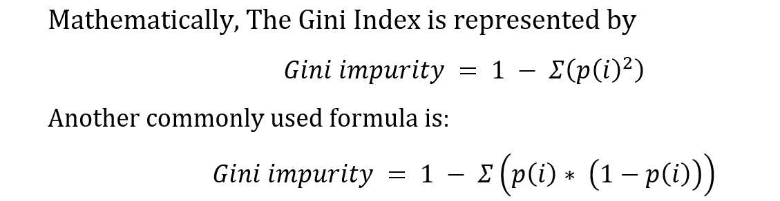

**------------------------------------------------------------------------------------------------------------------------------------------**

## **What is information gain?**

Information gain is a measure of **how much information is gained** by splitting a set of data on a particular feature. It is calculated by comparing the entropy of the **original set of data** to the **entropy of the two child sets**. A higher information gain indicates that the feature is more effective at splitting the data.

**------------------------------------------------------------------------------------------------------------------------------------------**

## **What is entropy in Machine learning?**

Entropy is a measure of the randomness or disorder within a set of data. In machine learning, it is often used to assess the purity of a dataset in classification problems. **In decision trees**, entropy is used to determine how a dataset should be split to make decisions that maximize information gain. Information gain measures the reduction in entropy after a dataset is split on an attribute. The goal is to minimize the entropy in the resulting subsets.

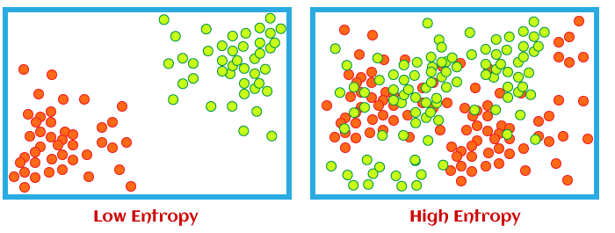

**------------------------------------------------------------------------------------------------------------------------------------------**

## **What is the difference between bagging & boosting?**

Both bagging and boosting are ensemble learning techniques that help in improving the performance of the model.

**Bagging** is the technique in which different models are trained on the dataset that we have and then the average of the predictions of these models is taken into consideration. The intuition behind taking the predictions of all the models and then averaging the results is making more diverse and generalized predictions that can be more accurate.

**Boosting** is the technique in which different models are trained but they are trained in a sequential manner. Each successive model corrects the error made by the previous model. This makes the model strong resulting in the least error.

**------------------------------------------------------------------------------------------------------------------------------------------**

## **What is the difference between stochastic gradient boosting and XGboost?**

A. XGBoost is an implementation of gradient boosting that is specifically designed to be efficient, flexible, and portable. Stochastic XGBoost is a variant of XGBoost that uses a more randomized approach to building decision trees, which can make the resulting model more robust to overfitting.

Both XGBoost and stochastic XGBoost are popular choices for building machine-learning models and can be used for a wide range of tasks, including classification, regression, and ranking. The main difference between the two is that XGBoost uses a deterministic tree construction algorithm, while stochastic XGBoost uses a randomized tree construction algorithm.

**------------------------------------------------------------------------------------------------------------------------------------------**

## **Decision Tree, Bagging, Random Forest, Boosting, Gradient Boosting, XG BOOST**

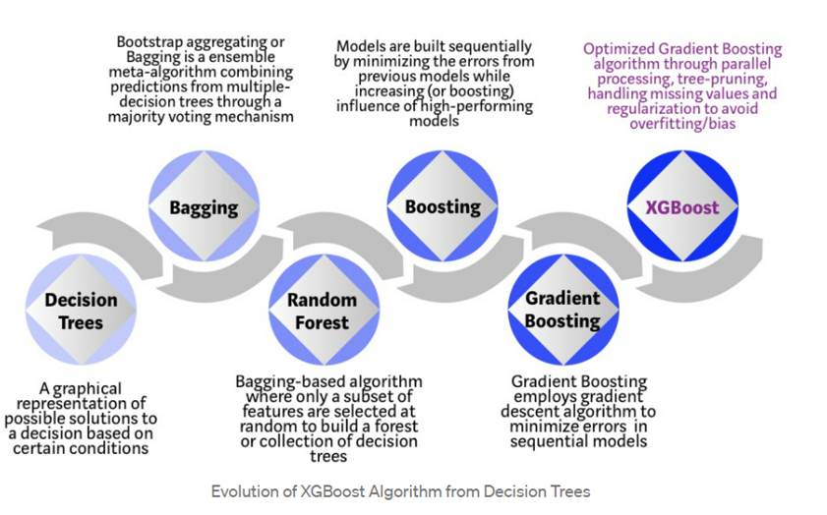

## **What is Different Between XG boost and Decision tree?**

XGBoost (Extreme Gradient Boosting) and decision trees are both machine learning algorithms, but they have distinct differences. Here are some key differences between XGBoost and decision trees:

1. **Ensemble vs. Single Model:**
   * **Decision Tree:** Decision trees are standalone models that make predictions based on a tree-like structure. Each internal node represents a decision based on a feature, and each leaf node represents the output or decision.
   * **XGBoost:** XGBoost is an ensemble learning method that combines the predictions of multiple weak learners, often decision trees. It builds a series of decision trees sequentially, with each tree correcting the errors of the previous ones.
2. **Training Approach:**
   * **Decision Tree:** Decision trees are typically trained using algorithms like ID3, CART, or C4.5, which use a recursive, greedy approach to split the data based on features that maximize information gain or minimize impurity.
   * **XGBoost:** XGBoost is a gradient boosting algorithm that optimizes a cost function by iteratively adding weak learners. It focuses on minimizing the overall prediction error by adding trees that correct the errors made by the previous ones.
3. **Regularization:**
   * **Decision Tree:** Decision trees can be prone to overfitting, especially if the tree is allowed to grow deep. Pruning techniques may be applied to control the tree's size.
   * **XGBoost:** XGBoost includes regularization terms in its objective function, helping to control the complexity of the ensemble and preventing overfitting.
4. **Handling Missing Values:**
   * **Decision Tree:** Decision trees can handle missing values by considering different paths for instances with missing values, but imputation or other methods may be needed.
   * **XGBoost:** XGBoost has built-in mechanisms to handle missing values during training and prediction, making it more robust in the presence of missing data.
5. **Parallelization:**
   * **Decision Tree:** Building a single decision tree can be parallelized to some extent, but it may not fully utilize multicore architectures.
   * **XGBoost:** XGBoost is designed to be highly parallelizable, making it efficient for training on multicore machines.
6. **Feature Importance:**
   * **Decision Tree:** Decision trees provide feature importance scores based on metrics like information gain or Gini impurity.
   * **XGBoost:** XGBoost provides feature importance scores based on the contribution of each feature to the model's performance. This is calculated during the training process.

In summary, while decision trees are standalone models, XGBoost is an ensemble method that employs decision trees as weak learners. XGBoost introduces several enhancements, such as regularization, handling of missing values, and parallelization, to improve the performance and robustness of the underlying decision trees. XGBoost is often favored in practice for its high predictive performance and versatility in handling a variety of data types and scenarios.

**------------------------------------------------------------------------------------------------------------------------------------------**

## **What are recommender systems?**

Recommender systems are a type of information filtering system designed to suggest items to users based on various criteria. They are widely used in various applications such as e-commerce, social media, and content streaming services to enhance user experience by providing personalized recommendations. Recommender systems typically fall into three main categories:

* **Collaborative Filtering:** This method makes recommendations based on the behavior and preferences of similar users. It can be user-based (recommending items liked by similar users) or item-based (recommending items similar to ones the user has liked before).
* **Content-Based Filtering:** This approach recommends items similar to those the user has shown interest in. It relies on the features of items and the user's profile, suggesting items with similar characteristics.
* **Hybrid Methods:** These systems combine collaborative filtering and content-based filtering to leverage the strengths of both approaches, often leading to more accurate recommendations.

Recommender systems use various techniques and algorithms, such as matrix factorization, nearest neighbor algorithms, and deep learning, to predict user preferences and improve the accuracy of recommendations.

**------------------------------------------------------------------------------------------------------------------------------------------**

**Difference Between Fine-tuning and Transfer Learning?**

Fine-tuning and transfer learning are related concepts in machine learning, often used in the context of training deep neural networks. Here's a brief explanation of the key differences between them:

1. **Transfer Learning:**
   * **Definition:** Transfer learning is a machine learning technique where a model trained on one task is adapted or transferred to a second related task.
   * **Idea:** The knowledge gained from learning one task is applied to a different, but related, task to improve performance or speed up the learning process.
   * **Process:** In transfer learning, a pre-trained model (often trained on a large dataset for a specific task) is used as a starting point. The knowledge gained by the model during its initial training is utilized as a foundation for learning a new task.
2. **Fine-tuning:**
   * **Definition:** Fine-tuning is a specific form of transfer learning where a pre-trained model is further trained on a new task, often with a smaller learning rate to avoid overfitting or catastrophic forgetting.
   * **Idea:** Fine-tuning involves taking a pre-trained model and adjusting its parameters on a new dataset related to the original task or a different but similar task.
   * **Process:** The pre-trained model's weights are used as an initialization, and then the model is trained on the new task with a smaller learning rate. This allows the model to adapt to the specifics of the new task while retaining the knowledge acquired during the initial training.

In summary, transfer learning is a broader concept where knowledge gained from one task is applied to another, while fine-tuning is a specific application of transfer learning where a pre-trained model is further trained on a related task. Fine-tuning allows the model to leverage the general features learned during the original training, making it a valuable approach when dealing with limited labeled data for a new task.

**------------------------------------------------------------------------------------------------------------------------------------------**

## **Logistic Regression Overview**

Logistic regression measures the relationship between input feature and target variable by estimating probability using its underlying logistic function (sigmoid). Logistic regression makes use of the sigmoid function which outputs a probability between 0 and 1.

The image shown below depicts how [logistic regression](https://www.simplilearn.com/tutorials/machine-learning-tutorial/logistic-regression-in-python) works:

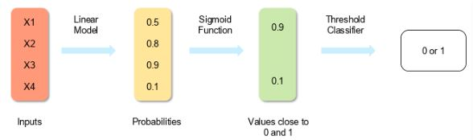

The formula and graph for the sigmoid function are as shown:

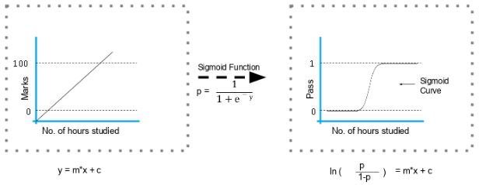

**------------------------------------------------------------------------------------------------------------------------------------------**

# **YOLO**

## **Yolo vs Faster R-CNN, SSD (Single Shot MultiBox Detector), and RetinaNet**

YOLO (You Only Look Once), Faster R-CNN, SSD (Single Shot MultiBox Detector), and RetinaNet are all popular object detection algorithms used in computer vision tasks. Each of these algorithms has its own strengths and weaknesses, making them suitable for different applications and scenarios. Here's a brief comparison of these algorithms:

1. **YOLO (You Only Look Once)**:
   * YOLO is known for its speed and efficiency. It processes images in a single pass through the network, making it extremely fast.
   * It divides the image into a grid and predicts bounding boxes and class probabilities for each grid cell.
   * YOLO tends to struggle with small objects and precise localization compared to some other methods.
   * YOLOv9 and YOLOv10 are the latest versions of the YOLO algorithm, which have further improved its performance and speed.
2. **Faster R-CNN**:
   * Faster R-CNN is a region-based convolutional neural network (CNN) approach. It consists of two modules: a region proposal network (RPN) for generating potential bounding boxes and a detection network for classifying these boxes.
   * It typically achieves high accuracy but may be slower compared to YOLO due to its two-stage architecture.
   * Faster R-CNN is often preferred for tasks where high precision is required, such as in medical imaging or autonomous driving.
3. **SSD (Single Shot MultiBox Detector)**:
   * SSD is another single-shot object detection algorithm similar to YOLO but with some differences in architecture.
   * It predicts bounding boxes and class probabilities using multiple feature maps at different scales.
   * SSD is faster than Faster R-CNN because it doesn't involve two separate stages for region proposal and classification.
   * It strikes a balance between speed and accuracy, making it suitable for real-time applications.
4. **RetinaNet**:
   * RetinaNet was designed to address the problem of class imbalance in object detection by introducing a focal loss function.
   * It utilizes a feature pyramid network (FPN) to generate feature maps at multiple scales and predicts object bounding boxes and class probabilities.
   * RetinaNet achieves high accuracy even for objects of varying sizes and is robust to class imbalance.
   * It may not be as fast as SSD or YOLO but offers competitive performance in terms of accuracy.

In summary, the choice between YOLO, Faster R-CNN, SSD, and RetinaNet depends on factors such as speed requirements, accuracy needs, and the characteristics of the objects being detected. YOLO and SSD are generally faster but may sacrifice some accuracy, while Faster R-CNN and RetinaNet prioritize accuracy at the expense of speed.Top of Form

**------------------------------------------------------------------------------------------------------------------------------------------**

## **What is Intersection over Union (IoU) for object detection.**

Intersection over Union (IoU) is a common evaluation metric used in object detection tasks to measure the accuracy of the detected objects bounding boxes. It is calculated as the ratio of the area of intersection between the predicted bounding box and the ground truth bounding box to the area of their union.

The formula for Intersection over Union (IoU) is:

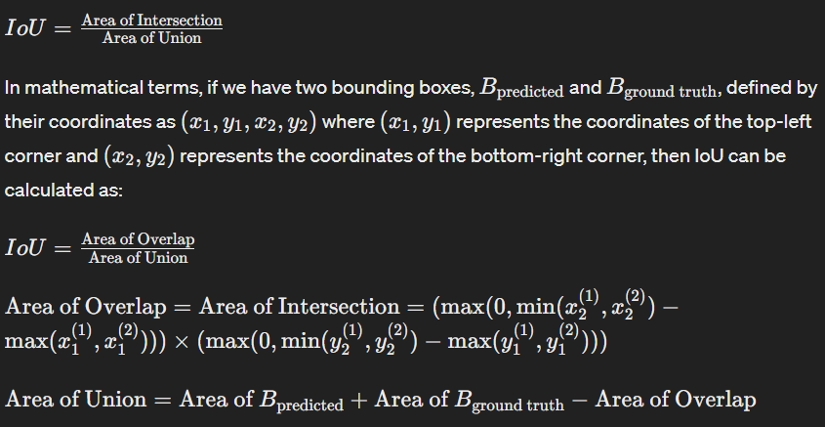

IoU ranges from 0 to 1, where a value of 0 indicates no overlap between the predicted and ground truth bounding boxes, and a value of 1 indicates perfect overlap, meaning the predicted bounding box precisely matches the ground truth bounding box.

IoU is commonly used as an evaluation metric in tasks such as object detection, instance segmentation, and semantic segmentation to measure the accuracy of the detected or segmented regions. Higher IoU values typically indicate better performance of the object detection algorithm.

**------------------------------------------------------------------------------------------------------------------------------------------**

## **Explain Yolo & its Working:**

YOLO, which stands for "You Only Look Once," is a state-of-the-art object detection system that revolutionized real-time object detection in images and videos. Developed by Joseph Redmon, Santosh Divvala, Ross Girshick, and Ali Farhadi, it introduced a novel approach to object detection that significantly improved speed without compromising accuracy.

Here's how YOLO works:

1. Single Neural Network: YOLO reframes object detection as a single regression problem, straight from image pixels to bounding box coordinates and class probabilities. Unlike traditional object detection methods that use complex pipelines combining region proposal algorithms and separate classifiers, YOLO approaches object detection as a single convolutional neural network (CNN).
2. Grid Division: The input image is divided into an S × S grid. Each grid cell is responsible for predicting bounding boxes and class probabilities for objects whose center falls within that grid cell. If an object spans multiple grid cells, only one grid cell is responsible for detecting it.
3. Bounding Box Prediction: For each grid cell, YOLO predicts bounding boxes. Each bounding box consists of five components: (x, y) coordinates of the bounding box's center relative to the grid cell, width (w), height (h) of the bounding box relative to the whole image, and a confidence score. The confidence score represents the probability that the box contains an object and how accurately the box predicts the object's location.
4. Class Prediction: YOLO also predicts class probabilities for each bounding box. This is done using softmax activation, assigning each bounding box a probability for each class. The final score for each bounding box is computed by multiplying the confidence score with the class probabilities.
5. Non-Max Suppression: Since YOLO predicts multiple bounding boxes for each object, a post-processing step called non-maximum suppression (NMS) is applied to remove duplicate detections. NMS selects the most confident bounding box among the overlapping ones and eliminates the rest.
6. Output: The final output of YOLO is a set of bounding boxes along with their class labels and confidence scores, representing detected objects in the input image.

The key advantage of YOLO is its efficiency. By directly predicting bounding boxes and class probabilities from image pixels in a single pass through the network, YOLO achieves real-time object detection, making it suitable for various applications such as autonomous driving, surveillance, and robotics. Additionally, YOLO provides a good balance between speed and accuracy compared to other object detection methods.

**------------------------------------------------------------------------------------------------------------------------------------------**

## **How to calculate the accuracy of Yolo model?**

Calculating the accuracy of a YOLO (You Only Look Once) model involves evaluating its performance in detecting objects within images. Accuracy in object detection is typically measured using metrics such as precision, recall, and the mean Average Precision (mAP) score. Here's how you can calculate these metrics for a YOLO model:

1. **Precision**: Precision measures the proportion of correctly detected objects among all objects that the model has predicted. It is calculated as the number of true positive detections divided by the total number of predicted detections.

**Precision** = True Positives / (True Positives + False Positives)

1. **Recall**: Recall measures the proportion of correctly detected objects among all ground truth objects in the dataset. It is calculated as the number of true positive detections divided by the total number of ground truth objects.

**Recall** = True Positives / (True Positives + False Negatives)

1. **Intersection over Union (IoU):** IoU measures the overlap between the predicted bounding box and the ground truth bounding box. It is computed as the area of intersection divided by the area of union between the two bounding boxes.

**IoU** = Area of Intersection / Area of Union

1. **Mean Average Precision (mAP):** mAP is a widely used metric for object detection that computes the **average precision** across **different object classes and IoU thresholds**. It involves calculating precision-recall curves for each class and then averaging the precision values at different recall levels.

**mAP** = (1 / n_classes) * Σ AP_i

Where AP_i is the Average Precision for class i, and n_classes is the total number of object classes.

To calculate these metrics for your YOLO model, you'll need a labeled dataset with ground truth annotations (bounding boxes and class labels) for the objects in the images. You'll run your YOLO model on the dataset and compare its predictions with the ground truth annotations to compute the metrics mentioned above. There are also evaluation tools and libraries available, such as the COCO evaluation toolkit, which can assist in calculating these metrics for object detection models.

**------------------------------------------------------------------------------------------------------------------------------------------**

## **Diff B/W Model Parameter Vs Hyper-Parameter?**

Model parameters and hyper parameters are both essential components of machine learning models, but they serve different purposes and are tuned or learned in different ways.

1. **Model Parameters:**
   * Model parameters are the variables that the model learns during training.
   * They are inherent to the model and are adjusted automatically during training to minimize the difference between the predicted output and the actual output.
   * Examples of model parameters include weights and biases in a neural network, coefficients in linear regression, or splitting thresholds in decision trees.
   * Model parameters directly contribute to defining the behavior and performance of the model on the training data.
2. **Hyper parameters:**
   * Hyper parameters are external configuration settings that govern the learning process.
   * They are not learned from the data but are set prior to the training process.
   * Hyper parameters are typically set by the machine learning engineer or data scientist before training begins.
   * Examples of hyper parameters include learning rate, number of hidden layers in a neural network, number of trees in a random forest, regularization strength, etc.
   * Hyper parameters control the overall behavior of the learning algorithm and can significantly impact the performance of the model.
   * Finding the optimal values for hyper parameters often involves techniques like grid search, random search, or more advanced optimization algorithms.

In summary, while model parameters are learned from the data during training and directly affect the model's performance on the training set, hyper parameters are external settings that are set prior to training and control the learning process itself. Properly tuning both model parameters and hyper parameters is crucial for building a successful machine learning model.

**------------------------------------------------------------------------------------------------------------------------------------------**

## **Diff B/W Batch learning vs Online Learning?**

Batch learning and online learning are two different approaches to training machine learning models, differing primarily in how they handle data and model updates. Here's a breakdown of the differences between the two:

1. **Data Processing:**
   * Batch Learning: In batch learning, the model is trained on the entire dataset at once. The algorithm processes the entire dataset and updates the model parameters based on the gradients computed from the entire dataset.
   * Online Learning: In online learning, the model is trained on individual data instances or small batches of data sequentially, updating the model's parameters after each instance or batch. The model learns incrementally as new data becomes available.
2. **Data Dependency:**
   * Batch Learning: Batch learning assumes that the entire dataset is available upfront and does not change during training. The model is trained once on this fixed dataset.
   * Online Learning: Online learning adapts to changing data over time. It can continuously update the model as new data arrives, allowing the model to adapt to changes or trends in the data distribution.
3. **Computational Efficiency:**
   * Batch Learning: Batch learning can be computationally intensive, especially for large datasets, as it requires processing the entire dataset in memory during each update step.
   * Online Learning: Online learning can be computationally efficient, especially for streaming data, as it processes data sequentially or in small batches, which reduces memory requirements and allows for real-time updates.
4. **Model Adaptability:**
   * Batch Learning: Batch learning produces a fixed model trained on a static dataset. To adapt the model to new data, the entire training process may need to be repeated with the updated dataset.
   * Online Learning: Online learning allows the model to adapt continuously to new data, making it well-suited for scenarios where the data distribution evolves over time or when the model needs to be updated frequently.
5. **Scalability:**
   * Batch Learning: Batch learning may not scale well to extremely large datasets due to memory and computational constraints.
   * Online Learning: Online learning can scale to large datasets and is particularly useful for scenarios where data arrives continuously, such as in real-time streaming applications.
6. **Robustness to Concept Drift:**
   * Batch Learning: Batch learning may struggle to adapt to concept drift (i.e., changes in the underlying data distribution over time) since the model is trained on a static dataset.
   * Online Learning: Online learning can better handle concept drift by continuously updating the model as new data arrives, allowing it to adapt to changes in the data distribution.

In summary, batch learning is suitable for scenarios where the entire dataset is available upfront and computational resources allow for processing the entire dataset at once, while online learning is more appropriate for scenarios where data arrives sequentially or in streams and the model needs to adapt to changing data over time.

**------------------------------------------------------------------------------------------------------------------------------------------**

## **Diff B/W Supervise learning vs Semi supervised learning**

Supervised learning and semi-supervised learning are both approaches to machine learning, but they differ in how they utilize labeled data during training:

1. **Supervised Learning:**
   * In supervised learning, the training data consists of input-output pairs, where each input is associated with a corresponding output or label.
   * The goal of supervised learning is to learn a mapping from inputs to outputs based on the labeled examples provided during training.
   * The learning algorithm uses this labeled data to generalize patterns and make predictions on new, unseen data.
   * Examples of supervised learning algorithms include linear regression, logistic regression, decision trees, support vector machines, and neural networks.
   * Supervised learning requires a large amount of labeled data for training.
2. **Semi-Supervised Learning:**
   * Semi-supervised learning is a hybrid approach that leverages both labeled and unlabeled data during training.
   * Unlike supervised learning, where all training examples are labeled, in semi-supervised learning, only a subset of the training data has labels, while the majority of the data is unlabeled.
   * The learning algorithm uses the labeled data to guide the learning process and the unlabeled data to extract additional information or structure from the data distribution.
   * Semi-supervised learning is particularly useful when labeled data is scarce or expensive to obtain, as it allows leveraging large amounts of readily available unlabeled data.
   * Common approaches in semi-supervised learning include self-training, co-training, and graph-based methods.

In summary, while supervised learning relies solely on labeled data to make predictions, semi-supervised learning exploits both labeled and unlabeled data to improve the learning process, making it more flexible and potentially more robust, especially in scenarios where labeled data is limited.

**------------------------------------------------------------------------------------------------------------------------------------------**

## **ASR-Pipeline:**

The ASR pipeline can be de-composed into three components:

1. A feature extractor which pre-processes the raw audio-inputs.
2. The model which performs the sequence-to-sequence mapping.
3. A tokenizer which post-processes the model outputs to text format.

**------------------------------------------------------------------------------------------------------------------------------------------**

## **Whisper:**

Whisper is a **Transformer based encoder-decoder model**, also referred to as a **sequence-to-sequence** model. It maps a sequence of audio spectrogram features to a sequence of text tokens.

1. First, the **raw audio inputs** are converted to a **log-Mel spectrogram** by action of the **feature extractor**.
   1. (A log-mel spectrogram is a type of spectrogram that represents the frequency content of an audio signal, using the mel scale for the frequency axis and applying a logarithmic transformation to the amplitude values.)
2. The **Transformer encoder** then **encodes** the **spectrogram** to form a **sequence** of **encoder hidden states**.
3. Finally, the **decoder** **autoregressively** predicts **text tokens**, conditional on both the **previous tokens** and the **encoder hidden states**.

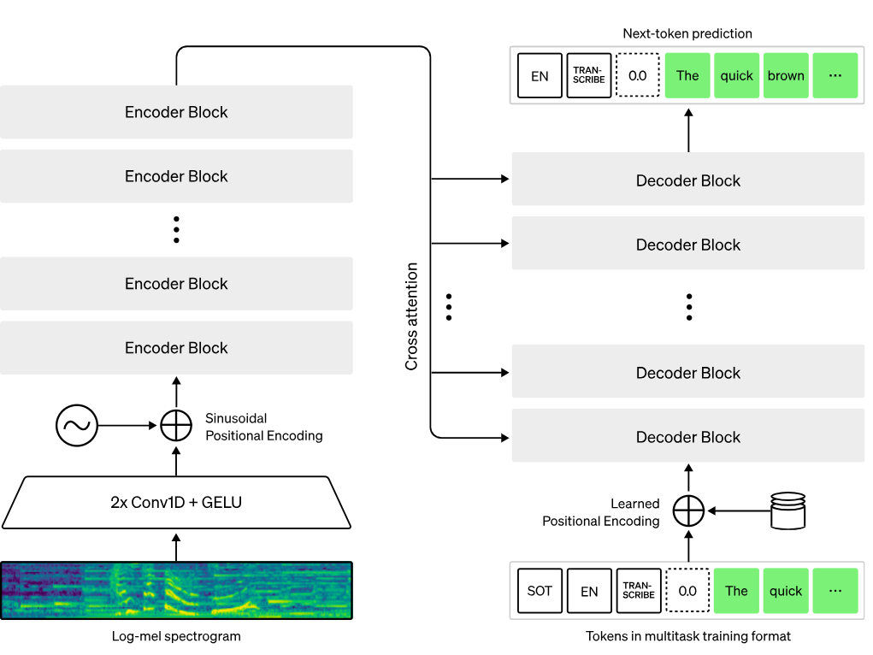

In a sequence-to-sequence model, the encoder transforms the audio inputs into a set of hidden state representations, extracting important features from the spoken speech. The decoder plays the role of a language model, processing the hidden state representations and generating the corresponding text transcriptions. Incorporating a language model internally in the system architecture is termed deep fusion. This is in contrast to shallow fusion, where a language model is combined externally with an encoder, such as with CTC + �n-gram (c.f. [Internal Language Model Estimation](https://arxiv.org/pdf/2011.01991.pdf)). With deep fusion, the entire system can be trained end-to-end with the same training data and loss function, giving greater flexibility and generally superior performance (c.f. [ESB Benchmark](https://arxiv.org/abs/2210.13352)).

Whisper is pre-trained and **fine-tuned using the cross-entropy objective function**, a standard objective function for training sequence-to-sequence systems on classification tasks. Here, the system is trained to correctly classify the target text token from a pre-defined vocabulary of text tokens.

The Whisper checkpoints come in five configurations of varying model sizes. The smallest four are trained on either English-only or multilingual data. The largest checkpoint is multilingual only.

**------------------------------------------------------------------------------------------------------------------------------------------**

## **Explain Word Error Rate (WER) Evaluation Metrics?**

Word Error Rate (WER) is an evaluation metric commonly used in the field of automatic speech recognition (ASR) and machine translation (MT) to assess the accuracy of a system's output compared to a reference or ground truth.

Here's how WER is calculated:

1. **Insertions (I):** The number of extra words present in the **Model prediction** compared to the **Ground Truth**. These are words that are in the **Model prediction** but not in the **Ground Truth**.
2. **Deletions (D):** The number of words missing from the **Model prediction** compared to the **Ground Truth**. These are words that are in the **Ground Truth** but not in the **Model prediction**.
3. **Substitutions (S):** The number of words in the **Model prediction** that are different from the corresponding words in the **Ground Truth**.
4. **Total Words (N):** The total number of words in the **Ground Truth**.

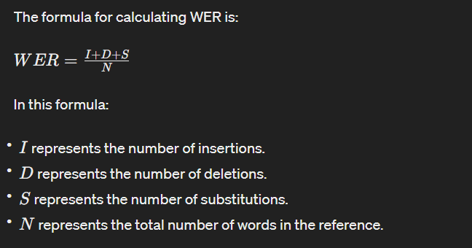

The lower the WER value, the better the performance of the system, as it indicates fewer errors in the output compared to the reference. A WER of 0 would indicate a perfect match between the system output and the reference.

WER is a useful metric because it provides a single numerical value that summarizes the accuracy of the **Model prediction**. However, it's important to note that WER doesn't consider the ordering of words. Therefore, it might not fully capture the fluency or coherence of the system's output, especially in tasks like machine translation where word order matters. Additionally, WER might not always correlate perfectly with human judgments of accuracy or fluency.

**------------------------------------------------------------------------------------------------------------------------------------------**

Encoder Decoder: https://chat.openai.com/share/0b51c9fb-adf0-4386-88aa-3593ed1b681b

**------------------------------------------------------------------------------------------------------------------------------------------**

## **What is stationary time series?**

Stationarity is a key concept in time series analysis. A stationary time series is one whose statistical properties, such as mean and variance, remain constant over time. In other words, the overall behavior and patterns in the data do not change with time.

Stationarity is essential for many time series models, including traditional ones like ARIMA, because these models assume that the statistical properties of the data do not vary over time. If your data is non-stationary, it may exhibit trends, seasonality, or other patterns that can interfere with the model's ability to make accurate predictions.

**------------------------------------------------------------------------------------------------------------------------------------------**

## **How can I check my data is stationary or non-stationary?**

To check whether your time series data is stationary or non-stationary, you can use statistical tests and visualizations. Here are two common methods:

1. **Visual Inspection:**
   * Plot the time series data and look for any obvious trends, seasonality, or cycles.
   * You can use line plots, scatter plots, or histograms to identify patterns.
   * If the plot shows a clear trend or seasonality, the data is likely non-stationary.

# Example in Python using matplotlib

import matplotlib.pyplot as plt

plt.plot(df['column’])

plt.title('Time Series Data')

plt.xlabel('Time')

plt.ylabel('Resign Count')

plt.show()

1. **Augmented Dickey-Fuller Test:**
   * The Augmented Dickey-Fuller (ADF) test is a statistical test for stationarity.
   * The null hypothesis of the test is that the time series is non-stationary.
   * If the p-value is less than a chosen significance level (e.g., 0.05), you reject the null hypothesis and conclude that the data is stationary.

# Example in Python using statsmodels

from statsmodels.tsa.stattools import adfuller

result = adfuller(df['resign_count'])

print('ADF Statistic:', result[0])

print('p-value:', result[1])

print('Critical Values:', result[4])

* + If the ADF Statistic is less than the critical values and the p-value is small, you can reject the null hypothesis, indicating stationarity.

Here's a simple function to perform the ADF test and print the results:

def test_stationarity(timeseries):

# Perform Dickey-Fuller test:

result = adfuller(timeseries)

print('ADF Statistic:', result[0])

print('p-value:', result[1])

print('Critical Values:', result[4])

# Check the p-value

if result[1] <= 0.05:

print("Reject the null hypothesis. Data is stationary.")

else:

print("Fail to reject the null hypothesis. Data is non-stationary.")

# Example usage

test_stationarity(df['resign_count'])

If the data is non-stationary, you may need to apply differencing, log transformation, or other methods mentioned earlier to make it stationary. After applying these transformations, you can re-run the ADF test to confirm stationarity.

**------------------------------------------------------------------------------------------------------------------------------------------**

## **How can I make my data stationary?**

Here are common techniques to make your time series data stationary:

1. **Differencing:**
   * One of the simplest ways to achieve stationarity is differencing.
   * Take the difference between consecutive observations (first-order differencing).
   * If needed, you can perform higher-order differencing until you achieve stationarity.

# Example in Python

df['column'] = df['column'].diff()

1. **Log Transformation:**
   * Applying a logarithmic transformation can stabilize the variance in the data.
   * This is particularly useful when the data exhibits exponential growth.

# Example in Python

import numpy as np

df['column'] = np.log(df['column'])

1. **Seasonal Differencing:**
   * If your data has a seasonal component, you may need to difference at the seasonal level.

# Example in Python

df['seasonal_diff'] = df['column'].diff(12) # Assuming a seasonal period of 12 months

1. **Removing Trends:**
   * Remove trends by subtracting a rolling mean or fitting a regression model and using the residuals.

# Example in Python (rolling mean)

df['column’] = df['column’] - df['column’'].rolling(window=window_size).mean()

1. **Decomposition:**
   * Decompose the time series into trend, seasonal, and residual components and work with the residuals.

# Example in Python using statsmodels

from statsmodels.tsa.seasonal import seasonal_decompose

result = seasonal_decompose(df['column’], model='additive', period=12)

df['column’] = result.resid

After applying these techniques, visually inspect the data and use statistical tests (e.g., Augmented Dickey-Fuller test) to confirm stationarity. Once you have a stationary time series, you can proceed with model training for forecasting.

**------------------------------------------------------------------------------------------------------------------------------------------**

## **What is the difference between K-means and KNN?**

A. K-means and [KNN](https://www.analyticsvidhya.com/blog/2022/01/introduction-to-knn-algorithms/) (K-Nearest Neighbors) are two different machine learning algorithms.

**K-means** is an **unsupervised** clustering algorithm that is used to divide a group of data points into K clusters, where each data point belongs to the cluster with the nearest mean. It is an iterative algorithm that assigns data points to a cluster and then updates the cluster centroid (mean) based on the data points assigned to it.

On the other hand, **KNN** is a supervised classification algorithm that is used to classify data points based on their similarity to other data points. It works by finding the K data points in the training set that are most similar to the data point being classified, and then it assigns the data point to the class that is most common among those K data points.

So, in summary, K-means is used for clustering, and KNN is used for classification.

**------------------------------------------------------------------------------------------------------------------------------------------**

## **What is the difference between K-means and hierarchical clustering and when to use what?**

A. K-means and hierarchical clustering are two different methods for clustering data. Both methods can be useful in different situations.

**K-means** is an **unsupervised** clustering algorithm that is used to divide a group of data points into K clusters, where each data point belongs to the cluster with the nearest mean. It is an iterative algorithm that assigns data points to a cluster and then updates the cluster centroid (mean) based on the data points assigned to it.

**Hierarchical clustering,** on the other hand, is a density-based algorithm that does not require us to specify the number of clusters beforehand. It builds a hierarchy of clusters by creating a tree-like diagram, called a dendrogram. There are two main types of hierarchical clustering: agglomerative and divisive. Agglomerative clustering starts with individual points as separate clusters and merges them into larger clusters, while divisive clustering starts with all points in one cluster and divides them into smaller clusters. Hierarchical clustering is a slow algorithm and requires a lot of computational resources, but it is more accurate than K-means.

So, when to use K-means and when to use hierarchical clustering? It really depends on the size and structure of your data, as well as the resources you have available. If you have a large dataset and you want to cluster it quickly, then K-means might be a good choice. If you have a small dataset or if you want more accurate clusters, then hierarchical clustering might be a better choice.

**------------------------------------------------------------------------------------------------------------------------------------------**

## **What is the difference between Statistical learning and Machine Learning with their examples?**

A. Statistical learning and [machine learning](https://www.analyticsvidhya.com/blog/2021/08/a-beginners-guide-to-statistics-for-machine-learning/) are both methods used to make predictions or decisions based on data. However, there are some key differences between the two approaches:

Statistical learning focuses on making predictions or decisions based on a statistical model of the data. The goal is to understand the relationships between the variables in the data and make predictions based on those relationships. Machine learning, on the other hand, focuses on making predictions or decisions based on patterns in the data, without necessarily trying to understand the relationships between the variables.

**------------------------------------------------------------------------------------------------------------------------------------------**

## **What are parametric and nonparametric models?**

A. A parametric model is a model that is described by a fixed number of parameters. These parameters are estimated from the data using a maximum likelihood estimation procedure or some other method, and they are used to make predictions about the response variable.

On the other hand, nonparametric models are models that do not make any assumptions about the form of the relationship between the dependent and independent variables. They are generally more flexible than parametric models and can fit a wider range of data shapes, but they also have fewer interpretable parameters and can be more difficult to interpret.

**------------------------------------------------------------------------------------------------------------------------------------------**

**------------------------------------------------------------------------------------------------------------------------------------------**

**------------------------------------------------------------------------------------------------------------------------------------------**

**------------------------------------------------------------------------------------------------------------------------------------------**

**------------------------------------------------------------------------------------------------------------------------------------------**

**------------------------------------------------------------------------------------------------------------------------------------------**

**------------------------------------------------------------------------------------------------------------------------------------------**

**------------------------------------------------------------------------------------------------------------------------------------------**

**------------------------------------------------------------------------------------------------------------------------------------------**

**------------------------------------------------------------------------------------------------------------------------------------------**

**------------------------------------------------------------------------------------------------------------------------------------------**

**------------------------------------------------------------------------------------------------------------------------------------------**

**------------------------------------------------------------------------------------------------------------------------------------------**

**------------------------------------------------------------------------------------------------------------------------------------------**

**------------------------------------------------------------------------------------------------------------------------------------------**

**------------------------------------------------------------------------------------------------------------------------------------------**

**------------------------------------------------------------------------------------------------------------------------------------------**

**------------------------------------------------------------------------------------------------------------------------------------------**

**------------------------------------------------------------------------------------------------------------------------------------------**

**------------------------------------------------------------------------------------------------------------------------------------------**

**------------------------------------------------------------------------------------------------------------------------------------------**

**------------------------------------------------------------------------------------------------------------------------------------------**

**------------------------------------------------------------------------------------------------------------------------------------------**

**------------------------------------------------------------------------------------------------------------------------------------------**

**------------------------------------------------------------------------------------------------------------------------------------------**

**------------------------------------------------------------------------------------------------------------------------------------------**

**------------------------------------------------------------------------------------------------------------------------------------------**Top of Form

**------------------------------------------------------------------------------------------------------------------------------------------**

**------------------------------------------------------------------------------------------------------------------------------------------**

**------------------------------------------------------------------------------------------------------------------------------------------**

**------------------------------------------------------------------------------------------------------------------------------------------**

**------------------------------------------------------------------------------------------------------------------------------------------**

**------------------------------------------------------------------------------------------------------------------------------------------**

**------------------------------------------------------------------------------------------------------------------------------------------**

**------------------------------------------------------------------------------------------------------------------------------------------**

**------------------------------------------------------------------------------------------------------------------------------------------**

**------------------------------------------------------------------------------------------------------------------------------------------**

**------------------------------------------------------------------------------------------------------------------------------------------**

**------------------------------------------------------------------------------------------------------------------------------------------**

**------------------------------------------------------------------------------------------------------------------------------------------**

**------------------------------------------------------------------------------------------------------------------------------------------**Top of Form

**------------------------------------------------------------------------------------------------------------------------------------------**

**------------------------------------------------------------------------------------------------------------------------------------------**

**------------------------------------------------------------------------------------------------------------------------------------------**

**------------------------------------------------------------------------------------------------------------------------------------------**

**------------------------------------------------------------------------------------------------------------------------------------------**

**------------------------------------------------------------------------------------------------------------------------------------------**

**------------------------------------------------------------------------------------------------------------------------------------------**

**------------------------------------------------------------------------------------------------------------------------------------------**

**------------------------------------------------------------------------------------------------------------------------------------------**

**------------------------------------------------------------------------------------------------------------------------------------------**

**------------------------------------------------------------------------------------------------------------------------------------------**

**------------------------------------------------------------------------------------------------------------------------------------------**

**------------------------------------------------------------------------------------------------------------------------------------------**

**------------------------------------------------------------------------------------------------------------------------------------------**Top of Form

Top of Form

**------------------------------------------------------------------------------------------------------------------------------------------**

**------------------------------------------------------------------------------------------------------------------------------------------**

**------------------------------------------------------------------------------------------------------------------------------------------**

**------------------------------------------------------------------------------------------------------------------------------------------**

**------------------------------------------------------------------------------------------------------------------------------------------**

**------------------------------------------------------------------------------------------------------------------------------------------**

**------------------------------------------------------------------------------------------------------------------------------------------**

**------------------------------------------------------------------------------------------------------------------------------------------**

**------------------------------------------------------------------------------------------------------------------------------------------**

**------------------------------------------------------------------------------------------------------------------------------------------**

**------------------------------------------------------------------------------------------------------------------------------------------**

**------------------------------------------------------------------------------------------------------------------------------------------**

**------------------------------------------------------------------------------------------------------------------------------------------**

**------------------------------------------------------------------------------------------------------------------------------------------**Top of Form