## **Bilal Hameed**

## **Data Scientist @ CareCloud**

## **Machine Learning Interview Notes**

_____________________________________________________________________________________

## **Explain the difference between mean, median, and mode. When would you use each?**

The mean, median, and mode are three different measures of central tendency used in statistics to describe the center point of a data set.

## **Mean**

* **Definition:** The mean (or average) is the sum of all the values in a data set divided by the number of values.
* **Use Case:** Best used when you want an overall average and the data does not have extreme outliers.

## **Median**

* **Definition:** The median is the middle value in a data set when the values are arranged in ascending or descending order. If there is an even number of values, the median is the average of the two middle values.
* **Calculation Steps:**
  1. Arrange the data in order.
  2. Find the middle value.
* **Use Case:** Best used when you need the central point of data and want to minimize the effect of outliers.

## **Mode**

* **Definition:** The mode is the value that appears most frequently in a data set. A data set may have one mode, more than one mode, or no mode at all.
* **Example:** For the data set [1,2,2,3,4], the mode is 2 because it appears most frequently. For the data set [1,1,2,3,3], the modes are 1 and 3 (bimodal).
* **Use Case:** Best used when you want to know the most common value(s) in the data set.

## **Summary**

* **Mean:** Sum of values divided by the number of values.
* **Median:** Middle value when data is ordered.
* **Mode:** Most frequent value(s) in the data set.

Each measure provides different insights and is useful in different scenarios depending on the nature of the data and the specific requirements of the analysis.

**______________________________________________________________________________**

## **What is Random Variables in statistic?**

In statistics, a **random variable** is a variable whose possible values are numerical outcomes of a random phenomenon. It essentially represents a quantity that can take different values depending on the outcome of a random event.

### **Key Concepts of Random Variables:**

1. **Types of Random Variables**:
   * **Discrete Random Variable**: Can take on a finite or countably infinite number of possible values. Examples include the roll of a die (which can result in one of six values) or the number of heads in a series of coin flips.
   * **Continuous Random Variable**: Can take on an infinite number of possible values within a given range. Examples include the exact height of individuals or the time taken for a task, where the values can vary continuously within a range.
2. **Probability Distribution**:
   * Each random variable is associated with a probability distribution, which specifies the likelihood of each possible outcome. For a discrete random variable, this is known as a **probability mass function (PMF)**, and for a continuous random variable, it's called a **probability density function (PDF)**.
3. **Expected Value (Mean)**:
   * The expected value of a random variable is a measure of the central tendency, or average, of the possible outcomes. It’s calculated differently for discrete and continuous random variables but represents the long-term average if the random process were repeated many times.
4. **Variance and Standard Deviation**:
   * These measures describe the spread or variability of the random variable’s possible outcomes around the mean. The variance is the average of the squared differences from the mean, and the standard deviation is the square root of the variance.

### Example:

* **Discrete Random Variable Example**: Suppose we have a random variable X that represents the outcome of rolling a six-sided die. X can take any value from 1 to 6, each with an equal probability of 1/6
* **Continuous Random Variable Example**: Suppose we have a random variable Y that represents the height of a randomly chosen person. Y could take any value within a reasonable range, say between 4.5 and 7 feet, with different probabilities associated with different ranges of heights.

In summary, random variables are foundational concepts in probability and statistics, enabling us to model and analyze uncertain or random processes mathematically.

**______________________________________________________________________________**

## **How do you calculate the variance and standard deviation of a dataset?**

To calculate the variance and standard deviation of a dataset, follow these steps:

### 1. **Calculate the Mean (Average):**

* Sum all the data points.
* Divide the sum by the number of data points.



Where *N* is the number of data points and *xi​* represents each data point.

### 2. **Calculate Each Deviation from the Mean:**

* Subtract the mean from each data point to find the deviation of each point from the mean.

Deviation=*xi−μ*

### 3. **Square Each Deviation:**

* Square each of the deviations calculated in step 2 to remove negative values.

(Deviation)^2=(xi−μ)^2

### 4. **Calculate the Variance:**

* Find the average of these squared deviations.
* For a **population variance** (if you're considering the data as the entire population):



* For a **sample variance** (if you're considering the data as a sample of a larger population):



The sample variance uses N−1N-1N−1 in the denominator (known as Bessel's correction) to correct for the bias that occurs when estimating a population parameter from a sample.

### 5. **Calculate the Standard Deviation:**

* Take the square root of the variance to get the standard deviation.
* For the population standard deviation:

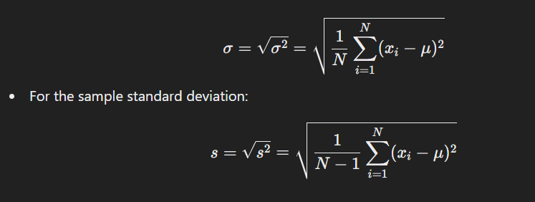

### Summary

* **Variance** gives a measure of how spread out the data points are around the mean.
* **Standard deviation** is the square root of the variance and provides a measure of the average distance of each data point from the mean, in the same units as the data.

These calculations help in understanding the dispersion or variability within a dataset.

______________________________________________________________________________

**What is skewness and kurtosis? How do they help in understanding data distribution?**

### Skewness

**Skewness** is a measure of the asymmetry of the probability distribution of a real-valued random variable about its mean. In simpler terms, it tells us whether the data is skewed to the left (negatively skewed), to the right (positively skewed), or if it's symmetrical (zero skewness).

* **Positive Skewness (Right-Skewed):** If the tail on the right side of the distribution is longer or fatter than the left side, the distribution has positive skewness. This indicates that there are more lower values and a few very high values pulling the mean to the right.
* **Negative Skewness (Left-Skewed):** If the tail on the left side of the distribution is longer or fatter than the right side, the distribution has negative skewness. This indicates that there are more higher values and a few very low values pulling the mean to the left.
* **Zero Skewness (Symmetrical Distribution):** If the distribution is perfectly symmetrical, it has zero skewness. This is typical of a normal distribution.

### Kurtosis

**Kurtosis** is a measure of the "tailedness" of the probability distribution of a real-valued random variable. It describes how heavy or light the tails of the distribution are compared to a normal distribution.

* **Leptokurtic (Positive Kurtosis):** Distributions with positive kurtosis have heavier tails than a normal distribution. This means there are more extreme values (outliers) than in a normal distribution.
* **Platykurtic (Negative Kurtosis):** Distributions with negative kurtosis have lighter tails than a normal distribution. This means there are fewer extreme values, and the distribution is flatter and more spread out.
* **Mesokurtic (Zero Kurtosis):** A mesokurtic distribution has a kurtosis value of zero, indicating that it has the same tailedness as a normal distribution.

### How They Help in Understanding Data Distribution

* **Skewness** provides insight into the symmetry of the data distribution. If data is skewed, it suggests that the mean is being influenced by outliers in one direction, which can affect statistical analyses like the mean, median, and mode.
* **Kurtosis** gives information about the presence of outliers and the shape of the tails. High kurtosis implies a higher likelihood of outliers, which can impact the reliability of certain statistical tests and models. Conversely, low kurtosis indicates a more uniform ditribution without many extreme deviations.

Together, skewness and kurtosis help in understanding the shape and characteristics of the data distribution, which is crucial for choosing appropriate statistical methods and interpreting results accurately.

______________________________________________________________________________

**What is the central limit theorem, and why is it important in statistics?**

The **Central Limit Theorem (CLT)** is a fundamental theorem in statistics that describes how the distribution of sample means approximates a normal distribution, regardless of the original population's distribution, as the sample size becomes large.

### **Key Points of the Central Limit Theorem:**

1. **Sample Means Distribution:** If you take a sufficiently large number of samples from a population with any shape of distribution (normal or not) and calculate their means, the distribution of those means will approximate a normal distribution (a bell curve).
2. **Population Mean and Variance:** The mean of the sample means will be equal to the population mean. The variance of the sample means will be equal to the population variance divided by the sample size (σ^2/n).
3. **Sample Size:** The larger the sample size, the closer the distribution of the sample means will be to a normal distribution. Typically, a sample size of 30 or more is considered sufficient for the CLT to hold.

### **Why is the Central Limit Theorem Important?**

1. **Justification for Using Normal Distribution:** Many statistical methods, such as confidence intervals and hypothesis testing, rely on the assumption that the data are normally distributed. The CLT provides the justification for this assumption when working with sample means, even if the original data does not follow a normal distribution.
2. **Simplifies Analysis:** Since the distribution of sample means approaches normality as sample size increases, it allows for the use of normal probability tables and other tools that assume normality. This simplifies analysis and makes it more accessible.
3. **Foundation for Inferential Statistics:** The CLT is the backbone of inferential statistics. It allows statisticians to make inferences about population parameters (like the mean) based on sample data, which is crucial for making predictions, decisions, and generalizations from a limited amount of data.

In summary, the Central Limit Theorem is crucial because it enables statisticians to use the normal distribution as a model for the distribution of sample means, facilitating the application of various statistical methods and making it easier to draw reliable conclusions from data.

______________________________________________________________________________

## **Describe different types of probability distributions (e.g., normal, binomial, Poisson).**

Probability distributions describe how the values of a random variable are distributed. Each type of probability distribution has its own characteristics, which make it suitable for modeling different types of random processes. Here's a look at some common probability distributions:

### 1. **Normal Distribution**

* **Concept:** The normal distribution, also known as the Gaussian distribution, is a continuous probability distribution characterized by its bell-shaped curve. It is symmetric around the mean, and most of the data points cluster around the central peak, with fewer points appearing as you move away from the mean.
* **Key Features:**
  + Mean (µ) determines the center of the distribution.
  + Standard deviation (σ) determines the spread or width of the distribution.
  + Many natural phenomena (like heights, test scores, etc.) follow a normal distribution.

### 2. **Binomial Distribution**

* **Concept:** The binomial distribution is a discrete probability distribution that models the number of successes in a fixed number of independent trials, where each trial has only two possible outcomes (success or failure). It is often used to model situations like the number of heads in a series of coin flips.
* **Key Features:**
  + The probability of success (p) and failure (1-p) is constant for each trial.
  + The number of trials (n) is fixed.
  + The distribution is characterized by the parameters n and p.

### 3. **Poisson Distribution**

* **Concept:** The Poisson distribution is a discrete probability distribution that models the number of times an event occurs in a fixed interval of time or space, given that these events happen with a known constant mean rate and independently of the time since the last event. It is often used to model rare events, such as the number of emails received in an hour or the number of accidents at an intersection.
* **Key Features:**
  + Defined by the average rate (λ) at which events occur.
  + The probability of more than one event occurring in an infinitesimally small time interval is negligible.
  + The events are independent.

### 4. **Uniform Distribution**

* **Concept:** The uniform distribution can be either discrete or continuous. In its continuous form, it models a situation where all outcomes in a range are equally likely. For example, the probability of getting any number between 0 and 1 in a random draw is the same.
* **Key Features:**
  + For a continuous uniform distribution between a and b, any value within [a, b] is equally likely.
  + The probability density function (PDF) is constant.

### 5. **Exponential Distribution**

* **Concept:** The exponential distribution is a continuous probability distribution often used to model the time between independent events that happen at a constant average rate. It's closely related to the Poisson distribution and is commonly used in scenarios like the time until the next customer arrives or the time until a light bulb burns out.
* **Key Features:**
  + Characterized by the rate parameter (λ), which is the inverse of the mean.
  + The distribution is memoryless, meaning the probability of an event occurring in the future is independent of the past.

### 6. **Chi-Square Distribution**

* **Concept:** The chi-square distribution is a continuous distribution that arises in the context of hypothesis testing and confidence interval estimation for variance. It is the distribution of the sum of the squares of independent standard normal variables.
* **Key Features:**
  + Used in statistical tests like the chi-square test for independence.
  + The shape of the distribution depends on the degrees of freedom.

### 7. **Student's t-Distribution**

* **Concept:** The t-distribution is a continuous probability distribution that is similar to the normal distribution but has heavier tails. It is used when the sample size is small and the population standard deviation is unknown, which makes it useful in estimating population parameters.
* **Key Features:**
  + It has a mean of 0 and is symmetric.
  + The spread of the distribution depends on the degrees of freedom.
  + As the sample size increases, the t-distribution approaches the normal distribution.

### 8. **Gamma Distribution**

* **Concept:** The gamma distribution is a continuous probability distribution used to model the time until an event happens a certain number of times. It generalizes the exponential distribution by allowing the shape parameter to take on non-integer values.
* **Key Features:**
  + Defined by a shape parameter (k) and a rate parameter (θ).
  + Useful in various fields such as queuing models and reliability analysis.

### 9. **Beta Distribution**

* **Concept:** The beta distribution is a continuous probability distribution that models the distribution of probabilities themselves. It's often used to model the behavior of random variables that are constrained within an interval, like proportions or percentages.
* **Key Features:**
  + Defined by two shape parameters, α and β.
  + The distribution can take on various shapes depending on the values of α and β, including uniform, U-shaped, or bell-shaped.

Each of these distributions is suited for modeling different types of real-world phenomena, and choosing the appropriate distribution depends on the nature of the data and the problem at hand.

______________________________________________________________________________

## **Explain the difference between a population and a sample. Why is sampling important?**

### Difference Between a Population and a Sample

* **Population**: A population includes all members or items that meet a particular criterion or set of criteria. It is the entire group about which you want to draw conclusions. For example, if you're studying the average height of adult men in a country, the population would include every adult man in that country.
* **Sample**: A sample is a subset of the population that is selected for the actual study or analysis. The sample should ideally represent the population from which it is drawn. For instance, if you can't measure the height of every adult man in the country, you might select a few thousand men as a sample to estimate the average height.

### Importance of Sampling

1. **Feasibility**: In many cases, it is impractical or impossible to study an entire population due to time, cost, or logistical constraints. Sampling allows researchers to gather and analyze data more efficiently.
2. **Cost-Effective**: Studying a smaller group (sample) instead of an entire population reduces the resources needed, making research more affordable.
3. **Time-Efficient**: Analyzing a sample is quicker than analyzing an entire population, which speeds up the research process and allows for faster decision-making.
4. **Manageability**: Working with a smaller sample makes data collection, storage, and analysis more manageable. Large data sets can be complex and challenging to work with.
5. **Accuracy**: If done correctly, sampling can provide accurate estimates of population parameters. Proper sampling techniques ensure that the sample represents the population, allowing for generalization of the results.
6. **Ethical Considerations**: In some cases, it may be unethical to study an entire population (e.g., testing a new drug on all patients). Sampling allows researchers to conduct studies in a way that minimizes harm or inconvenience.

In summary, while a population encompasses all members of a defined group, a sample is a manageable subset used for study. Sampling is crucial because it makes research feasible, cost-effective, and accurate while allowing researchers to draw meaningful conclusions about a larger group.

______________________________________________________________________________

## **How to Formulate Null and Alternative Hypotheses?**

1. **Identify the Research Question:**
   * Start with a clear research question or problem you want to investigate.
   * Determine what you want to prove or test.
2. **Formulate the Null Hypothesis (H₀):**
   * Assume no effect, no difference, or no change. This hypothesis should be stated in a way that can be tested directly.
   * Example: "The average weight loss from the new diet is equal to the average weight loss from the existing diet."
   * **H₀:** The population parameter equals a specific value (e.g., H0:μ=0 if testing for no difference).
3. **Formulate the Alternative Hypothesis (H₁ or Hₐ):**
   * This hypothesis should reflect the claim or effect you want to investigate. It is usually the opposite of the null hypothesis.
   * Example: "The average weight loss from the new diet is different from the average weight loss from the existing diet."
   * **H₁:** The population parameter differs from the value stated in H0​ (e.g., H1:μ≠0 for a two-tailed test).
4. **Determine the Type of Test (One-tailed or Two-tailed):**
   * **One-tailed test**: Used when you are testing for an effect in a specific direction (e.g., greater than or less than).
   * **Two-tailed test**: Used when you are testing for an effect in either direction (e.g., not equal).
5. **Set Up the Hypotheses:**
   * **Example:** Suppose a company claims that their light bulbs last for 1000 hours on average. You want to test this claim.
     + **Null Hypothesis (H₀):** The average life of the light bulbs is 1000 hours ( H0:μ=1000 ).
     + **Alternative Hypothesis (H₁):** The average life of the light bulbs is not 1000 hours ( H1:μ≠1000 ).

In summary, the null hypothesis is the claim you seek to test (often a statement of no effect), and the alternative hypothesis is what you are trying to find evidence for (a statement of an effect or difference).

______________________________________________________________________________

## **Describe the steps in conducting a hypothesis test.**

Conducting a hypothesis test involves several key steps, which are designed to assess the evidence against a null hypothesis. Here’s a step-by-step guide to performing a hypothesis test:

### 1. **State the Hypotheses**

* **Null Hypothesis (H₀):** This is the default assumption that there is no effect or no difference. It represents the status quo or the claim to be tested.
* **Alternative Hypothesis (H₁ or Hₐ):** This is what you want to prove. It represents a new effect, difference, or relationship that contradicts the null hypothesis.

Example:

* H₀: The mean of the population is equal to 50.
* H₁: The mean of the population is not equal to 50.

### 2. **Choose the Significance Level (α)**

* The significance level, denoted as α, is the probability of rejecting the null hypothesis when it is actually true. Common choices for α are 0.05, 0.01, or 0.10, with 0.05 being the most common.

Example:

* Set α = 0.05.

### 3. **Select the Appropriate Test**

* Choose the statistical test that matches your data and hypothesis. The choice depends on factors like the type of data (e.g., categorical or continuous), sample size, and whether you are comparing means, proportions, etc.

Common tests include:

* **Z-test or t-test:** For comparing means.
* **Chi-square test:** For categorical data.
* **ANOVA:** For comparing means across multiple groups.
* **Regression analysis:** For relationships between variables.

### 4. **Calculate the Test Statistic**

* The test statistic is a standardized value that measures the degree of departure from the null hypothesis. The formula and method for calculating the test statistic depend on the chosen test.

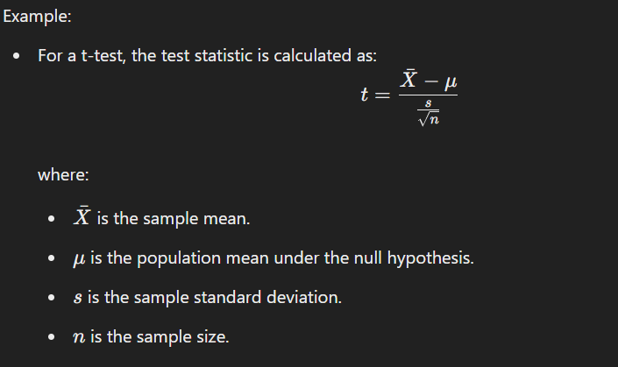

### 5. **Determine the p-value or Critical Value**

* **p-value:** The p-value is the probability of obtaining a test statistic at least as extreme as the one observed, assuming the null hypothesis is true. A small p-value indicates strong evidence against H₀.
* **Critical Value:** Alternatively, you can compare the test statistic to a critical value from a statistical distribution (e.g., t-distribution, Z-distribution) based on the chosen significance level.

Example:

* If using a p-value approach, calculate the p-value associated with the test statistic.
* If using a critical value approach, determine the critical value from statistical tables and compare it to the test statistic.

### 6. **Make a Decision**

* **Reject H₀:** If the p-value is less than or equal to α, or if the test statistic exceeds the critical value, reject the null hypothesis. This suggests there is sufficient evidence to support the alternative hypothesis.
* **Fail to Reject H₀:** If the p-value is greater than α, or if the test statistic does not exceed the critical value, fail to reject the null hypothesis. This suggests there is not enough evidence to support the alternative hypothesis.

### 7. **Draw a Conclusion**

* Based on the decision, conclude whether or not there is sufficient statistical evidence to support the alternative hypothesis. The conclusion should be stated in the context of the original research question or problem.

### 8. **Report the Results**

* Clearly report the test statistic, p-value, decision (whether H₀ was rejected), and the conclusion. It’s also helpful to include the confidence interval for the estimated effect size, if applicable.

Example:

* "The t-test results show that the mean is significantly different from 50 (t = 2.45, p = 0.017). Thus, we reject the null hypothesis at the 0.05 significance level.

Following these steps ensures a systematic and rigorous approach to hypothesis testing, allowing for sound conclusions based on statistical evidence.

______________________________________________________________________________

## **What is a p-value? How do you interpret it in the context of a hypothesis test?**

A **p-value** is a statistical measure that helps you determine the significance of your results in the context of a hypothesis test. It indicates the probability of obtaining a result at least as extreme as the one observed in your sample data, assuming that the null hypothesis is true.

### Interpreting the p-value in Hypothesis Testing:

1. **Null Hypothesis (H₀)**: This is the default assumption that there is no effect or no difference. For example, in a test comparing the means of two groups, the null hypothesis might state that the means are equal.
2. **Alternative Hypothesis (H₁)**: This represents the opposing assumption that there is an effect or a difference.
3. **p-value Meaning**:
   * **Low p-value (typically ≤ 0.05)**: This suggests that the observed data is unlikely under the null hypothesis. Therefore, you might reject the null hypothesis in favor of the alternative hypothesis. The lower the p-value, the stronger the evidence against the null hypothesis.
   * **High p-value (typically > 0.05)**: This suggests that the observed data is likely under the null hypothesis. Therefore, you fail to reject the null hypothesis. It does not necessarily prove that the null hypothesis is true, only that there isn't strong enough evidence to reject it.
4. **Significance Level (α)**:
   * The significance level, often denoted by α (e.g., 0.05), is a threshold set before conducting the test. If the p-value is less than or equal to α, you reject the null hypothesis; otherwise, you do not reject it.
   * For example, with α = 0.05, there is a 5% risk of rejecting the null hypothesis when it is actually true (Type I error).

### Example:

Imagine you are testing whether a new drug is more effective than a placebo. Your null hypothesis (H₀) might be that the drug has no effect (mean difference = 0). After conducting the test, you obtain a p-value of 0.03.

* Since 0.03 < 0.05 (assuming α = 0.05), you would reject the null hypothesis. This suggests that the drug likely has an effect, as the probability of observing such a result due to random chance is only 3%.

### Key Points:

* The p-value does not measure the probability that the null hypothesis is true.
* It also doesn't tell you the size of the effect or the importance of the result.
* It simply quantifies how compatible your data is with the null hypothesis.

______________________________________________________________________________

When would you use a t-test versus a z-test?

Both t-tests and z-tests are statistical methods used to compare sample data to a known value or between two groups. The choice between a t-test and a z-test depends on several factors, including sample size, whether the population standard deviation is known, and the underlying distribution of the data.

### When to Use a T-Test

1. **Sample Size is Small (Typically n<30n < 30n<30):**
   * When you have a small sample size, the t-distribution is used because it accounts for the added variability in the sample mean. The t-distribution is wider (has heavier tails) than the normal distribution, which helps account for the increased uncertainty.
2. **Population Standard Deviation is Unknown:**
   * The t-test is used when the population standard deviation (σ\sigmaσ) is unknown, and the sample standard deviation (sss) is used as an estimate. Since sss is just an estimate of σ\sigmaσ, the t-distribution, which is more conservative than the normal distribution, is appropriate.
3. **Small or Moderate Sample Size:**
   * Even with moderate sample sizes, if the population standard deviation is unknown, it's common practice to use a t-test, especially when n<30 n < 30n<30.

### When to Use a Z-Test

1. **Sample Size is Large (Typically n≥30n \geq 30n≥30):**
   * For large sample sizes, the Central Limit Theorem states that the sampling distribution of the sample mean tends to be normally distributed, regardless of the shape of the population distribution. In this case, you can use the z-test.
2. **Population Standard Deviation is Known:**
   * The z-test is used when the population standard deviation (σ\sigmaσ) is known. With this known value, the normal distribution (z-distribution) is appropriate, and the z-test is more straightforward.
3. **Comparing Proportions or Testing Hypotheses with Large Samples:**
   * Z-tests are also often used for hypothesis testing about proportions or for comparing means when sample sizes are large and population variances are known or assumed to be equal.

### Summary

* **Use a t-test** when:
  + Sample size is small.
  + Population standard deviation is unknown.
* **Use a z-test** when:
  + Sample size is large.
  + Population standard deviation is known.

In practice, with modern statistical software, the choice between t-test and z-test often defaults to a t-test because it handles more general cases and is appropriate even when the sample size is large (the t-distribution approximates the normal distribution closely as sample size increases).

______________________________________________________________________________

## **Explain how you would conduct an independent two-sample t-test. What assumptions must be met?**

An independent two-sample t-test is used to compare the means of two independent groups to determine whether there is a statistically significant difference between them. Here's how you would conduct this test and the assumptions that need to be met:

### Steps to Conduct an Independent Two-Sample T-Test

1. **State the Hypotheses**:
   * **Null Hypothesis (H0H_0H0​)**: The means of the two groups are equal (μ1=μ2\mu_1 = \mu_2μ1​=μ2​).
   * **Alternative Hypothesis (H1H_1H1​)**: The means of the two groups are not equal (μ1≠μ2\mu_1 \neq \mu_2μ1​=μ2​).
2. **Choose the Significance Level (α\alphaα)**:
   * Common choices are 0.05, 0.01, or 0.10, depending on how strict you want to be.
3. **Collect the Data**:
   * Gather data for the two independent samples. Ensure the sample sizes are n1n_1n1​ and n2n_2n2​ for groups 1 and 2, respectively.
4. **Check Assumptions**:
   * Before proceeding with the t-test, verify that the data meet the necessary assumptions (detailed below).

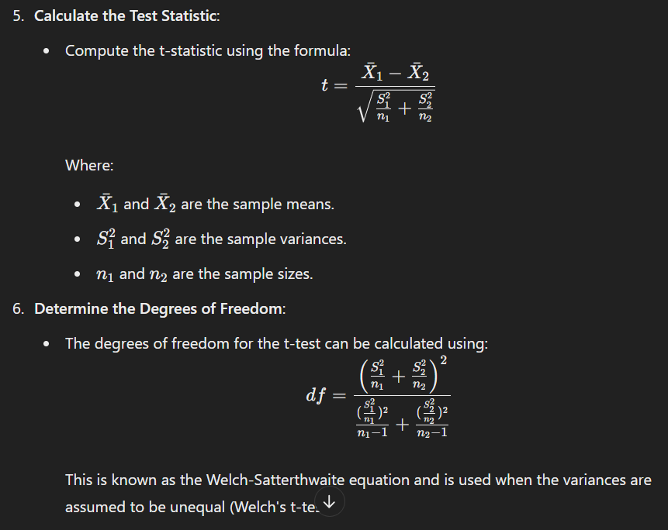

1. **Find the Critical Value or P-Value**:
   * Compare the calculated t-statistic to the critical value from the t-distribution (based on the degrees of freedom) or compute the p-value.
   * If using a p-value approach, compare it to the significance level α\alphaα.
2. **Make a Decision**:
   * **If ∣t∣>tcritical ​ or p<α**: Reject the null hypothesis. There is a significant difference between the two means.
   * **If ∣t∣≤tcritical or p≥αp**: Fail to reject the null hypothesis. There is no significant difference between the two means.
3. **Report the Results**:
   * Present the findings, including the means, t-statistic, degrees of freedom, and p-value, and interpret them in the context of your research question.

### Assumptions of the Independent Two-Sample T-Test

1. **Independence of Observations**:
   * The observations in each group must be independent of each other. This means that the data from one group should not influence the data from the other group.
2. **Normality**:
   * The data in each group should be approximately normally distributed. This assumption is more critical when the sample size is small. For large sample sizes (usually n>30n > 30n>30 per group), the Central Limit Theorem ensures that the sampling distribution of the mean is approximately normal.
3. **Homogeneity of Variances (Equal Variances)**:
   * The variances of the two groups should be approximately equal. This assumption can be tested using Levene's test or an F-test for equality of variances.
   * If this assumption is violated, you should use Welch's t-test, which does not assume equal variances.
4. **Scale of Measurement**:
   * The dependent variable should be measured on an interval or ratio scale (continuous data).

By meeting these assumptions and following the steps outlined above, you can accurately perform an independent two-sample t-test and determine whether there is a significant difference between the two groups.

______________________________________________________________________________

## **Describe a scenario where you would use a paired sample t-test.**

Sure! A paired sample t-test is used when you have two sets of related measurements and you want to determine if there is a significant difference between the means of these two sets. Here’s a practical scenario where you might use a paired sample t-test:

**Scenario: Evaluating the Effectiveness of a New Diet Plan**

Imagine you’re a nutritionist conducting a study to evaluate the effectiveness of a new diet plan. You want to see if the diet plan leads to a significant reduction in body weight.

**Procedure:**

1. **Pre-Diet Measurement:** You measure the body weight of each participant before they start the diet plan. This gives you your first set of data.
2. **Post-Diet Measurement:** After a certain period on the diet plan (e.g., 8 weeks), you measure the body weight of the same participants again. This gives you your second set of data.

**Applying the Paired Sample t-Test:**

* **Null Hypothesis (H₀):** The average weight before starting the diet is equal to the average weight after following the diet (no change in weight).
* **Alternative Hypothesis (H₁):** The average weight before starting the diet is different from the average weight after following the diet (there is a significant change in weight).

You’d use a paired sample t-test to analyze the data and determine whether the observed changes in body weight are statistically significant, or if they could be due to random chance.

______________________________________________________________________________

## **What is ANOVA, and how does it differ from a t-test?**

ANOVA (Analysis of Variance) and the t-test are both statistical methods used to compare means, but they are applied in different contexts and have distinct purposes.

### ANOVA

**Purpose:** ANOVA is used to compare the means of three or more groups to determine if there is a significant difference between them. It tests the null hypothesis that all group means are equal.

**How It Works:** ANOVA works by partitioning the total variability in the data into variability due to the differences between group means and variability due to differences within each group. It then compares the ratio of these variabilities using an F-statistic to determine if the group means are significantly different.

**Types of ANOVA:**

* **One-way ANOVA:** Tests differences between group means for one independent variable.
* **Two-way ANOVA:** Tests differences between group means for two independent variables, and can also examine interaction effects between the variables.

### t-test

**Purpose:** The t-test is used to compare the means of two groups to determine if there is a significant difference between them.

**How It Works:** The t-test calculates a t-statistic that reflects the difference between the group means relative to the variability within the groups. It then uses this t-statistic to determine if the observed difference is statistically significant.

**Types of t-tests:**

* **Independent (or unpaired) t-test:** Compares the means of two independent groups.
* **Paired t-test:** Compares the means of two related groups (e.g., before and after treatment on the same subjects).

### Key Differences

1. **Number of Groups:**
   * **ANOVA:** Compares three or more groups.
   * **t-test:** Compares only two groups.
2. **Purpose:**
   * **ANOVA:** Tests if there are any significant differences among multiple group means.
   * **t-test:** Tests if there is a significant difference between the means of two groups.
3. **Outcome:**
   * **ANOVA:** Provides an F-statistic and p-value to indicate whether there is a significant difference among the groups.
   * **t-test:** Provides a t-statistic and p-value to indicate whether there is a significant difference between the two groups.

In summary, ANOVA is the go-to method when you need to compare means across more than two groups, while the t-test is appropriate for comparing the means of exactly two groups.

______________________________________________________________________________

## **Explain how you would interpret the results of a one-way ANOVA.**

Interpreting the results of a one-way ANOVA (Analysis of Variance) involves several key steps:

1. **Understand the Hypotheses:**
   * **Null Hypothesis (H₀):** The means of the different groups are equal (no effect of the treatment or factor).
   * **Alternative Hypothesis (H₁):** At least one group mean is different from the others.
2. **Examine the ANOVA Table:** The ANOVA table typically includes:
   * **Sum of Squares (SS):** Measures the variability in the data.
   * **Degrees of Freedom (df):** Reflects the number of independent pieces of information.
   * **Mean Squares (MS):** Calculated as SS divided by df.
   * **F-Statistic (F):** Ratio of the variance between groups to the variance within groups. It helps determine if the group means are significantly different.
   * **p-Value:** Probability of observing the data assuming the null hypothesis is true. A low p-value (typically less than 0.05) indicates that you can reject the null hypothesis.
3. **Check the F-Statistic:**
   * If the F-statistic is large, it suggests that there is a significant difference between the group means. This means the variability between group means is greater than the variability within groups.
4. **Interpret the p-Value:**
   * Compare the p-value to your significance level (α, usually 0.05). If the p-value is less than α, you reject the null hypothesis, concluding that there are significant differences between at least some group means. If the p-value is greater than α, you do not reject the null hypothesis, suggesting that there are no significant differences.
5. **Post-Hoc Tests (if necessary):**
   * If the ANOVA indicates significant differences, you may need to conduct post-hoc tests (like Tukey's HSD, Bonferroni, or Scheffé) to determine which specific groups are different from each other.
6. **Check Assumptions:**
   * **Normality:** The data in each group should be approximately normally distributed.
   * **Homogeneity of Variances:** The variance among the groups should be roughly equal.
   * **Independence:** The observations should be independent of each other.

By following these steps, you can determine whether there are significant differences between group means and identify which groups differ if necessary.

______________________________________________________________________________

## **Describe a situation where you might use a two-way ANOVA.**

A two-way ANOVA (Analysis of Variance) is useful when you want to examine the effect of two different categorical independent variables on a continuous dependent variable and also check if there’s an interaction between these two independent variables.

Here’s an example scenario:

**Research Question:** Does the type of diet and exercise regimen affect weight loss, and is there an interaction between these two factors?

**Design:**

* **Independent Variable 1 (Diet Type):** Two levels (e.g., Low-Carb and Low-Fat)
* **Independent Variable 2 (Exercise Regimen):** Two levels (e.g., Cardio and Strength Training)
* **Dependent Variable:** Weight loss (measured in pounds or kilograms)

**Setup:**

1. **Groups:** You have four groups based on the combination of diet and exercise regimen:
   * Low-Carb + Cardio
   * Low-Carb + Strength Training
   * Low-Fat + Cardio
   * Low-Fat + Strength Training
2. **Participants:** Assign a group of participants to each of the four groups. Over a period of time, measure the weight loss for each participant.

**Analysis with Two-Way ANOVA:**

* **Main Effects:** Determine if there are significant differences in weight loss due to diet type (Low-Carb vs. Low-Fat) and exercise regimen (Cardio vs. Strength Training).
* **Interaction Effect:** Investigate if the effect of one factor (e.g., diet) on weight loss depends on the level of the other factor (e.g., exercise regimen). For instance, the effect of the Low-Carb diet might be different depending on whether participants do Cardio or Strength Training.

By using a two-way ANOVA, you can not only assess the individual effects of diet and exercise but also understand if and how these factors interact to influence weight loss.

______________________________________________________________________________

## **What is a chi-square test for independence? When would you use it?**

A chi-square test for independence is a statistical method used to determine if there is a significant association between two categorical variables. In other words, it helps you figure out whether the distribution of one variable is independent of the distribution of another variable.

Here's how it works:

1. **Set Up the Hypotheses:**
   * **Null Hypothesis (H0):** The variables are independent; there is no association between them.
   * **Alternative Hypothesis (H1):** The variables are dependent; there is an association between them.
2. **Collect and Organize Data:**
   * Create a contingency table (cross-tabulation) that displays the frequency of occurrences for each combination of categories from the two variables.

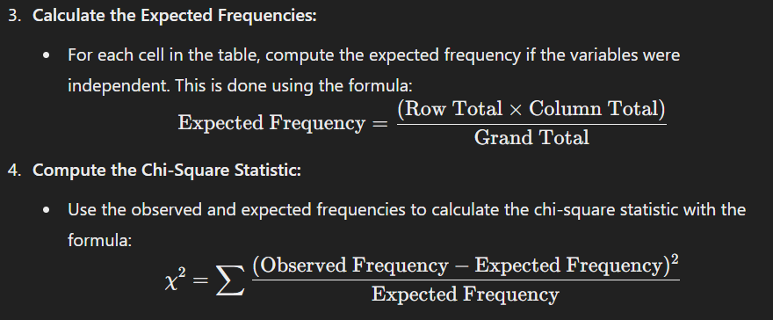

1. **Determine the P-Value:**
   * Compare the chi-square statistic to a chi-square distribution with the appropriate degrees of freedom to find the p-value.
2. **Make a Decision:**
   * If the p-value is less than the chosen significance level (e.g., 0.05), reject the null hypothesis, suggesting there is a significant association between the variables. Otherwise, do not reject the null hypothesis.

**When to Use It:**

* **When you have two categorical variables:** For example, if you want to examine whether gender (male, female) is associated with voting preference (Democrat, Republican).
* **When you want to test the independence of variables in a sample:** For instance, checking if the distribution of educational levels is independent of employment status in a survey.
* **When your data is organized into a contingency table:** The chi-square test is appropriate when data can be summarized in this way, and you want to test for independence between the row and column variables.

It’s important to ensure that the sample size is sufficiently large and that the expected frequency in each cell of the contingency table is adequate (generally at least 5) to make the chi-square test reliable. If this condition isn't met, you might need to use a different test, such as Fisher's exact test.

______________________________________________________________________________

## **How do you interpret the results of a chi-square goodness-of-fit test?**

Interpreting the results of a chi-square goodness-of-fit test involves several steps:

1. **Understand the Hypotheses:**
   * **Null Hypothesis (H0H_0H0​)**: Assumes that the observed data fits the expected distribution. For example, if you’re testing whether a die is fair, H0H_0H0​ would state that each face of the die has an equal probability of landing face up.
   * **Alternative Hypothesis (HAH_AHA​)**: Assumes that the observed data does not fit the expected distribution.

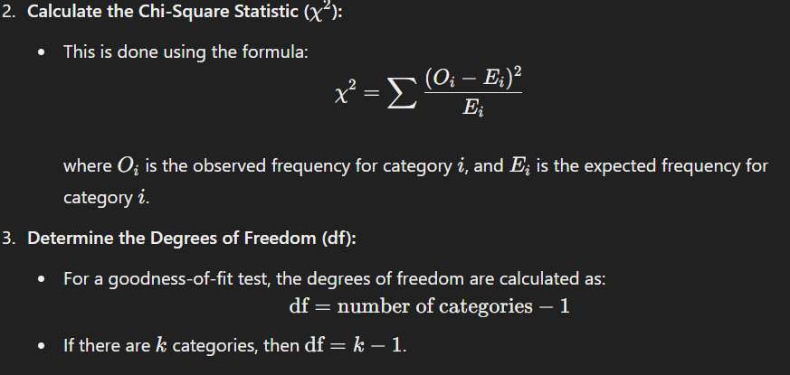

1. **Find the P-value:**
   * Use the chi-square distribution table or statistical software to find the p-value corresponding to your calculated χ2\chi^2χ2 statistic and the degrees of freedom. The p-value tells you the probability of obtaining a chi-square statistic at least as extreme as the one calculated, assuming the null hypothesis is true.
2. **Compare the P-value to Your Significance Level (α\alphaα):**
   * Common significance levels are 0.05, 0.01, or 0.10.
   * If the p-value is less than or equal to α\alphaα, you reject the null hypothesis, suggesting that there is a significant difference between the observed and expected frequencies.
   * If the p-value is greater than α\alphaα, you do not reject the null hypothesis, suggesting that the observed frequencies do not significantly differ from the expected frequencies.
3. **Draw Conclusions:**
   * If you rejected the null hypothesis, it means the data does not fit the expected distribution. You may need to investigate further to understand the nature of the discrepancy.
   * If you did not reject the null hypothesis, it means the data fits the expected distribution well within the margin of error allowed by your significance level.

By following these steps, you can interpret whether the observed data aligns with your expected theoretical model or if there are significant deviations.

______________________________________________________________________________

## **Explain the assumptions and limitations of chi-square tests.**

Chi-square tests are widely used statistical tests for categorical data, but they come with specific assumptions and limitations that should be kept in mind. Here’s a breakdown:

### Assumptions:

1. **Independence**: The observations should be independent of one another. This means that the occurrence of one observation does not affect the occurrence of another. In practice, this often means that each subject or item should only be in one category and not duplicated.
2. **Sample Size**: Chi-square tests require a sufficiently large sample size to ensure reliable results. Specifically, the expected frequency in each cell of the contingency table should be at least 5. If some expected frequencies are less than 5, the results of the test might not be reliable.
3. **Categorical Data**: The data being analyzed should be categorical, meaning that it falls into distinct categories. Chi-square tests are not appropriate for continuous data unless it is first categorized into groups.
4. **Mutually Exclusive Categories**: Each observation should fall into one and only one category. The categories should be mutually exclusive.

### Limitations:

1. **Sensitivity to Small Sample Sizes**: When sample sizes are small, the chi-square test may not be accurate. Small samples can lead to misleading results because the approximation to the chi-square distribution becomes less reliable.
2. **Not Suitable for Small Expected Frequencies**: If the expected frequency in any cell of the contingency table is less than 5, the chi-square test may not be valid. In such cases, alternative tests like Fisher's exact test might be more appropriate.
3. **Data Aggregation**: Chi-square tests require that data be aggregated into categorical bins. This means that some information might be lost if the data are inherently continuous and not naturally suited to categorization.
4. **Cannot Measure Strength of Association**: While chi-square tests can determine if there is an association between variables, they do not provide information about the strength or direction of the association.
5. **Assumption of Random Sampling**: The test assumes that the sample is randomly drawn from the population. If the sampling method is biased, the results may not be generalizable.

Understanding these assumptions and limitations helps in choosing the right statistical test and in interpreting the results appropriately.

______________________________________________________________________________

## **What is the difference between simple linear regression and multiple regression?**

Simple linear regression and multiple regression are both statistical methods used to understand relationships between variables, but they differ in terms of complexity and the number of predictors involved.

**Simple Linear Regression:**

* **Number of Predictors:** It involves just one predictor (independent variable) and one outcome (dependent variable).

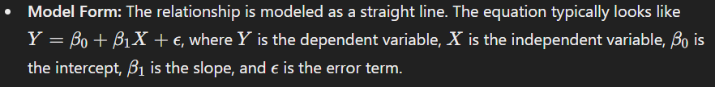

* **Usage:** It's used when you want to explore the relationship between two variables and predict the value of the dependent variable based on the independent variable.

**Multiple Regression:**

* **Number of Predictors:** It involves two or more predictors. This model can accommodate multiple independent variables and one dependent variable.

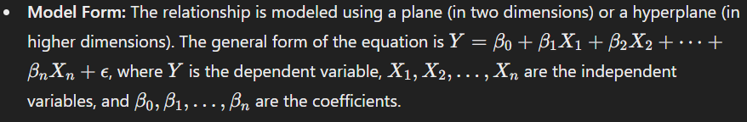

* **Usage:** It's used when you want to understand the relationship between the dependent variable and multiple independent variables, and also to see how each predictor contributes to the outcome, potentially controlling for the influence of other predictors.

In summary, simple linear regression examines the relationship between two variables, while multiple regression assesses the impact of several variables on a single outcome, providing a more nuanced view of how multiple factors interact to influence the dependent variable.

______________________________________________________________________________

## **How do you assess the goodness-of-fit of a regression model?**

Assessing the goodness-of-fit of a regression model involves evaluating how well the model's predictions match the actual data. Here are some common methods and metrics used for this purpose:

1. **R-squared (R2R^2R2)**: This statistic represents the proportion of variance in the dependent variable that is predictable from the independent variables. Values range from 0 to 1, where a higher value indicates a better fit. However, a high R2R^2R2 doesn’t necessarily mean the model is good, especially if it’s overfitting.
2. **Adjusted R-squared**: This adjusts R2R^2R2 for the number of predictors in the model. It’s useful for comparing models with different numbers of predictors, as it penalizes the addition of less significant predictors.
3. **Mean Absolute Error (MAE)**: This is the average of the absolute differences between the predicted and actual values. It gives a clear measure of prediction accuracy but doesn’t penalize large errors more heavily.
4. **Mean Squared Error (MSE)**: This is the average of the squared differences between the predicted and actual values. It gives more weight to larger errors compared to MAE, which can be useful if large errors are particularly undesirable.
5. **Root Mean Squared Error (RMSE)**: This is the square root of MSE. It has the same units as the dependent variable, making it easier to interpret than MSE.
6. **Residual Plots**: Plotting the residuals (differences between observed and predicted values) can help diagnose problems with the model. Residuals should be randomly scattered around zero if the model fits well. Patterns in residuals might indicate issues like non-linearity or heteroscedasticity.
7. **F-test**: In the context of linear regression, the F-test can be used to determine if the model is significantly better than a model with no predictors (i.e., a model that only uses the mean of the dependent variable).
8. **Cross-validation**: Techniques like k-fold cross-validation involve partitioning the data into subsets, training the model on some subsets, and testing it on others. This helps assess how well the model generalizes to unseen data.

Each method provides different insights, and often, a combination of these metrics is used to assess the overall performance of a regression model comprehensively.

## **Explain multicollinearity and how you would detect and handle it in a regression model.**

Multicollinearity occurs in regression analysis when two or more predictor variables (independent variables) are highly correlated with each other. This makes it difficult to determine the individual effect of each predictor on the dependent variable and can lead to unreliable estimates of regression coefficients.

### **Detection of Multicollinearity**

1. **Correlation Matrix**: Check the correlation matrix of the predictor variables. High correlations (usually above 0.8 or below -0.8) between predictors may indicate multicollinearity.
2. **Variance Inflation Factor (VIF)**: Calculate the VIF for each predictor. A VIF value greater than 10 (some use 5 as a threshold) suggests significant multicollinearity. VIF measures how much the variance of the estimated regression coefficients is inflated due to multicollinearity.
3. **Condition Index**: Compute the condition index, which is derived from the eigenvalues of the predictor variable matrix. A condition index greater than 30 may indicate multicollinearity.
4. **Eigenvalues**: Examine the eigenvalues of the correlation matrix. Small eigenvalues close to zero suggest multicollinearity.

### **Handling Multicollinearity**

1. **Remove Highly Correlated Predictors**: If two predictors are highly correlated, consider removing one of them from the model.
2. **Combine Predictors**: Use principal component analysis (PCA) or factor analysis to combine correlated predictors into a single predictor.
3. **Regularization Techniques**: Apply regularization methods such as Ridge Regression (L2 regularization) or Lasso Regression (L1 regularization). These techniques add a penalty to the regression model to reduce the impact of multicollinearity.
4. **Centering the Predictors**: Subtract the mean of each predictor to center them around zero. This can sometimes reduce multicollinearity, especially when dealing with interaction terms.
5. **Increase Sample Size**: Sometimes increasing the sample size can help mitigate the effects of multicollinearity.
6. **Check Data Quality**: Ensure there are no data entry errors or outliers that might be inflating correlations among predictors.

Addressing multicollinearity involves a balance between improving model stability and maintaining interpretability. The choice of method depends on the specific context and goals of your analysis.

______________________________________________________________________________

## **What is the difference between correlation and causation?**

The difference between correlation and causation is fundamental in understanding relationships between variables:

1. **Correlation**:
   * **Definition**: Correlation refers to a statistical relationship between two variables. It indicates that as one variable changes, the other tends to change in a specific pattern. This relationship can be positive (both variables increase or decrease together) or negative (one variable increases as the other decreases).
   * **Example**: There might be a correlation between ice cream sales and drowning incidents. As ice cream sales increase, drowning incidents might also increase. This doesn't mean that buying ice cream causes drowning; rather, both might be influenced by a third variable, such as hot weather.
2. **Causation**:
   * **Definition**: Causation implies that one variable directly affects another. In other words, a change in one variable directly leads to a change in the other variable.
   * **Example**: If you increase the amount of water a plant receives, it will grow faster. Here, the amount of water is causing the plant to grow faster.

To determine causation, researchers need to conduct experiments or studies that control for other variables and establish a direct cause-and-effect relationship. Correlation alone does not imply causation, and mistakenly assuming causation from correlation can lead to incorrect conclusions.

______________________________________________________________________________

## **How do you interpret the Pearson correlation coefficient?**

The Pearson correlation coefficient, often denoted as rrr, measures the strength and direction of the linear relationship between two continuous variables. It ranges from -1 to 1, where:

* **1** indicates a perfect positive linear relationship: as one variable increases, the other variable increases proportionally.
* **-1** indicates a perfect negative linear relationship: as one variable increases, the other variable decreases proportionally.
* **0** indicates no linear relationship: changes in one variable do not predict changes in the other variable.

In general:

* **0.1 to 0.3** (or **-0.1 to -0.3**): Small or weak correlation
* **0.3 to 0.5** (or **-0.3 to -0.5**): Moderate correlation
* **0.5 to 1.0** (or **-0.5 to -1.0**): Strong correlation

It's important to remember that correlation does not imply causation. A strong correlation between two variables doesn’t necessarily mean that one causes the other.

______________________________________________________________________________

## **When would you use Spearman rank correlation instead of Pearson correlation?**

Spearman rank correlation is used instead of Pearson correlation when the data doesn't meet the assumptions required for Pearson correlation. Here are some specific situations where Spearman might be preferred:

1. **Non-linearity**: When the relationship between variables is not linear, Spearman's correlation can be more appropriate. Pearson correlation measures linear relationships, while Spearman assesses monotonic relationships (i.e., if one variable increases, the other variable tends to increase or decrease, but not necessarily at a constant rate).
2. **Ordinal Data**: Spearman's rank correlation is suitable for ordinal data, where the variables represent ranks rather than actual quantities. For instance, if you're ranking preferences or survey responses, Spearman's method is appropriate.
3. **Non-Normality**: When the data is not normally distributed or when there are outliers, Spearman's correlation is more robust. Spearman ranks the data and calculates correlation based on these ranks, which mitigates the impact of extreme values.
4. **Non-Interval Scales**: If the data is on a non-interval scale, where the distances between values are not uniform, Spearman's correlation is better suited because it relies on ranks rather than actual values.

In summary, use Spearman rank correlation when you're dealing with ordinal data, non-linear relationships, non-normally distributed data, or outliers that could skew the results of Pearson correlation.

______________________________________________________________________________

## **What are some common methods for forecasting time series data?**

Forecasting time series data involves predicting future values based on historical data. Here are some common methods:

1. **Naive Methods**:
   * **Naive Forecast**: Uses the last observed value as the forecast for all future periods.
   * **Seasonal Naive Forecast**: Uses the value from the same season in the previous cycle (e.g., last month or last year) as the forecast.
2. **Moving Averages**:
   * **Simple Moving Average (SMA)**: Averages the values over a specified number of past periods.
   * **Weighted Moving Average (WMA)**: Assigns different weights to past observations, giving more importance to recent data.
3. **Exponential Smoothing**:
   * **Simple Exponential Smoothing**: Applies a smoothing factor to the most recent observation and the previous forecast.
   * **Holt’s Linear Trend Model**: Extends simple exponential smoothing to account for trends in the data.
   * **Holt-Winters Seasonal Model**: Adds seasonal components to Holt’s model, suitable for data with seasonality.
4. **Autoregressive Integrated Moving Average (ARIMA)**:
   * **ARIMA Model**: Combines autoregressive (AR) terms, differencing (I) to make the series stationary, and moving average (MA) terms. Suitable for univariate time series data.
   * **Seasonal ARIMA (SARIMA)**: Extends ARIMA to handle seasonality in the data.
5. **Autoregressive Integrated Moving Average with Exogenous Regressors (ARIMAX)**:
   * Similar to ARIMA but includes external variables (exogenous regressors) to improve forecasts.
6. **Vector Autoregression (VAR)**:
   * Used for multivariate time series where multiple time series are interdependent.
7. **State Space Models**:
   * **Kalman Filter**: A recursive algorithm that estimates the state of a dynamic system from a series of incomplete and noisy measurements.
   * **Dynamic Linear Models (DLM)**: Uses state space representations for time series forecasting.
8. **Machine Learning Methods**:
   * **Regression Trees**: Model time series data using tree-based algorithms.
   * **Support Vector Machines (SVM)**: Can be adapted for forecasting with time series data.
   * **Neural Networks**: Includes methods like Long Short-Term Memory (LSTM) networks and Gated Recurrent Units (GRU) which are effective for capturing complex patterns in time series data.
9. **Prophet**:
   * Developed by Facebook, Prophet is designed to handle daily observations and can accommodate holidays and other special events.
10. **Bayesian Methods**:
    * **Bayesian Structural Time Series (BSTS)**: Provides probabilistic forecasts and incorporates different structural components such as trend and seasonality.

The choice of method depends on the characteristics of your data, such as seasonality, trend, and the presence of external variables.

______________________________________________________________________________

## **Explain the components of a time series (trend, seasonality, residuals).**

In time series analysis, understanding the different components can help you interpret and model the data more effectively. Here’s a breakdown of the main components:

1. **Trend**:
   * **Definition**: The trend represents the long-term movement or direction in the data. It's the underlying tendency for the data to increase, decrease, or stay constant over time.
   * **Example**: If you’re looking at monthly sales data for a company, a trend might show that sales are gradually increasing over several years.
2. **Seasonality**:
   * **Definition**: Seasonality refers to regular, repeating patterns or fluctuations in the data that occur at specific intervals, such as daily, weekly, monthly, or quarterly. These patterns are often influenced by seasonal factors or events.
   * **Example**: Retail sales often spike during holiday seasons, like December, showing a yearly seasonal pattern.
3. **Residuals** (or **Irregular Component**):
   * **Definition**: Residuals represent the random noise or irregularities in the data that can’t be attributed to the trend or seasonality. These are the unpredictable variations or errors that remain after removing the trend and seasonal components.
   * **Example**: After accounting for the trend and seasonal effects in monthly sales data, the residuals might include sudden, unexplained spikes or drops due to unusual events, like a local promotion or supply chain issues.

In practice, when analyzing a time series, you often decompose it into these components to better understand and forecast future values. Techniques like additive or multiplicative decomposition can help in this process.

______________________________________________________________________________

## **How would you handle missing data in a time series dataset?**

Handling missing data in a time series dataset can be a bit tricky because you want to maintain the temporal structure of the data. Here are several common strategies:

1. **Imputation**:
   * **Forward Fill**: Replace missing values with the last known value. This is useful when the missing data is expected to be similar to the previous observations.
   * **Backward Fill**: Replace missing values with the next known value. This can be useful if the missing data is likely to be similar to future observations.
   * **Linear Interpolation**: Estimate missing values by interpolating between the known values before and after the missing data. This is often useful for time series with a trend.
   * **Spline Interpolation**: A more sophisticated form of interpolation that fits a spline curve to the data points, which can be useful for more complex trends.
2. **Time Series Specific Methods**:
   * **Seasonal Decomposition**: Decompose the time series into seasonal, trend, and residual components, and impute the missing values within these components.
   * **Kalman Filter**: Use a Kalman filter or similar state-space model to estimate missing values based on the model's predictions.
3. **Statistical Methods**:
   * **Mean/Median Imputation**: Replace missing values with the mean or median of the observed data. This is a simple method but might not capture temporal dependencies well.
   * **Model-Based Imputation**: Use statistical models like ARIMA (AutoRegressive Integrated Moving Average) to predict and impute missing values based on the patterns in the data.
4. **Machine Learning Methods**:
   * **k-Nearest Neighbors (k-NN)**: Impute missing values based on similar observations in the dataset.
   * **Regression Models**: Predict missing values using regression models where the target variable is the missing value and the features are other time series data.
5. **Drop Missing Data**:
   * If the amount of missing data is very small, you might opt to simply remove those data points, especially if they don't significantly impact the analysis or modeling.
6. **Modeling Considerations**:
   * **Handling Missing Data in Models**: Some models can handle missing data inherently (e.g., certain machine learning algorithms). Check if your model has built-in mechanisms for dealing with missing values.

The choice of method depends on the nature of your data, the amount of missing data, and the context of your analysis. It’s often a good idea to try different methods and validate their impact on your model or analysis results.

______________________________________________________________________________

## **Describe your approach to exploratory data analysis (EDA).**

Exploratory Data Analysis (EDA) is a crucial step in understanding and preparing data before diving into more complex analyses or modeling. My approach to EDA generally involves the following steps:

1. **Understand the Context**:
   * **Objective**: Clarify the goals of the analysis. What questions are we trying to answer?
   * **Data Source**: Know where the data comes from and any relevant domain knowledge.
2. **Initial Data Assessment**:
   * **Data Loading**: Import the data and check the basic structure (rows, columns).
   * **Summary Statistics**: Generate descriptive statistics (mean, median, standard deviation) to get an overview of numerical features.
   * **Data Types**: Identify and confirm data types for each column (e.g., integer, float, categorical).
3. **Data Cleaning**:
   * **Missing Values**: Identify and handle missing data (e.g., imputation, removal).
   * **Duplicates**: Check for and address duplicate records.
   * **Outliers**: Detect and consider how to manage outliers.
4. **Univariate Analysis**:
   * **Distribution**: Plot histograms or density plots to understand the distribution of individual features.
   * **Categorical Variables**: Use bar charts to visualize the frequency of categories.
5. **Bivariate/Multivariate Analysis**:
   * **Correlation**: Compute and visualize correlations between numerical features using heatmaps or pair plots.
   * **Relationships**: Use scatter plots, box plots, or violin plots to explore relationships between variables.
6. **Data Visualization**:
   * **Visual Exploration**: Create various plots (e.g., scatter plots, line plots, bar charts) to visually inspect the data and identify patterns or anomalies.
   * **Feature Engineering**: Based on insights, create new features or transform existing ones.
7. **Data Transformation**:
   * **Normalization/Standardization**: Scale features if necessary for further analysis or modeling.
   * **Encoding Categorical Data**: Convert categorical variables into numerical format using techniques like one-hot encoding or label encoding.
8. **Preliminary Findings**:
   * **Insights**: Summarize key findings and patterns discovered during the analysis.
   * **Next Steps**: Identify areas requiring further investigation or more sophisticated modeling techniques.

Throughout the process, the goal is to gain a thorough understanding of the data’s structure, patterns, and potential issues to ensure that any subsequent analysis or modeling is built on a solid foundation.

______________________________________________________________________________

## **How do you handle outliers in a dataset?**

Handling outliers in a dataset depends on the context and the goals of your analysis. Here are some common approaches:

1. **Identify Outliers**:
   * **Statistical Methods**: Use techniques like Z-scores, IQR (Interquartile Range), or Tukey's fences to detect outliers.
   * **Visual Methods**: Create plots such as box plots, scatter plots, or histograms to visually inspect data for anomalies.
2. **Assess the Impact**:
   * Determine whether the outliers are errors, extreme but valid values, or indicative of a different distribution.
   * Consider the domain context to understand if the outliers have meaningful implications.
3. **Decide on a Strategy**:
   * **Remove Outliers**: If they are errors or irrelevant, you can exclude them from the analysis. This is often done when the outliers skew results significantly.
   * **Transform Data**: Apply transformations (e.g., logarithmic or square root) to reduce the influence of outliers.
   * **Cap or Winsorize**: Replace outliers with a specified percentile value (e.g., capping extreme values at the 5th and 95th percentiles).
   * **Imputation**: Replace outliers with estimated values based on other observations in the dataset.
   * **Separate Analysis**: Treat outliers separately to understand their impact on the data or to perform different analyses.
4. **Model Robustness**:
   * Use robust statistical methods or models that are less sensitive to outliers (e.g., median instead of mean, robust regression techniques).
5. **Validate**:
   * Check how your decisions affect the analysis and whether the results align with domain knowledge or practical considerations.

Handling outliers effectively requires balancing between preserving the integrity of the data and ensuring accurate, meaningful analysis results.

______________________________________________________________________________

## **Explain the steps you would take to validate the results of your analysis.**

Validating the results of an analysis is crucial to ensure accuracy and reliability. Here’s a step-by-step guide to validate your results:

1. **Verify Data Quality**:
   * **Check for Accuracy**: Ensure that the data used in the analysis is correct and accurately recorded.
   * **Assess Completeness**: Confirm that the data set is complete and doesn’t have missing or incomplete values.
   * **Identify and Handle Outliers**: Detect and address any outliers that might skew the results.
2. **Review Methodology**:
   * **Reevaluate Assumptions**: Check if the assumptions made during the analysis are valid and appropriate.
   * **Inspect the Analysis Process**: Ensure that the correct statistical methods and algorithms were used for the analysis.
3. **Reproduce Results**:
   * **Perform Replication**: Re-run the analysis using the same data and methodology to see if you obtain the same results.
   * **Use Alternative Methods**: Apply different methods or tools to analyze the same data and compare the results.
4. **Cross-Validation**:
   * **Split Data**: Divide the data into training and testing sets (if applicable) to validate the results on unseen data.
   * **Check Consistency**: Ensure that the results are consistent across different subsets of data.
5. **Compare with Benchmark**:
   * **Use Known Standards**: Compare the results with established benchmarks or known values to verify accuracy.
   * **Benchmark Against Previous Studies**: See if the results align with findings from similar analyses or studies.
6. **Conduct Sensitivity Analysis**:
   * **Test Variations**: Examine how sensitive the results are to changes in data or assumptions.
   * **Assess Robustness**: Determine if the results hold up under different scenarios or conditions.
7. **Seek Peer Review**:
   * **Get Feedback**: Have others review your analysis and results to identify any errors or oversights.
   * **Incorporate Expertise**: Consult with experts in the field to validate the findings and interpretations.
8. **Document and Communicate**:
   * **Record Methodology and Findings**: Document the steps, assumptions, and results thoroughly.
   * **Communicate Clearly**: Present the results in a clear and understandable manner, including any limitations or uncertainties.

By following these steps, you can ensure that your analysis is robust, accurate, and reliable.

______________________________________________________________________________

## **Give an example of how you have used statistical analysis to solve a real-world problem**

Sure! One real-world example of using statistical analysis is in the field of public health, specifically in tracking and managing the spread of infectious diseases. For instance, during the COVID-19 pandemic, statistical models were crucial for understanding and predicting the virus's spread.

Researchers used statistical analysis to:

1. **Track Infection Rates**: By analyzing daily case numbers and testing data, they were able to estimate infection rates and identify trends in different regions.
2. **Predict Future Spread**: Using models like the SIR (Susceptible, Infected, Recovered) model or more complex variants, statisticians could forecast future infection rates under different scenarios, helping policymakers make informed decisions about interventions.
3. **Evaluate Interventions**: Statistical methods were employed to assess the effectiveness of public health measures like lockdowns, mask mandates, and vaccination campaigns. By comparing infection rates before and after these measures, analysts could gauge their impact.
4. **Resource Allocation**: Statistical analysis helped determine where to allocate resources such as ventilators and hospital beds based on projected needs, which was critical for managing healthcare capacity.

Overall, statistical analysis provided valuable insights that guided public health responses and helped mitigate the impact of the pandemic.

______________________________________________________________________________