******************************************************************************

## **Transformer in NLP**

Certainly! The Transformer is a **deep learning model** architecture that was introduced in the paper "**Attention is All You Need**" by Vaswani et al. in 2017. It has become a foundational model for various natural language processing (NLP) tasks due to its ability to capture **long-range dependencies** and **parallelize training effectively**.

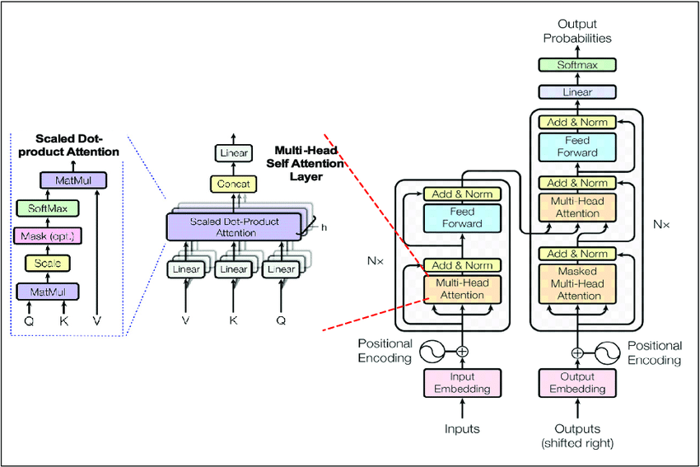

Here are the key components of the Transformer architecture:

1. **Self-Attention Mechanism:**
   * The core innovation of the Transformer is the self-attention mechanism, which allows the model to weigh different words in a sequence differently based on their importance.
   * Given a sequence of words, self-attention computes a set of attention scores for each word, indicating how much focus it should give to other words in the sequence.
   * This attention mechanism enables the model to consider the entire context of a word when making predictions.
2. **Encoder-Decoder Architecture:**
   * Transformers are often used in a sequence-to-sequence setup where an input sequence is transformed into an output sequence.
   * The model consists of an encoder and a decoder. The encoder processes the input sequence, and the decoder generates the output sequence.
   * Each encoder and decoder layer has its own self-attention mechanism.
3. **Multi-Head Attention:**
   * To capture different aspects of the input sequence, the self-attention mechanism is employed in multiple heads in parallel.
   * Each head learns different attention patterns, and their outputs are concatenated and linearly transformed.
4. **Positional Encoding:**
   * Since transformers don't have an inherent sense of order in the input sequence, positional encodings are added to the input embeddings to convey the position of each token in the sequence.
5. **Feedforward Neural Networks:**
   * After the attention mechanism, the output is passed through a feedforward neural network at each position in the sequence. FFNN’s introduce **non-linear** **transformations**, enabling the model to capture **complex patterns**; they help in **transforming data dimensions**; and they **enhance feature extraction**.
6. **Layer Normalization and Residual Connections:**
   * Layer normalization and residual connections are used to **stabilize and speed up training**.
7. **Transformer Training:**
   * The model is trained using a **variant** of the **attention mechanism** called **scaled dot-product attention**, and it is optimized using backpropagation and gradient descent.
8. **Masking:**
   * In training, the self-attention mechanism is often modified to prevent attending to future tokens, which is achieved through masking.
9. **BERT and GPT Models:**
   * **BERT (Bidirectional Encoder Representations from Transformers) and GPT (Generative Pre-trained Transformer)** are two popular **applications** of the **Transformer architecture in NLP.**
   * BERT is designed for tasks like **question answering and text classification**, while GPT is a **generative model** used for tasks like **language modeling and text generation.**

The Transformer architecture has shown remarkable performance in various NLP tasks and has become the foundation for many state-of-the-art models in the field. Its attention mechanism allows it to capture dependencies regardless of their distance in the input sequence, making it effective for tasks requiring a deep understanding of context.

******************************************************************************

## **Self-attention mechanisms in the encoder and decoder of a Transformer model**

The self-attention mechanisms in the encoder and decoder of a Transformer model serve different purposes, but the underlying self-attention mechanism itself is the same in terms of how it computes attention. Here's how they differ in usage:

### 1. **Encoder Self-Attention**

* **Purpose:** The self-attention in the encoder allows each token in the input sequence to attend to all other tokens in the sequence. This helps the model understand the context by considering the entire sequence when encoding each token.
* **Mechanism:** Each token's representation is updated by computing a weighted sum of all other token representations, where the weights are determined by the attention mechanism (typically scaled dot-product attention).

### 2. **Decoder Self-Attention**

* **Purpose:** The self-attention in the decoder operates similarly, but it has an additional role. It allows each token in the generated sequence to attend to all previous tokens in the sequence. This ensures that the prediction for each token is based only on the previously generated tokens and not on future tokens, which haven't been generated yet. This is crucial for maintaining the autoregressive nature of the decoder during training and inference.
* **Mechanism:** The self-attention mechanism in the decoder is the same as in the encoder (e.g., scaled dot-product attention), but with a key difference: **masking**. During training and inference, a mask is applied to prevent each position from attending to subsequent positions in the sequence. This is called **causal masking** or **look-ahead masking**.

### 3. **Cross-Attention in the Decoder**

* Besides self-attention, the decoder also has a **cross-attention** mechanism, where it attends to the output of the encoder. This allows the decoder to incorporate information from the encoded input sequence while generating each token.

### Summary:

* **Self-Attention Mechanism:** The self-attention mechanism itself (e.g., scaled dot-product attention) is the same in both the encoder and decoder.
* **Difference in Application:** The key difference lies in how the attention is applied:
  + The encoder allows each token to attend to all tokens without restrictions.
  + The decoder uses causal masking to ensure that each token only attends to itself and previous tokens, preventing information leakage from future tokens.

In essence, the core operation is the same, but the application differs to suit the roles of the encoder and decoder.

******************************************************************************

## **How we can calculate Positional Embedding in transformer?**

Positional embeddings are used in transformer models to provide information about the position of each token in a sequence, since transformers themselves are inherently order-agnostic. One common method of calculating positional embeddings is through sinusoidal functions. Here’s a step-by-step explanation of how sinusoidal positional embeddings are calculated:

### Sinusoidal Positional Embeddings

1. **Positional Encoding Function**: The positional encoding is calculated using sine and cosine functions of different frequencies. The formula for calculating the positional encoding for a position pospospos and dimension iii is as follows:



Here:

* pospospos is the position of the token in the sequence.
* iii is the dimension index.
* ddd is the dimensionality of the embeddings (e.g., 512, 768).

2. **Why Sinusoidal Functions?**: Sinusoidal functions allow the model to easily learn to attend by relative positions. The choice of using different frequencies allows the model to capture various levels of granularity.

3. **Implementation Steps**:

* Create a matrix of shape (max_len,d)(\text{max\_len}, d)(max_len,d) where max_len\text{max\_len}max_len is the maximum length of the input sequences and ddd is the embedding dimension.
* Fill this matrix using the sine and cosine functions as described above.

### Example Implementation

Here’s a simple implementation in Python:

import numpy as np

def positional_encoding(max_len, d_model):

pe = np.zeros((max_len, d_model))

for pos in range(max_len):

for i in range(0, d_model, 2):

pe[pos, i] = np.sin(pos / (10000 ** (i / d_model)))

if i + 1 < d_model:

pe[pos, i + 1] = np.cos(pos / (10000 ** ((i + 1) / d_model)))

return pe

# Example usage

max_len = 50

d_model = 512

positional_encodings = positional_encoding(max_len, d_model)

### Key Points

* **Position and Dimension**: The position (pos) varies from 0 to the maximum length of the sequence. The dimension (i) varies from 0 to ddd, the embedding size.
* **Alternating Sine and Cosine**: Even-indexed dimensions use sine functions, and odd-indexed dimensions use cosine functions.
* **Exponential Scaling**: The divisor in the sine and cosine functions is scaled exponentially, which allows for a range of frequencies.

### Conclusion

The sinusoidal positional embedding technique enables transformer models to capture positional information efficiently. The alternating sine and cosine functions provide a unique representation for each position and dimension, ensuring that each token's position can be distinguished by the model. This method is widely used due to its simplicity and effectiveness.

\*\*\*\*\*\*\*\*\*\*\*\*\*\*\*\*\*\*\*\*\*\*\*\*\*\*\*\*\*\*\*\*\*\*\*\*\*\*\*\*\*\*\*\*\*\*\*\*\*\*\*\*\*\*\*\*\*\*\*\*\*\*\*\*\*\*\*\*\*\*\*\*\*\*\*\*\*\***I have a sentence: How old are you? How can i calculate a Positional Embedding for this.**

To calculate the positional embedding for the sentence "How old are you?" mathematically, you can follow these steps:

1. **Tokenize the Sentence**: Tokenize the sentence into individual tokens: ["How", "old", "are", "you", "?"].
2. **Choose the Embedding Dimension**: Let’s assume the embedding dimension d=512d = 512d=512.
3. **Use the Positional Encoding Formulas**: For a position pospospos and dimension index iii, the positional encoding is calculated as:



Let's go through the calculations step-by-step for each token in the sentence with d=512:

### Token: "How" (Position 0)

For position pos=0:

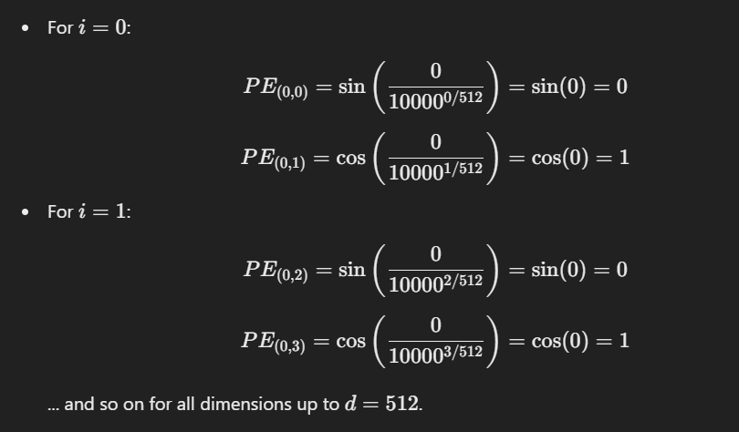

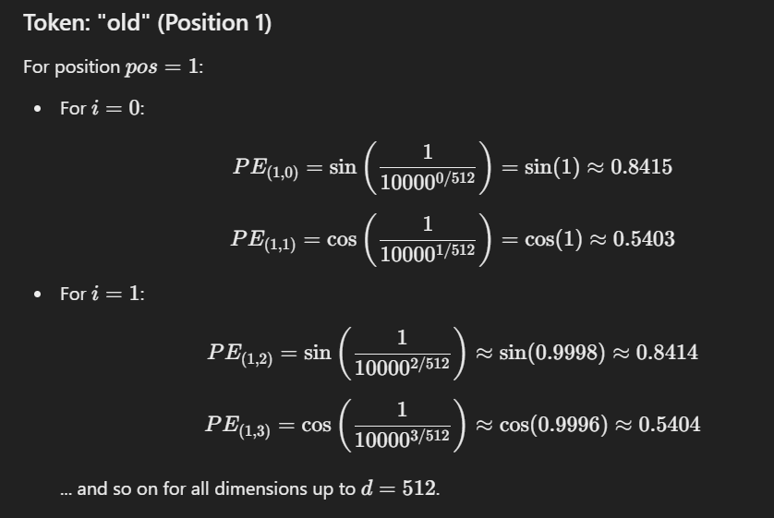

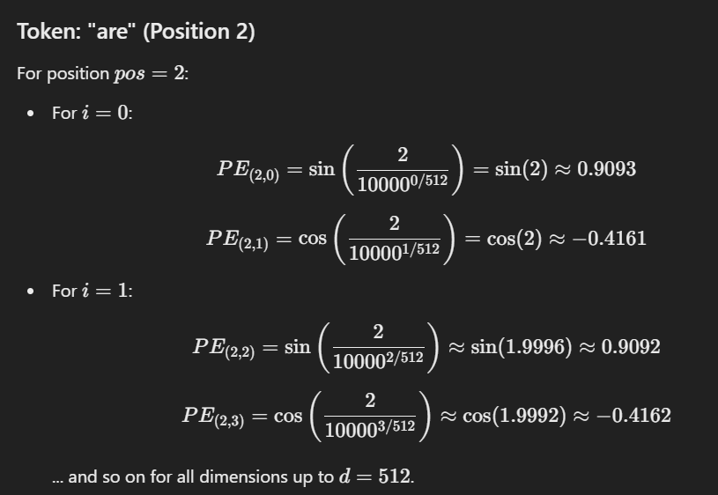

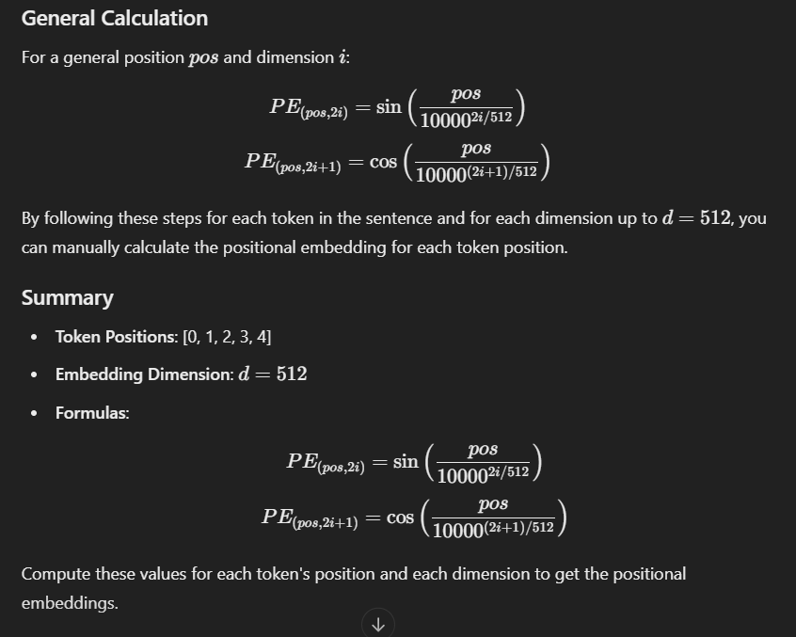

## **Why we choose embedding** **dimensions’ d = 512?**

The choice of embedding dimension d=512 in transformer models, such as the original Transformer model described by Vaswani et al. in "Attention is All You Need," is a design decision based on balancing several factors:

### 1. **Model Capacity and Expressiveness**

* **Higher Dimensionality**: A higher dimension allows the model to capture more complex patterns and relationships within the data. It increases the capacity of the model to learn detailed representations.
* **512 Dimensions**: In practice, 512 dimensions have been found to be a good trade-off for many tasks, providing sufficient capacity for capturing the necessary information without being excessively large.

### 2. **Empirical Performance**

* **Experimentation**: The choice of 512 dimensions was empirically determined to work well on a variety of natural language processing (NLP) tasks. This dimensionality is sufficient to achieve high performance on benchmarks like machine translation and other sequence-to-sequence tasks.

### 3. **Computational Efficiency**

* **Memory and Speed**: Using 512 dimensions strikes a balance between model complexity and computational resources. Larger dimensions require more memory and computational power, leading to longer training and inference times.
* **Feasibility**: For many practical applications, 512 dimensions are feasible to work with given typical hardware constraints.

### 4. **Consistency with Other Models**

* **Standard Practice**: Following the standard of 512 dimensions allows for easier comparison with other models and consistency across different implementations. It also aligns with widely used pre-trained models like BERT and GPT, which use similar or slightly higher dimensions.

### 5. **Architecture Design**

* **Transformer Architecture**: The transformer architecture's design, including its multi-head attention mechanism, positional encodings, and feed-forward networks, works well with an embedding dimension of 512. This dimensionality supports effective multi-head attention (typically with 8 or 16 heads) and ensures the feed-forward network layers are not excessively large.

### Examples from Research

* **Original Transformer (Vaswani et al., 2017)**: Used d=512 for both input embeddings and positional encodings.
* **BERT**: Uses d=768 for the base model and d=1024 for the large model.
* **GPT-2**: Uses d=768 for its base model.

### Conclusion

The embedding dimension d=512 is a well-considered choice balancing model capacity, empirical performance, computational efficiency, and practical feasibility. It has become a standard in the field, but it's important to note that different applications and models might use different dimensions based on specific needs and resource availability.

******************************************************************************

## **Self-Attention Mechanism Transformers?**

The self-attention mechanism is a key component of transformer models, which have become the foundation for many state-of-the-art natural language processing (NLP) systems. Here’s an overview of how the self-attention mechanism works and its role within transformers:

### Overview of Self-Attention

Self-attention allows the model to weigh the importance of different words in a sentence when encoding a word. It helps the model to capture dependencies between words, regardless of their distance from each other in the input sequence. This is crucial for understanding context and relationships in language.

### Steps in the Self-Attention Mechanism

1. **Input Embeddings**: The input words are first converted into embeddings, which are dense vector representations of words.
2. **Linear Projections**: The input embeddings are projected into three different vectors: Query (Q), Key (K), and Value (V) vectors, using learned linear transformations.
3. **Attention Scores**: The attention scores are computed by taking the dot product of the Query vector with the Key vectors of all words in the sequence. This results in a set of scores that indicate how much focus each word should have on every other word.

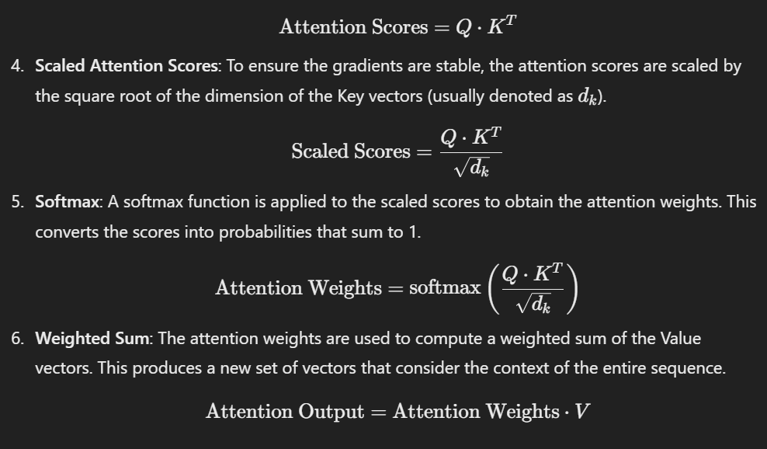

### Multi-Head Self-Attention

To allow the model to jointly attend to information from different representation subspaces, the transformer employs multiple self-attention heads. Each head performs the self-attention process independently, and their outputs are concatenated and linearly transformed to produce the final output.

### Position-wise Feed-Forward Networks

After the self-attention mechanism, the output goes through a position-wise feed-forward network (FFN), which consists of two linear transformations with a ReLU activation in between. This helps to introduce non-linearity and further transform the representations.

### Layer Normalization and Residual Connections

Transformers use layer normalization and residual connections around the self-attention and feed-forward sub-layers to stabilize training and enable better gradient flow.

### Transformer Architecture

The full transformer model is composed of an encoder and a decoder, each consisting of multiple layers of self-attention and feed-forward networks. In NLP tasks like machine translation, the encoder processes the input sentence, and the decoder generates the output sentence, attending to both its own outputs and the encoder’s outputs.

* **Encoder**: Each layer has a self-attention mechanism followed by a feed-forward network.
* **Decoder**: Each layer has a self-attention mechanism, an encoder-decoder attention mechanism (attending to the encoder’s output), and a feed-forward network.

### Key Benefits

* **Parallelization**: Unlike recurrent neural networks (RNNs), transformers process the entire input sequence simultaneously, allowing for parallelization and faster training.
* **Long-Range Dependencies**: Self-attention can capture dependencies regardless of the distance between words, which is challenging for RNNs and convolutional neural networks (CNNs).

### Applications

Transformers have revolutionized NLP and are used in models like BERT, GPT, T5, and many others. They excel in tasks such as machine translation, text generation, summarization, and more.

Understanding self-attention is crucial for grasping how modern transformer-based models work and why they have become so effective in handling a wide range of NLP tasks.

******************************************************************************

## **I have a Sentence "A Quick brown Fox jumped over the lazy dog" Perform Steps in the Self-Attention Mechanism Manually.**

Performing the self-attention mechanism manually on the sentence "A quick brown fox jumped over the lazy dog" involves several steps. To simplify, we'll use shorter vectors and fewer dimensions, but this will still illustrate the process.

### 1. Input Embeddings

First, let's assume we have embedded our words into vectors. For simplicity, let's use embeddings of dimension 3:

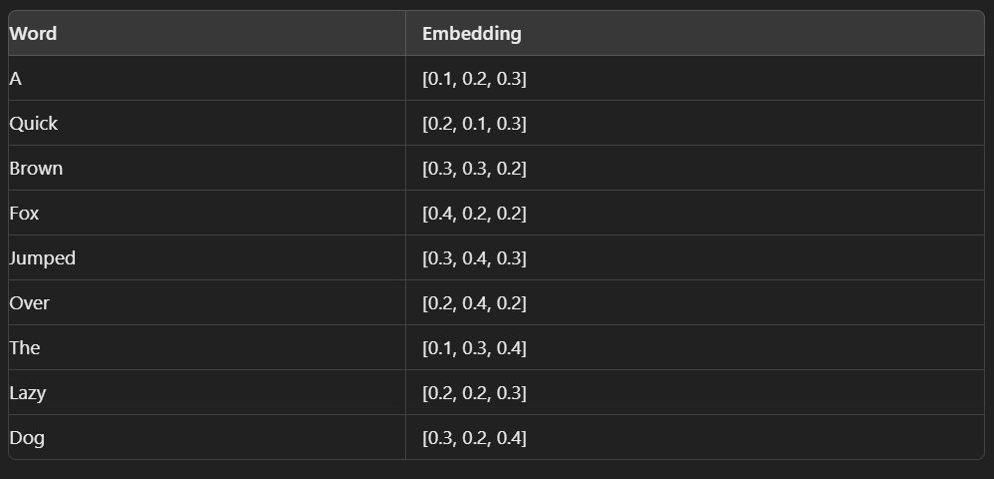

### 2. Linear Projections

We project these embeddings into Query (Q), Key (K), and Value (V) vectors. Let's assume the projection matrices are:

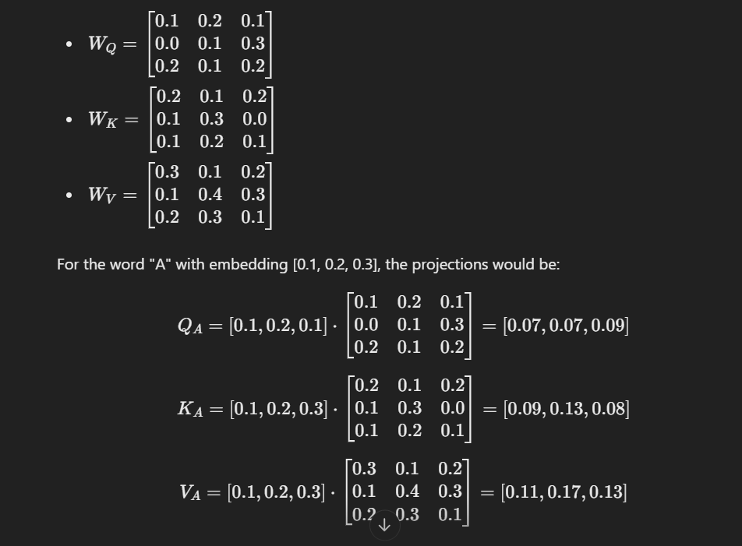

We repeat this process for each word to get the Q, K, and V matrices.

### 3. Attention Scores

Next, we compute the attention scores for a word with respect to all words (including itself). For simplicity, let's just focus on "A":

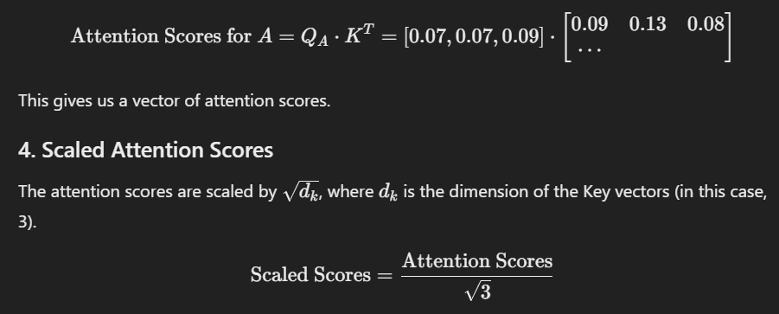

### 5. Softmax

We apply the softmax function to the scaled scores to obtain the attention weights.

### 6. Weighted Sum

We compute the weighted sum of the Value vectors using the attention weights to get the final output for "A".

This process is repeated for each word in the sentence. Due to the complexity and length of the calculation for all words, this gives a high-level overview of the steps involved in computing self-attention.

**\*\*\*\*\*\*\*\*\*\*\*\*\*\*\*\*\*\*\*\*\*\*\*\*\*\*\*\*\*\*\*\*\*\*\*\*\*\*\*\*\*\*\*\*\*\*\*\*\*\*\*\*\*\*\*\*\*\*\*\*\*\*\*\*\*\*\*\*\*\*\*\*\*\*\*\*\*\*\*\*\*\*\*\*\***

What is temperature, top p and top k in LLM. What is the difference in between them?

In the context of Large Language Models (LLMs), such as those used in natural language processing, the terms "temperature," "top-p," and "top-k" refer to different techniques used to control the randomness and creativity of the generated text. Each of these techniques affects how the model selects words when generating text.

1. **Temperature**:
   * **Definition**: Temperature is a parameter that controls the randomness of predictions by scaling the logits (the raw output probabilities before they are converted to actual probabilities).
   * **How it works**: Lower temperatures (<1) make the model more confident and conservative, often resulting in more predictable and repetitive outputs. Higher temperatures (>1) make the model more random and creative, increasing the diversity of outputs.

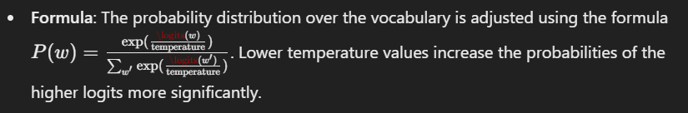

1. **Top-p (Nucleus Sampling)**:
   * **Definition**: Top-p sampling, also known as nucleus sampling, selects words from the smallest possible set of words whose cumulative probability exceeds a certain threshold p.
   * **How it works**: The model sorts all the possible next words by their probability and then selects a subset of these words whose cumulative probability is at least ppp. From this subset, it samples the next word.
   * **Effect**: This allows for dynamic control over the number of candidates considered, often resulting in more fluent and coherent text compared to top-k sampling.
   * **Example**: If p=0.9, the model will consider the smallest set of words that together have a probability of 90%.
2. **Top-k**:
   * **Definition**: Top-k sampling restricts the model to choosing the next word from the top k most probable words.
   * **How it works**: The model selects the top k words with the highest probabilities and then samples the next word from this set.
   * **Effect**: This technique limits the number of words considered, which can help in reducing the chances of selecting very unlikely words, leading to more focused and less random output.
   * **Example**: If k=50, the model will only consider the 50 words with the highest probabilities for sampling the next word.

### Differences

* **Temperature** controls the overall randomness by adjusting the probability distribution over the entire vocabulary. Lower temperatures lead to more deterministic outputs, while higher temperatures introduce more randomness.
* **Top-p** sampling dynamically adjusts the number of candidates considered based on their cumulative probability, often leading to more coherent and contextually appropriate text by focusing on a variable set of high-probability words.
* **Top-k** sampling fixes the number of candidates considered, ensuring that only the top k most probable words are sampled from, which can make the output more predictable and less prone to very low-probability words.

By adjusting these parameters, users can fine-tune the balance between creativity and coherence in the text generated by LLMs.