## **Bilal Hameed**

## **Data Scientist @ CareCloud**

## **Machine Learning Interview Notes**

## **Evaluate the performance of a binary classifier in machine learning, you can use various metrics:**

## **Confusion Matrix**

A confusion matrix is sometimes used to illustrate classifier performance based on the above four values (TP, FP, TN, FN). These are plotted against each other to show a confusion matrix:

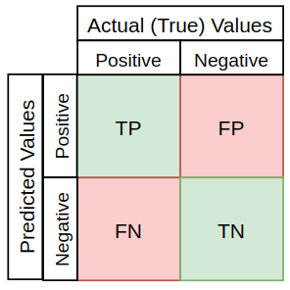

Using the cancer prediction example, a confusion matrix for 100 patients might look something like this:

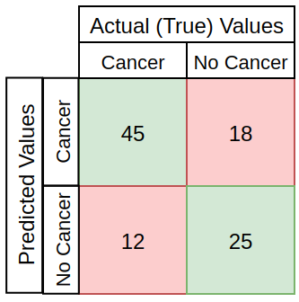

- True Positive (TP): Instances correctly predicted as positive.

- True Negative (TN): Instances correctly predicted as negative.

- False Positive (FP): Instances incorrectly predicted as positive.

- False Negative (FN): Instances incorrectly predicted as negative.

## **2. Accuracy**

The base metric used for model evaluation is often Accuracy, describing the number of correct predictions over all predictions:

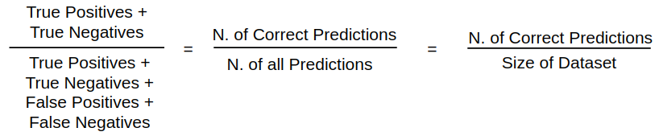

## **3. Precision**

Precision is a measure of how many of the positive predictions made are correct (true positives). The formula for it is:

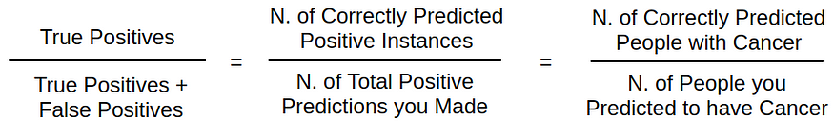

## **4. Recall / Sensitivity**

Recall is a measure of how many of the positive cases the classifier correctly predicted, over all the positive cases in the data. [It is sometimes also referred to as Sensitivity](https://stats.stackexchange.com/questions/362332/is-there-any-difference-between-sensitivity-and-recall). The formula for it is:

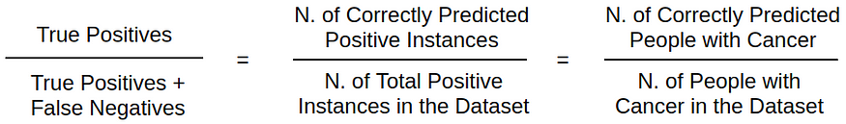

## **5. Specificity**

Specificity is a measure of how many negative predictions made are correct (true negatives). The formula for it is:

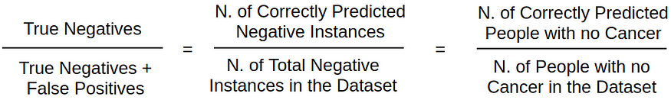

## **6. F1-Score**

F1-Score is a measure combining both precision and recall. It is generally described as the [harmonic mean](https://en.wikipedia.org/wiki/Harmonic_mean) of the two. Harmonic mean is just another way to calculate an “average” of values, generally described as more suitable for ratios (such as precision and recall) than the traditional arithmetic mean. The formula used for F1-score in this case is:

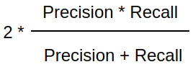

**------------------------------------------------------------------------------------------------------------------------------------------**

# **Class imbalance and solutions of class imbalance**

Class imbalance in machine learning refers to the situation where one class has significantly fewer samples than another, leading to a biased model. Solutions include:

## **Resampling Techniques:**

**Undersampling**: Reduce the size of the majority class.

**Oversampling:** Increase the size of the minority class (e.g., duplication or generation of synthetic samples).

## **Algorithmic Approaches:**

Use algorithms that handle imbalanced data well, like Random Forests, Gradient Boosting, or ensemble methods.

## **Cost-sensitive Learning:**

Assign different misclassification costs to different classes to make the model more sensitive to minority class errors.

## **Ensemble Methods:**

Combine predictions from multiple models to improve overall performance, as ensemble methods can be more robust to class imbalance.

## **Data Augmentation:**

Increase the size of the minority class by creating new, slightly modified samples.

## **Customized Evaluation Metrics:**

Use metrics like precision, recall, F1-score, or area under the Precision-Recall curve that focus on model performance regarding the minority class.

## **Transfer Learning:**

Leverage knowledge from a related task or pre-trained models to boost performance on the imbalanced dataset.

Choose the technique based on the specific characteristics of your dataset and the requirements of your problem.

**------------------------------------------------------------------------------------------------------------------------------------------**

# **Explain variance, low variance and high variance**

Variance in the context of statistics and machine learning refers to the spread or dispersion of a set of values. It quantifies how much the values in a dataset deviate from their mean or expected value.

## **Low Variance:**

If a dataset has low variance, the values are closely packed around the mean.

It suggests that the data points are consistent and don't vary much from the average.

A model trained on low-variance data may be overly simplistic and might not capture underlying patterns well.

## **High Variance:**

If a dataset has high variance, the values are more spread out from the mean.

It indicates greater variability among the data points.

A model trained on high-variance data may capture noise in the training set, leading to poor generalization on new, unseen data.

## **In the context of machine learning models:**

## **Low Variance Model:**

Predictions are relatively consistent and stable across different datasets.

There's a risk of underfitting, meaning the model may not capture the underlying patterns in the training data.

## **High Variance Model:**

Predictions can vary widely depending on the training data.

There's a risk of overfitting, where the model learns the training data too well, including its noise, but performs poorly on new data.

Achieving a balance between low and high variance is crucial for building models that generalize well to new, unseen data. This balance is often referred to as the bias-variance tradeoff.

**------------------------------------------------------------------------------------------------------------------------------------------**

# **How to reduce variance or over fitting?**

Reducing variance, or mitigating overfitting, involves strategies to make your model generalize better to new, unseen data. Here are some common techniques:

## **Cross-Validation:**

Use techniques like k-fold cross-validation to assess how well your model generalizes to different subsets of the data. This helps identify overfitting.

## **Regularization:**

Introduce regularization terms in your model's cost function (e.g., L1 or L2 regularization). This discourages overly complex models by penalizing large coefficients.

## **Pruning:**

For decision tree-based models, pruning involves removing branches that add little predictive power. This helps prevent the model from becoming too specific to the training data.

## **Feature Selection:**

Choose a subset of relevant features and discard unnecessary ones. This can simplify the model and reduce overfitting.

## **Data Augmentation:**

Increase the size of your training dataset by creating slightly modified copies of existing data. This helps the model generalize better to variations in the input.

## **Ensemble Methods:**

Use ensemble methods like Random Forests or Gradient Boosting. These combine predictions from multiple models, reducing the risk of overfitting present in individual models.

## **Early Stopping:**

Monitor the model's performance on a validation set during training. Stop training when the performance starts degrading, preventing the model from learning noise in the training data.

## **Cross-Validation and Hyperparameter Tuning:**

Use cross-validation to evaluate different hyperparameter settings. This helps in selecting the model configuration that generalizes well.

## **Dropout (Neural Networks):**

In neural networks, dropout involves randomly ignoring a proportion of neurons during training. This prevents the model from relying too much on specific neurons and helps prevent overfitting.

## **Simpler Model Architectures:**

Choose simpler model architectures that are less prone to overfitting. For example, reduce the number of layers or nodes in a neural network.

By applying a combination of these techniques, you can often strike a balance between fitting the training data well and generalizing to new, unseen data.

**------------------------------------------------------------------------------------------------------------------------------------------**

## **Null and Alternate Hypothesis with Example.**

Certainly! In statistics, hypotheses are used to make inferences about populations based on sample data. The two main types of hypotheses are the null hypothesis (H0) and the alternative hypothesis (H1 or Ha).

## **Null Hypothesis (H0):**

The null hypothesis is a statement of no effect or no difference. It represents the status quo or a default assumption that there is no real change or no effect. This hypothesis states that there is no difference between groups or no relationship between variables.

It is denoted by H0.

**Example:** Suppose you are testing a new drug, and you want to know if it has any effect on reducing blood pressure. The null hypothesis might be that the drug has no effect, and the average blood pressure before and after taking the drug is the same.

**H0:** The mean blood pressure before = the mean blood pressure after

## **Alternative Hypothesis (H1 or Ha):**

The alternative hypothesis contradicts the null hypothesis.

It represents a claim that there is a real effect, difference, or relationship in the population.

It is denoted by H1 or Ha.

**Example:** Continuing with the drug example, the alternative hypothesis might be that the new drug does have an effect on reducing blood pressure.

**Ha:** The mean blood pressure before is not equal to the mean blood pressure after (indicating a change in blood pressure)

When conducting a hypothesis test, you collect sample data and use statistical methods to determine whether there is enough evidence to reject the null hypothesis in favor of the alternative hypothesis.

Here are a few scenarios after collecting and analyzing data:

If there is enough evidence to reject the null hypothesis, you may accept the alternative hypothesis.

If there is not enough evidence to reject the null hypothesis, you fail to accept the alternative hypothesis. The null hypothesis is not proven; it's just not rejected based on the available data.

It's important to note that statistical hypothesis testing involves a level of uncertainty, and decisions are made based on probabilities. Researchers use significance levels (e.g., 0.05) to determine the threshold for rejecting the null hypothesis.

In summary, the null hypothesis represents the default assumption of no effect, while the alternative hypothesis suggests a specific effect or difference. Hypothesis testing helps researchers make informed decisions about population parameters based on sample data.

**------------------------------------------------------------------------------------------------------------------------------------------**

# **P value in data science and statistics:**

In statistics, the p-value is a measure that helps you assess the evidence against a null hypothesis. It indicates the probability of observing the data or more extreme results, assuming the null hypothesis is true. A lower p-value suggests stronger evidence against the null hypothesis, often leading to its rejection in favor of an alternative hypothesis. Typically, a significance level (e.g., 0.05) is chosen, and if the p-value is below this threshold, the results are considered statistically significant.

**------------------------------------------------------------------------------------------------------------------------------------------**

# **What is statistically significant.**

"Statistically significant" refers to the likelihood that an observed effect or relationship in data is not due to random chance but is a genuine and meaningful pattern. When conducting statistical hypothesis testing, researchers set a significance level (often denoted as alpha, typically 0.05), which represents the threshold for accepting or rejecting the null hypothesis.

If the p-value associated with a statistical test is less than or equal to the chosen significance level, the results are considered statistically significant. In practical terms, this means that the observed data is unlikely to have occurred by random chance alone, and researchers may reject the null hypothesis in favor of the alternative hypothesis.

It's important to note that statistical significance does not necessarily imply practical or clinical significance. A result can be statistically significant but still have a small effect size or limited real-world relevance. Researchers should consider both statistical and practical significance when interpreting their findings.

**------------------------------------------------------------------------------------------------------------------------------------------**

# **How to compute p value?**

To compute a p-value, follow these general steps:

## **Formulate Hypotheses:**

**Null Hypothesis (H0​):** Assumes no effect or no difference.

**Alternative Hypothesis (H1​ or Ha​):** Assumes an effect or a difference.

## **Select a Significance Level (α):**

Common choices are 0.05, 0.01, etc. This is the threshold below which you would reject the null hypothesis.

## **Choose a Statistical Test:**

The choice depends on your data and the type of comparison you're making (e.g., t-test, chi-square test, ANOVA).

## **Collect and Analyze Data:**

Use the chosen statistical test on your data.

## **Calculate the Test Statistic:**

This depends on the chosen test and the nature of your data.

## **Determine the p-value:**

The p-value is the probability of obtaining results as extreme as or more extreme than the observed results, assuming the null hypothesis is true.

## **Make a Decision:**

If the p-value is less than your chosen significance level (α), you reject the null hypothesis. Otherwise, you fail to reject it.

## **Interpret Results:**

If you reject the null hypothesis, it suggests evidence for the alternative hypothesis. If you fail to reject, it suggests insufficient evidence to support the alternative.

It's important to note that the process may vary depending on the specific statistical test being used and the characteristics of your data. Statistical software or calculators are often employed to perform the calculations associated with these steps.

**------------------------------------------------------------------------------------------------------------------------------------------**

# **What is Feature Selectin and How can we select features in machine Learning/Data Science**

Feature selection is a process in machine learning and data science where you choose a subset of relevant and significant features (variables or attributes) from a larger set of features in your dataset. The goal of feature selection is to improve the performance of a machine learning model by reducing dimensionality, removing irrelevant or redundant features, and enhancing the model's interpretability.

There are several methods for feature selection, broadly classified into three categories:

## **Filter Methods:**

**Statistical Methods:** These methods use statistical measures to rank and select features. Common statistical measures include correlation, mutual information, and chi-square.

**Variance Thresholding**: Features with low variance are often less informative. This method filters out features with low variance.

**Information Gain or Gini Index:** These are used for feature ranking in decision tree-based models.

## **Wrapper Methods:**

**Forward Selection:** Start with an empty set of features and add one feature at a time, choosing the one that improves model performance the most.

**Backward Elimination:** Start with all features and iteratively remove the least important ones, based on model performance.

**Recursive Feature Elimination (RFE):** A method that recursively removes the least important features until the desired number of features is reached.

## **Embedded Methods:**

**LASSO (Least Absolute Shrinkage and Selection Operator):** Adds a penalty term to the linear regression cost function, forcing some coefficients to be exactly zero, effectively performing feature selection.

**Tree-based Methods:** Decision tree-based models like Random Forest and Gradient Boosting naturally perform feature selection by considering feature importance during training.

Choosing the appropriate feature selection method depends on the characteristics of your dataset and the specific machine learning algorithm you are using. It's common to experiment with different methods and evaluate their impact on model performance using metrics like accuracy, precision, recall, or F1 score.

Here's a basic example using scikit-learn in Python to perform feature selection:

from sklearn.feature_selection import SelectKBest, f_classif

# Assuming X is your feature matrix and y is the target variable

X_new = SelectKBest(f_classif, k=5).fit_transform(X, y)

In this example, f_classif is a statistical test for the analysis of variance (ANOVA), and SelectKBest selects the top k features based on the chosen statistical test. Adjust the method and parameters based on your specific needs and the characteristics of your data.

**------------------------------------------------------------------------------------------------------------------------------------------**

# **What is Correlation and How can we calculate it?**

Correlation is a statistical measure that quantifies the degree to which two variables change together. In other words, it assesses the strength and direction of a linear relationship between two variables. The most common measure of correlation is the **Pearson correlation coefficient**, denoted by **r**. The Pearson correlation coefficient ranges from **-1 to 1**, where:

**r=1** indicates a perfect positive linear relationship.

**r=−1** indicates a perfect negative linear relationship.

**r=0** indicates no linear relationship.

The formula for calculating the Pearson correlation coefficient (r) between two variables X and Y with n data points is as follows:

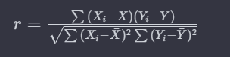

Where:

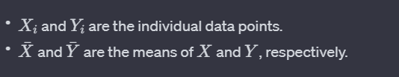

In Python, you can use libraries like NumPy or pandas to calculate the Pearson correlation coefficient. Here's a simple example using NumPy:

import numpy as np

# Sample data

X = np.array([1, 2, 3, 4, 5])

Y = np.array([2, 3, 4, 5, 6])

# Calculate Pearson correlation coefficient

correlation_coef = np.corrcoef(X, Y)[0, 1]

print(f"Pearson correlation coefficient: {correlation_coef}")

Alternatively, if you are working with a pandas DataFrame, you can use the corr() method:

import pandas as pd

# Create a DataFrame

df = pd.DataFrame({'X': [1, 2, 3, 4, 5], 'Y': [2, 3, 4, 5, 6]})

# Calculate Pearson correlation coefficient

correlation_coef = df['X'].corr(df['Y'])

print(f"Pearson correlation coefficient: {correlation_coef}")

These methods will give you the Pearson correlation coefficient between the two variables. Remember that correlation does not imply causation, and a correlation coefficient close to zero does not necessarily mean there is no relationship; it might indicate a nonlinear relationship or other factors influencing the data.

**------------------------------------------------------------------------------------------------------------------------------------------**

# **What is dimensionality reduction?**

Dimensionality reduction is a technique used in machine learning and data analysis to reduce the number of features (or dimensions) in a dataset while preserving its essential information. High-dimensional datasets, where the number of features is large, can suffer from the curse of dimensionality, leading to increased computational complexity, overfitting, and difficulties in visualization and interpretation.

There are two main approaches to dimensionality reduction:

## **Feature Selection:**

In feature selection, you choose a subset of the original features and discard the rest. The goal is to retain the most relevant and informative features while eliminating irrelevant or redundant ones.

Feature selection methods include filter methods (e.g., based on statistical measures), wrapper methods (e.g., forward selection, backward elimination), and embedded methods (e.g., LASSO regularization).

## **Feature Extraction:**

Feature extraction involves transforming the original features into a new set of features, typically of lower dimensionality. These new features are combinations of the original features, and they aim to capture the most important information in the data.

**Principal Component Analysis (PCA)** is a common technique for feature extraction. It identifies the directions (principal components) in which the data varies the most and projects the data onto a lower-dimensional subspace.

## **Principal Component Analysis (PCA):**

PCA is a widely used technique for dimensionality reduction. It works by finding the principal components (PCs) of the data, which are linear combinations of the original features. The first principal component captures the most variance in the data, and each subsequent component captures the maximum remaining variance orthogonal to the previous components.

**------------------------------------------------------------------------------------------------------------------------------------------**

# **What is Cost Function In Machine Learning**

In machine learning, a **cost function, also known as a loss function or objective function**, is a crucial component used to measure the difference between the predicted values of a model and the actual values (ground truth) of the target variable. The goal of a machine learning algorithm is to minimize this cost function.

The choice of the cost function depends on the type of machine learning problem being addressed, such as regression or classification. Here are some common types of cost functions:

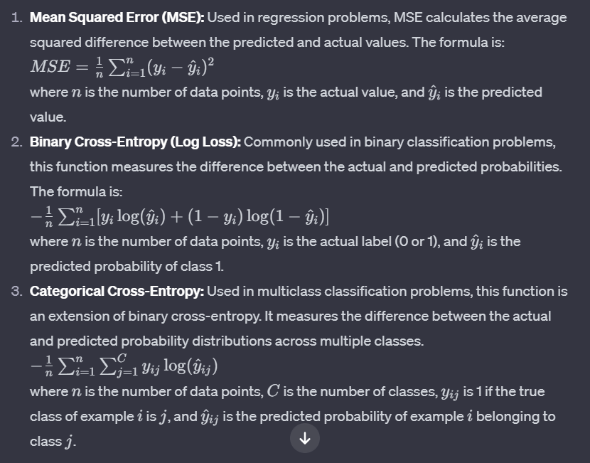

Choosing an appropriate cost function is essential because it directly influences the training process and the performance of the machine learning model. The optimization algorithm adjusts the model parameters to minimize the cost function during the training process.

**------------------------------------------------------------------------------------------------------------------------------------------**

# **What is back propagation?**

Backpropagation, short for "backward propagation of errors," is a supervised learning algorithm used for training artificial neural networks. It is a key component of training neural networks and involves minimizing the error or loss by adjusting the model's weights.

Here's a high-level overview of the backpropagation algorithm:

## **Forward Pass:**

During the forward pass, input data is fed into the neural network, and calculations are performed layer by layer to generate predictions.

Each layer in the network applies a set of weights to the input data, passes the result through an activation function, and produces an output.

## **Compute Loss:**

The output of the neural network is compared to the actual target values, and a loss (error) is calculated. The loss is a measure of the difference between the predicted and actual values.

## **Backward Pass (Backpropagation):**

The key idea of backpropagation is to propagate the error backward through the network and adjust the weights to minimize the error.

Starting from the output layer and moving backward towards the input layer, the algorithm computes the gradient of the loss with respect to the weights of the network. This is done using the chain rule of calculus.

## **Weight Update:**

The calculated gradients are used to update the weights of the neural network in the direction that reduces the error. This is typically done using optimization algorithms such as gradient descent.

The learning rate parameter determines the size of the steps taken during the weight update.

## **Iteration:**

Steps 1-4 are repeated iteratively for multiple epochs or until the model converges to a satisfactory level of performance.

The backpropagation algorithm enables neural networks to learn from training data by adjusting their internal parameters (weights) to minimize the difference between predicted and actual outcomes. It leverages the gradient of the loss function with respect to the model parameters to guide the learning process.

It's worth noting that backpropagation is a computationally efficient way to train neural networks and has played a crucial role in the success of deep learning. Additionally, variations such as stochastic gradient descent and mini-batch gradient descent are often used to speed up the training process.

**------------------------------------------------------------------------------------------------------------------------------------------**

# **How to Evaluate the Accuracy of Regression Results?**

Evaluating the accuracy of regression results is crucial to assess how well the model is performing and to make informed decisions about its suitability for a given task. Here are some common methods for evaluating the accuracy of regression results:

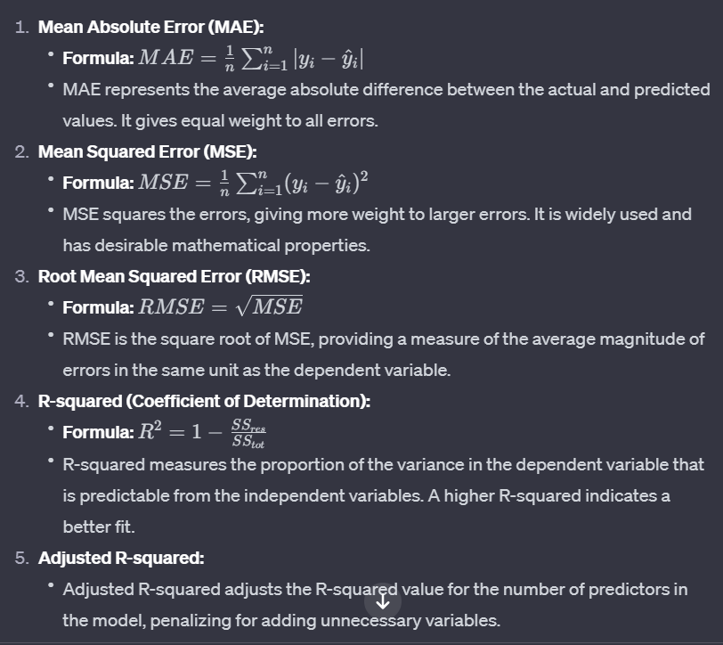

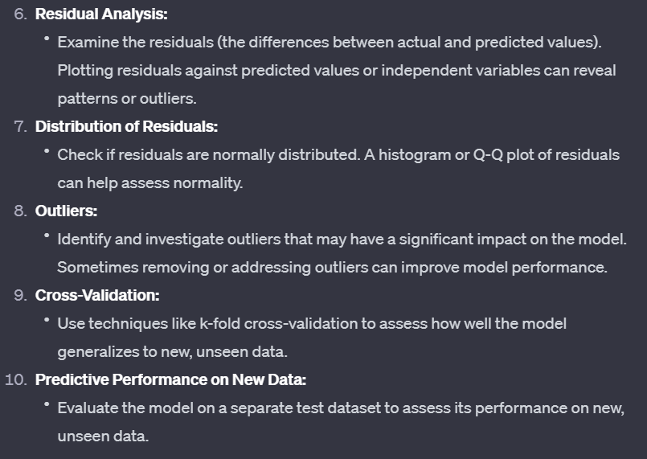

When evaluating regression results, it's essential to consider a combination of these metrics and analyses to get a comprehensive understanding of the model's accuracy and reliability. Keep in mind that the choice of evaluation metrics may depend on the specific characteristics of the data and the goals of the modeling task.

**------------------------------------------------------------------------------------------------------------------------------------------**

# **Activation Function & their use cases:**

Certainly! Let's go through each activation function and discuss their characteristics and common use cases:

1. **Sigmoid Function (Logistic Function):**

- **Range**: (0, 1)

- **Formula**: 

- **Use Case**: Historically used in the output layer for binary classification problems. It squashes the output between 0 and 1, providing probabilities.

2. **Hyperbolic Tangent Function (tanh):**

- **Range**: (-1, 1)

- **Formula**: 

- **Use Case**: Similar to the sigmoid function but with a range from -1 to 1. It's often used in hidden layers of neural networks, providing stronger gradients during training compared to the sigmoid function.

3. **Rectified Linear Unit (ReLU):**

- **Range:** [0, +∞)

- **Formula**: 

- **Use Case:** One of the most widely used activation functions. It introduces non-linearity and is computationally efficient. Suitable for most hidden layers in deep neural networks.

4. **Leaky ReLU:**

- **Range**: (-∞, +∞)

- **Formula**: 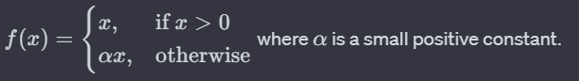

- **Use Case:** Addresses the "dying ReLU" problem where neurons might become inactive during training. Leaky ReLU allows a small, non-zero gradient when the input is negative, helping information flow during backpropagation.

5. **Parametric ReLU (PReLU):**

- **Use Case:** Similar to Leaky ReLU, but with the slope (α (alpha)) as a learnable parameter. It allows the network to adapt the slope during training.

6. **Exponential Linear Unit (ELU):**

- **Range**: (-∞, +∞)

- **Formula**: 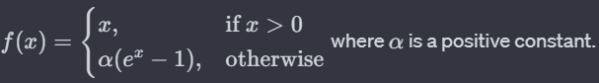

- **Use Case:** ELU can alleviate the vanishing gradient problem and may lead to faster convergence compared to ReLU. It is suitable for architectures where learning long-term dependencies is important.

7. **Softmax:**

- **Range**: (0, 1) and the sum of all output values is 1.

- **Formula**: 

- **Use Case**: Specifically used in the output layer for multi-class classification problems. It converts the raw output scores into probabilities, making it suitable for scenarios where the model needs to choose among multiple classes.

Choosing the appropriate activation function depends on the specific problem, architecture, and characteristics of the data. ReLU and its variants are often preferred in many scenarios due to their simplicity and effectiveness, but experimentation is crucial to find the best fit for a particular task.

**------------------------------------------------------------------------------------------------------------------------------------------**

# **Decision boundary in Machine Learning?**

In machine learning, a decision boundary is a dividing line or surface that separates different classes in a classification problem. It represents the regions in the input space where the algorithm assigns different labels or outcomes to the data points. The decision boundary is a crucial concept, especially in binary classification problems where the goal is to classify input data points into one of two classes.

The nature and complexity of the decision boundary depend on the algorithm used and the characteristics of the data. Here are a few examples to illustrate different types of decision boundaries:

## **Linear Decision Boundary:**

In linear classifiers like Support Vector Machines (SVM) or logistic regression, the decision boundary is a straight line in two-dimensional space or a hyperplane in higher-dimensional space.

**Example**: In a binary classification problem with two features (2D space), the decision boundary might be a straight line that separates the points of one class from the other.

## **Non-Linear Decision Boundary:**

In many real-world scenarios, the relationship between features and classes is not linear. In such cases, non-linear classifiers like decision trees, k-nearest neighbors, or kernelized SVMs may create decision boundaries that are curves or more complex surfaces.

**Example**: A decision boundary in a 2D space could be a circle, ellipse, or any non-linear shape.

## **Complex Decision Boundary:**

Deep learning models, especially neural networks with multiple hidden layers, can learn highly complex decision boundaries. These boundaries can adapt to intricate patterns and relationships in the data.

**Example**: In image classification, a deep neural network might learn a decision boundary that accurately separates images of cats from images of dogs, even when the differences are subtle and complex.

Understanding the decision boundary is essential for assessing the performance and generalization of a machine learning model. The goal is to find a decision boundary that accurately separates classes in the training data and generalizes well to unseen data. Visualizing the decision boundary is a helpful technique for gaining insights into how a model makes predictions and for diagnosing potential issues such as overfitting or underfitting.

**------------------------------------------------------------------------------------------------------------------------------------------**

**Regularization in machine Learning**

Regularization is a technique used in machine learning to prevent overfitting and improve the generalization of a model. Overfitting occurs when a model performs well on the training data but fails to generalize to new, unseen data. Regularization introduces a penalty term to the model's objective function, discouraging overly complex models that might fit the training data too closely.

The basic idea behind regularization is to add a term to the cost function that penalizes large weights or complex model structures. This additional term encourages the learning algorithm to choose simpler models that are more likely to generalize well to new data.

There are different types of regularization commonly used in machine learning:

## **L1 Regularization (Lasso):**

In L1 regularization, a penalty term is added to the cost function proportional to the absolute values of the model parameters (weights).

It encourages sparsity in the model, meaning it tends to drive some weights to exactly zero. This leads to feature selection, as some features become irrelevant and are effectively ignored by the model.

## **L2 Regularization (Ridge):**

L2 regularization adds a penalty term to the cost function proportional to the square of the model parameters.

It discourages large weights and tends to distribute the importance of features more evenly. L2 regularization is less likely to drive weights to exactly zero, but it still helps in preventing overfitting.

## **Elastic Net Regularization:**

Elastic Net is a combination of L1 and L2 regularization. It adds both the absolute values of the weights (L1) and the squares of the weights (L2) to the cost function.

Elastic Net allows for a balance between the sparsity-inducing property of L1 and the smoothing effect of L2.

Regularization is typically applied during the training phase of a machine learning model. The strength of the regularization (the amount of penalty applied) is controlled by a hyperparameter, often denoted as "lambda" or "alpha." The choice of the regularization strength depends on the specific problem and the characteristics of the data.

By using regularization techniques, machine learning practitioners can build models that are more robust, less prone to overfitting, and better at generalizing to new, unseen data.

**------------------------------------------------------------------------------------------------------------------------------------------**

**Eigenvectors and Eigenvalues in machine Learning**

Eigenvectors and eigenvalues are concepts from linear algebra that are widely used in machine learning, especially in tasks such as dimensionality reduction, feature extraction, and solving systems of linear equations. They play a significant role in various algorithms, including principal component analysis (PCA) and the covariance matrix.

Eigenvalues and Eigenvectors:

## **Eigenvalues:**

Eigenvalue is a scalar that is used to transform the eigenvector. The basic equation is

**Ax = λx**

## **Eigenvectors:**

Eigenvectors are the vectors (non-zero) that do not change the direction when any linear transformation is applied. It changes by only a scalar factor

Let us say A is an “n × n” matrix and λ is an eigenvalue of matrix A, then **x**, a non-zero vector, is called as eigenvector if it satisfies the given below expression;

A**x** = λ**x**

**x** is an eigenvector of A corresponding to eigenvalue, λ.

### **Can Eigenvalue be Zero?**

Yes, Eigenvalue can be zero. But we don’t consider the zero vector to be an Eigenvector.

### **How many Eigenvalues does a 2×2 matrix can have?**

A 2×2 matrix can have 2 Eigenvalues, as a 2×2 matrix has two Eigenvector directions.

## **Application in Machine Learning:**

**Principal Component Analysis (PCA):**

PCA is a dimensionality reduction technique that uses eigenvectors and eigenvalues to transform the data into a new coordinate system.

The eigenvectors of the covariance matrix of the data represent the principal components, and the corresponding eigenvalues indicate their importance.

**Covariance Matrix:**

Eigenvectors and eigenvalues are used in the context of the covariance matrix to capture the directions of maximum variance in the data.

The eigenvectors of the covariance matrix represent the directions of maximum variance, and the corresponding eigenvalues indicate the amount of variance along those directions.

**Solving Systems of Linear Equations:**

In some machine learning applications, systems of linear equations arise, and eigenvectors can be used to solve these systems.

**Graph Theory:**

In graph-based algorithms, eigenvectors of certain matrices (e.g., Laplacian matrix) are used for tasks like clustering and community detection.

Understanding eigenvectors and eigenvalues is crucial in various machine learning contexts because they provide a way to analyze and transform data in a mathematically meaningful manner. The eigenvalues indicate the importance or significance of certain directions or features, while eigenvectors represent the directions themselves.

**------------------------------------------------------------------------------------------------------------------------------------------**

# **Local minima, Local maxima, Global minima and global maxima:**

In the context of machine learning and deep learning, the terms local minima, local maxima, global minima, and global maxima are associated with optimization problems, particularly during the training of models. Let's break down each term:

## **Local Minimum:**

A local minimum is a point in the parameter space where the objective function (often a loss function in machine learning) has a lower value than its neighboring points.

It is important to note that a local minimum is not necessarily the absolute lowest point in the entire parameter space.

## **Local Maximum:**

A local maximum is a point in the parameter space where the objective function has a higher value than its neighboring points.

Similar to local minima, a local maximum is not necessarily the highest point in the entire parameter space.

## **Global Minimum:**

The global minimum is the absolute lowest point in the entire parameter space. It represents the lowest value of the objective function over all possible combinations of model parameters.

In the context of machine learning, finding the global minimum is the goal during the training process, as it indicates the best set of parameters for the model.

## **Global Maximum:**

The global maximum is the absolute highest point in the entire parameter space. It represents the highest value of the objective function over all possible combinations of model parameters.

In practice, finding the global maximum is not usually a goal in machine learning, as the objective is often to minimize a loss function rather than maximize it.

In the context of training machine learning models, the optimization process involves adjusting the model parameters to minimize a given loss function. The challenge is that the parameter space is vast, and there may be multiple local minima and maxima. Finding the global minimum is the ideal scenario, but it's not guaranteed, and the optimization algorithm might converge to a local minimum instead.

Various optimization algorithms, such as gradient descent, are used to navigate the parameter space and converge to a minimum. However, the choice of optimization algorithm, learning rate, and other hyperparameters can impact whether the algorithm converges to a local or global minimum. Additionally, the presence of multiple minima adds complexity to the optimization process. Techniques like random initialization and advanced optimization methods aim to mitigate issues related to local minima and help improve the chances of finding a good set of parameters for the model.

**------------------------------------------------------------------------------------------------------------------------------------------**

# **One Hot Encoding in ML DL:**

One Hot Encoding is a technique used in Machine Learning and Deep Learning to represent categorical variables as binary vectors. In this encoding, each category is represented by a binary vector with all zeros except for the index corresponding to the category, which is marked with a one. This helps machine learning models better understand and process categorical data, as it transforms qualitative information into a numerical format suitable for algorithms.

**------------------------------------------------------------------------------------------------------------------------------------------**

# **What is binary relevance and how it can be applied to solve classification challenge**

Binary relevance is a technique used in multi-label classification where each instance can be associated with multiple labels, and the task is to predict the presence or absence of each label independently. In binary relevance, the multi-label problem is decomposed into multiple binary classification problems, one for each label.

**For example**, if you have a set of documents and each document can belong to multiple topics (labels), binary relevance would involve creating a separate binary classifier for each topic. Each classifier then predicts whether a document belongs to its corresponding topic or not.

This approach simplifies the multi-label classification problem into several binary classification problems, making it easier to apply traditional binary classifiers. It's a straightforward and intuitive way to extend binary classification algorithms to handle multi-label scenarios.

**To apply binary relevance:**

**Data Transformation:** Represent the problem as a binary matrix where each row corresponds to an instance, and each column corresponds to a label. The entries in the matrix indicate whether a label is present for a given instance.

**Binary Classifiers:** Train a binary classifier (e.g., logistic regression, decision tree) for each label independently. Each classifier focuses on predicting the presence or absence of a specific label.

**Prediction:** When making predictions, apply all the binary classifiers to an instance. The output of each classifier represents the predicted presence or absence of the corresponding label.

Binary relevance is a simple and effective method, but it doesn't consider label dependencies. If labels are correlated, other approaches like label powerset or classifier chains may be more suitable.

**------------------------------------------------------------------------------------------------------------------------------------------**

# **What is Bayes theorem and what is it about?**

Bayes' theorem is a mathematical formula that describes the probability of an event, based on prior knowledge of conditions that might be related to the event. It is named after Thomas Bayes, an 18th-century statistician. The theorem is fundamental in probability theory and statistics, often used for updating probabilities as new evidence becomes available. It's expressed as P(A|B) = P(B|A) * P(A) / P(B), where A and B are events, and P(A|B) is the probability of A given B.

**------------------------------------------------------------------------------------------------------------------------------------------**

# **Its application in NLP:**

In Natural Language Processing (NLP), Bayes' theorem is frequently employed in the context of text classification and sentiment analysis. One specific application is in Naive Bayes classifiers. These classifiers assume that the features used to describe an input are conditionally independent, given the class label. Despite its "naive" assumption, Naive Bayes often performs well in text classification tasks.

For instance, in spam detection, Bayes' theorem can be used to calculate the probability that an email is spam given certain words or features observed in the email. The model learns from a training dataset, updating probabilities based on the occurrence of words in spam and non-spam emails. This probabilistic approach makes it suitable for various NLP tasks where dealing with uncertainty and updating beliefs based on evidence are essential.

**------------------------------------------------------------------------------------------------------------------------------------------**

# **How would you define your own spell checker in NLP**

To create a spell checker in NLP, you can use techniques like Levenshtein distance, which measures the minimum number of single-character edits (insertions, deletions, or substitutions) needed to transform one word into another. You would typically have a dictionary of correctly spelled words and compare the input text against this dictionary.

**Tokenization**: Break the text into individual words.

**Dictionary**: Have a dictionary of correctly spelled words.

**Similarity Measure**: Use a distance metric like Levenshtein distance to calculate the similarity between each input word and the words in the dictionary.

**Threshold:** Set a threshold for similarity to decide if a word is misspelled.

**Suggestions**: If a word falls below the threshold, suggest corrections based on the closest matches from the dictionary.

This is a basic approach, and more sophisticated methods might involve language models, contextual embeddings, or machine learning algorithms.

**------------------------------------------------------------------------------------------------------------------------------------------**

# **How would you define number of neuron, layers in DNN**

In a Deep Neural Network (DNN), the number of neurons refers to the individual processing units in each layer. A layer consists of neurons, and the number of neurons in a layer is a design choice based on the complexity of the task and the data.

Layers in a DNN are organized into an input layer, one or more hidden layers, and an output layer. The number of layers in a DNN is known as its depth. Deeper networks can capture more complex patterns but may require more data and computational resources.

So, the architecture of a DNN is defined by the number of neurons in each layer and the overall structure, which includes the number of hidden layers and the type of connections between neurons.

**------------------------------------------------------------------------------------------------------------------------------------------**

# **What is the Goal of Dropout in DNN**

The goal of dropout in a Deep Neural Network (DNN) is to prevent overfitting. Overfitting occurs when a model learns not only the underlying patterns in the training data but also captures noise or random fluctuations that are present in that specific dataset. This can lead to poor generalization to new, unseen data.

Dropout is a regularization technique where, during training, randomly selected neurons are ignored or "dropped out" with a certain probability. This means that their contribution to the forward pass and backward pass is temporarily removed. By doing this, dropout helps prevent the co-adaptation of neurons and encourages the network to learn more robust features.

Dropout acts as a form of ensemble learning within a single neural network, as different combinations of neurons are active during each training iteration. This randomness during training helps the network generalize better to new, unseen data, making it more robust and less prone to overfitting.

**------------------------------------------------------------------------------------------------------------------------------------------**

# **How do you check did we get over fitting?**

Overfitting in a machine learning model can be assessed through various methods. Here are some common approaches to check if your model is experiencing overfitting:

## **Training and Validation Loss Comparison:**

Plot the training and validation loss over time. If the training loss continues to decrease, but the validation loss plateaus or starts increasing, it's a sign of overfitting. The model is becoming too specific to the training data and may not generalize well.

## **Learning Curves:**

Analyze learning curves that show the model's performance on the training and validation sets during training. A large gap between the training and validation curves suggests overfitting.

## **Cross-Validation:**

Use cross-validation to assess the model's performance on multiple subsets of the data. If the model performs significantly better on the training data compared to validation or test data, it might be overfitting.

## **Evaluation Metrics:**

Look at evaluation metrics on both the training and validation sets. If there is a significant difference in performance, it may indicate overfitting.

## **Validation Set Performance:**

Monitor the performance on a separate validation set. If the model's accuracy is high on the training set but low on the validation set, overfitting may be occurring.

## **Regularization Techniques:**

Apply regularization techniques like dropout, L1 or L2 regularization, or early stopping to prevent overfitting.

## **Data Augmentation:**

If applicable, use data augmentation techniques to artificially increase the size of the training dataset, which can help the model generalize better.

Remember, it's crucial to strike a balance between model complexity and generalization. If a model is too complex relative to the amount of available training data, overfitting becomes a risk. Regular monitoring and thoughtful adjustments to the model architecture and training process can help mitigate overfitting issues.

**------------------------------------------------------------------------------------------------------------------------------------------**

## **How can we convert regression model to classification model?**

Converting a regression model to a classification model involves changing the nature of the prediction problem. Here are common approaches:

1. **Thresholding:**
   * In regression, the model predicts continuous values. To convert it to a classification task, you can introduce a threshold.
   * Set a threshold value, and predictions above the threshold are classified as one class, while those below are classified as another.
2. **Binning or Discretization:**
   * Transform the continuous output into discrete classes or bins.
   * Define intervals and assign each prediction to the corresponding bin, effectively turning it into a classification problem.
3. **Softmax Activation:**
   * If you're using neural networks, switch the activation function in the output layer.
   * Replace a linear activation (common in regression) with softmax for multi-class classification or sigmoid for binary classification.
4. **One-Hot Encoding:**
   * If your regression model is predicting a single continuous variable, you can discretize the variable into categories and then apply one-hot encoding.
   * Each category becomes a binary feature, and the problem turns into a multi-class or multi-label classification task.
5. **Problem Transformation:**
   * Reformulate the problem entirely, considering it as a classification problem with a suitable loss function (e.g., cross-entropy).
   * This may require rethinking the target variable and the training approach.

Choose the method based on the characteristics of your data and the nature of your regression problem. Be cautious about the implications of the conversion, as it might affect the interpretability and performance of the model.

**------------------------------------------------------------------------------------------------------------------------------------------**

## **Difference between validation set and test set:**

Both the validation set and test set are subsets of data used to assess the performance of a machine learning model, but they serve different purposes in the training and evaluation process:

1. **Validation Set:**
   * **Purpose:** The validation set is used during the training phase to tune hyperparameters and make decisions about the model's architecture.
   * **Role:** It helps prevent overfitting by providing an independent dataset that the model has not seen during training.
   * **Frequency of Use:** The validation set is used multiple times during the training process to adjust the model based on its performance.
   * **No Influence on Model Parameters:** The model does not learn from the validation set; it is solely used for evaluation and adjusting hyperparameters.
2. **Test Set:**
   * **Purpose:** The test set is reserved for the final evaluation of the model after training is complete and hyperparameters are set.
   * **Role:** It provides an unbiased assessment of the model's generalization to unseen data, simulating its performance on new, real-world examples.
   * **Frequency of Use:** The test set is used only once or a limited number of times after the model is trained and tuned.
   * **No Influence on Model Parameters:** Similar to the validation set, the test set does not influence the model's parameters; its purpose is to assess the model's performance.

In summary, the validation set is actively used during the training process to guide the model's development, while the test set is held out until the end to provide an unbiased evaluation of the model's overall performance on unseen data. Separating these sets helps ensure that the model's reported performance is a reliable indicator of its ability to generalize to new, unseen examples.

**------------------------------------------------------------------------------------------------------------------------------------------**

## **Which function we can use to solve multi label classification?**

In multi-label classification, where instances can belong to multiple classes simultaneously, you typically use activation functions and loss functions that support multiple classes for each instance. Here are common choices:

1. **Activation Function:**
   * **Sigmoid Activation:** Use sigmoid activation for the output layer of your neural network. Sigmoid activation squashes the output between 0 and 1, making it suitable for binary classification tasks. When used in a multi-label scenario, each output node corresponds to a class, and the sigmoid activation allows each node to independently represent the probability of presence for its corresponding class.
2. **Loss Function:**
   * **Binary Crossentropy:** For each instance, you can use binary crossentropy as the loss function. This loss function is suitable for binary classification tasks, and in the context of multi-label classification, it can be applied independently to each output node. The overall loss is the sum or average of the losses across all output nodes.

Here's a simple example in Python using a neural network framework like TensorFlow/Keras:

from tensorflow.keras.models import Sequential

from tensorflow.keras.layers import Dense

# Assuming X_train and y_train are your input and target data

# where y_train is a binary matrix indicating the presence of each label

model = Sequential()

model.add(Dense(units=num_classes, activation='sigmoid', input_shape=(input_dim,)))

# Use binary crossentropy for multi-label classification

model.compile(optimizer='adam', loss='binary_crossentropy', metrics=['accuracy'])

Make sure your target labels are encoded as binary vectors (one-hot encoding) where each element corresponds to the presence or absence of a class. Additionally, adjust the number of output units in the last layer according to the number of classes in your multi-label classification problem.

**------------------------------------------------------------------------------------------------------------------------------------------**

## **What is Different Between XG boost and Decision tree?**

XGBoost (Extreme Gradient Boosting) and decision trees are both machine learning algorithms, but they have distinct differences. Here are some key differences between XGBoost and decision trees:

1. **Ensemble vs. Single Model:**
   * **Decision Tree:** Decision trees are standalone models that make predictions based on a tree-like structure. Each internal node represents a decision based on a feature, and each leaf node represents the output or decision.
   * **XGBoost:** XGBoost is an ensemble learning method that combines the predictions of multiple weak learners, often decision trees. It builds a series of decision trees sequentially, with each tree correcting the errors of the previous ones.
2. **Training Approach:**
   * **Decision Tree:** Decision trees are typically trained using algorithms like ID3, CART, or C4.5, which use a recursive, greedy approach to split the data based on features that maximize information gain or minimize impurity.
   * **XGBoost:** XGBoost is a gradient boosting algorithm that optimizes a cost function by iteratively adding weak learners. It focuses on minimizing the overall prediction error by adding trees that correct the errors made by the previous ones.
3. **Regularization:**
   * **Decision Tree:** Decision trees can be prone to overfitting, especially if the tree is allowed to grow deep. Pruning techniques may be applied to control the tree's size.
   * **XGBoost:** XGBoost includes regularization terms in its objective function, helping to control the complexity of the ensemble and preventing overfitting.
4. **Handling Missing Values:**
   * **Decision Tree:** Decision trees can handle missing values by considering different paths for instances with missing values, but imputation or other methods may be needed.
   * **XGBoost:** XGBoost has built-in mechanisms to handle missing values during training and prediction, making it more robust in the presence of missing data.
5. **Parallelization:**
   * **Decision Tree:** Building a single decision tree can be parallelized to some extent, but it may not fully utilize multicore architectures.
   * **XGBoost:** XGBoost is designed to be highly parallelizable, making it efficient for training on multicore machines.
6. **Feature Importance:**
   * **Decision Tree:** Decision trees provide feature importance scores based on metrics like information gain or Gini impurity.
   * **XGBoost:** XGBoost provides feature importance scores based on the contribution of each feature to the model's performance. This is calculated during the training process.

In summary, while decision trees are standalone models, XGBoost is an ensemble method that employs decision trees as weak learners. XGBoost introduces several enhancements, such as regularization, handling of missing values, and parallelization, to improve the performance and robustness of the underlying decision trees. XGBoost is often favored in practice for its high predictive performance and versatility in handling a variety of data types and scenarios.

**------------------------------------------------------------------------------------------------------------------------------------------**

**Difference Between Fine-tuning and Transfer Learning?**

Fine-tuning and transfer learning are related concepts in machine learning, often used in the context of training deep neural networks. Here's a brief explanation of the key differences between them:

1. **Transfer Learning:**
   * **Definition:** Transfer learning is a machine learning technique where a model trained on one task is adapted or transferred to a second related task.
   * **Idea:** The knowledge gained from learning one task is applied to a different, but related, task to improve performance or speed up the learning process.
   * **Process:** In transfer learning, a pre-trained model (often trained on a large dataset for a specific task) is used as a starting point. The knowledge gained by the model during its initial training is utilized as a foundation for learning a new task.
2. **Fine-tuning:**
   * **Definition:** Fine-tuning is a specific form of transfer learning where a pre-trained model is further trained on a new task, often with a smaller learning rate to avoid overfitting or catastrophic forgetting.
   * **Idea:** Fine-tuning involves taking a pre-trained model and adjusting its parameters on a new dataset related to the original task or a different but similar task.
   * **Process:** The pre-trained model's weights are used as an initialization, and then the model is trained on the new task with a smaller learning rate. This allows the model to adapt to the specifics of the new task while retaining the knowledge acquired during the initial training.

In summary, transfer learning is a broader concept where knowledge gained from one task is applied to another, while fine-tuning is a specific application of transfer learning where a pre-trained model is further trained on a related task. Fine-tuning allows the model to leverage the general features learned during the original training, making it a valuable approach when dealing with limited labeled data for a new task.

**------------------------------------------------------------------------------------------------------------------------------------------**

# Logistic Regression Overview

Logistic regression makes use of the sigmoid function which outputs a probability between 0 and 1. The sigmoid function with some weight parameter *θ* and some input *x^*(*i*) is defined as follows.

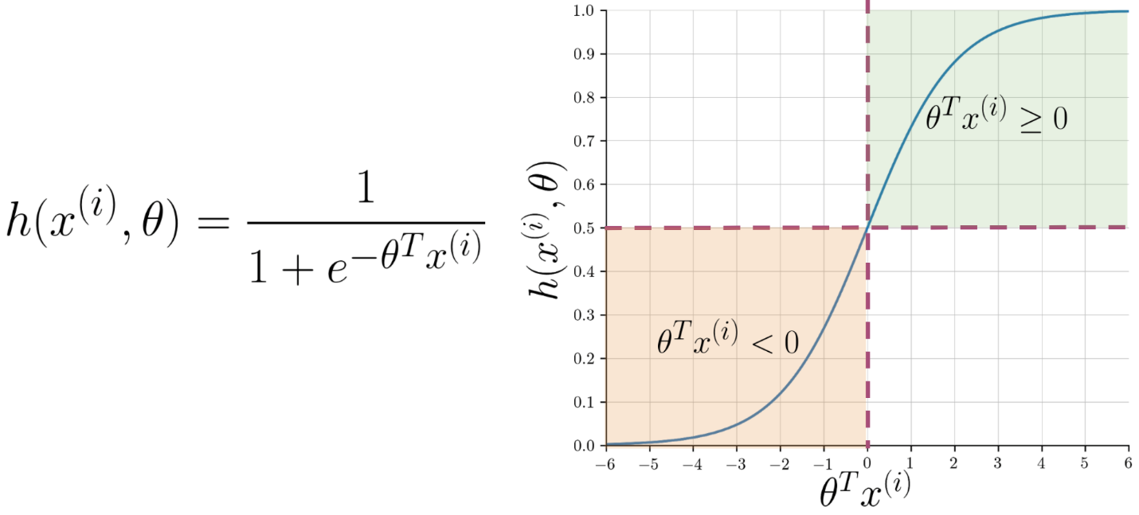

Note that as ***θT x*(*i*)** gets closer and closer to −∞ the denominator of the sigmoid function gets larger and larger and as a result, the sigmoid gets closer to 0. On the other hand, as ***θT x*(*i*)**gets closer and closer to ∞ the denominator of the sigmoid function gets closer to 1 and as a result the sigmoid also gets closer to 1.

Now given a tweet, you can transform it into a vector and run it through your sigmoid function to get a prediction as follows:

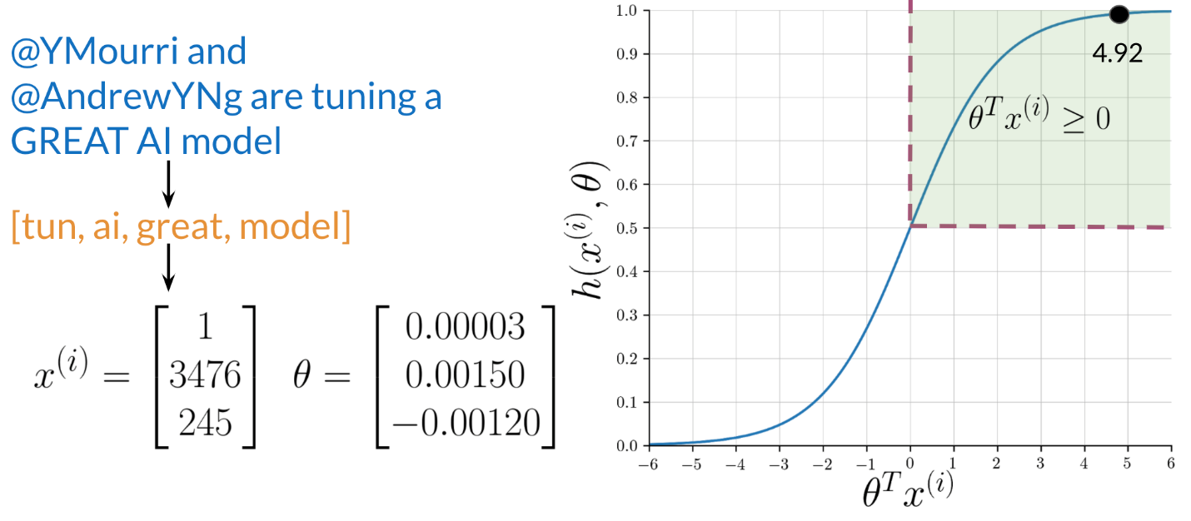

**------------------------------------------------------------------------------------------------------------------------------------------**

**------------------------------------------------------------------------------------------------------------------------------------------**

**------------------------------------------------------------------------------------------------------------------------------------------**

**------------------------------------------------------------------------------------------------------------------------------------------**

**------------------------------------------------------------------------------------------------------------------------------------------**

**------------------------------------------------------------------------------------------------------------------------------------------**

**------------------------------------------------------------------------------------------------------------------------------------------**

**------------------------------------------------------------------------------------------------------------------------------------------**

**------------------------------------------------------------------------------------------------------------------------------------------**

**------------------------------------------------------------------------------------------------------------------------------------------**Top of Form