4. Align the top and bottom lines of product cards (the quantity and add to cart buttons must always be aligned, blank space between price and quantity selector is OK); see image above with pink lines

Response: make the title no longer than 2 lines. In case there is a 3 line title do not display the 3rd line and end with “…”

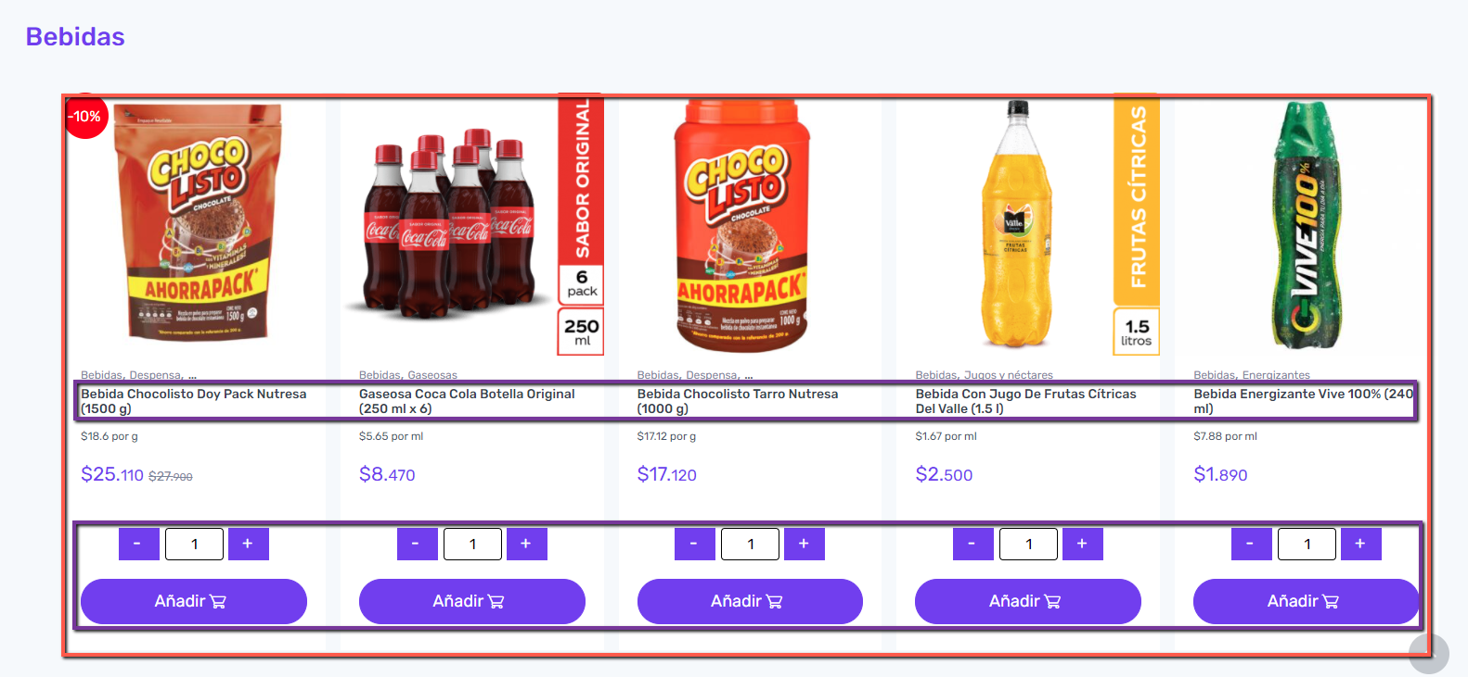

NOTE:

We make the title no longer than 1 lines because if we change the title (no longer than 2 lines) then alignment of the product card will be disturb.

15. Registration translation issues: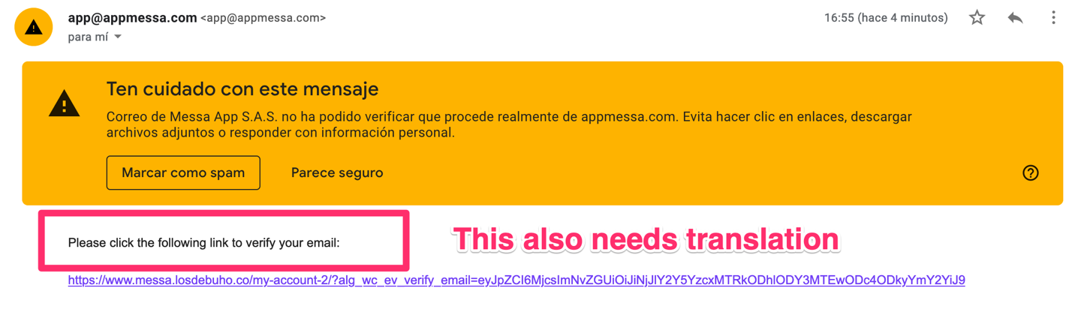

Response: This email is still in English, please show us where to translate it

FIND THE SOLUTION

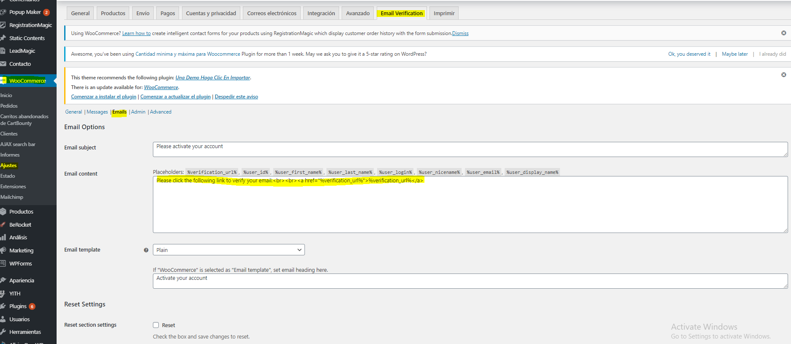

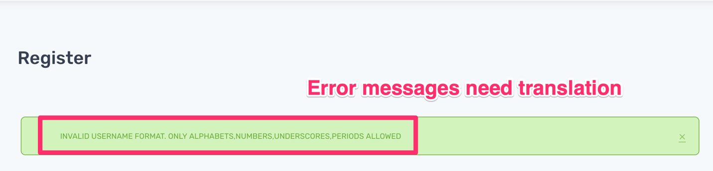

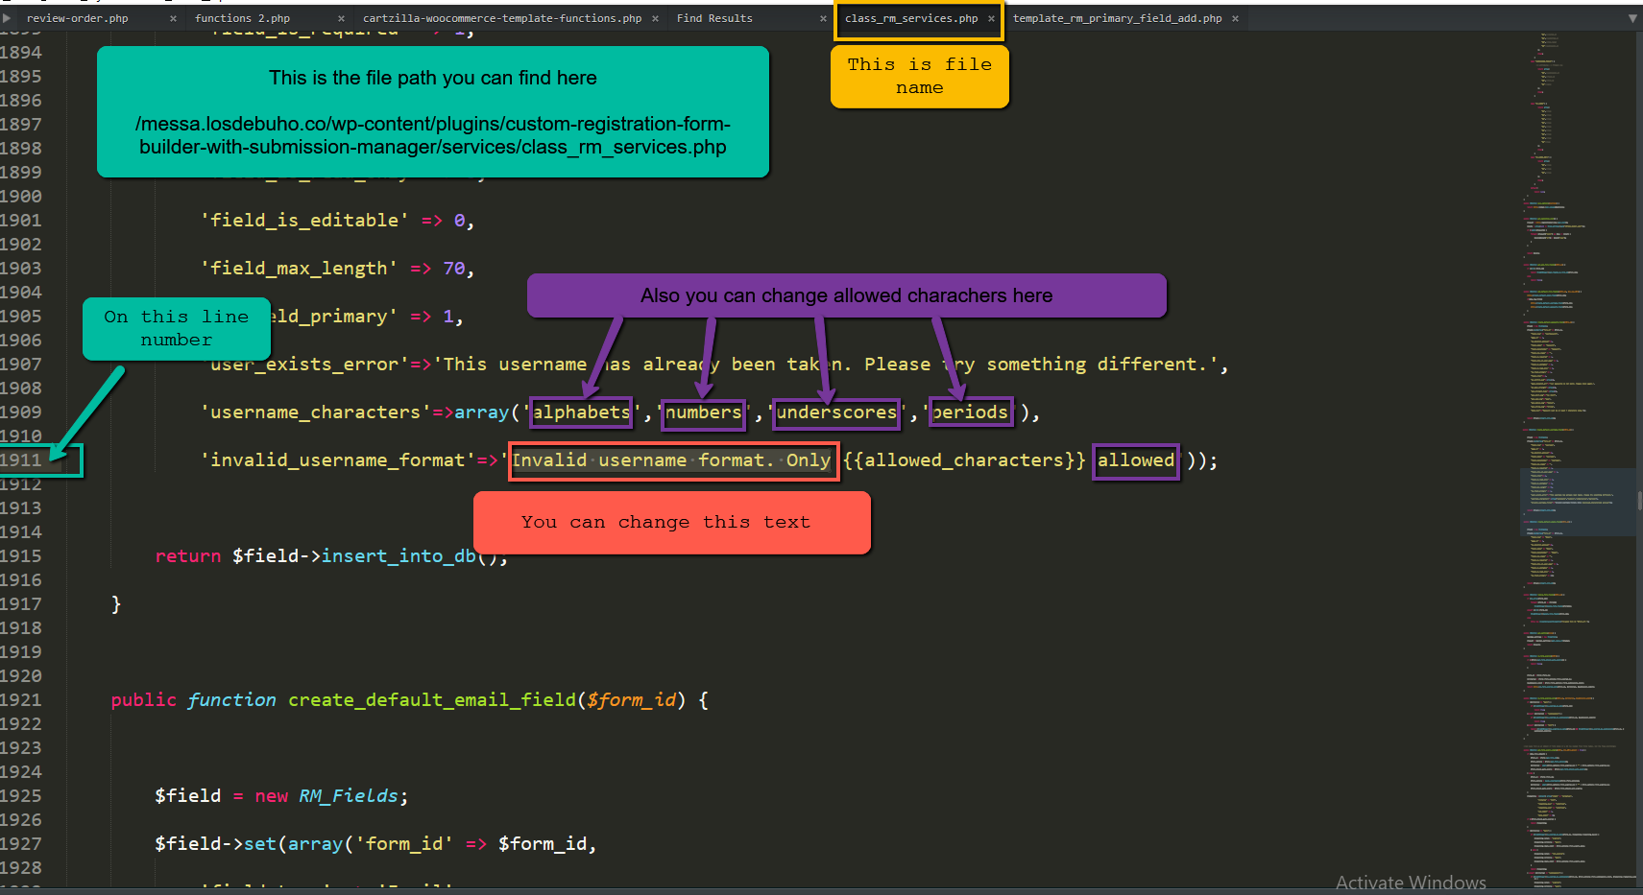

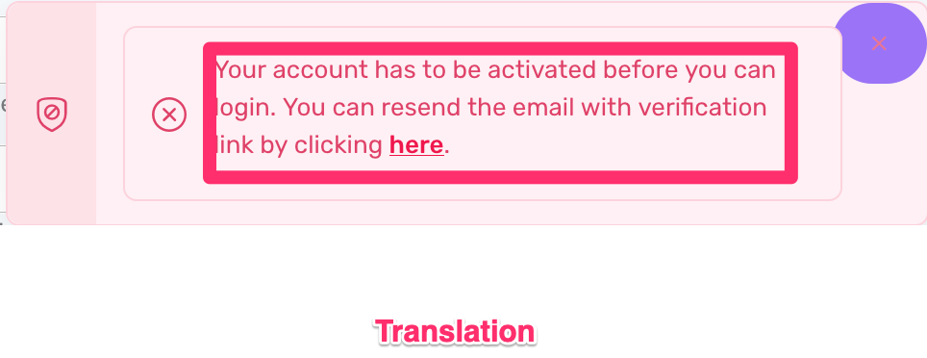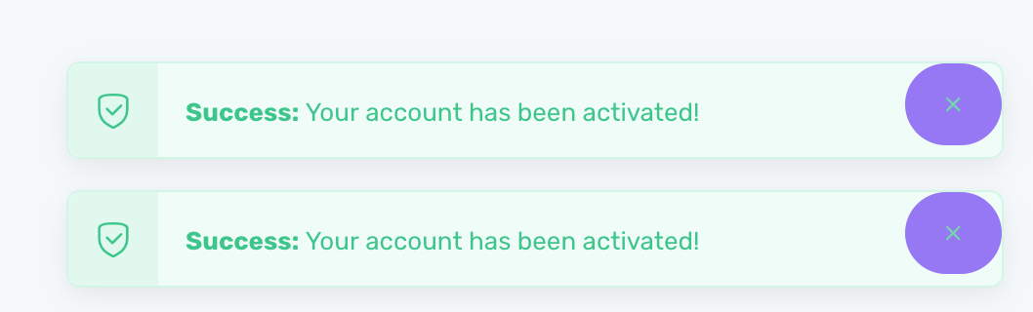

FIND THE SOLUTION

