Banking Customer & Operations Analytics
Data Dictionary

Purpose for the Sprint
This document describes the tables and fields visible in the Banking Customer & Operations Analytics Power BI data model. It provides a reference for understanding customer information, accounts, transactions, loans, cards, customer support calls, and the calendar table. Field meanings are based on the names shown in the supplied model image; definitions should be confirmed against the underlying source data where necessary.

Data Model & Table Relationships
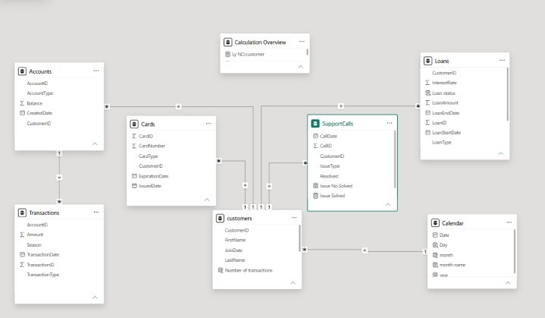
The model image shows the main banking tables and their relationships in Power BI. The model is intended to support analysis of customers, account balances, transaction activity, loan portfolios, card operations, and customer support. The Calendar table supports time-based reporting. Relationship direction and cardinality should be validated in the Power BI model before final analysis.

1. Accounts
Table Type: Account / customer-related table
Table Description: Stores account-level information, including account type, balance, creation date, and the customer associated with each account.

Column Definitions
Column | Definition
AccountID | Identifier for an account; likely the account key.
AccountType | Category or type of bank account.
Balance | Recorded balance for the account.
CreatedDate | Date the account was created.
CustomerID | Identifier of the customer associated with the account; used to connect accounts with customers.

Analytical Notes
- Check whether AccountID is unique before treating it as the primary key.
- Confirm the currency and the point-in-time meaning of Balance before comparing balances.

2. Transactions
Table Type: Transaction fact table
Table Description: Records account transactions and the transaction amount, date, season, and transaction type.

Column Definitions
Column | Definition
AccountID | Identifier of the account associated with the transaction.
Amount | Recorded monetary amount of the transaction.
Season | Season label associated with the transaction, as provided in the dataset.
TransactionDate | Date the transaction occurred.
TransactionID | Unique identifier for a transaction, subject to validation.
TransactionType | Classification of the transaction, such as its recorded type.

Analytical Notes
- Use the transaction-level grain when counting transactions or aggregating Amount.
- Check whether Amount includes both deposits and withdrawals, and whether signs or transaction types distinguish them.
- Validate TransactionDate data type and its relationship to the Calendar table.

3. Cards
Table Type: Card-related table
Table Description: Contains card records linked to customers, including card type and issue and expiration dates.

Column Definitions
Column | Definition
CardID | Identifier for a card record.
CardNumber | Card number field. Avoid exposing full card numbers in reports or public outputs.
CardType | Type or category of card.
CustomerID | Identifier of the customer associated with the card.
ExpirationDate | Date the card expires.
IssuedDate | Date the card was issued.

Analytical Notes
- Treat card numbers as sensitive information and do not display them in dashboard visuals.
- Check date fields for blanks and confirm whether expired cards should be included in operational measures.

4. Customers
Table Type: Customer dimension table
Table Description: Stores customer identity fields and customer-level information used to connect customers to banking products and activity.

Column Definitions
Column | Definition
CustomerID | Identifier for a customer; expected to identify a customer record.
FirstName | Customer's first name.
JoinDate | Date the customer joined or was registered, according to the source definition.
LastName | Customer's last name.
Number of transactions | A calculated field or measure shown in the model. Confirm its DAX definition and whether it counts transaction rows or distinct transaction IDs.

Analytical Notes
- CustomerID should be checked for uniqueness in the customer table.
- Names are personally identifiable information and should not be exposed in general dashboard summaries unless required.

5. SupportCalls
Table Type: Customer support / operational table
Table Description: Contains customer support call records, issue classifications, and fields related to whether issues were resolved.

Column Definitions
Column | Definition
CallDate | Date associated with the support call.
CallID | Identifier for a support call.
CustomerID | Identifier of the customer associated with the call.
IssueType | Category or type of issue reported.
Resolved | Field indicating whether the issue was resolved; confirm the values and data type.
Issue Not Solved | Calculated field or measure shown in the model; confirm its formula.
Issue Solved | Calculated field or measure shown in the model; confirm its formula.

Analytical Notes
- Validate whether CallID is unique at the call-record level.
- Confirm the meaning of Resolved values (for example, Yes/No or True/False) before calculating resolution rates.

6. Loans
Table Type: Loan / customer-related table
Table Description: Stores loan records, including amount, interest rate, loan type, status, and loan start and end dates.

Column Definitions
Column | Definition
CustomerID | Identifier of the customer associated with the loan.
InterestRate | Interest rate recorded for the loan. Confirm whether it is stored as a decimal or a percentage.
Loan status | Recorded status of the loan.
LoanAmount | Recorded amount of the loan.
LoanEndDate | Scheduled or recorded end date for the loan.
LoanID | Identifier for a loan record.
LoanStartDate | Start date of the loan.
LoanType | Category or type of loan.

Analytical Notes
- Check whether LoanID is unique before using it as the primary key.
- Standardize InterestRate formatting before displaying it as a percentage.
- Use the correct date field for each analysis, such as LoanStartDate for loan originations.

7. Calendar
Table Type: Date dimension table
Table Description: Provides calendar attributes for filtering and analyzing banking activity over time.

Column Definitions
Column | Definition
Date | Calendar date; should contain one row per date if used as a standard date dimension.
Day | Day attribute derived from Date; exact format depends on the calculation.
month | Month number or month attribute; confirm the underlying data type.
month name | Text name of the month.
year | Year component of Date.

Analytical Notes
- Mark this table as the date table in Power BI if it meets the date-table requirements.
- Sort month name by month number to keep months in chronological order.
- Confirm which date relationships are active for each fact table.

8. Calculation Overview
Table Type: Measure / calculation container (as displayed)
Table Description: The model image includes a table named Calculation Overview with a field displayed as 'by NO.customer'. Its precise name and calculation are not fully legible in the screenshot.

Column Definitions
Column | Definition
by NO.customer | Displayed field/measure label; verify the exact spelling and DAX expression in Power BI.

Analytical Notes
• This section is based only on the supplied screenshot. The exact measure definition cannot be determined from the image alone.

Relationships
The supplied model image appears to show these main connections:
- Customers.CustomerID → Accounts.CustomerID: connects customers to their accounts.
- Accounts.AccountID → Transactions.AccountID: connects accounts to their transactions.
- Customers.CustomerID → Cards.CustomerID: connects customers to their cards.
- Customers.CustomerID → Loans.CustomerID: connects customers to their loans.
- Customers.CustomerID → SupportCalls.CustomerID: connects customers to support-call records.
- Calendar.Date → the applicable date field in a related table: supports time-based analysis. The screenshot alone does not make every date relationship and its active status unambiguous.
Note: The exact cardinality, active/inactive status, and cross-filter direction should be checked in Power BI. The screenshot is a visual reference and does not expose the full relationship properties.

Data Model Structure
The model combines customer and product/operational records with activity tables. Accounts, Cards, Loans, and Customers hold descriptive or entity-level information, while Transactions and SupportCalls represent dated activities. Calendar provides date attributes for time-based analysis. The final classification of each table as a dimension or fact table should follow the actual row grain and relationships in the underlying data.

Data Quality & Business Rules

1. Key and Relationship Validation
- Check uniqueness of candidate identifiers such as CustomerID, AccountID, CardID, TransactionID, CallID, and LoanID in their respective tables.
- Investigate blank or unmatched foreign keys before relying on relationships.
- Confirm that one-to-many relationships are supported by the actual data.

2. Missing Values and Data Types
- Do not automatically replace missing numeric values with zero; determine whether blank means unknown, not applicable, or no recorded value.
- Validate date fields and convert them to Date or Date/Time as appropriate.
- Check numeric fields such as Balance, Amount, LoanAmount, and InterestRate for correct data types and units.

3. Reporting and Calculation Consistency
- Define transaction totals using a consistent rule for transaction types and positive/negative amounts.
- Define loan and card status metrics using documented business logic rather than assumptions.
- Document the DAX formulas for calculated fields and measures, including Number of transactions, Issue Solved, and Issue Not Solved.
- Avoid exposing sensitive customer names or card-number details in published dashboards.

Scope and Verification Note
This dictionary was prepared from the visible fields and relationships in the supplied Power BI model screenshot. The uploaded Power BI Desktop shortcut (.lnk) is not the underlying .pbix project file, so DAX expressions, exact data types, hidden fields, and complete relationship properties could not be inspected.
Those details should be verified in the original Power BI file before final submission.

