**Project Title:** Hotel management system

**Deliverable Name:** Sprint 1 and 2 Implementation

**Team Name:** StayEase

**Members:**

1. Abdurrahman Khan
2. Bilal Javed
3. Sohaib Sattar

**Submission Date: Mar 23, 2025**

**PART A:**

**Functional Requirements**

User Authentication → Users (admins, staff, customers) must be able to log in securely.

Room Booking → Customers can view and book available rooms.

Payment Processing → The system should support online payments.

Check-in and Check-out → The hotel staff should manage check-ins and check-outs.

Billing and Invoicing → Generate and print invoices.

Room Management → Admins can add, update, and remove rooms.

Staff Management → Manage hotel employees and their roles.

Reports and Analytics → Generate daily reports on bookings and revenue.

**Non - Functional Requirements**

a. Product Requirements

The system should work on Windows, Linux, and macOS.

The system must process at least 1000 transactions per hour.

The UI should be responsive and user-friendly.

b. Organizational Requirements

The system should follow Java coding best practices.

The project should be managed using GitHub for version control.

c. External Requirements

The system must comply with GDPR (General Data Protection Regulation) for handling user data.

It should integrate with third-party payment APIs like PayPal or Stripe.

**Use Case Diagram**

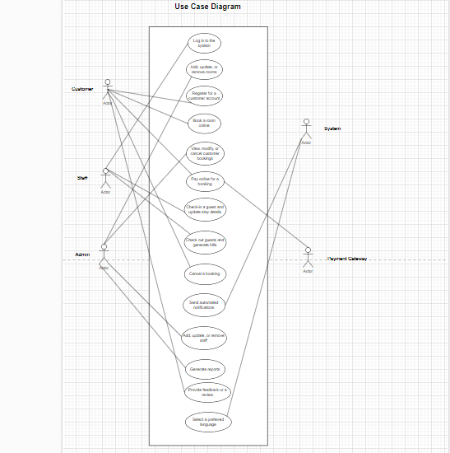

## **Sprint 1: Core Features (Authentication, Room Management, Booking)**

1. **User Authentication**
   * **User Role:** Hotel Staff/Admin
   * **Goal:** Allow authorized users to log in securely.
   * **Reason:** Ensures that only authorized personnel can access system functionalities.
   * **Pre-conditions:**
     + The user must be registered in the system.
   * **Post-conditions:**
     + The user is redirected to the dashboard upon successful authentication.
     + Unauthorized login attempts are blocked.
2. **Customer Registration**
   * **User Role:** Customer
   * **Goal:** Enable customers to create an account for booking hotel rooms.
   * **Reason:** Allows customers to access booking and hotel services.
   * **Pre-conditions:**
     + The customer provides valid details (name, email, contact information).
   * **Post-conditions:**
     + The customer account is successfully created.
     + The customer can now log in to the system.
3. **Room Management**
   * **User Role:** Admin
   * **Goal:** Allow admins to add, update, and remove rooms in the system.
   * **Reason:** Ensures accurate and up-to-date room availability.
   * **Pre-conditions:**
     + The user must be logged in as an admin.
   * **Post-conditions:**
     + The system updates the room listings based on admin actions.
     + The changes reflect in the customer’s booking view.
4. **Room Booking**
   * **User Role:** Customer
   * **Goal:** Allow customers to book hotel rooms online.
   * **Reason:** Enables users to secure accommodations easily.
   * **Pre-conditions:**
     + The customer must be logged in.
     + The selected room must be available.
   * **Post-conditions:**
     + The booking is confirmed, and the customer receives a confirmation email.
     + The room’s availability status is updated.
5. **Booking Management (Admin/Staff)**
   * **User Role:** Admin/Staff
   * **Goal:** Allow staff to view, modify, or cancel customer bookings.
   * **Reason:** Ensures efficient reservation management.
   * **Pre-conditions:**
     + The user must be logged in as an admin or staff member.
   * **Post-conditions:**
     + The booking data is updated accordingly.
     + Customers are notified of any changes.

## **Sprint 2: Payment, Check-in/Check-out, Notifications**

1. **Online Payment Processing**
   * **User Role:** Customer
   * **Goal:** Enable secure online payment for room bookings.
   * **Reason:** Confirms reservations by processing payments.
   * **Pre-conditions:**
     + A valid booking must exist.
   * **Post-conditions:**
     + The payment is successfully processed, and a digital receipt is generated.
     + The booking status is updated to "Confirmed."
2. **Check-in Process**
   * **User Role:** Staff
   * **Goal:** Allow staff to check guests into the system.
   * **Reason:** Facilitates a seamless arrival experience.
   * **Pre-conditions:**
     + The guest has a valid, confirmed booking.
   * **Post-conditions:**
     + The system updates the guest’s check-in status.
     + The room is marked as “Occupied.”
3. **Check-out Process & Billing**
   * **User Role:** Staff
   * **Goal:** Enable staff to check out guests and generate a final bill.
   * **Reason:** Ensures accurate billing and room availability updates.
   * **Pre-conditions:**
     + The guest has completed their stay.
   * **Post-conditions:**
     + The check-out status is updated.
     + A detailed bill is generated and provided to the guest.
     + The room is marked as “Available” for future bookings.
4. **Booking Cancellation**
   * **User Role:** Customer
   * **Goal:** Allow customers to cancel their bookings and receive a refund if applicable.
   * **Reason:** Provides flexibility for changing travel plans.
   * **Pre-conditions:**
     + The booking exists and falls within the cancellation policy window.
   * **Post-conditions:**
     + The booking is canceled in the system.
     + If eligible, a refund is processed.
     + The room is marked as available again.
5. **Automated Notifications**
   * **User Role:** Customer
   * **Goal:** Send automated notifications for booking confirmations, reminders, and check-out alerts.
   * **Reason:** Keeps customers informed about their reservations.
   * **Pre-conditions:**
     + The customer has a valid booking.
   * **Post-conditions:**
     + The system sends an email or SMS notification.
     + Customers receive timely reminders about their stay.

## **Sprint 3: Additional Features & Enhancements**

1. **Customer Feedback & Ratings**
   * **User Role:** Customer
   * **Goal:** Allow customers to rate their stay and provide feedback.
   * **Reason:** Helps improve service quality and customer satisfaction.
   * **Pre-conditions:**
     + The customer has completed their stay.
   * **Post-conditions:**
     + The feedback is recorded and displayed in the system.
2. **Discount & Promotions System**
   * **User Role:** Admin
   * **Goal:** Enable admins to create and apply promotional discounts.
   * **Reason:** Attracts more customers and increases bookings.
   * **Pre-conditions:**
     + The admin is logged in and authorized to create promotions.
   * **Post-conditions:**
     + Discounts are applied to eligible bookings.
     + Customers are notified of promotions.
3. **Multi-Language Support**
   * **User Role:** Customer
   * **Goal:** Provide multi-language options in the system.
   * **Reason:** Enhances accessibility for international users.
   * **Pre-conditions:**
     + The customer selects their preferred language.
   * **Post-conditions:**
     + The system displays content in the selected language.
4. **Loyalty Program Implementation**
   * **User Role:** Customer
   * **Goal:** Reward frequent guests with loyalty points.
   * **Reason:** Encourages repeat bookings and customer retention.
   * **Pre-conditions:**
     + The customer must have a registered account.
   * **Post-conditions:**
     + Loyalty points are added based on booking history.
     + Customers can redeem points for discounts.
5. **Staff Role Management**
   * **User Role:** Admin
   * **Goal:** Allow admins to assign different roles and permissions to staff members.
   * **Reason:** Ensures proper access control within the system.
   * **Pre-conditions:**
     + The user must be logged in as an admin.
   * **Post-conditions:**
     + Staff roles and permissions are updated.
     + Users can only access features assigned to their role.

**Sequence Diagram :**

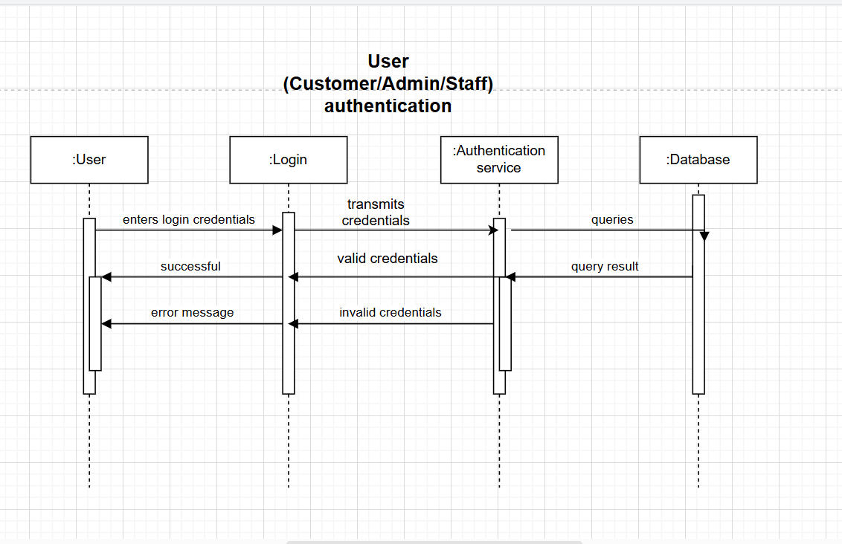

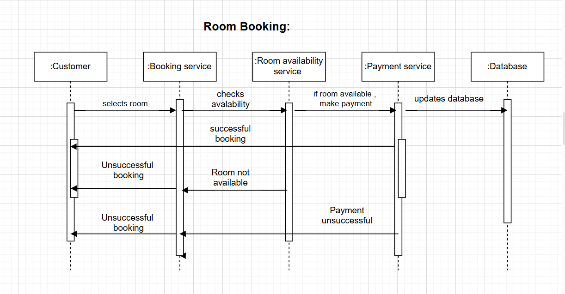

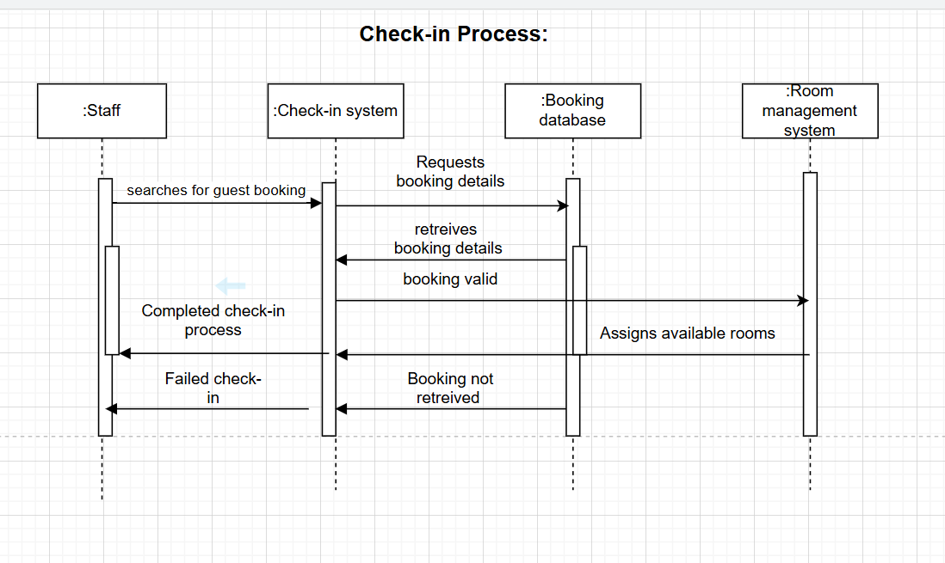

**Class Diagram**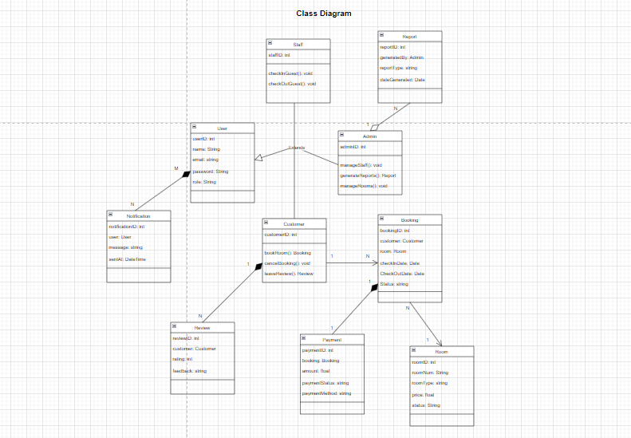

**PART B:**

**Product backlog:**

### Sprint 1: Core Functionality and Initial Setup

User Story 1: User Authentication [High]  
 *Description:* As a user (admin, staff, or customer), I want to log in securely to access the system so that only authorized personnel can use it.  
 *Acceptance Criteria:*

* Valid credentials are required for access.
* Successful authentication redirects the user to the appropriate dashboard.  
   *Pre-conditions:* The user must be registered in the system.

User Story 2: Customer Registration [High]  
 *Description:* As a prospective customer, I want to create an account to book hotel rooms online so that I can access additional services.  
 *Acceptance Criteria:*

* The registration form collects necessary details such as name, email, and contact information.
* An account is created after data validation.  
   *Pre-conditions:* The user provides valid registration details.

User Story 3: Room Management [High]  
 *Description:* As an admin, I want to add, update, and remove rooms so that the room listings are current and accurate.  
 *Acceptance Criteria:*

* Admins can add new rooms with all required details including room type, price, and availability.
* Existing room details can be updated or removed.  
   *Pre-conditions:* The user must be logged in as an admin.

User Story 4: Room Booking [High]  
 *Description:* As a customer, I want to view available rooms and book one that suits my needs so that I can secure a reservation.  
 *Acceptance Criteria:*

* Available rooms are displayed with complete details and images.
* A booking confirmation is generated upon a successful transaction.  
   *Pre-conditions:* The customer must be logged in and the room must be available.

User Story 5: Booking Management (Admin/Staff) [Medium]  
 *Description:* As an admin or staff member, I want to view, modify, or cancel customer bookings to manage reservations efficiently.  
 *Acceptance Criteria:*

* The system provides access to all booking records with their current status.
* Modifications or cancellations update the booking data accordingly.  
   *Pre-conditions:* The user must be authenticated as admin or staff.

### Sprint 2: Payment Processing and On-site Operations

User Story 6: Online Payment Processing [High]  
 *Description:* As a customer, I want to pay for my booking online so that my reservation is confirmed securely.  
 *Acceptance Criteria:*

* The system integrates with a payment gateway (e.g., PayPal or Stripe) to support multiple payment methods.
* A payment receipt is generated upon successful processing.  
   *Pre-conditions:* A valid booking must exist.

User Story 7: Check-in Process [High]  
 *Description:* As a staff member, I want to check in guests and update their stay details in the system to ensure a smooth arrival process.  
 *Acceptance Criteria:*

* The system verifies the guest’s booking information during check-in.
* The guest’s check-in status is updated and reflected on the dashboard.  
   *Pre-conditions:* The guest must have a valid booking.

User Story 8: Check-out Process & Billing [High]  
 *Description:* As a staff member, I want to check out guests and generate a final bill for their stay so that the guest’s account is settled accurately.  
 *Acceptance Criteria:*

* The check-out process updates the guest’s status in the system.
* A detailed invoice or bill is generated and made available for printing.  
   *Pre-conditions:* The guest must have completed their stay.

User Story 9: Booking Cancellation [Medium]  
 *Description:* As a customer, I want to cancel my booking and receive a refund if eligible so that I have flexibility in my travel plans.  
 *Acceptance Criteria:*

* The system verifies that the cancellation request is within the allowed window.
* The booking status is updated to canceled and, if applicable, a refund is processed.  
   *Pre-conditions:* A valid booking exists within the defined cancellation period.

User Story 10: Automated Notifications [Medium]  
 *Description:* As a system, I want to send automated notifications for booking confirmations, reminders, and check-out alerts so that customers stay informed about their reservations.  
 *Acceptance Criteria:*

* Notifications are sent via email or SMS based on user preferences.
* A log of notification history is maintained.  
   *Pre-conditions:* A valid booking or triggering event initiates the notification process.

### Sprint 3: Advanced Features and System Enhancements

User Story 11: Reports & Analytics [Medium]  
 *Description:* As an admin, I want to generate daily reports on bookings and revenue to make informed business decisions.  
 *Acceptance Criteria:*

* The system can generate comprehensive reports on a daily basis.
* Reports are exportable in formats such as PDF or Excel.  
   *Pre-conditions:* None.

User Story 12: Staff Management [Low]  
 *Description:* As an admin, I want to manage hotel employees and assign roles to streamline operations.  
 *Acceptance Criteria:*

* The system allows for the creation, updating, and removal of staff records.
* Role-based access control is implemented to secure sensitive functions.  
   *Pre-conditions:* The user must be logged in as an admin.

User Story 13: GDPR Compliance & Data Security [High]  
 *Description:* As a system, I must handle user data in compliance with GDPR to ensure data privacy and protection.  
 *Acceptance Criteria:*

* Data storage and processing methods adhere to GDPR standards.
* Users are informed about data usage and provided with options for data control.  
   *Pre-conditions:* None.

User Story 14: Multi-Platform Compatibility [Medium]  
 *Description:* As a system, I need to operate seamlessly on Windows, Linux, and macOS to serve a broad user base.  
 *Acceptance Criteria:*

* The application delivers a consistent user experience across all platforms.
* Functionality is tested on each operating system.  
   *Pre-conditions:* None.

User Story 15: Performance & Scalability [High]  
 *Description:* As a system, I must process at least 1000 transactions per hour to support peak usage periods.  
 *Acceptance Criteria:*

* Performance benchmarks are defined and met through rigorous testing.
* The system is scalable to handle increased transaction volumes.  
   *Pre-conditions:* None.

**PART C:**

## **Sprint 1 Backlog – Core Functionality and Initial Setup:**

The first sprint is dedicated to establishing the fundamental components of the system, including authentication, user registration, room management, and booking functionalities.

### User Authentication [High Priority]

Description: As a user (admin, staff, or customer), I want to securely log into the system to ensure that only authorized personnel can access its functionalities.  
 Acceptance Criteria:

* Users must provide valid credentials for authentication.
* Successful authentication grants access to the appropriate user dashboard.  
   Pre-conditions: Users must be registered in the system.

### Customer Registration [High Priority]

Description: As a prospective customer, I want to create an account to book hotel rooms online and access additional services.  
 Acceptance Criteria:

* The registration form captures essential details such as name, email, and contact information.
* An account is successfully created upon validation of the provided information.  
   Pre-conditions: The user must enter valid registration details.

### Room Management [High Priority]

Description: As an administrator, I want to add, update, and remove rooms to ensure that the system maintains accurate and up-to-date room listings.  
 Acceptance Criteria:

* Administrators can add new rooms, specifying type, pricing, and availability.
* Existing room details can be modified or removed as required.  
   Pre-conditions: The user must be logged in as an administrator.

### Room Booking [High Priority]

Description: As a customer, I want to browse available rooms and make reservations so that I can secure accommodations in advance.  
 Acceptance Criteria:

* The system displays a list of available rooms, complete with details and images.
* A booking confirmation is generated upon successful payment.  
   Pre-conditions: The customer must be logged in and the selected room must be available.

### Booking Management (Admin/Staff) [Medium Priority]

Description: As an administrator or staff member, I want to view, modify, or cancel customer bookings to ensure efficient reservation management.  
 Acceptance Criteria:

* The system provides an overview of all active and past bookings.
* Modifications or cancellations update booking data accordingly.  
   Pre-conditions: The user must be authenticated as an administrator or staff member.

## **Sprint 2 Backlog – Selected Subset:**

Sprint 2 focuses on enhancing system capabilities by introducing payment processing, check-in/check-out procedures, and booking cancellations. The selected user stories represent approximately one-quarter of the total backlog effort.

### Online Payment Processing [High Priority]

Description: As a customer, I want to securely complete my booking payment online to confirm my reservation.  
 Acceptance Criteria:

* The system integrates with a payment gateway (e.g., PayPal, Stripe) to process transactions.
* A payment confirmation receipt is generated upon successful completion.  
   Pre-conditions: A valid booking must exist.

### Check-in Process [High Priority]

Description: As a staff member, I want to check guests into the system and update their stay details to facilitate a smooth arrival process.  
 Acceptance Criteria:

* The system verifies booking details before completing check-in.
* The guest’s check-in status is updated on the dashboard.  
   Pre-conditions: The guest must have a valid reservation.

### Check-out Process & Billing [High Priority]

Description: As a staff member, I want to check guests out and generate a final bill to ensure accurate payment settlement.  
 Acceptance Criteria:

* The system updates the guest’s status upon check-out.
* A detailed invoice is generated for the guest’s stay.  
   Pre-conditions: The guest must have completed their stay.

### Booking Cancellation [Medium Priority]

Description: As a customer, I want to cancel my reservation and receive a refund if eligible so that I have flexibility in my travel plans.  
 Acceptance Criteria:

* The system verifies that cancellation requests meet the refund eligibility criteria.
* The booking status is updated, and a refund is processed if applicable.  
   Pre-conditions: A valid booking exists within the permitted cancellation period.

**PART D:**

**https://github.com/khang805/Software-Engineering**

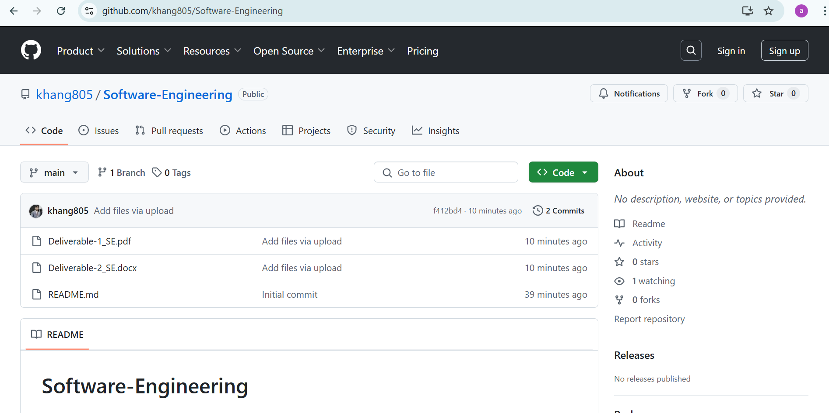

**PART E:**

**Trello Board:**

