Style Guidelines for Final Year Project ReportsFood Donor

Final Year Project Proposal

Session 2014-2018

A 4th Year Student

A project submitted in partial fulfilment of the

COMSATS-Lancaster Dual Degree

Of

BSc. (Hons.)BS in Computer Science / Software Engineering (CIIT)

BS in Computing / Software Engineering (LU)

**C:\Documents and Settings\drzhabib\Desktop\lancaster-university-logo.png**

Department of Computer Science

COMSATS Institute of Information Technology, Lahore

31 August 2017

**Project Registration**

|  |  |  |  |  |  |  |  |
| --- | --- | --- | --- | --- | --- | --- | --- |
| Project ID (for office use) | | |  | | | | |
| Type (Nature of project) | | | [ * ] **D**evelopment [ ] **R**esearch [ ^ ] **R**&**D** | | | | |
| Area of specialization | | | Android, GPS and Database. | | | | |
| **Project Group Members** | | | | | | | |
| Sr.# | Reg. # | Student Name | | CGPA | Email ID | Phone # | Signature |
| (i) | Ddp-sp14-bse-045 | M.Bilal Kafayat | |  | bilalkafayat@gmail.com | 03464087887 | Bilal |
| (ii) | Ddp-sp14-bse-089 | Ali Haider | |  | omair0334@gmail.com | 03035630600 | Ali |
| (iii) |  |  | |  |  |  |  |
| Name & Signature of Batch Advisor  (If students are eligible for FYP) | | | | Humaira Afzal | | | |

# Plagiarism Free Certificate

This is to certify that, I am _M.Bilal Kafayat_________ S/D/o ________Kafayat Ullah_______________, group leader of FYP under registration no CIIT/__ddp-sp14-bse-045__/LHR at Computer Science Department, COMSATS Institute of Information Technology, Lahore. I declare that my FYP proposal is checked by my supervisor and the similarity index is ____0____% that is less than 20%, an acceptable limit by HEC. Report is attached herewith as Appendix A.

Date: ___22 Feb 2017__ Name of Group Leader: ____M.Bilal Kafayat___Signature: __Bilal__

Name of Supervisor: ___Dr.M.Hussnain______ Co-Supervisor (if any):____________________

Designation: ___AP________ Designation: _____________________

Signature: ____M.Hussnain________ Signature: _____________________

**Approval of FYP Management Committee**

Committee Member 1: Name: _____________________

[ ] Accept [ ] *Defer [ ] *Reject Signature: _______________

*Remarks: _____________________________________________________________________

Committee Member 2: Name: _____________________

[ ] Accept [ ] *Defer [ ] *Reject Signature: _______________

*Remarks: _____________________________________________________________________

Convener: Name: _____________________

[ ] Accept [ ] *Defer [ ] *Reject Signature: _______________

*Remarks: _____________________________________________________________________

**Project Abstract**

This earth is our home. Humans are our family members. We cannot let anyone **sleep hungry**. Let’s change the world! This project is an android application which is a platform for the people to donate daily routine extra food which they wasted in no manners. Our aim is to reduce the food waste and feed the hungry people. People can use this application to donate their foods or to collect food for the hungry people. Millions of lives are starving for food around us, have a Tap to feed a life. Let’s work together to bridge the gap and reduce hunger and food waste in our beloved country.

**Introduction**

**Food Donor** is an android application that provides opportunities to people to donate food easily even they don’t need to search a hungry one. This app allows a layman to use technology for their ease in an efficient way.Integrated maps will be used in this application which automatically gets the location of the person who wants to donate food and display the location of the person who request for the food. Using location data, the app matches between the donor and a nearby organization to collect food. This app allows a layman to use technology for their ease in an efficient way.

User can share the food to available Charity services. User can find Charities near to the location and can deliver them self, user will get the root map assistance to charity which will easy to reach the location. Otherwise all the user need to do is to upload the food images in the app and immediately all the volunteers will get notification and will contact you to pick up the food and serve to charity, the user can also track the status of food up to delivery. Those who ready to act as a volunteer can register as a volunteer in the app itself and can collect food from different donors and serve to Charity.

**Donate Food**

In this module, the user add food items and will submit the request which will be shown in both food and receive modules.

**Receive Food**

Receivers may be NGO or Food banks and also a poor man who know the use of mobile, can request himself for food. The screen show the different variety of food and user can request for food. Also Volunteer can request for food and he can perform his tasks accordingly.

**Donate Money**

User have two options in this module, he or she can donate for our application or for charity bank.

**Hunger Spot**

NGO’s location can be added by user in map. As well as user can view the location in nearby area.

**Food Delivery Service**

If the needy cannot collect food himself then the team of our volunteers will deliver the food to the needy person. The location of this needy person will get by the request of this person in Receiver module.

**Motivation and Scope**

**Mostly people** when they want to donate some food they are in looking for some bagger to safe their food from waste while in restaurants they also waste food in daily routine. So, we want to safe the food waste and provide food to the hungry people and different food banks and different NGO’s where people are feed.

Internet and smartphone is the major invention of this age and people are moving towards it very extensively so in that perspective our application will have the greatest scope in market. We are also using GPS system in our application which is the very fine feature of smartphone so it also plays a major role in increasing the scope of our application.

**Related Work**

Mobile application industry has grown rapidly in the past few years. Many Applications related to No Food Waste & are developed and are in use. Like Surplus food, Food banks, **Zero Percent** etc.

As we're focusing on Pakistan and many services are working to feed the hungry people. Our work is different in the sense that we are providing a platform to develop communication among different services.

**Waste no food** {1} is an app that helps the needy people by collecting the food as well as the goods from different service areas, stores to provide charity.

(<http://wastenofood.org/>)

**Zero percent** {2} app has also a social motive to help the hungry people by collecting food from the commercial kitchens and donate it to those who really deserve it.

(<https://www.zeropercent.us/>)

**Surplus food** {3} through a website and mobile **app**, Feeding Forward matches businesses that have **surplus food** with nearby homeless shelters.

(<https://www.cnet.com/news/feeding-forward-app-delivers-food-to-homeless-shelters-in-real-time/>)

**Goals and Objectives**

* User friendly
* Easy to use
* Less Time Consuming
* Provide fast tracking system
* Provide accuracy as compare to different applications
* Change cultural of bagging system

Our major goal is to provide a platform for food donating and people can easily donate their foods and we provide this food to different food banks and to the hungry people with help of volunteers.

This application provides a source of communication between different services which are working on same mission. It will increase efficiency and will create awareness among people for using technology in a best way as it should be used. As countries in first world are transforming their every aspect into technological advancement.

**Individual Tasks**

* DDP-SP14-BSE-045(A)

(Graphic Designing and Documentation and Backend Development)

* DDP-SP14-BSE-089(A)

(Frontend Development)

**Gantt chart**

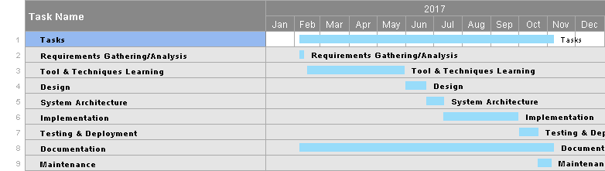

**Future Work**

Our future work will be fixing the problem of people to donate food. Each Donor or Receiver will have its own record. This will make managing the volunteers easier for people who are new in record. We will make Web application to provide more ease to the users. In future this app would also be available on IOS platform. We will overcome the location inaccuracy problems of the users in Google Maps.

**Tools and Technologies**

1. Android programing
2. Java programming
3. Firebase database
4. Android studio
5. XML
6. Google Map API

**References**

{1} Waste no food

(Manresa, n.d.)

{2} Zero percent

<https://www.zeropercent.us/>

{3} Surplus food

<https://www.cnet.com/news/feeding-forward-app-delivers-food-to-homeless-shelters-in-real-time/>

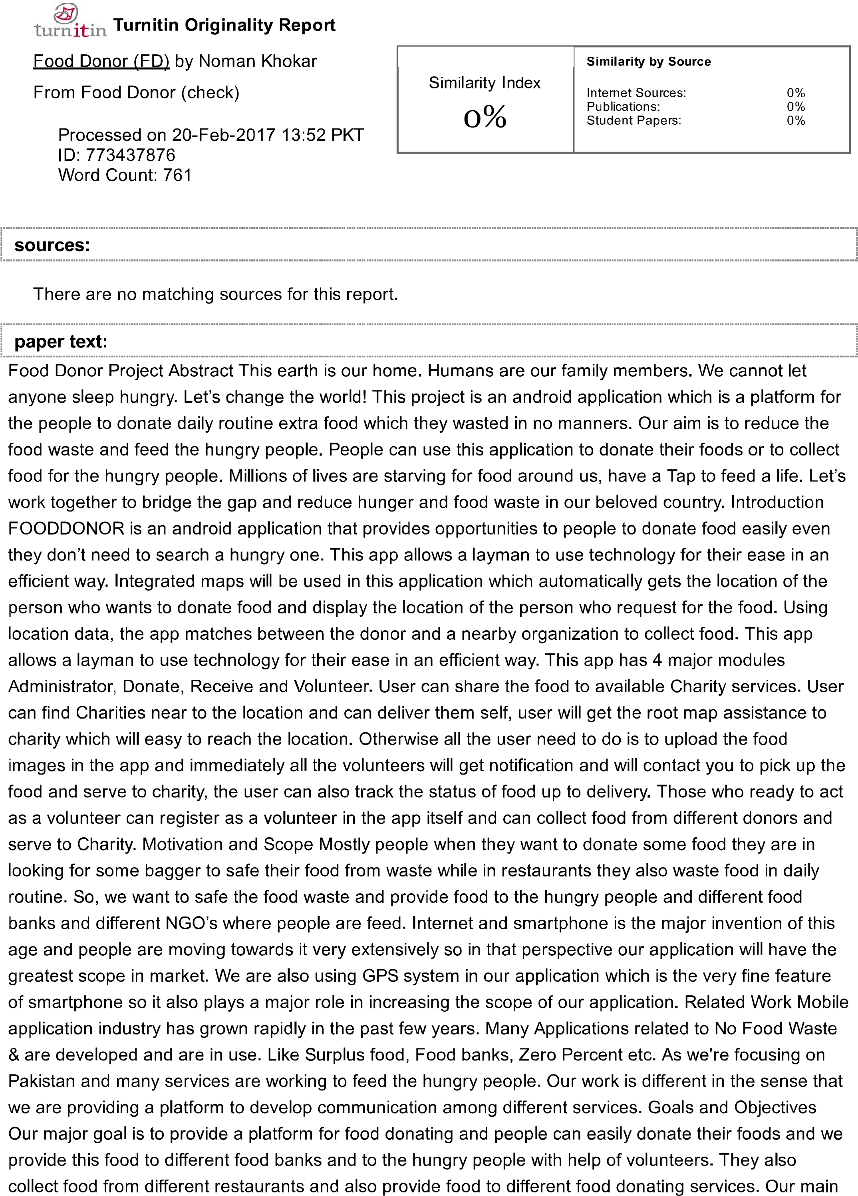

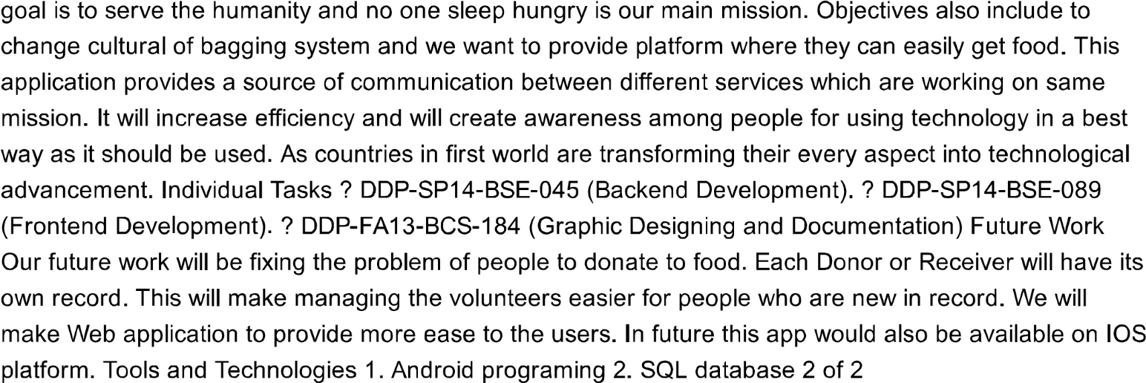

Appendix A