ASSIGNMENT - Deploy My-App-Project-Repo with Jenkins

STEP-1 : Install Git, Maven, Tomcat, Jenkins

STEP-2 : Edit pom.xml for maven version

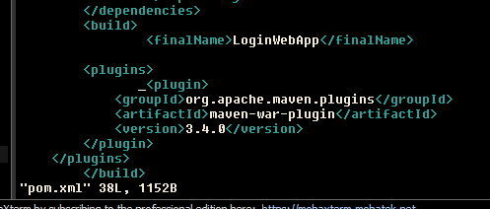

STEP-3 : Package Project Directory into WAR file using mvn clean package command

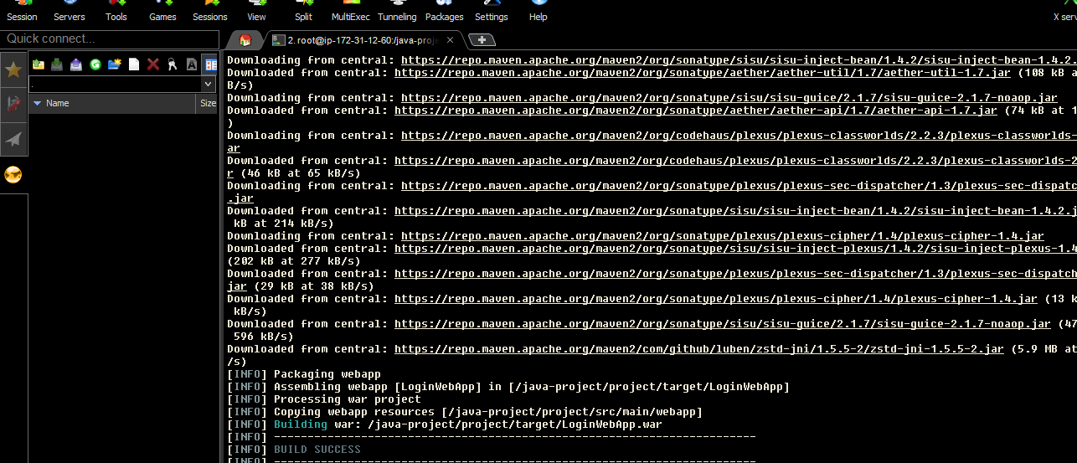

STEP-4 : Changed port of tomcat to 8081 in conf/server.xml

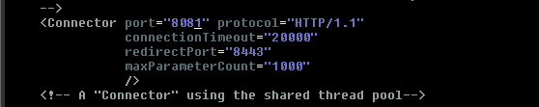

STEP-5 : Copy WAR file to Tomcat

cp /java-project/project/target/LoginWebApp.war \
/mnt/servers/apache-tomcat-9.0.122/webapps/

STEP-6 : Test the Application

