ASSIGNMENT : Trigger Multiple Jobs Sequentially from different Repository Branches

STEP-1 : Upload index.html file in Velocity Repository ( Q1-branch )
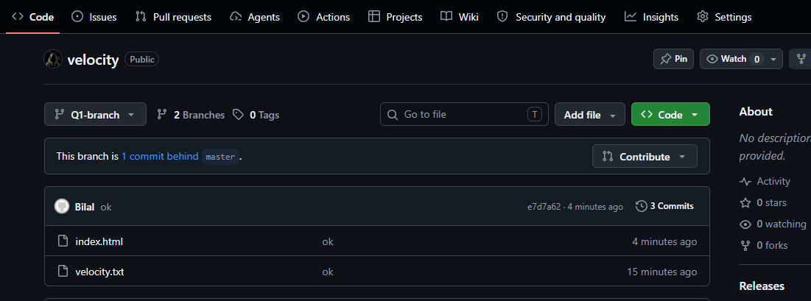

STEP-2 : Similarly in velocity2-(Q2-branch) & velocity3-(Q3-branch)

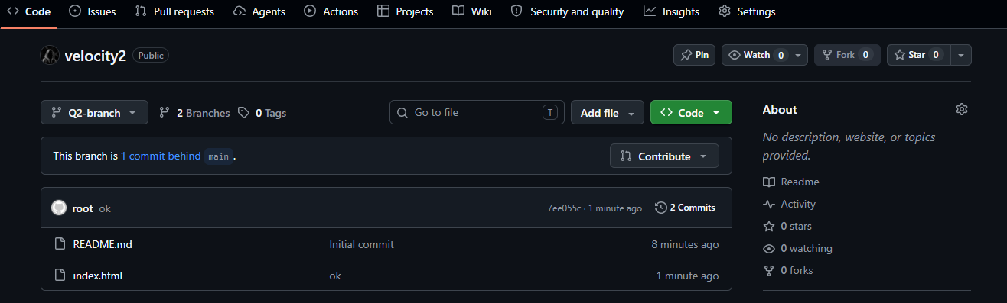
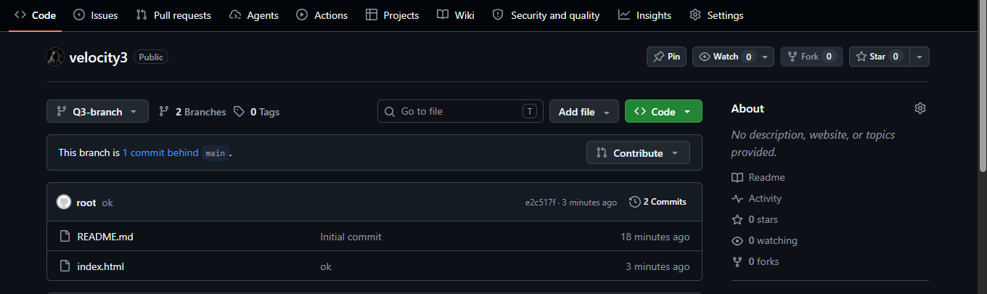
STEP-3 : Create Jenkins Job for Q1-branch
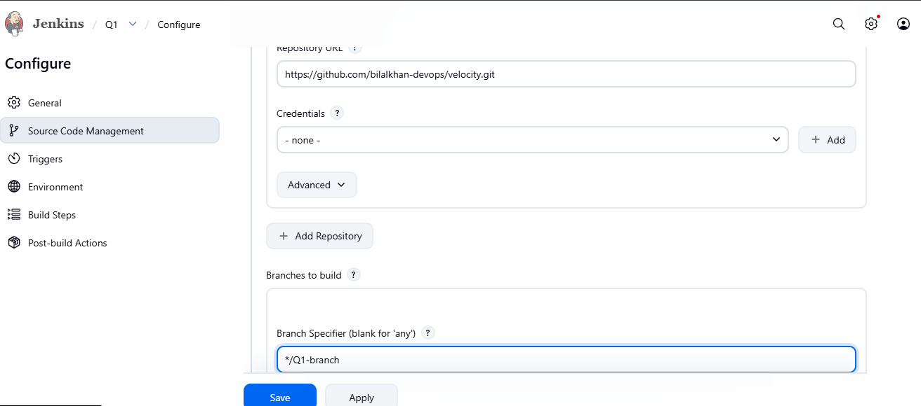
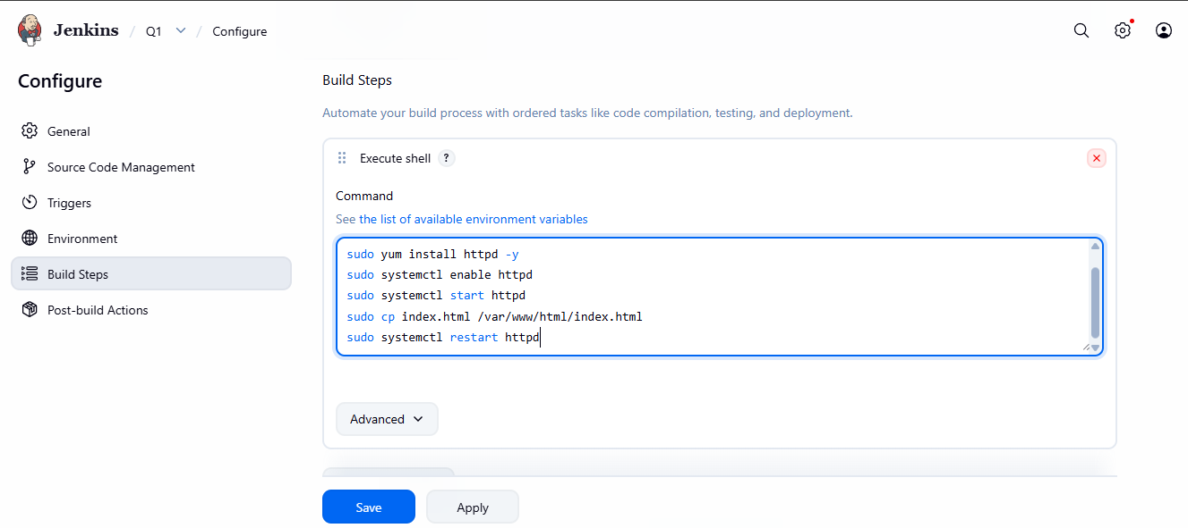
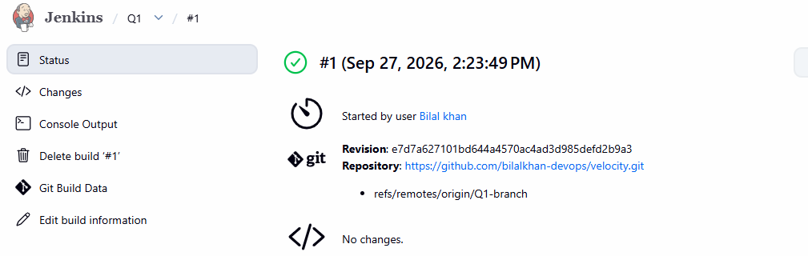
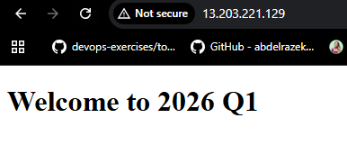
STEP-4 : Create Jenkins Job for Q2-branch

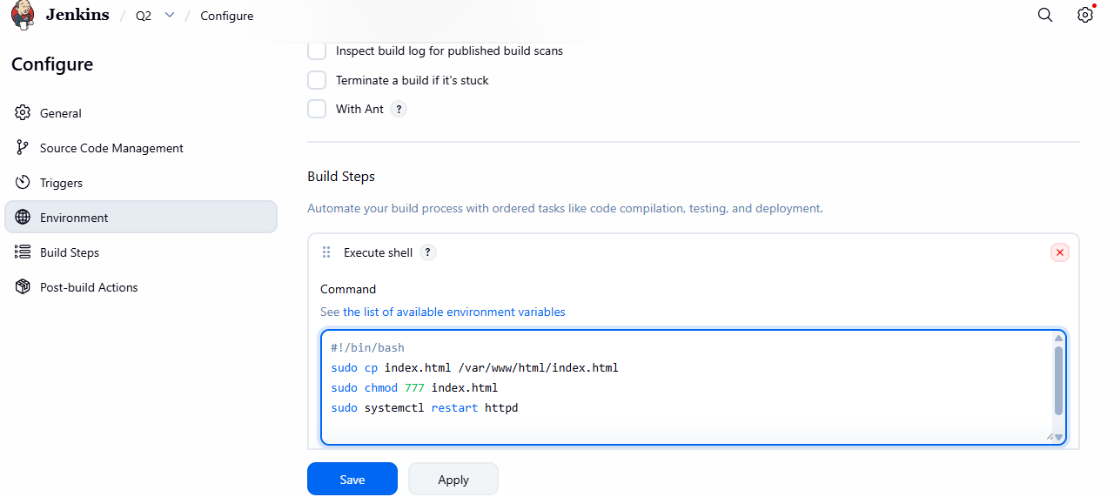
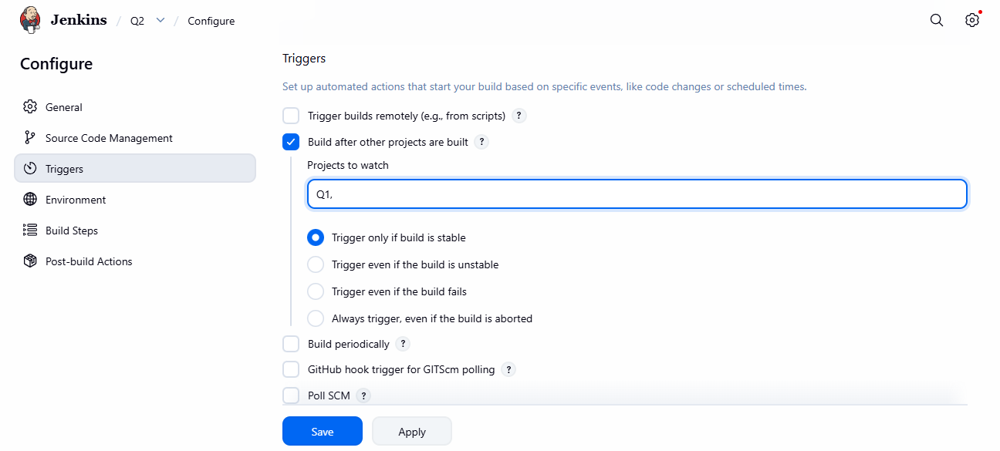
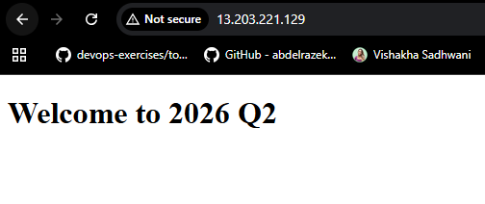
STEP-5 : Create Jenkins Job for Q3-branch
