ASSIGNMENT - Clone Private Github Repo and Enable HTTPD with Jenkins

STEP-1 : Create Branch and upload index.html
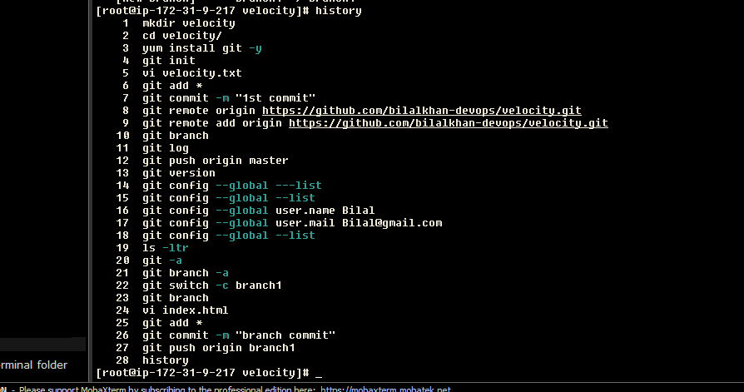

STEP-2 : Create an .SSH key on Jenkins server and Github
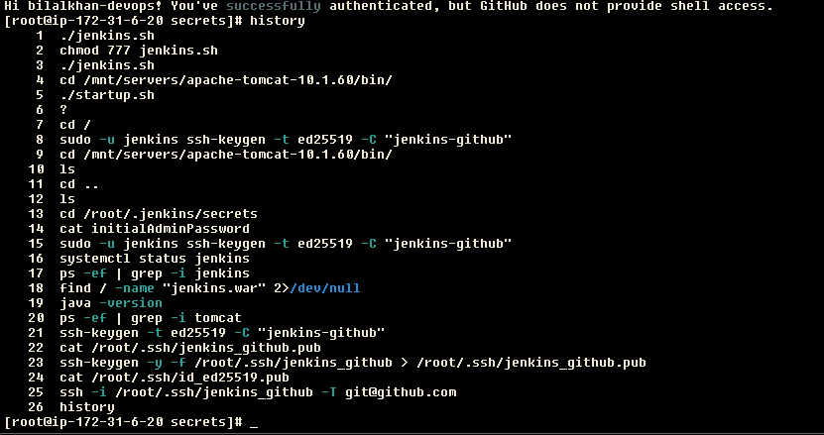
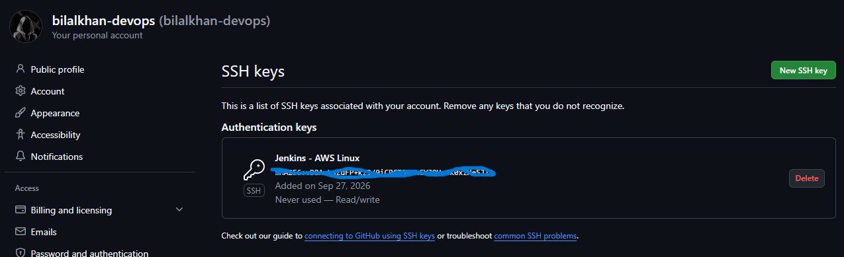

STEP-3 : Add KEY to Jenkins
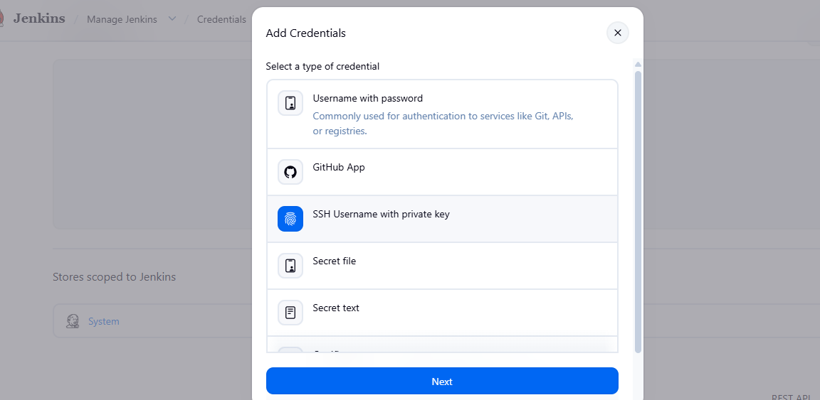
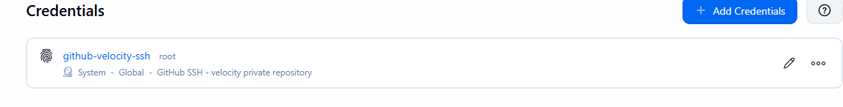
STEP-4 : Create Jenkins JOB
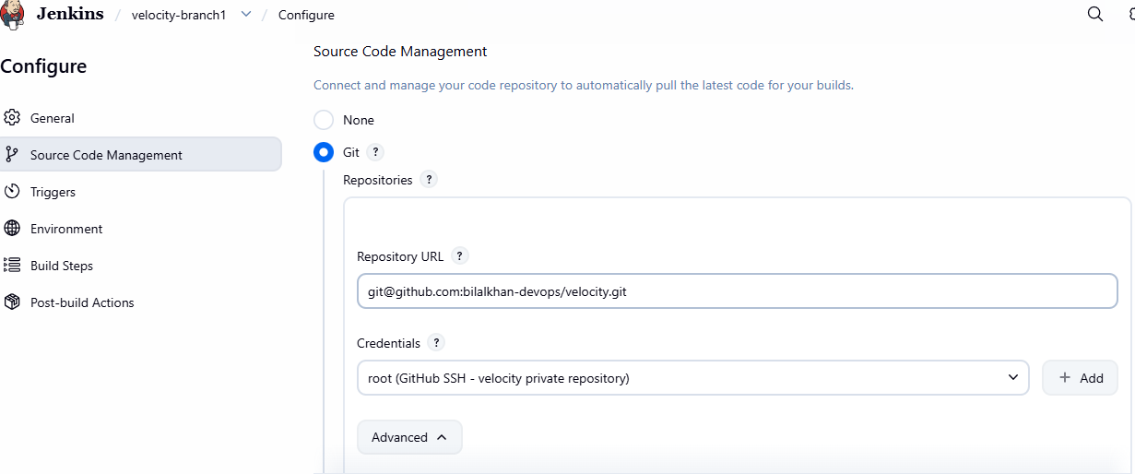
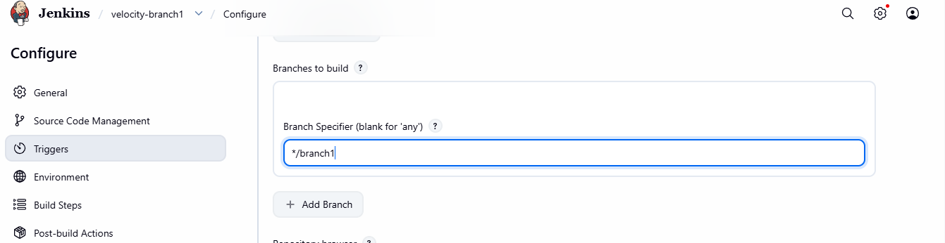
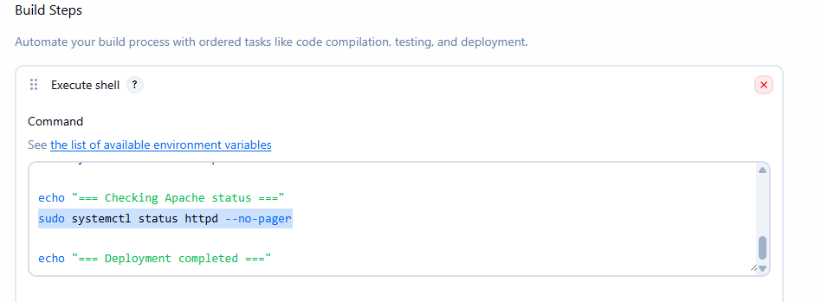
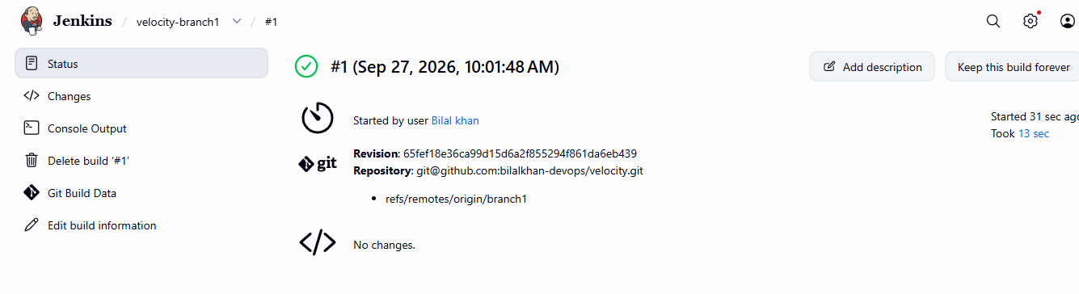
STEP-5 : Acces Public IP


