ASSIGNMENT = “ Create Jenkins Installation Script & HTTPD Installation Job in Jenkins “

STEP-1 : Launch Machine

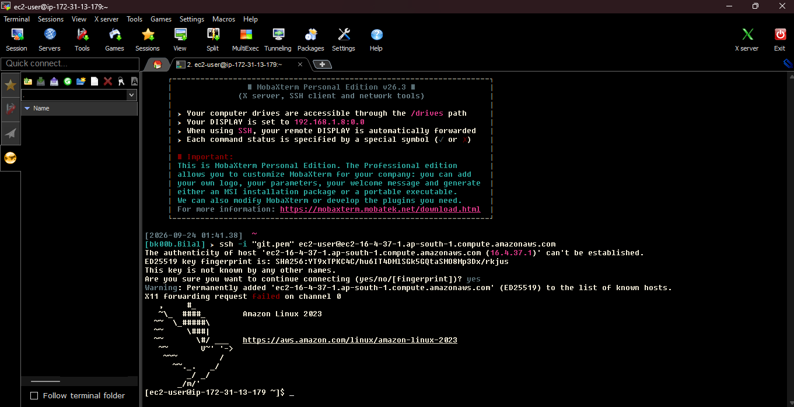

STEP-2 = jenkins.sh script in /home/ec2-user
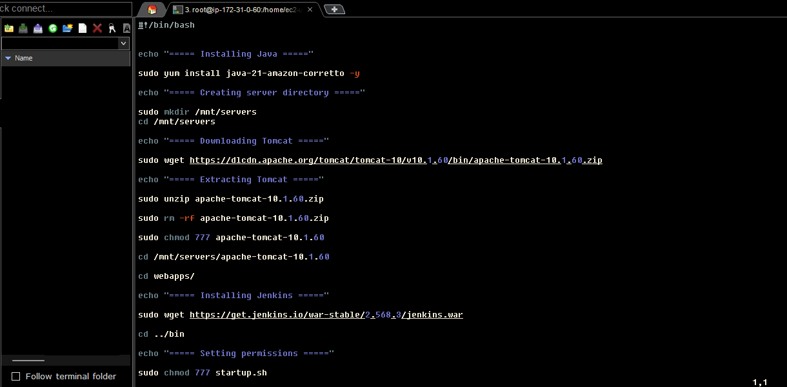
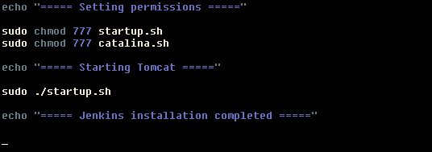

STEP-3 = Run ./jenkins.sh
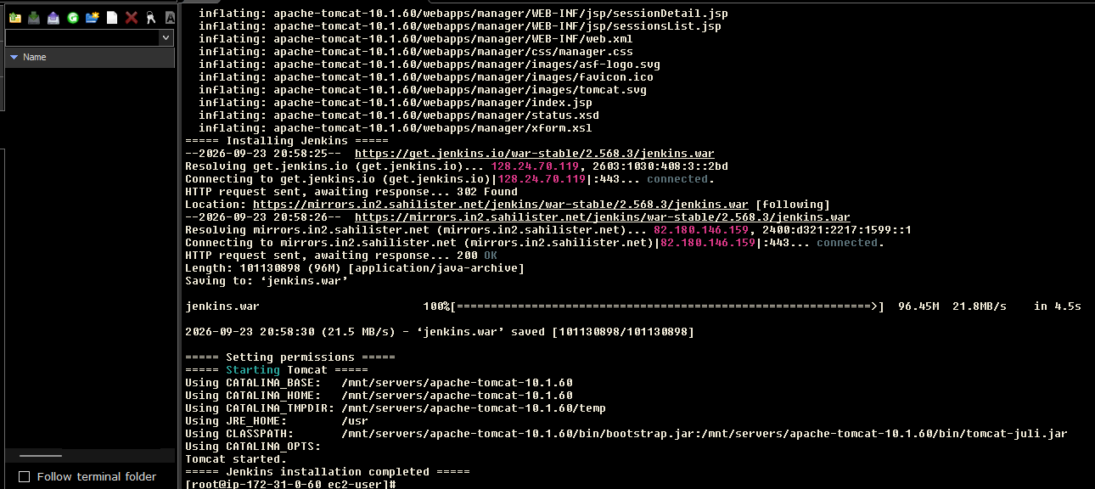
STEP-4 = Access Jenkins
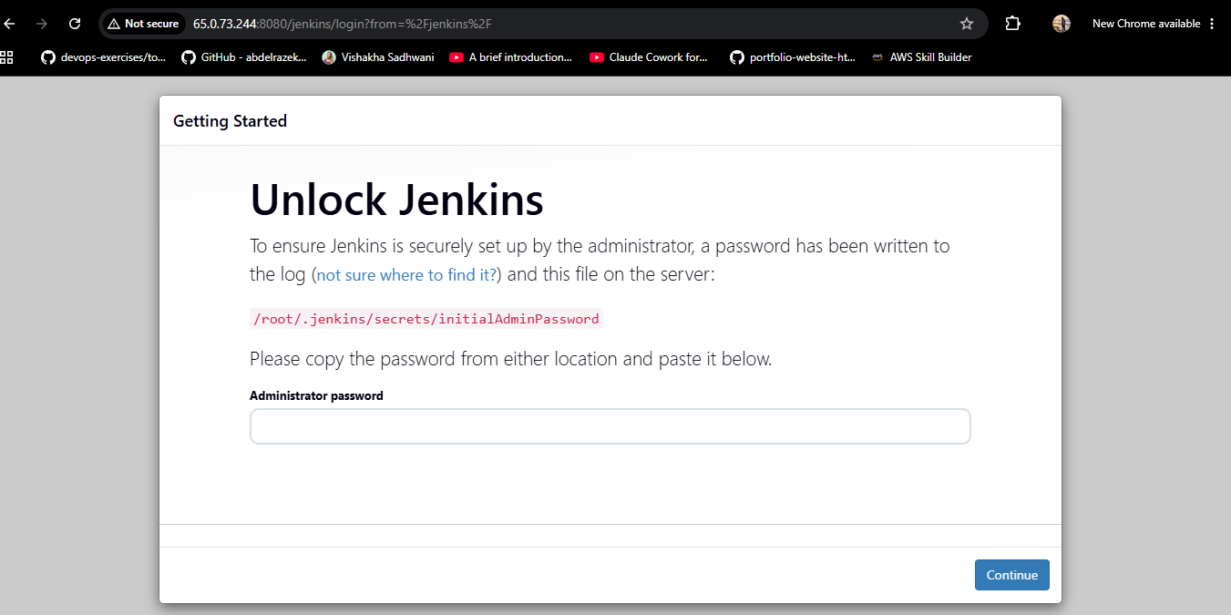
STEP-5 = Get password from secrets folder and Login

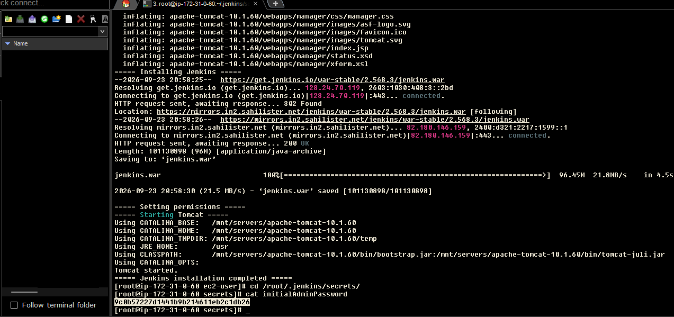

STEP-6 = Then Install suggested Plugins

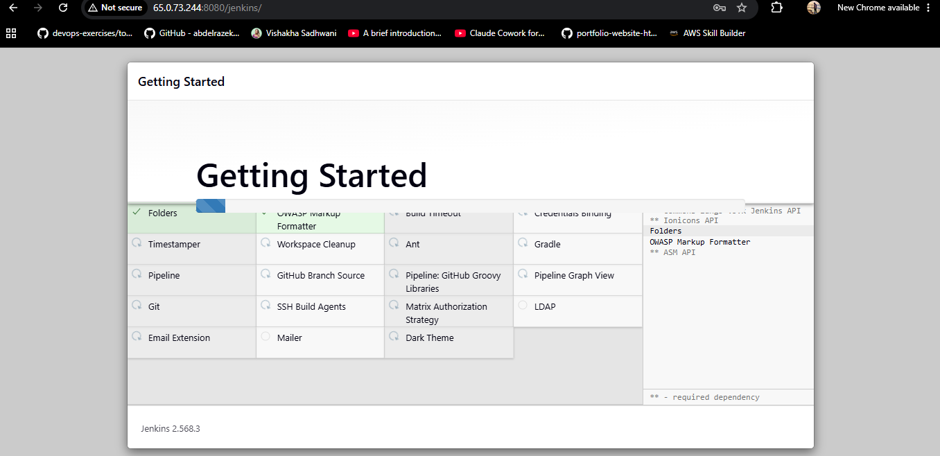

STEP-7 = Create new Job for HTTPD

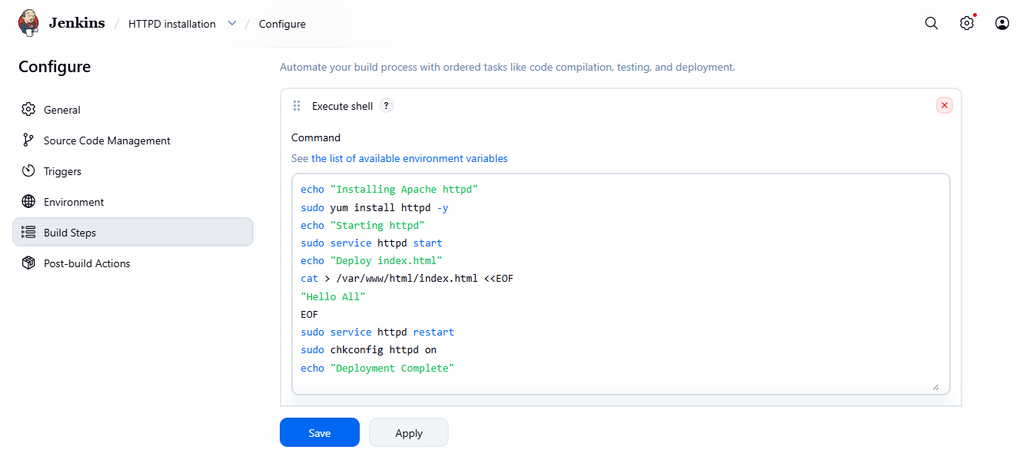
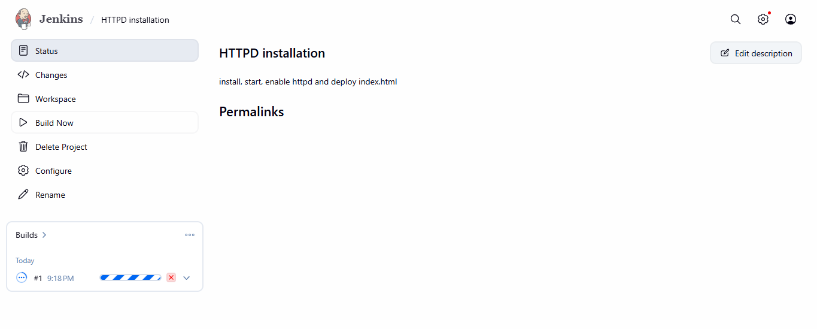

STEP-8 = Access PublicIP

