⚠ SYNTHETIC FIXTURE DATA: not real satellite results

Preliminary Observation Report: DB-0004
Report generated: 2026-10-12 16:26 UTC

Location
Site | Site C
Centroid (lon, lat) | 114.03305, 22.46277
Zoning (indicative) | Other zoning (Indicative overlay only, not a zoning determination.)
Area | 1.15 ha
First detected | 2025-02-01
Persistence | 6 of 6 months
Confidence | High

Satellite metrics
Measure | Baseline | Current | Change
Radar backscatter VV (dB) | -18.9 dB | -12.4 dB | +6.5 dB vs baseline
NDWI (water index) | 0.27 | -0.09 | -0.36 vs baseline

Before and after
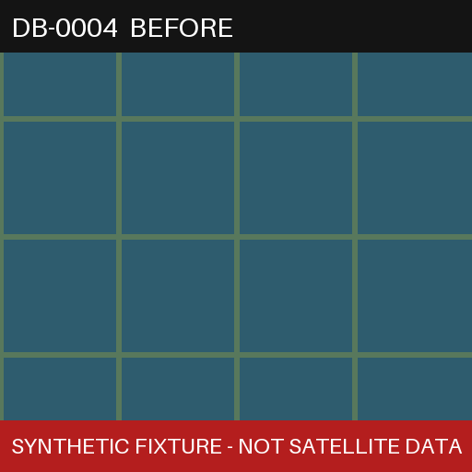  Before (baseline) (synthetic test image) | 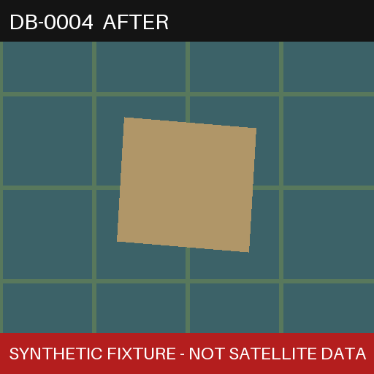  After (current) (synthetic test image)

Preliminary brief
Brief status: Cited

Preliminary Observation: Possible Wetland Loss at Site C
Summary
A 1.15 ha area outside the Wetland Conservation and Buffer Areas (indicative zoning) shows a persistent transition from water-covered to dry or filled surface, first observed in February 2025 and present in 6 of the last 6 months.
Evidence
- Affected area: 1.15 ha
- Radar backscatter rose +6.5 dB above the 2023-2024 baseline for the same month
- NDWI changed by -0.36 against the same-month baseline
- First detected 2025-02, persistent in 6 of 6 recent months
Statutory basis
1. Synthetic test claim used to check that statutory claims and their citations render correctly. [1] [2]
Recommended action
Refer for site inspection and zoning confirmation by the relevant authority.
Limitations
Satellite-derived indicator for screening purposes only. This is not a legal determination of unauthorised development. Findings require site verification by the relevant authority.
Generated 2026-10-01 00:00 UTC · model fixture-generator (no LLM)

Citations
[1] Synthetic Test Document A (fixture) · Page 3 · Section: Test section 1
“Synthetic placeholder text for interface testing only; not quoted from any real document.”
https://example.invalid/fixture-document-a
[2] Synthetic Test Document B (fixture) · Page 11 · Section: Test section 2
“Second synthetic placeholder passage used to check multi-citation layout.”
https://example.invalid/fixture-document-b

Disclaimer
Satellite-derived indicator for screening purposes only. This is not a legal determination of unauthorised development. Findings require site verification by the relevant authority.

