

# **Social Network Graph Analysis Report**

## **Name: Muhammad Bilal Nadeem**

## **Roll no.: 2022-CS-629**

## **Submitted To: Dr. Irfan Yousaf**

# **Introduction:**

Social networks model individuals' relationships with others in a particular group. Each student is represented as a node, and each friendship as an edge. In this project, a friendship graph of CS-22 is analyzed to examine patterns of relationships among students of that batch.

Key tasks include graph construction, visualization, centrality analysis, community detection, and evaluation of small-world characteristics. Through this, we aim to gain meaningful insights into the dynamics of the social group.

# **Dataset Description:**

The dataset used in this project is a .csv file (Friendship_Graph_2022.csv) representing a friendship network from the CS-22 batch. Each row has a list of roll no. of students. The first column contains the roll number of the student, and the next columns (up to ten) list the roll numbers of their friends. These entries define undirected, unweighted edges between students, indicating mutual friendships.

# **Graph Connectivity and Visualization:**

As per instructions, before analyzing the network I had to remove myself (my roll no.) from the graph. After removal, the graph remained fully connected. Therefore, all subsequent analysis was performed on this connected graph.

The graph is as follows:

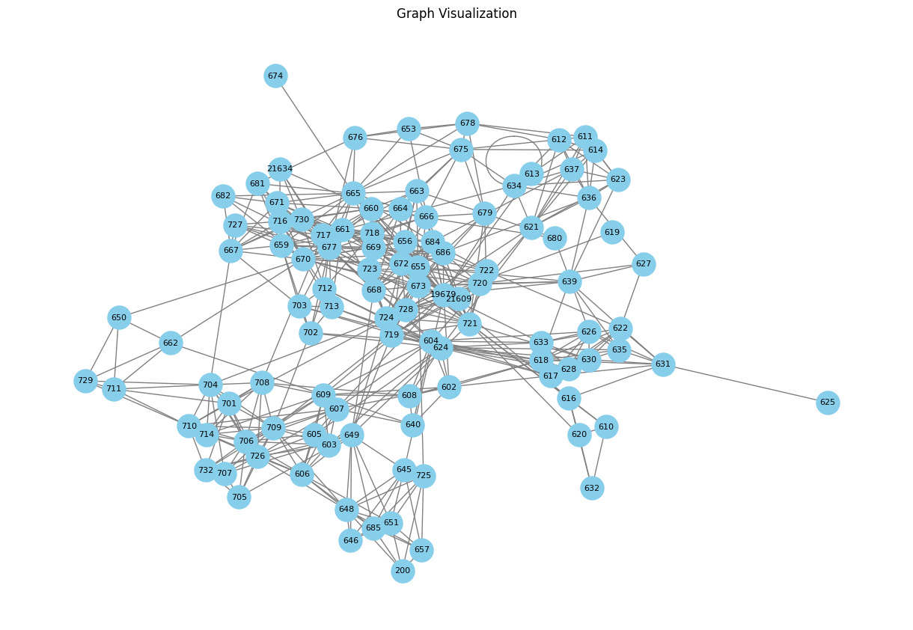

# **Graph Properties and Statistics:**

|  |  |
| --- | --- |
| Measure | Value |
| Average Degree | 9.90 |
| Average Clustering Coefficient | 0.52 |
| Average Path Length | 2.69 |
| Diameter | 6 |
| Assortativity Value | 0.07 |
| Highest Degree Node | 677 |
| Lowest Degree Node | 625 |

# **Distribution Analysis:**

1. **Distribution of Degree**

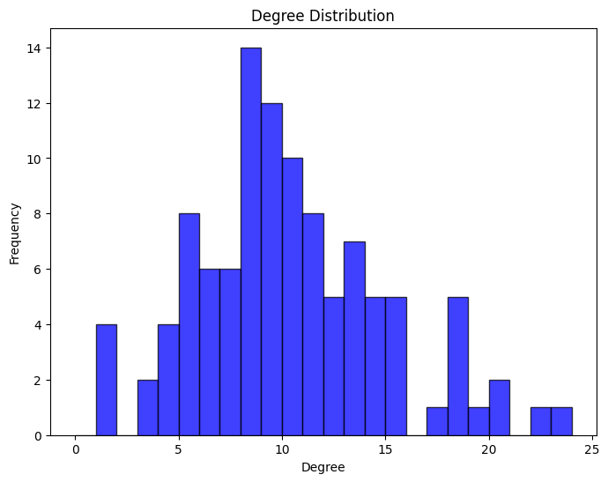

The degree of a node represents the number of connections (or friends) it has in the network.

From the histogram, we can observe:

* Most students have between **8 to 12** connections.
* A few students have a very high degree **(more than 18)**, indicating they are highly connected.

1. **Clustering Coefficient Distribution**

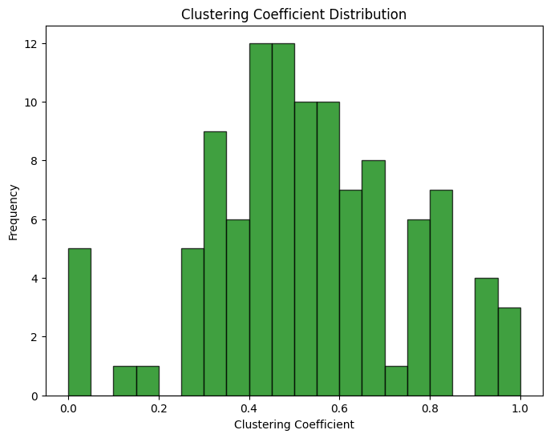

The clustering coefficient measures how connected a node's neighbors are to each other. It reflects the tendency of friends to form groups or cliques.

From the graph:

* Most nodes have a clustering coefficient between **0.3 and 0.7**, showing a moderate level of clustering.
* A few nodes have very **low (near 0)** coefficients, indicating their friends are not well connected.
* Others have **high values (close to 1)**, meaning their friends are also connected with one another.

1. **Path Length Distribution**

Path length refers to the number of steps required to go from one node to another in the network.

From the graph:

* The most common path **length is 3**, meaning most students are connected to each other through three steps.
* Many paths are also of **length 2 or 4**.
* Very few paths are **longer than 4**, and only a few are **shorter than 2**.

# **Centrality Measures:**

The centrality measures for top **10 nodes** are listed below:

|  |  |  |  |  |
| --- | --- | --- | --- | --- |
| Node | Degree Centrality | Closeness Centrality | Betweenness Centrality | Eigenvector Centrality |
| 677 | 0.226415 | 0.46087 | 0.072336 | 0.226868 |
| 655 | 0.207547 | 0.452991 | 0.068076 | 0.225251 |
| 721 | 0.188679 | 0.458874 | 0.073621 | 0.198057 |
| 670 | 0.188679 | 0.445378 | 0.055994 | 0.226174 |
| 673 | 0.169811 | 0.443515 | 0.047909 | 0.223885 |
| 672 | 0.169811 | 0.447257 | 0.01822 | 0.224016 |
| 19-679 | 0.169811 | 0.504762 | 0.149184 | 0.145729 |
| 684 | 0.169811 | 0.458874 | 0.041003 | 0.203679 |
| 709 | 0.169811 | 0.40458 | 0.040149 | 0.052222 |
| 624 | 0.160377 | 0.445378 | 0.065878 | 0.080267 |

# **Community Detection and Analysis:**

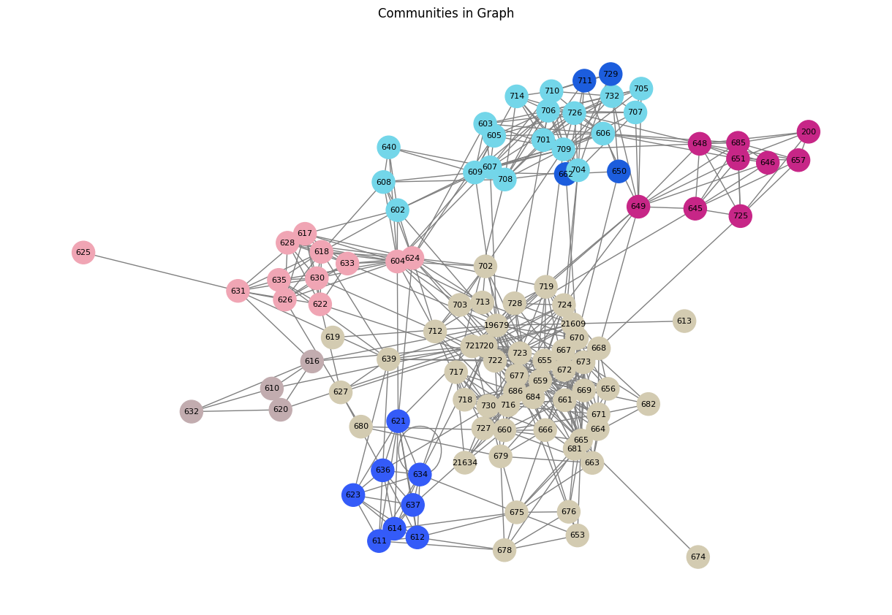

The graph above reveals a total of 6 distinct communities within the CS-22 network. Each community is represented by different colors.

# **Small World Properties Check:**

A graph exhibits small-world properties if it has:

* A low average path length
* A high clustering coefficient

Based on our analysis:

* **Random Graph Average Path Length:** 2.236
* **Graph Average Path Length:** 2.6910
* **Random Graph Clustering Coefficient:** 0.0850
* **Graph Clustering Coefficient:** 0.5230
* **Comparison with a Random Graph:** The average path length of 2.69 is slightly longer than that of the random graph (2.236), suggesting that the network is **less efficiently connected**. Therefore, while the graph shows high clustering, the path length does **not strongly** support small-world characteristics.

# **Conclusion:**

In this project, a friendship graph of the **CS-22** batch was analyzed using **Social Network Analysis techniques**. Key structural properties, centrality measures, and community structures were explored. Although the network showed high clustering, it did not fully meet the criteria for a small-world network due to its relatively longer path lengths. Overall, the analysis provided valuable insights into the connectivity and group dynamics among students.