Aim : write a html code to fetch to fetch the xml data by using httprequest
Input:
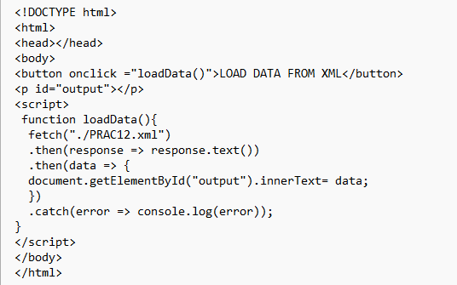
Output :
