2. Working with Directories
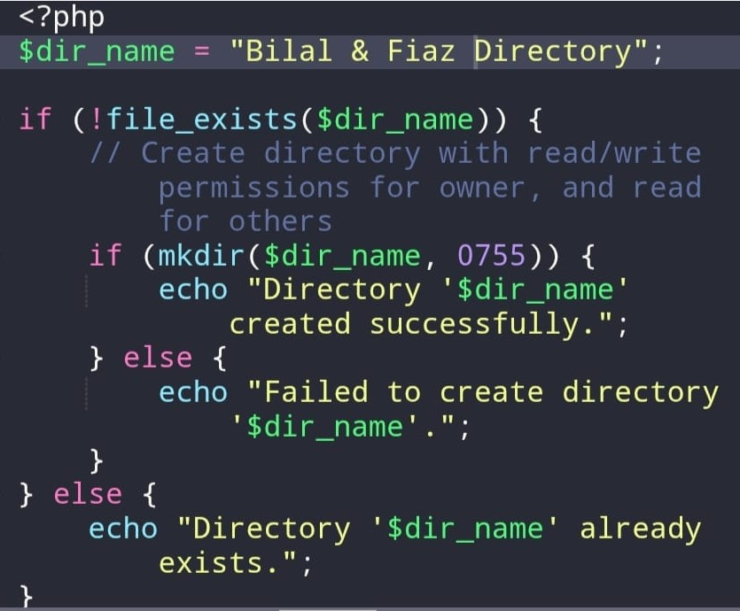
​#PHP code for creating directories
To run this code, open chrome search localhost/filename php, also open xampp and start apache.
