PROJECT DOCUMENTATION
Pursuit
Automatic Job Application Tracker — Browser Extension & Web Platform

Prepared by
Bilal Patel
Repository: github.com/bilalpatel813/extension-v1.o
Live application: pursuit-sandy-three.vercel.app
July 2026

Table of Contents
1. Introduction 3
2. Problem Statement 4
3. Data Analysis and Interpretation 4
4. Methodology 5
5. Conclusion and Result 8
Application Screenshots — Browser Extension 9
Application Screenshots — Website 10
References 11

1. Introduction

1.1 About the Project
Pursuit is a system that automatically keeps track of every job a person applies to. It has two connected parts: a Chrome extension that quietly watches LinkedIn, Indeed, and Naukri while someone applies, and a companion website where the same person can sign up, log in, and see every tracked application in one dashboard. The goal is simple — a job seeker should never have to remember, by hand, where they applied and what happened next.
The project is split into three pieces that work together: the browser extension (the part that notices when an application happens), the website (the part a person actually looks at and manages their account through), and the backend API (the part that safely stores everyone's data). All three are already built and connected to a live, working database.

1.2 Technologies Used
The table below lists every technology used in the project, grouped by which layer of the system it belongs to.
Layer | Technology | Purpose
Browser Extension | HTML, CSS, JavaScript (Manifest V3) | Detects and tracks applications directly on job sites
 | Chrome Extension APIs: storage, tabs, runtime, notifications | Local data storage, messaging between extension parts, alerts
Website Frontend | Next.js 16 (App Router), TypeScript | Landing page, authentication pages, dashboard, profile
 | Tailwind CSS v4, Framer Motion | Styling and animation across every page
Backend API | Django 5.2, Django REST Framework | Serves the REST API that stores and returns application data
 | djangorestframework-simplejwt | Issues and verifies JWT access and refresh tokens
 | django-cors-headers, djangorestframework-camel-case | Safe cross-origin requests; consistent field naming
Database | PostgreSQL (hosted on Neon) | Stores user accounts and job application records
Hosting & Deployment | Vercel (website), Render (backend API) | Public hosting for the two live services
 | Gunicorn, WhiteNoise | Production application server and static file serving
Supporting Tools | Git & GitHub, Archify (diagramming) | Version control and this documentation's diagrams

2. Problem Statement
Most job seekers apply to many roles at once, often across several different websites in the same week. Without a system to track this, it becomes very easy to lose track of basic facts: which companies has this person already applied to, what stage each application is at, and which listing on LinkedIn matched which listing on Indeed.
In practice, this shows up as a few specific problems:
- Applications pile up across LinkedIn, Indeed, and Naukri with no single place to see all of them together.
- Spreadsheets require a person to stop, switch tabs, and manually type in the job title, company, and date — a step most people skip after the first few applications.
- There is no easy way to see the shape of a job search at a glance — how many applications turned into interviews, how many turned into offers, and how many went nowhere.
- Details fade from memory quickly: which resume version was sent, what the role actually was, or whether a follow-up is even needed.

Pursuit addresses each of these by removing the manual step entirely. The extension recognizes the moment an application is submitted and records it on its own, so tracking stops depending on a person's memory or discipline. The dashboard then turns that raw list of applications into a clear picture of the job search as a whole.

3. Data Analysis and Interpretation

3.1 What Data the System Captures
Every tracked application is stored as one record with the fields below. These are the same fields defined in the backend's JobApplication database table.
Field | What it records
title / company | The role and the organization it was posted by
location | Where the role is based, or "Remote"
source | Which site the application came from — LinkedIn, Indeed, Naukri, or entered manually
status | Where the application currently stands: Applied, Interview, Offer, or Rejected
applied_at | The date the application was submitted
notes | Free-text space for anything the person wants to remember about that application

3.2 Sample Data
The table below is a small, illustrative set of tracked applications, similar to what a real user's dashboard would show after a couple of weeks of job hunting.
Role | Company | Source | Status | Applied
Frontend Engineer | Vercel | LinkedIn | Interview | 2 days ago
Product Designer | Notion | Indeed | Applied | 4 days ago
UX Researcher | Figma | Naukri | Rejected | 9 days ago
Design Systems Lead | Stripe | LinkedIn | Offer | 14 days ago
Software Engineer | Razorpay | Naukri | Applied | 1 day ago
Backend Engineer | Postman | Indeed | Interview | 6 days ago

3.3 Interpretation
Even a small sample like this is enough to show why a status-based dashboard is useful. Out of six tracked applications, two are still sitting at "Applied," two have progressed to "Interview," one has become an "Offer," and one was "Rejected." Read as a funnel, four of the six applications (about two-thirds) moved past the first stage — a number a person would have no easy way of knowing without something adding up the totals for them.
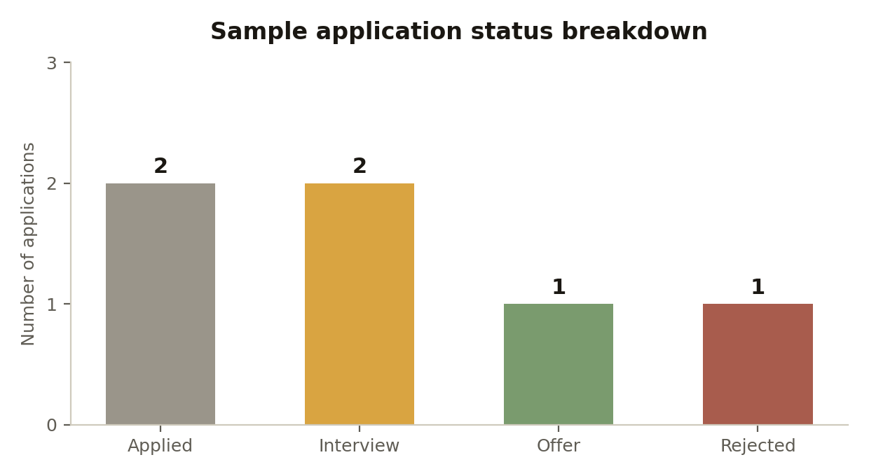
Figure 1 — Status breakdown for the sample dataset above.
The source field tells a second story: applications are spread fairly evenly across the three supported sites (two each from LinkedIn, Indeed, and Naukri) in this sample. In a real account, this is exactly the kind of pattern the dashboard's filter and search tools are built to surface — for example, noticing that interviews are disproportionately coming from one source, which is useful information for deciding where to focus more time.

4. Methodology

4.1 Development Approach
The project was built iteratively, one working piece at a time, rather than all at once. The browser extension was built first, since it is the part that actually produces the data. Once the extension could reliably detect and store applications on its own, the companion website was built to give that same data a proper home outside the browser — first as a working interface backed by local storage, and then connected to a real backend once the API existed.
This order meant every stage of the project had something real and testable behind it, instead of building three disconnected parts and hoping they would fit together at the end.

4.2 System Architecture Overview
Pursuit follows a standard client–server model. There are two clients — the browser extension and the Next.js website — and both talk to the same backend. The backend is a single Django REST API responsible for authentication and for storing and returning application records. The API is the only part of the system allowed to read or write the database directly; neither client ever touches it on its own.

4.3 Database Design
The database has two main tables. The User table holds account information (a unique ID, full name, email, and a securely hashed password) and uses email instead of a username to log in. The JobApplication table holds one row per tracked application and is linked to the User table through a foreign key, so every application always belongs to exactly one account. The entity relationship diagram below shows this structure and how the two tables connect.
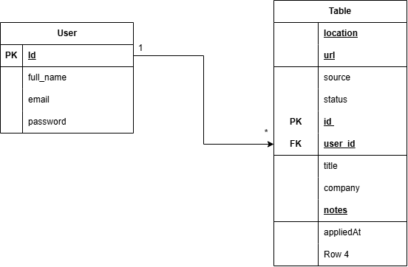
Figure 2 — Entity relationship diagram: User and JobApplication.

4.4 Backend Workflow and API Connection
The diagram below shows how a request actually travels through the system. Both clients — the extension and the website — send requests to the same Django REST API hosted on Render. The API checks each request's JWT before doing anything else, then reads from or writes to the PostgreSQL database hosted on Neon, and sends a response back.
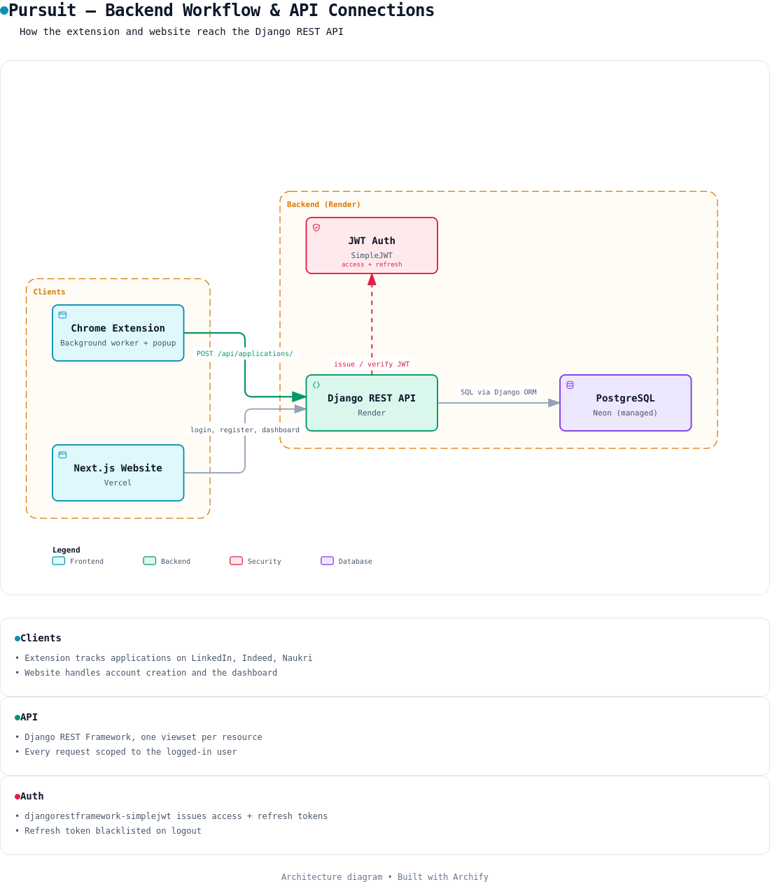
Figure 3 — Backend workflow and API connections between the extension, website, Django API, and database.
In practice, a single request follows these steps:
- The extension or website sends a request to the Django API and attaches the current JWT access token in its headers.
- Django REST Framework checks the token before the request reaches any view — if it is missing or expired, the request is rejected.
- For a valid request, the matching view runs (for example, ApplicationAPI for job applications) and only ever touches records that belong to the logged-in user.
- The view talks to PostgreSQL through Django's ORM, so no raw SQL is written by hand.
- The response is converted to camelCase JSON (via djangorestframework-camel-case) before being sent back, so the frontend and backend can use matching field names.

4.5 Extension Workflow
Inside the extension itself, a content script runs on each supported job site and watches the page for the moment an application is confirmed — for example, text like "Application sent" appearing after LinkedIn's Easy Apply flow. When that happens, the content script hands the job details to the background service worker, which is the extension's single source of truth. The background worker saves the application to the browser's local storage immediately (so it works offline), updates the toolbar badge, and then forwards the same record to the Django API if the person is logged in.

4.6 Authentication Flow
Accounts are protected using JSON Web Tokens through djangorestframework-simplejwt. When someone registers or logs in, the API returns two tokens: a short-lived access token (used on every request) and a longer-lived refresh token (used only to get a new access token once the first one expires). Logging out blacklists the refresh token on the server, so it cannot be reused even if it was somehow exposed afterward.

5. Conclusion and Result
Pursuit successfully removes the manual work from job-application tracking. The extension detects applications on LinkedIn, Indeed, and Naukri without the user doing anything extra, and the website gives that data a real home — with accounts, a working dashboard, and a status pipeline that turns a long list of applications into an at-a-glance view of a job search.

5.1 What Was Delivered
- A Manifest V3 Chrome extension that detects and logs applications automatically on three job sites, with a manual save option as a fallback.
- A popup showing live stats and recent applications, plus a full in-extension dashboard.
- A responsive Next.js website with a landing page, account creation, login, a dashboard, and a profile page — all matching the extension's visual identity, including light and dark themes.
- A Django REST API with JWT authentication (register, login, logout, change password) and full CRUD for job applications, scoped per user.
- A live PostgreSQL database (hosted on Neon) with a documented schema, and the whole backend deployed and reachable on Render.

5.2 Limitations and Future Scope
- The Analytics module exists in the backend as a placeholder app but does not yet compute or serve statistics of its own — today's stats are calculated on the frontend from the raw application list.
- Only three job sites are supported; adding a new site currently means writing a new content script by hand.
- There is currently no two-way sync — the extension pushes data to the backend, but does not yet pull existing applications back down onto a new device.
- Resume attachments, reminders, and interview scheduling are natural next features that build on the data already being collected.

Application Screenshots — Browser Extension
Paste screenshots of the popup and in-extension dashboard below.

Application Screenshots — Website
Paste screenshots of the landing page, login/signup, dashboard, and profile pages below.

References
- Project repository — github.com/bilalpatel813/extension-v1.o
- Live website — pursuit-sandy-three.vercel.app
- Django REST Framework documentation — django-rest-framework.org
- djangorestframework-simplejwt documentation — github.com/jazzband/djangorestframework-simplejwt
- Next.js documentation — nextjs.org/docs
- Neon (managed PostgreSQL) — neon.tech

