Lab 1 - Getting Started with RISC-V (Assembly Language) in VS Code

Name:M.BilalRehan | Student ID:11065

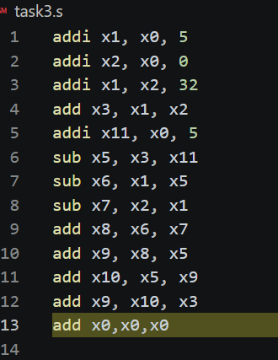
Task 3:

Code:
addi x1, x0, 5
addi x2, x0, 0
addi x1, x2, 32
add x3, x1, x2
addi x11, x0, 5
sub x5, x3, x11
sub x6, x1, x5
sub x7, x2, x1
add x8, x6, x7
add x9, x8, x5
add x10, x5, x9
add x9, x10, x3

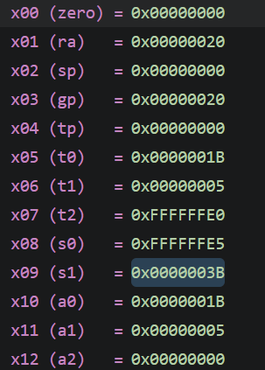
Results:

Task 4a:
- Store x10 as unsigned integer at address 0x100.
li x5, 0x100
sw x10, 0(x5)

- Store x11 as unsigned integer at address 0x1F0.
li x5, 0x1F0
sw x11, 0(x5)

- Load an unsigned short integer (two bytes) from address 0x100 in x12.
li x5, 0x100
lhu x12, 0(x5)

- Load a short integer from address 0x1F0 in register x13.
li x5, 0x1F0
lh x13, 0(x5)

- Load a singed character from address 0x1F0 in register x14.
li x5, 0x1F0
lb x14, 0(x5)

Task 4b:

Code:
li x5, 0x100 #a
li x6, 0x200 #b
li x7, 0x300 #c

lb x10, 0(x5)
lh x11, 0(x6)
add x12, x10, x11
sw x12, 0(x7)

lb x10, 1(x5)
lh x11, 2(x6)
add x12, x10, x11
sw x12, 4(x7)

lb x10, 2(x5)
lh x11, 4(x6)
add x12, x10, x11
sw x12, 8(x7)

lb x10, 3(x5)
lh x11, 6(x6)
add x12, x10, x11
sw x12, 12(x7)

Results:
• Base Addresses: Immediate values 0x100, 0x200, and 0x300 are loaded into base address registers using the li instruction.
• Data Types and Memory Offsets:
- Array a (char, 1 byte): Loaded using lb (load byte, sign-extended). Offsets increment by 1 byte per element (0, 1, 2, 3).
- Array b (short, 2 bytes): Loaded using lh (load halfword, sign-extended). Offsets increment by 2 bytes per element (0, 2, 4, 6).
- Array c (unsigned int, 4 bytes): Stored using sw (store word). Offsets increment by 4 bytes per element (0, 4, 8, 12).
• Execution Flow: For each index i from 0 to 3, a[i] and b[i] are loaded using displacement addressing, added together with add, and saved to c[i] at its calculated 4-byte offset.

Assessment Rubric
Lab 1: Getting Started with RISC-V (Assembly Language) n VS Code

Name M.BilalRehan | Student ID:11065 | Section:

Points Distribution:

 | Task No. | LR 2 (Code) | LR 5 (Results)
In-Lab | Task 1 | - | /15
 | Task 2 | - | /15
 | Task 3 | /10 | /5
 | Task 4a | /10 | /5
 | Task 4b | /10 | /10
Total Points: 100 |  | /30 | /50
CLO Mapped |  | CLO 2

Affective Domain Rubric |  | Points | CLO Mapped
AR7 | Report Submission & Git Upload | /10 & /10 | CLO 2

CLO | Total Points | Points Obtained
2 | 100
Total | 100

