EBS Encryption:
- Enable encryption as it has very little impact on latency.
- Snapshot of unencrypted volume -> unencrypted snapshot
- copy of unencrypted snapshot can be encrypted.
- volume created from encrypted snapshot is encrypted.
I won’t talk about this below so remember and do it!!!
EBS Volume:
- Drive connected over the network
- Can be connected to 16 instances at once but all instances have to be in the same availability zone, multi – attach depends on the volume you choose.
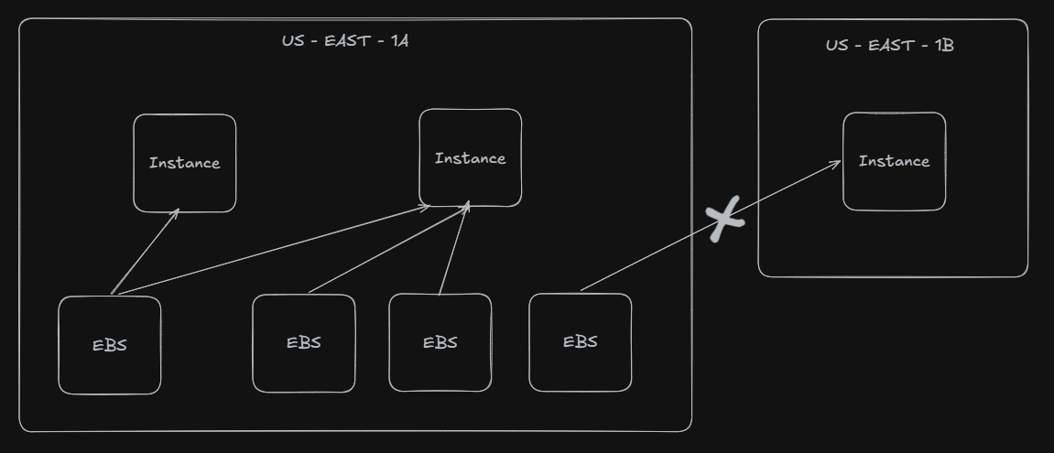
- By default, root EBS volume is deleted when instance terminates.
- By default, any other attached EBS volume is not deleted.
Select your instance -> networking, and identify the availability zone:
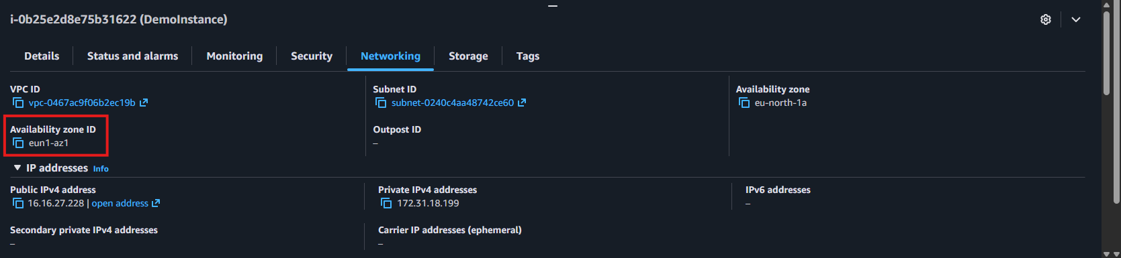
Head over to Volumes -> enter your desired configurations, and make sure to select the AZ you saw in Networking:
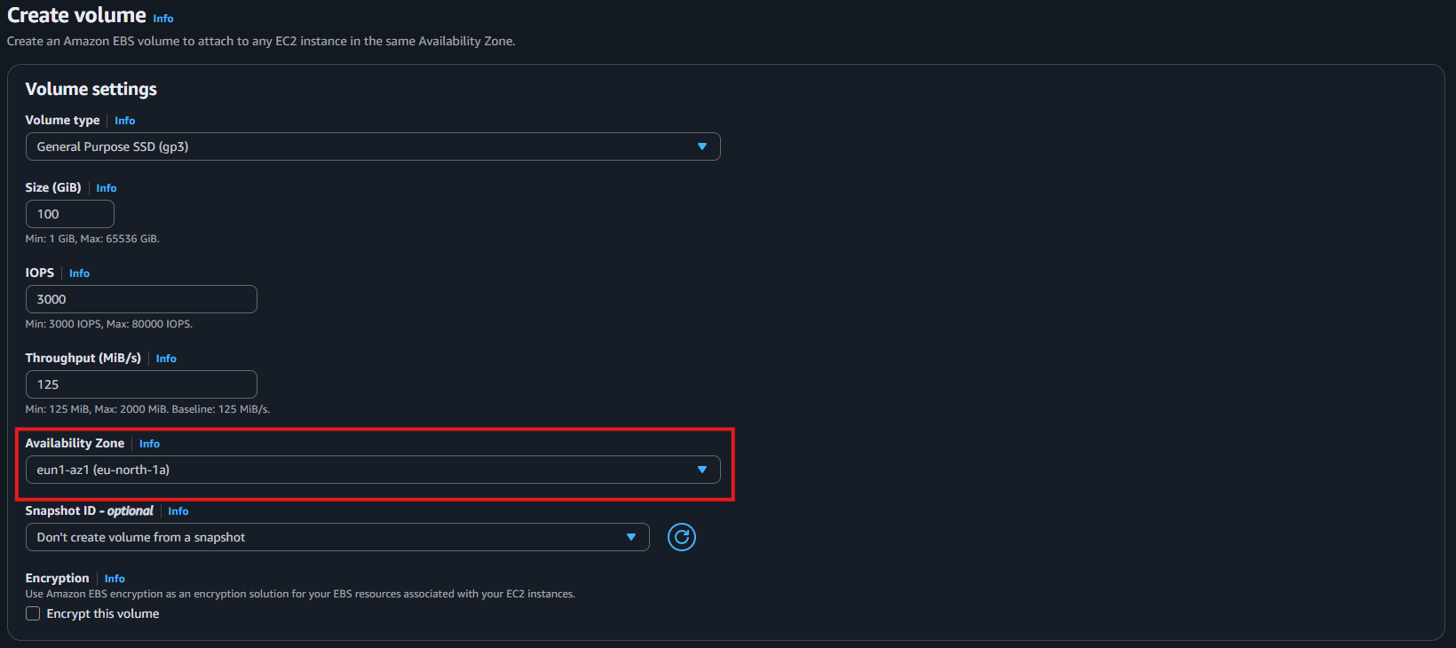
And hit “Create Volume”.
Select your newly created volume -> Actions -> Attach volume
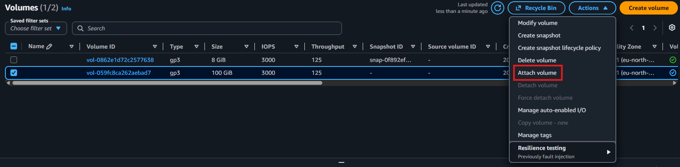
Select your Instance -> Attach Volume:
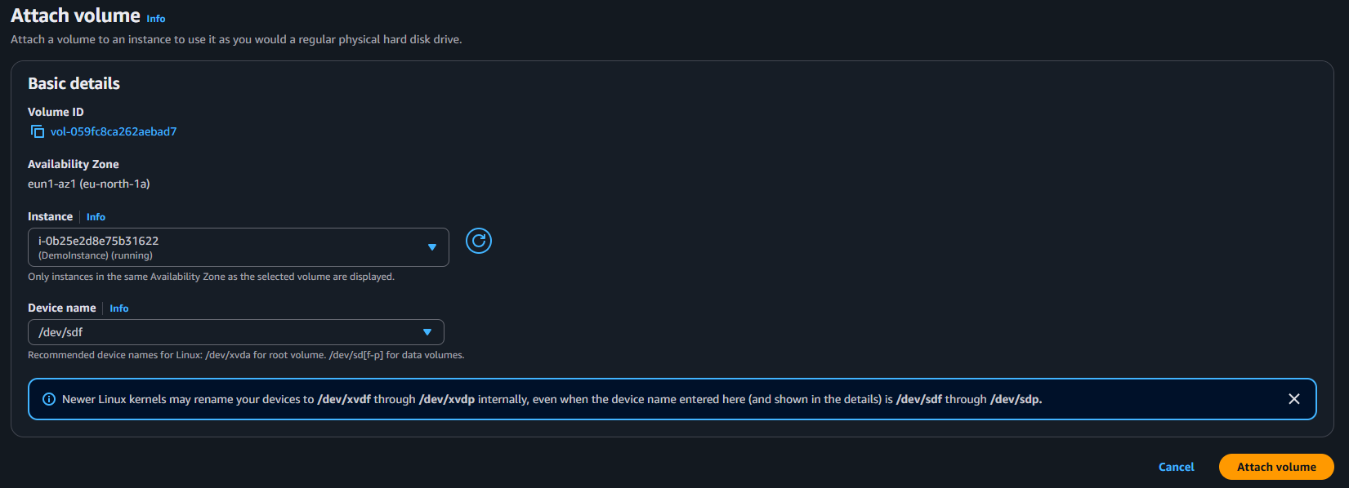
Head over to your instance -> Storage, it should be attached here:
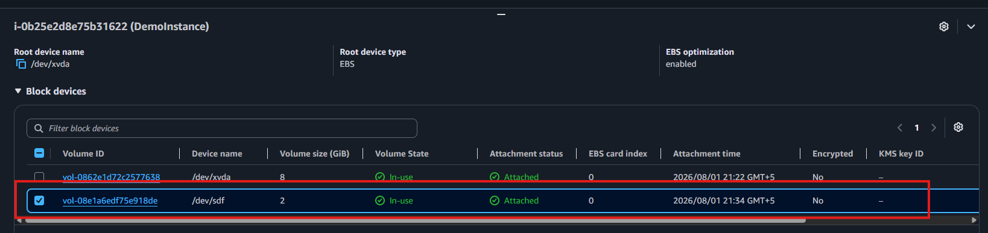
EBS Volume Types:
1. General Purpose SSD (1 TB – 16 TB):
- gp3:
- base: 3000 IOPS and throughput of 125 MB/s
- max: 16000 IOPS and throughput up to 1000 MB/s independently.
- gp2:
- AWS calculates your baseline IOPS based on the volume size.
- Baseline IOPS = 3 IOPS per GiB
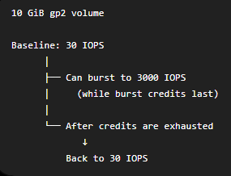
- Throughput cannot be configured independently and depends on IOPS and Volume size
- max: 5334 GB, 250 MB/s throughput and 16000 IOPS

2. Provisioned IOPS SSD:
- only to one supports EBS Multi-attach
- for extremely heavy workloads e.g. database workloads
- io 1 (4 GB – 16 TB):
- max: 64000 PIOPS for Nitro EC2 instances & 32000 for other
- PIOPS independent from storage size.
- io 2 (4 GB – 64 TB):
- sub-millisecond latency
- max: 256,000 PIOPS, 1000 IOPS for every 1 GB.
3. Hard Disk Drives (HDD) – (125 GB – 16 TB):
- intended for data storage, not operating system disks, so that is why they can’t be boot
volumes.
- st 1:
- Big Data, Data Warehouses, Log Processing
- max: 500 MB/s, 500 IOPS
- sc 1:
- For data that is infrequently accessed
- Scenarios where lowest cost is important
- max: 250 MB/s, IOPS 250

EBS Snapshot:
- You can copy snapshots across AZ or region
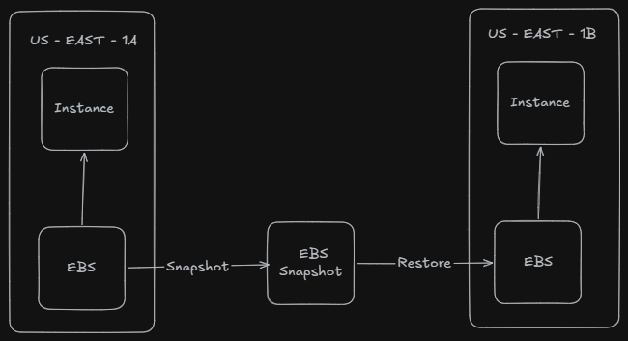
- If you store snapshot in EBS snapshot archive:
  - 75% cheaper
  - Takes within 24 – 72 hours for restoring the archive
- You can quickly restore it using FSR but costs a lot of money.
- Default:
  - delete snapshot -> permanently deleted,
- If you set up Recycle Bin:
  - delete snapshot -> stored in recycle bin for some time, and you can recover it before it deletes permanently after some time.

AMI:
- Our own customized EC2 instance,
- Built for a specific region (and can be copied across regions)
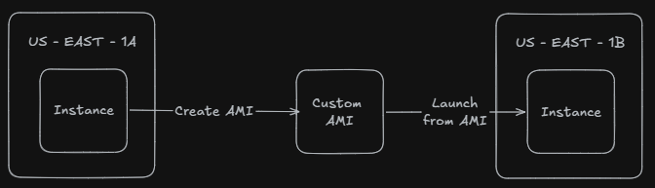
EC2 Instance Store:
- High-performance hardware disk
- Better I/O performance
- When you terminate or stop your EC2 instance connected to EC2 Instance store, data in instance store is lost. (Ephemeral storage)
- Used to mainly store buffer / cache / scratch data / temporary content.
- Site down – > Disk down
- Backups are a MUST!

Amazon EFS:
- Managed network file system.
- Can be connected to many EC2 instances present in different availability zones
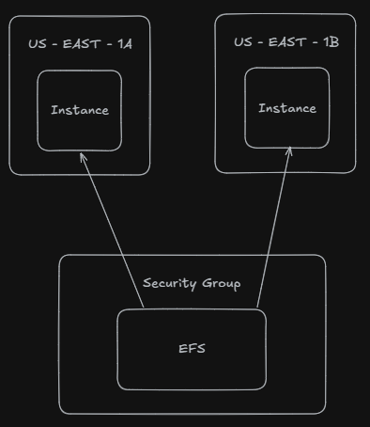
- Highly available, auto-scalable, expensive (3x gp2), pay per use.
- Available for only Linux based AMI.

