Untitled

Klea Kojku, Sureya Ahmed, Bilal Shahid

2024-12-09

install.packages(“survminer”)

library(ggplot2)  
library(dplyr)

##   
## Attaching package: 'dplyr'

## The following objects are masked from 'package:stats':  
##   
## filter, lag

## The following objects are masked from 'package:base':  
##   
## intersect, setdiff, setequal, union

library(survival)  
library(survminer)

## Loading required package: ggpubr

##   
## Attaching package: 'survminer'

## The following object is masked from 'package:survival':  
##   
## myeloma

library(car)

## Loading required package: carData

##   
## Attaching package: 'car'

## The following object is masked from 'package:dplyr':  
##   
## recode

library(MASS)

##   
## Attaching package: 'MASS'

## The following object is masked from 'package:dplyr':  
##   
## select

library(tidyr)  
library(car)  
library(readxl)

ba2020 <- read_xlsx("breast_alpelisib_2020_cleaned.xlsx")

# Distribution of Alpelisib Dose

ggplot(ba2020, aes(x = factor(alpelisib_dose_mg))) +  
  
geom_bar(fill = "steelblue") +  
  
labs(title = "Distribution of Alpelisib Dose", x = "Dose (mg)", y = "Count")

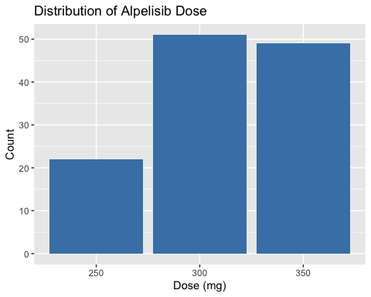 # Distribution of Alpelisib Scheduling

ggplot(ba2020, aes(x = factor(alpelisib_scheduling))) +  
  
geom_bar(fill = "coral") +  
  
labs(title = "Distribution of Alpelisib Scheduling", x = "Scheduling Type", y = "Count")

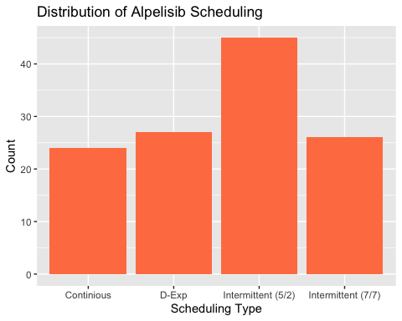

# Distribution of Endocrine Therapy

ggplot(ba2020, aes(x = factor(endocrine_therapy))) +  
  
geom_bar(fill = "purple") +  
  
labs(title = "Distribution of Endocrine Therapy", x = "Therapy Type", y = "Count")

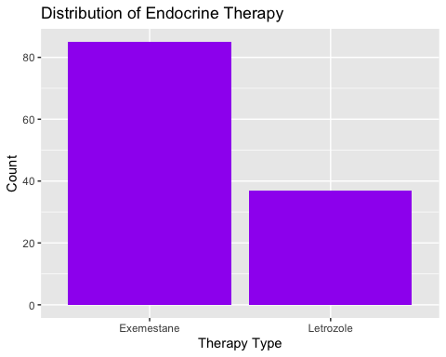

# Distribution of Clinical Benefit

ggplot(ba2020, aes(x = factor(clinical_benefit))) +  
  
geom_bar(fill = "green") +  
  
labs(title = "Distribution of Clinical Benefit", x = "Clinical Benefit (Yes/No)", y = "Count")

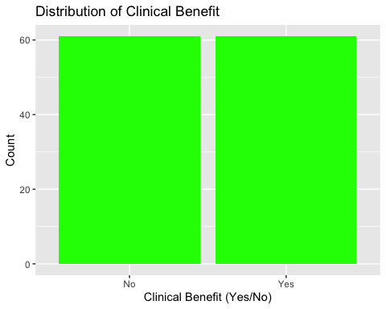

# Distribution of Treatment Best Response

ggplot(ba2020, aes(x = factor(treatment_best_response))) +  
  
geom_bar(fill = "orange") +  
  
labs(title = "Distribution of Treatment Best Response", x = "Response", y = "Count")

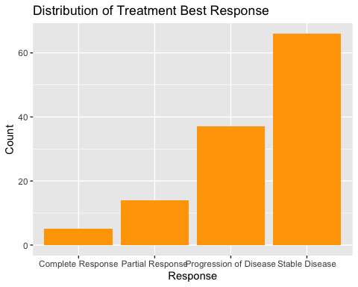

# Distribution of Weeks on Study

ggplot(ba2020, aes(x = weeks_on_study)) +  
  
geom_histogram(fill = "blue", bins = 30, color = "black") +  
  
labs(title = "Distribution of Weeks on Study", x = "Weeks", y = "Frequency")

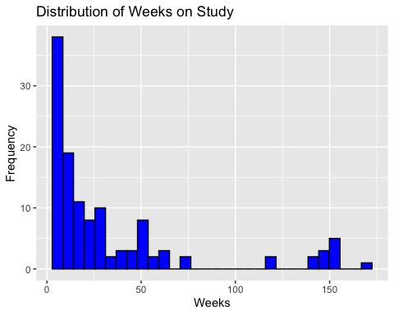

# Distribution of Mutation Count

ggplot(ba2020, aes(x = mutation_count)) +  
  
geom_histogram(fill = "skyblue", bins = 30, color = "black") +  
  
labs(title = "Distribution of Mutation Count", x = "Mutation Count", y = "Frequency")

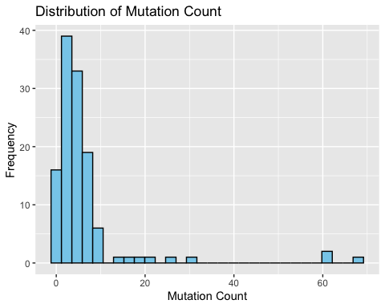

# Descriptive Statistics for Weeks on Study

outcome_summary <- ba2020 %>%  
  
summarise(  
  
weeks_on_study_mean = mean(weeks_on_study, na.rm = TRUE),  
  
weeks_on_study_median = median(weeks_on_study, na.rm = TRUE),  
  
weeks_on_study_sd = sd(weeks_on_study, na.rm = TRUE),  
  
weeks_on_study_min = min(weeks_on_study, na.rm = TRUE),  
  
weeks_on_study_max = max(weeks_on_study, na.rm = TRUE),  
  
weeks_on_study_iqr = IQR(weeks_on_study, na.rm = TRUE)  
  
)  
  
print(outcome_summary)

## # A tibble: 1 × 6  
## weeks_on_study_mean weeks_on_study_median weeks_on_study_sd weeks_on_study_min  
## <dbl> <dbl> <dbl> <dbl>  
## 1 34.3 16 41.9 5  
## # ℹ 2 more variables: weeks_on_study_max <dbl>, weeks_on_study_iqr <dbl>

# Descriptive Statistics for Mutation Count

covariates_summary <- ba2020 %>%  
  
summarise(  
  
mutation_count_mean = mean(mutation_count, na.rm = TRUE),  
  
mutation_count_median = median(mutation_count, na.rm = TRUE),  
  
mutation_count_sd = sd(mutation_count, na.rm = TRUE),  
  
mutation_count_min = min(mutation_count, na.rm = TRUE),  
  
mutation_count_max = max(mutation_count, na.rm = TRUE),  
  
mutation_count_iqr = IQR(mutation_count, na.rm = TRUE)  
  
)  
  
print(covariates_summary)

## # A tibble: 1 × 6  
## mutation_count_mean mutation_count_median mutation_count_sd mutation_count_min  
## <dbl> <dbl> <dbl> <dbl>  
## 1 6.18 4 10.1 1  
## # ℹ 2 more variables: mutation_count_max <dbl>, mutation_count_iqr <dbl>

# Create a contingency table  
  
endocrine_response_table <- table(ba2020$endocrine_therapy, ba2020$treatment_best_response)  
  
  
# Perform Chi-square test  
  
chi_square_test <- chisq.test(endocrine_response_table)

## Warning in chisq.test(endocrine_response_table): Chi-squared approximation may  
## be incorrect

# If expected frequencies are too low, perform Fisher’s exact test  
  
if (any(chi_square_test$expected < 5)) {  
  
fisher_test <- fisher.test(endocrine_response_table)  
  
print("Fisher's Exact Test Results:")  
  
print(fisher_test)  
  
} else {  
  
print("Chi-Square Test Results:")  
  
print(chi_square_test)  
  
}

## [1] "Fisher's Exact Test Results:"  
##   
## Fisher's Exact Test for Count Data  
##   
## data: endocrine_response_table  
## p-value = 0.4151  
## alternative hypothesis: two.sided

t_test_result <- t.test(weeks_on_study ~ endocrine_therapy, data = ba2020, var.equal = TRUE)  
  
print(t_test_result)

##   
## Two Sample t-test  
##   
## data: weeks_on_study by endocrine_therapy  
## t = 0.54133, df = 120, p-value = 0.5893  
## alternative hypothesis: true difference in means between group Exemestane and group Letrozole is not equal to 0  
## 95 percent confidence interval:  
## -11.90952 20.87232  
## sample estimates:  
## mean in group Exemestane mean in group Letrozole   
## 35.67059 31.18919

anova_result <- aov(weeks_on_study ~ factor(endocrine_therapy), data = ba2020)  
  
print("ANOVA Results:")

## [1] "ANOVA Results:"

summary(anova_result)

## Df Sum Sq Mean Sq F value Pr(>F)  
## factor(endocrine_therapy) 1 518 517.7 0.293 0.589  
## Residuals 120 212006 1766.7

ba2020$clinical_benefit1 <- ifelse(ba2020$clinical_benefit == "Yes", 1, 0)  
  
  
# Convert alpelisib_dose_mg to numeric (250 = 1, 300 = 2, 350 = 3)  
  
ba2020$alpelisib_dose_mg1 <- ifelse(ba2020$alpelisib_dose_mg == 250, 1,  
  
ifelse(ba2020$alpelisib_dose_mg == 300, 2, 3))  
  
  
ba2020$alpelisib_scheduling1<-ifelse(ba2020$alpelisib_scheduling == "Intermittent (5/2)", 1,  
  
ifelse (ba2020$alpelisib_scheduling == "Intermittent (7/7)", 2,  
  
ifelse (ba2020$alpelisib_scheduling == "Continious", 3,  
  
ifelse (ba2020$alpelisib_scheduling == "D-Exp", 4,0  
  
))))  
  
  
# Convert endocrine_therapy to numeric ("Letrozole" = 1, "Exemestane" = 2)  
  
  
ba2020$endocrine_therapy1 <- ifelse(ba2020$endocrine_therapy == "Letrozole", 1, 2)  
  
  
print(ba2020)

## # A tibble: 122 × 30  
## patient_id alpelisib_dose_mg alpelisib_scheduling breast_cancer_subtype  
## <chr> <dbl> <chr> <chr>   
## 1 P-0000129 250 Continious HR+/HER2-   
## 2 P-0000138 300 Continious HR+/HER2-   
## 3 P-0000204 300 Intermittent (5/2) HR+/HER2-   
## 4 P-0000216 300 Intermittent (7/7) HR+/HER2-   
## 5 P-0000234 300 Intermittent (5/2) HR+/HER2-   
## 6 P-0000247 350 D-Exp HR+/HER2-   
## 7 P-0000414 250 Continious HR+/HER2-   
## 8 P-0000422 300 Intermittent (5/2) HR+/HER2-   
## 9 P-0000514 350 D-Exp HR+/HER2-   
## 10 P-0000624 300 Intermittent (7/7) HR+/HER2-   
## # ℹ 112 more rows  
## # ℹ 26 more variables: cancer_type <chr>, cancer_type_detailed <chr>,  
## # clinical_benefit <chr>, endocrine_therapy <chr>,  
## # fraction_genome_altered <chr>, measurable_disease <chr>,  
## # mutation_count <dbl>, off_study_reason <chr>, oncotree_code <chr>,  
## # pik3ca_tumor_mutation <chr>, `PIK3CA Pre Treatment Tumor` <chr>,  
## # best_recist_response <chr>, sample_class <chr>, …

#3. Multiple Linear Regression Model (MLRM) # Fit the initial full model

full_model <- lm(weeks_on_study ~ alpelisib_dose_mg + alpelisib_scheduling + endocrine_therapy +  
 mutation_count, data = ba2020)  
summary(full_model)

##   
## Call:  
## lm(formula = weeks_on_study ~ alpelisib_dose_mg + alpelisib_scheduling +   
## endocrine_therapy + mutation_count, data = ba2020)  
##   
## Residuals:  
## Min 1Q Median 3Q Max   
## -55.371 -19.776 -9.968 10.423 117.471   
##   
## Coefficients:  
## Estimate Std. Error t value Pr(>|t|)   
## (Intercept) -96.1144 40.7822 -2.357 0.02013 *   
## alpelisib_dose_mg 0.3779 0.1307 2.890 0.00460 **  
## alpelisib_schedulingD-Exp -8.8190 14.6070 -0.604 0.54720   
## alpelisib_schedulingIntermittent (5/2) 27.1233 12.3119 2.203 0.02959 *   
## alpelisib_schedulingIntermittent (7/7) -41.3735 14.0345 -2.948 0.00387 **  
## endocrine_therapyLetrozole 54.1457 16.4132 3.299 0.00129 **  
## mutation_count -0.4497 0.3592 -1.252 0.21309   
## ---  
## Signif. codes: 0 '***' 0.001 '**' 0.01 '*' 0.05 '.' 0.1 ' ' 1  
##   
## Residual standard error: 38.64 on 115 degrees of freedom  
## Multiple R-squared: 0.1922, Adjusted R-squared: 0.15   
## F-statistic: 4.56 on 6 and 115 DF, p-value: 0.0003475

# Perform backward elimination

library(MASS)  
final_model <- stepAIC(full_model, direction = "backward")

## Start: AIC=898.42  
## weeks_on_study ~ alpelisib_dose_mg + alpelisib_scheduling + endocrine_therapy +   
## mutation_count  
##   
## Df Sum of Sq RSS AIC  
## - mutation_count 1 2340 174023 898.08  
## <none> 171683 898.42  
## - alpelisib_dose_mg 1 12472 184154 904.98  
## - endocrine_therapy 1 16247 187930 907.46  
## - alpelisib_scheduling 3 33085 204768 913.92  
##   
## Step: AIC=898.08  
## weeks_on_study ~ alpelisib_dose_mg + alpelisib_scheduling + endocrine_therapy  
##   
## Df Sum of Sq RSS AIC  
## <none> 174023 898.08  
## - alpelisib_dose_mg 1 13251 187274 905.03  
## - endocrine_therapy 1 14772 188795 906.02  
## - alpelisib_scheduling 3 33192 207215 913.37

# View the final model  
summary(final_model)

##   
## Call:  
## lm(formula = weeks_on_study ~ alpelisib_dose_mg + alpelisib_scheduling +   
## endocrine_therapy, data = ba2020)  
##   
## Residuals:  
## Min 1Q Median 3Q Max   
## -54.775 -18.001 -10.963 9.432 122.015   
##   
## Coefficients:  
## Estimate Std. Error t value Pr(>|t|)   
## (Intercept) -101.2175 40.6771 -2.488 0.01426 *   
## alpelisib_dose_mg 0.3887 0.1308 2.972 0.00360 **  
## alpelisib_schedulingD-Exp -9.8553 14.6191 -0.674 0.50156   
## alpelisib_schedulingIntermittent (5/2) 26.9568 12.3412 2.184 0.03095 *   
## alpelisib_schedulingIntermittent (7/7) -40.4170 14.0479 -2.877 0.00478 **  
## endocrine_therapyLetrozole 51.0338 16.2635 3.138 0.00216 **  
## ---  
## Signif. codes: 0 '***' 0.001 '**' 0.01 '*' 0.05 '.' 0.1 ' ' 1  
##   
## Residual standard error: 38.73 on 116 degrees of freedom  
## Multiple R-squared: 0.1812, Adjusted R-squared: 0.1459   
## F-statistic: 5.133 on 5 and 116 DF, p-value: 0.0002734

#Model Diagnostics # Check normality of residuals

qqnorm(residuals(final_model))  
qqline(residuals(final_model), col = "red")

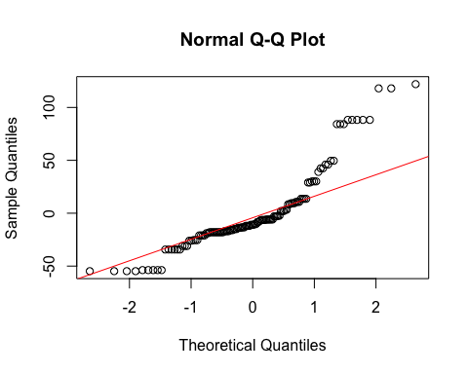

# Check homoscedasticity  
plot(fitted(final_model), residuals(final_model),  
 xlab = "Fitted Values",  
 ylab = "Residuals",  
 main = "Residuals vs Fitted Values")  
abline(h = 0, col = "red")

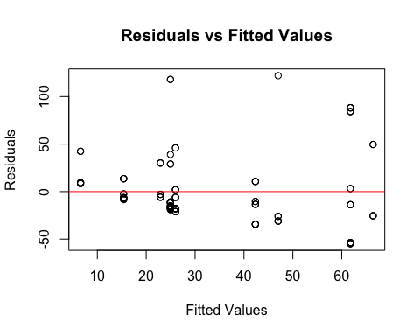

# Check for multicollinearity using VIF

vif_values <- vif(final_model)  
print(vif_values)

## GVIF Df GVIF^(1/(2*Df))  
## alpelisib_dose_mg 1.853233 1 1.361335  
## alpelisib_scheduling 5.870522 3 1.343114  
## endocrine_therapy 4.545083 1 2.131920

# Adjusted R-squared

cat("Adjusted R-squared:", summary(final_model)$adj.r.squared, "\n")

## Adjusted R-squared: 0.1458669

# Akaike Information Criterion (AIC)  
cat("AIC:", AIC(final_model), "\n")

## AIC: 1246.297