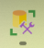
Step 1 – create database and table in SQL Server Management Studio
Step 1.1 : open sql server management studio
Step 1.2 :- Go to the downloaded project folder where you will find the SQL script file.
Right-click the script file → Open With → choose any text editor.
Step 1.3 : - Copy all the script from that file.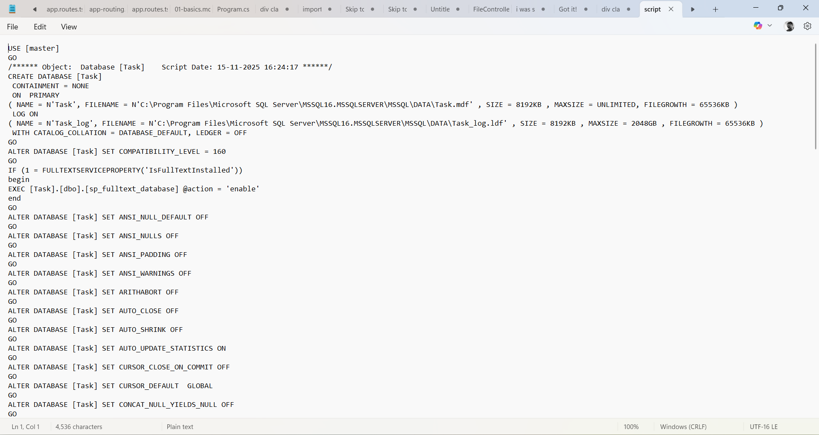
Step 1.4 :- Open SQL Server Management Studio, click New Query, and paste the copied script there.
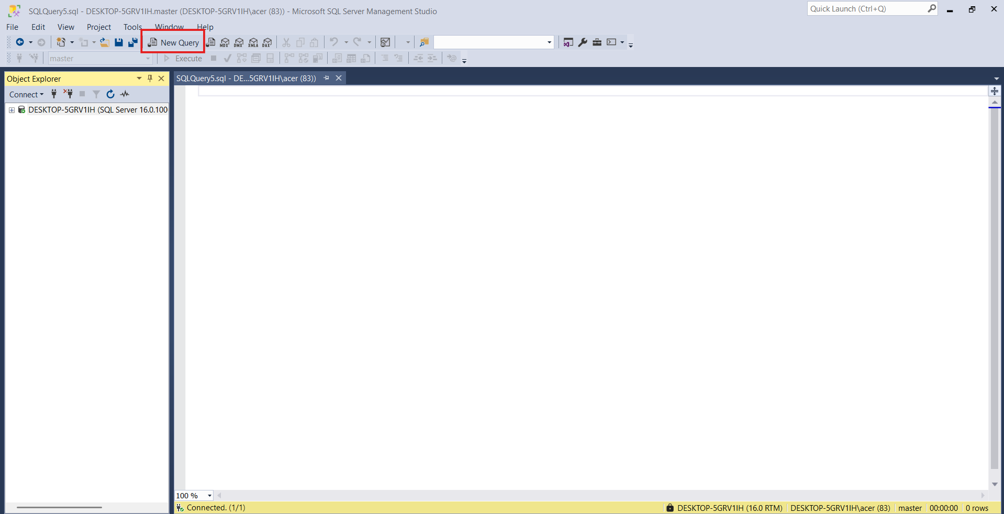
Paste all copied script (follow below image )
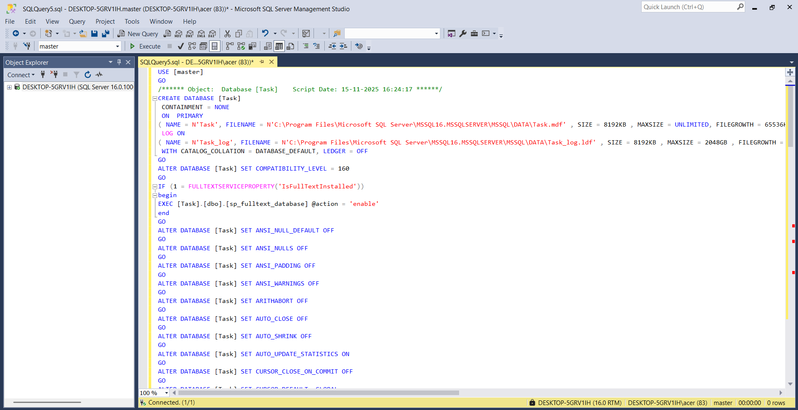

Step 1.5 :- Click Execute, then Refresh the database view.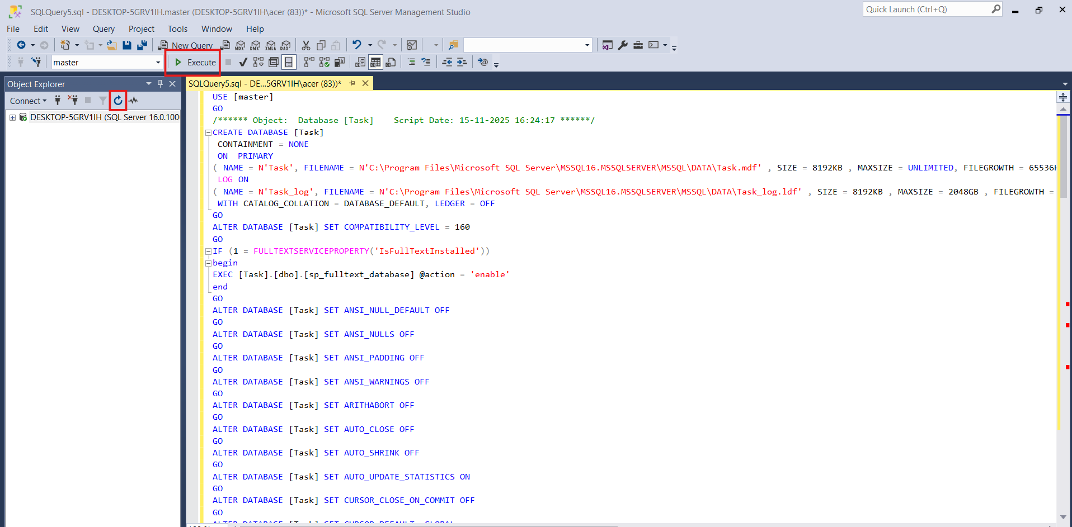
Step 1.6 :- finally Your database and tables are now created successfully.
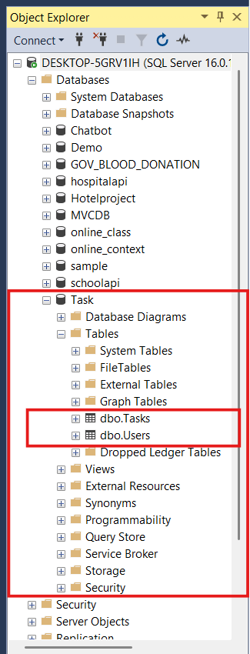

Step 2 : let’s run .net web API (backend)
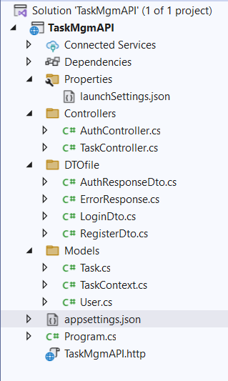
File structure :-

Step 2.1 :- Run the following command in the Package Manager Console:
Scaffold-DbContext "Server=DESKTOP-5GRV1IH;Database=Task;Trusted_Connection=True;TrustServerCertificate=True;" Microsoft.EntityFrameworkCore.SqlServer -OutputDir Models -force
Notes : Change the value of Server=... according to your own SQL Server name.
Step 2.2: - Open appsettings.json and update the database configuration, for example:
Like this _ >
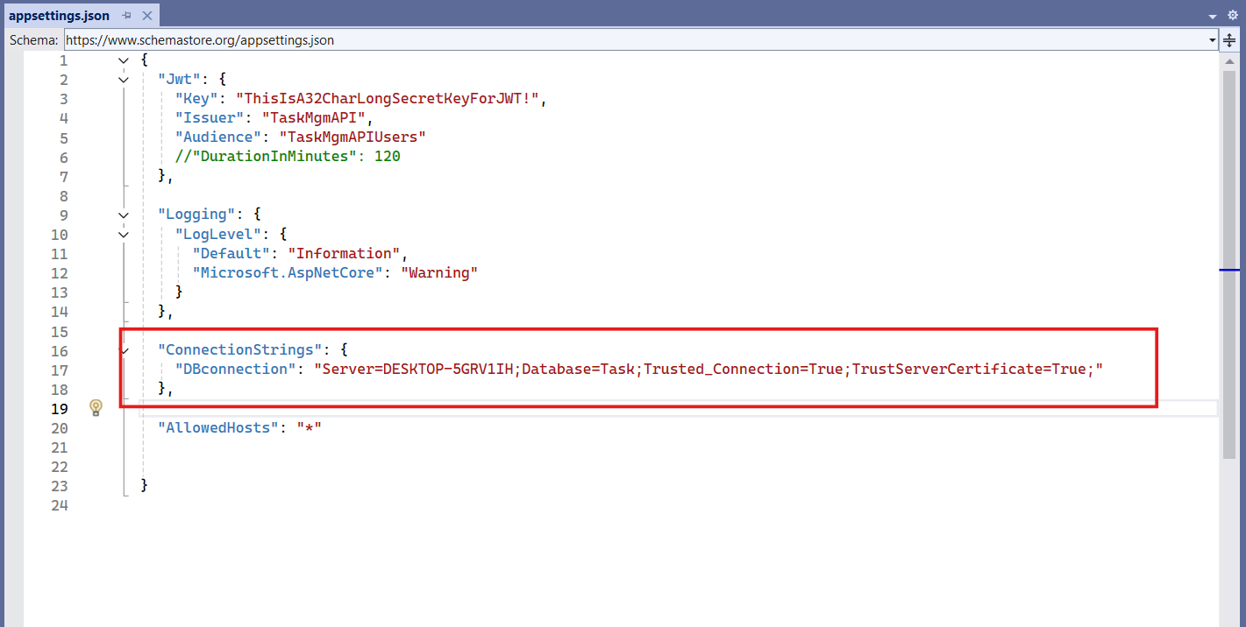

Step 2.3 Run your .NET application.
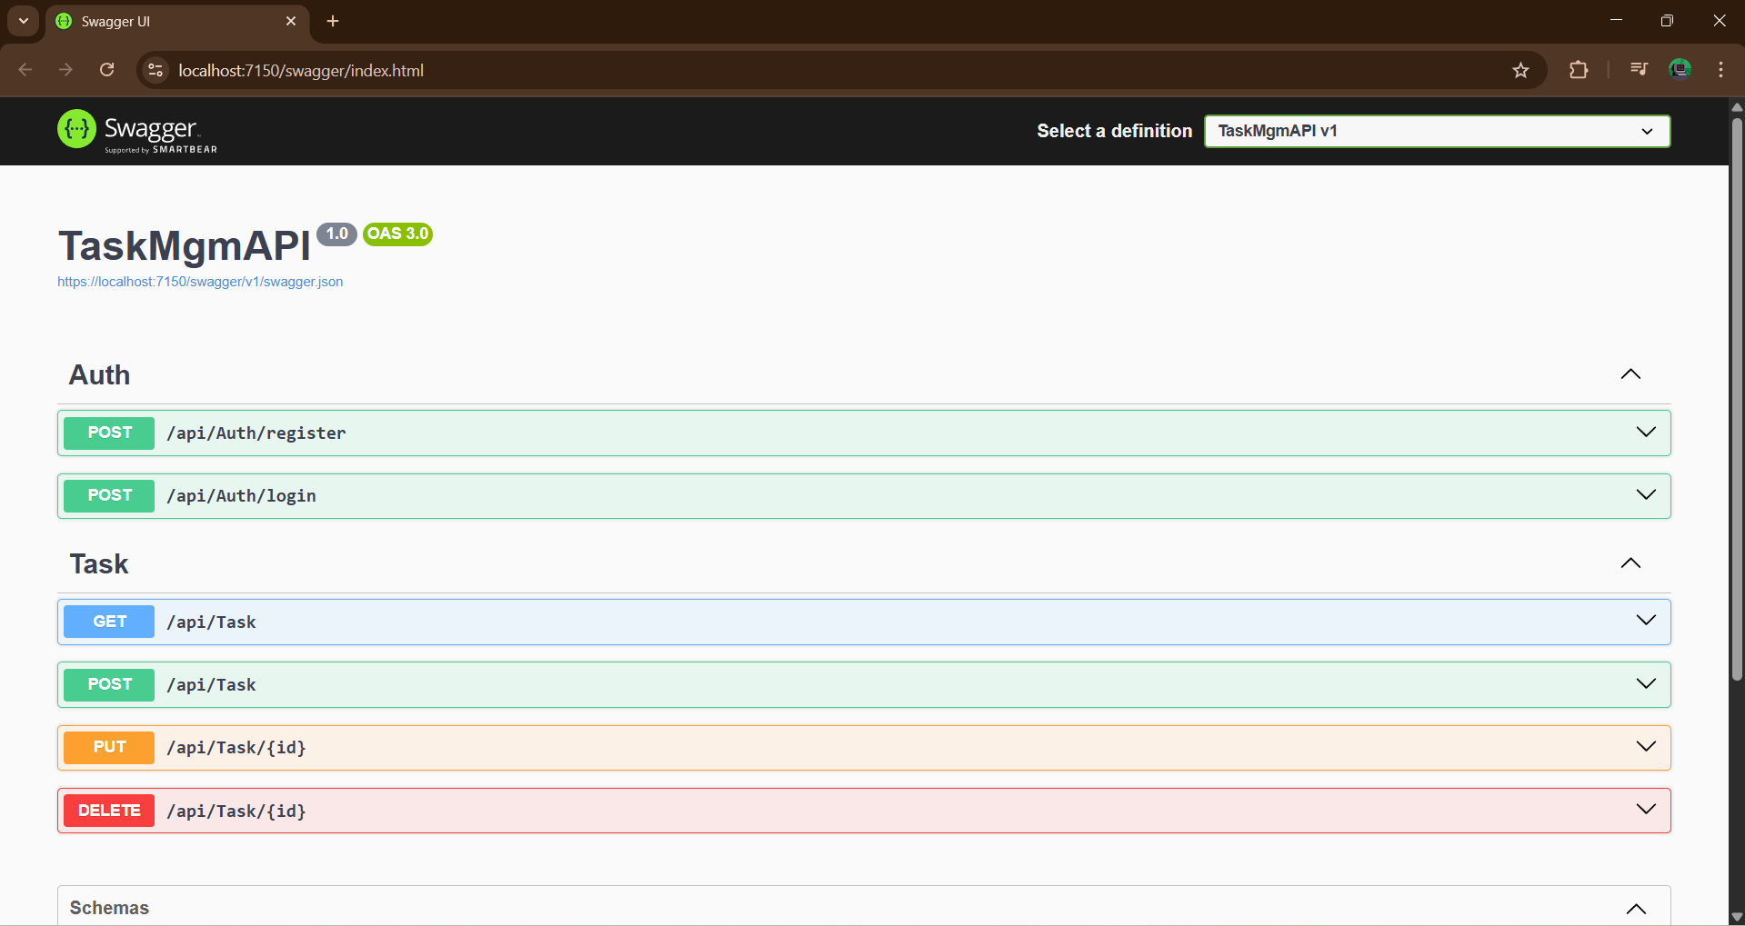

Step 3 : - Run Angular application (frontend)

Angular CLI :- (List the versions I used here)
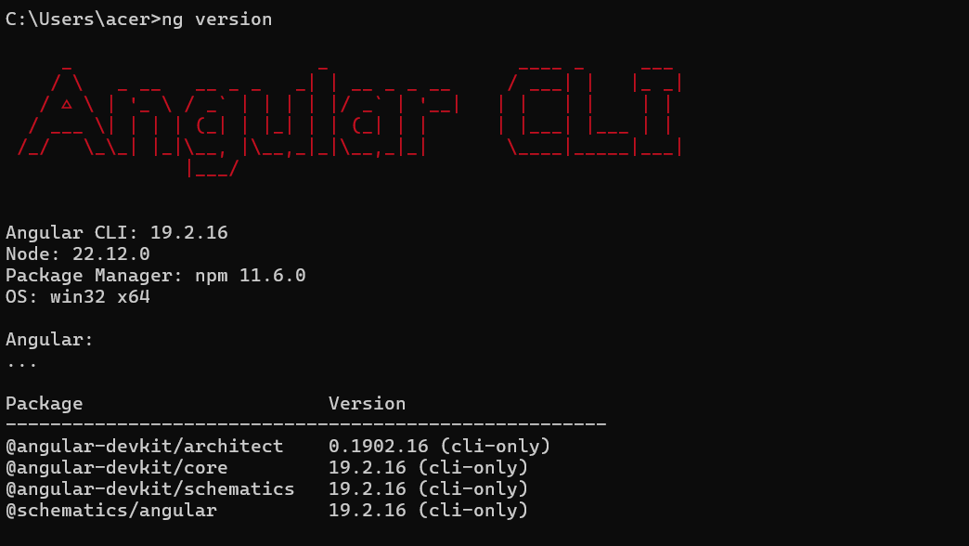
These version I use in Task

Step 3.1 : - Navigate to your Angular project directory:
D:\task\TaskMgmFrontend\task-frontend>
Step 3.2 :- Install dependencies:
D:\task\TaskMgmFrontend\task-frontend> npm install
Step 3.4 :- Run the Angular application:
D:\task\TaskMgmFrontend\task-frontend> ng serve --o

Note:
Ensure your API base URL is correct inside the Angular service file (if required).

Testing the Application

Test Via UI

When you run the project, the first screen should look similar to the example shown.

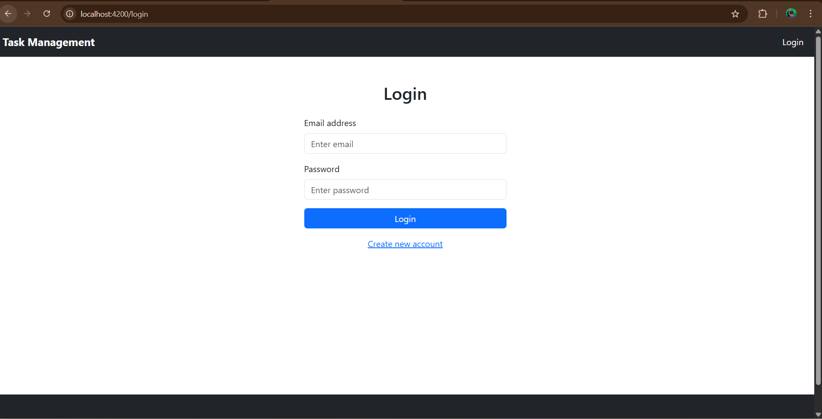

First you have to do registration first (click on create new account link)
- Registration
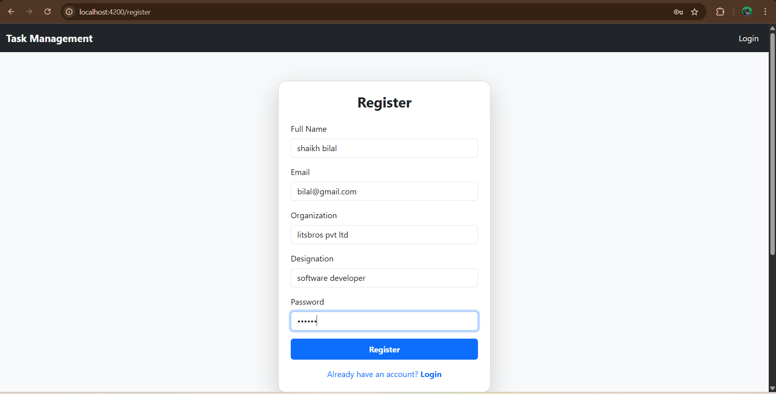
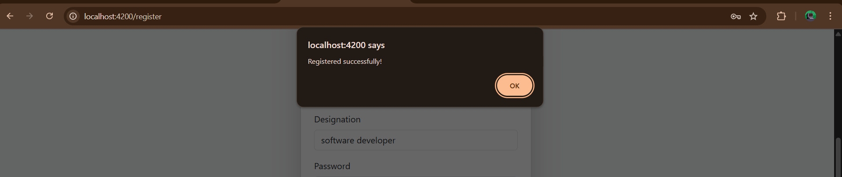

- Log in :- Enter your credentials and log in.
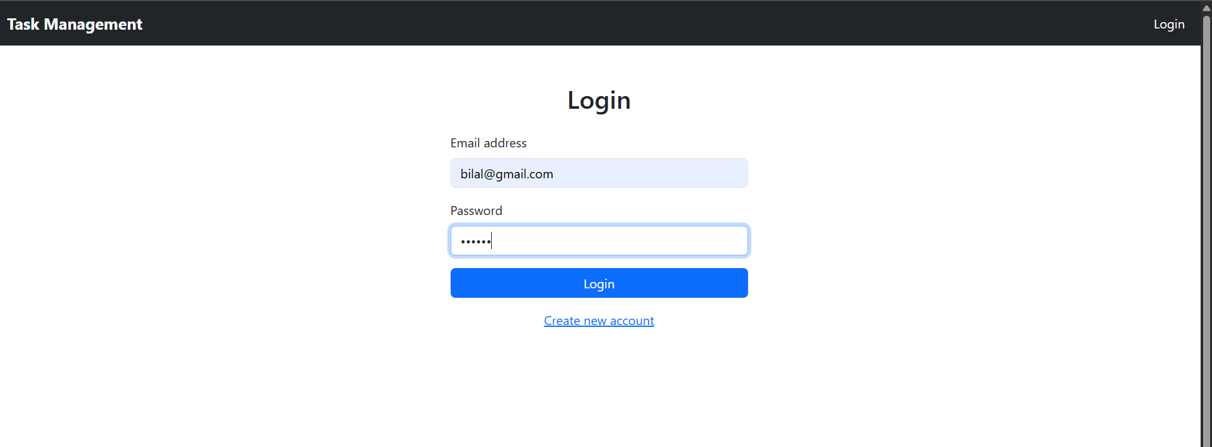
- Add a new task (Click Add Tasks, fill out the form, and submit. )
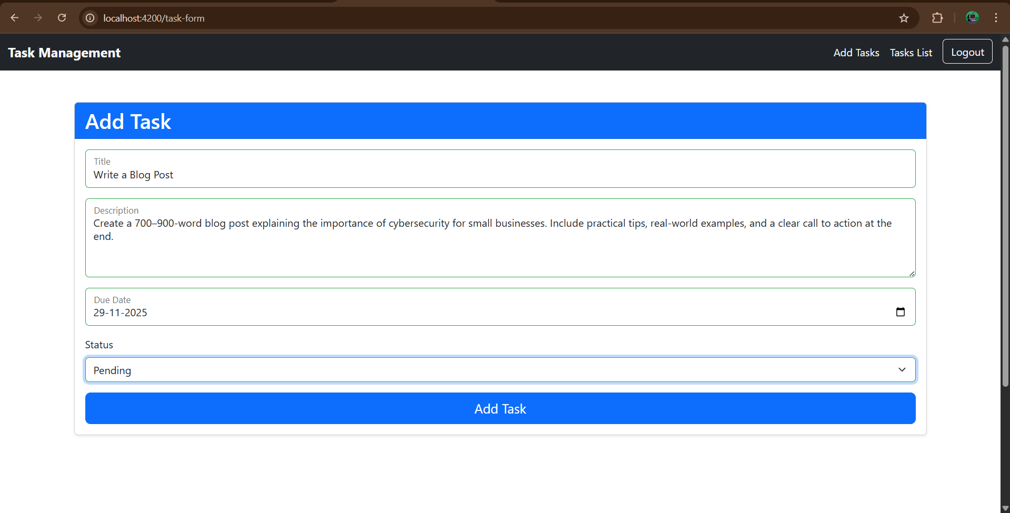
A success message will appear.
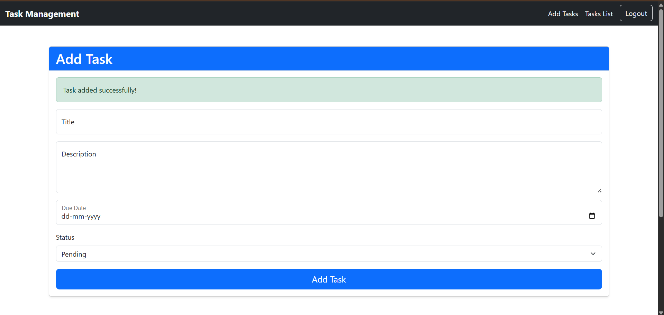
- Check add task (Click Tasks List to verify that the task has been added.)
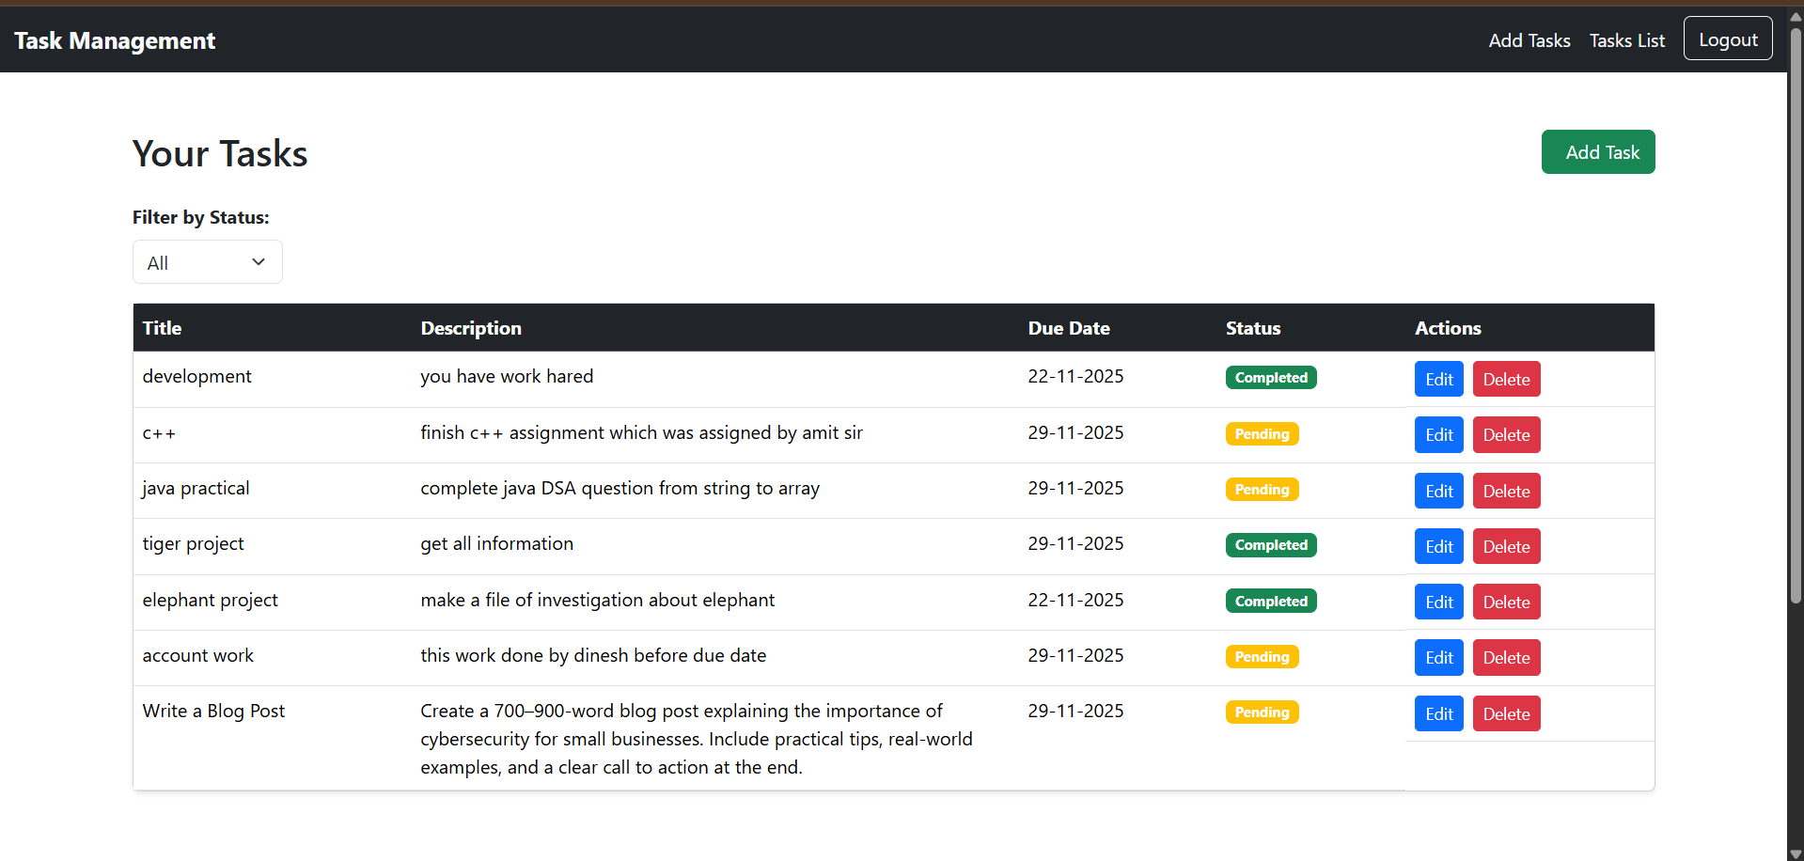
- Edit the task (Click the Edit action next to the task you want to modify.)
Here I chooses task second for edit(update )
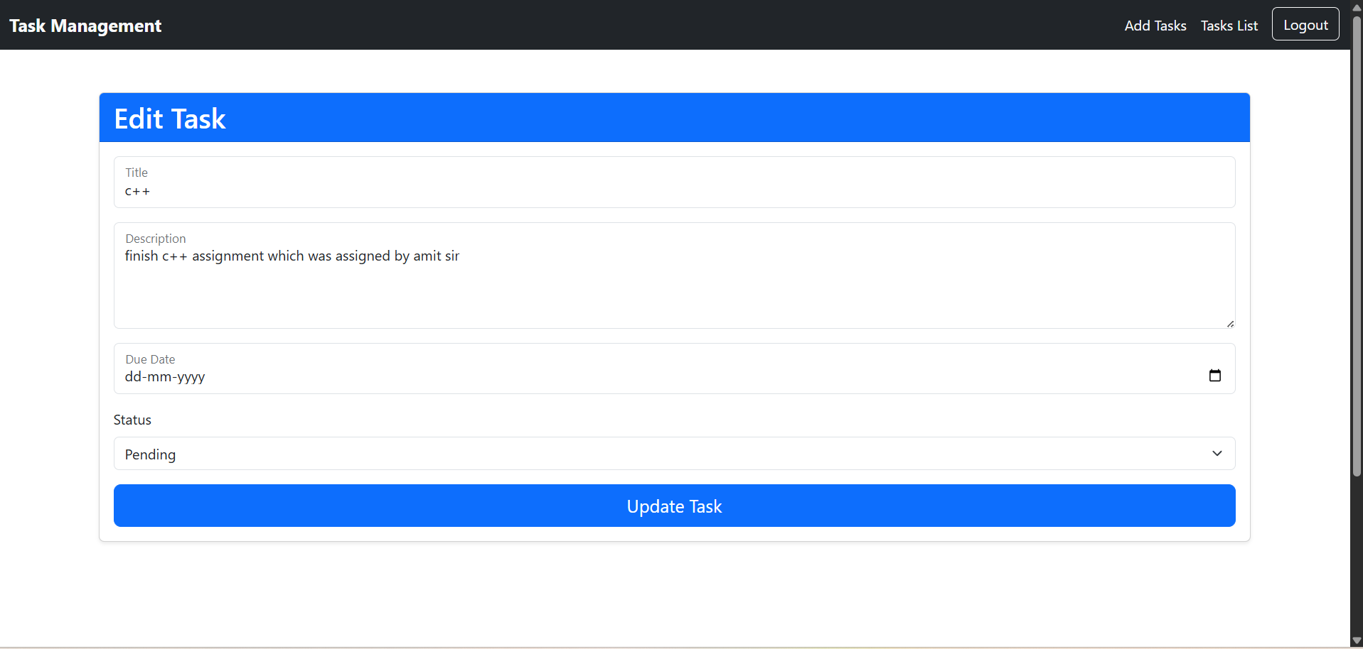
Update the information and click Update Task.
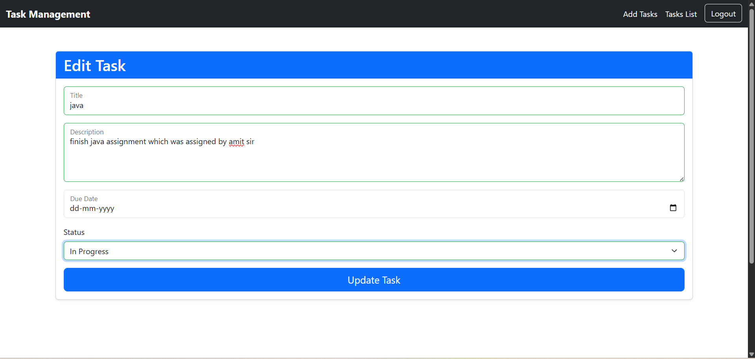
A success message will appear.
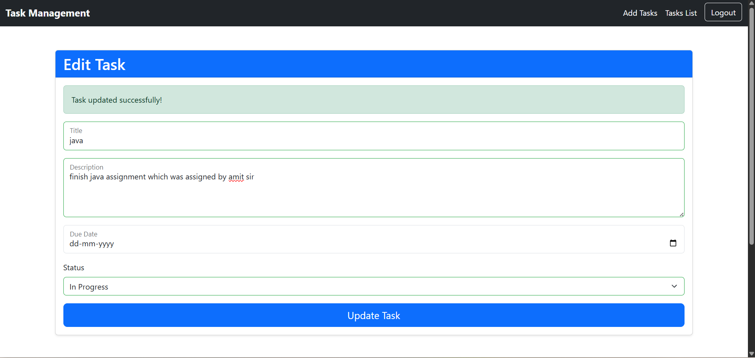
Return to the task list to confirm the changes.
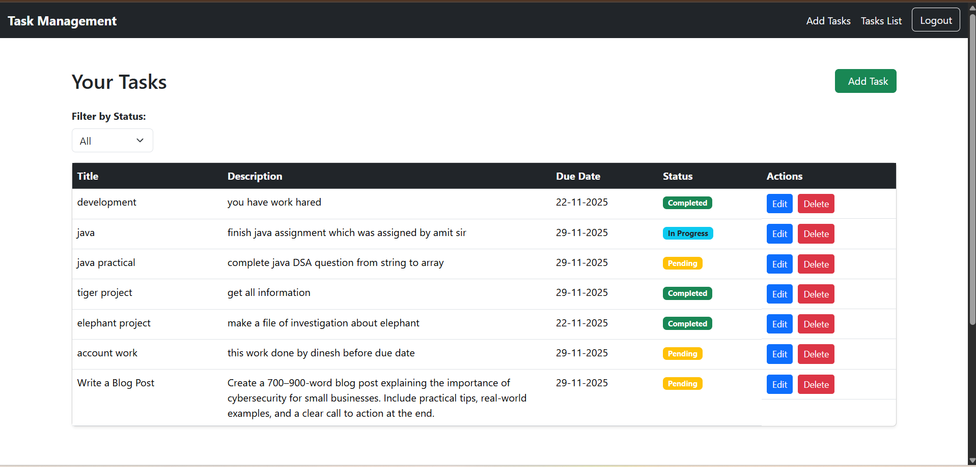

- Delete the task (Click the Delete action next to the task.)
Here I want to delete second task from list therefor click on delete action
A confirmation message will appear.
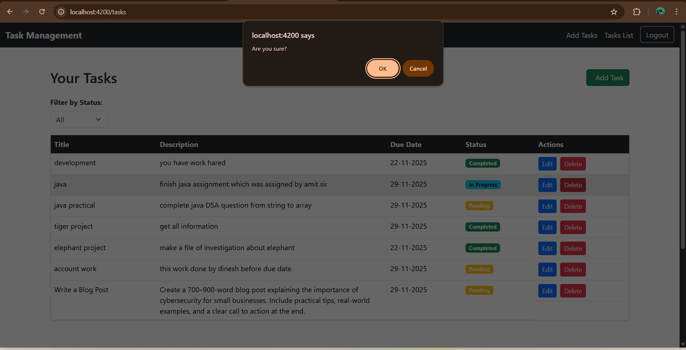
After confirming, the task will be removed from the list.
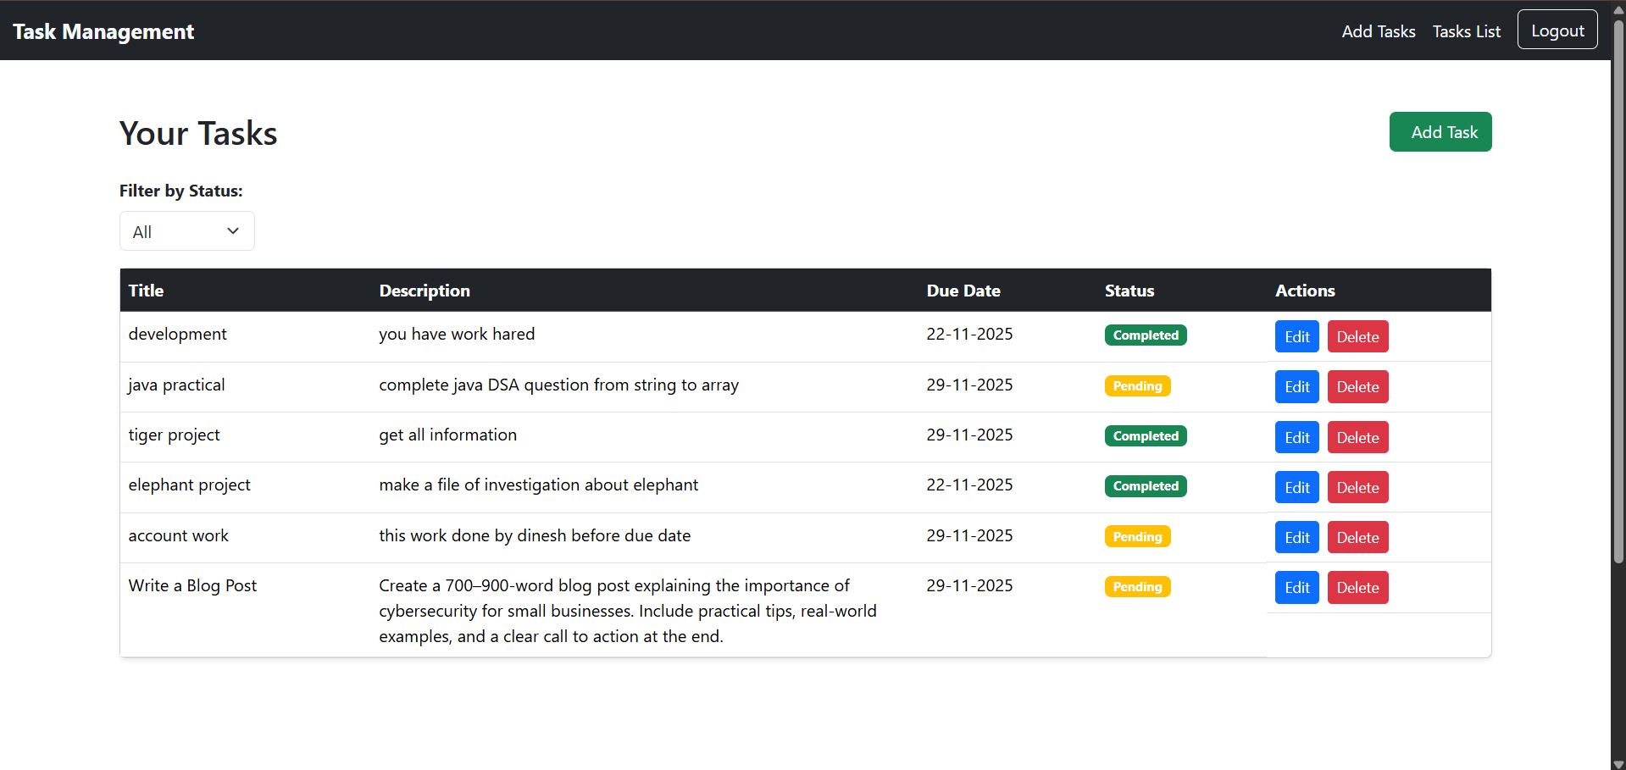
- Filter tasks by status
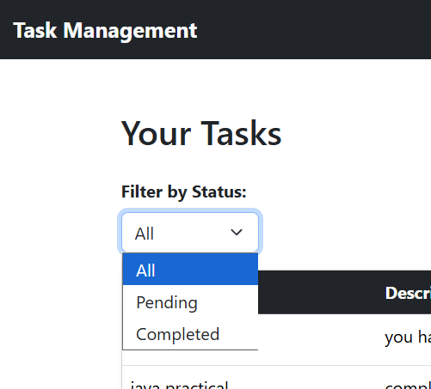
Pending → shows only tasks with pending status
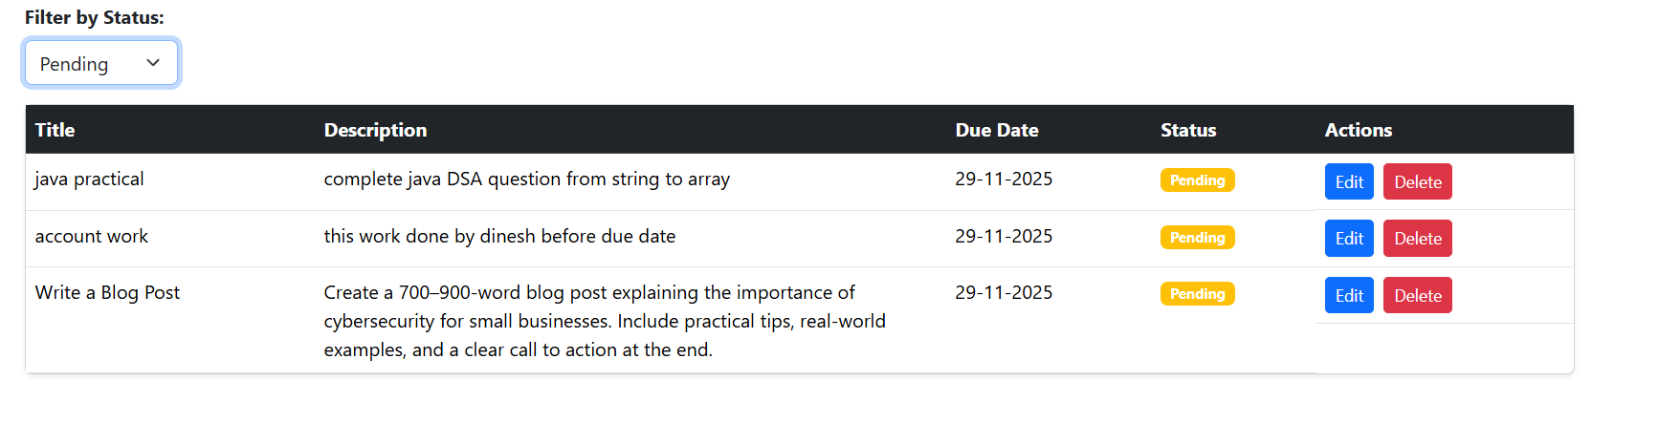
Completed → shows only completed tasks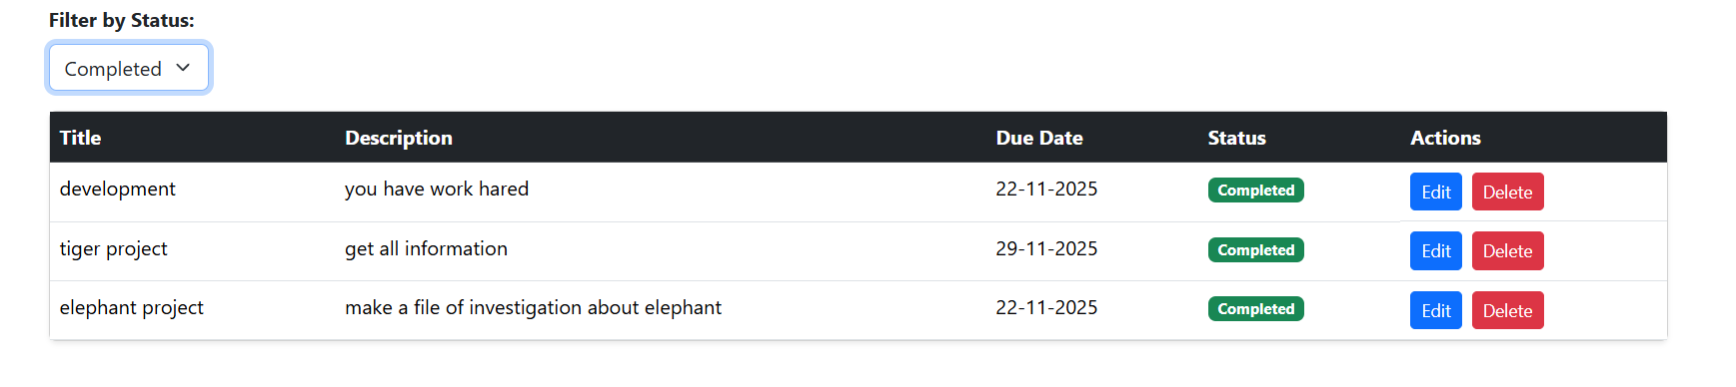

- Check form validation errors:-
8.1 If you click a field but leave it empty, a validation message will appear.:-
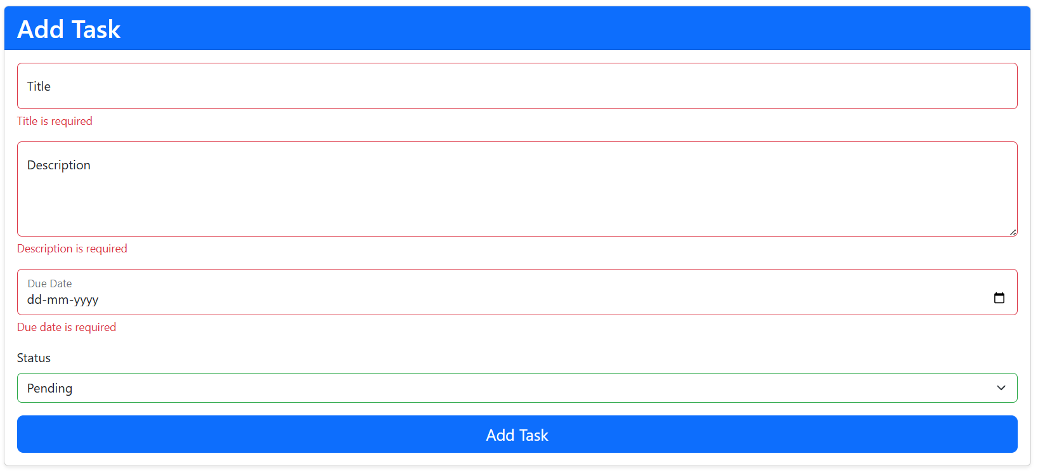
8.2 _If you try to submit the form without filling required fields, warnings will be shown.
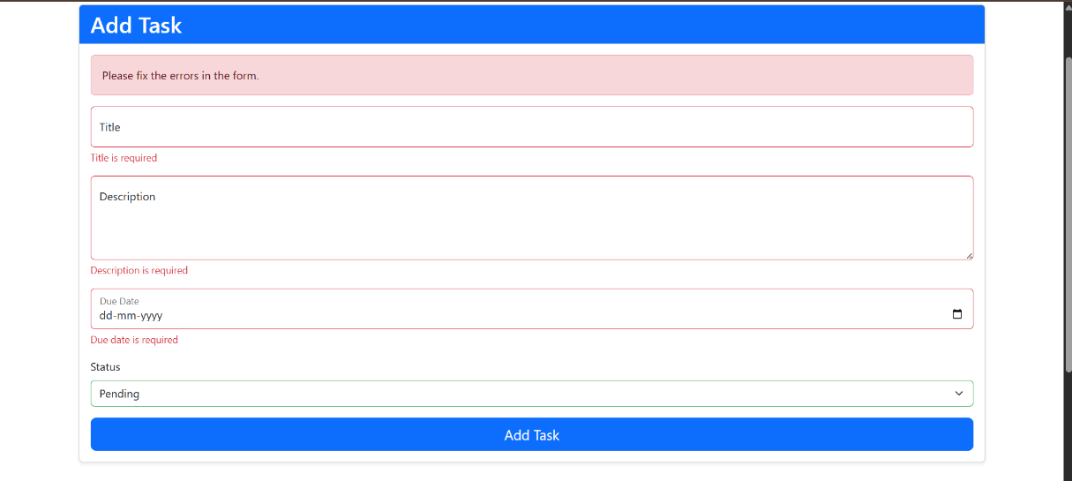

8.3 , Title is required validation.
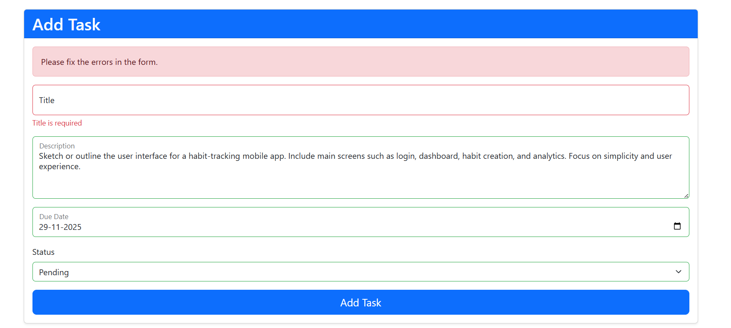
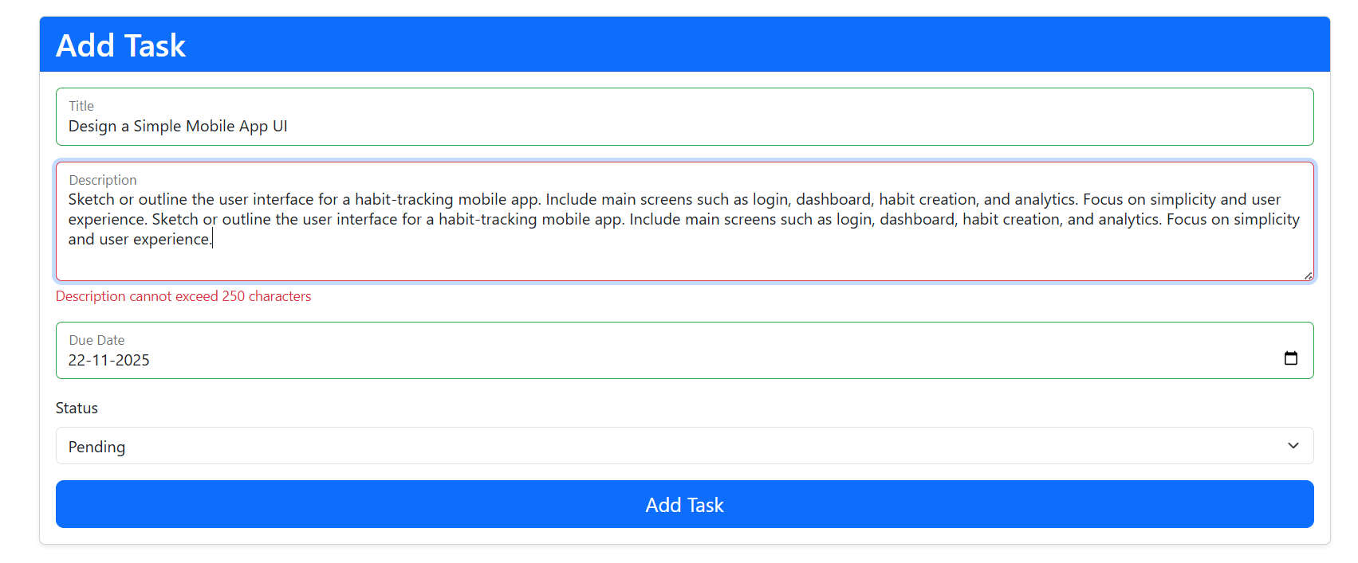
8.4 description cannot exceed 250 characters validation

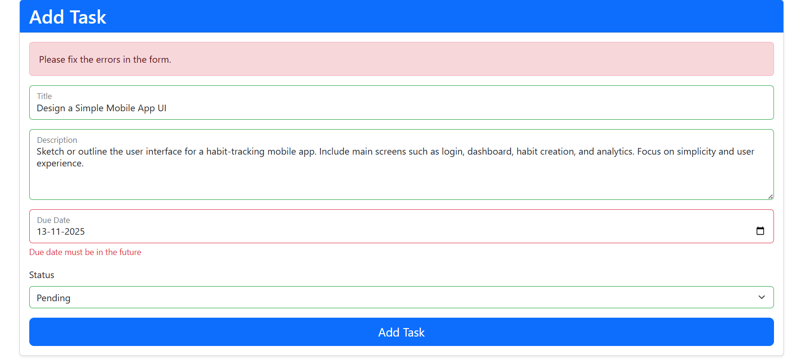
8.5 due date must be in the future validation

Thank you

