14-06-2026
Bilal Hamdani
Discord analayse, FoodShouldTasteGood Discord server
FRS2526-2.2

FoodShouldTasteGood Discord server
Case FRS2526-2.2 - SOCMINT investigation - username silentnomore24
Date: 14-06-2026 Analyst: Bilal Hamdani
This is a short look at the Discord server "FoodShouldTasteGood", linked from the @zebrainzion Instagram post.

The server
The server has two text channels (what-did-you-eat and weird-foods-yum-or-not) and two voice channels (Lounge and Meeting Room). In the what-did-you-eat channel, several members are welcomed over time, including BertaBosrana, XxVEr21Xx, Hubert.Hall, Blinde Mol, MetallicOdyssey, hughmccallen, and Snowbuster4life.
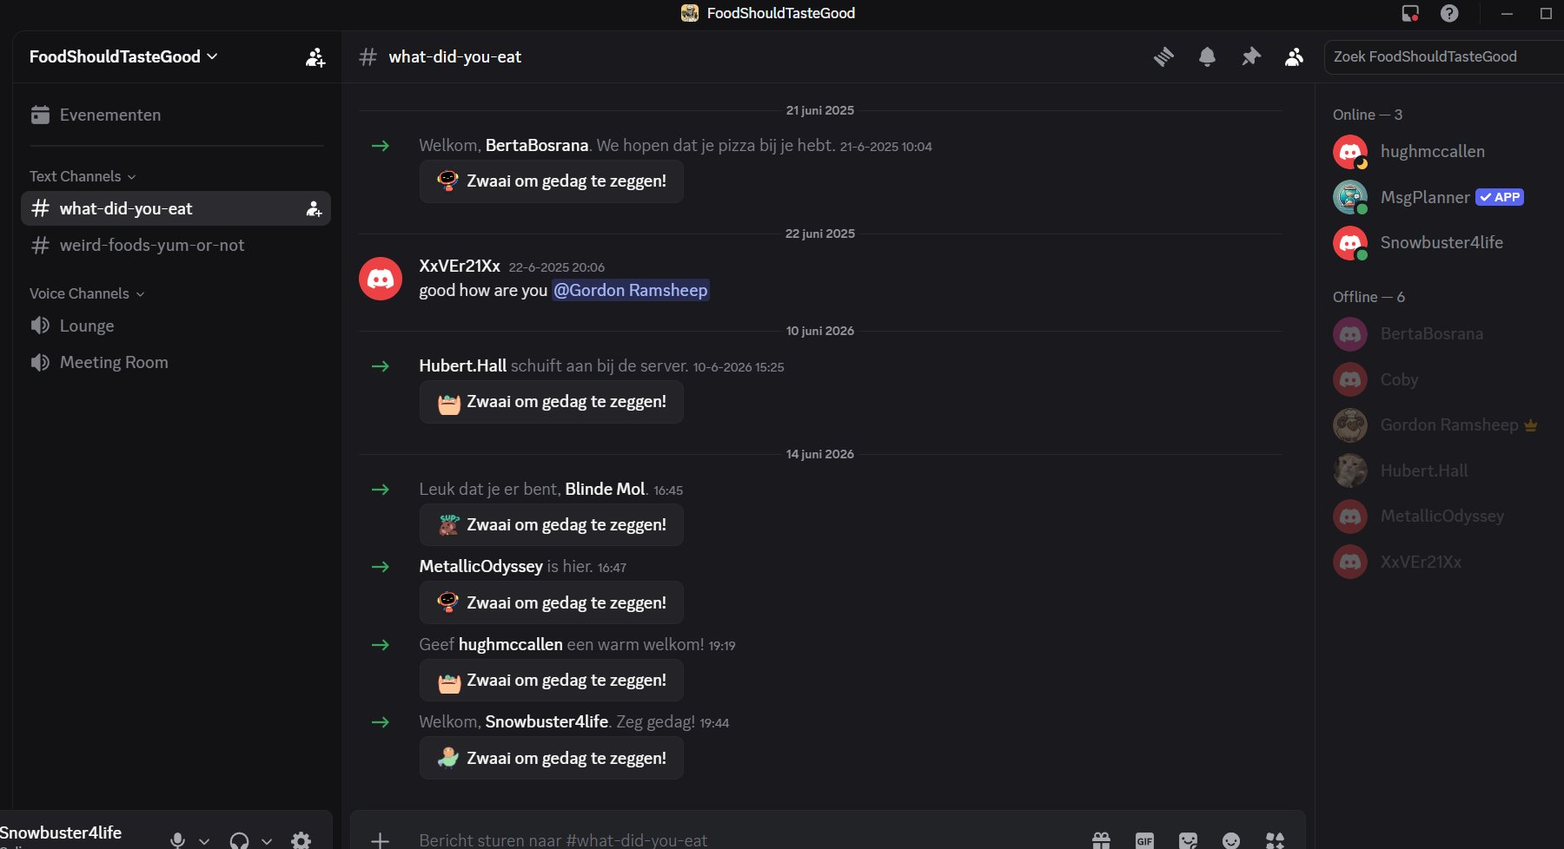
The what-did-you-eat channel, showing welcome messages for different members over time.

Connection between XxVEr21Xx and Gordon Ramsheep
On 20 June 2025, Gordon Ramsheep messaged XxVEr21Xx directly: "Hey @XxVEr21Xx how are you?". On 22 June 2025, XxVEr21Xx replied: "good how are you @Gordon Ramsheep". This back-and-forth suggests these two members may know each other or have some kind of friendship.
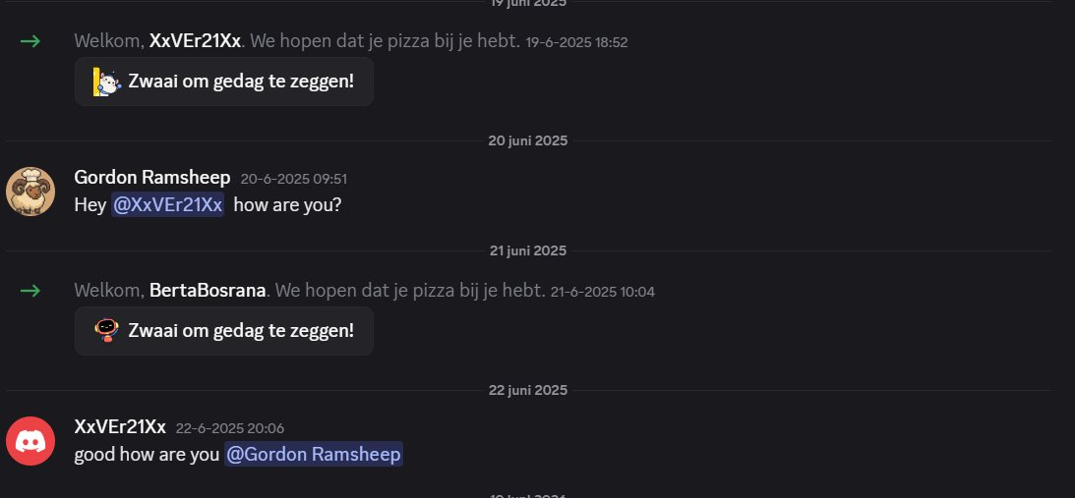
Direct messages between Gordon Ramsheep and XxVEr21Xx, June 2025.

Gordon Ramsheep (server owner)
Gordon Ramsheep is the owner of this server. Clicking on the profile shows the underlying username is jaylinnvorelle. This username should be searched further in a following step.
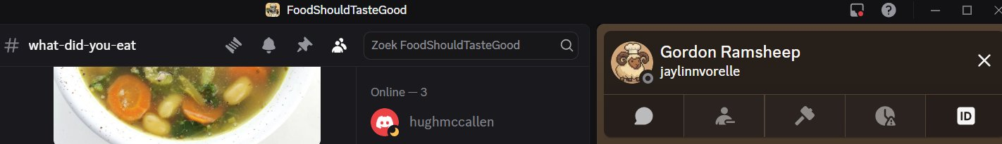
Gordon Ramsheep's profile, showing the underlying username jaylinnvorelle.

Hidden channel
Using the Vencord plugin, one hidden text channel was found, labelled "Geen toegang" (No access). It is not possible to see the messages in this channel. A check for deleted messages using Vencord did not find anything either.
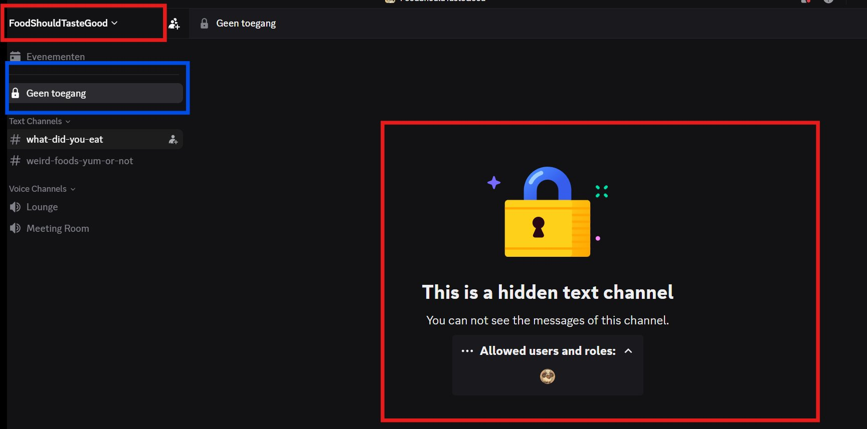
Hidden text channel found with Vencord, no access to its messages.

Conclusion
Nothing in this server matches the topics mentioned in the case briefing, which describes concerns about infrastructure, logistics, and environmental issues, and possible preparation for protest or sabotage in Europe. The server is focused on food.
Two leads from this server are worth following up. First, the connection between XxVEr21Xx and Gordon Ramsheep, since they appear to know each other. Second, the username jaylinnvorelle behind Gordon Ramsheep, which has not yet been searched. The hidden channel could not be accessed and has no further leads for now.

