14-06-2026
Bilal Hamdani
Follow-up: Jaylinn Vorelle (@JLVorelle) Analayse
FRS2526-2.2

Jaylinn Vorelle (@JLVorelle)
Case FRS2526-2.2 - SOCMINT investigation - username silentnomore24
Date: 14-06-2026 Analyst: Bilal Hamdani
This document looks at the Twitter account Jaylinn Vorelle (@JLVorelle), found through the username jaylinnvorelle, which is the underlying username of Gordon Ramsheep, the owner of the FoodShouldTasteGood Discord server.

The account
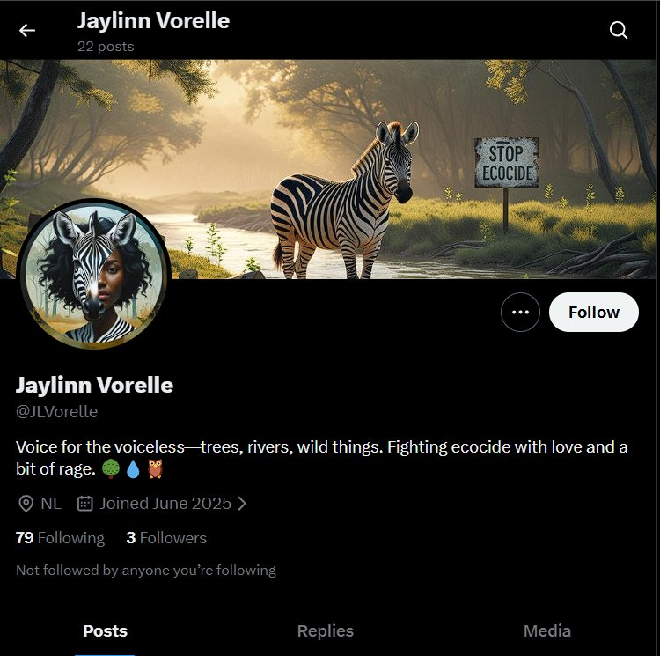
Twitter profile @JLVorelle, joined June 2025, location NL, 79 following, 3 followers, 22 posts.
The account is named Jaylinn Vorelle (@JLVorelle), created on 4 June 2025, with location set to NL (Netherlands). The bio reads “Voice for the voiceless, trees, rivers, wild things. Fighting ecocide with love and a bit of rage.” It has 79 accounts it follows, 3 followers, and 22 posts.
The profile picture and banner both show a zebra combined with a person of colour with dark curly hair, with a “STOP ECOCIDE” sign in the banner image. This style and theme (zebra imagery, AI-generated nature graphics, climate/ecocide activism) is similar to the @zebrainzion Instagram account, which also uses a zebra-themed name and AI-generated activism graphics.

Who this account follows
Of the 79 accounts followed, most are climate and environmental organisations and figures, including Greenpeace, WWF, Extinction Rebellion, 350.org, the IPCC, UNEP, and Greta Thunberg. A smaller group is food-related (Food Network, Bon Appétit, MasterChef Australia, and others), which matches the food theme of the FoodShouldTasteGood Discord server. Two accounts stand out for location: “buitengebieden”, a Dutch-language account, and “Plastic Soup Foundation”, based in Amsterdam. Both fit the NL location on this profile.
No account in this following list is connected to silentnomore24, @zebrainzion, or any of the other accounts found so far.

Posts
Most of the 22 posts are retweets or short replies (“So beautiful”, “Go Green!”, “Wow....”) on climate-related content from accounts such as UNDP, Climate Reality, and Treemissions. Two original posts stand out:
Date | Post
16 June 2025 | “One month from now... ✌️, © Danny Cornelissen”, posted with a photo.
10 June 2025 | “They're drilling, burning, dumping, and calling it business as usual. But which crisis demands urgent resistance right now? Vote. Organize. Stay loud. #ClimateCrisis #ActNow #NoMoreExcuses”
9 June 2025 | “They bulldoze ancestral land, poison water, and call it 'development'. But destruction isn't progress, it's theft. Of land, of life, of future. And we're done watching quietly. #takeitback #climatejustice #actnow”
The first post, crediting “© Danny Cornelissen”, is worth following up. A photographer with this name is known for maritime and port photography, including work for the Port of Rotterdam. If the photo in this post is one of his, it could point to a Dutch port or industrial location, which would fit the case briefing's focus on infrastructure and logistics. The image itself has not yet been viewed directly and should be checked in a following step.
The other two posts (10 and 9 June 2025) use a tone that goes beyond general climate concern: phrases like “which crisis demands urgent resistance right now? Vote. Organize. Stay loud” and “we're done watching quietly” call for action rather than just raising awareness. This tone is closer to the “possible preparations for protest actions” mentioned in the case briefing than anything seen on the other accounts so far.

Conclusion
@JLVorelle shares a strong visual and thematic link with @zebrainzion (zebra imagery, AI-generated activism graphics, ecocide/climate theme), and its NL location and Dutch-related follows fit the European focus of the case. The tone of two posts (calls to “resist” and “not watch quietly”) is closer to the case briefing's concern about protest preparation than anything found before. The biggest lead from this account is the “© Danny Cornelissen” photo from 16 June 2025, which should be examined directly in a following step to check what it shows and whether it points to a specific location.

