**21F-9243_BCS-6B_Assignment-01**

**Task_1:**

<!DOCTYPE html>

<html>

  <head>

    <title>Task_1</title>

  </head>

  <body>

    <h1>Name:</h1>

    <p>Bilal Tariq</p>

    <h1>Roll No:</h1>

    <p>21F-9243</p>

    <h1>About:</h1>

    <p>

      Passionate CS student specializing in mobile and web application

      development. Proficient in Flutter and MERN stack technologies. <br />

      Excited about creating impactful user experiences and leveraging

      cutting-edge technologies in the field. Open to collaboration and

      continuously exploring new avenues in software development.

    </p>

  </body>

</html>

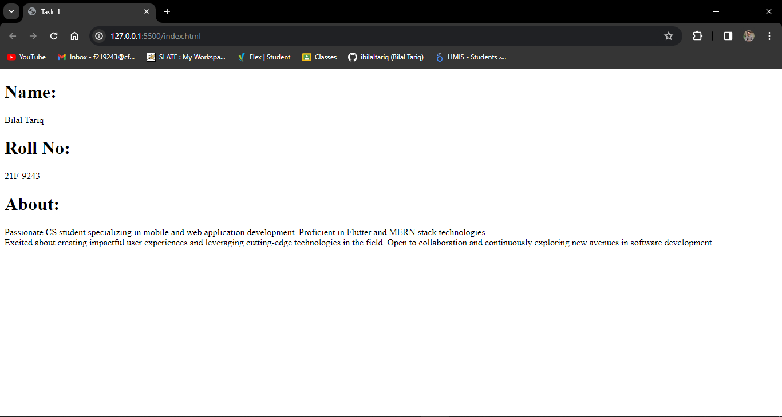

**Task_2:**

<!DOCTYPE html>

<html>

  <head>

    <title>Task_2</title>

  </head>

  <body>

    <p><b>This text is bold</b></p>

    <p><strong>This text is strong</strong></p>

    <p><big>This text is big</big></p>

    <p><i>This text is italic</i></p>

    <p><em>This text is emphasized</em></p>

    <code>This is computer output</code>

    <p>This is <sub>subscript</sub> and <sup>superscript</sup></p>

  </body>

</html>

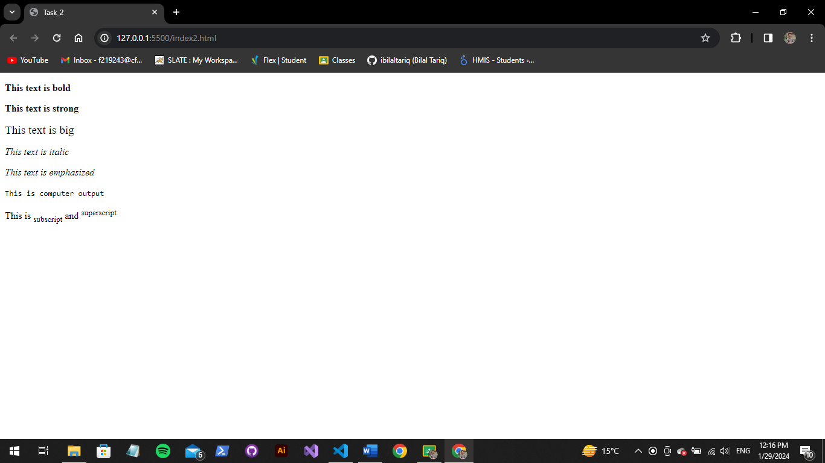

**Task_3:**

<!DOCTYPE html>

<html>

  <head>

    <title>Task_3</title>

  </head>

  <body>

    <img src="NUCES.png" alt="Fast-Nuces" width="1000" height="1000" />

  </body>

</html>



**Task_4:**

<!DOCTYPE html>

<html>

  <head>

    <title>Task_4</title>

  </head>

  <body>

    <a href="https://www.nu.edu.pk/" target="_blank">

      <img src="NUCES.png" alt="Fast-Nuces" width="1000" height="1000" />

    </a>

  </body>

</html>

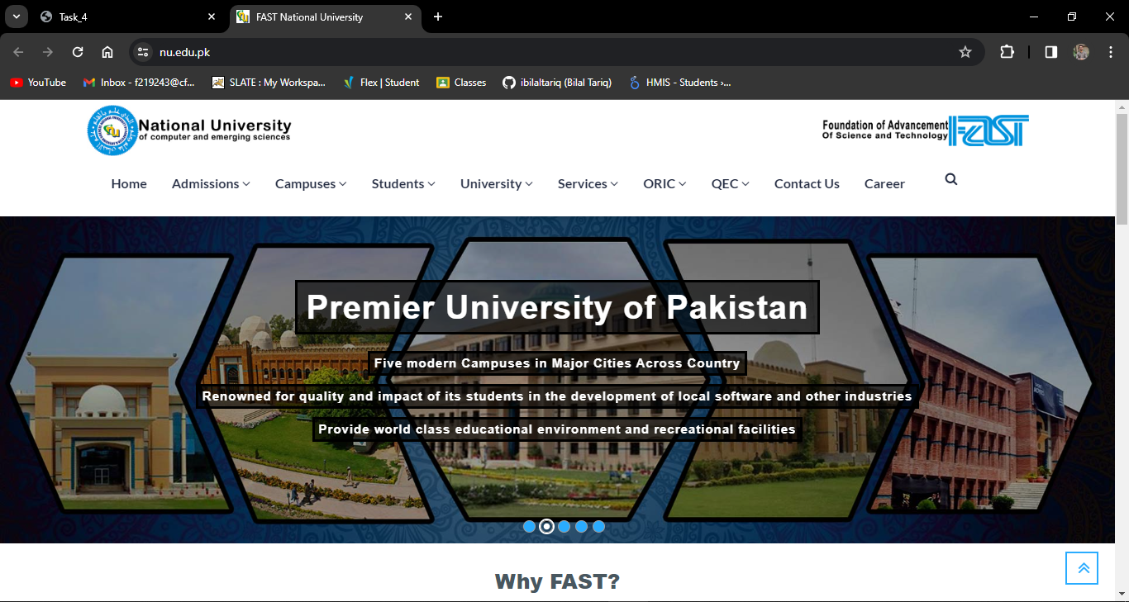

**Task_5:**

<!DOCTYPE html>

<html>

  <head>

    <title>Task_5</title>

  </head>

  <body>

    <h1>HTML Lists</h1>

    <h2>Unordered List</h2>

    <p>We have variety of books</p>

    <ul>

      <li>ORACLE</li>

      <li>JAVA</li>

      <li>HTML</li>

      <li>CSS</li>

    </ul>

    <h2>Ordered List</h2>

    <p>Follow these steps to install JAVA</p>

    <ol>

      <li>Download the software</li>

      <li>Exract to a folder</li>

      <li>Double click the executeable to run</li>

      <li>CSS</li>

    </ol>

  </body>

</html>

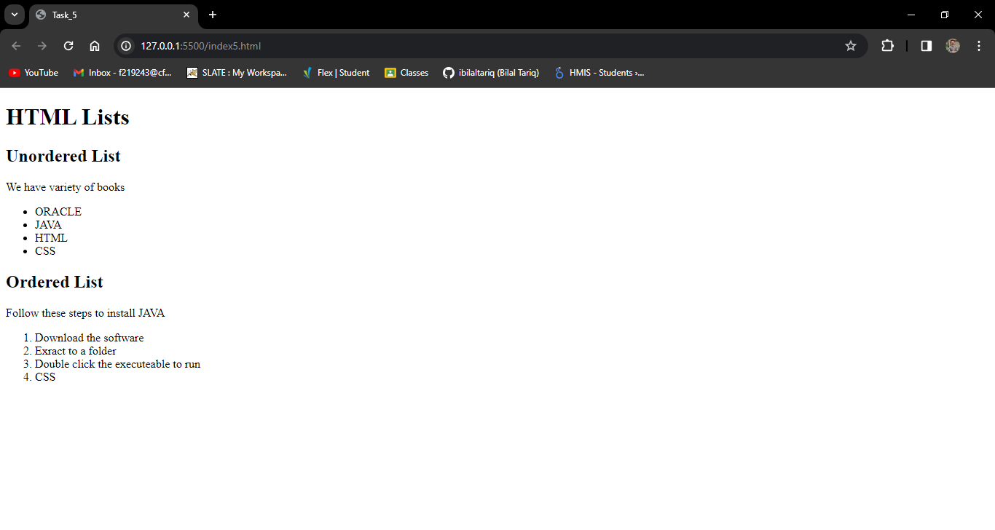

**Task_6:**

<!DOCTYPE html>

<html>

  <head>

    <title>Task_6</title>

    <style>

      table,

      th,

      td {

        border: 1px solid black;

        border-collapse: collapse;

        width: 25%;

      }

    </style>

  </head>

  <body>

    <table>

      <tr>

        <th rowspan="3">April</th>

        <th>.</th>

        <th>.</th>

      </tr>

      <tr>

        <td>.</td>

        <td>.</td>

      </tr>

      <tr>

        <td>.</td>

        <td>.</td>

      </tr>

      <tr>

        <td>.</td>

        <td>.</td>

        <td>.</td>

      </tr>

      <tr>

        <td>.</td>

        <td>.</td>

        <td>.</td>

      </tr>

    </table>

  </body>

</html>

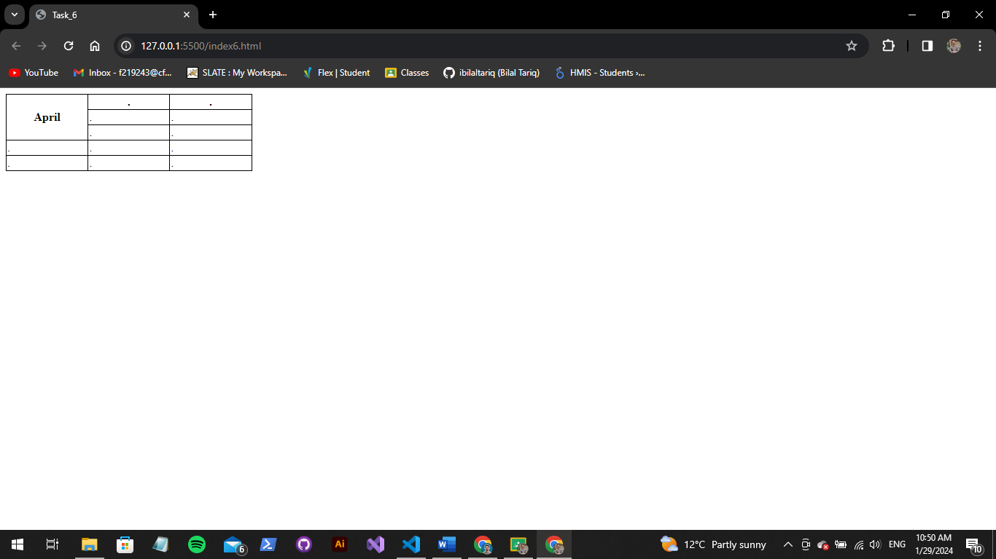

**Task_7:**

**Task_7:**

<!DOCTYPE html>

<html>

  <head>

    <title>Task_7</title>

    <style>

      table,

      th,

      td {

        border: 1px solid black;

        border-collapse: collapse;

        width: 25%;

      }

    </style>

  </head>

  <body>

    <table>

      <tr>

        <th colspan="3">2022</th>

      </tr>

      <tr>

        <td>.</td>

        <td>.</td>

        <td>.</td>

      </tr>

      <tr>

        <th rowspan="2" colspan="2">FIESTA</th>

        <td>.</td>

      </tr>

      <tr>

        <td>.</td>

      </tr>

      <tr>

        <td>.</td>

        <td>.</td>

        <td>.</td>

      </tr>

    </table>

  </body>

</html>

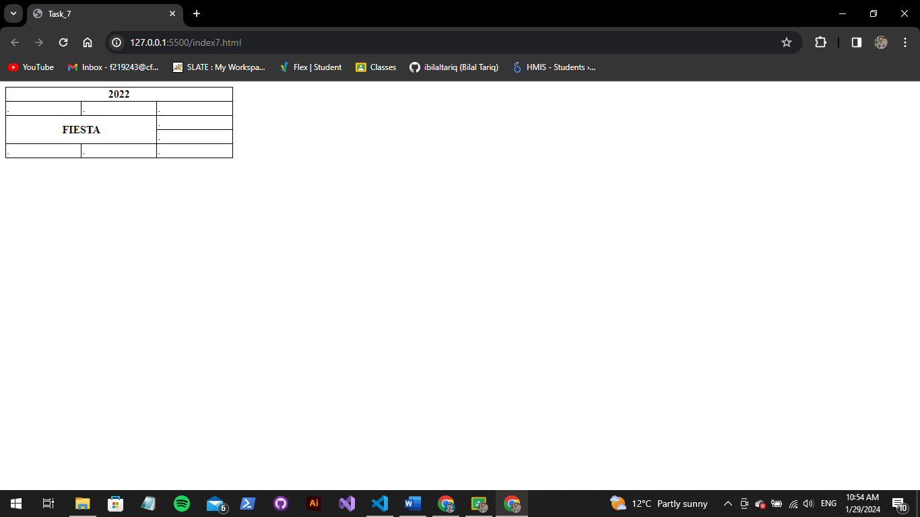

**Task_8:**

<!DOCTYPE html>

<html>

  <head>

    <title>Task_8</title>

  </head>

  <body>

    <h2>Sign-Up Form</h2>

    <form>

      <label for="username">Name:</label><br />

      <input type="text" id="username" name="username" /><br />

      <label for="email">Email:</label><br />

      <input type="email" id="email" name="email" /><br />

      <label for="password">Password:</label><br />

      <input type="password" id="email" name="password" /><br />

      <label for="confirm-password">Confirm Password:</label><br />

      <input type="password" id="email" name="confirm-password" /><br />

      <br />

      <button type="submit">Submit</button> <br />

      <br />

      <button type="reset">Reset</button>

    </form>

  </body>

</html>

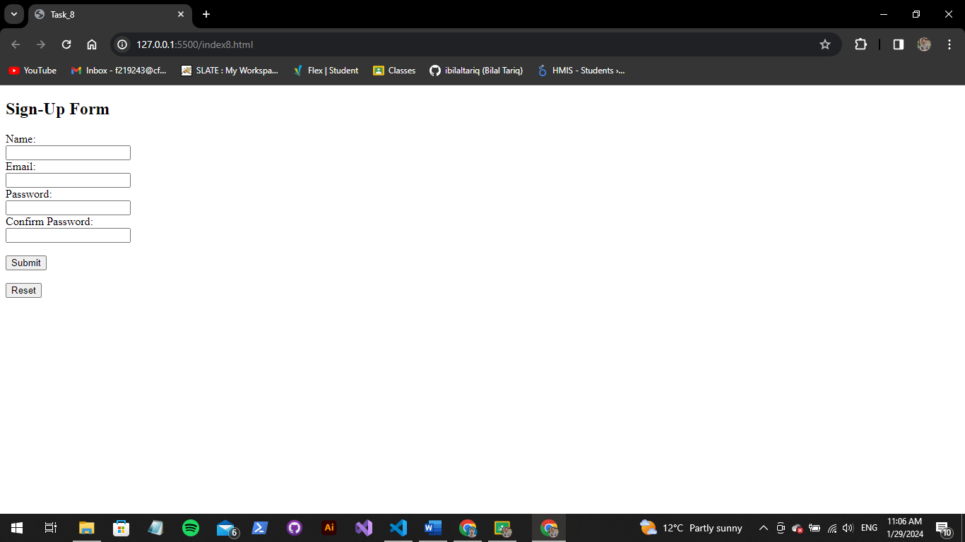

**Task_9:**

<!DOCTYPE html>

<html>

  <head>

    <title>Task_9</title>

    <style>

      h1,

      h2,

      h3,

      p {

        text-align: center;

      }

      .center {

        display: flex;

        justify-content: space-evenly;

        text-align: end;

      }

      .options {

        display: flex;

        justify-content: space-evenly;

      }

      .time,

      .btn {

        display: flex;

        justify-content: center;

        align-items: unsafe;

        padding-top: 30px;

      }

      .ins {

        display: flex;

        justify-content: center;

        align-items: unsafe;

      }

    </style>

  </head>

  <body>

    <h1>Pete's Pizza Delivery</h1>

    <h2>Online order form</h2>

    <form>

      <div class="center">

      <div class="col-1">

        <label for="username">*Name: </label>

        <input type="text" id="username" name="username" required /> <br />

        <label for="address">*Address: </label>

        <input type="text" id="address" name="address" required /> <br />

        <label for="town">*Town/city: </label>

        <input type="text" id="town" name="town" required /> <br />

        <label for="passcode">*Passcode: </label>

        <input type="number" id="passcode" name="passcode" required /><br />

      </div>

      <div class="col-2">

        <label for="tel">*Tel: </label>

        <input type="tel" id="tel" name="tel" required /><br />

        <label for="email">*Email: </label>

        <input type="text" id="email" name="email" required /> <br />

      </div>

    </div>

    <p>*required fields</p>

    <div class="options">

      <div class="topping">

        <h2>Topping</h2>

        <div class="semi-opt">

          <input type="radio" />

          <label for="mar">Margherita</label>

        </div>

        <div class="semi-opt">

          <input type="radio" />

          <label for="for-seasons">Four Seasons</label>

        </div>

        <div class="semi-opt">

          <input type="radio" />

          <label for="meat-feast">Meat Feast</label>

        </div>

      </div>

      <div class="size">

        <h2>Size</h2>

        <div class="semi-opt">

          <input type="radio" />

          <label for="small">Small</label>

        </div>

        <div class="semi-opt">

          <input type="radio" />

          <label for="medium">Medium</label>

        </div>

        <div class="semi-opt">

          <input type="radio" />

          <label for="large">Large</label>

        </div>

      </div>

      <div class="extras">

        <h2>Extras</h2>

        <div class="semi-opt">

          <input type="checkbox" />

          <label for="mushrooms">Mushrooms</label>

        </div>

        <div class="semi-opt">

          <input type="checkbox" />

          <label for="green-peppers">Green peppers</label>

        </div>

        <div class="semi-opt">

          <input type="checkbox" />

          <label for="anchovies">Anchovies</label>

        </div>

        <div class="semi-opt">

          <input type="checkbox" />

          <label for="extra-cheese">Extra cheese</label>

        </div>

      </div>

    </div>

    <div class="time">

      <label for="time">Prefered delivery time: </label>

      <input type="time" />

      <br />

    </div>

    <div class="ins">

      <label for="instructions">Delivery instructions: </label>

      <textarea name="instructions" id="instructions" rows="3"></textarea>

      <br />

    </div>

    <div class="btn">

      <button type="submit">Submit Order</button>

    </form>

    </div>

  </body>

</html>

