***Software Engineering***

***Software Requirements Specification***  ***(SRS) Document***

**Fitness Gym-Bud**

**09/23/2023**

# [Version]

**By: Jacob Crews, Rohan Waheed, Bilal Zahid**

**[Honor Code]**

# Table of Contents

1. Introduction 2
   1. Purpose 2
   2. Document Conventions 2
   3. Definitions, Acronyms, and Abbreviations 3
   4. Intended Audience 3
   5. Project Scope 3
   6. Technology Challenges 4
   7. References 4
2. General Description 4
   1. Product Perspective 4
   2. Product Features 4
   3. User Class and Characteristics 4
   4. Operating Environment 4
   5. Constraints 4
   6. Assumptions and Dependencies 5
3. Functional Requirements 5
   1. Primary 5
   2. Secondary 5
4. Technical Requirements 5
   1. Operating System and Compatibility 5
   2. Interface Requirements 5
      1. User Interfaces 5
      2. Hardware Interfaces 5
      3. Communications Interfaces 6
      4. Software Interfaces 6
5. Non-Functional Requirements 6
   1. Performance Requirements 6
   2. Safety Requirements 6
   3. Security Requirements 6
   4. Software Quality Attributes 6
      1. Availability 6
      2. Correctness 6
      3. Maintainability 6
      4. Reusability 6
      5. Portability 6
   5. Process Requirements 7
      1. Development Process Used 7
      2. Time Constraints 7
      3. Cost and Delivery Date 7
   6. Other Requirements 7
   7. Use-Case Model Diagram 8
   8. Use-Case Model Descriptions 8
      1. Actor: Actor Name (Responsible Team Member) 8
      2. Actor: Actor Name (Responsible Team Member) 8
      3. Actor: Actor Name (Responsible Team Member) 8
   9. Use-Case Model Scenarios 8
      1. Actor: Actor Name (Responsible Team Member) 8
      2. Actor: Actor Name (Responsible Team Member) 9
      3. Actor: Actor Name (Responsible Team Member) 9
6. Design Documents 9
   1. Software Architecture 9
   2. High-Level Database Schema 10
   3. Software Design 10
      1. State Machine Diagram: Actor Name (Responsible Team Member) 10
      2. State Machine Diagram: Actor Name (Responsible Team Member) 10
      3. State Machine Diagram: Actor Name (Responsible Team Member) 10
   4. UML Class Diagram 10
7. Scenario 10
   1. Brief Written Scenario with Screenshots 10

# 1. Introduction

## 1.1. Purpose

The goal of the Fitness Gym-Bud is to help connect not only the average person to a personalized trainer but also make it easy for the gym itself to offer its services to its members while also making it easy for the trainers themselves to connect with their clients and offer better training and dietary suggestions to make actual progress with clients further increasing the trainer's reputation and the gym's influx of members.

## 1.2. Document Conventions

The purpose of this Software Requirements Document (SRD) is to describe the requirements for the developers and the clients for the Fitness Gym-Bud app. In it, we will describe the application from the perspective of each type of user the app aims to service, and describe the application from a developers perspective, including descriptions of data, performance and other elements.

## 1.3. Definitions, Acronyms, and Abbreviations

[Include any specialized terminology dictated by the application area or the product area. For example:]

|  |  |
| --- | --- |
| Java | A programming language originally developed by James Gosling at Sun  Microsystems. We will be using this language to build the Restaurant Manager. |
| MySQL | Open-source relational database management system. |
| .HTML | Hypertext Markup Language. This is the code that will be used to structure and design the web application and its content. |
| SpringBoot | An open-source Java-based framework used to create a micro Service. This will be used to create and run our application. |
| MVC | Model-View-Controller. This is the architectural pattern that will be used to implement our system. |
| Spring Web | Will be used to build our web application by using Spring MVC. This is one of the dependencies of our system. |
| Thymeleaf | A modern server-side Java template engine for our web environment. This is one of the dependencies of our system. |
| NetBeans | An integrated development environment (IDE) for Java. This is where our system will be created. |
| API | Application Programming Interface. This will be used to implement a function within the software where the current date and time is displayed on the homepage. |
| PR | Personal record. A gym member can log their personal records on lifts. |

## 1.4. Intended Audience

[Describe which part of the SRS document is intended for which reader. Include a list of all stakeholders of the project, developers, project managers, and users for better clarity.]

## 1.5. Project Scope

The goal of the application is to connect people with gyms and personal trainers through an easy-to-use app to help gyms reach more people. This aligns with the overall goal of the gyms that use this app, as it will allow the gym to grow, and better provide their services.

The benefits of this app to Gyms include:

* Increase in trainer and client connection
* Physical hassle of creating workouts and meal plans removed
* Better understanding of calories and food intake
* Easy method of setting availability for trainers

**1.6. Technology Challenges**

[Any technological constraints that the project will be under. Any new technologies you may need to use]

## 1.7. References

[Mention books, articles, web sites, worksheets, people who are sources of information about the application domain, etc. Use proper and complete reference notation. Give links to documents as appropriate. You should use the APA Documentation model (Alred, 2003, p. 144).]

# 2. General Description

## 2.1. Product Perspective

[Describe the context and origin of the product.]

Fitness Gym-Bud was founded with the idea of making it easier for regular people to connect with a gym and a personal trainer. From personal experience from the founders, staying on track to meet fitness goals can be hard, this app aims to keep is clients motivated with easy access to a gym and a trainer.

## 2.2. Product Features

The product features include the ability for a gym admin, trainer, and gym member to create accounts with different features. The gym admin has the ability to assign trainers to clients, remove or add the gym to the app, pay trainers, and remove clients, The trainer has the ability to create a meal plan, create a workout plan, set availability, and set food/workout reminders for their clients. The client/gym member has the ability to pay gym fees, request a new trainer/remove a trainer, leave the gym, and also create a workout/meal plan.

## 2.3. User Class and Characteristics

[A categorization and profiling of the users the software is intended for and their classification into different user classes]

Our website application only expects users to know how to use a web browser. Trainers will be expected to be knowledgeable on fitness and healthy eating, and the gym admin will be expected to know how to manage multiple trainers and clients. The clients will need no prior knowledge in anyway to be successful with this app.

## 2.4. Operating Environment

[Specification of the environment the software is being designed to operate in.] The application is designed to operate on the web across many different devices.

## 2.5. Constraints

[Any limiting factors that would pose challenge to the development of the software. These include both design as well as implementation constraints.]

## 2.6. Assumptions and Dependencies

[A list of all assumptions that you have made regarding the software product and the environment along with any external dependencies which may affect the project]

The software will be dependent on Spring Web and Thymeleaf in order to create and execute the MVC architecture that will be developed within NetBeans. The application will also use the My Fitness Pal API [(http://myfitnesspalapi.com/)](http://myfitnesspalapi.com/) to [http://myfitnesspalapi.com/)](http://myfitnesspalapi.com/) to allow users to track their nutrition in the foods they eat throughout the day.

# 3. Functional Requirements

[Statements of services the system should provide, how the system should react to particular inputs and how the system should behave in particular situations.]

The system first has a login feature and sign up feature for what type of user you are. For example if a gym member tried logging in as a trainer it would not work. The system also responds to food and workouts the trainer or client inputs. The gym admin also has the ability to remove gym members and pay trainers while clients/ members can pay their fees and add/remove a trainer.

## 3.1. Primary

[All the requirements within the system or sub-system in order to determine the output that the software is expected to give in relation to the given input. These consist of the design requirements, graphics requirements, operating system requirements and constraints if any.] Admins can add new trainers and clients to the system.

## 3.2. Secondary

[Some functions that are used to support the primary requirements.]

Members have their own space in the app where they can see and change their own gym schedules and trainer appointments. We will use a food api because it allows for easier input.

# 4. Technical Requirements

## 4.1. Operating System and Compatibility

[The environments that will be needed to operate the system]

The application will be compatible with any operating system that is able to view and to interact with traditional web pages.

## 4.2. Interface Requirements

**4.2.1. User Interfaces**

[The logic behind the interactions between the users and the software. This includes the sample screen layout, buttons and functions that would appear on every screen, messages to be displayed on each screen and the style guides to be used.]

**4.2.2. Hardware Interfaces**

[All the hardware-software interactions with the list of supported devices on which the software is intended to run on, the network requirements along with the list of communication protocols to be used.]

The web application will run on any hardware device that has access to the internet, the ability to display webpages, and the ability to interact with web pages. This includes, but is not limited to, smartphones, tablets, desktop computers, and laptops.

**4.2.3. Communications Interfaces**

[Determination of all the communication standards to be utilized by the software as a part of the project]

**4.2.4. Software Interfaces**

[The interaction of the software to be developed with other software components such as frontend and the backend framework to the used, the database management system and libraries describing the need and the purpose behind each of them.]

# 5. Non-Functional Requirements

[Constraints on the services or functions offered by the system (e.g., timing constraints, constraints on the development process, standards, etc.). Often apply to the system as a whole rather than individual features or services.]

## 5.1. Performance Requirements

[The performance requirements need to be specified for all the functional requirements.]

-

## 5.2. Safety Requirements

[List out any safeguards that need to be incorporated as a measure against any possible harm the use of the software application may cause.]

**5.3. Security Requirements**

[Privacy and data protection regulations that need to be adhered to while designing of the product.]

## 5.4. Software Quality Attributes

[Detailing on the additional qualities that need to be incorporated within the software like maintainability, adaptability, flexibility, usability, reliability, portability etc.]

**5.4.1. Availability**

There is an easy sign-up process for new users, and the app can be accessed at any time.

**5.4.2. Correctness**

The developers will take extra precautions to ensure there are no bugs and everything available to the users works as intended

**5.4.3. Maintainability**

The code will be well documented so the developers can easily make changes or maintain the app

**5.4.4. Reusability**

The client, trainer, and gym admin will all be in constant contact with each other through the app, Giving all users reason to continue using the app

**5.4.5. Portability**

The app will be available to download on multiple devices, and can be used anytime the user has access to the internet.

**5.5. Process Requirements**

**5.5.1. Development Process Used**

[Software Process Model]

**5.5.2. Time Constraints**

**5.5.3. Cost and Delivery Date**

**5.6. Other Requirements**

# TBD

## 5.7. Use-Case Model Diagram

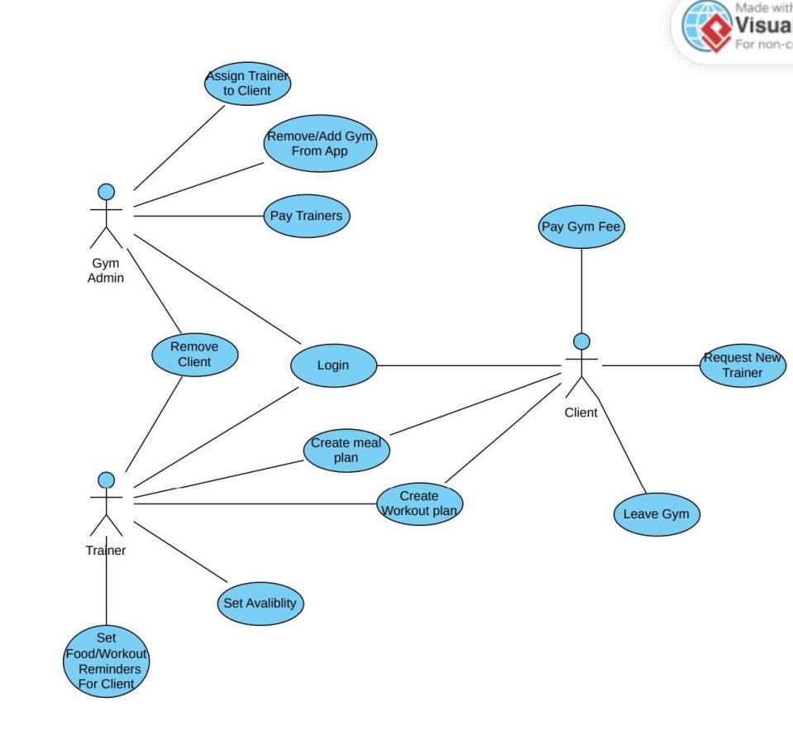

## 5.8. Use-Case Model Descriptions

**5.8.1. Actor: Bilal Zahid**

* **Client/Member**: Muhammed Zahid is responsible of Client (pay gym fee, request new trainer, leave gym, create meal plan, create workout plan, login).

**5.8.2. Actor: Rohan Waheed**

* **Use-Case Name**: Khawaja waheed is responsible off Gym Admin( Assign trainer, remove/add Gym from app, pay trainers, login , remove client).

**5.8.3. Actor: Jacob Crews**

* **Use-Case Name**: Jacob Crews is responsible for Trainer (remove client, login, create meal plan, create workout plan, set availability

## 5.9. Use-Case Model Scenarios

**5.9.1. Actor: Bilal Zahid**

* **Use-Case Name**: client/ gym member
  + **Initial Assumption**: Needs to be able to work in tandem with trainer.
  + **Normal**:
  + **What Can Go Wrong**: Conflict between trainer food and workout logs and client ● **Other Activities**: login and log off feature ● **System State on Completion**:
* **Use-Case Name**:
  + **Initial Assumption**:
  + **Normal**:
  + **What Can Go Wrong**:
  + **Other Activities**:
  + **System State on Completion**:

**5.9.2. Actor: Actor Name (Jacob Crews)**

- **Use-Case Name**: Create Workout Plan

* + - * **Initial Assumption**: Trainer creates workout plan for client.
      * **Normal**: Client agrees with and follows the plan.
      * **What Can Go Wrong**: Client disagrees with the plan, causing the trainer to accomidate to the client and make adjustments.
      * **Other Activities**: The client can adjust the workout plan themselevs and discus the changes with the trianer.
      * **System State on Completion**: The trainer has created a workout plan that satisfies the client.
* **Use-Case Name**: Set avalibility
  + - * **Initial Assumption**: The Trainer sets their avalibilty for their clients to be able to reach them.
      * **Normal**: The trainers avalability
      * **What Can Go Wrong**: The Trainers avalability does not line up with the avalibility of a client. The trainer has the option to drop this client to reslove this issue for both of them.
      * **Other Activities**: The trainer and clients can communicate with each other to come to an arrangement that works for them both.
      * **System State on Completion**: The trainer has set their avalibility and it works with their clients.

**5.9.3. Actor: Actor Name (Responsible Team Member)** - **Use-Case Name**:

* + - * **Initial Assumption**:
      * **Normal**:
      * **What Can Go Wrong**:
      * **Other Activities**:
      * **System State on Completion**:
* **Use-Case Name**:
  + - * **Initial Assumption**:
      * **Normal**:
      * **What Can Go Wrong**:
      * **Other Activities**:
      * **System State on Completion**:

## 6. Design Documents

**6.1. Software Architecture**

User interface:

Browser view

Configuration Services:

Acount management, gym management, client management

Application Services:

Workout-plan, meal-plan, set-avalibility, set-client-reminders, remove-client, leave-gym, request-new-trainer, pay-fee, pay-trainer, add/remover-app, assign-trainer

Utility Services:

login/authentication sysem, Workout/Meal plan storage, clients/trainer databases,

### 6.2. High-Level Database Schema

Fitness Gym Bud stores user account details, food logs, and workout logs in a data base.



Use

r

s

ID

Us

e

r

n

a

m

e

Pa

s

s

w

o

r

d

Ac

c

o

u

n

t

t

y

p

e

In

t

St

ring

St

ring

St

ring



Lo

g

w

o

r

k

o

u

t

Wo

r

k

o

u

t

We

i

g

h

t

Set

s

Re

p

s

S

t

r

i

n

g

Int

Int

Int

Lo

g

f

o

o

d

Fo

o

d

Ca

l

o

r

i

es

Pr

o

t

ei

n

Ca

r

b

o

h

y

d

r

a

t

es

Fa

t

Sug

ar

Str

i

ng

In

t

Do

u

b

le

Do

u

b

le

Do

u

b

le

Do

u

b

le

Set a

v

ailab

ility

Dat

e

Ti

m

e

String

Int

### 6.3. Software Design

**6.3.1. State Machine Diagram: GymAdmin (khawaja waheed)**

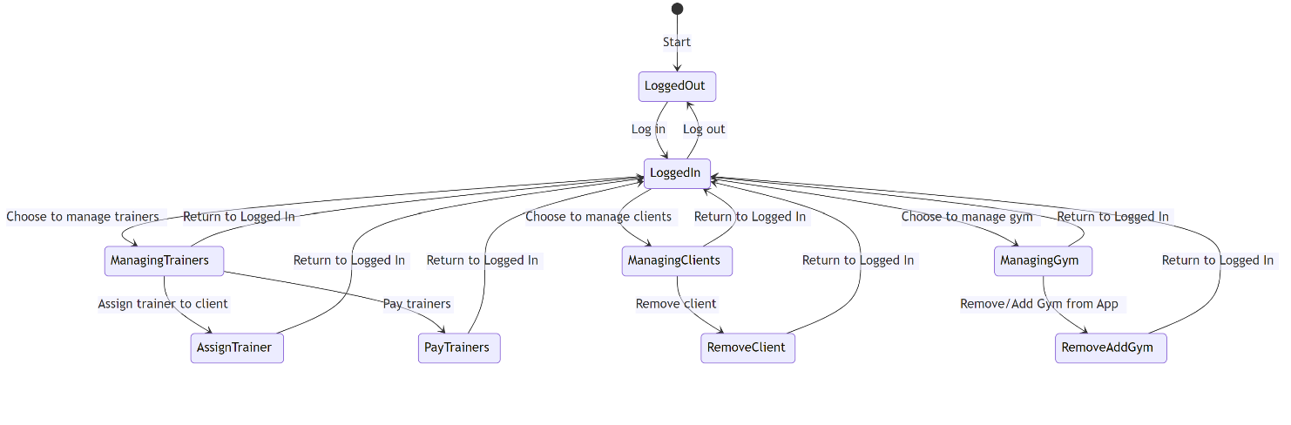

**6.3.2. State Machine Diagram: Trainer (Jacob Crews)**

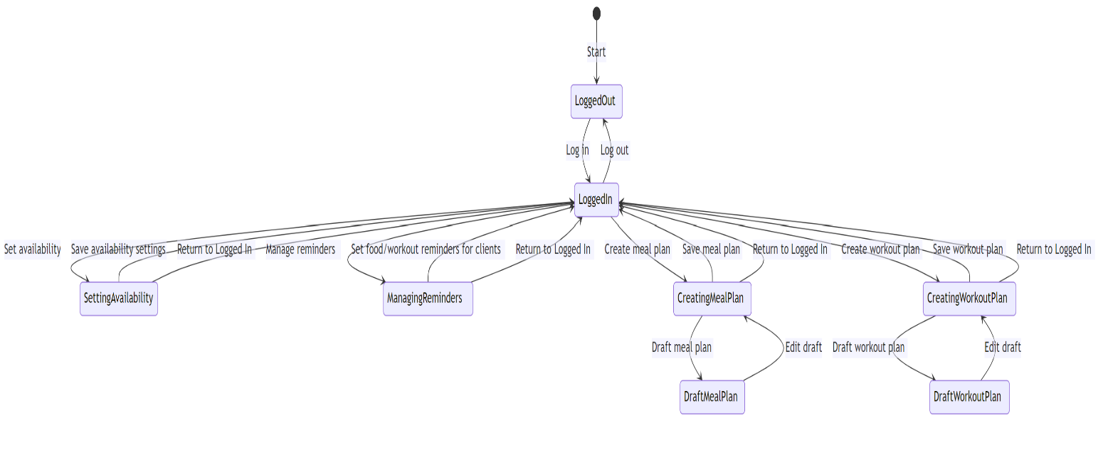

**6.3.3. State Machine Diagram: Client (Muhammad Zahid)**

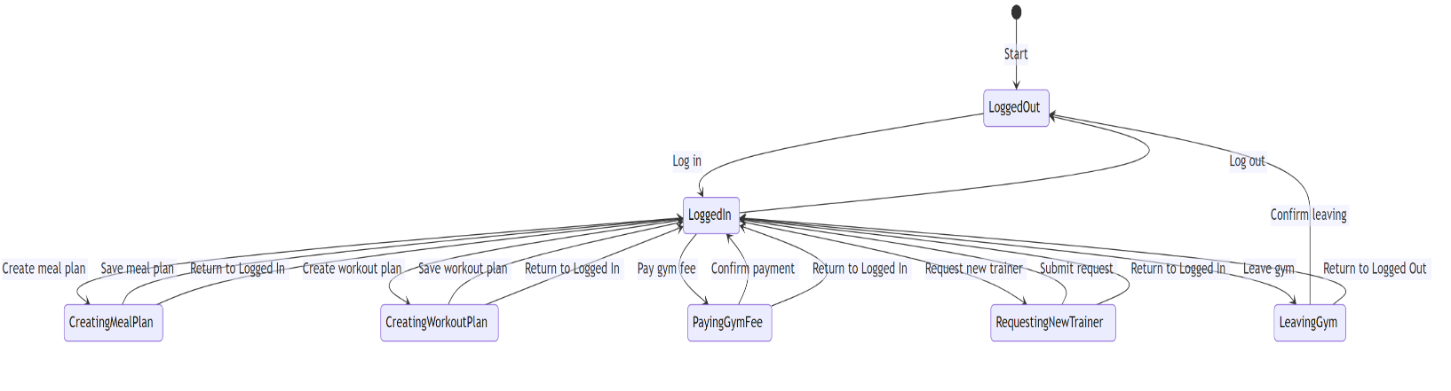

**6.4. UML Class Diagram**

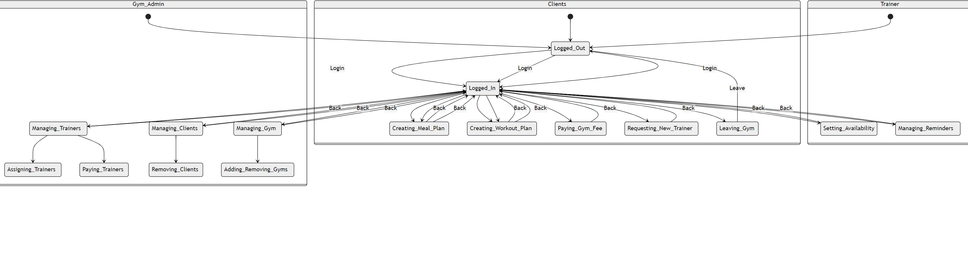

## 7. Scenario

### 7.1. Brief Written Scenario with Screenshots