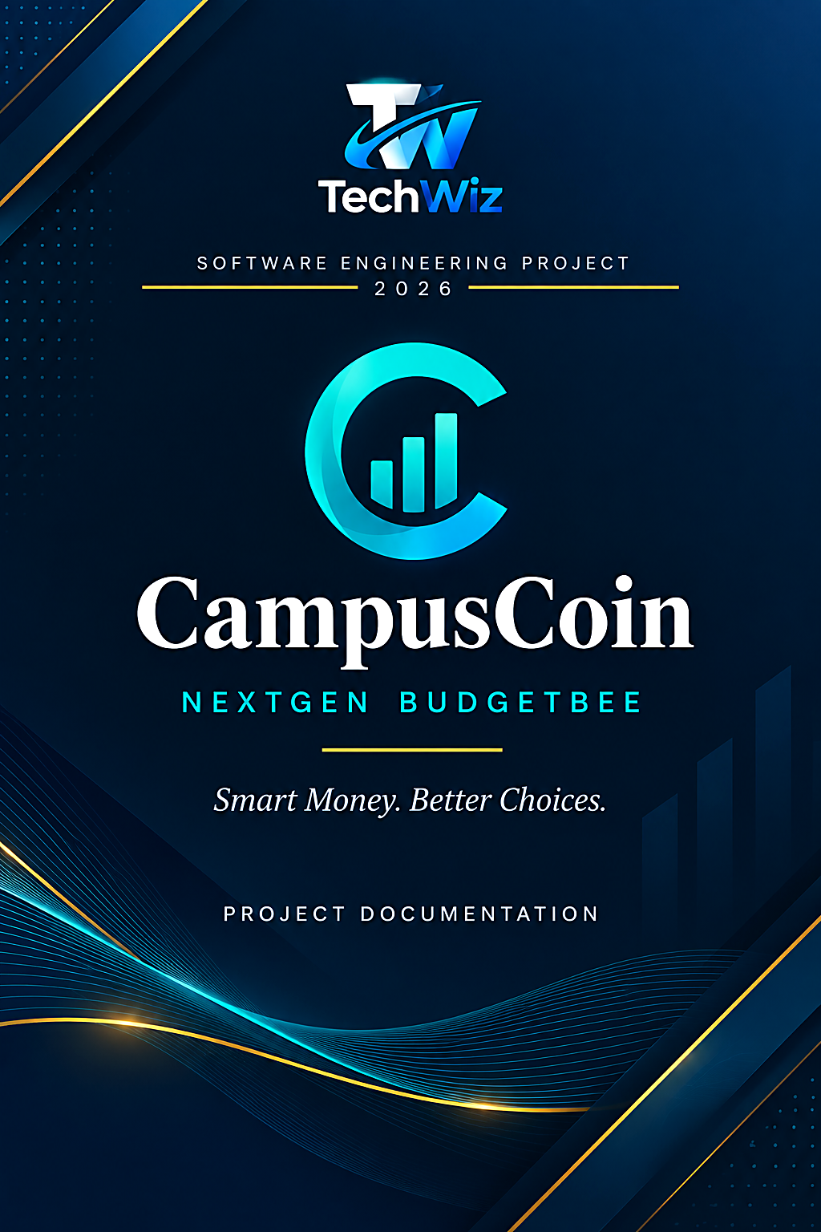

Submission Details
Submitted By | M. Junaid(Student1654758), Bilal(Student1668767), Numan(Student1677431), Rameen, Hareem, Maryam
Institution | Aptech Scheme 33
Project Category | End to end web Solution
Technology Stack | Laravel (PHP), MySQL, Blade, CSS

Team Contributions
Team Member | Work Done
M. Junaid | User login, register, profile, file integration, database design
Bilal | Admin panel, database design
Numan | Income and expense logging, category management
Maryam | Bookmarking, notes, and sharing
Rameen | Budget goals and alerts
Hareem | Frontend, plus helped with budget goals and bookmarking/notes/sharing

Declaration
I, M. Junaid, hereby declare that this project documentation and the accompanying CampusCoin application are the result of my own work and effort, carried out as part of the TechWiz 7 student technology competition organized under Aptech Computer Education. All sources of information and reference material used in the preparation of this document have been duly acknowledged.

Acknowledgement
I would like to express my sincere gratitude to my instructors and mentors at Aptech Scheme 33 for their continuous guidance and support throughout the development of this project. I am also thankful to the TechWiz 7 organizing committee for providing a platform to design, build, and showcase this application, and to my peers for their feedback during development and testing.

Table of Contents
Declaration 2
Acknowledgement 2
1. Introduction 4
2. System Requirements 5
3. Technology Stack 6
4. Design Specifications 7
5. System Architecture 11
6. Security Features 13
7. Wireframes / Mockups 14
8. System Modules / Features 15
9. Test Data 17
10. Project Installation Instructions 18
11. Testing 19
12. Implementation Status 20
13. Future Enhancements 21
14. Conclusion 22
15. References 23

1. Introduction
CampusCoin (internally also referred to during development as “Budget Basics” / “NextGen BudgetBee”) is a web-based personal finance and budgeting application designed specifically for students. It gives students a simple way to record income and expenses, organize spending into categories, set savings goals, and receive insights and tips that help them build healthier money habits while at campus.
The project was developed as a submission for TechWiz 7 at Aptech Computer Education, and is built on the Laravel PHP framework with a MySQL database and a Tailwind-CSS-enabled front end compiled through Vite.

1.1 Problem Definition (from Official SRS)
Students typically receive money from several irregular sources — monthly allowance, part-time work, scholarships, and occasional gifts — but rarely have a structured way to track where it goes. Mainstream personal-finance apps are designed for salaried professionals with fixed pay cycles and bank integrations, making them overly complex, subscription-based, or simply mismatched with a student's actual spending pattern, which usually revolves around food, transport, hostel costs, textbooks, subscriptions, and social outings. This creates a clear need for a lightweight, student-first platform that makes it effortless to log income and expenses, view spending broken down by category, and receive simple, actionable guidance on saving money — all without requiring a linked bank account or any financial expertise. Campus Coin was built to close this gap: a fast, student-relevant expense-logging system paired with a personalized tips engine and optional AI-assisted categorization and monthly insights, giving students an easy way to understand and improve their spending habits.

1.2 Objectives
- Provide a lightweight, student-focused platform to log income and expenses.
- Let users organize transactions using default and custom categories.
- Support monthly budgets and savings goals so students can plan ahead, not just record after the fact.
- Surface reports and insights that turn raw transaction data into understandable spending patterns.
- Offer saving tips, bookmarking, and (as the platform matures) a conversational assistant to answer common budgeting questions.
- Give administrators a way to manage shared content such as categories, tips, and announcements.

1.3 Scope
The current build focuses on the core account and category workflows — registration, login, password reset, and full category management — on top of a front end that already covers the full intended experience: dashboard, income/expense entry, budgets and goals, reports and insights, saving tips, bookmarks, profile, and an admin panel. The complete data model for the finished product — 22 application tables plus Laravel's built-in users/sessions tables — is documented in the Entity Relationship Diagram (Section 4.2) and defines the target scope for upcoming development.

2. System Requirements

2.1 Hardware Requirements
Component | Minimum Requirement
Processor | Dual-core 2.0 GHz or higher
RAM | 4 GB (8 GB recommended for local development)
Storage | 500 MB free space for application and dependencies
Network | Internet connection (for package installation and, if used, AI/chat features)

2.2 Software Requirements
Software | Version / Notes
Operating System | Windows 10/11, macOS, or Linux
Local Server Stack | XAMPP or WAMP (Apache + MySQL + PHP)
PHP | ^8.3
Composer | Latest stable (PHP dependency manager)
Node.js & npm | Required to build front-end assets via Vite
Database | MySQL 8
Browser | Any modern browser (Chrome, Edge, Firefox)
Code Editor | VS Code (recommended)

3. Technology Stack
CampusCoin follows a classic Laravel MVC (Model–View–Controller) architecture:
- Models — Eloquent ORM classes (e.g. User, Category) that represent and query database tables.
- Views — Blade templates rendering the UI (dashboard, categories, budgets, reports, etc.), styled with custom CSS and Bootstrap CSS.
- Controllers — Handle HTTP requests, validate input, talk to models, and return views (e.g. CategoryController, AuthController, PasswordResetController).
- Routing — Defined centrally in routes/web.php, separating public pages, authenticated routes, and guest-only auth routes.
Key third-party packages include laravel/framework, laravel/tinker for REPL debugging, fakerphp/faker and PHPUnit for testing, and Laravel Pint for code style. On the front end, CSS3 is integrated through the official Vite plugin for fast builds and hot module reload during development, alongside Font Awesome icons and Google Fonts (Inter).
Layer | Technology
Backend Framework | Laravel 13 (PHP ^8.3)
Database | MySQL 8
Frontend Build Tool | Vite ^8, laravel-vite-plugin
Styling | Bootstrap, custom CSS, Font Awesome
Templating | Blade (Laravel's server-side templates)
Package Managers | Composer (PHP), npm (JavaScript)
Testing | PHPUnit ^12
Version Control | Git

4. Design Specifications

4.1 Data Flow Diagram (DFD)
The diagram below shows how data moves through the system across three levels: the system-in-context view (Level 0), the major process breakdown (Level 1 — session management, financial data management, tools/calculators, and support/feedback), and a detailed view of each of those processes (Level 2).
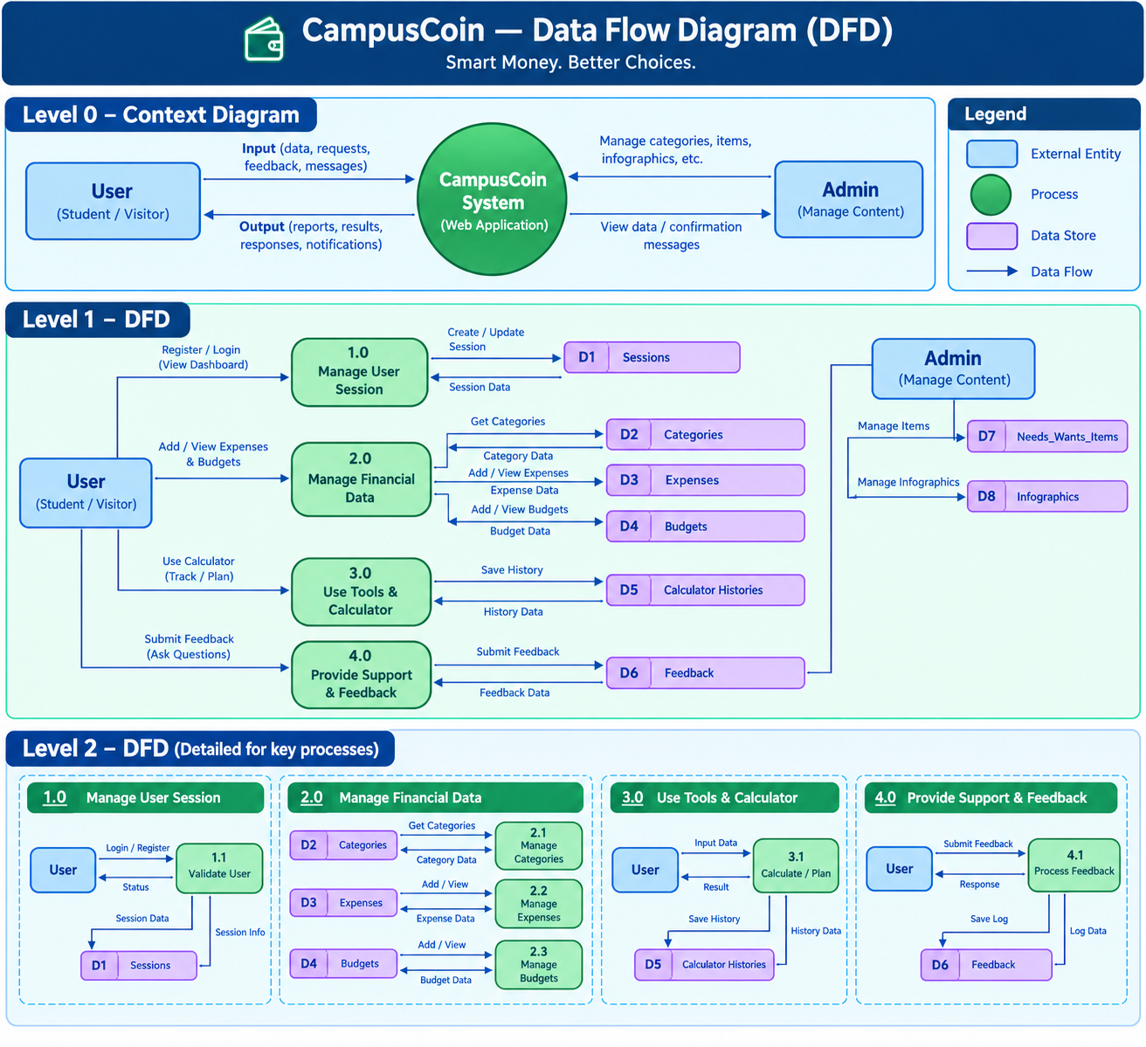
Figure 1: Data Flow Diagram — CampusCoin

4.2 Entity Relationship Diagram (ERD)
The full data model spans 22 application-level tables plus two Laravel built-in tables (sessions, password_reset_tokens), grouped into six functional areas: Core/Auth, Money, Insights & Alerts, Admin, Chatbot, and standalone reference tables. This ERD represents the target schema for the completed product; the tables actually migrated in the current codebase are a subset of this (see Section 12).
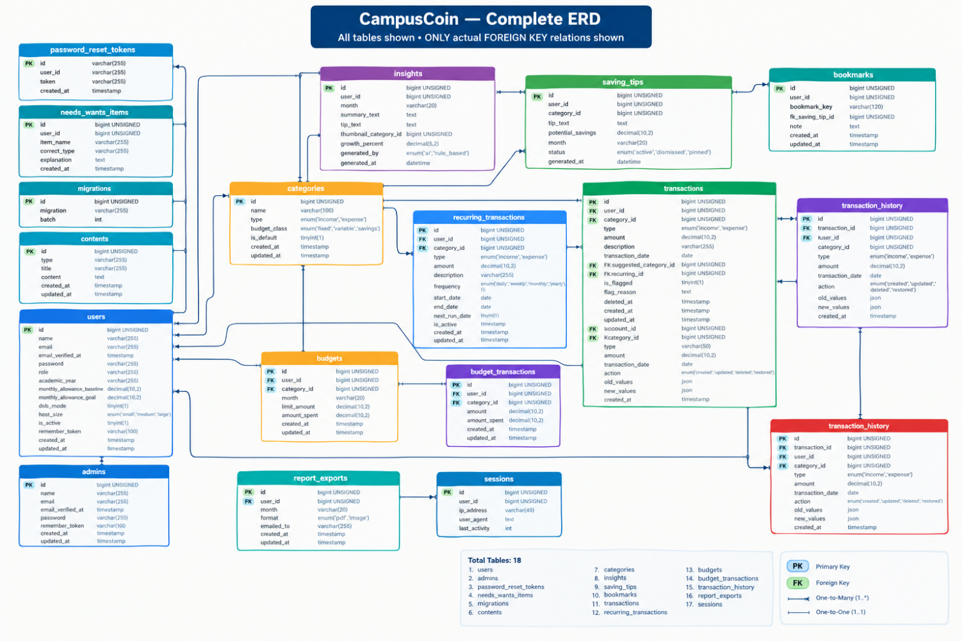
Figure 2: Entity Relationship Diagram — CampusCoin (MySQL 8, crow's foot notation)

4.3 Flowchart
The flowchart below traces a typical student's journey through the application, from account access through daily tracking to reviewing insights and saving tips.
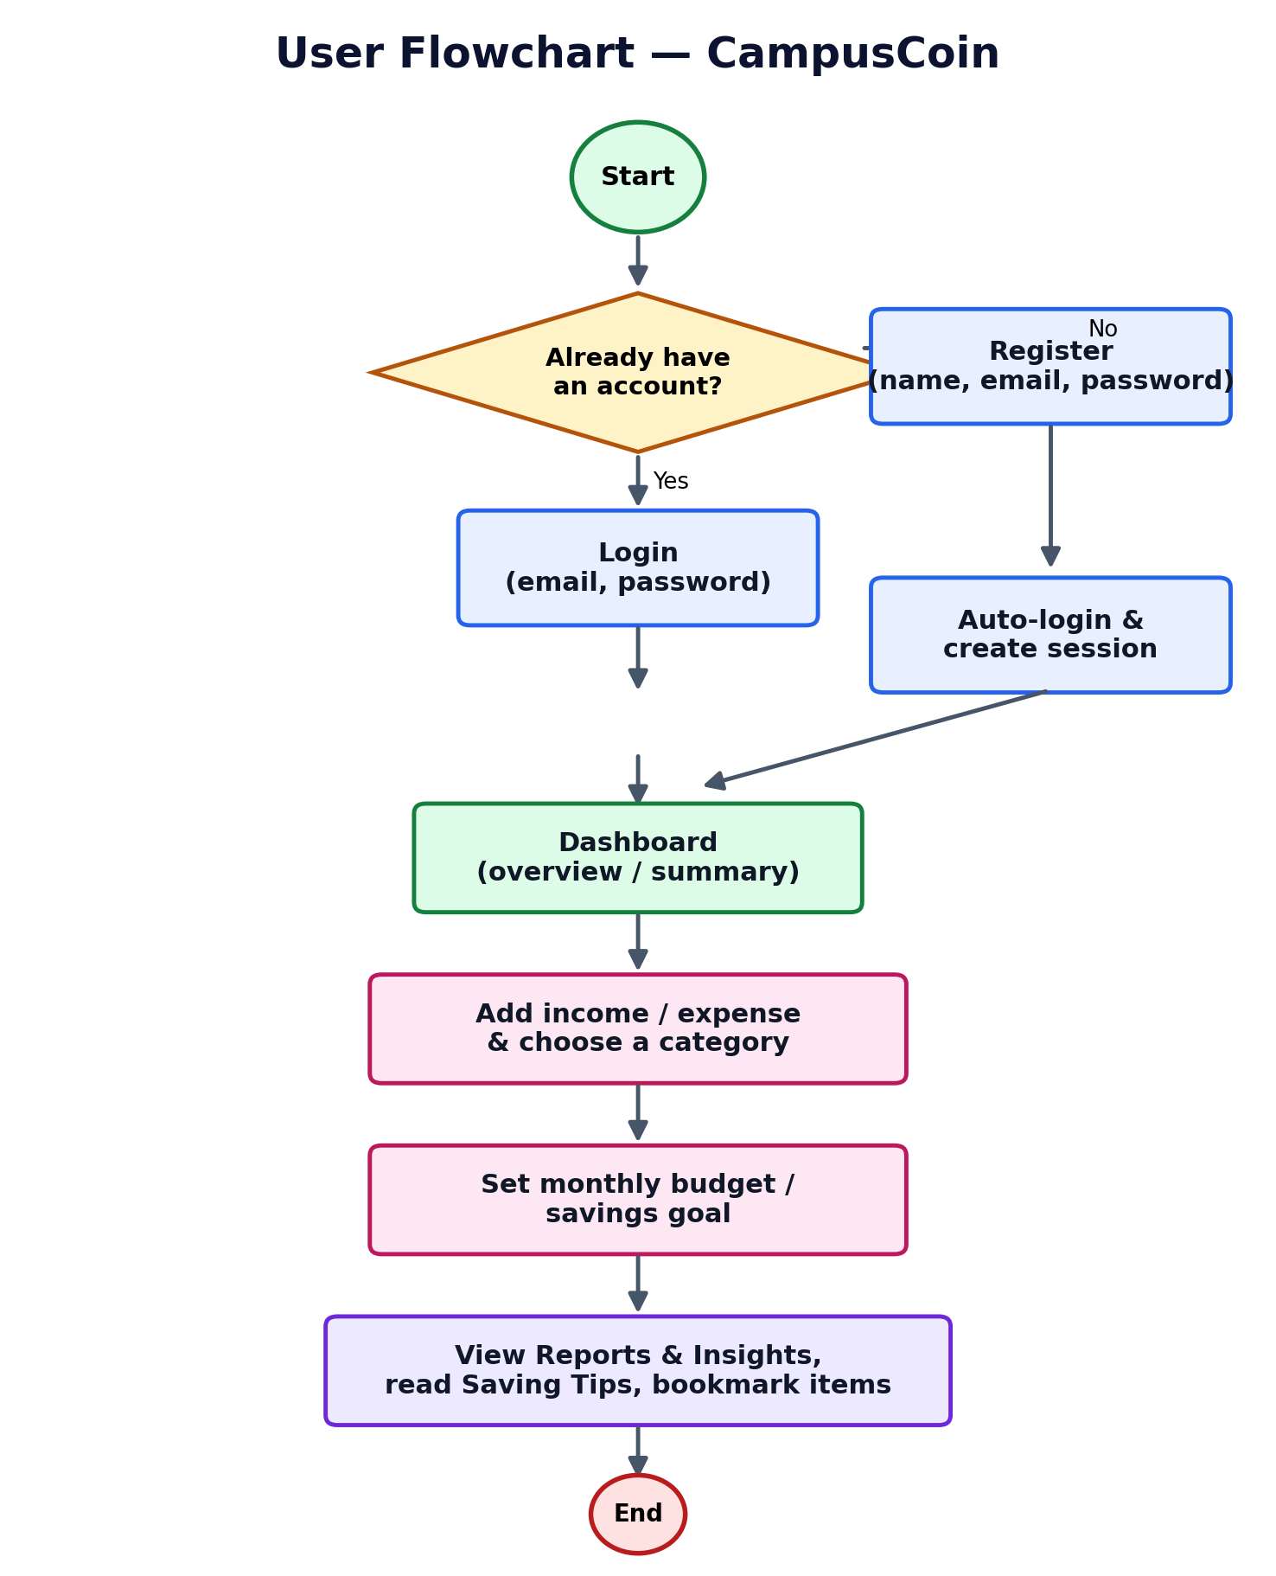
Figure 3: User Flowchart — CampusCoin

4.4 Core Entities Overview
Table Group | Key Tables | Purpose
Core / Auth | users, sessions, password_reset_tokens | Account creation, login sessions, password recovery.
Money | categories, transactions, recurring_transactions, budgets | Income/expense categorization, transaction ledger, recurring entries, monthly budget limits.
Insights & Alerts | insights, saving_tips, notifications, bookmarks, report_exports | Auto-generated spending insights, savings advice, alerts, saved items, exported reports.
Admin | announcement_templates | Admin-managed announcements and tips shown to users.

5. System Architecture

5.1 Overall Architecture
CampusCoin is built as a monolithic, server-rendered Laravel application. The browser sends HTTP requests to a web server (Apache/Nginx, provided locally by XAMPP or WAMP), which routes them through routes/web.php to the appropriate controller. Controllers validate input, interact with Eloquent models, and return Blade views, which are styled with custom CSS and Tailwind CSS and enhanced with Font Awesome icons.

5.2 Frontend
The front end is composed of Blade templates — one per page (home, dashboard, categories, budget-goal, income-expense, reports-insights, saving-tips, bookmarks, profile, admin, about, auth) — each with page-scoped CSS variables for theming (including a light/dark mode toggle) and Google Fonts (Inter) for typography.

5.3 Backend
The backend follows Laravel conventions: thin controllers (AuthController, PasswordResetController, CategoryController) handle requests and delegate persistence to Eloquent models (User, Category). Laravel's built-in authentication, hashing, validation, and session services are used rather than custom implementations, keeping the codebase consistent with framework best practice.

5.4 Database
MySQL 8 stores all persistent data in a database named campuscoin. The schema is designed around 22 application tables (see Section 4.2 and 4.4) plus Laravel's built-in sessions and password_reset_tokens tables. At the time of writing, the users, sessions, password_reset_tokens, and categories tables are migrated and in active use; the remaining tables are fully designed in the ERD and scheduled for implementation as each module is wired up.

5.5 Component Interaction
Because CampusCoin does not currently expose a separate REST/JSON API, the browser and server communicate purely through standard HTML form submissions and full-page navigations (GET/POST) secured by Laravel's CSRF protection. This keeps the architecture simple and easy to reason about for a project of this scope, while leaving room to introduce an API layer (e.g. for the planned chatbot or a future mobile client) without restructuring the existing MVC core.

5.6 Architecture Diagram
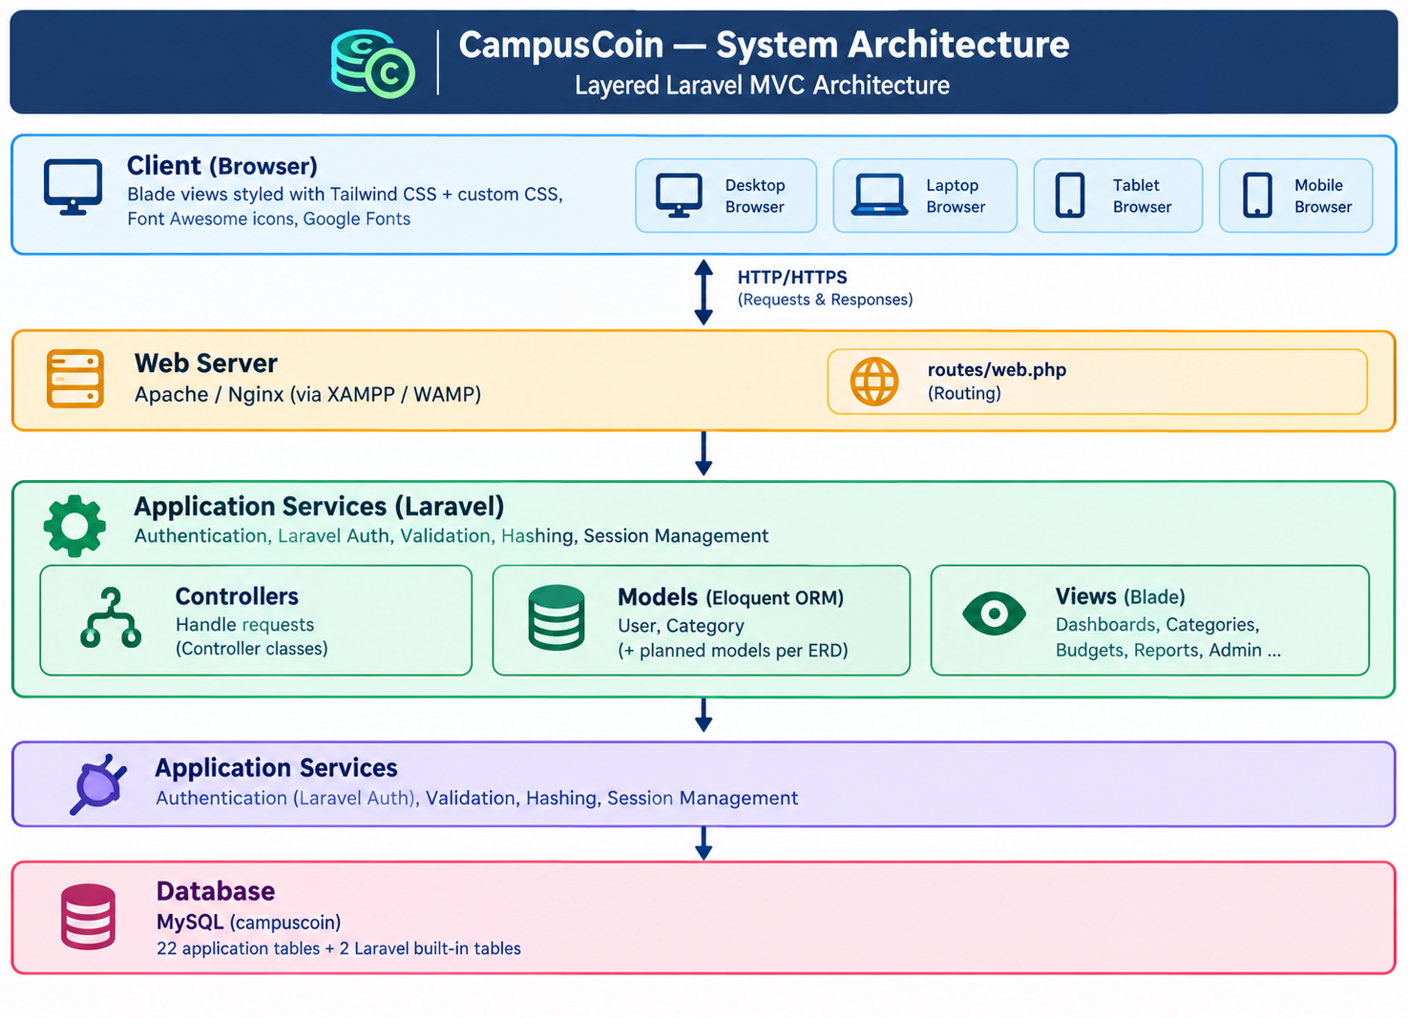
Figure 4: Layered System Architecture — CampusCoin

6. Security Features
CampusCoin relies on Laravel's built-in security primitives rather than custom, unaudited code, which keeps the attack surface small and well-tested:
- Password hashing — passwords are never stored in plain text; the User model casts the password attribute through Laravel's hashed cast (bcrypt-based) before it is persisted.
- CSRF protection — every state-changing form (login, register, category create/update/delete, logout) includes Laravel's @csrf token, and the framework rejects requests without a valid token.
- Session security — authentication uses server-side sessions stored in the database (sessions table); the session ID is regenerated on login and on logout to prevent session fixation.
- Guarded routes — guest middleware keeps authenticated users away from login/register pages, while auth middleware restricts actions such as logout to signed-in users.
- Hidden attributes — the User model marks password and remember_token as hidden so they are never accidentally exposed in JSON responses or debug output.
- Server-side validation — all form input (registration, login, category fields) is validated with Laravel's validation rules before it reaches the database, guarding against malformed or malicious input.
- Tokenized password reset — forgotten passwords are recovered through a single-use, time-limited token e-mailed to the user, handled by Laravel's Password broker.
- Secure-by-default configuration — the .env file keeps secrets (database credentials, app key) out of source control, and APP_DEBUG should be set to false in any production deployment.

7. Wireframes / Mockups
The low-fidelity wireframes below outline the layout of three key screens — the combined Login/Register screen, the Dashboard, and the Categories page — before visual styling is applied. They reflect the structure actually implemented in the Blade views.
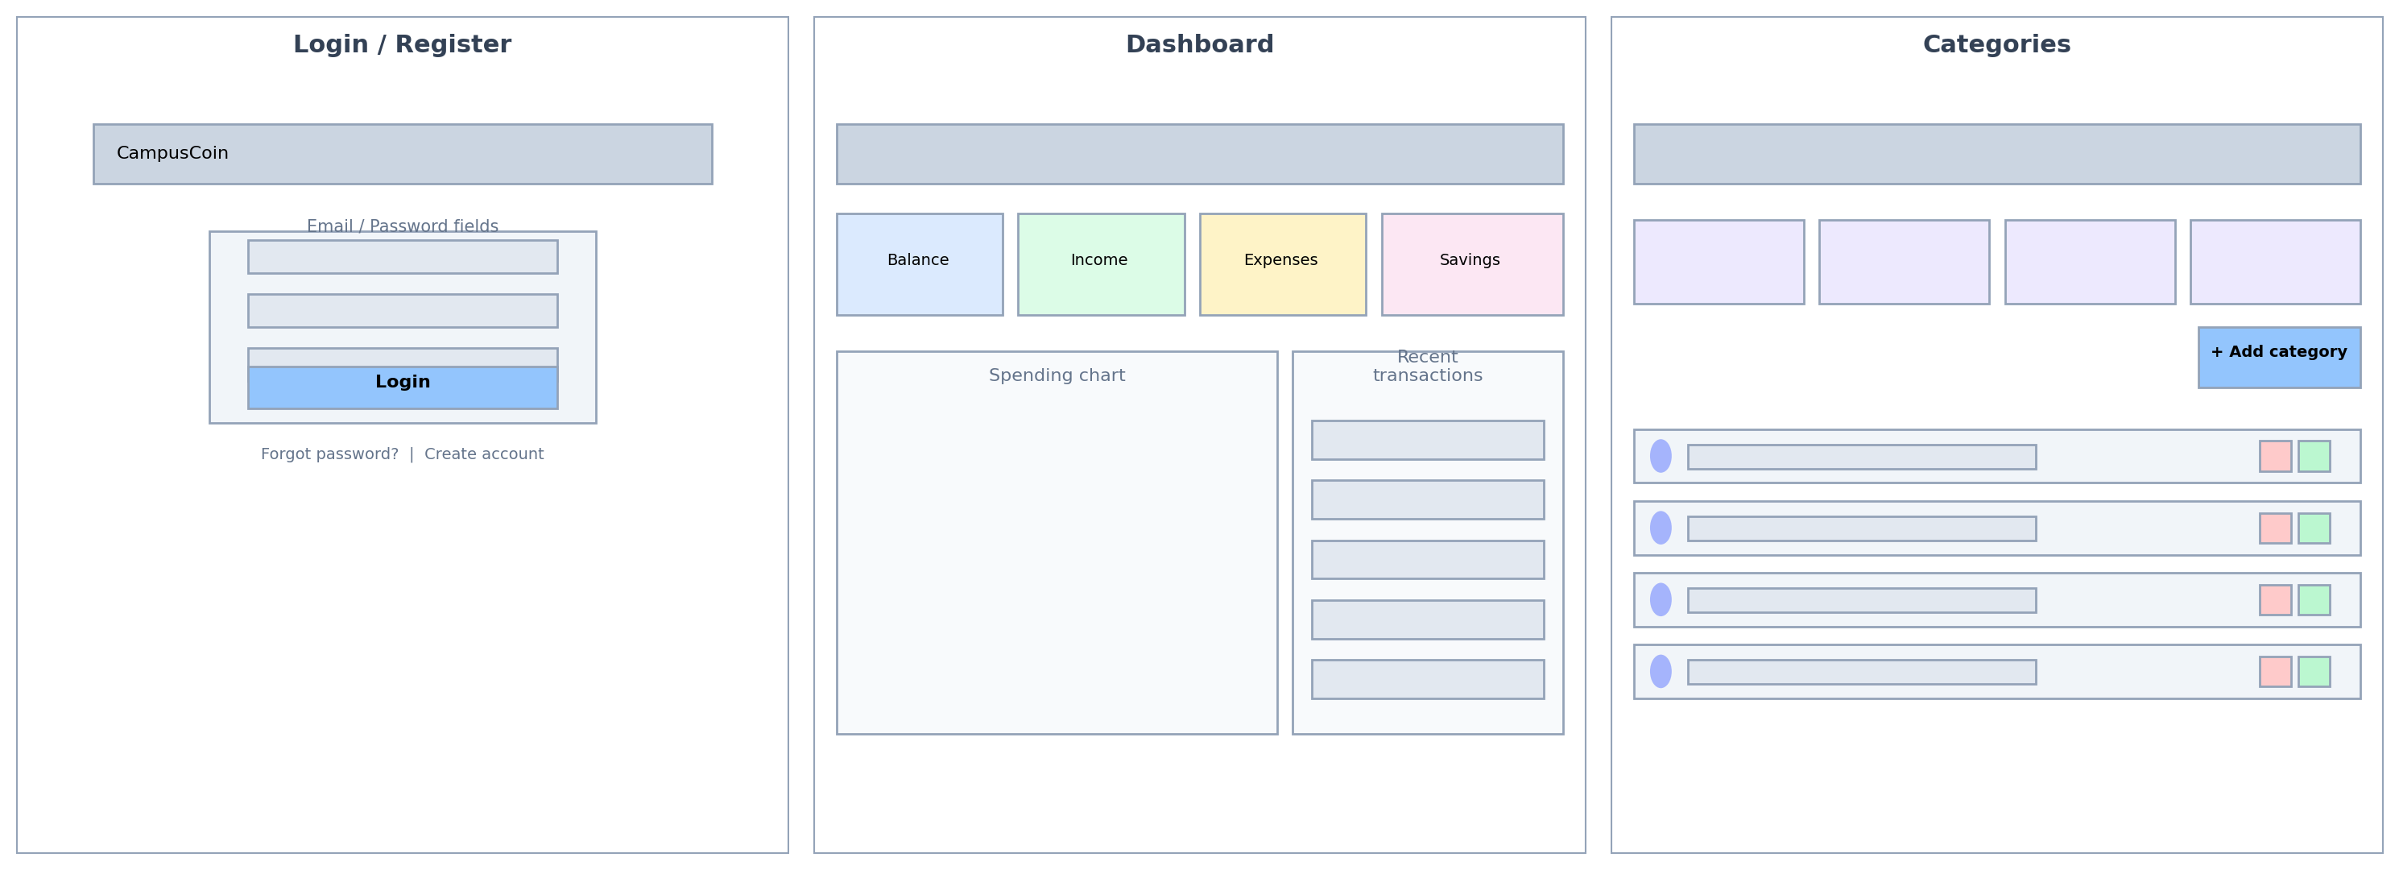
Figure 5: Wireframes — Login/Register, Dashboard, Categories
Login / Register: a centered card with email/password fields, a primary Login action, and links to password recovery and account creation, matching the guest-only auth routes.
Dashboard: a top row of summary cards (balance, income, expenses, savings) above a spending chart and a recent-transactions list — the intended landing page after login.
Categories: a filter/search bar, a set of summary count cards (total, income, expense, custom), an “Add category” action, and a list of existing categories with edit/delete controls, mirroring CategoryController's index view.

8. System Modules / Features

8.1 Authentication
Users can register, log in, log out, and reset a forgotten password via a tokenized email flow. Guest-only routes (login, register, forgot/reset password) are separated from authenticated routes (logout) using Laravel route middleware groups. Passwords are stored using Laravel's hashed cast, and the User model exposes name, email, and password as fillable while hiding password and remember_token from serialization.

8.2 Dashboard
The dashboard (and an in-progress userdashboard variant) is the landing page after login, intended to summarize a student's balance, recent transactions, and budget progress at a glance.

8.3 Category Management
Fully implemented end-to-end. Categories can be created, listed, filtered by type (income/expense) or searched by name, edited, and deleted through CategoryController. The categories index view also displays summary counts: total categories, income categories, expense categories, and custom (non-default) categories.

8.4 Income & Expense Tracking
A dedicated page for logging income and expense entries, designed to work against the transactions table defined in the ERD (amount, description, date, category link, income/expense type, and flags for recurring or flagged/duplicate entries).

8.5 Budgets & Savings Goals
Lets a student set a monthly allowance baseline, per-category budget limits, and savings goals, then track progress against them over the month.

8.6 Reports & Insights
Presents auto-generated summaries (spending by category, growth/decline percentages) intended to be generated on a schedule or on demand from the underlying transaction data.

8.7 Saving Tips
Displays curated and category-linked money-saving tips, which users can browse and act on.

8.8 Bookmarks
Allows users to save insights or tips they want to revisit later, with optional personal notes.

8.9 Profile
Lets a user view and update their account details.

8.10 Admin Panel
A separate interface for administrators to manage shared/default categories, announcement templates, and other platform-wide content.

8.11 About Page
A static informational page describing CampusCoin's purpose: a budgeting tool made for student budgets.

9. Test Data
The project ships with a database seeder (database/seeders/DatabaseSeeder.php) that creates one sample account for local testing and demonstration purposes:
Field | Value
Email | arifjunaid549@gmail.com
Password | 12345678

Seed this account by running php artisan db:seed after migrating. Additional realistic sample accounts can be generated at any time via User::factory(10)->create() (the line is present, commented out, in DatabaseSeeder.php) using the Faker-backed UserFactory, which assigns a random name/email and the same default password (“password”).
Note on the Admin account: the current codebase does not yet migrate a role column or seed a dedicated administrator user — the admin panel view exists on the front end, but role-based access control is listed under Future Enhancements (Section 13) and Implementation Status (Section 12). Until that is implemented, the admin screen should be treated as a design preview rather than an access-restricted area.

10. Project Installation Instructions
Follow these steps to run CampusCoin on a local machine using XAMPP or WAMP:
- Install a local server stack — make sure XAMPP or WAMP is installed on your machine, and start Apache and MySQL from its control panel.
- Place the project folder — copy the project into C:\xampp\htdocs (XAMPP) or C:\wamp64\www (WAMP64).
- Create the database — open phpMyAdmin and create a new, empty database with the same name given in the project's .env file (DB_DATABASE=campuscoin).
- Configure environment — copy .env.example to .env (if not already present) and set DB_HOST, DB_DATABASE, DB_USERNAME, and DB_PASSWORD to match the local MySQL setup, then run php artisan key:generate.
- Install PHP dependencies — open a terminal in the project folder and run: composer install
- Import database an run migration
- Start the application — run: php artisan serve
- Open the app — once “Serve” starts successfully, Ctrl+click the link shown in the terminal (typically http://127.0.0.1:8000) to open CampusCoin in the browser.
- Sign in — use the test data and routes provided in Section 9 to log in and explore the application, or register a new account from the /register page.

A separate, invigilator-facing ReadMe.doc accompanies this documentation and repeats these steps in a shorter, sequential checklist format for use during evaluation/judging.

11. Testing
The project ships with PHPUnit configured via tests/TestCase.php and starter Feature/Unit example tests, which can be extended as controllers are built out. Recommended testing approach going forward:
- Unit tests for model logic (e.g. Category scopes, User casts).
- Feature tests for each controller action (category store/update/destroy, auth flows) covering both success and validation-failure paths.
- Manual UI testing across each Blade view for responsive behavior, given the CSS-variable-based theming and light/dark mode toggle.
- Database seeding via factories (UserFactory is already present) to support repeatable test data.

12. Implementation Status
To keep this documentation accurate to the actual codebase rather than only the intended design, the table below summarizes what is implemented versus planned at the time of writing.
Module | Status | Notes
User registration / login / logout | Implemented | AuthController + guest/auth middleware groups.
Password reset | Implemented | Tokenized email flow via PasswordResetController.
Category CRUD | Implemented | Full create/read/update/delete with search and type filtering.
Static page views (dashboard, income-expense, budgets, reports, saving tips, profile, admin, about) | Implemented | Blade views and routes exist; most render without a dedicated controller or live data yet.
Transactions, budgets, recurring transactions | Implemented | Modeled in the ERD; migrations/controllers not yet present in the current build.
Insights, saving tips, notifications, bookmarks, report exports | Implemented | Modeled in the ERD; some views exist as UI mockups.
Admin content management | Implemented | Admin view exists; category creation currently defaults new categories to shared (user_id = null).

13. Future Enhancements
- Wire the remaining Blade views (dashboard, income-expense, budgets-goal, reports-insights, saving-tips, bookmarks, admin) to real controllers and the corresponding ERD tables.
- Implement the transactions and recurring_transactions tables with full CRUD and category linkage.
- Build the insights-generation logic to turn raw transactions into the summaries shown on the Reports & Insights page.
- Implement the chatbot intent-matching system for conversational budgeting help.
- Add CSV import support so students can bulk-upload bank/transaction exports.
- Add role-based access control to separate student and admin permissions more formally, including a seeded admin test account.
- Add automated test coverage for all new controllers as they are implemented.

14. Conclusion
CampusCoin lays a solid architectural foundation for a student-focused budgeting platform: a clear Laravel MVC structure, a fully designed 22-table data model covering money tracking, insights, admin content, and an AI chatbot, and a complete front end covering every planned screen. Authentication and category management are fully functional today, and the detailed DFD and ER diagram give a clear, already-agreed roadmap for wiring up the remaining modules — transactions, budgets, insights, and the chatbot — in future development cycles.

15. References
- Laravel 13 Documentation — https://laravel.com/docs
- Project ER Diagram, DFD & supporting documents — supplied within the project repository (Important documents/)

