Lab 4

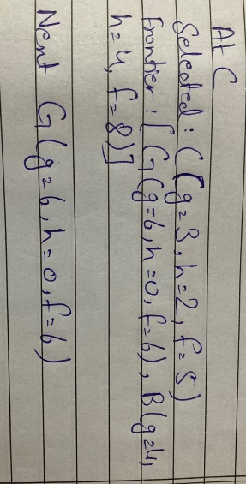
TASK1_Compute g, h and f values for the first three expansions by hand. Use the supplied campus graph, heuristic, start S and goal G. For each of the first three expansions, write the selected node, g, h and f, plus all remaining frontier entries. Show each arithmetic calculation and explain why the next node is selected. Use successor order and the stated queue tie-breaking consistently.

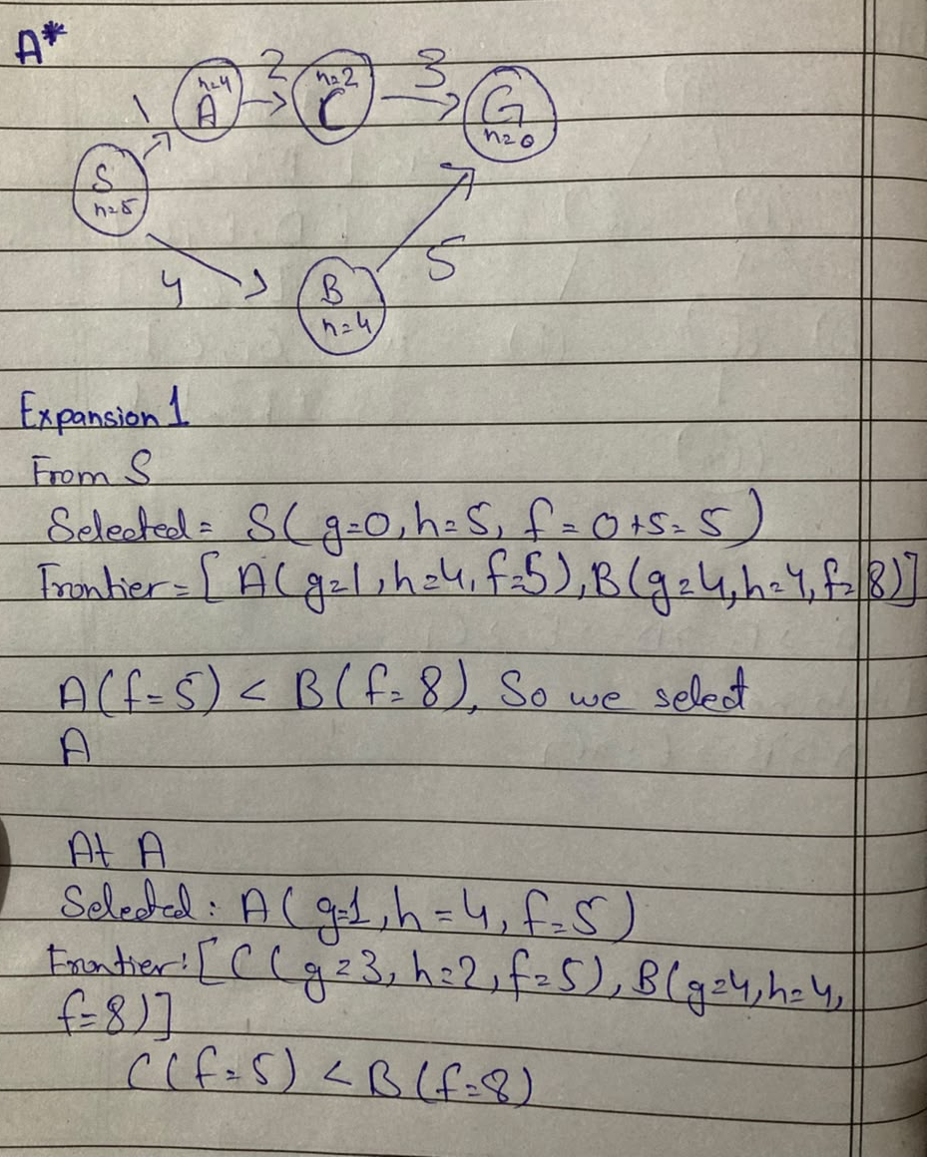

TASK2_Run A* and UCS on the same graph and record expanded nodes. Keep the weighted graph and endpoints identical. Run the supplied heuristic and a zero-heuristic UCS control. Record returned path, independently summed path cost, processed-node trace and expansion count. Use the same counting convention in both runs; explain any stale-entry or goal-counting differences.

import heapq

graph = {
"S": [("A", 1), ("B", 4)],
"A": [("C", 2)],
"B": [("G", 5)],
"C": [("G", 3)],
"G": []
}

f = {"S": 5, "A": 4, "B": 4, "C": 2, "G": 0}

def perform_graph_search(topology, heuristic_map, origin, target):
frontier = []
heapq.heappush(frontier, (heuristic_map[origin], 0, origin, [origin]))

node = []
closed_set = set()

while frontier:
expected_total, current_depth, active_node, current_path = heapq.heappop(frontier)

if active_node in closed_set:
continue

node.append(active_node)
closed_set.add(active_node)

if active_node == target:
return current_path, current_depth, node, len(node)

for successor, edge_weight in topology.get(active_node, []):
if successor not in closed_set:
cumulative_g = current_depth + edge_weight
projected_f = cumulative_g + heuristic_map[successor]
heapq.heappush(frontier, (projected_f, cumulative_g, successor, current_path + [successor]))

return None, float('inf'), node, len(node)

null_heuristic = {key: 0 for key in f}
ucs_route, ucs_total_weight, ucs_nodes_log, ucs_total_expansions = perform_graph_search(
graph, null_heuristic, "S", "G"
)
astar_route, astar_total_weight, astar_nodes_log, astar_total_expansions = perform_graph_search(
graph, f, "S", "G"
)

print("=== CONFIGURATION 1: Uniform Cost Search (UCS) ===")
print(f"Resolved Path: {' -> '.join(ucs_route)}")
print(f"Accumulated Cost: {ucs_total_weight}")
print(f"Expansion Log: {', '.join(ucs_nodes_log)}")
print(f"Expansion Count: {ucs_total_expansions}\n")

print("=== CONFIGURATION 2: A* Graph Search ===")
print(f"Resolved Path: {' -> '.join(astar_route)}")
print(f"Accumulated Cost: {astar_total_weight}")
print(f"Expansion Log: {', '.join(astar_nodes_log)}")
print(f"Expansion Count: {astar_total_expansions}")
Output
=== CONFIGURATION 1: Uniform Cost Search (UCS) ===
Resolved Path: S -> A -> C -> G
Accumulated Cost: 6
Expansion Log: S, A, C, B, G
Expansion Count: 5

=== CONFIGURATION 2: A* Graph Search ===
Resolved Path: S -> A -> C -> G
Accumulated Cost: 6
Expansion Log: S, A, C, G
Expansion Count: 4
Explaination
UCS which compared with the path cost g comapres from S to A=1 and B=4. A=1< B=4 So the path moves toward A and then to the goal state the final path Stale-Entry Prevention on both was 9 and 6 so 9 > 6 the path with less cost chooses while in A* the path also calculate the h for finding the optimal path so when it stats from the S then the frontier was A=f(5), B=f(8) the optimal path was A so the path contineous at A.
Task3_Deliberately change one heuristic value to an overestimate and discuss whether the returned result changes. Change one heuristic value only, record its original and modified values, and compare it with that node’s true remaining cost on this small graph. Use h(C)=10 as a reproducible example or justify an equivalent experiment. Rerun, report whether path/cost/count changes, and explain why an overestimate can remove the optimality guarantee even when a particular run appears unchanged.
import heapq
def astar(graph,h,start,goal):
pq=[(h[start],0,start,[start])]; best={start:0}
while pq:
f,g,node,path=heapq.heappop(pq)
if node==goal: return g,path
if g!=best[node]: continue
for nxt,w in graph.get(node,[]):
ng=g+w
if ng < best.get(nxt,float("inf")):
best[nxt]=ng
heapq.heappush(pq,(ng+h[nxt],ng,nxt,path+[nxt]))

def unchanged():
g={"S":[("A",1),("B",4)],"A":[("C",2)],"B":[("G",5)],"C":[("G",3)],"G":[]}
h={"S":5,"A":4,"B":4,"C":2,"G":0}
print(f"Unchanged Graph C=2 {astar(g,h,"S","G")}")

def changed():
g={"S":[("A",1),("B",4)],"A":[("C",2)],"B":[("G",5)],"C":[("G",3)],"G":[]}
h={"S":5,"A":4,"B":4,"C":10,"G":0}
print(f"Changed Graph C=10 {astar(g,h,"S","G")}")

unchanged()
changed()
Output
Unchanged Graph C=2 (6, ['S', 'A', 'C', 'G'])
Changed Graph C=10 (9, ['S', 'B', 'G'])
When changing an heuristic value of the provided graph C from 2 to 10 the optimal path changes as when the graph reached at c=h(10) the c=f(13) became higher then the b=f(8) so the program choose the optimal path as S->B->G with a cost 9
Failure or edge case
The failure or edge case I have noticed is that when the C=2 changed to C=10 the A* give the path of cost 9 but the other path have the cost 6.

